Assessment Title: Individual Report – Tesco PLC’s International Expansion Strategy: A Strategic Analysis and Market Entry Plan for Vietnam



Students Name: Nwakaego peace Elumese
Students ID: 2114106
Module code: LCMB7003
Module name: Strategic Management
Lecturer name: Dr Andry
Submission date: 22/12/2025
Master of Business Administration (MBA)

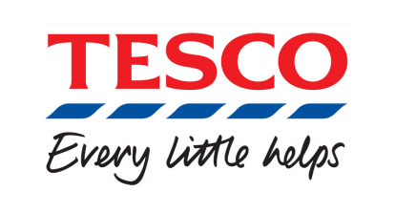
https://theedinburghreporter.co.uk/2024/04/plans-for-new-tesco-store-scrapped/

Table of Contents
1Introduction…………………………………………..3
2. Organisation and Target Market …………………4
2.1 Company Overview………………………………………………4
2.2 Rationale for International Expansion…………5
2.3 Target Market: Vietnam…………………………6
2.4 Strategic Fit and Justification……………………7
3. Comprehensive Strategic Analysis………………8
3.1 PESTLE Analysi………………………………….8
3.2 Porter’s Five Forces Analysis…………………10
4. Strategy Development and Formulation​…………15
4.1 Strategic Rationale……………………………...15
4.2 Application of the Ansoff Matrix………………15
4.3 Market Entry Strategy:​…………………………………15
4.4 Porter’s Generic Strategies…………………...16
4.5 BCG Matrix and Product Portfolio Management……………………………………… 17
4.6 Corporate Social Responsibility (CSR) and Sustainability Integration:​……………………….,………………………………………………. 17
4.7 Risk Management and Mitigation:​………………18
4.8 Implementation Framework………………….18
4.9 Evaluation of Strategic Models:​…………………19
5. Performance Evaluation Framework​……………19
5.1 The Balanced Scorecard Framework…. 19
5.3 Integration of the Triple Bottom Line (TBL...)21
6. Discussion and Critical Evaluation:​……………… 22
6.1 Strategic Integration and Coherence…….:​22
6.2 Strategic Agility and Learning Orientation:​23
6.3 Challenges and Critical Reflection……… 23
7. Conclusion and Recommendations:​………… 23
7.1 Conclusion………………………………….:​23
Reference list:​……………………………., ………………..25
Appendices……………………………………………….25

1. Introduction:
Jack Cohen produced the idea for the British corporation Tesco in 1919. The internet platforms, hypermarkets, and convenience stores owned and run by the corporation serve millions of people on a weekly basis. Tesco, a company that specialises in food, has expanded into a global retailer that places a strong emphasis on technology, agility, and sustainability. Increasing the amount of money that is collected from each shopping bucket is the key to achieving operational excellence, innovation for growth, and customer pleasure (Birmingham, 2022). Rather than providing shoppers with a slightly improved experience daily, our business logic now demands that we provide "better every day for customers." Tesco can compete in well-established countries such as the United Kingdom, Ireland, and Central Europe by emphasising cost leadership, quality, convenience, and Big Data for the purpose of gaining customer insights

1: Different Services Provided by Tesco Plc.
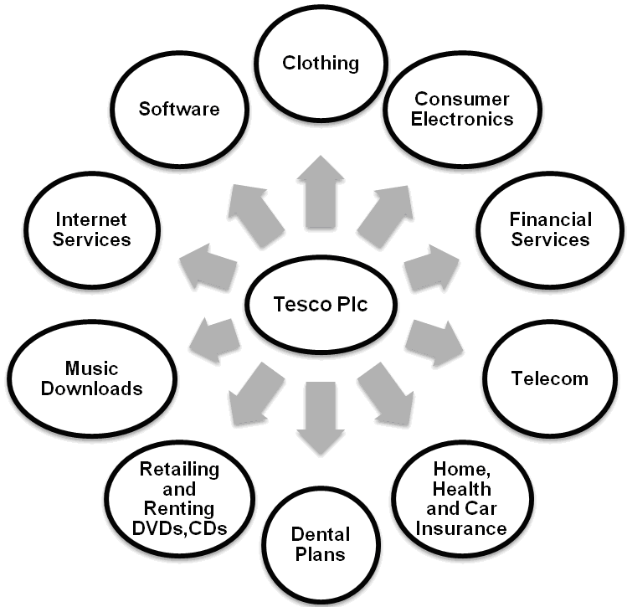

https://business-essay.com
/Management-report-tesco-personal-finance

Both Fresh & Easy's and Japan's withdrawals from the corporation are examples of the dangers associated with worldwide expansion. Before entering new markets, it is essential to conduct a strategic study and context
analysis, as demonstrated by these cases. A vast amount of potential lies inside the Asian growing economies. It is a potential market since Vietnam's gross domestic product (GDP) growth has been stable, the income of the middle class has been rising, urbanisation has occurred, and the retail sector is open to international investment.
In the research, a global expansion strategy for Tesco's entry into the Vietnamese market is proposed. To determine how Tesco can utilise its global skills and adapt to Vietnam's local environment to conduct research that is evidence-based and analytical. PESTLE, Porter's Five Forces, VRIO, and Porter's Diamond Model are the tools that are utilised in this article to investigate both the external and internal environments of Tesco (Birkinshaw, 2022). The Ansoff Matrix, Porter's Generic Strategies, and the BCG Matrix are utilised in the process of developing a unified market entry and growth plan. The Triple Bottom Line (TBL) approach and the Balanced Scorecard will be utilised in order to assess both performance and effect.
According to the findings of this study, strategic management might guide Tesco's global expansion. When it comes to achieving success on a global scale, it is essential to emphasise strategic agility, local adaptation, and responsible business practices.
Organisation and Target Market
2.1 Company Overview:

England's Welwyn Garden City serves as the location of Tesco PLC's headquarters. Since its founding in 1919, the shop has grown from a small market stall to become one of the largest in both Europe and Asia. As of 2024, Tesco owns 27% of the grocery sales in the United Kingdom (MAZIDI, 2025). Booker, Tesco Extra, and Tesco Express employ a total of approximately 330,000 individuals. Most of Tesco.com, the leading online supermarket in the United Kingdom, is virtual.
The mission statement of Tesco, which is well-written, encourages quality, responsibility, and customer understanding to provide better service to customers daily. Achieving operational excellence, achieving success with customers, and expanding in a sustainable manner are all long-term aims. As a global pioneer in environmental protection, the company has set a goal to achieve net-zero carbon operations by the year 2035 and to reduce food waste by fifty per cent by the year 2030 (MAZIDI, 2025). Tesco's digital retail agility is improved by automation, coordination powered by artificial intelligence, and data analysis.
Rationale for International Expansion:

When it comes to wealthy countries like the United Kingdom, Tesco is saturated. Domestic profitability is negatively affected by the recession, competition from Aldi and Lidl, and shifting preferences among customers. Tesco's revenue may be diversified through international expansion, which would also assist the company in satisfying the growing demand in high-growth regions.
Increasing levels of discretionary income, increased urbanisation, and the growth of the middle classes are all factors that are beneficial to Asia (Zhuang, 2022). Even though Tesco left Japan and the United States due to misaligned consumer demands and expensive operational costs, the company's success in Thailand and Malaysia proves that it can achieve success in economies that are culturally diverse and growing.
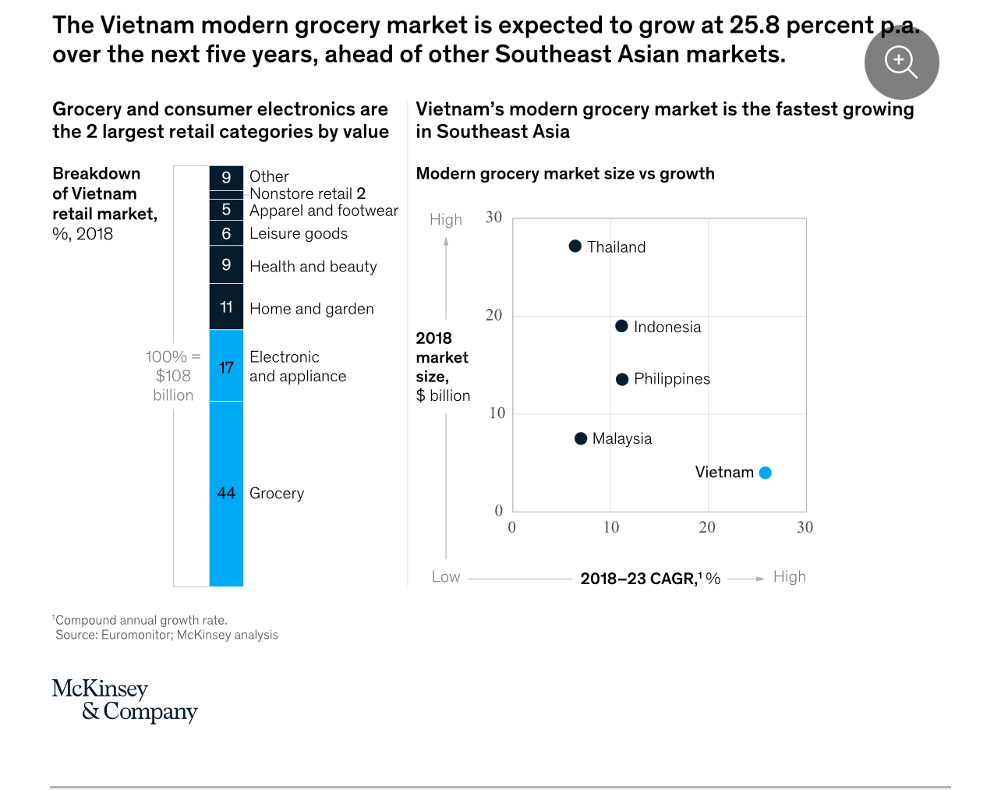

Image accessed at https://www.mckinsey.com

3 Target Market: Vietnam

Tesco can achieve its long-term goals in the rapidly expanding retail sector in Vietnam. According to the World Bank (2024), the country is moving from a lower-middle income to an upper-middle income, with a population of 100 million people and a GDP growth rate of 6–7% (SergiyKorablin, 2025). Many of the major cities in Vietnam, such as Ho Chi Minh City and Hanoi, are home to contemporary supermarkets, convenience stores, and online shopping platforms.
According to Statista (2024), young Vietnamese individuals who are proficient in technology are expected to propel Vietnam's retail industry to a value of USD 250 billion by the year 2026 (Coppo, 2024). It is advantageous for foreign merchants to take advantage of the tax benefits and simplified ownership laws that are included in the Vietnam Retail Industry Development Plan 2030.
As time goes on, Vietnamese customers are becoming more health-conscious, brand-conscious, and accommodating to Western retail. Because customer loyalty and trust are the primary drivers of sales, Tesco needs to localise its product mix and pricing. Saigon Co-op, Aeon (Japan), and Lotte are just a few of the local and global merchants that compete with one another. "Value with integrity" is a phrase that Tesco may use to differentiate itself in the realm of currency and virtue.
2.4 Strategic Fit and Justification:

Because of the company's data-driven logistics and efficient global supply chain, it may be possible for the company to offer competitive prices in an industry that is growing (Kamboj and Rana, 2021). The fact that it has experience operating both large hypermarkets and smaller urban stores reflects the fact that Vietnam combines traditional wet markets with sophisticated retail.
Similarly, Tesco's corporate social responsibility purpose of sustainability, community participation, and ethical sourcing aligns with Vietnam's environmental aims. Through reusable packaging, local sourcing, and the decrease of food waste, Tesco can alleviate the problems of plastic waste and food security that the nation is facing.
The Vietnamese market presents Tesco with a favourable risk-reward profile. By lowering tariffs on a wide variety of imported goods, the UKVFTA helps to strengthen commerce with the United Kingdom. Elevated levels of consumer spending and demographics that are appealing are indicators of promise for the long-term market. In order to engage customers, Tesco relies on young individuals who are devoted to the company. Tesco can integrate Clubcard e-commerce and incentives due to the rapid digital transformation that Vietnam is experiencing.
There are problems with the supply chain, including complex bureaucracy, local competitiveness, and adaptation. It would be beneficial for Tesco to collaborate with a local company in order to overcome regulatory obstacles and acquire cultural understanding (Kamboj and Rana, 2021). By using this strategy, risk is eliminated, resources are distributed, and the localisation process is sped up.
3. Comprehensive Strategic Analysis: This article investigates both the external and internal factors that led to Tesco's expansion into Vietnam. When analysing market dynamics, competitive pressures, and organisational capabilities, many models, such as PESTLE, VRIO, and Porter's Diamond Model, are utilised.
3.1 PESTLE Analysis:

Political Factors
Because of its stable administration, Vietnam can attract investments from other countries. As a result of the socialist government's implementation of the Đổi Mới reforms, the economy underwent a transition from central planning to market orientation, hence promoting economic liberalisation (Capobianco et al., 2021). The commitment of Vietnam to free trade is shown in its membership in the CPTPP and the UKVFTA. Companies based in the United Kingdom, such as Tesco, get the benefits of reduced tariffs and increased market access.
Economic Factors
Over the past ten years, Vietnam's gross domestic product has grown by between 6 and 7 per cent annually (World Bank, 2024). The need for innovative retail experiences is a direct result of rising disposable incomes and the expansion of the middle class. By the year 2026, the retail industry could reach USD 250 billion (Statista, 2024). If employment remains stable and the government continues to provide help for domestic consumption, consumer confidence and inflation will remain at 3%.
Social Factors
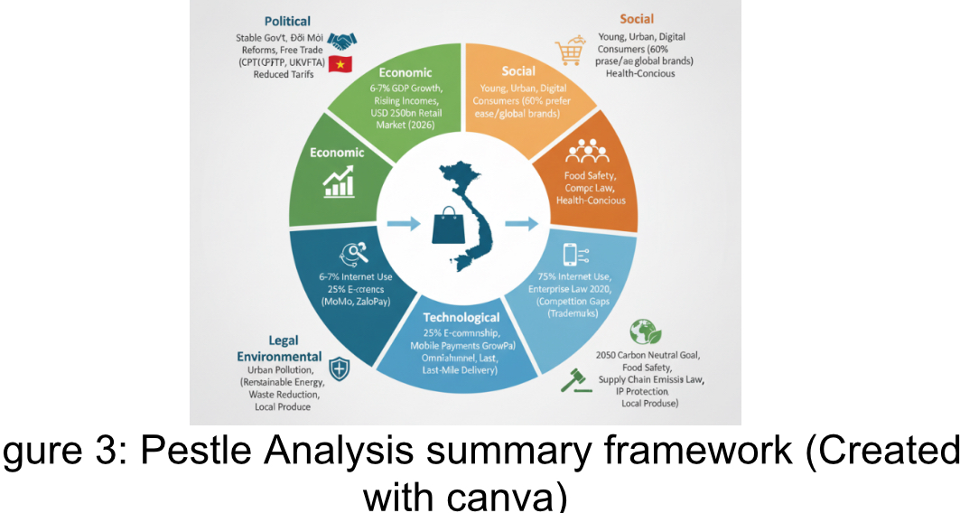
There are one hundred million young, urbanising, and digital Vietnamese people. Among consumers under the age of 35, more than sixty per cent prefer ease, affordability, and global brands. Markets that are more traditional are used by customers in rural areas, whereas urban buyers prefer more contemporary methods (Saloner, 2021). In order to accommodate this diversity, Tesco needs to combine global quality with products that are created locally and promotions that are customised to different cultures.
Technological Factors
There is now a digital revolution taking on in Vietnam. The percentage of people using the internet has surpassed 75%, while the revenue generated from online shopping has surpassed 25% (Van, 2025). MoMo and e are supported by a range of smartphones. Tesco's customer service and efficiency can be improved by the implementation of predictive analytics, AI-driven inventory management, and Club-card loyalty programs. Integration of Omani channel platforms and last-mile delivery are both essential in densely populated cities that face challenges in terms of logistics.
Legal Factors
Laws governing foreign retail investment in Vietnam were improved. The Enterprise Law of 2020 makes the process of registering a business easier and, under certain circumstances, allows foreign retail ownership of one hundred percent. Distribution, labour, and food safety standards are all strictly enforced at the local level. Food Safety (2010) and Competition Law (2018) are two regulations that Tesco must adhere to in order to protect its reputation (Tesco PLC, 2021). Tesco should apply for brand trademarks early on and deploy anti-counterfeit measures for private-label products since the company's intellectual property protection is inadequate.
Environmental Factors
Long-term viability Sustainability is a top priority for Vietnam, and the country's goal is to achieve zero carbon emissions by the year 2050. Debris made of plastic, pollution in urban areas, and emissions from supply chains are all issues. Sustainable Store is committed to achieving Vietnam's environmental goals by promoting the use of renewable energy, reducing waste, and promoting local cuisine. Tesco may be able to increase its corporate social responsibility and attract customers who are environmentally sensitive by implementing these local strategies.
3.2 Porter’s Five Forces Analysis:

1. Competitive Rivalry (High)
Retailers in Vietnam face competition from both indigenous and international businesses. Competitiveness is increased as a result of Tesco's aggressive pricing, frequent markdowns, and high retail space fixed costs; yet, these factors compromise service, technology, and sustainability (Barney and Hesterly, 2019).
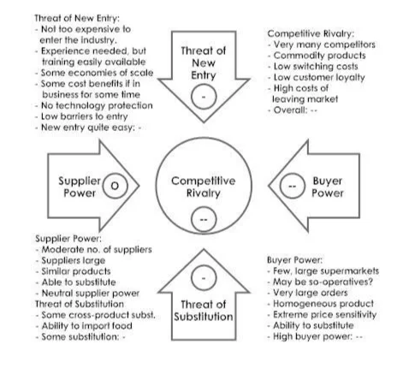

FivePorters-forces-in-tesco- https://www.dissertationhomework.com/samples/assignment-essay-
. 2. Threat of New Entrants (Moderate)
New enterprises are drawn to Vietnam because of its economic openness, despite the country's high expenses and stringent restrictions. Tesco possesses reach around the globe, economies of scale in terms of supply chain efficiency, and trust in its brand. Documentation was reduced thanks to local distribution.
3. Threat of Substitutes (Low to Moderate)
Rural grocery shopping is primarily done at markets and via street sellers. Those who place a greater priority on convenience, hygiene, and branding will experience a reduction in the threat. Education and promotion are two ways that Tesco can facilitate the promotion of quality and sustainability.
4. Bargaining Power of Suppliers (Moderate)
Small-holder suppliers in Vietnam's fragmented agriculture industry do not have the ability to negotiate, which makes it impossible for them to reduce prices. Tesco can better manage both its expenses and its supplies thanks to global sourcing. When you shop locally, you help preserve both community and freshness. By providing training and supporting fair pricing, Tesco may be able to enhance its supply chain and its links with Vietnamese farmers (Barney and Hesterly, 2019).
5. Bargaining Power of Customers (High)
Consumers in Vietnam are price-conscious, but they are increasingly inclined to prioritise quality and service. Many different shop alternatives provide customers with the ability to negotiate. Tesco is able to tailor its offerings and retain customers with the help of data analytics and loyalty programs such as Clubcard Vietnam. Customer loyalty can be maintained by transparent pricing and consistent quality.
3.3 VRIO Analysis
The VRIO Framework assesses Tesco’s internal resources and capabilities for competitive advantage.
Resource/Capability | Valuable | Rare | Inimitable | Organised | Outcome
Global Supply Chain Network | ✔ | ✔ | ✔ | ✔ | Sustainable Advantage
Brand Reputation | ✔ | ✔ | ✖ | ✔ | Temporary Advantage
Data Analytics & Clubcard | ✔ | ✔ | ✔ | ✔ | Sustainable Advantage
Financial Strength | ✔ | ✖ | ✖ | ✔ | Competitive Parity
Sustainability & CSR Practices | ✔ | ✔ | ✔ | ✔ | Sustainable Advantage
Human Capital & Management Expertise | ✔ | ✖ | ✖ | ✔ | Competitive Parity

Interpretation:
The advantages that Tesco possesses include environmental consciousness, smart analytics, and efficient global supply chain operations. These capabilities are unique, valuable, and difficult to replicate due to the organisational culture and technological advancements that have occurred. In Vietnam, Tesco may stand to gain from VRIO's supply chain management, consumer data utilisation, and corporate social responsibility branding.
3.4 Porter’s Diamond Model
An evaluation of Vietnam's host market competitiveness is conducted using Porter's Diamond Model.
1. Factor Conditions
It is possible to find young, low-cost labour in Vietnam that is also becoming highly skilled. Improvements to roadways and seaports enhance the efficiency of distribution. Tesco has the ability to address these concerns by investing in infrastructure for cold chain infrastructure and rural mobility.
2. Demand Conditions
Intelligent Vietnamese consumers are drawn to foreign brands because of their convenience, quality, and foreign brands. Tesco is able to enter the market because of the growing number of consumers in the middle class and urbanisation. These consumers want more sophisticated shopping experiences (Porter, 1980).
3. Related and Supporting Industries
There is a possibility that the private-label supply chain of Tesco will benefit from the agricultural and food industry boom in Vietnam. Retail is being modernised by innovative logistics and information and communication technology. Supply chain risks are posed by a variety of different types of imports.
3.4 Porter’s Diamond Model
An evaluation of the competitiveness of Vietnam's host market is carried out using Porter's Diamond Model.
1. Factor Conditions
It is possible to find young, low-cost labour in Vietnam that is also becoming highly skilled. Building enhancements to roadways and seaports increase the effectiveness of distribution. Tesco has the ability to address these concerns by investing in infrastructure for cold chain infrastructure and rural mobility.
2. Demand Conditions
Intelligent Vietnamese consumers are drawn to foreign brands because of their convenience, quality, and foreign brands. Tesco is able to enter the market because of the growing number of consumers in the middle class and urbanisation. These consumers want more sophisticated shopping experiences (Porter, 1980).
3. Related and Supporting Industries
There is a possibility that the private-label supply chain of Tesco will benefit from the agricultural and food industry boom in Vietnam. Retail is being modernised by innovative logistics and information and communication technology. Supply chain risks are posed by a variety of different types of imports.

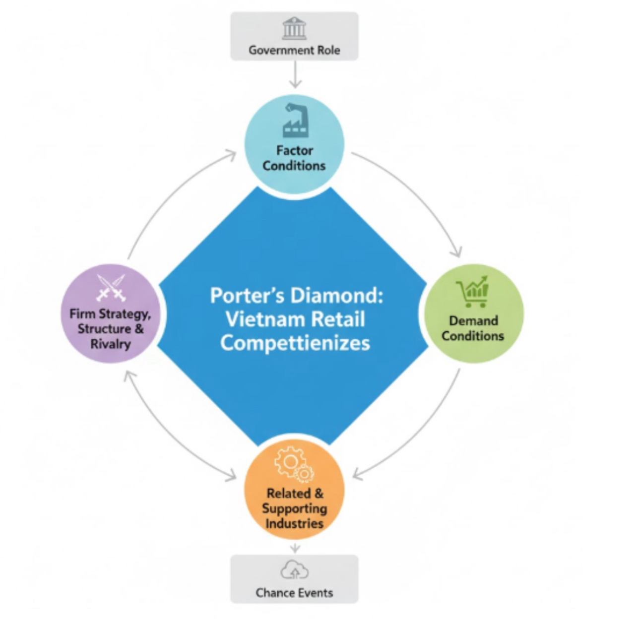
Figure 5: Theoretical model of Porter’s Diamond Model (Created with Canva)

Implementation
4. Firm Strategy, Structure, and Rivalry
Quality, efficiency, and creativity are all improved when there is competition between domestic and international shops. As a result of this circumstance, Tesco must innovate and adjust to the behaviour of local consumers(Porter, 1980). Relationship-based marketing by Vietnamese merchants highlights the importance of corporate social responsibility and local engagement for Tesco in order to build trust.
5. Government Role
Providing financial incentives and infrastructure, Vietnam is eager to attract foreign investment. Joint ventures or strategic partnerships may be encouraged above first arrival, however, because to the limits imposed by local content and regulatory requirements.
6. Chance Events
It is possible for operational expenses to increase because of disruptions in supply chains, global inflation, and regional trade disputes (Saloner, 2021). Resilience in the face of global crises demonstrates the institutional flexibility of Vietnam.
3.5 Evaluation of Analytical Tools
Every paradigm has its own set of limitations, but it also offers some insights.
• There are no dynamic factor links, but PESTLE provides a comprehensive perspective.
• The reasons why Porter's Five Forces might not apply to the digital disruption in retail.
• Internals are given more weight than fluctuations in the market by VRIO.
• Rather than focusing on firm-specific advantages, the Diamond Model prioritises national competitive competence.
4. Strategy Development and Formulation
4.1 Strategic Rationale:

In one country

Tesco entered the Vietnamese market to avoid becoming oversaturated in the European market. The performance of the corporation in the United Kingdom and Central European markets has been hindered by factors such as low population growth, intense competition from Aldi and Lidl, and shifting preferences among consumers. For Tesco to continue to be profitable and to increase shareholder value, new growth is required. An expanding middle class, robust economic statistics, and a sophisticated retail infrastructure are all factors that contribute to Vietnam's attractiveness. Retail is anticipated to experience an annual growth rate of more than 10% because of consumer spending and the digital revolution.
The global, digital, and environmental knowledge that Tesco owns can help the company in satisfying clients in Vietnam who are concerned about cost but also want convenience and quality. Consumers are encouraged to connect with products that are both economical and of excellent quality through the extension.
4.2 Application of the Ansoff Matrix:

Tesco may continue to attract customers by offering competitive prices and quality for its private label, fresh items, and Club-card Vietnam clients. Tesco has formed a partnership with a local company to build a better grasp of the market and distribution networks for both traditional and online shopping. To cater to the preferences of the locals, Tesco needs to provide regional snacks, Asian condiments, and local food (Kotler and Keller, 2016). A click-and-collect platform and an online grocery ordering system are both included in the diversification initiatives.
4.3 Market Entry Strategy:

Tesco ought to enter Vietnam through a joint venture because of the country's regulatory environment and the highly competitive retail sector. Using this strategy drops the risks associated with entering the market, ensures compliance with local investment laws, and helps with cultural and regulatory adaptation. Through a partnership with Saigon Co-op or WinCommerce (Masan Group), Tesco may be able to take advantage of the local retail infrastructure and consumer networks while simultaneously delivering global best practices in terms of organisation, technology, and environmental protection (Kotler and Keller, 2016).
Tesco must possess 49% of the joint venture to follow Vietnam's investment regulations, and the local partner must support control of the investment. The decisions on operations, marketing, and supply chain management are made by joint management committees, which also share their knowledge.
4.4 Porter’s Generic Strategies:

A competitive advantage can be achieved through the use of cost leadership, distinctiveness, and focus, as suggested by Porter's Generic Strategies. The cost leadership and selected distinctiveness that Tesco possesses are essential for Vietnam.
Tesco is able to maintain its position as a cost leader while simultaneously discounting its products thanks to the effectiveness of its global supply chain and economies of scale. Tesco is able to save money on travel and currency by purchasing locally (Porter, 1980). Private-label products that are both affordable and of excellent quality can assist the company in achieving cost leadership in Vietnam.
Put your attention on providing excellent customer service, advancing technology, and being environmentally responsible. Using data analytics and Tesco's Clubcard loyalty program, advertisements can be personalised to better retain customers. Companies can differentiate themselves in a market that is socially and environmentally responsible by implementing eco-friendly store designs, reducing the amount of plastic packaging they use, and getting involved in the community (Rothaermel, 2024).
Tesco is able to attract customers in Vietnam who are price-conscious but conscientious about quality because of its cost-effectiveness and innovation. It is vital to implement this strategy to compete with pricing and service specialists such as Aeon, Lotte Mart, and Big C.
4.5 BCG Matrix and Product Portfolio Management:

The BCG Matrix should be utilised by Tesco's Vietnam product portfolio in order to achieve a balance between investment and resource allocation.
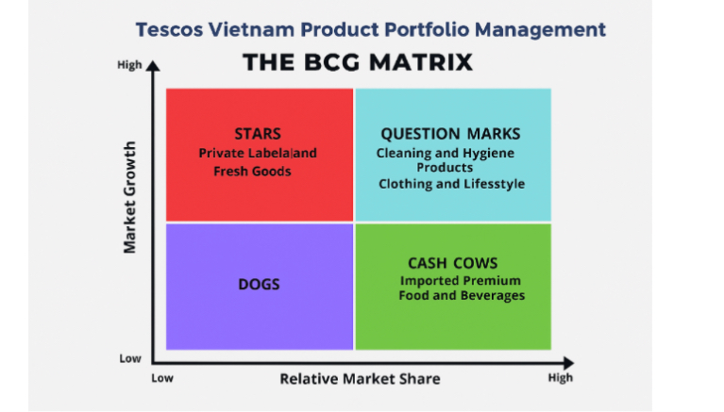
Figure 6: The BCG Matrix (Self-Made)
Private-label and fresh items sold by Tesco will see growth in the "Star" category because of pricing and relevancy to the local market (Kotler and Keller, 2016). For these, active marketing and purchasing from local vendors are required to keep the investment. It's possible that "Question Mark" cleaning and hygiene products may become household names thanks to advertising and partnerships with local suppliers. The F&F clothes and lifestyle products sold by Tesco ought to be positioned as Question Marks in urban hypermarkets that have a lower initial awareness. There are several locations where imported premium food, and beverages have the potential to be Cash Cows with consistent margins. Tesco's earnings and product diversity will both benefit from a portfolio that is well-balanced.
4.6 Corporate Social Responsibility (CSR) and Sustainability Integration:

Tesco is required to implement CSR to fulfil the sustainable development goals of Vietnam and the expectations of its customers. The responsibilities of multinational enterprises provide support for local adaptation (Rothaermel, 2024).
Tesco ought to begin by promoting local sourcing and educating Vietnamese farmers on topics such as food safety, sustainable agriculture, and supply chain management. The development of rural areas and the reduction of imports are both possible outcomes of local cooperatives (Saloner, 2021). With renewable energy, energy-efficient stores, and a complete absence of single-use plastics, Tesco has the potential to take the lead in environmental leadership. Tesco appears to be more responsible and environmentally conscious because of these measures.
Tesco can foster healthy eating, provide food to non-governmental organisations (NGOs), and finance nutrition and education programs. The improvement of Tesco's employer brand and compliance with the Labour Code of Vietnam (2019) would be achieved through the implementation of career development, gender equality, and fair compensation (Wilhelm et al., 2024).
The establishment of trust and social value with customers, regulators, and investors through corporate social responsibility and sustainability may provide Tesco with an advantage over its competitors.
4.7 Risk Management and Mitigation:

Tesco has to manage strategic and operational risks irrespective of the well-offering opportunities. In some cases, expansion could be stifled by patchy enforcement, licensing delays, and cumbersome restrictions. There is some degree of risk through proactive government and the experience on the ground from JV partners. Western retail formats might clash with Vietnamese shopping habits. Tesco may shift its product mix and hire local marketers (Khanuja and Jain, 2021).
It is possible to improve rural organisation and cold-chain systems through the implementation of innovative inventory management and regional distribution facilities. Both hedging and distinct products reduce the amount of price competition from established competitors. Hedging helps to reduce currency volatility. Lastly, public reporting and audits conducted by third parties help to reduce the repetitional risks associated with CSR non-compliance and support the trust of stakeholders.
4.8 Implementation Framework:

This is the stage in Tesco's plan for growth and risk management in Vietnam. As part of Phase One (Years 1–2), the joint venture should be proved, approvals from the government should be obtained, and the first flagship hypermarket should be opened in Ho Chi Minh City (Woods, 2022). The second phase, which spans years two and three, should place an emphasis on e-commerce, marketing, Clubcard Vietnam, and brand growth. Phase Three (Years 3–5) includes development into Hanoi and Da Nang, as well as CSR and local sourcing reaching sixty per cent. In the fourth phase, which covers years five and beyond, evaluations are made about performance, earnings, and development into Southeast Asian markets such as Cambodia and Laos.
Using this tiered system, Tesco can establish a powerful foundation, evaluate performance, and alter strategy based on the input from the market and the circumstances of the economy.
4.9 Evaluation of Strategic Models:

The Ansoff Matrix, Porter's Generic Strategies, and the BCG Matrix all perform well in terms of analysis. The Ansoff Matrix is used to guide expansion, while Porter competes by generating value and reducing or dropping costs. To align investment goals with market opportunities, portfolio managers make use of the BCG Matrix. Through corporate social responsibility, Tesco operates in an ethical and environmentally responsible manner (Saloner, 2021).
These models are faulty at the statistical level. The retail industry in Vietnam is changing because of technological advancements and changes in consumer behaviour. To adjust, Tesco needs to employ real-time data about the market and its customers.
5. Performance Evaluation Framework
5.1 The Balanced Scorecard Framework:
The Balanced Scorecard, which was developed by Kaplan and Norton in 1992, evaluates performance in the areas of finances, customers, internal processes, and learning and growth (Saloner, 2021). The use of key performance indicators (KPIs), it establishes a connection between short-term initiatives and long-term goals. "Serving shoppers a little better every day" is the goal that Tesco Vietnam strives to achieve by utilising this notion to link its everyday operations with the company's overall goals.
a. Financial Perspective
Tesco is growing financially. ROI, gross profit margin, and increase in sales revenue are all important metrics. Tesco needs to achieve a return on investment (ROI) of 10–12% through the third year. Efficiency can be measured using the cost-to-income ratio as well as inventory turnover (MAZIDI, 2025). In the highly competitive retail industry of Vietnam, there must be a balance between profit and affordability. Using data analytics, Tesco can watch product margins and adjust prices to remain competitive.
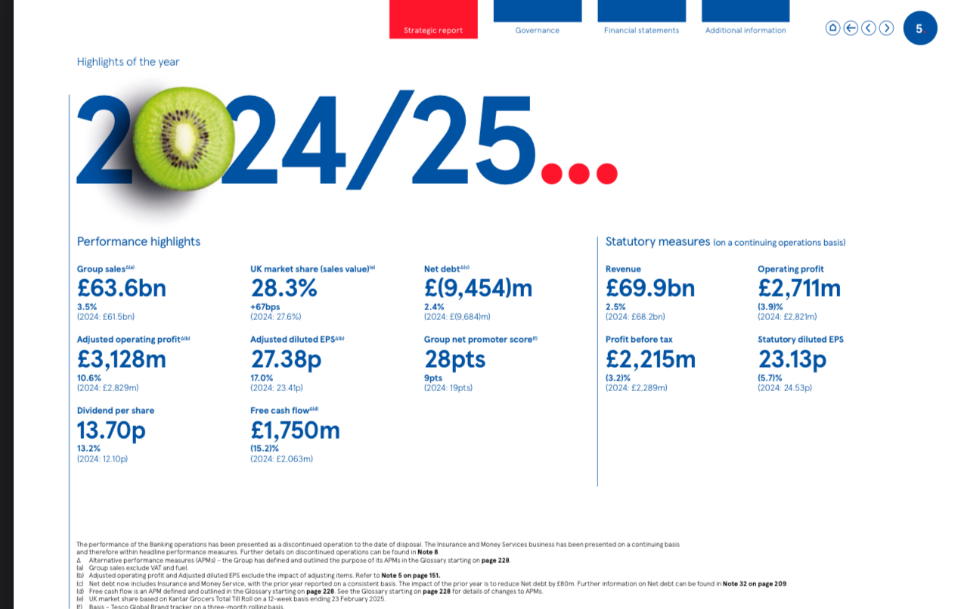

https://www.tescoplc.com/media/ky0bfwpo/tesco_ar25_interactive.pdf

b. Customer Perspective
Tesco's Vietnam strategy places a strong emphasis on client satisfaction, as well as trust in and loyalty to the brand. NPS, average transaction value, and client retention are all examples of key performance indicators (KPIs). Within the next two years, Tesco ought to aim for a customer satisfaction rate of eighty per cent (Kamboj and Rana, 2021). Using Clubcard Vietnam, buyers will be tracked, loyalty will be awarded, and incentives will be customised. Omnichannel adoption and brand health may be reflected in the frequency of online orders and app downloads.
c. Internal Process Perspective
Internal operations that are both efficient and of high quality have an impact on both client happiness and profits. The reliability of Tesco's supply chain, the availability of goods, and the fulfilment of orders should all be evaluated. The availability of the item must be at least 95%, and it must be delivered to cities immediately (MAZIDI, 2025). The utilisation of predictive and dynamic data analysis results in improvements in inventory management and waste reduction. Tesco's requirements for global sourcing are satisfied by the implementation of routine supplier audits that encourage both operational integrity and brand authenticity.
d. Learning and Growth Perspective
To enter new markets, workers need to develop their skills and be creative. Consider the amount of time spent on training, the length of the workforce, and the innovation index (new goods or services). Tesco ought to provide ten hours of annual training to all its staff in the areas of customer service, digital platform, and environmental awareness (Meng, 2024). Leadership development course for the local Vietnamese manager. The next generation of Vietnamese leaders would receive training in cultural compatibility, sustainability, and top-level selection.
5.3 Integration of the Triple Bottom Line (TBL):

However, the Balanced Scorecard provides both operational and financial discipline, which is necessary for Tesco's sensible expansion in Vietnam, which demands sustainability. Considering people, the environment, and profits, Triple Bottom Line (TBL) evaluations encourage decision-making that is both ethical and environmentally responsible.
a. People (Social Responsibility)
Analyse the social impact that Tesco has had in Vietnam by focusing on the well-being of its employees and the community. Key Performance Indicators (KPIs) include local employment, diversity, and profit-share community investment. Seventy per cent of businesses should be local, and one per cent should be donated to education and food security (Srivastava, Dixit and Srivastava, 2021). Tesco's social responsibility is increased through the utilisation of "Food Waste Heroes" in underprivileged communities.
b. Planet (Environmental Stewardship)
Environmental protection is a primary focus of Vietnam's sustainability goals. Tesco monitors its operations regarding carbon emissions, recycling, and the utilisation of renewable energy. Twenty per cent of the company's carbon footprint should be reduced during the next five years, and fifty per cent of the company's stores should be powered by renewable energy (Nguyen et al., 2025). Both Tesco's environmental impact and its efficiency could be improved using sustainable packaging and sourcing.
c. Profit (Economic Sustainability)
The value of stakeholders must be prioritised over money for economic viability. KPIs consist of things like the ratio of local procurement, the efficiency of supplier payment, and the GDP from taxes and investments. With Tesco's target of sourcing sixty per cent of its items locally, Vietnam's agriculture and industry will benefit, and the country's imports will decrease (Srivastava, Dixit and Srivastava, 2021).
5.4 Implementation of the Performance Framework
Tesco must establish a Performance Monitoring Committee for its joint venture in Vietnam (Woods, 202Vietnam ((The committee would be responsible for cross-functional activities, and its members would include finance, operations, human resources, and corporate social responsibility. As well as local stakeholders, Tesco's headquarters in the United Kingdom requires quarterly BSC and TBL data. Using digital dashboards and automatic reporting, it is possible to adjust in real time.

6. Discussion and Critical Evaluation:
6.1 Strategic Integration and Coherence:
Tesco's expansion into Vietnam makes sense from a conceptual standpoint. Obtaining a multidimensional perspective of the organisation can be carried out by incorporating PESTLE, Porter's Five Forces, VRIO, and the Ansoff Matrix. The PESTLE framework provides a contextualisation of the influences of the macro-environment, Porter's model sets up the level of competitive intensity, VRIO reveals Tesco's strengths, and the ANSI Matrix encourages growth. Due to the use of tiered analysis, the strategy plan is both flexible and responsive to the market. To attract customers in Vietnam who are price-conscious but quality-oriented, Tesco employs a hybrid strategy of cost leadership and distinctiveness (Nguyen et al., 2025).
The premise behind the strategy is great, but how it is implemented is key. In the event that governance principles are not explicit, joint ventures might make administration more difficult, but they can lower risk and cultural flexibility. Tesco must strike a balance between global and local governance. It is necessary to exercise control over cultural differences in consumer behaviour, negotiation, and communication to prevent problems with brand misfit and integration.
6.2 Strategic Agility and Learning Orientation:

A strategic agility is required for Tesco's Vietnam business in order to observe, assess, and quickly adjust to changes in the external environment. The retail market in emerging markets is volatile, thanks to new consumer tastes, digital disruption and regulatory changes. Localisation over standardisation threats are illustrated by Tesco's crises in the US and Japan. In Thailand and Malaysia, the company has been successful thanks to its “management” with active leadership and connections locally. True, Tesco can leverage on findings to further solidify its Vietnam strategy.
6.3 Challenges and Critical Reflection:

Despite the fact that it has several advantages, the strategy might not be successful. In order to attract clients in Vietnam's retail sector, which is very competitive, creativity is required. Tesco needs to provide a better value in order to compete with Aeon and Lotte, two local competitors who are loyal to their brands (Meng, 2024). It's possible that regulations and infrastructure will slow down expansion and drive up costs. Green initiatives may result in an increase in capital expenditures; therefore, it is necessary to strike a balance between cost efficiency and sustainability.
7. Conclusion and Recommendations:
7.1 Conclusion:

To summarise, Tesco's foray into the Vietnamese market is a strategic opportunity for the company to enhance its worldwide presence and support growth outside of the mature European regions. According to the findings of the investigation, Vietnam's young population, dynamic economy, and growing middle class are all characteristics that are conducive to modern retail. PESTLE, Porter's Five Forces, VRIO, and Ansoff's Matrix are some of the tools that Tesco employs in order to connect its internal and external capabilities. Both market flexibility and operational management are provided by the hybrid cost-leadership and differentiation strategy, as well as the joint venture entrance approach. Tesco's ethics and brand are improved by their use of CSR and sustainability.
7.2 Recommendations
Tesco ought to begin operations in Ho Chi Minh City and Hanoi before spreading its operations across the country. Competitiveness is increased through the use of digital platforms and organization infrastructure (Rothaermel, 2024). Frameworks such as the Balanced Scorecard and the Triple Bottom Line can be utilised in order to assess performance in the areas of finance, society, and the environment. Last but not least, Tesco has the potential to establish itself as a reliable, long-term, and forward-thinking retail leader in Vietnam by cultivating local relationships, fostering individual agency, and fostering cultural awareness (Rothaermel, 2024).
Reference
Barney, J.B. and Hesterly, W.S. (2019). Strategic Management and Competitive Advantage. Harlow, United Kingdom: Pearson Education, Limited.
Birkinshaw, J. (2022). Strategic management. 1st ed. Northampton, Ma: Edward Elgar Pub.
Capobianco, N., Basile, V., Loia, F. and Vona, R. (2021). Toward a Sustainable Decommissioning of Offshore Platforms in the Oil and Gas Industry: A PESTLE Analysis. Sustainability, [online]13(11) p.6266. doi: https://doi.org/10.3390/su13116266.
11.Nov.2025

Coppo, G. (2024). The role of e-commerce in the international expansion of Italian SMEs: an analysis of the Calicantus Srl case study. Unive.it. [online] doi: https://hdl.handle.net/20.500.14247/22962.
11.Nov.2025
Kamboj, S. and Rana, S. (2021). Big data-driven supply chain and performance: a resource-based view. The TQM Journal, ahead-of-print(ahead-of-print). doi:
https://doi.org/10.1108/tqm-02-2021-0036.
11.Nov. 2025

Khanuja, A. and Jain, R.K. (2021). The conceptual framework on integrated flexibility: an evolution to data-driven supply chain management. The TQM Journal, ahead-of-print(ahead-of-print). doi: https://doi.org/10.1108/tqm-03-2020-0045. 20/11/2025

Kotler, P. and Keller, K.L. (2016). Marketing Management. 14th ed. Pearson Education.
MAZIDI, S. (2025). The Digital Shift: An Overview of the Retail and Delivery Sectors Post-Covid-19. Unipd.it. [online] doi: https://hdl.handle.net/20.500.12608/89519.
20/11/2025

Meng, S. (2024). Operation Management of Grocery Retailer in the UK: A Case of Tesco. Pacific International Journal, 7(2), pp.136–142.
Nguyen, P.M., Le, H.-L., Nghiem, X.-H. and Tran, L.L. (2025). Corporate Social Responsibility Practices Toward Promoting Environmental Sustainability: Case Studies in Vietnam. World sustainability series, pp.319–346. doi: https://doi.org/10.1007/978-3-031-81469-3_14. Accesses
21/11/2025

Porter, M.E. (1980). Competitive Strategy. The Academy of Management Review, 10(4), p.873. doi available at https://doi.org/10.2307/258056.
Accessed 21. Nov. 2025

Rothaermel, F. (2024). Strategic Management. 6th ed. New York, New York: Mcgraw-Hill Education.
Saloner, G. (2021). Strategic Management. 1st ed. S.L.: John Wiley.
Sergiy Korablin (2025). World Economy: Some Trends and Their Possible Consequences. pp.3–26. doi: https://doi.org/10.1007/978-3-031-90851-4_1. Accessed
22. Nov. 2025

Srivastava, A.K., Dixit, S. and Srivastava, A.A. (2021). Criticism of Triple Bottom Line: TBL (With Special Reference to Sustainability). Corporate Reputation Review, 25(2).
Statista (2024). Global retail sales 2021-2026| Statista. [online] Statista. Available, at: https://www.statista.com/statistics/443522/global-retail-sales/?
srsltid=AfmBOorRmnHV7eclnQWT7-Z8ZLpytOzGMUIYSd-d4erE8SG1W7HHUPnL [Accessed 22 Nov. 2025].

Tesco PLC (2021). Our Code of Business Conduct. Contents. [online] Available at: https://www.tescoplc.com/media/757929/tesco-cobc_sept-2021.pdf.
[Accessed 12 Dec. 2025].

Van, T. (2025). Vietnam’s e-commerce market surpasses $25 billion in 2024. [online] Vietnam Investment Review - VIR. Available at: https://vir.com.vn/vietnams-e-commerce-market-surpasses-25-billion-in-2024-120262.html.
[Accessed 12 Dec. 2025].

Wilhelm, M., Vikram Bhakoo, Soundararajan, V., Crane, A. and Alin Kadfak (2024). Beyond Compliance-Based Governance: The Role of Social Intermediaries in Mitigating Forced Labour in Global Supply Chains. Production and Operations Management. doi: https://doi.org/10.1177/10591478231224922.
Accessed 14/12/2025

Woods, M. (2022a). Risk Management in Retail. Risk Management in Organisations, pp.109–156. doi: https://www.taylorfrancis.com/chapters/edit/10.4324/9781315208336-7/risk-management-retail-margaret-woods.
Woods, M. (2022b). Risk Management in Retail. Risk Management in Organisations, pp.109–156. doi: https://www.taylorfrancis.com/chapters/edit/10.4324/9781315208336-7/risk-management-retail-margaret-woods.
[Accessed 14. Dec. 2025].

World Bank (2024). World Bank Annual Report 2024: A Better Bank for a Better World. [online] World Bank. Available at:
https://documents.worldbank.org/en/publication/documents-reports/documentdetail/099101824180532047. [Accessed 14/12/ 2025].

Zhuang, J. (2022). Income and Wealth Inequality in Asia and the Pacific: Trends, Causes, and Policy Remedies. Asian Economic Policy Review, 18(1). doi:
https://doi.org/10.1111/aepr.12399.

26
Appendices
Appendix A: Tesco Annual Report

https://www.tescoplc.com/investors/reports-results-and-presentations/annual-report-2025

Image accessed at: https://www.mckinsey.com/industries/retail/our-insights/how-companies-can-seize-opportunity-in-vietnams-growin-retail-marke

