

LCHS7007 Population Health and Digital Health Promotion

Component 1

Student Name: - Jenish Naineshbhai Kava
Student ID: - 2406508
Module Name :- Population Health and Digital Health Promotion
Course Coad :- (LCHS7007_LON)

Module Leader :- Dr Ping Wu

Blog 1: Headspace: Digital Mindfulness to Address Mental Health Challenges
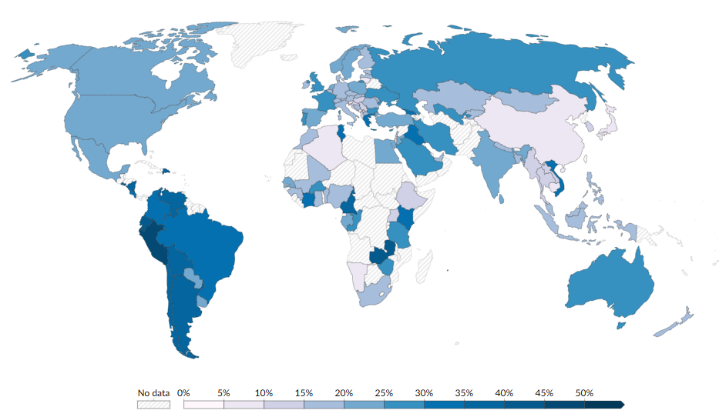
Mental health problems are known for being increasingly prevalent in the present fast-paced world including stress, anxiety, along with depression. Such conditions result in impairing the daily functionality along with productivity and overall well-being of individuals (Meghrajani et al., 2023). According to WHO (2023), one in eight people around the world are living with mental health conditions, which underscores the urgent requirement for accessible mental health solutions.

Share of lifetime anxiety or depression in 2020
(Source: Our World in Data, 2024)

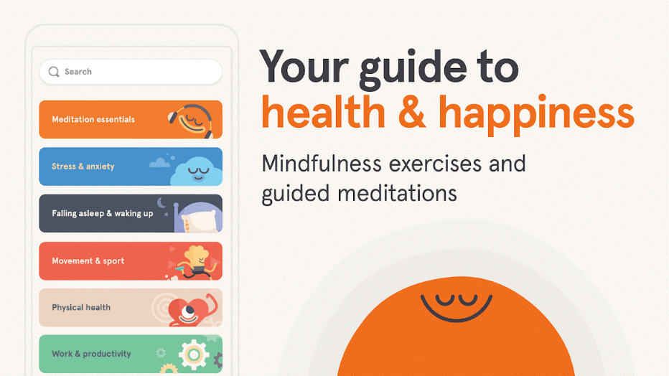
Digital Technology Overview (Headspace)
Headspace can be mentioned as one such solution, which is known for being a popular digital mindfulness meditation app. It is designed for improving the overall mental well-being of an individual through guided practices. The app is known for offering various features, such as guided meditations, that are designed for reducing stress and improving sleep alongside emotional regulation. The app also has the feature of tracking mood, various breathing exercises, along with sleep casts for assisting users in developing healthier mental habits (Headspace, 2024).

Evidence of Health Promotion Impact
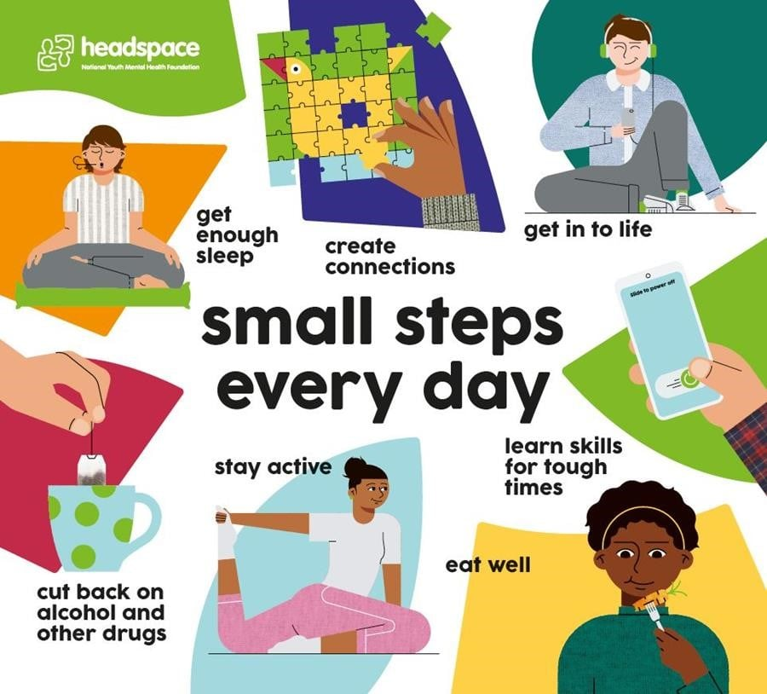
Headspace is known for being significantly effective in promoting mental wellness. According to O’Daffer et al. (2022), The app is known to have improved depression in 75% of studies that evaluated it as an outcome. On the other hand, a study by Callahan et al. (2024) also suggests that engaging more with Headspace, particularly weekly active days and sessions, have greater chances of reducing stress. Headspace (2024) reports that utilising the app after 10 days resulted in a 10% increase in physiological sleep quality.

Critical Analysis
However, Headspace has both strengths along with limitations. One of the many strengths of the app is its accessibility. The app is available on smartphones and tablets, which makes it easier to integrate into the daily life of a user (Headspace, 2019). The app also has a user-friendly interface, and with its scientifically backed meditations, it becomes an appealing choice for various individuals who are seeking relief from depression and anxiety. However, one major limitation is its reliance on user motivation, which can result in limiting long-term engagement (Bitrián, Buil and Catalán, 2021). This is especially particular for users who are struggling with severe mental health conditions. On the other hand, there is a subscription-based model, which might also pose a financial barrier for particular users.

Addressing Shortfalls
In order to address such shortfalls, healthcare partnerships could be focused on as they will help in facilitating wider access. This will be possible through subsidised subscriptions or by integrating Headspace into public health initiatives. For example, African Health Markets for Equity is known for working with government agencies to extend subsidised insurance coverage for those with low income along with enrolling them into National Health Insurance schemes (Suchman, Hart and Montagu, 2018). On the other hand, collaborating the app with mental health support, such as therapist-guided sessions, could also develop a holistic approach, which will be beneficial for users with complex needs.
Blog 2: Serenika - Your Personal Digital Companion for Better Mental Health
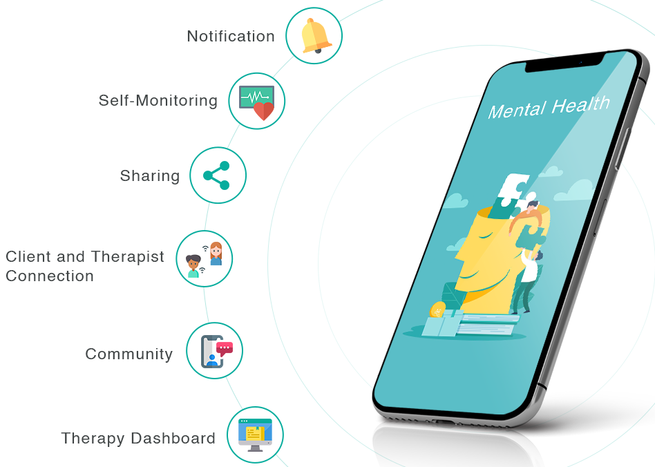
Several mental health challenges, such as anxiety along with depression, are known for continuing to rise around the world. Those are known for negatively impacting various individuals across various age groups and backgrounds. Such conditions are often known to go untreated, mainly due to stigma, higher therapy costs, along with limited access to professional care (Wainberg et al., 2020). Such a growing challenge brings up the critical requirement for mental health interventions that will be user-friendly and accessible in nature, being able to be seamlessly integrated into daily lives.

Introducing Serenika (Designed Technology)
Serenika is a smartphone app that will be designed to fill the gap in mental health support. This will be possible by combining Cognitive Behavioural Therapy techniques with various mindfulness practices. The app will be developed with the guidance of various mental health professionals and tech experts and offer an evidence-based approach to managing stress, anxiety, along with depression. The app will include the following key features:
Daily Mood Tracking: Helps users monitor emotional patterns and triggers.
- Personalised CBT Exercises
- Mindfulness-Based Stress Reduction
- Virtual Support Communities
- AI-Driven Counseling

How Serenika Addresses Mental Health Issues
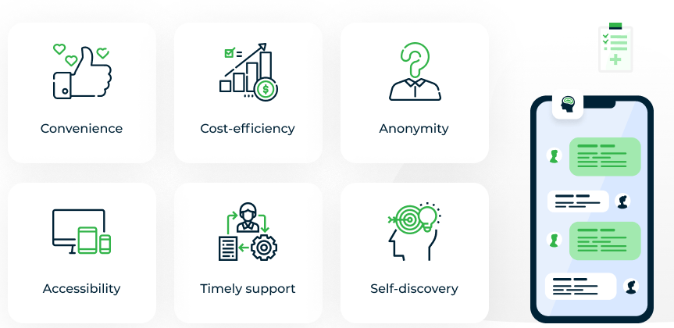
Serenika will be providing beyond surface-level interventions. This will be possible by offering various assessments that will be AI-based, providing individualised coping strategies alongside recommendations (Olawade et al., 2024). Such features will help users to fully understand their mental health along with also taking actionable steps for improving. There will be virtual support communities, which will help in encouraging a sense of belonging while reducing feelings of isolation. It will also help in motivating users to stay engaged (Rayland and Andrews, 2023). On the other hand, various educational resources along with self-care exercises, will help in empowering users to build sustainable coping mechanisms. This will also enable them to equip lifelong skills for improving mental resilience.

Critical Analysis of Serenika
Advantages
Serenika will be presenting various clear advantages, such as delivering personalised therapeutic interventions in an accessible and affordable format. This will help in lowering the barrier to mental health care (Cerniglia, 2024). On the other hand, it will also be utilising a digital platform for helping in reducing the stigma that is often associated with seeking therapy (Olawade et al., 2024).
Disadvantages
However, it is also essential to note that users might be facing privacy concerns, which will be particularly due to the presence of sensitive mental health data (Iwaya et al., 2022). On the other hand, digital literacy barriers could also result in preventing a number of individuals from benefiting fully (Kloza, 2023). Serenika might also offer limited support for individuals with severe mental health conditions without professional guidance.

Addressing Shortfalls
In order to mitigate such challenges, Serenika could focus on incorporating robust data protection measures along with transparent privacy policies to ensure user trust. The app could also focus on encouraging referrals to various professional therapists for individuals with severe menthol health conditions. Serenika could also provide step-by-step tutorials for users who are unfamiliar with such technology to make mental health support more accessible.

References
Bitrián, P., Buil, I. and Catalán, S. (2021). Enhancing user engagement: The role of gamification in mobile apps. Journal of Business Research, 132(1), pp.170–185. https://doi.org/10.1016/j.jbusres.2021.04.028.
Callahan, C., Kimber, J., Hu, E., Tanner, L. and Kunkle, S. (2024). The Real-World Impact of App-Based Mindfulness on Headspace Members With Moderate and Severe Perceived Stress: Observational Study. JMIR mHealth and uHealth, 12, pp.e52968–e52968. https://doi.org/10.2196/52968.
Cerniglia, L. (2024). Advancing Personalised Interventions: A Paradigm Shift in Psychological and Health-Related Treatment Strategies. Journal of Clinical Medicine, 13(15), pp.4353–4353. https://doi.org/10.3390/jcm13154353.
Headspace (2019). How Does Headspace Work? [online] Headspace. Available at: https://www.headspace.com/how-it-works [Accessed 24 Mar. 2025].
Headspace (2024). Headspace Outcomes. [online] get.headspace.com. Available at: https://get.headspace.com/outcomes [Accessed 24 Mar. 2025].
Iwaya, L.H., Babar, M.A., Rashid, A. and Wijayarathna, C. (2022). On the privacy of mental health apps. Empirical Software Engineering, 28(1). https://doi.org/10.1007/s10664-022-10236-0.
Kloza, B. (2023). Impact of the Digital Divide: Economic, Social, and Educational Consequences - Connecting the Unconnected. [online] Connecting the Unconnected. Available at: https://ctu.ieee.org/blog/2023/02/27/impact-of-the-digital-divide-economic-social-and-educational-consequences/ [Accessed 24 Mar. 2025].
Meghrajani, V.R., Marathe, M., Sharma, R., Potdukhe, A., Wanjari, M.B. and Taksande, A.B. (2023). A Comprehensive Analysis of Mental Health Problems in India and the Role of Mental Asylums. Cureus, 15(7). https://doi.org/10.7759/cureus.42559.
O’Daffer, A., Colt, S., Wasil, A.R. and Lau, N. (2022). Efficacy and Conflicts of Interest in RCTs Evaluating Headspace and Calm Apps: A Systematic Review. JMIR Mental Health, 9(9). https://doi.org/10.2196/40924.
Olawade, D.B., Wada, O.Z., Odetayo, A., David-Olawade, A.C., Asaolu, F. and Eberhardt, J. (2024). Enhancing Mental Health with Artificial Intelligence: Current Trends and Future Prospects. Journal of medicine, surgery, and public health, 3(3). https://doi.org/10.1016/j.glmedi.2024.100099.
Our World in Data (2024). Share who report lifetime anxiety or depression. [online] Our World in Data. Available at: https://ourworldindata.org/grapher/share-who-report-lifetime-anxiety-or-depression [Accessed 24 Mar. 2025].
Rayland, A. and Andrews, J. (2023). From Social Network to Peer Support Network: Opportunities to Explore Mechanisms of Online Peer Support for Mental Health. JMIR Mental Health, 10(1), p.e41855. https://doi.org/10.2196/41855.
Suchman, L., Hart, E. and Montagu, D. (2018). Public–private partnerships in practice: collaborating to improve health finance policy in Ghana and Kenya. Health Policy and Planning, 33(7), pp.777–785. https://doi.org/10.1093/heapol/czy053.
Wainberg, M.L., Scorza, P., Shultz, J.M., Helpman, L., Mootz, J.J., Johnson, K.A., Neria, Y., Bradford, J.-M.E., Oquendo, M.A. and Arbuckle, M.R. (2020). Challenges and Opportunities in Global Mental Health: a Research-to-Practice Perspective. Current Psychiatry Reports, 19(5). https://doi.org/10.1007/s11920-017-0780-z.
WHO (2023). World Mental Health Day 2023. [online] www.who.int. Available at: https://www.who.int/campaigns/world-mental-health-day/2023 [Accessed 24 Mar. 2025].

Poster


