Gemma Wilkinson
BMMB4006

Robyn Griffths

Assignment 1- Stitchco essay.

Introduction
Organisational change is an inevitable process in maintaining competitiveness within dynamic industries. StitchCo, a family-owned garment manufacturer, recently introduced advanced technology on its shop floor to improve productivity and efficiency. The shift from a traditional hierarchical culture to one that encourages distributed leadership represents a significant cultural transformation. However, the initiative faced resistance due to inadequate training, job insecurity, communication breakdowns, and ineffective leadership responses. This essay critically examines how StitchCo can better prepare its employees for change, drawing on theories of organisational behaviour, leadership, and communication. It explores the impact of change, the challenges of cultural transformation, and the role of effective communication and leadership in enhancing organisational performance.

Stitch and co is a family-owned garment company that supplies their garments to a major high street retailer using a traditional business model that had a clear division of labour. Upon starting out this worked seemingly well for the company but as time has progressed, they have been met financial difficulties which meant that change was cruicial for the company to thrive. The company began using a clear hierarchical structure where senior management made decisions, middle managers coordinated staff and planned what work needed to be conducted at the right times and general employees carried out these tasks. Stitch and co went on to use a piecework payment model which meant the staff had a greater encouragement to work quickly and effiently as they were paid for how many items they made staff generally tried to maximise their output.(Taylor, 1911)

Change can have both a positive and negative impact amonst staff and the company in general and this all depends on how well it is managed and communicated amonst the company’s employees.
According to Mullins (2019), employees often experience anxiety and uncertainty when their familiar work systems are altered, particularly if they feel excluded from decision-making. In StitchCo’s case, the introduction of automation and new performance metrics disrupted the traditional piecework system and threatened employees’ sense of job security. Many workers feared redundancy, while others felt unprepared to use modern technology. Such reactions align with Lewin’s (1951) three-stage model of change—unfreezing, changing, and refreezing—where resistance typically occurs during the ‘unfreezing’ stage when old habits are challenged.

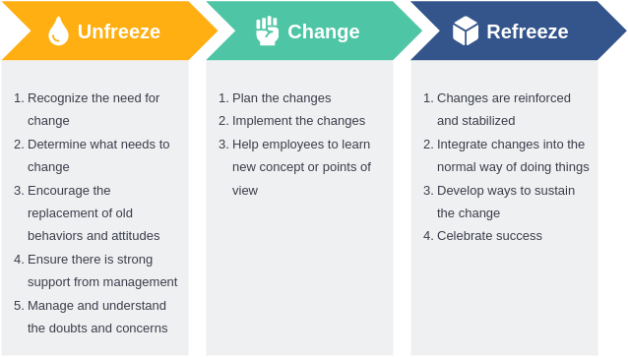
(Visual Paradigm, 2022)

The emotional impact of change cannot be taken too lightly. Harvard Business Review journal’s articles put great empasis on the fact that a successful change depends on how the technical and human sides are managed. This will ensure a smoother transition. Employees often need psychological safety to adapt to their new expectations. When change is abrupt as at Stitchco it can trigger unwanted defensive behaviors, decresed motivation and a resistance to change. Therefore, had stitchco supported these changes with better training, support and communication they may have had less transistional hurdles.

Looking at these issues from a performance perspective, when change is unmanaged it creates clear damage to staff’s productivity and morale. Research from the Journal of Organisational Behaviour indicates that when employees lack clarity about their roles or perceive inequity in rewards, performance declines. StitchCo’s new pay-related targets created inter-group rivalry and conflict, further weakening teamwork. Therefore, change management at StitchCo must not only focus on technology implementation but also on human adaptation, ensuring that employees are emotionally and practically prepared for transition. (Harvard business review)

Organizational culture in a business looks at the shared values, beliefs and attitudes of how employees work and behave in the workplace. Previously Stitchco’s cultural environment followed a clear hierarchical structure which employees had assigned departments from senior management, middle management and the shop floor workers. This traditional method meant that employees took direction from above and when Stitchco introduced the distributed leadership and use of automation these changes challenged the normal structure that employees were used to.
Mullins (2019) highlights that cultural change is one of the most complex forms of organizational transformation because it requires people to alter deeply embedded attitudes and behaviors.
Stitch Co’s communication was poor when making these changes and employees did not adjust well. The sudden changes left staff with a feeling of second guessing and clueless as to what their new role entailed. The use of automation was a substantial change when shopfloor workers were used to manually making the garments by hand.
A Harvard Business Review perspective on cultural transformation suggests that successful change requires alignment between organizational systems and culture. Simply introducing modern technology without changing reward systems, communication patterns, and leadership behavior creates cultural dissonance. StitchCo’s reliance on old pay structures while expecting teamwork undermined collaboration.

The Journal of Organizational Behavior supports this by noting that cultural change must be led from the top, with leaders modelling the desired behaviors.

At Stitchco, senior managers did not distribute leadership tasks and instead of empowering employees they introduced these new responsibilities without any clear guidance or support which created resistance from staff.

Cultural transformation, therefore, requires StitchCo to show shared values around innovation, collaboration, and learning. This involves redefining success measures, encouraging open dialogue, and celebrating adaptability rather than just output.

Communication amongst employees plays a vital role in how they respond to change. Ensuring effective communication reduces uncertainty, develops trust and ensures that all employees understand the reasons for the changes.
According to Mullins (2019), communication is not merely about disseminating information but about creating a shared understanding of organizational goals.

At Stitchco, one of the weakest links in the change process was communication and support for employees. Stitchco was not transparent with their employees’ concerns about job security, and this meant that employees felt reluctant to give solid feedback on how the new systems were working. The lack of communication created a large gap in trust between managers and shop floor workers.
As Harvard Business Review frequently highlights, when employees do not understand why change is happening, they tend to resist rather than engage. This is what has happened with employees at Stitchco.
TED Talks on organizational leadership and change often stress the importance of storytelling and emotional connection in communication. Leaders who frame change as a collective journey, rather than a top-down directive, can inspire a sense of purpose. Stichco adopting this approach could really help staff morale and overall success by involving employees in regular staff meetings/briefings, focus groups or training sessions to ensure that employees are heard and have a clear understanding of why these changes had to take place.

The Journal of Organizational Behaviour notes that two-way communication promotes psychological ownership of change. Stitchco’s management should create a mechanism in which staff can communicate concerns or issues, invite staff to offer suggestions and arrange regular team meetings to give employees an opportunity to voice their concerns or experiences and take part in problem solving. This will contribute to reducing uncertainty amongst staff and give a sense of respect for employees’ different perspectives. This type of transparency with could raise morale and create a sense of teamwork when discussions about progress, setbacks and support that are readily available.

Specific leadership styles massively influence how employees respond to change. Stichco’s quick transition from hierarchical to distributed leadership forced a significant behavioral change affecting employees at all levels. The company previously ran in a traditional way using a command-and-control model which is when authority came from the top. This model can be effective in a more stable environment but is less effective in managing change this is because it discourages initiative and employees adaptability.

Mullins (2019) describes leadership as a process of influencing and motivating others to achieve common goals. When times are changing, opting for transformational leadership is usually a better approach. In 2005 Alan Cutler designed a ‘jigsaw’ of best practice and in the model, there are 6 interlinking pieces: vision, example, relationships, motivation, empowerment and communication as a guide to the measurement of leadership skills. Using this model could really help Stitchco’s future.

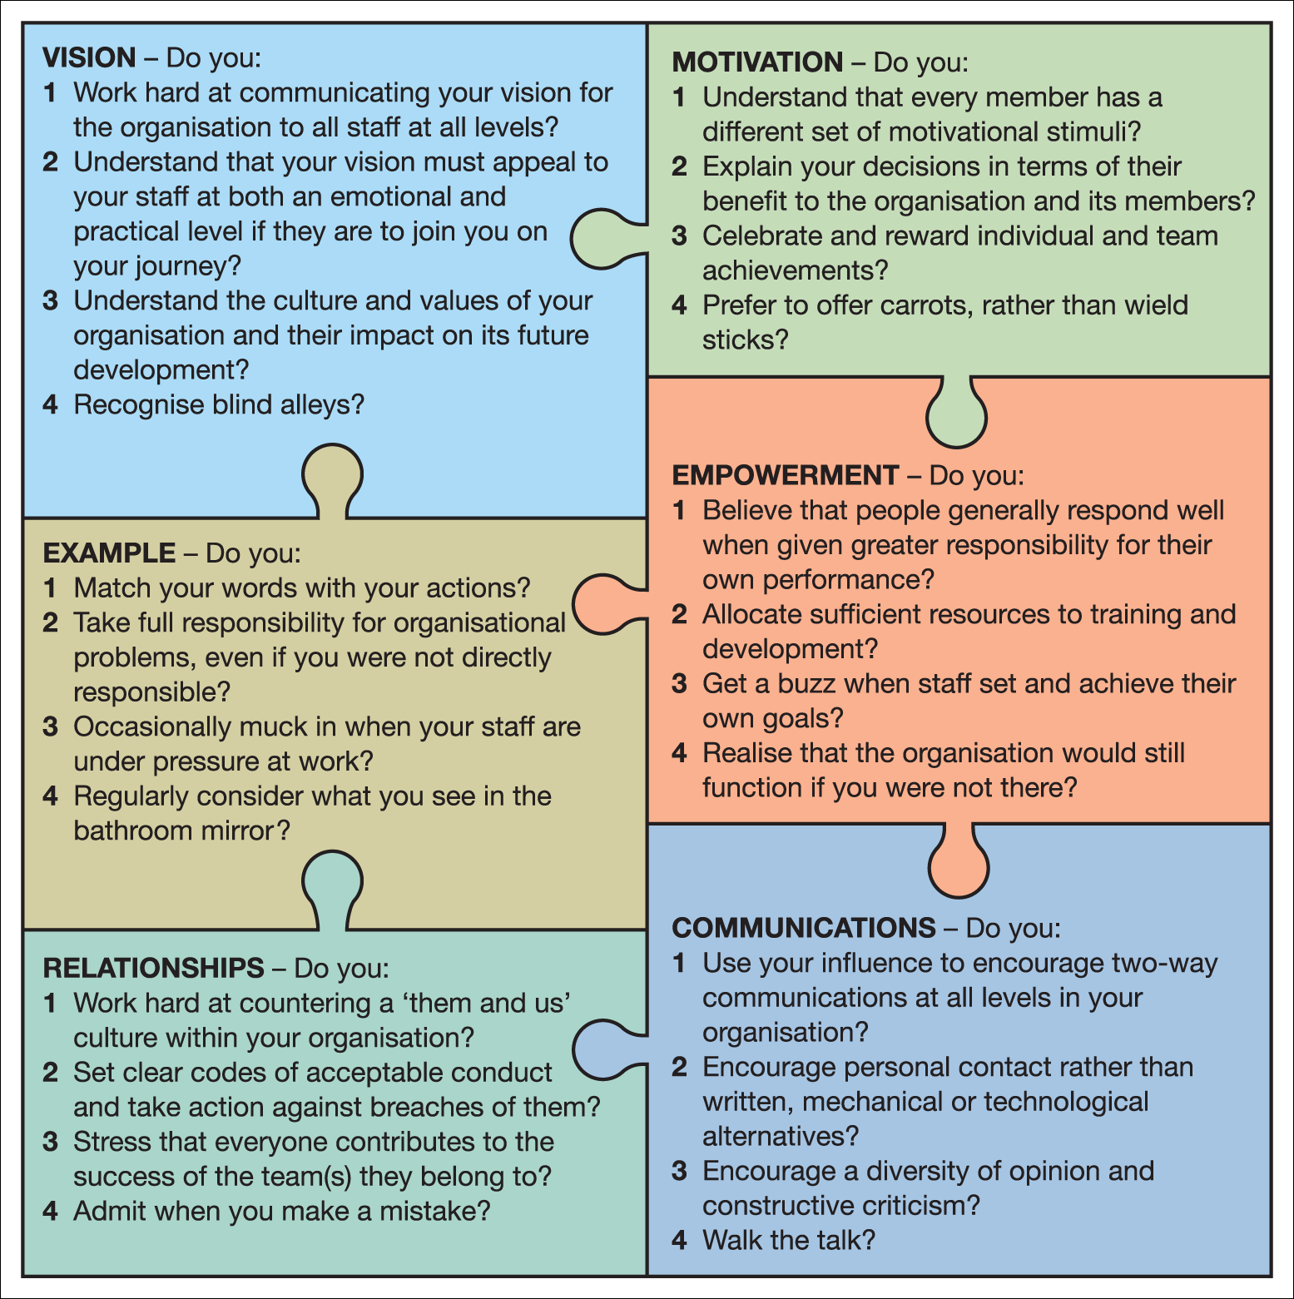

Source: Cutler, A. ‘A Good Fit Is Essential’, Professional Manager, vol. 15, no. 3, May 2005, p. 38. Reproduced with permission from Chartered Management Institute and Alan Cutler. (“Laurie J. Mullins with Gill Christy Laurie J. Mullins ESSENTIALS OF ...”)

Transformational leaders help employees see the bigger picture, align personal goals with organizational vision, and embrace innovation.

Stitchco’s managers appeared to not have prepared for this rapid change in leadership and the production managers’ reluctance to intervene with team conflicts reflected the misunderstanding of the new role. The lack of clear leadership meant the workplace engaged in rivalry and confusion lowering morale and overall productivity. This could have been avoided had Stichco followed through with a leadership model better suited to the changes the business was going through. Empowering their employees shouldn’t have meant they withdraw all managerial support, it should have involved guiding staff teams to work together and resolve conflicts or issues constructively.

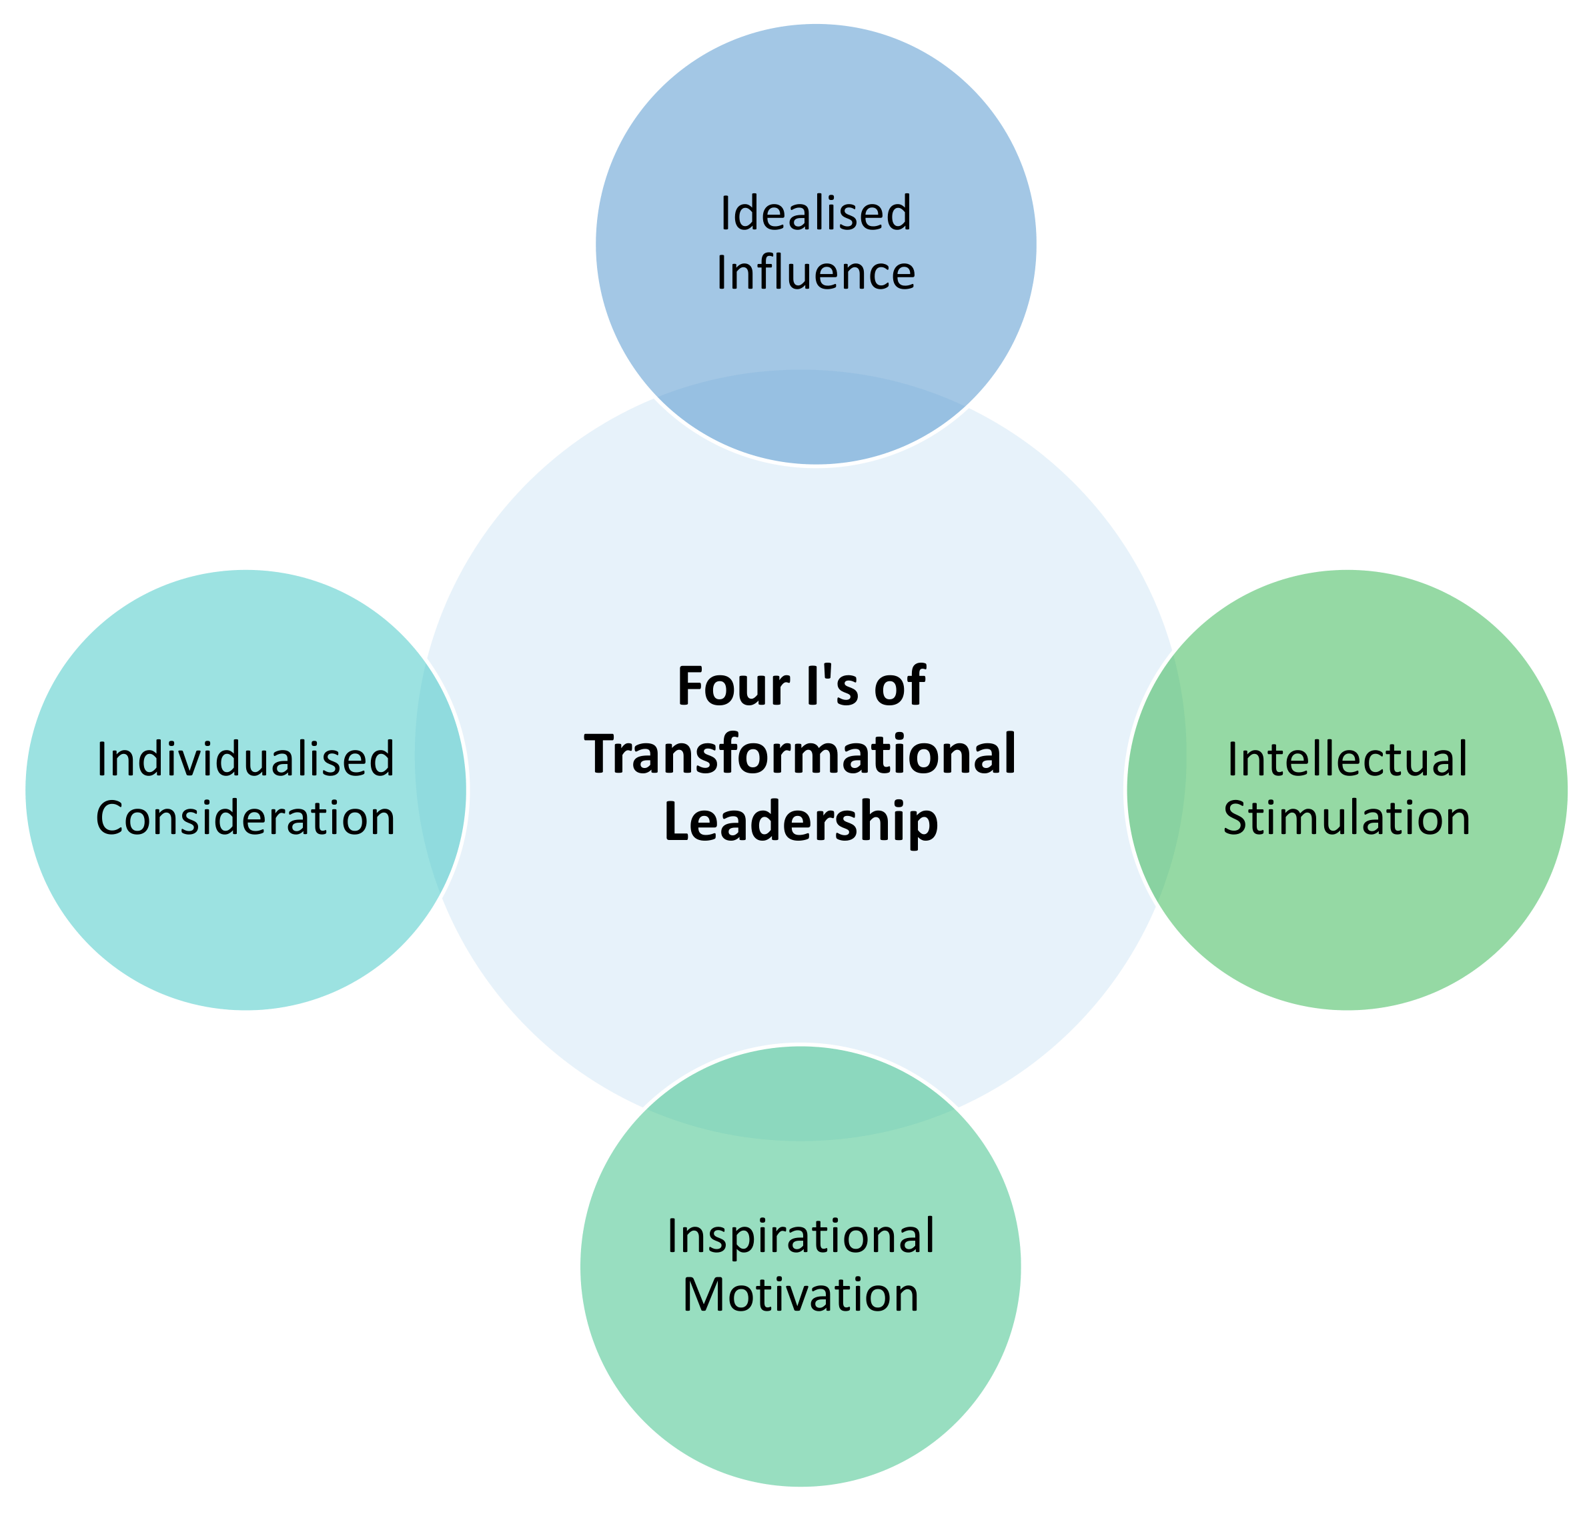
HBR and TED speakers often emphasize emotional intelligence as a key trait of effective leaders. Leaders who show empathy, self-awareness, and communication skills can build trust during uncertainty. StitchCo’s leaders need to develop these competencies through training and coaching, ensuring they can balance empowerment with accountability.
The Journal of Organizational Behavior supports the view that leadership style is directly linked to organizational performance. Companies that foster participative and supportive leadership tend to experience higher employee engagement, creativity, and retention. If Stitchco were to opt for a transformational leadership style this could enhance innovation, strengthen team unity and improve performance outcomes.

o better prepare employees for change, StitchCo must adopt a holistic and people-centred approach to organisational transformation. One of the most important steps is to provide comprehensive training and development opportunities. Employees should receive ongoing, practical training that enables them to operate new technology confidently and effectively. This training should go beyond technical instruction to include the development of soft skills such as teamwork, adaptability, and problem-solving, which are essential for success in a more collaborative working environment.
Equally crucial is the establishment of a transparent and consistent communication strategy. StitchCo should implement a structured communication plan that keeps employees fully informed about the reasons for change, the process involved, and the expected outcomes. Regular updates, feedback sessions, and opportunities for open discussion—such as Q&A forums or team meetings—would help to reduce uncertainty and build trust. Clear and continuous communication ensures that employees feel included and valued rather than alienated by organisational change.
In addition to improved communication, employees should be actively involved in decision-making processes. Consultation groups, employee representatives, and collaborative forums can provide staff with a platform to express concerns and contribute to shaping how changes are implemented. This involvement can foster a sense of ownership and commitment to the organisation’s goals, reducing resistance and enhancing morale.
Leadership development is also critical to ensuring a successful transformation. StitchCo’s managers should receive targeted training in transformational and emotionally intelligent leadership, enabling them to inspire confidence, demonstrate empathy, and balance empowerment with accountability. Leaders who model openness, support, and adaptability can play a key role in motivating employees through periods of uncertainty.
Furthermore, StitchCo should consider redesigning its reward systems to align with the new working practices. Instead of focusing solely on individual piecework output, reward structures should recognise teamwork, innovation, and quality. Linking performance incentives to collaborative achievements would help to reduce inter-group rivalry and strengthen cohesion across the organisation.
Finally, sustaining change requires cultural reinforcement. StitchCo should promote and celebrate innovation, flexibility, and learning through recognition schemes and internal communication campaigns. Publicly acknowledging examples of adaptability and collaboration will help to embed these values into the company’s culture, ensuring that change is perceived as a shared and positive journey rather than an imposed disruption.
By implementing these strategies, StitchCo can create a more resilient, engaged, and high-performing workforce. A focus on training, communication, participation, leadership, and culture will not only support employees through current technological changes but also prepare them to embrace future challenges with confidence and commitment.

The StitchCo case illustrates the challenges of managing organizational change within a traditional, hierarchical culture. While the introduction of advanced technology aimed to enhance productivity and competitiveness, Stitchco’s lack of preparation, communication, and leadership led to resistance and operational challenges. Drawing on organizational behavior theory, successful change requires alignment between culture, leadership, and communication. By adopting transformational leadership, investing in training, and adopting open discussions, StitchCo can build a culture of trust, collaboration, and adaptability. Ultimately, the company’s ability to thrive in an increasingly unpredictable industry depends not only on technological innovation but on its commitment to developing and empowering its people.

References.

Brynjolfsson, E. and McAfee, A. (2014) The Second Machine Age: Work, Progress, and Prosperity in a Time of Brilliant Technologies. New York: W.W. Norton & Company.
Harvard Business Review. (Various articles on organisational change, leadership, and communication).
Journal of Organisational Behaviour. (Various studies on employee engagement, culture, and change management).
Manyika, J., Chui, M., Miremadi, M., Bughin, J., George, K., Willmott, P. and Dewhurst, M. (2017) A Future That Works: Automation, Employment, and Productivity. McKinsey Global Institute.
Mullins, L. J. (2019) Organisational Behaviour in the Workplace. Harlow: Pearson Education Limited.
Mullins, L. J. and Rees, G. (2023) Management and Organisational Behaviour. 13th edn. Harlow: Pearson Education Limited.
Taylor, F. W. (1911) The Principles of Scientific Management. New York: Harper & Brothers.
TED Talks. (Various talks on leadership, motivation, and organisational transformation).
The Complete Medic. (n.d.) Transformational Leadership. Available at: https://thecompletemedic.com/leadership/transformational-leadership (Accessed: [4/11/2025]).
Visual Paradigm. (2022) What is Lewin's Three-Stage Change Process Model? Available at: https://www.visual-paradigm.com/guide/organizational-change/what-is-lewins-three-stage-change-process-model/ (Accessed: [5/11/2025]).
YouTube / Bing Videos. (n.d.) Transformational Leadership Model. Available at: https://www.bing.com/videos/riverview/relatedvideo?q=transformational+leadership+model&&mid=FB27245A59F1F7815D7AFB27245A59F1F7815D7A&FORM=VAMGZC (Accessed: [5/11/2025).

