

TOPIC: MARKETING MANAGEMENT
ASSESSMENT 1

Student ID: 2210107
Student Name: Siddhi Raut
Module Code: LCMB7001
Tutor Name: Tushara Balendran
Submission Date:
Word Count: 3500

TABLE OF CONTENTS
INTRODUCTION 3
BACKGROUND 3
COMMUNICATION 4
Integrated Marketing Communication 5
PROMOTIONAL STRATEGIES 6
INTERNAL AND EXTERNAL STAKEHOLDERS 7
Branding and Brand Equity 7
Keller's Brand Equity Model 8
CUSTOMER JOURNEY 8
Customer Touchpoint 9
H&M's Customer Journey Map 10
Strengths 11
Weaknesses 12
INNOVATIVE MARKETING STRATEGIES 12
EVALUATION AND MEASUREMENT 13
CONCLUSION 13
REFERENCES 14

INTRODUCTION
Numerous obstacles arise when attempting to remain clear of the competition in the current business landscape. Managing and evaluating the consumer experience across various communication channels is an initial success factor. This report will assess H&M's marketing strategy for managing and estimating the client journey via colourful communication channels to meet stakeholder prospects and increase brand awareness. As one of the world's greatest fashion retailers, H&M confronts severe competition from its competitors in the industry. To maintain its demand dominance, H&M must devise a new marketing strategy.
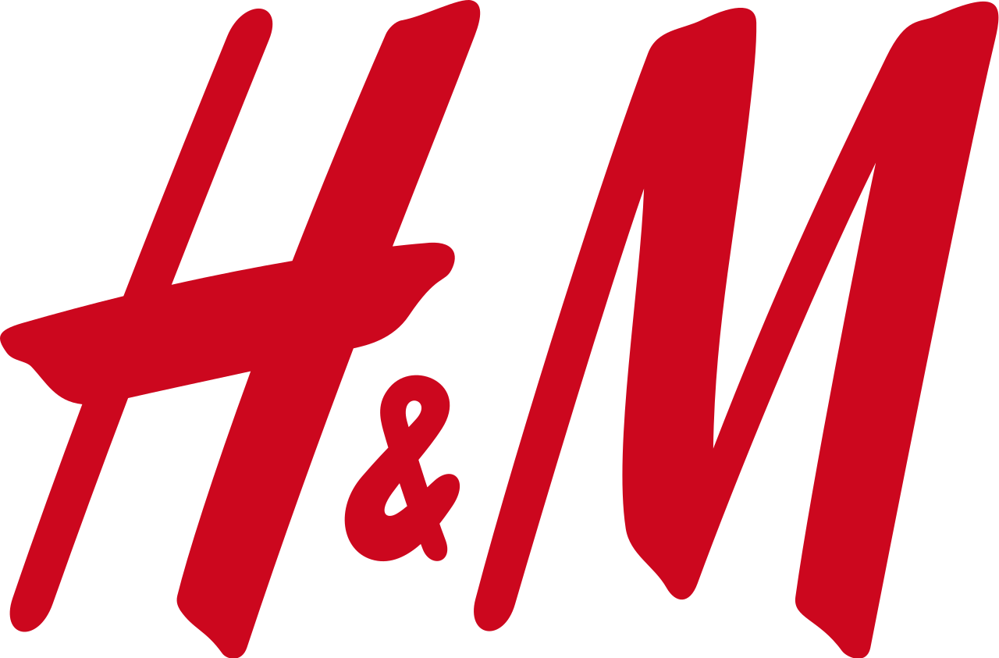
Figure 1: H&M Logo, 2023
Source: Google, 2023
This report provides a comprehensive analysis of H&M's current marketing strategy, identifies areas for improvement, and makes suggestions for implementing innovative marketing strategies to enhance the consumer experience across various communication channels. This report examines the effectiveness of H&M's marketing sweats in reaching its target audience, increasing brand awareness, and boosting sales.
The report also estimates the client's journey through various communication channels, including in-store and online interactions, social media engagement, and customer service. Evaluate H&M's strategy for providing guests with a seamless and unified experience across all touch points. This report primarily investigates H&M's advertising style, identifies probable areas for improvement, and makes suggestions for developing innovative advertising strategies to expand the consumer journey and meet mate hypotheses.

BACKGROUND
H&M is a Swedish international apparel shop that strives to advance towards an indirect and renewable fashion astuteness while keeping equitable and equal business practices. H&M was founded in 1947 and is currently headquartered in Stockholm (Tarnovskaya, et. al., 2022). It is committed to fulfilling this aim by offering stylish items of high quality at competitive pricing (Camargo, et. al., 2020). H&M was established in 1947, and since then, the company has grown to encompass more than 4,900 stores across 74 countries and employs roughly 179,000 people worldwide. The company's attention to sustainability is demonstrated by its efforts to source materials in a manner that is friendly to the environment, cut down on waste, and enhance the working conditions of a manual labourer.
H&M educates its consumers on how to properly care for their clothing to extend its lifespan and lessen the environmental impact of rapid fashion. This is an important aspect of H&M's plan for achieving sustainability. H&M's dedication to protecting the environment has been acknowledged by several organizations, including Commercial Knights. According to Commercial Knights, H&M is also one of the most lucrative firms in the world (Sicoli, et. al. 2019). The notion that it is possible to make a profit while simultaneously making a constructive contribution to society and the environment is reflected in the priority that the company places on sustainability. The commitment to sustainability that has been shown by H&M serves to remind us of the role that businesses play in developing a future that is more sustainable for everyone (H&M website, 2023).

COMMUNICATION
It is fundamental to everyday life for individuals or organizations to communicate with one another via written letters to share information and ideas. The viewpoint on communication that Shannon and Weaver (1949) presented offers valuable insight into the process by which communication takes shape. The sender, the channel, the receiver, and the feedback are the five fundamental components that are considered necessary for communication according to this paradigm.
In this setting, the term "sender" refers to the person or group that kicks off the process of communication by jumbling together a message. This could be an individual or a group. Garbling refers to the process of picking suitable words, gestures, or symbols to express a message. Garbling can take place in a variety of contexts. Information that is intended to be transmitted from one party to another is known as communication. It is possible to communicate dispatches through a variety of methods, such as face-to-face communication, dispatch, phone calls, videoconferencing, and social media (Arslan, and Altuna, 2020).
The person or organization that initiates the delivery of packages to their intended recipients is known as the sender (Kubota, 2019). Deciphering the transmission may involve deciphering the source's visuals or text. The philanthropist may do either. Variables such as the philanthropist's level of knowledge, perception, and linguistic skills can all have an impact on the decoding process. The receiver, having demonstrated that they have correctly comprehended the communication, then provides feedback to the sender. Since it influences both the effectiveness of the communication and the level of comprehension that the philanthropist possesses, feedback is a vital component of the communication process.
The act of exchanging complicated thoughts and information between individuals or organizations is what we refer to as communication. The model of communication developed by Shannon and Weaver in 1949 provides an abecedarian understanding of how communication occurs by linking the fundamental building pieces of the process. For communication to be successful, both the one doing the sending and the person doing the receiving need to comprehend what is being said and provide feedback to verify that it is being understood properly.

Integrated Marketing Communication
In recent years, the advertising technique known as Integrated Marketing Communication (IMC) has emerged as the most popular choice (Sawaftah, 2020). This involves combining all marketing techniques and tools to provide a single message to the audience that is intended to receive it (Gordon-Isasi, et. al., 2021). The basic goal of IMC is to make certain that all of the components of a letter work together coherently to produce substantial brand image strengths.
Integrated marketing communications, often known as IMC, is a client-centric strategy that emphasizes the link between the target audience and the requirements of that audience (Ronnqvit, 2021). The goal is to deliver the appropriate communication to the appropriate recipient at the appropriate time and through the appropriate channel. A plan needs to incorporate several different communication channels, including advertising, public relations, and the formation of deals, particularly selling, direct marketing, and digital marketing, among others. By utilizing these platforms, associations can communicate with their target audience and exert influence on decision-making regarding capping (Todorovic, and Gagic, 2018).
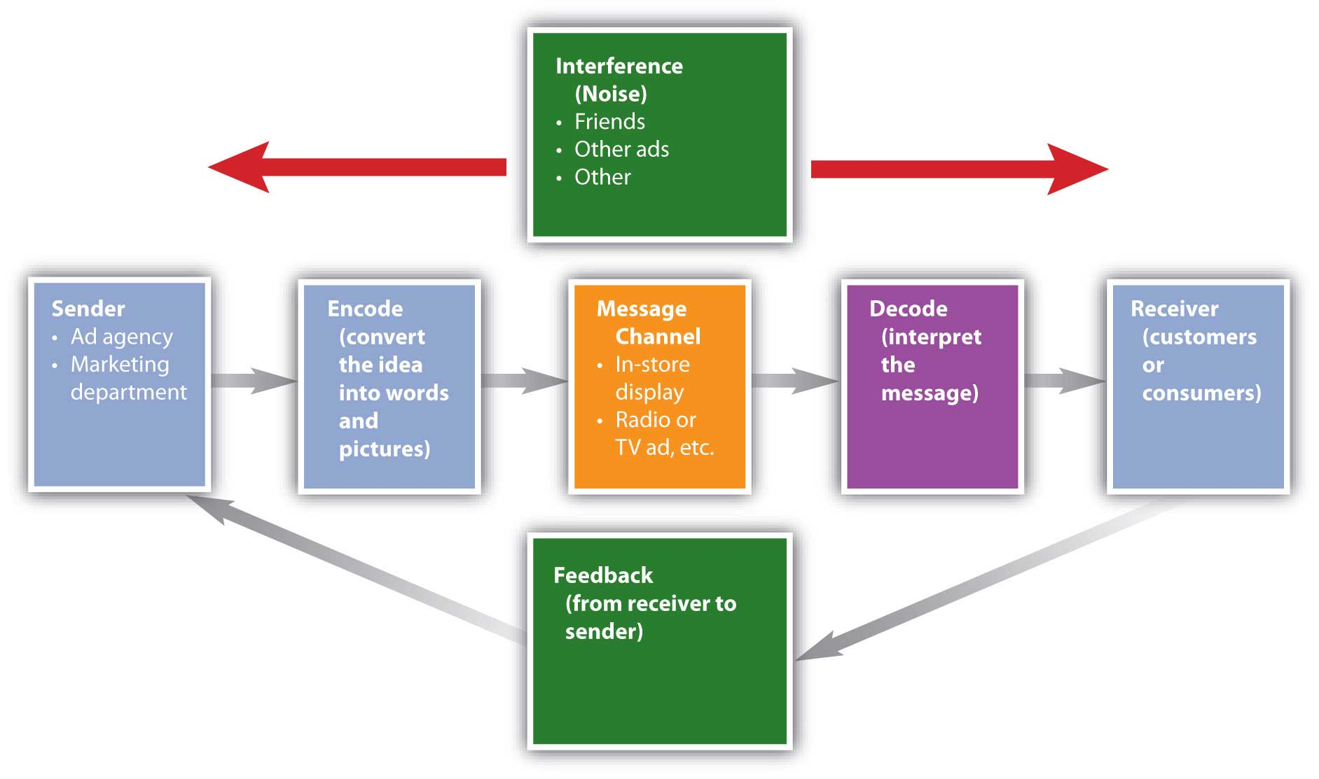
Figure 2: Integrated Marketing Communication, 2022
Source: Business Jargons, 2023
It is necessary, to have a successful IMC strategy, to always have the communication and values of the brand at the forefront of all communications (Farmaki, et. al., 2022). The characteristics of the brand need to be reflected in all the marketing materials, and the language needs to be consistent no matter what channel of communication is used. Because of its thickness, the brand's identification, loyalty, and image are all improved. IMC is extremely important now, as consumers are constantly being inundated with marketing messages due to the proliferation of digital technology. Businesses can effectively interact with their target audience and rise above the din by employing a tactic known as interweaving.
In addition, strategies allow companies to analyse the efficacy of their marketing activities and modify their strategies by the results of such evaluations. IMC is a vital business approach for companies that want to develop a powerful and enduring brand image for their company. Businesses can efficiently reach their target audience, raise brand awareness, and strengthen customer loyalty when all marketing communication tools and techniques are incorporated into their marketing strategy. A client-focused strategy makes that the relevant communication is sent to the appropriate people at the appropriate time via the appropriate channel.

PROMOTIONAL STRATEGIES
H&M is a well-known apparel brand that is well-known for its collection of stylish items. To broaden its customer base and increase its awareness of the brand, the company uses sales methods both offline and online. H&M can engage with its followers and digitally advertise its most recent collections by utilizing the marketing capabilities of social media. The company maintains a presence on Instagram, Facebook, and Twitter, in addition to several other important social media platforms. By publishing posts that are both imaginative and visually appealing, H&M hopes to convince its followers to shop at its online stores.
To strengthen its online presence using virtual entertainment, H&M takes advantage of the possibility to categorize donations. To build word-of-mouth and attract people to their online stores, brands often work together with influential influencers and companies to advertise their garments and accessories (Huang, and Chen, 2021).
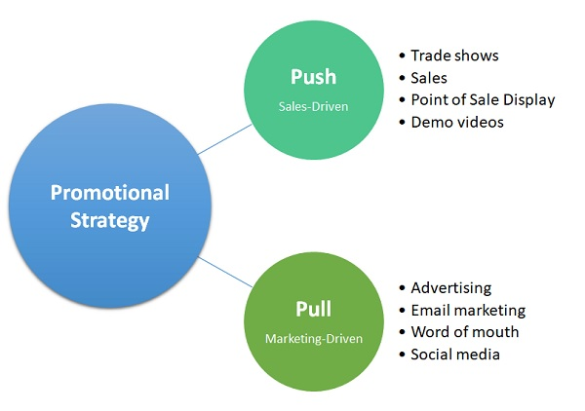
Figure 3: Example of Promotional Strategies, 2023
Source: Forbes, 2023
The H&M Internet donation system is an excellent example of a donation system that is based on email. Through the collection of book data, brands can deliver specialized communications to their fans, alerting them of the most recent shipments, promotions, and accomplishments. The visitors' interest in the brand will improve as a result, and they will be more likely to make a purchase. The design of H&M's website is now undergoing several revisions so that the company can improve its online presence.
This includes adjusting the metadata and text of the post so that it rises to the top of search engine result runners for terms pertinent to the discussion. In addition to having a presence on the internet, H&M also uses traditional methods of marketing. To bring in new clients, these companies invest enormous sums of money in print advertisements and billboards located in heavily travelled areas. To further engage its customers, H&M also hosts events that are analogous to fashion showcases, pop-up shops, and other existential marketing tactics. H&M's limited-time approach is, in general, varied, and well-balanced. It uses both online and offline techniques to engage the general public and raise brand recognition.

INTERNAL AND EXTERNAL STAKEHOLDERS
Every day, H&M, which is an international retailer of clothing, deals with many different consumers. In addition to their customers, their workers, distributors, and suppliers all play an important role in the business's overall performance and day-to-day operations. The H&M supply chain is made up of several different vendors. They offer beginning accessories that are equivalent to the textiles and fabrics used in the creation of clothing sold by H&M. Company is dependent on many overseas suppliers, and the company is dedicated to ensuring that these suppliers uphold the highest ethical standards. The organization has taken several measures to lessen the negative effects that its supply chain has on the environment and to enhance the working conditions of the people who are employed by its suppliers (Edelman, 2018).
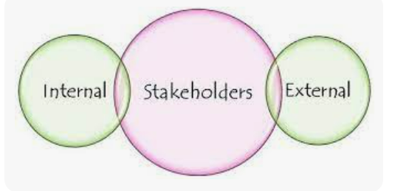
Source: Edelman, 2018
Figure 4: Stakeholders, 2018
Distributors are an essential type of stakeholder for H&M since they enable the firm to advance towards its objectives by ensuring that its products are sold in every region of the world. H&M works with a variety of distributors to ensure that customers have a simple and speedy means of accessing the products they sell. The success of H&M is contingent on the company's employees, who are accountable for respecting the principles of the brand and providing exceptional customer service. H&M provides a working environment that is not only secure but also comfortable for its staff members. Associations devote money to staff training and the improvement of internal systems to continue to stretch and empower their workforce.
Both H&M's performance and its financial results are affected by a variety of internal and external factors. Companies recognize the relevance of these co-workers by holding celebrations and working together to achieve goals while preserving morale and core values.

Branding and Brand Equity
Branding and brand equity are indispensable marketing concepts for launching a successful business. Branding is the creation of a unique identity for a product or service that distinguishes it from its competitors. This identity can be a name, symbol, or design that is instantly recognizable by consumers. A strong brand influences the client's perception of a company, which in turn fosters trust and brand loyalty. Brand equity, on the other hand, is the value a brand adds to a product or service. It is a measure of the value of a brand beyond its practical function. Advanced value brands are regarded as more valuable, and consumers pay a slight premium for them.

Keller's Brand Equity Model
Keller's brand equity model describes the four constraints of brand equity. These elements are exemplified by brand association, brand fidelity, and brand awareness.
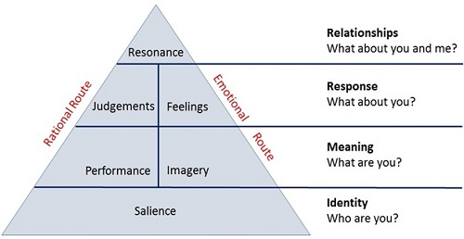
Figure 5: Keller's Brand Equity Model, 2022
Source: Mind Tools, 2022
Brand fidelity is the extent to which consumers are devoted to and willing to purchase a brand. Recurring transactions, positive word of mouth, and brand development are all dependent on brand fidelity. The extent to which consumers recall a brand with fondness. The addition of brand consciousness contributes to a strong brand image and the attraction of new visitors (Keller, 2019).
Perceived quality is the consumer's perception of a brand's quality relative to its competitors. A superior position in terms of perceived quality strengthens client trust and confidence. In the end, brand associations are the internal associations that consumers make between a brand and a particular benefit or quality. Positive brand associations enable brands to distinguish themselves from competitors and cultivate a distinct identity (Keller, 2019).
A company's success is contingent on the strength of its brand and brand equity. Guests may create a powerful print of a strong brand, adhere to it, and pay a decoration fee. To promote brand power, four fundamentals of brand equity, as measured by Keller's image value model, must be nearly covered: brand association, brand consciousness, perceived quality, and brand fidelity.

CUSTOMER JOURNEY
H&M is not an exception when it comes to the significance of client experience. The iconic fashion retailer H&M has embarked on a journey that visitors can appreciate from the beginning to the end. This procedure consists of three stages: before the purchase, during the purchase, and after the purchase.
Throughout the purchase period, H&M endeavours to attract the attention of its target guests. H&M achieves this by employing vibrant marketing and advertising behemoths, social media conditioning, and in-store elevations. The objective of brands is to cultivate a positive character and brand image and communicate their unique value proposition to implicit visitors. During purchasing days, H&M is frequented by consumers. H&M desires to make this time effortless and enjoyable. The business provides an extensive and user-friendly online store that accepts credit and debit cards, PayPal, Klarna, and other payment methods.
Guests can anticipate personalized product recommendations, and H&M employees trained to provide superior in-store service will assist them in locating the items they seek. In the post-purchase period, the client examines the purchase and determines to return the item to H&M. This period is crucial for H&M because it allows consumers to determine whether to increase brand loyalty. H&M is committed to providing superior after-sales services, such as simple returns and exchanges and prompt responses to customer complaints and inquiries. In addition, the company continuously improves its products based on customer feedback. The purpose of the H&M client excursion is to provide visitors with a memorable purchasing experience. By analyzing the pre-purchase, purchase, and post-purchase phases, H&M capitalizes on its core competencies to build client relationships and cultivate a loyal customer base (Lee, et al., 2018).

Figure 6: Customer Journey Map, 2020
Source: Briedis, et. al., 2020

Customer Touchpoint
A client contact point is any point where a client interacts with a brand, such as a website, social network, client service, or tangible store. Touchpoints may occur at any stage of a client's business. Relationships that occur before a customer makes a purchase are known as pre-purchase touchpoints. Examples include announcements, social media posts, website visits, online reviews, newsletter distributions, and supplier interactions. Pre-purchase points are intended to increase interest in an item or table and assist visitors in making the best purchase decision.
The commerce that occurs during the purchase procedure is known as the " point of purchase " This could involve examining an item closely in a store, loading an item onto a vehicle, installing a system, or speaking with a salesperson. The procurement contact point aims to enhance and simplify the procurement system (Mok and Deans, 2020). Touchpoints that occur after a customer makes a purchase are known as post-purchase touchpoints. Shipping notifications, customer service inquiries, confirmations, and tracing emails are examples of this. Post-purchase touch points are designed to increase client loyalty, encourage repeat purchases, and capture client feedback to enhance the overall client experience.
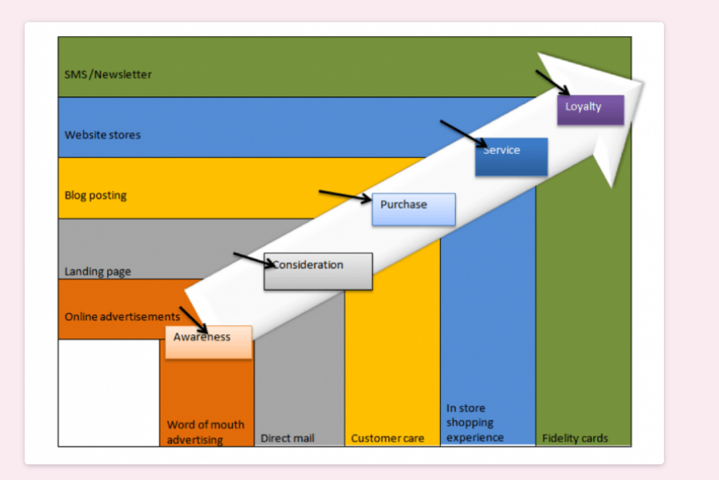
Figure 7: Customer Journey Map, 2020
Source: Mok and Deans, 2020

H&M's Customer Journey Map
H&M, one of the world's largest fashion retailers, has a detailed client journey chart that outlines the various phases customers experience before, during, and after a purchase. The first of the seven phases of the client journey chart is brand and product consciousness. In the preference phase, consumers select H&M as their preferred brand for a particular product or service, evaluate the brand in comparison to its competitors, and choose H&M. Following the decision stage, the client enters the purchase phase, where they purchase the product or service. After making a purchase, customers anticipate efficient delivery during the shipping period. During the usage period, the consumer utilizes the purchased product or service. Consumers base repurchase decisions on their initial H&M purchasing experiences (H&M Customer Journey Map, 2023).
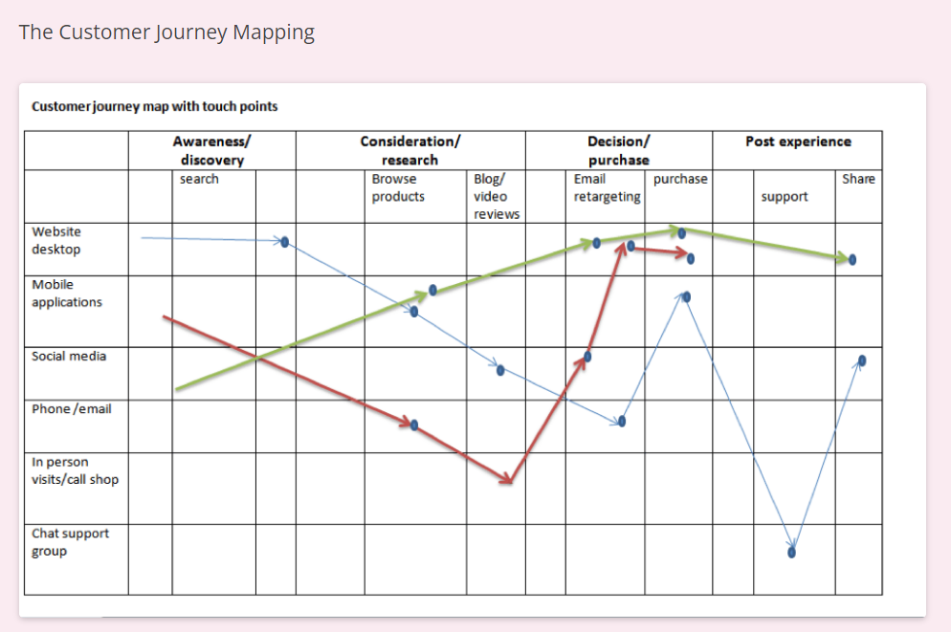
Figure 8: H&M Customer Journey Map, 2023
Source: H&M Customer Journey Map, 2023
At each stage of a client's journey, multiple touchpoints can either enhance or detract from the experience. These touchpoints include the H&M website, social media, brick-and-mortar stores, customer service, and delivery process. This information can be used by H&M to create a client travel chart to enhance the client experience at each stage of the client journey. This can result in paperback loyalty, advanced agreements, and diminished brand awareness.

Strengths
Numerous H&M shipments are responsible for the global fashion retailer's prosperity. Its emotional client gets chart, which guides customers through a purchasing system with erected-in touchpoints across multiple channels, including brick-and-mortar stores, websites, wearable apps, and online entertainment accounts, is perhaps its greatest strength. This strategy strengthens the company's brand identity and personality, creating a positive and harmonious customer experience.
Additionally, one of H&M's assets is its commitment to sustainability. The company's products and messaging reflect consumers' diminishing interest in ethical and sustainable business practices. Guests value H&M's commitment to reducing its environmental impact, as demonstrated by its support commitment. Despite its extensive store network and delivery affiliation, H&M can deliver products to its customers quickly and efficiently. In today's fast-paced retail environment, consumers expect rapid and simple access to the products they desire. H&M can fulfil these prospects due to its capable workforce and distribution network, which increases customer loyalty.

Weaknesses
An implicit strike of H&M's client trip chart is the limited personalization and customization options available to guests. While the company offers some introductory customization options like colour and size options, guests have further options to conform the shopping experience to their unique preferences and conditions. Another implicit weakness is the lack of communication between the colourful touch points of the client’s start companion. Each touchpoint works well collectively, but there's room for enhancement in how they work together to deliver a flawless client experience. Eventually, H&M's client trip chart may not reach its entire target followership, especially those who prefer to protect in high-end stores. The company's focus on availability and affordability has helped it attract many guests but makes it delicate to acquire guests with a lot of plutocrats.

INNOVATIVE MARKETING STRATEGIES
H&M can enhance the consumer experience with a variety of innovative marketing strategies. This section outlines the strategies H&M can employ to increase customer satisfaction and loyalty. H&M may use data analysis to personalize the consumer experience. H&M may utilize consumer information to generate personalized product offers, bundle offers, and promotions. Personalization has the potential to enhance both the consumer experience as a whole and customer satisfaction.
H&M can enhance the consumer experience by using digital channels such as e-commerce, mobile applications, and social media (Briedis, et. al., 2020). H&M utilises online entertainment to engage customers, provide customer service, and allow them to voice their opinions. Additionally, H&M may use mobile applications to provide mobile-exclusive advertising and personalized user experiences. Online enterprises can offer consumers convenience, versatility, and selection.
Sustainability can be utilised as a differentiator to improve the consumer experience at H&M (Pei, et. al., 2020). H&M can educate consumers about the materials used in its products, promote sustainable practices, and encourage recycling and garment donations. Sustainability can enhance a business's reputation and attract eco-conscious consumers. Through experiential advertising, H&M can create meaningful and engaging interactions with shoppers. H&M may host fashion displays, events, and pop-up stores to promote its products and increase brand awareness. Experiential marketing can increase brand awareness and generate positive word-of-mouth.

EVALUATION AND MEASUREMENT
To identify growth opportunities and make data-driven decisions, H&M must evaluate and quantify the efficacy of its marketing strategies. H&M can evaluate the customer journey using customer satisfaction, net promoter score, lifetime value, and retention rate metrics. In addition, H&M can utilise examination to monitor client behaviour, including navigation rates, rate of change, and rate of exit. In addition, H&M should collect consumer feedback and monitor social media to understand customer sentiment.

CONCLUSION
In conclusion, H&M must develop new marketing strategies to enhance the customer experience, boost customer satisfaction, and boost customer loyalty. H&M can use personalization, digitalization, manageability, and experiential marketing to differentiate itself from competitors and build a positive brand image. In addition, H&M should evaluate and quantify the efficacy of its marketing strategies to identify growth opportunities and modify its strategy accordingly.

REFERENCES
Arslan, M., and Altuna, O. (2020). Communication strategies of fashion brands in social media. Journal of Marketing Communications, 26(2), 129-144.
Briedis, H., and et al. 2020. Adapting to the next normal in retail: The customer experience imperative. http://dln.jaipuria.ac.in:8080/jspui/bitstream/123456789/1510/1/Adapting-to-the-next-normal-in-retail-the-customer-experience-imperative.pdf
Camargo, L.R., and et al. 2020. Fast and ultra-fast fashion supply chain management: an exploratory research. International Journal of Retail & Distribution Management, 48(6), pp.537-553. [Online] Available Through: https://fgvcelog.fgv.br/sites/gvcelog.fgv.br/files/artigos/camargo_pereira_scarpin_ijrdm-04-2019-0133.pdf [Accessed on 25th April 2023]
Edelman, D. (2018). Communicating with internal and external stakeholders during a crisis: The case of the H&M hoodie controversy. Case Studies in Strategic Communication, 7, 87-103.
Farmaki, A., and et al. 2022. CSR communication and international marketing: Insights from the COVID-19 pandemic. International Marketing Review. https://eprints.whiterose.ac.uk/191054/1/CSR%20communication.pdf [Accessed on 25th April 2023]
Gordon-Isasi, J., and et al. 2021. Revisiting integrated marketing communication (IMC): A scale to assess IMC in higher education (HE). Journal of Marketing for Higher Education, 31(1), pp.58-90. https://www.tandfonline.com/doi/pdf/10.1080/08841241.2020.1758283 [Accessed on 25th April 2023]
H&M Customer Journey Map. (2023). Retrieved April 26, 2023, from https://www.hotjar.com/customer-journey-mapping/hm/
H&M website. (2023). https://www2.hm.com/en_us/index.html. [Accessed on 25th April 2023]
Huang, M. H., and Chen, Y. S. (2021). A study on the effects of promotional activities and product diversification on customer loyalty in fast fashion industry. Journal of Retailing and Consumer Services, 61, 102583.
Keller, K. L. (2019). Building and managing brand equity. In Strategic Brand Management: Building, Measuring, and Managing Brand Equity (pp. 1-20). Pearson.
Keller, K. L. (2019). Building and managing brand equity. In Strategic Brand Management: Building, Measuring, and Managing Brand Equity (pp. 21-58). Pearson.
Kubota, M., 2019. What is" Communication"?-Beyond the Shannon & Weaver’s Model. International Journal for Educational Media and Technology, 13(1). https://ijemt.org/index.php/journal/article/download/187/49 [Accessed on 25th April 2023]
Lee, S., Lee, J. A., and Koo, D. M. (2018). Customer journey management in the digital age: Importance, challenges, and opportunities. Journal of Business Research, 89, 220-227.
Mok, J., and Deans, K. R. (2020). Consumer-brand engagement on social media: The impact of brand touchpoints. Journal of Interactive Marketing, 51, 72-83.
Pei, X.L., and et al. 2020. Does the effect of customer experience on customer satisfaction create a sustainable competitive advantage? A comparative study of different shopping situations. Sustainability, 12(18), p.7436. https://www.mdpi.com/2071-1050/12/18/7436/pdf [Accessed on 25th April 2023]
Rönnqvist, O., 2021. Developing a product group marketing communication in b2b context. https://www.theseus.fi/bitstream/handle/10024/505425/Ronnqvist_Outi.pdf?sequence=2
Sawaftah, D., 2020. The effectiveness of electronic integrated marketing communications on customer purchase intention of mobile service providers: The mediating role of customer trust. Journal of Sustainable Marketing, 1(1), pp.47-61. http://luminousdev.s3.amazonaws.com/gallery/438071656559023.pdf [Accessed on 25th April 2023]
Sicoli, G., and et al. 2019. The importance of sustainability in the fashion sector: Adidas case study. International Business Research, 12(6), pp.41-51. https://pdfs.semanticscholar.org/4ddd/e982b79ebf3c9b8fec30ba9e85d1c65fe443.pdf [Accessed on 25th April 2023]Tarnovskaya, V., and et al. 2022. Proactive Corporate Sustainability via Social Innovation—A Case Study of the Hennes & Mauritz Grand Challenge in Bangladesh. Sustainability, 14(2), p.599. https://www.mdpi.com/article/10.3390/su14020599
Todorovic, A., and Gagic, S. (2018). Integrated marketing communications in the fashion industry. Strategic Management, 23(3), 37-44.

