Dimitar Premyanov (1918696)
Digital Skills and Research Methods (BMSW4003)
Digital Skills and Research Methods
Amitave Banik
Health and Social Care (Term 2)

INTRODUCTION

In this research report I will be discussing the impact of the Virtual Learning Environment (VLE) Moodle on students’ learning experiences in the University of Wales Trinity Saint David London Campus.
A Virtual Learning Environment is a place where students can access school resources given to them by their teachers. It has become more and more popular as technology has advanced and a lot of schools have started using it.
For this research on VLEs and their impact on student’s learning, I will be conducting my own questionnaire to serve as my primary data, whilst also using external relevant resources to act as my secondary data. I will also be making use of quantitative (statistical) research and qualitative (word orientated) research, to aid my point.
Quantitative will be used to test the theories and the assumptions whilst the qualitative research will be used to comprehend the thoughts or experiences of the students (Streefkerk, 2019).
I am conducting this research with my aim being to successfully reach a conclusion that will hopefully shed light on to how Moodle helps those students who use it and how those some students find the Virtual Learning Environment as a whole.

BACKGROUND

VLEs first began to appear in the 1990s. They were first not web based but eventually began to head in that direction more and more.
The features of a VLE are not as simple as they may seem at first glance. The job of one is not just to let the student access information, but to do so in a sophisticated yet easy-to-grasp manner. I am not going to go into each and every single detail of a VLE as that is not the question I am focusing my study around, but it is vital for us to understand that a VLE’s purpose can range from offering students school related recourses all the way to helping them to easily align their studies with other plans and activities they may have (The Use Of Virtual Learning Environment In Education | SCAND Blog, 2020).
Many students are extremely happy with the VLEs offered by their schools. They firmly believe that the use of them really benefits their overall educational progress. According to a research conducted by Jenny Barker and Peter Gossman about the VLE Moodle, we can clearly see that 58.5% of students either agree or strongly agree with the statement that Moodle has been an important and valuable aid to their personal studies (Barker and Gossman, 2013).
According to the same research, 48.8% of the students also agreed that the Virtual Learning Environment Moodle improves the effectiveness and quality of their learning.
Knowing all of that information, we can firmly say that according to a large number of the student population, VLEs are indeed something extremely beneficial for them. Another huge benefit to Virtual Learning Environments such as Moodle, is the fact that they offer the students an opportunity to develop their ICT skills and understandings. When a student interacts with the Virtual Environment, they start to get used to it and comprehend more information. Not only is the student learning their courses online, but they are also learning how to use digital platforms (Meru School, 2020). Nowadays, it is of extreme importance that everyone knows and learns how to use digital software in order to expand on their learning as a whole. The usage of VLE can also expand on their communication skills as it offers a place for you to freely speak with your teachers/lecturers about anything that bothers you or you need more information about.
On the opposite side of the spectrum, many people will argue that Virtual Learning Environments act as a replacement to actual classrooms and campuses, meaning that they are not as useful as they are made out to be as that leaves those public spaces useless. In fact, VLEs are the exact opposite of that, as what they do is that they add value as they technically expand the space of the physical learning environment. (What is a Virtual Learning Environment (VLE)?, n.d.).
On top of that, they allow students who are not capable of attending a campus to also get the education they seek for, even if they do not have all the available finances to pay for campus fees, making it especially convenient for students who are studying abroad.
A more suitable disadvantage would be that a VLE does not offer the human-to-human contact, which can actually limit your opportunities for effective team building (Johnson, 2019). This would mean communication would be more restricted, but if a VLE is paired up with a classroom and a physical place to study with others, then that would yet again expand the learning environment.
As a whole, according to multiple external resources, Virtual Learning Environments have served a huge purpose in enhancing students’ experiences in learning and overall stay at a school, as not only did they help them in their studies, but also with engaging with their teachers/lecturers. Even though they do have their limitations, such as not being able to physically be there to participate, in my opinion, the benefits presented definitely outweigh the disadvantages, portraying VLEs as a certain and vital feature of modern-day education.
All of this information will heavily benefit me in reaching the most appropriate conclusion when paired with my own research that I have set to do.

AIMS & OBJECTIVES

One of my aims is to find exactly how students feel about VLEs and if they really do have a beneficial impact on those who use them.
My other aim would be to gain valuable insight on whether or not students prefer studying with or without a Virtual Learning Environment.
My objective for those aims would be to first construct a questionnaire with questions linked to the VLE Moodle.
After that, I will conduct the appropriately designed questionnaire that would reflect how students feel about the Virtual Learning Environment Moodle and whether or not they prefer studying with it or without it.

METHOD

Prior to conducting my own primary research, I decided to gain information on the topic at hand and research more about it in order to gain proper insight onto what questions I should and should not ask (secondary research). As well as that, I also used the resources offered to me by my university and lecturer regarding appropriate questionnaires, how we should lay them out, and the types and varieties of questions we should be asking the participants.
When I had collected enough beneficial and suitable information, I decided to finally have a go at constructing my own questionnaire on Microsoft Forms consisting of both qualitative questions and quantitative questions. Those questions included some open-ended ones, and others included a Linkert scale and a rating scale where the person submitting their answers will have to answer them depending on how they feel about the specific question asked.
For this particular research, I decided to conduct my questionnaire online, through email, my sampling frame being students studying at the University of Wales Trinity Saint David. I figured that in order to get the most valuable, honest and accurate answers, then it would be best to survey students who are studying at a university.
I then sent my questionnaire to a sample of 20 students, many of whom are in different groups than my own. I got a reply from 15 of them.

RESULTS

After conducting my questionnaire, I decided to summarise the results I got. Below are some of the results I found the most interesting:

1)

2)

3)

4)

5)

DISCUSSION

The first question (1st Graph) I analysed was an open-ended question and as you can clearly see, 14 of the replies I got were all positive.
Most of the students were really happy with how quickly they can access their lessons and the information given to them by their teachers.
The second question (2nd Graph) which I mentioned used the Linkert scale and asked the participant what they think of the following statement: Moodle improves the standard of my learning.
The table shows us that 87% of people either agreed or strongly agreed and that 13% were neutral. This means that there were 0 negative replies to this statement.
The third question (3rd Graph) I talked about used a different structure than the previous two. It was a simple Yes or No question with an extra option for further clarification. It asked the students: Has Moodle helped you organise your studies?
As an answer, I got 12 people saying yes and only 3 saying to an extent.
This question was linked to what I was discussing earlier and how a VLE is not only there to provide you with learning resources, but to also guide you with your learning and help you organise your schedules.
Seeing that 80% of the people were sure that it has helped them, yet again shows us that VLEs such as Moodle have a positive impact on students’ learning.
The fourth (4th Graph) and penultimate question I mainly focused on was: Do you find Moodle easy to use?
For this question, I asked the students to rate themselves from 1 to 5 (1 being not at all and 5 being completely) on how easy they find it.
For this question, I got a mixture of results and none of them fell below the value of 3.
These results would suggest that Moodle is not hard for people to use. Of course, the two results of ‘3’ could imply that some people do not find it easy to such a great extent but that could be due to many different factors such as the age of the student or how frequently they go on Moodle to familiarise with the setting.
Talking about frequency of usage, the last question (5th Graph) I found especially intriguing was: How often, on average, do you use Moodle? I found this result particularly important, as the replies I got imply that students prefer using the Virtual Learning Environment, Moodle, to not using it at all as all of the students surveyed (13 of them saying that they use Moodle daily and 2 of them saying they use it more than once a week) are frequent users of it.
One thing that I could have done better to carry out this research is to have gotten more sampling units (students) to survey. Unfortunately, not every student answered the questionnaire, but I am still happy with the number of participants there were there at the end.
Another thing I could have expanded on was the amount of open-ended questions there were, in order for me to obtain a wider variety of answers.

CONCLUSION

In conclusion, based on both secondary data and primary data that I have both gathered myself and used from other resources, I think it is clear to see that VLEs such as Moodle have had a huge positive impact on students. This positive impact has been on their learning and also on their overall organisation of free time and studies.
Moodle also offers students the ability to freely communicate with their teachers/lecturers whilst also expanding on the students’ computing and ICT skills.
As a whole, in this day and age, I find Virtual Learning Environments to be of huge significance and importance to students and their learning, and according to mine and other peoples’ research, most students think so too.

Reference:

Barker, J. and Gossman, P., 2013. The Learning Impact Of A Virtual Learning Environment: Students’ Views. [ebook] Available at: <http://insight.cumbria.ac.uk/id/eprint/1455/1/146-574-1-PB.pdf> [Accessed 30 December 2020].

Firefly. n.d. What Is A Virtual Learning Environment (VLE)?. [online] Available at: <https://fireflylearning.com/what-is-a-virtual-learning-environment-vle> [Accessed 16 December 2020].

Johnson, S., 2019. Knowledge Anywhere :: The Advantages And Disadvantages Of A Virtual Learning Environment. [online] Knowledge Anywhere. Available at: <https://www.knowledgeanywhere.com/resources/article-detail/the-advantages-and-disadvantages-of-a-virtual-learning-environment> [Accessed 17 December 2020].

SCAND. 2020. The Use Of Virtual Learning Environment In Education | SCAND Blog. [online] Available at: <https://scand.com/company/blog/the-use-of-virtual-learning-environment-in-education/> [Accessed 16 December 2020].

School, M., 2020. Advantages & Disadvantages Of Virtual Classroom » Meru International School. [online] Meru International School. Available at: <https://www.meruinternationalschool.com/advantages-disadvantages-of-virtual-classroom/> [Accessed 19 December 2020].

Streefkerk, R., 2019. Qualitative Vs. Quantitative Research | Differences & Methods. [online] Scribbr. Available at: <https://www.scribbr.com/methodology/qualitative-quantitative-research/> [Accessed 19 December 2020].

Appendix:

Appendix A:
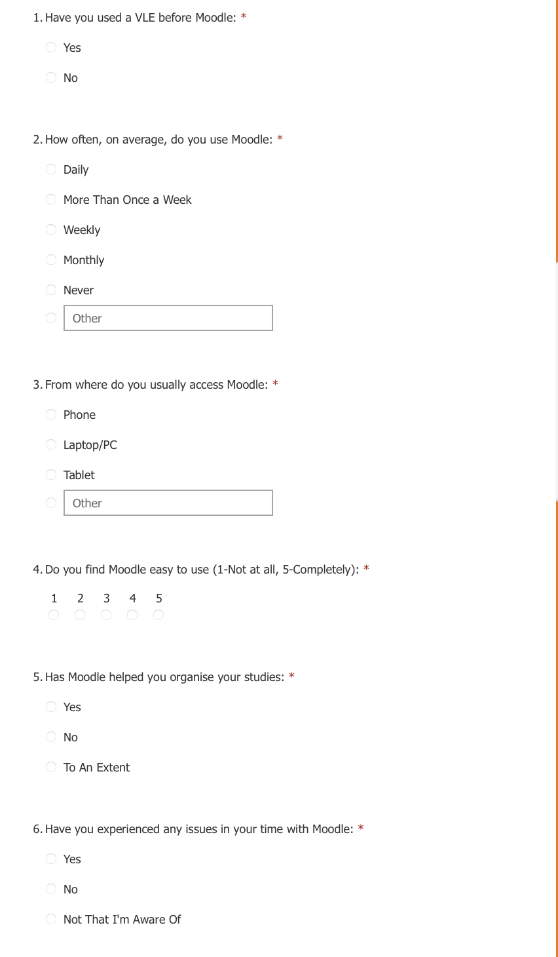
Appendix B:
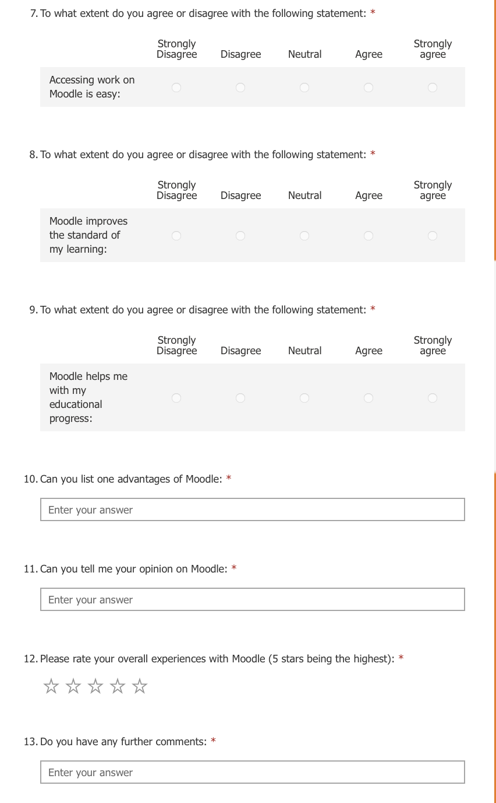

Appendix C:

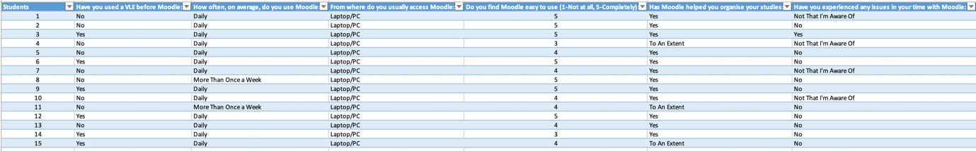

Appendix D:



