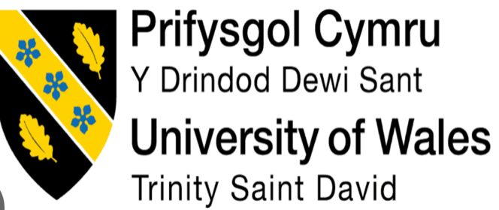

Student: Name: Nwakaego peace Elumese
Student number: 21124106
Module code: (LCMB7026-LON)
Module name: International marketing principles and practices
Lecturer name: Tushara Balendran
Submission date: 19/12/2025

Table of Contents

Executive Summary​…………………………………………………………………4
Introduction…………………………………………..​………………….5
2. Brand Overview: BMW's Global Legacy and Local Footprints​………………………………………………………………………………………………6
2.1 BMW in the United Kingdom​………………………………………………………………………………………………6
2.2 BMW in Nigeria……………………………………​………………..8
3. Comparison of the Macro-Environment: A PESTLE Analysis of the UK and Nigeria​…………………………………………………………………………8
3.1 Political Factors​……………………………………………………………………8
3.2 Economic Factors………………………………………………..9
3.3 Social Factors​…………………………………………………………………….10
3.4 Technological Factors………………………………​………………10
3.5 Legal Factors……………………………………………………………………..11
3.6 Environmental Factors​………………………………………………………..11
3.7 PESTLE Similarities:​………………………………………………………… 12
3.8 Pros and Cons Post PESTLE………………………………….. 12
3.9 BMW's Market Position and Challenges: Favourable or Unfavourable​…………………………………………………………………………13
4. A Comparison of the STP Strategies Employed by Brands in the United Kingdom and Nigeria……………………………….. …..13
4.1 Segmentation and Targeting……………………….………….14
4.2 Positioning………………………………………………………15
4.3 Targeting Benefits and drawbacks…………………………….. ​16
5. Comparison of Marketing Mix Strategies in the UK and Nigeria​…….……………………………………………………………………………………….16
5.1 Product……………………………………………,……… ….17
5.2 Price…………………………………………,,,,,,,,………………18
5.3 Place (Distribution)…………………………...….………….. 18
5.4 Promotion……………………………………………………….20
5.5 People…………………………………………………………..20
5.6 Process……………………………………………​…………………21
5.7 Physical Evidence​………………………………………………………………22
5.8 Similarities of the 7 P’s…………………………...:​………………22
5.9 The distribution channels………………………………………23
6. Evaluation of the Performance of Marketing Strategies…………………………………………… .………….. ..23
6.1 United Kingdom​…………………………………………………………………23
6.2 Nigeria…………………………………………….…………….24
7. Evaluation of Marketing Ethics Practice…………………………26
Implications of Hoisted following Social Factors:​……………………………………………………………………………. …………..27
Models, Rationale, Advantages and Disadvantages:​…………………… 27
8. Recommendations & Conclusion………………………………..28
8.1 Recommendations for Future International Marketing Strategies……………​………………………………………………………………28
8.2 Conclusion………………………………………………………29
Reference list………………………………………….…………….30

Executive Summary

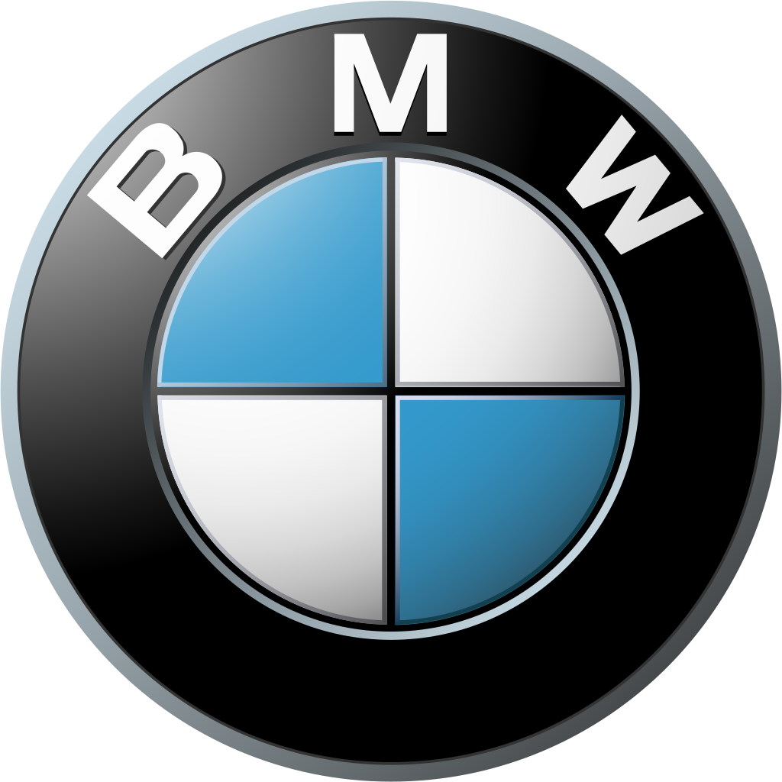
BNW logo access from this website page https://www.forbes.com/companies/bmw-group

The marketing strategy that BMW employs in the United Kingdom and Nigeria exemplifies
how to combine brand consistency with adaptability in the local market. Even though BMW keeps its luxury and performance brand on a global scale, the company's strategic
execution in these two locations is different due to the varied macro-environments in each of these regions. Families and older citizens in the United Kingdom can take advantage of BMW's global distribution, affordable prices, and innovative financing options. The phrase "Sheer Driving Pleasure," as well as technology and electric cars, was promoted through mass marketing and the internet.
The ultra-wealthy are the target audience for BMW in Nigeria's growing market. Achievement and social distinction are represented by BMW's high-end SUVs and luxury cars, premium retail pricing, restricted exclusive dealerships, and relationship-driven marketing strategies.
According to the review, BMW is at the forefront of premium markets in both the United Kingdom and Nigeria. Accelerate the electrification of the United Kingdom and construct market-specific models and elite ownership in Nigeria to achieve sustained growth. According to the findings of the inquiry, BMW's ability to adapt its marketing strategies to a certain set of conditions is one of the factors that contribute to the company's global premium leadership position.

Introduction
Despite the most significant level of interconnectedness to have perpetually existed, the global business landscape is still a multifaceted tapestry consisting of several economic, political, social, and cultural environments. Multinational corporations face this complexity through the development of their global brand, which they are then expected to acclimatise and appeal to one or even many local markets at a time (Williams and Blyth, 2023). The automotive industry needs to address two categories of engineering, prestige, and consumer. In contrast, the UK and Nigeria are two highly contrasting markets; this paper entails an analysis of BMW's international breach-marketing strategy.
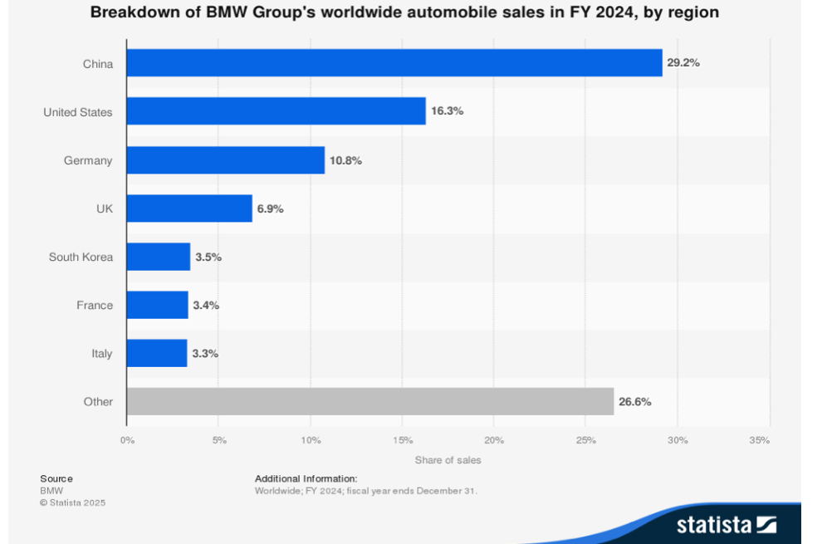
Figure 1: Breakdown of BMW Group's worldwide automobile sales in FY 2024, by region (Carlier, 2024)
It is possible to draw parallels between the selected countries. The United Kingdom is a mature, saturated, and competitive automobile market by the standards formulated for the European Union. Thus, the country is characterised by informed consumers, strict environmental regulations, and a well-established system of driving both for traditional and electric vehicles. Economic instability, an insufficiently developed system of roads and driving quality, and a complex system of socio-political relations are the challenges facing Nigeria, a developing market with prospects. The Nigerian automotive market is underdevelopment. Moreover, it is represented by second-hand imported cars. However, a significant part of the country’s elite is more than open to luxury brands (Talking, 2025).
PESTLE will then be used to make a comparison of the macro-environmental factors that are present in both countries. Subsequently, the report will investigate BMW's Strategic Target Position (STP) and tactical Marketing Mix (7Ps) in each country. The various market performance indicators will be utilised to evaluate these strategies. Within this framework, the report will investigate the ethical marketing practices of BMW. As the report ends, recommendations will be provided to strengthen BMW's market position and growth in the United Kingdom and Nigeria.
Brand Overview: BMW's Global Legacy and Local Footprints
BMW is a manufacturer of high-end automobiles and motorcycles. The primary identity for this brand, which was headquartered in Munich, is performance, engineering innovation, aesthetic design, and “Sheer Driving Pleasure”. It is this core identity that is associated with BMW’s global capacity, technological advancement, performance, and dynamic luxury. The automobile manufacturers that serve targeted premium automotive markets are Rolls-Royce, BMW, and the BMW M series (Swartz and Iacobucci, 2000).

2.1 BMW in the United Kingdom
It is well-established and integrated in the United Kingdom, which is a significant market in Europe. The United Kingdom is home to many dealerships, larger manufacturing facilities, and national sales companies. The global production network of BMW, which includes the Oxford Mini and Goodwood Rolls-Royce factories, is dependent on the United Kingdom because of its location. Within the United Kingdom, Mercedes-Benz, Audi, as well as British and Japanese luxury brands, engage in fierce competition. In response to the push for electrification that has been made by the government of the United Kingdom, BMW UK has promoted its electric and plug-in hybrid i Series and Performance models through nationwide television and digital campaigns as well as through promotions at local dealer events (Smith and Sarabi, 2020).

Parameter | BMW Group (Global) | BMW United Kingdom | BMW Nigeria
Brand Portfolio | BMW, Mini, Rolls-Royce, BMW Motorrad | BMW, Mini, Rolls-Royce, BMW Motorrad | Primarily BMW; Limited Mini presence
Global Vehicle Sales (2023) | 2,555,341 units (BMW Brand: 2,252,793) | 146,487 new BMW & Mini registrations | An estimated 500-700 new units annually (Official Channels)
Market Position | Top 3 Global Premium Automotive Manufacturers | Consistent #1 or #2 in UK Premium Segment | Niche Player in Ultra-Luxury Segment
Operational Model | Global Production & Sales Network | National Sales Company; Local Manufacturing (Mini, Rolls-Royce) | Importation via Authorized Dealers (e.g., cos Charis Motors)
Key Manufacturing/Assembly Presence | 30+ Production Sites Worldwide | Plants in Oxford (Mini) and Goodwood (Rolls-Royce) | No Local Assembly
Dealer Network Density | Global Network | ~150 Retail Outlets | 3-5 Major Authorised Dealerships
Primary Target Audience | Global Affluent Consumers & Driving Enthusiasts | Broad: Company Car Users, Professionals, Families | Ultra-High-Net-Worth Individuals, Executives
Core Marketing Message | "Sheer Driving Pleasure" / "The Ultimate Driving Machine" | Performance, Innovation, & Sustainable Mobility | Status, Prestige, & Exclusivity
Key Product Focus | Full Portfolio (ICE, PHEV, EV) | Diverse, with strong emphasis on EVs & PHEVs (e.g., i4, iX, 330e) | Curated: Large SUVs (X5, X7) & High-End Saloons (7 Series)
Sample Vehicle Price (BMW X5) | Varies by Market | ~£68,000 (New) | ~₦125,000,000 (New - approx. £115,000)
Table 1: BMW Group Global & Local Presence: UK vs. Nigeria (2023/2024 Data) (Kazemi, Rafsanjani and Firozjaei, 2025)

2.2 BMW in Nigeria
The Nigerian operation of BMW is one of a kind and reflects the expansion of the market. Because the brand does not produce vehicles within the country, vehicles are imported by a small number of authorised dealers as well as a larger network of parallel importers. When it comes to the wealthy upper class of the country, including business owners, executives, and public figures, BMWs are significant status symbols (Roberts and Cullinane, 2022). Because Cochairs Motors is an authorised distributor, the sales, service, and parts support that they provide are restricted by the local infrastructure. In comparison to the market in the United Kingdom, this one is smaller and less structured due to the presence of Mercedes-Benz and Lexus, as well as the substantial market for used luxury automobiles of older models that are imported from Europe and North America. The wealthy residents of Lagos and Abuja are the target audience for high-end events, exclusive partnerships, and digital marketing services (Nwangwu, Obeta and Chike Osegbue, 2020).
Comparison of the Macro-Environment: A PESTLE Analysis of the UK and Nigeria
BMW's marketing strategies in the United Kingdom and Nigeria are influenced by external factors, as explained by the PESTLE analysis.
3.1 Political Factors
United Kingdom: The United Kingdom is distinguished by its robust legal system and politically stable government. Trade, supply chain coordination, and EU regulations are all thrown into disarray because of Brexit, which may have an impact on product prices and delivery times. The EV strategy of BMW is also backed, in terms of grants, subsidies, and investments in charging infrastructure, by the government of the United Kingdom (Ngara, 2021).
Nigeria: The cause of the Nigerian political instability is the policy inconsistency, as well as the red tape obstacles. The latter shall ease with Nigerian bureaucracy reform, while the NAIDP implementation proves a slow and inconsistent process, although it calls for local assembly. An exceedingly small percentage of the Nigerian population is allowed to afford brand-new BMWs, as fully built units are heavily taxed by duties and import tariffs, in order to stimulate used cars. The regional security shall also influence the confidence of consumers and coordination effectiveness (Nerlich, 2023).

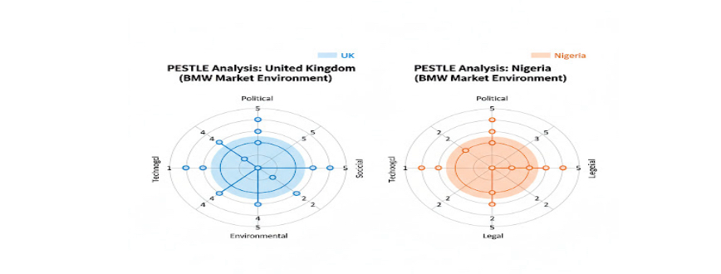
Figure 2: Macro-Environmental Analysis of BMW's UK and Nigerian Markets (Self-Made)
Country | Favourable Factors | Unfavourable Factors
United Kingdom (UK) | • Government electrification incentives support BMW’s EV expansion (electrification kickbacks) | • Brexit may disrupt EU trade, increase costs, cause delivery delays, and add pricing unpredictability (Nerlich, 2023)
Nigeria | • NAIDP supports local manufacturing, reducing dependency on costly imports | • Corruption, political instability, and security threats disrupt supply chains and reduce customer confidence

3.2 Economic Factors
United Kingdom: The UK’s economy is developed, with a high income, even as inflationary pressures and the cost of living rise. While luxury vehicles become more accessible to a middle-class professional through many and advanced personal contract purchase and leasing programs, the PPV of premium manufacturers is influenced, as are factors such as GDP per capita (Mbithi, Muturi and Rambo, 2017).
Nigeria: This Nigerian state is highly dependent on oil prices due to an unstable economy, but encouraging exports, which makes it a favourable market for new oil cylinders. The main problems in this country are long-term inflation, frequent accusations of the Nigerian Naira, the national currency devaluation, and the insufficient low-cost car insurance. The economy of scarcity excludes the sales of new BMWs from this country, making them send their used products instead. The wealthy and powerful buyers who are immune to economic downturns are the target audience for BMW (Abut et al., 2017).
3.3 Social Factors
United Kingdom: Car buyers in the United Kingdom place a high value on engineering, safety, and the heritage of the brand. Increasing social awareness of the importance of environmental sustainability drives demand for electric vehicles and low-emission vehicles. It is commonly believed that car ownership is synonymous with independence and success; however, major cities are increasingly adopting car-sharing and subscription services (Agbo, 2020).
Nigeria: The possession of a car is considered a status symbol in Nigeria. In the eyes of the wealthy, BMWs are a symbol of wealth and status. A social culture defined by aspiration. Environmental problems such as emissions are not as significant or urgent as they are in the United Kingdom. There is a high value placed on the prestige of the brand, the size of the vehicle (especially SUVs for safety and status), and the tough road durability (Albert et al., 2022).
3.4 Technological Factors
United Kingdom: The United Kingdom is experiencing rapid expansion of electric vehicle charging stations, high-speed internet, and widespread adoption of digital platforms. The connected drive, OTG updates, and advanced digital marketing are all options that BMW can utilise (Campling et al., 2019).
Nigeria: Nigeria has a deficient technological infrastructure. Electric vehicles are not widely adopted because there is a lack of power and a limited network of charging stations for electric vehicles. Urban areas have a high internet penetration rate, which makes digital marketing possible; however, network limitations may restrict the connected services that BMW can provide. In harsh urban environments, consumers place a high value on technology that provides comfort and security (Carlier, 2024).

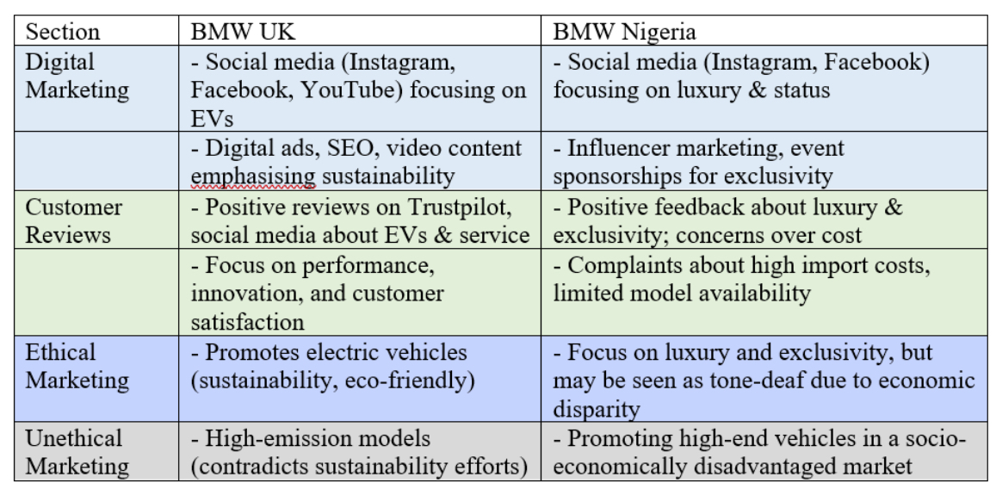

Figure 2: Comparison of BMW's Promotional Strategies and Customer Feedback: UK vs Nigeria (Self-Made)
3.5 Legal Factors
United Kingdom: In the United Kingdom, there are stringent regulations about consumer protection, emissions (EU), and vehicle safety (Euro NCAP). By 2035, BMW is required by law to achieve zero emissions (Carlier, 2024).
Nigeria: Laws in Nigeria are enforced in a variety of ways. Less stringent standards and regulations regarding vehicle emissions than in Europe. Fake components pose a risk to intellectual property. Practising business law can be a challenging and time-consuming endeavour (Chamberlain and Al-Majeed, 2021).
3.6 Environmental Factors
United Kingdom: The United Kingdom's government and consumer policy are affected by environmentalism. The hybrid and electric models produced by BMW are encouraged in London's low-emission zones.
Nigeria: Factors related to the physical environment predominate in Nigeria. Because many regions have poor roads, it is desirable to have high ground clearance and suspension. At this time, there is no evidence that Lagos's air pollution has prompted either regulatory or consumer demand for cleaner vehicles (Chamberlain and Al-Majeed, 2021).

Environmental Similarities and Differences – BMW in the UK vs Nigeria
Environmental Factor | United Kingdom | Nigeria | Similarities / Differences
Climate Change Regulation | Strong environmental laws, strict emissions the standards, and net-zero targets (Gov.uk, 2023). | The environmental policies exist, but they are very weakly enforced; emissions regulation is limited (Adewuyi, 2022). | Difference: the UK has high regulatory pressure; Nigeria, low.
Adoption of Electric Vehicles (EVs) | The rapid EV infrastructure growth, the government incentives, and strong consumer awareness (SMMT, 2023). | There is very slow EV uptake, inadequate charging infrastructure, and the high cost of EVs (Ogunleye, 2023). | Difference: UK EV-ready; Nigeria EV-limited.
Anticipations for Sustainability | There is a significant consumer demand for luxury cars that are environmentally friendly, and CSR standards are high (Mintel, 2023). | Price sensitivity predominates, and consumer demand for sustainability features is lower (Okafor, 2022). | Difference: Sustainability is more important to UK consumers.
Air Quality and Emission Pressures | Major cities enforce Clean Air Zones and emissions penalties (DfT, 2023). | Less enforcement of urban emissions controls; higher pollution in some regions due to industrial activity (NEMA, 2021). | Difference: the UK enforces emissions; Nigeria has limited enforcement.
Infrastructure Dependability | BMW service centres are supported by reliable transport and electricity networks (National Grid, 2023). | EV charging and maintenance are impacted by frequent power outages and deteriorating road infrastructure (IEA, 2022).  A. | Nigeria's infrastructure is weak compared to the UK's.
Risks Associated with Climate Change | The risk of flooding is rising, but it can be reduced with effective national planning (Met Office, 2023). | increased susceptibility to severe heat, erosion, and flooding (World Bank, 2023). | Similarity: Both are at risk from climate change. Difference: Nigeria faces greater risks.
Environmental Taxes and Penalties | stringent rules governing waste management and high carbon taxes (HMT, 2021); | environmental taxes and inadequate waste management systems (Nwosu, 2022). | UK-high disparity. The UK's adherence to environmental regulations matters.
(Self-made table).

BMW's Market Position and Challenges: Favourable or Unfavourable
United Kingdom | Nigeria
Favourable or | Unfavourable
Strong demand for premium cars; accessible financing (PCP & leasing); large dealer network; strong EV/hybrid adoption; trusted brand reputation. | High import costs; limited local production; infrastructure challenges (e.g., EV charging); affordability issues; BMW is mostly accessible only to the wealthy.
(Self-made table)
4. A Comparison of the STP Strategies Employed by Brands in the United Kingdom and Nigeria
Brands are able to name valuable customer groups, concentrate their efforts, and differentiate themselves from the competition with the assistance of the Segmentation, Targeting, and Positioning (STP) framework. The STP allows BMW to strike a balance between global brand coherence and local adaptation. Maintaining its premium automotive identity while reflecting the economic, social, and cultural realities of the United Kingdom and Nigeria, BMW's positioning, market segmentation, and audience selection are all ways in which the company positions itself. The following are in-depth comparisons of these various strategies (Chiromawa, Cross and Daniel, 2020).

STP Element | United Kingdom | Nigeria
SEGMENTATION
Demographic | Professionals,  company users, families | Ultra-wealthy executives, officials
Psychographic | Performance lovers, eco-conscious  VALS Primary Motivation (self made table) | Status seekers, success demonstrators
   | Description | Favourable / Unfavourable | Explanation
    VALS Primary Motivation
  Ideals | Consumers guided by knowledge, beliefs, and principles. | Favourable | These consumers make thoughtful, value-driven decisions and remain loyal to brands that align with their principles.
  Achievement | Consumers motivated by success, status, and recognition. | Favourable | Highly responsive to brands that signal prestige, quality, and social approval, strong spenders in premium markets.
  Self-Expression | Consumers seeking activity, variety, risk, and individuality. | Favourable | Open to new experiences, trends, and expressive products; engage more with innovative and bold brands.
Geographic | Nationwide urban/suburban | Major cities (Lagos, Abuja)
TARGETING
Strategy | Multiple segments | Elite niche only
Primary | Corporate, professionals, tech users | Billionaires, tycoons, elite
POSITIONING
Core Message | "Ultimate Driving Machine" | "Symbol of Success"
Value | Performance, technology | Prestige, status, power
Focus | Driving experience, innovation | Brand image, exclusivity
Table 2: BMW STP Strategy: UK vs Nigeria (Self-Made)

4.1 Segmentation and Targeting
SEGMENTATION — UNITED KINGDOM (UK)

Demographic/Socioeconomic Segmentation: Wealthy professionals, executives, and business owners aged 30+ (Smith & Surabaya, 2020). Behavioural Segmentation: Company-car users are extremely sensitive to Benefit-in-Kind (BIK) tax incentives for low-emission vehicles (Smith & Surabaya, 2020). Psychographic Segmentation: Consumers who value engineering quality, performance, aesthetics, and brand heritage—seeking “Sheer Driving Pleasure” (Smith & Surabaya, 2020). Environmental Segmentation: Eco-conscious luxury buyers who want sustainable but high-performance vehicles (Smith & Surabaya, 2020). Geographic/Psychographic Segmentation: Urban professionals who prefer compact premium models like the 1 Series for city driving (Smith & Surabaya, 2020).

SEGMENTATION — NIGERIA
Demographic/Socioeconomic Segmentation: Ultra-high-net-worth individuals (UHNWIs), senior executives, government officials, and business leaders (Swartz & Isco I Co, 2000). Psychographic Segmentation: Consumers driven primarily by prestige, luxury symbolism, and social recognition (Swartz & Isco I Co, 2000). Behavioural Segmentation: Buyers prioritising exclusivity, powerful engines, and visible luxury attributes (Swartz & Isco I Co, 2000). Cultural Segmentation: Individuals who associate luxury vehicles with accomplishment, respect, and elevated social status (Swartz & Isco I Co, 2000).

TARGET MARKET — UNITED KINGDOM (UK)
Affluent professionals and business leaders are seeking high-performance premium vehicles (Smith & Surabaya, 2020). BIK tax savings and low-emission BMW models (Smith & Surabaya, 2020) motivate company-car drivers. Eco-conscious luxury buyers who want sustainable performance vehicles (Smith & Surabaya, 2020). Urban professionals need compact, premium vehicles for city mobility (Smith & Surabaya, 2020).

TARGET MARKET — NIGERIA
UHNWIs and elite buyers capable of buying new luxury vehicles (Swartz & Isco I Co, 2000). Senior corporate executives and government officials are seeking high-status cars (Swartz & Isco I Co, 2000). Prestige-driven customers prioritising brand image, exclusivity, and social recognition (Swartz & Isco I Co, 2000). Consumers value powerful, luxury vehicles as symbols of success and societal influence (Swartz & Isco I Co, 2000).

Segmentation and Targeting Strategies for BMW in the UK and Nigeria
Undifferentiated, differentiated, and concentrated table

 | UK | Nigeria
  Targeting Strategy
Undifferentiated | Unused – market excessively intricate | Not utilised – market is insufficiently sized
Differentiated | Multiple lifestyle, income, and psychographic segments include the primary strategy (SMMT, 2023). | restricted distinction solely among the elite (Ogunleye, 2023).
Concentrated | primarily used in the EV market (Hardman et al., 2018). | Targeting affluent, elite consumers is the main strategy (Adewuyi, 2022).
(Self-made table)

4.2 Positioning
Positioning is the process of designing the overall image and offering of the company so that it is appealing to the target market.
United Kingdom: BMW's global positioning of "The Ultimate Driving Machine" and "Sheer Driving Pleasure" in the United Kingdom places an emphasis on superior engineering, sporty performance, technological leadership, and a dynamic driving experience. The target audience consists of discriminating drivers who place a high value on luxury, innovation, and driving excitement. BMW is a proponent of "sustainable mobility," and it markets its i Series and plug-in hybrid car models as environmentally friendly premium performance vehicles. Communication in general
is a key factor in the accomplishment of goals by successful modern professionals. The positioning shifts subtly but critically using global brand equity of quality and prestige (Muniroh, 2023).
Nigeria: This is something that is happening in Nigeria. Power, success, and exclusivity are emphasised more than "Sheer Driving Pleasure" in this positioning. Driving is no longer the symbol of "arrival" and social dominance; rather, the vehicle has taken its place. Within the realm of automotive marketing, the X7 and 7 Series are highlighted for their unparalleled luxury, comfort, technological sophistication, and, most importantly, their stature. The elite consumers of Nigeria are given the assurance that they are buying a totem of achievement that is recognised all over the world (Casciano, 2022); a statement that is both visible and respected of their success. Automobiles are armoured status symbols that traverse the physical and social landscapes of the country. A mature, multi-segment premium market is the target of BMW's comprehensive STP strategy in the United Kingdom, which places an emphasis on performance and innovation. Within the context of this niche Nigerian strategy, the elite's thoughts are dominated by status and exclusivity. According to the findings of this comparative analysis, a global brand must modify its marketing strategy in order to accommodate the vastly different realities of its consumers (Wang, Sung and Phau, 2021).

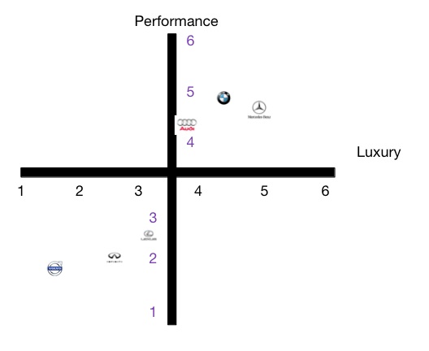

Images from https://bmvsmb.wordpress.com accessed date 03/12/2025

STP Similarities BMW in Nigeria and Uk

BMW employs a uniform segmentation, targeting, and positioning (STP) strategy in both the UK and Nigeria. BMW targets high-income professionals and business elites through segmentation based on demographic and psychographic variables associated with status, performance, and technological sophistication. These superior attributes surpass national borders, easing analogous segmentation in both developed and emerging markets (Kotler & Keller, 2016).

BMW employs a differentiated targeting strategy, providing models such as the 3 Series, 5 Series, and X Series to cater to specific premium sub-segments, with demand primarily concentrated in major urban centres like London and Lagos (Verbeke & Kano, 2016).

BMW upholds a uniform global image that highlights German engineering superiority, innovation, and driving enjoyment, thereby enhancing brand consistency and competitive edge worldwide (Verbeke & Kano, 2016).

5. Comparison of Marketing Mix Strategies in the UK and Nigeria
The proposed comparison of the Marketing Mix of the United Kingdom and Nigerian firms applies the so-called 7Ps of the Marketing Mix to enable the plan to move and reposition its brand in the marketplace. As concerns BMW, the primary brand culture and values are as close or separated. However, the interpretation of certain ideas is dramatically elastic. Specifically, the following seven core values will be examined in execution: Product, Price, Place, Promotion, People, Process, and Physical Evidence. These elements shall be analysed in a mixed pattern, concerning both target countries simultaneously (Mohammad, 2015).

Pictures of the 7ps
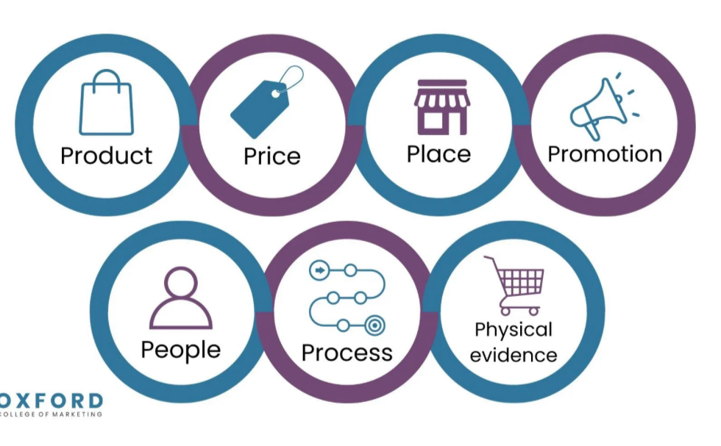
Image from the link https://blog.oxfordcollegeofmarketing.com/2020/10/08/understanding-the-7ps-of-the-marketing-mix/

5.1 Product
The Products are goods and services, both tangible and intangible, designed for the target market. The product strategy of BMW is a contrast between handpicked, status-driven products and full-line, innovation-driven products (Sushmith, 2024).
United Kingdom: In the United Kingdom, BMW caters to a sophisticated and multi-segmented market with a diverse selection of products. The line of vehicles is opulent, ranging from the 1 Series and 2 Series Gran Coupé, which are designed for younger professionals and families with fewer children, to the 7 Series saloon and the X7 SUV. In the UK product strategy, there is emphasis on customisation. Customers are allowed to customise their ability to pick from the track lines, which include Sport, Luxury, and M Sport, and a longer list of accessories that includes innovative driver aid technologies, premium audio, and interior finishes. Electrification is the first step. Environmental consciousness, government incentives, and shifting consumer preferences create a unique opportunity to market electric vehicles such as the i4 and iX and plug-in hybrid electric vehicles such as the 330e and X5 xDrive45e. There are three selling points for this product: safety, innovative technology, and "Sheer Driving Pleasure."
Nigeria: Not breadth, but careful selection is what constitutes product strategy in Nigeria. The portfolio has been simplified, with an emphasis placed on status-driven and community-oriented businesses. On the road, large SUVs such as the X5, X6, and flagship X7 stand out due to their presence on the road, their safety, and their capacity to manage challenging roads. These luxury saloons, such as the 5 Series and the 7 Series, are also popular (Williams and Blyth, 2023). The M3, M5, and X5 M models from the BMW M division are featured because of their exceptionally high performance and unique characteristics. Problems with the infrastructure make it difficult to commercialise electric vehicles. It is usual for consumers in Nigeria to have strong air conditioning, updated suspension for poor road surfaces, and factory-fitted ballistic protection. These features are designed to safeguard security-conscious consumers.

Product pictures of BMW in both countries
United Kingdom
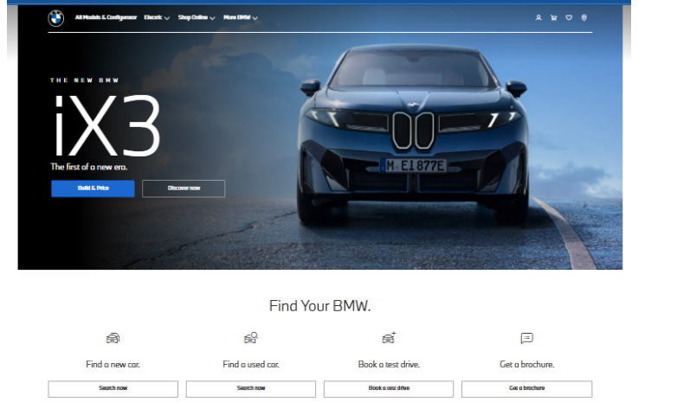

And Nigeria

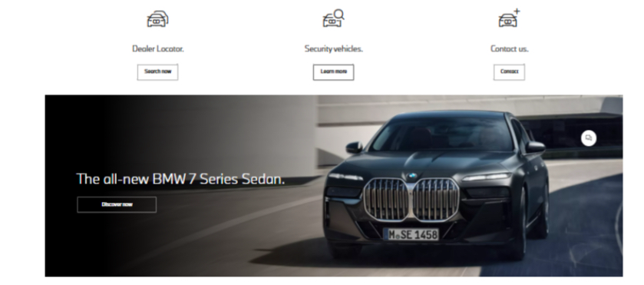

5.2 Price
Pricing conveys information about the audience and the positioning of the brand. BMW utilises smart value pricing in the United Kingdom and premium skimming in Nigeria.
United Kingdom: The premium pricing that BMW charges in the United Kingdom is purposefully set to compete with Mercedes-Benz and Audi in the extremely competitive market that exists in the United Kingdom. Because of the reasonable financing choices and the sticker price, it is an accessible option. To make ownership of a BMW more accessible to the professional middle class, personal contract purchase (PCP) and lease arrangements have been implemented to lower the financial hurdles and monthly costs associated with automobile ownership (Haines-Doran, 2023). It is possible to claim sales volume using tactical marketing, contributions from the manufacturer, and low-interest financing agreements.
Nigeria: In Nigeria, premium skimming is a customary practice. As a result of import duties, value-added taxes, and lower economies of scale, retail markets in the United States charge higher prices for identical models than they do in Europe. Price increases are not only an expense; rather, they are intended to increase the product's significance and increase its level of exclusivity (Kotler and Keller, 2016; Nerlich, 2023). Through private banks, wealthy individuals have access to financing for automobiles. The high price is seen as a sign of exclusivity and a barrier to entrance by the brand's clients, who have an extremely high net worth.

5.3 Place: The distribution (location) of Product delivery is decided by the place, often known as the distribution route. The BMW network is both extensive and limited in scope. United Kingdom: Distribution in the United Kingdom is managed by a network of company-owned and franchised dealerships that includes a dense, sophisticated, and strategically located network. Accessibility is maximised by contemporary "BMW Retail Outlets," which are in city centres, retail parks, and significant towns across the country. A better experience for the customer is achieved through the integration of sales, service, and parts. Consumers are able to conduct research and personalise their vehicle from the comfort of their own homes thanks to the forefront online configurator and virtual showrooms. They are also completely integrated with the retail network for test drives and purchases (Nwangwu, Obeta and Chike Osegbue, 2020).
Nigeria: The distribution model prevalent in Nigeria is one that is exclusive and concentrated. Coscharis Motors is one of the few licensed dealers in Nigeria that has flagship showrooms in the upmarket neighbourhoods of Lagos and Abuja. Service that is more customised and discreet is provided to VIPs. There is a significant amount of both new and used BMWs that are brought into the Nigerian market. In the grey market, BMW is confronted with challenges including brand management, customer experience, after-sales support, and warranty claims of various kinds (Roberts and Cullinane, 2022).

The model of distribution channel used by bmw is very simple

(Self made)
Manufacturer
Dealers

Customers

Market Entry Strategy for BMW in the UK and Nigeria
Market entry strategies for BMW UK
1. Expansion of Electric Vehicle (EV) Portfolio: BMW should augment its electric vehicle offerings in the UK by expanding the "Neue Klaus" electric models, supported by an increasingly sophisticated EV charging infrastructure (McKinsey, 2023).
2. Digital Retail and E-commerce Platforms: Investing in online configuration tools, virtual showrooms, and digital sales processes will meet the sophisticated digital consumer expectations in the UK (Accenture, 2023).
3. Flexible Ownership Frameworks: To conform to UK consumer trends, BMW should offer subscription-based ownership and short-term leasing alternatives (PwC, 2022).
4. Improve After-Sales and Electric Vehicle Maintenance Services: Premium service centres and EV-certified workshops will elevate the brand's reputation and customer satisfaction (SMMT, 2023).

WHY These Strategies Fit the UK
1. Robust demand for premium and electric vehicles—The UK luxury automobile sector is expanding, characterised by heightened interest in German engineering and high-specification vehicles (SMMT, 2023).
2. Government support for electric vehicle mobility—UK policies promote decarbonisation and the adoption of electric vehicles, in alignment with BMW’s global electric vehicle portfolio (Department for Transport, 2023).
3. Elevated purchasing power – UK consumers own substantial disposable income and prioritise premium brands (Statistic, 2024).
4. The UK automotive sector is characterised by stability and competitiveness, fostering innovation (McKinsey, 2023).

BMW Market Entry Strategy for BMW Nigeria
Local Assembly through CKD Partnerships BMW should collaborate with well-known Nigerian automotive firms to assemble vehicles locally, thereby reducing import duty costs (Federal Ministry of Industry, 2022).
2. Concentration on Premium SUVs: BMW ought to prioritise premium SUVs like the X5, X6, and X7, which align with local road infrastructure and consumer preferences (PwC Nigeria, 2023).
3. Present Financing and Leasing Solutions; Local consumers rely significantly on financing; collaborations with banks and fintechs can enhance affordability (KPMG, 2022).
4. Establish a Robust After-Sales and Parts Network: Investing in accredited service centres, authentic parts procurement, and technician education enhances brand credibility (Deloitte, 2022).
5. Prestige-Oriented Marketing: Nigerian consumers perceive luxury vehicles as status symbols, making aspirational branding imperative (Deloitte, 2022).
Why these strategic fits Nigeria for BMW
Nigeria's automotive sector is evolving, expanding, and propelled by status-driven luxury consumers.
1. Increasing demand for luxury vehicles – Nigeria owns one of the fastest-growing premium automobile markets in Africa (KPMG, 2022).
2. High-net-worth demographic – Nigeria owns a robust affluent class that favours luxury brands such as BMW, Lexus, and Mercedes (Deloitte, 2022).
3. The demand for luxury SUVs is heightened due to challenging road conditions and lifestyle preferences (PwC Nigeria, 2023).
4. Unexploited potential for electric vehicles – Although in its nascent stages, Nigeria's long-term mobility trajectory is congruent with sustainable technology (UNECA, 2023).

Models, Rationale, Advantages and Disadvantages:
United Kingdom – Foreign Direct Investment (FDI): Manufacturing & Sales Subsidiaries
Advantages
Ensures strong brand consistency and strategic control over operations and marketing (Carlier, 2024). • Enhances supply chain efficiency through local production and integrated distribution. • Receives help from a stable, mature automotive market with predictable demand.
Disadvantages
• Requires high capital investment, increasing financial risk (Carlier, 2024). • Exposes BMW to regulatory and trade disruptions, particularly post-Brexit uncertainty (Ngara, 2021). • Higher operational and compliance costs compared to indirect entry modes.

Nigeria – Authorised Importers (Indirect Market Entry)
Advantages
• Lower financial risk and reduced capital exposure in a volatile economic environment (Nwangwu, Obeta and Ojukwu, 2023). • Allows market presence without heavy investment in local manufacturing infrastructure. • Flexibility to exit or restructure operations more easily if conditions worsen.
Disadvantages
• Limited control over customer experience, pricing, and after-sales service quality (Roberts and Cullinane, 2022). • Increased vulnerability to grey imports and parallel markets, which weakens brand positioning. • Weaker long-term brand loyalty due to inconsistent service standards.

5.4 Promotion
Consumers are informed, persuaded, and reminded about companies and products through promotions. However, BMW's promotions in Nigeria are relationship-driven, while those in the United Kingdom are mass-market.
United Kingdom: UK promotion that is multi-channel, expensive, and brand focused. Included are a wide variety of activities: There are many forms of mass media advertising, including luxury broadsheets and lifestyle magazines, as well as premier television and film. Digital marketing includes advanced search engine optimisation (SEO), targeted display advertising, captivating content for social media platforms (such as YouTube, Instagram, and Facebook), and email marketing. Public relations and sponsorship: The sponsorship of high-profile events that align with the brand, such as the PGA Championship and the Good-wood Festival of Speed. Make it possible for customers to experience the concept of the "Ultimate Driving Machine" by holding test drives across the country, track days at racing circuits, and immersive brand experience centres (Nwangwu, Obeta and Ojukwu, 2023).
Nigeria: Nigeria is a relationship-driven and niche-oriented market for promotion. Methods are aimed at a particular group by: Events and sponsorships that are well-known: Participating in high-society weddings, product launches, art exhibitions, and other premium social events that attract the demographic that is being targeted might be beneficial. Engaging in brand ambassadorship and influencer work with Nollywood actors, singers, business moguls, and socialites with the purpose of promoting their respective networks. Putting money into Instagram, which is popular among the wealthy young and elite. Promotion in affluent leisure and business journals. The Elite of CRM and Direct Marketing make use of customer relationship management to extend invitations to wealthy customers to take part in test drives or model previews (Wang, Sung and Phau, 2021).
5.5 People
In the "People" factor, all human actors who have an impact on the service and the impression that a consumer gets are included.
United Kingdom: The skills of these people vary greatly depending on the market. Employees in the United Kingdom receive training to become product specialists. The brand places a high priority on information, technology, and excellent customer service. When it comes to building brand loyalty and recurring business, transaction processing, consultative selling, client needs research, and long-term cooperation are all effective strategies. iDrive and driving dynamics are two examples of the complicated technology that they describe.
Nigeria: In Nigeria, where the importance of human ties is highly regarded, "people" are more important. Salespeople should be selected and trained to handle customers who are unique, discriminating, and demanding. Their service is individualised and similar to that of a concierge. In order to sell in this premium market, they need to understand the need for bespoke products, as well as prestige and confidentiality (Chamberlain and Al-Majeed, 2021).

Number of employees for BMW in the United Kingdom and Nigeria
United Kingdom: BMW Group employs around 8,000 people across manufacturing, sales, and support operations, with added employment through its UK BMW and MINI dealerships, reflecting a strong corporate presence (Careermap, 2023).
Nigeria: BMW has no major corporate subsidiary or manufacturing facility. Operations are conducted via approximately 21 authorised dealerships, each staffed by local employees, though official total workforce figures are not published (PoiData, 2023).
5.6 Process
Process Service delivery methods and flow are discussed in this section. The customer trips in the United Kingdom are efficient, while the ones in Nigeria are personalised.
United Kingdom: Using digital technologies, the process is streamlined, standardised, and supported. Each touchpoint is designed with the intention of achieving ease, efficiency, and customer happiness. This includes the online booking of service appointments and test drives, as well as the straightforward online application process for loans. To meet the market's expectations for professional and hassle-free service, the procedure is dependable, smooth, and predictable (Nanta et al., 2025).
Nigeria: Nigeria is a technique that is flexible and adaptable. Most of the time, one-on-one interactions, negotiations over pricing and terms, and special requests are made. A few instances of this would be offering advanced importing, one-of-a-kind customisations, and after-sales service that is unparalleled. It is possible to adapt each stage to provide premium consumers with a sense of being pampered and cherished (Wang, Sung and Phau, 2021).

Customer Complaints Process for BMW: UK vs Nigeria
United Kingdom:
Phone Support: Dedicated customer service line for inquiries and complaints.
Email Support: Contact via BMW UK’s official email for help.
Live Chat: Available on BMW UK’s website for real-time support.
Nigeria:
Phone Support: Provided through authorised dealers like Cochairs Motors.
Email Support: Managed via BMW Nigeria’s official email or dealership.
Social media: Feedback and complaints via Instagram or Facebook.
5.7 Physical Evidence
The space in which services are provided, the contact between the company and its clients, and any performance or communication aids are examples of physical evidence.
United Kingdom: Physical evidence is subject to stringent regulations and norms in the United Kingdom. BMW dealerships typically have architecture that is sophisticated, contemporary, and minimalistic. Additionally, they typically have service bays that are clean and well-organised, uniformed employees, high-quality marketing brochures, and luxury loaner cars for servicing. With each detail, the brand proves its commitment to innovation, quality, and German engineering (Haines-Doran, 2023).
Nigeria: Premium physical evidence that satisfies local conditions is available in Nigeria. Because they are designed to suit the image of the brand, authorised dealerships are in the most prestigious and safe commercial districts. When it comes to physical evidence, the product in its natural environment is often the most compelling in Nigeria. A powerful mobile advertisement would be a brand-new BMW X7 or 7 Series that is driven by a chauffeur throughout Ikoyi or Victoria Island, or that is parked at a five-star hotel or a luxury shopping complex. To confirm accomplishment and aspiration within that social stratum, it is necessary to have organic visibility to the individual being targeted (Roberts and Cullinane, 2022).

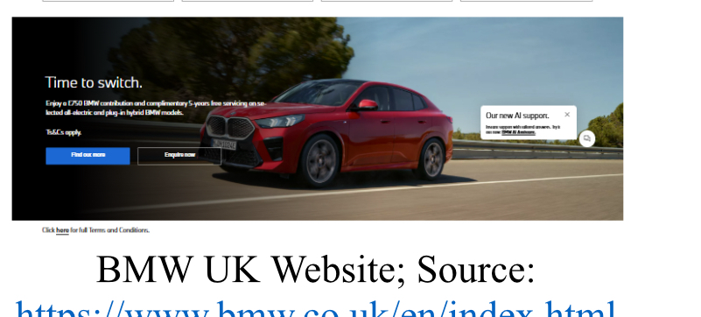
BMW UK Website; Source: https://www.bmw.co.uk/en/index.html
BMW UK Dealership:

BMW UK Website; Source:
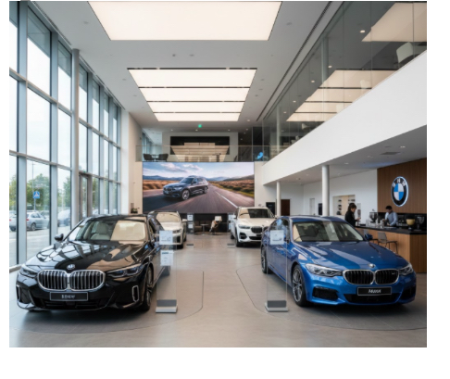
https://www.bmw.co.uk/en/index.html BMW UK Dealership
6.2 Nigeria
There are a variety of criteria that are needed to evaluate the performance of Nigeria.

BMW Nigeria Website; Source: https://www.bmw-nigeria.com/en/index.html
BMW Nigeria Dealership:
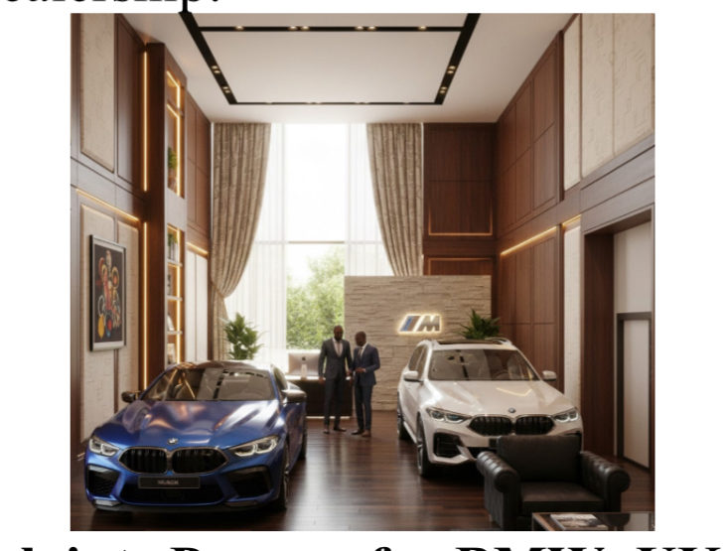
Customer Complain

5.8 Similarities of the 7 Ps:
Irrespective of the variations in market maturity and consumer purchase power, BMW has several significant similarities in the 7P of its marketing mix in both the United Kingdom and Nigeria. In both scenarios,
the Product strategy is based on high-end engineering, modernised technology and luxury design that contributes to the world-renowned brand of the company, oriented on performance and innovations (Swartz and Iacobucci, 2000; Sushmith, 2024).
The Price strategy is known to enforce exclusivity. Although the pricing systems vary across countries because of taxes and the economic environment, BMW uses a premium-pricing model in all markets to keep its luxurious status (Kotler and Keller, 2016).
As far as Promotion is concerned, BMW still has coherent global brand messages, such as Sheer Driving Pleasure, but it decides to localise the channels and communicate using digital channels, sponsorships, and experiences (Wang, Sung and Phau, 2021).
The People aspect will still be based on high-quality customer interactions with trained specialists who can guide wealthy and discriminating buyers (Chamberlain and Al-Majeed, 2021). In the same way,
Process is designed to offer a smooth high-end experience to both markets, which could be digitally driven in developed economies or be relationship-based in developing ones (Nanta et al., 2025). There is also consistency in
Physical Evidence: no matter where BMWs are found, the brand experience in both showrooms and service centres is incredibly high-end and modern (Haines-Doran, 2023).

Evaluation of the Performance of Marketing Strategies
United Kingdom
Most BMW's marketing efforts in the United Kingdom are successful. The brand competes with Mercedes-Benz to become the most popular premium car brand in the country in terms of sales. The 3 Series, the 5 Series, and the X3 SUV are all seeing increased sales, and the company's plug-in hybrid and electric vehicles are also seeing growth (BMW, 2025). Through years of marketing, a brand's awareness and reputation have been built up, which has resulted in customers who are loyal to the brand. That BMW's electric "i" sub-brand has been so successful is a good sign for the future. With over 150 retail facilities, BMW is able to dominate the luxury car market in the United Kingdom.

6.1 United Kingdom
Many of BMW's marketing efforts in the United Kingdom are successful. The brand competes with Mercedes-Benz to become the most popular premium car brand in the country in terms of sales. The 3 Series, the 5 Series, and the X3 SUV are all seeing increased sales, and the company's plug-in hybrid and electric vehicles are also seeing growth (BMW, 2025). Through years of marketing, a brand's awareness and reputation have been built up, which has resulted in customers who are loyal to the brand. That BMW's electric "i" sub-brand has been so successful is a good sign for the future. With over 150 retail facilities, BMW is able to dominate the luxury car market in the United Kingdom.
There are a variety of criteria that are needed to evaluate the performance of Nigeria. Due to the size of the market, BMW only sells a small part of its total volume in the United Kingdom. The success of an elite market is dependent on the strength and belief of the brand. Here, BMW is a leader. It continues to be a leading premium automobile manufacturer. It is not mass-market share but rather wealthy mindshare that is indicative of performance. New BMW saloons and SUVs have been seen in Ikoyi and Victoria Island, Lagos, which is evidence of the brand's success in a certain market segment. Although new automobile sales are diluted as a result of unofficial competition from the vast used import market, brand awareness is increased, nonetheless. It ensures that the brand's distinctiveness and status are maintained, which is essential in the rapidly increasing market in Nigeria.

. BMW's Marketing Strategy in the United Kingdom and Nigeria
BMW's marketing strategy in the UK focuses on digital innovation, sustainability, and premium performance, emphasising the promotion of electric vehicles via online platforms and data-driven marketing (Accenture, 2023; McKinsey, 2023). Intense competition in the premium EV segment constrains significant differentiation and growth (PwC, 2022).
BMW employs a prestigious, aspirational strategy in Nigeria, emphasising luxury SUVs and elite branding to appeal to affluent clientele (Deloitte, 2022; PwC Nigeria, 2023). Notwithstanding robust brand allure, elevated expenses, constrained funding, and inadequate post-purchase help hinder enduring customer allegiance (KPMG, 2022).
BMW excels in innovation in the UK and brand prestige in Nigeria yet encounters structural and affordability challenges in both markets.
Profit and sales UK and Nigeria

7. Evaluation of Marketing Ethics Practice
When it comes to marketing, the multinational corporation BMW emphasises authenticity and claims support. However, its operations may be unethical.
United Kingdom: Communication about the environment that is ethical. It is great that electric cars are being marketed, but in this climate-conscious era, high-performance, high-emission M series models or large SUVs can be considered problematic. Steer clear of "greenwashing." The narrative of "sustainable luxury" needs to be promoted throughout the whole value chain of the corporate entity. As a result of its connected drive data privacy, ethical management is required (Nanta et al., 2025).
Implications of Hoisted following Social Factors:
When connected to social factors, the model by Hoisted helps to explain the major differences in behaviours. Preference towards sustainability, engineering excellence, and innovative driving technologies is also strengthened in the UK through individualism and long-term orientation, aiding the business of EV and PHEV by BMW (Smith and Sarabi, 2020). Low power distance is congruent with organised financing and open-ended retail experiences. High power distance and masculinity in Nigeria also contribute to the popularity of BMW as a symbol of visible success, and thus, SUVs and luxury sedans are extremely desirable (Casciano, 2022). Collectivist factors are empowering relationship-oriented marketing and short-term orientation, and weak infrastructure diminishes electrification and long-term mobility planning readiness (Agbo, 2020).

Strategies for Market Entry and Expansion in Nigeria
1. Local Assembly (CKD) via Collaborations: Partnering with established Nigerian automotive firms, such as Cochairs Motors, to locally assemble models will diminish import duties and enhance affordability (Federal Ministry of Industry, 2022).
2. Concentrate on Premium SUVs and Luxury Variants: BMW ought to prioritise its X-series (X5, X6, and X7), which corresponds with the preferences of Nigerian consumers for robust and high-end SUVs (PwC Nigeria, 2023).
3. Adaptable Financial and Leasing Agreements: Collaborating with local banks and fintech companies to offer instalment plans will enhance the accessibility of luxury vehicles (KPMG, 2022).
4. Enhancing After-Sales Support and Authentic Parts Accessibility: Providing BMW-certified workshops in Lagos, Abuja, and Port Harcourt bolsters customer confidence and brand loyalty (Deloitte, 2022).
5. Premium Branding and Localised Marketing: BMW ought to implement aspirational marketing strategies that resonate with Nigerian consumers' aspirations for prestige and exclusivity (Deloitte, 2022).
Create a Program for Ownership That Is Extremely Exclusive: The provision of a "BMW Platinum" or analogous concierge service with a dedicated relationship manager, first access to new models, exclusive event invitations, and global service help to ultra-high-net-worth individuals (UHNWIs) is an effective strategy for gaining loyalty and providing an explanation for the high price.
Ethical and unethical marketing of BMW United Kingdom and Nigeria

In the United Kingdom, BMW's marketing is primarily ethical, conforming to rigorous advertising regulations and sustainability standards. The company promotes electric mobility, diminished emissions, and clear vehicle performance metrics, thus supporting ethical branding and corporate social responsibility (BMW Group, 2023; ASA, 2022). However, prior global scandals related to diesel emissions have raised ethical concerns about environmental claims (Ewing, 2017).
In Nigeria, BMW owns a distinguished brand reputation but faces ethical challenges due to insufficient regulatory enforcement. Concerns include the importation and promotion of used luxury vehicles, inadequate transparency about emissions data, and limited consumer protection (FRSC, 2022; PwC, 2021). While official dealerships work ethically, unethical practices primarily appear from unregulated third-party vendors. Unethical Marketing – BMW (United Kingdom)
Example of Ethical and unethical marketing of BMW United Kingdom
Example of ethical marketing in the United Kingdom
BMW advocates for sustainability via its electric vehicle (EV) range, emphasising diminished tailpipe emissions and commitment to electrification. Accurately presented campaigns promote environmentally responsible behaviour and adhere to advertising standards, exemplifying ethical marketing practices (Rosamond, 2024).
Example of Unethical or Misleading Marketing
In 2024, the Advertising Standards Authority (ASA) prohibited BMW UK from asserting “Zero Emissions Cars” in online advertisements without specifying that emissions from production or electricity generation were not included. The ASA considered this misleading and mandated BMW to amend future communications, highlighting unethical exaggeration in environmental marketing (Advertising Standards Authority, 2024).
8. Recommendations
8.1 Recommendations for Future International Marketing Strategies
United Kingdom: Market and develop electric vehicles to speed up the transition to electric vehicles. One way to alleviate range anxiety is to set up public charging agreements and educate people about the benefits of electric vehicles.
Improve the Digital Customer Journey by utilising augmented reality for the setup of automobiles and virtual reality test drives to make it easier for customers to make purchases that involve technology.
Create Micro-Mobility Solutions: To attract customers who place a higher value on access than ownership, you could promote car-sharing subscriptions in large cities, such as BMW's "Access by BMW (BMW, 2025)."

Recommendations for Future International Marketing Strategies
Nigeria:
The formation of a local assembly In the long run, the strategy is to inform the government of Nigeria about the NAIDP. SKD assembly for popular models such as the X5 might save money, end the need for import fees, and make new BMWs more affordable for buyers with higher incomes.
For competing with parallel imports, the legitimate dealer network should be improved by expanding and upgrading the authorised merchants. In marketing, it is important to highlight the fact that authorised dealers provide a guarantee, authentic parts, certified servicing, and a better residual value.
Create a Program for Ownership That Is Extremely Exclusive: The provision of a "BMW Platinum" or analogous concierge service with a dedicated relationship manager, first access to new models, exclusive event invitations, and global service help to ultra-high-net-worth individuals (UHNWIs) is an effective strategy for gaining loyalty and providing an explanation for the high price.

8.2 Conclusion
In general, BMW is a master of global marketing because it can preserve its brand identity in the United Kingdom and Nigeria by focusing on luxury, performance, and quality. Its success can be attributed to the strategic adaptation it has made to the vastly different macro-environments, consumer behaviours, and competition landscapes of various economies. Through the implementation of a multi-segment strategy that is centred on performance, technology, and sustainability, a dense and sophisticated distribution and promotion network is used in the mature market of the United Kingdom. A niche approach that places an emphasis on status, exclusivity, and product curation through a highly tailored channel is the strategy that is being used to reach the ultra-affluent population of Nigeria.
The investigation shows that there is no single recipe that guarantees success in international marketing. Flexibility is essential for both global and local brands. The fact that BMW can offer "The Ultimate Driving Machine" as an engineering marvel in one location and as the ultimate success in another location proves the company's capacity to market its products on a worldwide scale. Following the proposals will allow BMW to strengthen its leadership position in the United Kingdom and capitalise on the long-term promotion

Reference list
Abutu, F., M, I.A., Abdulkadir, M., Audu, R. and Mohammed, M.Aminu. (2017). THE AUTOMOTIVE INDUSTRY IN NIGERIA: TRENDS, CHALLENGES AND PROSPECTS IN THE 21ST CENTURY. Futminna.edu.ng. [online] Available at: http://repository.futminna.edu.ng:8080/jspui/handle/123456789/3120 [Accessed 11/11/2025
].
Agbo, C.O.A. (2020). Nigeria’s automotive policy and the quest for a viable automotive industry: a lesson for the developing economies. Journal of Science and Technology Policy Management, 11(4), pp.585–603. doi: https://doi.org/10.1108/jstpm-07-2019-0073. Accessed date
11/11/2025

Albert, M.D.A., Bennett, K.O., Adams, C.A. and Gluyas, J.G. (2022). Waste heat mapping: A UK study. Renewable and Sustainable Energy Reviews, 160, pp.112–230. doi: https://doi.org/10.1016/j.rser.2022.112230.
BMW (2025). BMW Group posts third-quarter sales growth. [online] BMW Group PressClub. Available at: https://www.press.bmwgroup.com/global/article/detail/T0453185EN/bmw-group-posts-third-quarter-sales-growth?language=en accessed date: 11/11/2025
.
Campling, L., Harrison, J., Richardson, B., Smith, A. and Barbu, M. (2019). South Korea’s Automotive Labour Regime, Hyundai Motors’ Global Production Network and Trade‐Based Integration with the European Union. British Journal of Industrial Relations, 59(1). doi: https://doi.org/10.1111/bjir.12506. Accessed date 12/11/2025

Carlier, M. (2024). Breakdown of BMW Group’s Worldwide Automobile Sales in FY 2022, by region. [online] Statista. Available at: https://www.statista.com/statistics/267252/key-automobile-markets-of-bmw-group/ [Accessed 12 Nov. 2025].

Casciano, D. (2022). Popular tales of Pastors, Luxury, Frauds and Corruption. Journal of Extreme Anthropology, 5(2), pp.52–71. doi: https://doi.org/10.5617/jea.9008.15/11/2025

Chamberlain, K. and Al-Majeed, S. (2021). Standardisation of UK Electric Vehicle Charging Protocol, Payment and Charge Point Connection. World Electric Vehicle Journal, [online] 12(2), p.63. doi: https://doi.org/10.3390/wevj12020063. Accessed date 15/11/2025

Chiromawa, Y., Cross, O. and Daniel (2020). Impact of Government Policies on the Development of Automotive Industry in Nigeria. [online] 22, p.PP. doi: https://doi.org/10.9790/487X-2206030106. Accessed date 19/11/2025

Focacci, C.N. and Perez, C. (2022). The importance of education and training policies in supporting technological revolutions: A comparative and historical analysis of UK, US, Germany, and Sweden (1830–1970). Technology in Society, [online] 70. doi: https://doi.org/10.1016/j.techsoc.2022.102000. Accessed from 20/11/2025

Haines-Doran, T. (2023). The financialisation of car consumption. New Political Economy, pp.1–19. doi: https://doi.org/10.1080/13563467.2023.2254727.

Kazemi, N., Arsanjani, J.J. and Firozjaei, M.K. (2025). Developing a Multi-Criteria Decision Model to Unlock Sustainable Heritage Tourism Potential. Sustainability, [online] 17(8), pp.3703–3703. doi: https://doi.org/10.3390/su17083703.
Accessed from 5/December 2025.

The Careermap (2023) offers a summary of
of BMW in the UK. Available at: ttps://careermap.co.uk/employers/bmw (Accessed: 15 December 2025).

PoiData (2023) lists BMW dealers in Nigeria. Available at: https://www.poidata.io/report/bmw-dealer/nigeria (Accessed: 15 December 2025).

Kotler, P. and Keller, K.L. (2016). A Framework for Marketing Management. 6th ed. Boston: Pearson.
Mbithi, B., Muturi, W. and Rambo, C. (2017). Macro environment moderating effects on strategy and performance. Macro Environment Moderating Effects on Strategy and Performance, [online] 2(5), pp.197–209. doi: https://doi.org/10.21276/haya.

Mohammad, H.I. (2015). 7PS MARKETING MIX AND RETAIL BANK CUSTOMER SATISFACTION IN NORTHEAST NIGERIA. ResearchGate, 3(3), pp.71–88.
Muniroh, L. (2023). The Influence of Brand Image and Consumer Lifestyle on BMW Car Purchasing Decisions. Journal of International Trade, 2(1), pp.18–24.
Nanta, T.M., Noermijati, N., Rohman, F. and Hussein, A.S. (2025). The Effect of Digital Touchpoint Usage Experience on Customer Loyalty Mediated by Digital Engagement and Customer Satisfaction. Businesses, 5(1), p.3. doi: https://doi.org/10.3390/businesses5010003.
Accessed from 24/11/2025

Nerlich, T. (2023). Exploring Strategies in the Digital Age : the Case of BMW’s Business Ecosystem - ProQuest. [online] Proquest.com. Available at: https://search.proquest.com/openview/3c2cd516cfc8898409f0dea55d18e19b/1?pq-origsite=gscholar&cbl=2026366&diss=y
[Accessed 24/ Nov. 2025].

Ngara, C. (2021). The Need for Effective Implementation of the National Automotive Policy to achieve Industrialisation in Nigeria. Nilds.gov.ng. [online] doi: https://ir.nilds.gov.ng/handle/123456789/413.

Nwangwu, J., Obeta and Chike Osegbue, P. (2020). The State and Industrial Development Policies: A Study of Local Content Policy in Nigeria’s Automotive Sector, 2014-2022. Journal of Political Science and Leadership Research E-ISSN, [online] 11(3). doi: https://doi.org/10.56201/jpslr.vol.11.no3.2025.pg53.65.
Accessed date 24/11/2025

Nwangwu, J., Obeta and Ojukwu, U. (2023). Industrial Development and the Implementation of Local Content Policy in Nigeria’s Automotive Sector. Journal of Political Science and Leadership Research E-ISSN, [online] 11(3). doi: https://doi.org/10.56201/jpslr.vol.11.no3.2025.pg66.78.
Roberts, R. and Cullinane, N. (2022). Skilled maintenance trades under lean manufacturing: Evidence from the car industry. New Technology, Work and Employment. doi: https://doi.org/10.1111/ntwe.12256.
Accessed date 24/11/2025
Smith, M. and Sarabi, Y. (2020). UK trading patterns within and between regions in the automotive sector – a network analysis. The World Economy, 44(2). doi: https://doi.org/10.1111/twec.13006.

Sushmith (2024). BMW’s Luxury Marketing Strategy: Innovation & Branding. [online] Sprintzeal.com. Available at: https://www.sprintzeal.com/blog/bmw-marketing-strategy.
ssions-claims Accessed on 15 December 2025.

Advertising Standards Authority (2024) ASA ruling on BMW UK Ltd – “Zero Emissions Cars” ad. Available at: https://www.asa.org.uk/rulings/bmw–uk–ltd-a23-1209400-bmw–uk–ltd.html (Accessed: 15 December 2025).

Rosamond, C. (2024) BMW and MG electric car adverts banned over ‘zero emissions’ claims, Auto Express, 7 February. Available at: https://www.autoexpress.co.uk/news/362223/bmw-and-mg-electric-car-adverts-banned-over-zero-emissions-claims (Accessed: 15 December 2025).

Swartz, T.A. and Iacobucci, D. (2000). Handbook of services marketing & management. Thousand Oaks, Calif.: Sage.
Talikine, A. (2025). Case study on BMW AG: road to 2030 electrification. Ulisboa.pt. [online] doi: http://hdl.handle.net/10400.5/102710. Accessed date 28/11/2025

Wang, X., Sung, B. and Phau, I. (2021). Examining the influences of perceived exclusivity and perceived rarity on consumers’ perception of luxury. Journal of Fashion Marketing and Management: An International Journal, [online] 26(2), pp.365–382. doi: https://doi.org/10.1108/jfmm-12-2020-0254. Accessed from 04/12/2025
BMW Group (2023) BMW Group Sustainability Report.
Advertising Standards Authority – ASA (2022) UK Advertising Regulations.Ewing, J. (2017) Faster, Higher, farther: The Volkswagen Scandal.Federal Road Safety Corps – FRSC (2022) Nigeria Vehicle Import Report.PwC (2021) Nigeria Automotive Industry Outlook.

Williams, I.D. and Blyth, M. (2023). Autogeddon or autoheaven: Environmental and Social Effects of the Automotive Industry from Launch to Present. Science of The Total Environment, [online] 858(3). doi: https://doi.org/10.1016/j.scitotenv.2022.159987. Accessed from 05/12/2025



