

Marketing Management
(LCMB7024)

Name : BHASHIT P SHAH
Student id : 2426567
Title : Assessment 2
Lecturer name : Dr. Jayalakshmi Gopalkrishnan
Date of Submission : 28/04/2025
Total words : 2448

Contents
Introduction 3
Brand extension 4
STP For New Brand Extension 5
1. Segmentation 5
2. Targeting 7
3. Positioning 7
Customer personal profile 8
Marketing mix strategy 10
1. Product 10
2. Price 11
3. Promotion 12
4. Place 13
Conclusion 14
Reference list 16

Introduction
One of the planet's highest-valued technology businesses, Apple Inc. has established global recognition on account of revolutionary consumer gadgets, software, and services. Apple's growth has been led by business-oriented commodities such as Mac, iPhone, iPad, Apple Watch, and AirPods, and software and services such as iCloud, Apple Music, and Apple TV+. It was founded in 1976. The foundations of Apple's brand are quality, high-end looks, technical innovation, seamless integration into the ecosystem, user interface, and simplicity. Apple has established a customer base willing to pay a premium for products that combine functionality with status aspirations based on its simplicity and "Think Different" philosophy. (Levy and Montevirgen, 2025)
Apple Vision Curved Monitor is a suggested Apple brand extension tested in this study. Apple is positioning itself as a visionary within the professional and creative marketplaces through products like the Mac Studio, Pro Display XDR, and Vision Pro. This curved monitor is a strategic addition to the company's display technology offerings. To effectively introduce and establish this product into Apple's current ecosystem, the study will measure how well this product aligns with Apple's brand values, define target market segments, create a consumer profile, and provide a detailed marketing plan. 

Brand extension
A thoughtful addition to Apple's line of display technology, the Apple Vision Curved Monitor will be one of the company's quickly growing aspirations among high-end productivity experts and creative professionals. Apple's Ultrawide Curved Display brings together the company's cutting-edge visual technology and an immersive design that is not yet available in Ultrawide Curved Display throughout their lineup. Apple's P3 wide color gamut with profound color accuracy and 40-inch 5K curved mini-LED display with ProMotion adaptive refresh up to 240Hz are display standouts.
Apple's intrinsic values of quality without peer, cutting-edge technology, and stunning beauty are all in the spirit of this brand extension. Thin aluminium casing, edge-to-edge glass, and a traditional Apple stand with precise height and tilt adjustment, the screen is a manifestation of Apple's minimalist approach. The Vision Curved Monitor, which operates to the philosophy of Apple's philosophy, provides glitch-free interaction between macOS and iOS devices with spatial audio, Apple Centre Stage camera, and continuity features to provide instant flipping between Mac and iPad input.
Apple Vision Curved Monitor is a significant addition to the Apple product family. While the Pro Display XDR competes with high-end professionals and the base Apple Studio Display addresses the mass market, neither of these offers the immersed curved experience desired by so many creative professionals, developers, and power users. This add-on leverages the rising demand for ultrawide curved screens by software developers, financial professionals, gamers who value screen real estate and immersion, and content specialists. By acquiring this slot in the marketplace with its one-of-a-kind Apple taste, the company has an opportunity to sway high-end customers who might otherwise be patronizing competing vendors like Samsung, LG, or Dell for an existing curved monitor solution, even more establishing Apple within the realm of the professional work environment space.

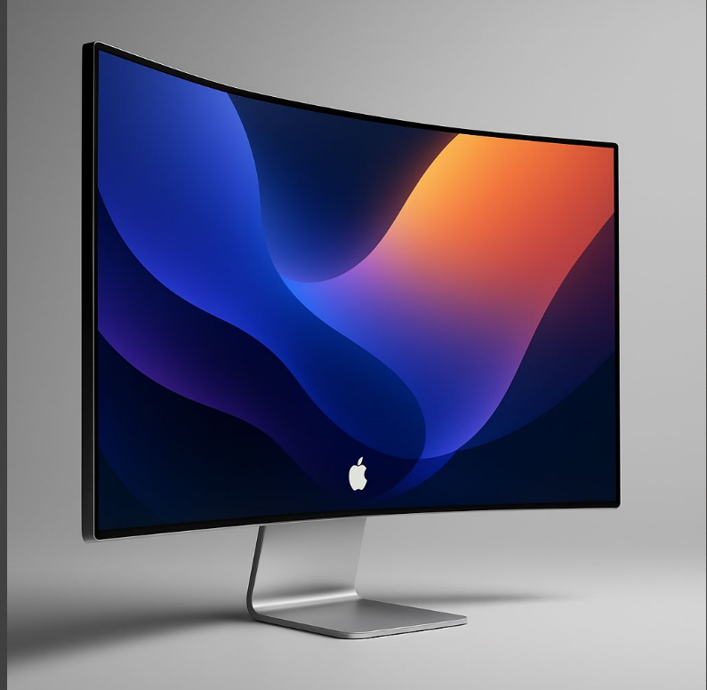

STP For New Brand Extension

Segmentation

Demographic Segmentation:

- Age: 25-55 years old professionals
- Income: Upper middle to high income (£100,000+ annual income)
- Education: Bachelor's degree or higher
- Occupation: Creative professionals, software developers, financial analysts, architects, video editors, and other knowledge workers

Geographic Segmentation:

- Primary: Urban and suburban areas in North America, Western Europe, Australia, and East Asia.
- Secondary: Emerging tech hubs in Southeast Asia, the Middle East, and Latin America.
- Target high-density areas of tech companies, creative agencies, and financial institutions.

Psychographic Segmentation:

- Early adopters and enthusiasts of new technology.
- Design-oriented professionals who value aesthetics.
- Productivity-focused individuals who invest in their workspace optimization.
- Apple loyalists who pay a premium for quality.
- Status-driven professionals for whom technology is both a tool and a statement.

Behavioural Segmentation:

- Apple ecosystem users with multiple devices currently.
- Heavy users of computers (8+ hours a day).
- Professionals who desire workflow efficiency and reduced eye strain.
- Individuals who perform multi-window/multi-application work on a daily basis.
- Individuals with a willingness to invest in long-term productivity tools.

These segmentation criteria are suitable for the Apple Vision Curved Monitor since they align with the premium positioning of Apple's products and aim at users who will derive the utmost utility from an ultrawide curved display. The segments identified are customers who possess both the budget and professional need for such a premium display, so the product is addressing real market needs rather than a show of technological prowess. (Dumitrescu, 2024)

Targeting
Apple Vision Curved Monitor will have a strong emphasis on three segments:
Creative Professionals: They are video editors, graphic designers, photographers, music producers, and digital artists who require color accuracy, screen space, and an appealing visual experience. This group likes the technical features that enhance their creative process.
Software Developers & IT Professionals: They are programmers, UX/UI designers, and system architects who enjoy the added horizontal real estate for code and lots of windows. They prefer reduced eye strain for extended work sessions and enjoy the native integration with dev environments.
Financial & Business Professionals: They are executives, analysts, consultants, and traders who are required to track various streams of information simultaneously. They value improvements in efficiency and business appearance, and the feel of expensive technology.
Apple will be employing a differentiated approach to targeting, creating customized marketing messages to each segment but with brand consistency overall. This strategy recognizes the specific needs and drivers to purchase within each segment while leveraging the cross-over attraction of Apple's design language and ecosystem benefits.
These segments are a priority because they are less price sensitive, higher-value customers with specific professional needs serviced by the product, and they make buying decisions that are likely to affect entire companies. The segments have also demonstrated that they will pay for quality productivity tools and will typically have strong brand loyalty if satisfied. (Cai and Chen, 2024)

Positioning
Positioning Statement: "For creative professionals and productivity-oriented users who demand the best visual environment, the Apple Vision Curved Monitor is the premium curved display that offers unmatched color accuracy, immersive viewing experience, and silky-smooth ecosystem integration, because only Apple combines cutting-edge display technology with the user-friendly software experience that streamlines your creative and professional workflow."
The Apple Vision Curved Monitor will occupy the high-end slot of being a professional premium device, occupying the market niche of curved monitors in the high-end. Unlike others that are vying for the gaming (e.g., Samsung Odyssey series) or office productivity (e.g., Dell UltraSharp lines) niches, Apple's value proposition is based on the intersection point of professional creative needs and excellent design.
The product will differ on the basis of:
- Improved construction and material compared to plastic-centric competitor products.
- Professional-grade colour accuracy and calibration.
- Only Apple ecosystem features are not present on other third-party displays.
- Sleek minimalist design that breaks away from the usual aggressive appearance of gaming-focused curved monitors.

This positioning aligns with Apple's overall brand identity as a maker of premium, design-oriented hardware products for creatives and moves into an opportunity in the curved monitor market, lacking a luxury-level solution optimized for creative professionals. (Peev and Kumar, 2020)

Customer personal profile

Name: Alex Chen
Demographic:
- Age: 34
- Senior UX Designer at a technology company
- Master’s in Interaction Design
- Gross annual income: £ 120000
- Lives in an apartment in the city centre
- Single and childless

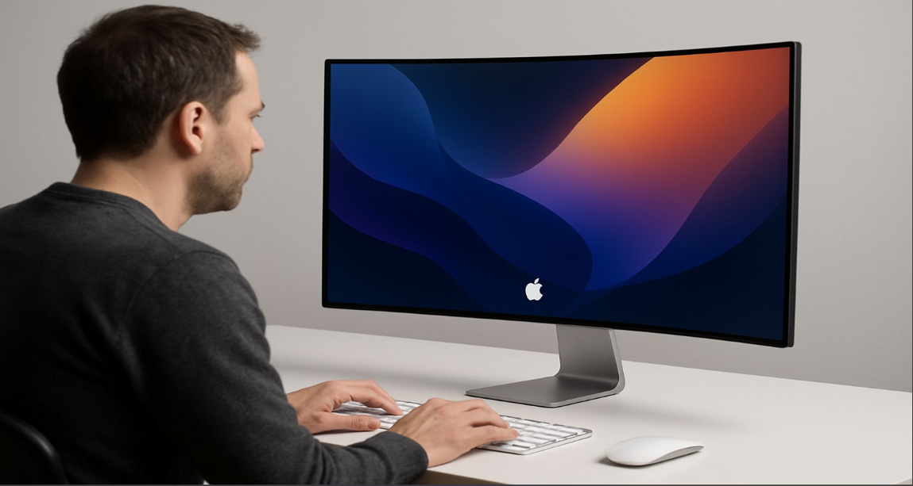
Image generated by ChatGPT

Psychographics:
- Happy to pay more for quality over price and sees technology as both a working necessity and personal interest.
- Design oriented in all aspects of life, from house design to clothing and technology accessories.
- An innovation early adopter who enjoys being among the first to use new products.
- Environmentally conscious and appropriates what Apple is doing to go green.
- Prioritises work-life integration rather than separateness.

Lifestyle & Behaviours:
- Remotely works 3 days a week and has invested considerable money to get the home office up and running.
- Expenditure of 9-10 hours per day of computer time on work, plus additional computer time for non-work projects.
- Multitasks a series of apps, including design packages, communication packages, and research material, constantly.
- Already has several Apple products: MacBook Pro, iPad, iPhone, and AirPods.
- Utilises Mac Studio as primary workstation but currently supplements it with a third-party ultra-wide monitor.
- Spends significant time researching purchases, reading professional reviews, and watching technical analysis videos.
- Will pay higher prices for equipment that enhances productivity and creativity.

Pain Points & Aspirations:
- Disappointed with colour incoherence on existing monitor.
- Experiencing eye fatigue after long work sessions on the existing monitor.
- Wants to get rid of cable clutter and simplify workspace operation.

Alex is the ideal candidate for the Apple Vision Curved Monitor: a style-conscious professional who values both the usability benefits and aesthetic satisfaction of high-end technology, has the ability to pay for premium hardware, and already has a stake in the Apple Universe.

Marketing mix strategy

Product

Apple Vision Curved Monitor will be an ultimate display solution with the following key, most notable features and specs:

Core Product:
- 40-inch 5K ultrawide curved panel at 5120×2160 resolution.
- Mini-LED backlight tech featuring support for 1,600 peak nits and 1,000,000:1 contrast ratio.
- Pro-Motion technology with adaptive refresh rates up to 240Hz.
- P3 wide colour gamut supported with factory calibration and True Tone tech.
- Nano-texture glass option with reduced glare in bright environments.

Augmented Product:
- Integrated 12MP Ultra Wide Centre Stage camera with Studio Light effect.
- Six-speaker spatial audio with Dolby Atmos support.
- Three Thunderbolt 4 ports with 96W charging.
- Integrated Apple Silicon chip to enable features like AirPlay, Sidecar, and Universal Control.
- Magnetic connector for easy pairing with compatible Macs.

Support Services:
- Three-year Apple Care+ option with priority support and accidental damage protection.
- Professional calibration service through Apple Stores.
- Current monitor trade-in program.
- Installation support via Today at Apple sessions.

The design will come with Apple's iconic minimalist design with machined aluminum, edge-to-edge glass, and thinness. The packaging will be 100% recyclable as part of Apple's environmental programs. The product will be introduced in a standard silver and space gray configuration in line with current Apple professional offerings. (Madhavedi et al., 2024).

Price

The Apple Vision Curved Monitor will adopt a premium price positioning strategy in sync with Apple's brand identity and the high-end specification of the product:
Base Model Price:
- Nano-texture glass model: £2,499

Optional Accessories:
- Pro Stand: £899 (full height, tilt, and swivel adjustment)
- Thunderbolt 4 Pro Cable (3m): £149
- VESA Mount Adapter: £149

Payment Options:
- Apple Card Monthly Instalments: interest-free credit over 12 months.
- Apple Business Financing: Business customers get extended payment terms.
- Education pricing: 10% discount to qualified students and teachers.
This price positioning puts the Apple Vision Curved Monitor above the mass market for curved monitors, but at the level of professional displays. High technology, ease of integration into an ecosystem, and brand equity warrant the higher price. Price skimming will be employed at introduction to appeal to early adopters and business professionals who appreciate the newest technology. After initial market acceptance, limited-time offers bundling the monitor with Mac Studio or MacBook Pro sales may be made to enable more extensive market penetration (Kotler and Armstrong, 2017).

Promotion
The promotion plan for Apple Vision Curved Monitor will leverage Apple's established channels of communication and emphasize the differentiated benefits to professional target segments:

Digital Campaigns:
- Dedicated product page on Apple.com with 3D experiences and interactive demonstrations of the benefits of the curved screen.
- YouTube videos of creative professionals utilizing the monitor in real workflows.
- Targeted display ads on design, development, and business websites.
- Current Pro Display XDR and Studio Display customers through email marketing.

Traditional Media:
- Print ads in creative industry publications (Adobe Create Magazine, Communication Arts).
- Billboard ad in creative city hubs.
- Product placement in movies and TV shows with creative studios or tech companies.

Experiential Marketing:
- Special experience areas in Apple Stores where customers can experience professional software on the curved screen.
- "Today at Apple" training sessions on ultrawide screen workflow optimization.
- Participation in industry conferences like Adobe MAX, WWDC, NAB Show, and fintech conferences.

Influencer Partnerships:
- Collaboration with globally recognized creative master artists in various fields of work.
- Technical critique from well-known technology YouTubers and websites.
- Professional studio case studies that have used the display.

PR Strategy:
- Launch through Apple Special Event with complementary products.
- Press kits with special behind-the-scenes material on the development process.
- Editorial in design and technology publications.

The place message will emphasize productivity increases, eye strain minimization, and the seamless ecosystem experience that differentiates Apple's solution from the rest (Xia, 2023).

Place
The place strategy for the Apple Vision Curved Monitor will leverage Apple's established channels and maintain the high-end character of the product:

Direct Channels:
- Apple.com web store with extensive configuration levels and a visualization interface.
- Apple retail stores with Pro zones for product demonstration.
- Apple Enterprise Sales team for large business bulk orders and customized deployment.
- Apple Education sales channel for institutional purchases.

Indirect Channels:
- Some designated Apple premium resellers with appropriately trained staff and sufficient display points.
- Audiovisual and creative equipment professional dealers.
- Business solution providers for IT for business customers.

Physical Presentation:
- Live creative demonstration in-store with live applications running on the monitors.
- Competitive comparison with legacy flat monitors to show workflow advantage.
- Tightly controlled light environments to bring out the color accuracy and anti-glare capabilities of the display.

Logistics and Inventory:
- White-glove delivery service for fragile shipments.
- In-store pickup and professional installation.
- Just-in-time inventory control for high-dollar SKUs.
- Centralized fulfilment from regional distribution centres.

The selective distribution approach allows the product to be channeled through channels strong enough to adequately highlight its qualities and provide the quality of customer service desired for a high-end product. Direct channel focus allows Apple to control the customer experience and receive valuable first-party information on buyer demographics and behavior. (Rao, 2025).

Conclusion
Apple Vision Curved Monitor is a strategic move to extend Apple's range of displays for creative professionals, developers, and productivity-focused users who desire an immersive environment with integration into the ecosystem. The product would find its niche within Apple's current product offerings and address its customer values of innovation, quality, and harmony in the ecosystem.
The marketing strategy is leveraging Apple's direct-to-consumer prowess, premium positioning, and savvy user interactions. Its competitors are pursuing gaming or office productivity as their initial targeting, but Apple's professionalism creates a special positioning that is virtually impossible for its competitors to dislodge without the benefit of Apple's ecosystem.
The future prospects are niche versions for pro industries, innovative applications of the software leveraging the shape advantage of being curved, and partnerships with the developers for the highest creative applications. By rolling out smoothly, such a product will reposition Apple as the greatest professional market leader, earn plenty of money, and make Apple even the biggest technology partner of creative professionals.

Reference list
Cai, Q. and Chen, S. (2024). Analysis of the Influencing Factors of Marketing Strategy on Consumer Purchasing Behaviour: A Case Study of Apple. SHS web of conferences, 188(188), pp.03005–03005. doi:https://doi.org/10.1051/shsconf/202418803005.
Dumitrescu, A. (2024). Market Segmentation Based on Materialistic, Conspicuous, and Traditionalist Goals in Support of an Effective Industrial Design. Bulletin of the Transilvania University of Brasov. Series V : Economic Sciences, pp.25–36. doi:https://doi.org/10.31926/but.es.2023.16.65.2.3.
Kotler, P. and Armstrong, G. (2017). Principles of marketing. 17th ed. Harlow: Pearson Education Limited.
Levy, S. and Montevirgen, K. (2025). Apple Inc. [online] Britannica. Available at: https://www.britannica.com/money/Apple-Inc.
Madhavedi, Dr.S., Sudhaker, P., Prathima, Ch. and Chakradhar, G. (2024). A STUDY ON MARKETING MIX ELEMENTS (PRODUCT, PRICE, PLACE, PROMOTION) AND THEIR INTERPLAY IN DRIVING CUSTOMER ACQUISITION, RETENTION. Turkish Journal of Computer and Mathematics Education, 11(3), pp.2649–2655. doi:https://doi.org/10.61841/turcomat.v11i3.14490.
Peev, P.P. and Kumar, P. (2020). Consumers’ evaluation of extensions among extensions and the backdrop effect. Journal of Strategic Marketing, pp.1–17. doi:https://doi.org/10.1080/0965254x.2020.1857427.
Rao, N. (2025). Research on the Marketing Strategy and Future Development of Commercial Companies Based on 4Ps Theory: A Case Study of Apple. Advances in Economics Management and Political Sciences, [online] 148(1), pp.54–59. doi:https://doi.org/10.54254/2754-1169/2024.LD19167.
Xia, Y. (2023). The 4Ps of Marketing and Applications in Various Brands. Journal of Education, Humanities and Social Sciences, 16(1), pp.165–170. doi:https://doi.org/10.54097/ehss.v16i.9601.

