APPLICATION FOR ETHICAL APPROVAL

In order for research to result in benefit and minimise risk of harm, it must be conducted ethically. A researcher may not be covered by the University’s insurance if ethical approval has not been obtained prior to commencement.

The University follows the OECD Frascati manual definition of research activity: “creative work undertaken on a systematic basis in order to increase the stock of knowledge, including knowledge of man, culture and society, and the use of this stock of knowledge to devise new applications”. As such this covers activities undertaken by members of staff, postgraduate research students, and both taught postgraduate and undergraduate students working on dissertations/projects.

The individual undertaking the research activity is known as the “principal researcher”.

Ethical approval is not required for routine audits, performance reviews, quality assurance studies, testing within normal educational requirements, and literary or artistic criticism.

Please read the notes for guidance before completing ALL sections of the form.

This form must be completed and approved prior to undertaking any research activity. Please see Checklist for details of process for different categories of application.

Delete the Guidance Notes at the end of the form BEFORE submitting your application

SECTION A: About You (Principal Researcher)
Full Name: |  | Danielle Jones
Tick all boxes which apply: |  | Member of staff: | ☐ | Honorary research fellow: | ☐
Undergraduate Student | ☐ | Taught Postgraduate Student | ☒ | Postgraduate Research Student | ☐

Faculty/School/Centre: | Yr Athrofa: ITE
Campus: | Swansea- SA1
E-mail address: | 1900107@student.uwtsd.ac.uk
Contact Telephone Number: | 07951436055
For students:
Student Number: | 1900107
Programme of Study: | PGCE
Director of Studies/Supervisor: | Catherine Morgan, Module Lead

SECTION B: Approval for Research Activity
Has the research activity received approval in principle?  (please check the Guidance Notes as to the appropriate approval process for different levels of research by different categories of individual) |  | YES | ☒ | NO | ☐
 |  |  |  | Date
If Yes, please indicate source of approval (and date where known): Approval in principle must be obtained from the relevant source prior to seeking ethical approval | Research Degrees Committee |  | ☐
 | Faculty Research Committee |  | ☐
 | Other- Catherine Morgan, Module Lead |  | ☒ | 17/12/19

SECTION C: Internal and External Ethical Guidance Materials
Please list the core ethical guidance documents that have been referred to during the completion of this form (including any discipline-specific codes of research ethics, and also any specific ethical guidance relating to the proposed methodology). Please tick to confirm that your research proposal adheres to these codes and guidelines.
UWTSD Research Ethics & Integrity Code of Practice | ☒
UWTSD Research Data Management Policy | ☒
Ethical Guidelines for Ethical Research, fourth edition- BERA, 2018 | ☒

SECTION D: External Collaborative Research Activity
Does the research activity involve collaborators outside of the University? |  | YES | ☐ | NO | ☒
If Yes, please provide the name of the external organisation and name and contact details for the main contact person and confirmation this person has consented to their personal data being shared.as part of this collaboration.
Institution
Contact person name
Contact person e-mail address

Has this individual consented to sharing their details on this form? |  | YES | ☐ | NO |  |  | ☐
Are you in receipt of a KESS scholarship? |  | YES | ☐ | NO |  |  | ☐
Is your research externally funded |  | YES | ☐ | NO |  |  | ☐
Are you specifically employed to undertake this research in either a paid or voluntary capacity? | Voluntary | YES | ☐ | NO |  | ☐
 | Employed | YES | ☐ | NO |  | ☐
Is the research being undertaken within an existing UWTSD Athrofa Professional Learning Partnership (APLP) | If YES then the permission question below does not need to be answered. | YES | ☒ | NO |  |  | ☐
Permission to undertake the research has been provided by the partner organisation | (If YES attach copy)  If NO the application cannot continue | YES | ☐ | NO |  |  | ☐

Where research activity is carried out in collaboration with an external organisation
Does this organisation have its own ethics approval system? | YES | ☐ | NO | ☐
If Yes, please attach a copy of any final approval (or interim approval) from the organisation

SECTION E: Details of Research Activity
Indicative title: | Does the ‘Crash, Bang, Boom’ differentiation strategy work as it is intended?
Proposed start date: | 27/01/2020 | Proposed end date: | 21/02/2020
Introduction to the Research (maximum 300 words)
Ensure that you write for a Non-Specialist Audience when outlining your response to the three points below:
- Purpose of Research Activity
- Proposed Research Question
- Aims of Research Activity
- Objectives of Research Activity
Demonstrate, briefly, how Existing Research has informed the proposed activity and explain
- What the research activity will add to the body of knowledge
- How it addresses an area of importance.
Purpose of Research Activity
The main purpose is to research one differentiation strategy which is focused on the needs of the learners and their progress in order to inform future teaching practice, and to develop my teaching practice.

(this box should expand as you type)
Research Question

Does the ‘Crash, Bang, Boom’ differentiation strategy work as it is intended?
(this box should expand as you type)
Aims of Research Activity
Is the differentiation strategy appropriate and effective in supporting and challenging the needs within this year group?

(this box should expand as you type)
Objectives of Research Activity
- They will use the ‘Crash, Bang, Boom’ differentiation strategy to select the work they will complete
- Observe the use of the ‘Crash, Bang, Boom’ strategy within the classroom
- Observe whether the pupils select appropriate work for themselves and can identify if they need additional support or not
- I will observe if additional work is needed for students if they finish their classwork
(this box should expand as you type)
Proposed methods (maximum 600 words)
Provide a brief summary of all the methods that may be used in the research activity, making it clear what specific techniques may be used. If methods other than those listed in this section are deemed appropriate later, additional ethical approval for those methods will be needed.
- Lesson study method will be used throughout this research. This is a model for collaborative classroom professional learning where two or more teachers work together, developing practice in the classroom. It will be focused on the needs and learning of real pupils and trying to solve a teaching or learning based problem that is affecting pupils’ progress. Dudley (2011) highlights that Lesson study focuses on the development of teacher practice knowledge.
- There will be a range of methods conducted in order to answer the questions asked. The first method will be the use of observation in order to capture the actions of the pupils in regard to differentiation strategy ‘Crash, Bang, Boom’, to identify which’ strategy’ they select and if it is appropriate. There will also be an observation schedule which will allow the other researcher (student teacher) to complete observations regarding the 3 pupils involved within the research by ticking the boxes provided and making notes and we will be spending 5 minutes on each pupil, in order to identify if the work selected is appropriate, if they need additional support, or if they complete their work early and need additional work.
- The second method will be the use of a focus group semi-structured interview with 3 selected a range of prior attaining students within the chosen class, we have chosen this because it will allow us to focus on certain responses, but expand on other points. The interview will essentially have a range of open/ closed ended questions in order to gain knowledge on their thoughts and feelings towards the ‘Crash, Bang, Boom’ differentiation strategy. Furthermore, within this focused group interview process there will be note taking occurring from the responses provided by the students involved, and also potentially audio recordings taken place which will always be stored in a password protected device which can be shared on the universities OneDrive in order to abide with BERA’s (2018) and the Universities ethical guidelines.
- Following this, the next method undertaken will be the use of reflection. Within this area, we will focus on Gibbs’ reflective cycle which has been adapted in order to correlate with our research ideas. There will be a reflection period, due to the importance of studying what occurred within the lessons, what was effective within the lesson and how to improve in future practice. This reflection period will also give us as researchers the opportunity to identify students’ actions on the differentiation strategy and what their thoughts are surrounding it.
Gibbs (1988) highlights the importance of reflection as it allows for increased learning, promoting of deep learning and also identification of educational needs.

(this box should expand as you type)

Location of research activity
Identify all locations where research activity will take place.
The school is an English- medium school situated in Swansea.

(this box should expand as you type)
Research activity outside of the UK
If research activity will take place overseas, you are responsible for ensuring that local ethical considerations are complied with and that the relevant permissions are sought. Specify any local guidelines (e.g. from local professional associations/learned societies/universities) that exist and whether these involve any ethical stipulations beyond those usual in the UK (provide details of any licenses or permissions required). Also specify whether there are any specific ethical issues raised by the local context in which the research activity is taking place, for example, particular cultural and/or legal sensitivities or vulnerabilities of participants.
(this box should expand as you type)
Use of documentation not in the public domain: Are any documents NOT publicly available? | NO | ☒
 | YES | ☐
If Yes, please provide details here of how you will gain access to specific documentation that is not in the public domain and that this is in accordance with prevailing data protection law of the country in question and England and Wales.

(this box should expand as you type)

SECTION F: Scope of Research Activity
Will the research activity include: | YES | NO
Use of a questionnaire or similar research instrument? | ☐ | ☒
Use of interviews? (focus group) | ☒ | ☐
Use of diaries? | ☐ | ☒
Participant observation with their knowledge? | ☒ | ☐
Participant observation without their knowledge? | ☐ | ☒
Use of video or audio recording? | ☒ | ☐
Access to personal or confidential information without the participants’ specific consent? | ☐ | ☒
Administration of any questions, test stimuli, presentation that may be experienced as physically, mentally or emotionally harmful / offensive? | ☐ | ☒
Performance of any acts which may cause embarrassment or affect self-esteem? | ☐ | ☒
Investigation of participants involved in illegal activities? | ☐ | ☒
Use of procedures that involve deception? | ☐ | ☒
Administration of any substance, agent or placebo? | ☐ | ☒
Working with live vertebrate animals? | ☐ | ☒
Other primary data collection methods, please explain in this box  For example, ‘focus groups’. Please indicate the type of data collection method(s) in this box and tick the accompany box. | ☒ | ☐
Details of any other primary data collection method:  Lesson reflection  (this box should expand as you type) | ☒ | ☐
If NO to every question, then the research activity is (ethically) low risk and may be exempt from some of the following sections (please refer to Guidance Notes).

If YES to any question, then no research activity should be undertaken until full ethical approval has been obtained.

SECTION G: Intended Participants
Who are the intended participants: | YES | NO
Students or staff at the University? | ☒ | ☐
Adults (over the age of 18 and competent to give consent)? | ☐ | ☒
Vulnerable adults? | ☐ | ☒
Children and Young People under the age of 18? (Consent from Parent, Carer or Guardian will be required) | ☒ | ☐
Prisoners? | ☐ | ☒
Young offenders? | ☐ | ☒
Those who could be considered to have a particularly dependent relationship with the investigator or a gatekeeper? | ☐ | ☒
People engaged in illegal activities? | ☐ | ☒
Others (please identify specifically any group who may be unable to give consent) please indicate here and tick the appropriate box. | ☐ | ☒
Other – please indicate here:  (this box should expand as you type) | ☐ | ☒

Participant numbers and source
Provide an estimate of the expected number of participants. How will you identify participants and how will they be recruited?
How many participants are expected? | - Two classes of 29 pupils  - 1 PGCE Student  (this box should expand as you type)
Who will the participants be? | - Pupils in identified classes  - 1 additional adult from the PGCE from my teaching group  (this box should expand as you type)
How will you identify the participants? | - Our pupils are based on a spread of prior attainment  - Identified through similar research interests  (this box should expand as you type)

Information for participants: | YES | NO | N/A
Will you describe the main research procedures to participants in advance, so that they are informed about what to expect? | ☒ | ☐ | ☐
Will you tell participants that their participation is voluntary? | ☒ | ☐ | ☐
Will you obtain written consent for participation? | ☒ | ☐ | ☐
Will you explain to participants that refusal to participate in the research will not affect their treatment or education (if relevant)? | ☒ | ☐ | ☐
If the research is observational, will you ask participants for their consent to being observed? | ☒ | ☐ | ☐
Will you tell participants that they may withdraw from the research at any time and for any reason? | ☒ | ☐ | ☐
With questionnaires, will you give participants the option of omitting questions they do not want to answer? | ☐ | ☐ | ☒
Will you tell participants that their data will be treated with full confidentiality and that, if published, it will not be identifiable as theirs? | ☒ | ☐ | ☐
Will you debrief participants at the end of their participation, in a way appropriate to the type of research undertaken? | ☒ | ☐ | ☐
If NO to any of above questions, please give an explanation
(this box should expand as you type)

Information for participants: | YES | NO | N/A
Will participants be paid? | ☐ | ☒ | ☐
Is specialist electrical or other equipment to be used with participants? | ☐ | ☒ | ☐
Are there any financial or other interests to the investigator or University arising from this study? | ☐ | ☒ | ☐
Will the research activity involve deliberately misleading participants in any way, or the partial or full concealment of the specific study aims? | ☐ | ☒ | ☐
If YES to any question, please provide full details
(this box should expand as you type)

SECTION H: Anticipated Risks

Outline any anticipated risks that may adversely affect any of the participants, the researchers and/or the University, and the steps that will be taken to address them.

If you have completed a full risk assessment (for example as required by a laboratory, or external research collaborator) you may append that to this form.
Full risk assessment completed and appended? |  | Yes | ☐
 |  | No | ☒
Risks to participants
For example: emotional distress, financial disclosure, physical harm, transfer of personal data, sensitive organisational information
Risk to Participant:  - Affecting pupils’ self-esteem through not being chose as a participant of the research  - Pupils may feel under pressure to give a ‘correct’ answer to the question  - Safeguarding issues  - Anonymity  (this box should expand as you type) | How will you mitigate the Risk to Participant  - Behaving in a professional manner  - Taking appropriate steps to remove raw data when it has been analysed  - Making sure all pupils are included in the lesson as a whole  - Saw raw data on password protected laptops and backing it up to the University drive which has sufficient firewall protection  - Inform pupils that there is no ‘correct’ answer and to be honest  - Explaining the rights to the pupils and withdrawing from the research  - Acting in accordance with guidelines set out in BERA and UWTSD Research Ethic & Integrity Code of Practice  (this box should expand as you type)
If research activity may include sensitive, embarrassing or upsetting topics (e.g. sexual activity, drug use) or issues likely to disclose information requiring further action (e.g. criminal activity), give details of the procedures to deal with these issues, including any support/advice (e.g. helpline numbers) to be offered to participants. Note that where applicable, consent procedures should make it clear that if something potentially or actually illegal is discovered in the course of a project, it may need to be disclosed to the proper authorities
(this box should expand as you type)
Risks to investigator
For example: personal safety, physical harm, emotional distress, risk of accusation of harm/impropriety, conflict of interest
Risk to Investigator:  - Allegations from pupils in the classroom whilst completing the research  - Possibility of being accused of favouritism by pupils who are not part of the focus group  - Accusation of fabrication of falsification of data  - Possible conflict of interest  - Possible bias  (this box should expand as you type) | How will you mitigate the Risk to Investigator:  - Behaving in a professional manner  - Ensuring all pupils are included in the lesson as a whole  - Not falsifying data  - Clearly explaining to the participants their rights in participating and withdrawing from the research  - Acting in accordance with guidelines set out in BERA and UWTSD Research Ethic & Integrity Code of Practice  (this box should expand as you type)
University/institutional risks
For example: adverse publicity, financial loss, data protection
Risk to University:  - The need to uphold the good name of the university  - Not falsifying any data which could impact the representation and standards of the university  - Not behaving in a way that could impact the relationship between school and university  (this box should expand as you type) | How will you mitigate the Risk to University:  - Behaving in a professional manner  - Not falsifying data  - Acting in accordance with guidelines set out in BERA and UWTSD Research Ethic & Integrity Code of Practice  (this box should expand as you type)

Disclosure and Barring Service
If the research activity involves children or vulnerable adults, a Disclosure and Barring Service (DBS) certificate must be obtained before any contact with such participants. | YES | NO | N/A
Does your research require you to hold a current DBS Certificate? | ☒ | ☐ | ☐

SECTION I: Feedback, Consent and Confidentiality
Feedback
What de-briefing and feedback will be provided to participants, how will this be done and when?
At the end of the focus group, there will be a de-briefing for all participants.

(this box should expand as you type)
Informed consent
Describe the arrangements to inform potential participants, before providing consent, of what is involved in participating. Describe the arrangements for participants to provide full consent before data collection begins. If gaining consent in this way is inappropriate, explain how consent will be obtained and recorded in accordance with prevailing data protection legislation.
A letter will be sent to parents, and only children who have consent will be observed.
Assent method- In order to abide with BERA’s (2018) ethical guidelines, at the beginning of the lesson there will be an opportunity for verbal assent, I will provide cards with a happy face and a sad face on them in order for the pupils to assent to the research being undertaken within the lesson. Furthermore, this method will not draw attention to any pupils as the cards will be close to them on the table.

(this box should expand as you type)
Confidentiality / Anonymity
Set out how anonymity of participants and confidentiality will be ensured in any outputs. If anonymity is not being offered, explain why this is the case.
- Anonymise at source
- Participants will be anonymised as, child 1, 2 and 3

(this box should expand as you type)

SECTION J: Data Protection and Storage
In completing this section refer to the University’s Research Data Management Policy and the extensive resources on the University’s Research Data Management web pages (http://uwtsd.ac.uk/library/research-data-management/).
Does the research activity involve personal data (as defined by the General Data Protection Regulation 2016 “GDPR” and the Data Protection Act 2018 “DPA”)? | YES | NO
“Personal data” means any information relating to an identified or identifiable natural person (‘data subject’). An identifiable natural person is one who can be identified, directly or indirectly, in particular by reference to an identifier such as a name, an identification number, location data, an online identifier or to one or more factors specific to the physical, physiological, genetic, mental, economic, cultural or social identity of that natural person. | ☐ | X
If YES, provide a description of the data and explain why this data needs to be collected:
(this box should expand as you type)
Does it involve special category data (as defined by the GDPR)? | YES | NO
“Special category data” means sensitive personal data consisting of information as to the data subjects’ –  (a) racial or ethnic origin,  (b) political opinions,  (c ) religious beliefs or other beliefs of a similar nature,  (d) membership of a trade union (within the meaning of the Trade Union and Labour Relations (Consolidation) Act 1992),  (e) physical or mental health or condition,  (f) sexual life,  (g) genetics,  (h) biometric data (as used for ID purposes), | ☐ | X
If YES, provide a description of the special category data and explain why this data needs to be collected:
(this box should expand as you type)
Will the research activity involve storing personal data and/or special category data on one of the following: | YES | NO
Manual files (i.e. in paper form)? | ☐ | ☐
University computers? | ☐ | ☐
Private company computers? | ☐ | ☐
Home or other personal computers? | ☐ | ☐
Laptop computers/ CDs/ Portable disk-drives/ memory sticks? | ☐ | ☐
“Cloud” storage or websites? | ☐ | ☐
Other – specify: | ☐ | ☐
For all stored data, explain the measures in place to ensure the security of the data collected, data confidentiality, including details of password protection, encryption, anonymisation and pseudonymisation:
(this box should expand as you type)
All Data Storage
Will the research activity involve any of the following activities: | YES | NO
Electronic transfer of data in any form? | ☐ | ☒
Sharing of data with others at the University? | ☒ | ☐
Sharing of data with other organisations? | ☐ | ☒
Export of data outside the European Union or importing of data from outside the UK? | ☐ | ☒
Use of personal addresses, postcodes, faxes, emails or telephone numbers? | ☐ | ☒
Publication of data that might allow identification of individuals? | ☐ | ☒
Use of data management system? | ☐ | ☒
Data archiving? | ☒ | ☐
If YES to any question, please provide full details, explaining how this will be conducted in accordance with the GDPR and DPA (and/or any international equivalent):
- Data will not be provided via email, it will be provided via a password protected folder in the UWTSD provided OneDrive in line with UWTSD Research Data Management Statement, 2018

(this box should expand as you type)
List all who will have access to the data generated by the research activity:
- Researcher and the research partner

(this box should expand as you type)
List who will have control of, and act as custodian(s) for, data generated by the research activity:
- Researcher and the research partner

(this box should expand as you type)
Give details of data storage arrangements, including security measures in place to protect the data, where data will be stored, how long for, and in what form. Will data be archived – if so how and if not why not.
- Data will be stored and archived on the University OneDrive for the duration of the PGCE course.

(this box should expand as you type)
Please indicate if your data will be stored in the UWTSD Research Data Repository (see https://researchdata.uwtsd.ac.uk/ ). If so please explain. (Most relevant to academic staff)
No. The data will not be stored in the UWTSD repository.

(this box should expand as you type)
Confirm that you have read the UWTSD guidance on data management (see https://www.uwtsd.ac.uk/library/research-data-management/) | YES | ☐
 | NO | ☐
Confirm that you are aware that you need to keep all data until after your research has completed or the end of your funding | YES | ☐
 | NO | ☐

SECTION K: Declaration
The information which I have provided is correct and complete to the best of my knowledge. I have attempted to identify any risks and issues related to the research activity and acknowledge my obligations and the rights of the participants.

In submitting this application I hereby confirm that I undertake to ensure that the above named research activity will meet the University’s Research Ethics and Integrity Code of Practice
Signature of applicant: | Danielle Jones | Date:  17/12/2019

For STUDENT Submissions:
Director of Studies/Supervisor: |  | Date:
Signature: |  | Date:

For STAFF Submissions:
Head of School/Assistant Dean: |  | Date:
Signature: |  | Date:

Checklist: Please complete the checklist below to ensure that you have completed the form according to the guidelines and attached any required documentation:
☒ | I have read the guidance notes supplied before completing the form.
☒ | I have completed ALL RELEVANT sections of the form in full.
☒ | I confirm that the research activity has received approval in principle
☐ | I have attached a copy of final/interim approval from external organisation (where appropriate)
☐ | I have attached a full risk assessment (and have NOT completed Section H of this form) (where appropriate) ONLY TICK IF YOU HAVE ATTACHED A FULL RISK ASSESSMENT
☒ | I understand that it is my responsibility to ensure that the above named research activity will meet the University’s Research Ethics and Integrity Code of Practice.
☒ | I understand that before commencing data collection all documents aimed at respondents (including information sheets, consent forms, questionnaires, interview schedules etc.) must be confirmed by the DoS/Supervisor, module tutor or Head of School.
☒ | I have deleted the guidance notes before submitting the PG2 for consideration

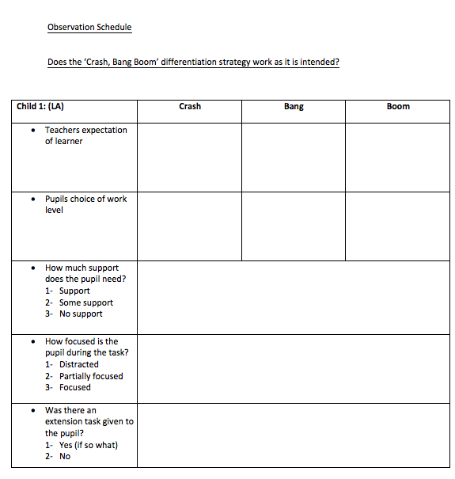

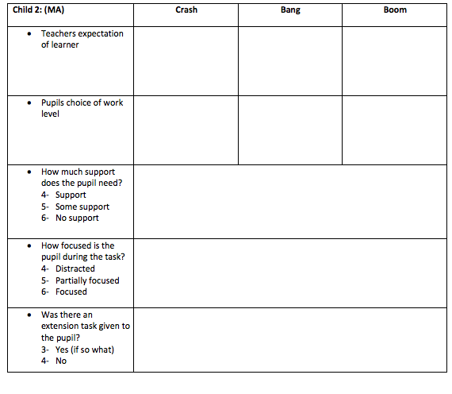

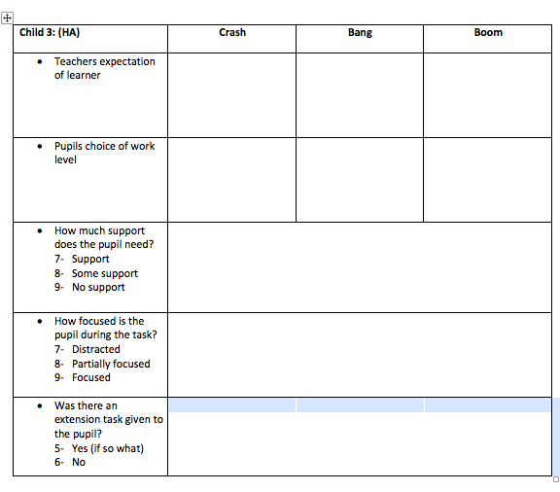

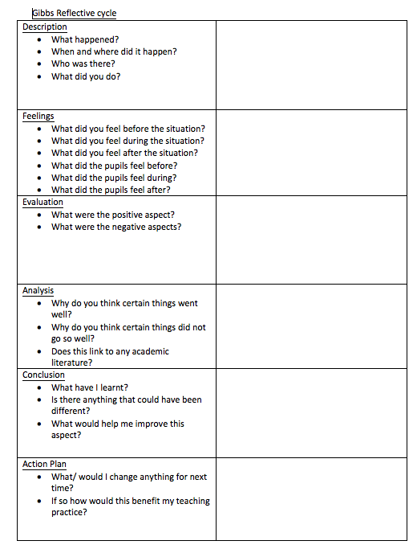

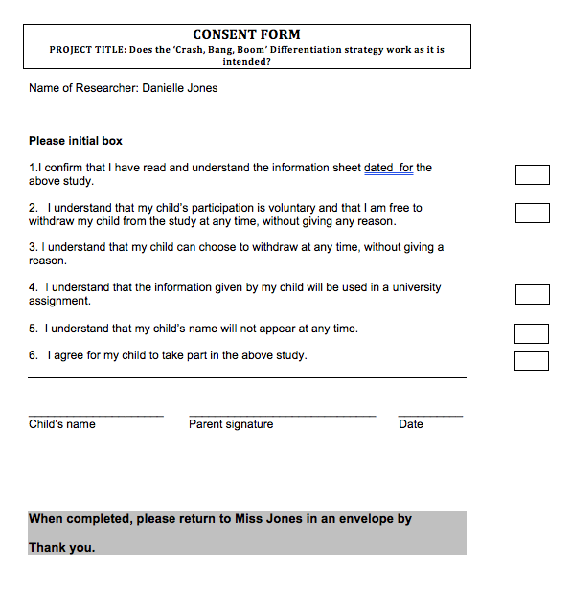

INFORMATION sheet

PROJECT TITLE: Does the ‘Crash, Bang, Boom’ Differentiation strategy work as it is intended?

Dear Parent / Guardian,

My name is Danielle Jones and I am studying for a PGCE qualification at Yr Athrofa, University of Wales Trinity Saint David. I am currently a student teacher within Cwm Glas and am teaching in your child’s class.
I would like to invite your child to participate in my research project. The title of the project is Does the ‘Crash, Bang, Boom’ Differentiation strategy work as it is intended? and I aim to identify whether pupils select the appropriate work for them through your child’s participation, I hope to ascertain whether the ‘Crash, Bang, Boom’ Differentiation strategy works as it is intended?
There will be a number of methods used throughout the lesson in order to answer the research questions. Observations will be the first method, this is where the pupils will be observed to identify whether they select the appropriate work for themselves. Following that, semi- structured interviews will occur, where questions will be asked regarding pupils’ feelings on how they felt about the differentiation strategy. Furthermore, audio recordings will occur in order to gain additional information regarding the research area.
All names will be kept strictly confidential and will only be known by myself and my research partner. Your child’s participation in this study is completely voluntary so you or your child can withdraw from the study at any stage. Your child will also be asked to give their assent before the beginning of the study.
After careful and precise analysis of the data obtained from the lesson observation and group interview, I would be happy to provide you with a copy of the findings at your request. The results of the research will be discussed in a university assignment that will contribute to my PGCE course. The results of this study will be stored on a secure universities OneDrive and all raw data will be destroyed once the assessment has been marked.
I thank you in advance for your time. If any questions do arise, feel free to contact me at your convenience.

Yours sincerely,

Danielle Jones

