


LOCATION: Coleg sir gâr | LLEOLIAD: coleg sir gâr
LEVEL 4 | LEFEL 4
EXAMINATION PERIOD | CYFNOD ARHOLIADAU
January 2019 | Ionawr 2019

MODULE CODE: DUM4005
SOFTWARE DEVELOPMENT

TIME: 2 HOURS

answer ALL QUESTIONS

Equipment or materials required – Open Book
Adnoddau neu ddefnyddiau sydd eu hangen – Open Book

ANSWER ALL QUESTIONS

QUESTION 1

a) Provide one definition for Incremental development and one for Iterative development, describing why they are different but complementary.

(Marks 9)

b) Define TWO advantages of using increments and iterations in software development, as opposed to using a traditional mode of development.

(Marks 6)

QUESTION 2

In the context of software reuse, give an example of a reusable component.

(5 marks)

QUESTION 3

A binary tree structure is designed to contain strings and uses the following rules:
- The left pointer indicates the condition “earlier or at the same position in the alphabet”
- The right pointer indicates the condition “later in the alphabet”

a) Construct a binary tree using these rules and the data entered in the following order:
Husky; Poodle; Bloodhound; Affenpinscher; Chihuahua; Cavalier King Charles; Dalmatian;
Newfoundland; Mutt

(Marks 5)

- Identify and highlight (shade) the leaf nodes

(Marks 2)

- Carry out a pre-order traversal of the tree and give one use of pre-order traversals.

(Marks 3)
QUESTION 4

Wonder Pet Foods is a new Pet supply business based in Llanelli. The business offers a wide variety of different Pet Foods and supplies to its customers. Wonder Pet Foods stores the details of its products in an array, which is sorted in order of price (lowest to highest). Using a recognised convention, design an algorithm that performs a search for all of the ProductIDs that are available between two entered price ranges.

The algorithm should accept the following inputs:
- A pre-sorted array
- The data item to search for

The algorithm should output:
- The location in the array of the search value
- A message to say “item not found” if the item is not located.

(10 marks)

QUESTION 5

Using C#, create a computer program that counts the instances of a single character in a single string that is input from a user. Your program should store the user input and should count and display the instances of the chosen character at the end of the program.

Sample output:

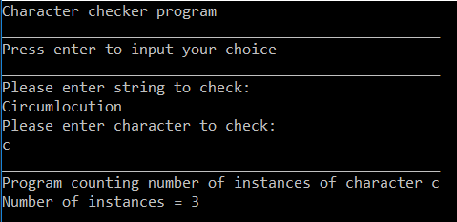

- marks)

QUESTION 6

- Briefly outline the software testing methods used in:
1) 'White-box' testing.
2) 'Black-box' testing.
3) ‘Grey-box’ testing.

(8 marks)

b) Describe and give examples of the processes involved within integration testing.

(12 marks)

QUESTION 7

Using pseudocode, write a “Largest number” algorithm that calculates the largest of three numbers input from a user.

(Marks 5)

QUESTION 8

Using C#, create a computer program to solve the “Largest number” algorithm as described above.

(20 marks)

Diwedd/End

