

LEVEL 6

SEMESTER 1

MODULE CODE: BMOE6003
Landscape and Sustainable Recreation
aSSESSMENT TYPE: assignment
Assessment: 2

COMPONENT WEIGHTING: 50%

WORD COUNT: 2,500 WORDS

MODULE TUTOR: Anthony Burns

Reflective Fieldwork Journal
As part of this module there will be a number of virtual/physical site visits as fieldwork. As you visit each site you will need to keep detailed notes relating to the following issues:

• Landscape Character
• Landscape Quality
• Designations
• Use
• Access
• Future Potential

You should choose two sites of your choice from those visited (whether virtual or physical) and the notes you took should subsequently form the basis of a reflective and critical account of the landscape at each location, including relevant academic and policy related literature also providing suggestions for sustainable approaches to recreational development at each site. Maps, sketches and photographic evidence should be used as appropriate.

SUBMISSION DETAILS:

Submit by Turnitin on or before 22nd January Friday 2021
Feedback to be returned to student: on or before19th February 2021

School of Sport, Health & Outdoor Education

Assessment Feedback Sheet

Student No./Name: Georgina Ireland 1805551
Module: Landscapes and sustainable recreation
Module Code: BMOE6003

Personal Evaluation – to support your academic progress please complete the section below BEFORE submitting your work.
What do you consider to be the best aspects of this work? |  |  | Research on Lundy island
Which aspects do you consider could have been improved in this piece of work? |  |  | Referencing
What have you found most satisfying whilst undertaking this submission? |  |  | Researching Lundy and Cheddar Gorge
ASSESSMENT CRITERIA | Learning  Outcomes |  | GRADE
ASSESSMENT CRITERIA |  |  | Poor  < 20% | Weak  20-29% | Unsatisfactory  30-39% |  | Satisfactory  40 – 49% | Good  50 – 59% | Very Good  60 – 69% | Excellent  70 – 84% |  | Exceptional  85– 100% | %
Your discussion of the nature of landscape within the context of the fieldwork locations | 1 |  |  |  |  |  |  |  |  |  |  |  | 20%
Your critical evaluation of external and internal influences that affect the perception, interpretation and use of landscape at the fieldwork sites. | 2 |  |  |  |  |  |  |  |  |  |  |  | 20%
Your critical discussion of the relationship between landscape and recreation and your suggestion of sustainable approaches to the interpretation and use of landscape for recreation. | 3 |  |  |  |  |  |  |  |  |  |  |  | 40%
Your identification and use of relevant academic and other material to help inform and develop your argument | 1,2,3 |  |  |  |  |  |  |  |  |  |  |  | 20%
It is expected that students will present work that is proof read, correctly referenced and adheres to the Assessment Checklist. Therefore a range of 0 – 10 marks will be deducted for non-completion of any of the points on the checklist below.
TUTOR COMMENTS:

Submission date:  via Turnitin |  | Return date:  (at least within 4 weeks) |  |  |  | Tutor: |  |  |  |  | Mark:

Landscapes and Sustainable recreation BMOE6003
In this essay I will be exploring the different aspects of Lundy Island and Cheddar Gorge, looking into the landscapes at each place and how they are used for recreational purposes. The essay will consider the relationship between landscape and recreation whilst focusing on how sustainable approaches can be used to strengthen that relationship. To understand the differences between these two places the same issues will be observed in each place. These issues are: Landscape character, Landscape quality, designations, use, access, and future potential.
Lundy Island
Lundy Island is an island that sits of off the coast of North Devon. The island has the Atlantic Ocean to the west and the Bristol Channel to the East, it sits 20km from its nearest mainland and takes 2 hours by boat to reach its dock. (Landmark Trust, 2021, B).
Lundy is quite distinguishable compared to other small islands. The island is only 3 miles long and half-a-mile wide and has an area of 451 Ha. (Landmark Trust, 2021, B) On the western side of Lundy there are steep cliffs dropping into the ocean whereas on the eastern side there is a mixture of grassy slopes and cliffs (Landmark Trust, 2021, C). Lundy island has a completely flat top and does not have any major hills on the island, because of this the island experiences a milder climate then the mainland, they get less rain and more sunny days however the wind can still be strong (Landmark Trust, 2021, C). The island is made up of ‘Tertiary Granites, which account for the majority of the island, intruded into Devonian Slates, which form the south-eastern peninsula.’ (Natural England, 2014). View a map of Lundy in Appendix 2.
Lundy Island has a good landscape quality and the National Trust work to keep it that way. The island has no pollution due to not having any cars on the island. Due to the lack of cars, there are no roads on the island and there are also no streetlights which allows the island true darkness at night and allows for amazing views of the stars the likes of which are rarely seen on the mainland. (Landmark Trust, 2021, C). In 2019 Lundy was declared a plastic free island. (Smart,2020), because of this lack of pollution the island holds a natural wild aesthetic which allows the island to look untouched and gives visitors the feeling of tranquil isolation.
On the island you can take part in climbing, walking, diving, birdwatching, and fishing. There are also letterboxes hidden around the island that you can find and collect stamps from as you travel around. The island also now provides educational days for school groups teaching them about the history of the island.
In the past Lundy has been used for many different practices which has led to it having a varied history. Lundy Island has been inhabited at different times since the Bronze age (Landmark Trust, 2021, A). It has been involved in religious piety, piracy, enterprises, and roguery (Landmark Trust, 2021, A). Over the 85 years that the Hudson family owned the island from 1834 they built the St Helen’s church, Beach road and Millcombe House. From 1925 to1968 the Harman family owned Lundy and in that time, they were responsible for establishing Lundy’s private postal system as well as introducing many of the animals. After the Harman’s sold the island in 1968 the Landmark Trust has owned Lundy and leased it to the National Trust to maintain, restore and run the island (Landscape Trust, 2021, A).
The National Trust and Landmark Trust now run Lundy as a place of historical interest due to the buildings that are on the island that show the unique history of the island. It is also a tourist destination where people can come and experience the wildlife of the island as well as taking part in certain activities (Landscape trust, 2021). Due to the cliffs around Lundy, there are many climbing routes to explore and the interesting wildlife on the island and in the sea allows for diving experiences and birdwatching form the cliff tops.
The island can be accessed by boat during most of the year, it can also be accessed by helicopter. There is a ferry, the MS Oldenburg, which transports tourists to the island as well as essential supplies that the island cannot provide for itself. You can also dock your own boat in the harbour for a landing fee of £6. The island has two Tramper 4x4 scooters which are available to tourists with mobility difficulties to help them access as much of the island as possible (Landmark Trust, 2021, D). Due to Covid the island is currently closed to visitors.
Lundy has been well managed by the National Trust and the Landmark Trust, they have allowed the development of some recreational activities without it becoming the main feature of the island, they continue to protect the wildlife and history of the area whilst also encouraging people to have an adventure on the island. In the future there could possibly be an opportunity to develop the experience of sea cliff camping, this is where visitors can spend the night in a ‘portaledge attached to the rocks above the sea’ (Hepworth Adventures, 2021). This would allow people to immerse themselves in nature and understanding the conditions birds nest in whilst also allowing a great advantage spot for birdwatchers. However, this may not be a long / full time option as the cliffs are where the birds come to nest during parts of the year as well as this there is also the wind which can be unpredictable.

Cheddar Gorge
Cheddar Gorge is located in the Mendip hills outside the village of Cheddar in Summerset, England. Cheddar Gorge is England’s largest gorge standing at 122m deep and 3 miles long (National Trust, 2021, A). The gorge is made up of limestone and is classed as a dry gorge because there is no river because the water drains into the ground. (Natural England, 2013) Woodland covers the slopes of Cheddar Gorge and some of the surrounding areas allowing for a range of wildlife.
This video shows how cheddar gorge looks today and gives a good overview of the area. 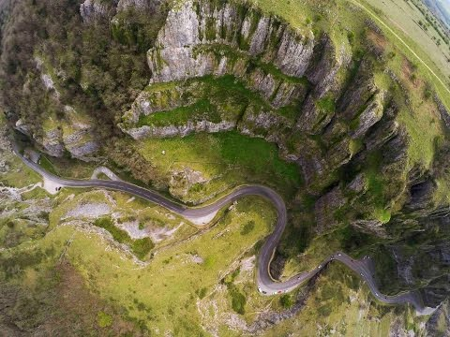 (Skyflicks Media, 2015)
Due to the amount of people that visit Cheddar Gorge each year there are a lot of cars travelling through the area increasing the pollution in that area. Despite this the area still has impressive views and is considered a natural wonder (Grayston, 2018).
Cheddar gorge has many different activities that you can take part in whilst you are there. It is probably most famous for its caves which you can explore year-round and discover the history of the early man. You can also climb, cycle, and walk around cheddar gorge, one possible route to walk can be seen in Appendix 1. There is also opportunity to take part in crazy gold, escape room, visit the museum of prehistory, as well as the opportunity to take part in the black cat free fall (Endless Distances, 2021). The unique landscape of cheddar gorge and its surrounding areas allows for these activities to take place. The cliffs allow for visitors to climb whilst the caves allow people to explore underground and see where the early man lived. The flat ground around cheddar allows for the activities such as walking to take place (which can be seen in the video above).
The gorge has its own carparks where you can park and travel to each of the different activities from. Although there are paths to follow around the gorge, they can be steep and difficult for people with limited mobility to access. However, to get to many of the shops and information stand is wheelchair friendly (National Trust, 2021, B). Due to Covid cheddar gorge is closed expected for walks for people they live locally (National Trust, 2021, B).
There is already a huge range of activities available to guests visiting cheddar gorge, which allows them to explore the history of the area or have an adventure filled day climbing, cycling, or walking. However, because of the range of activities it attracts a lot of visitors from all over the country and is very popular throughout the year. This can lead to overuse of the paths and surrounding areas (Healy, 1994) and can lead to certain areas needing to be closed as they are no longer viable to use. A future idea for the area could be an underground trampoline park in one of the caves or even a zip line across the gorge. However, I personally would avoid adding any more activities to the immediate area and focus on working toward sustainable approaches towards the activities that are already in place to increase the chances of the landscape lasting for the generations to come to continue to use.
Recreation is a broad term which can be defined as ‘a way of enjoying yourself when you are not working.’ (Cambridge Dictionary, 2021) because of this recreation can be anything from reading to skydiving. In order to discuss the relationship between landscape and recreation we must first also define landscape. Landscape can be defined as ‘a picture representing a view of natural inland scenery.’ (Merriam-webster, 2021) or ‘a portion of territory that can be viewed at one time from one place.’ (Merriam-webster, 2021). Landscapes vary depending on where you are and who you are, this is because everyone connects with places differently and create their own sense of place.
Landscapes exist without recreation. The landscapes around us that we use for recreational activities would still exist if we did not use them for activities such as hiking or climbing. They are the land formations that have been here for thousands of years before humans existed (Simon, 2019). The landscapes would continue to exist and thrive if humans did not exist, they may even be better as there would be no restrictions placed upon them for our benefit, there would be no damage on habitats and human activity would not change the landscape (Ibáñez et al., 2014). The presence of human beings speeds up the natural process of erosion (National Society, 2011).
However, the fact we explore these landscapes through recreational activities such as hiking allows us to identify different types of landscapes and allows us to define landscape itself. Without human beings exploring and defining landscape it would just simply be, ‘geography is a reflection of the people’s curiosity about the differences between part of the Earth’s surface.’ (Cresswell, 2008). By using the landscapes around us we are encouraged to learn more about them and in turn we learn that we need to care about our landscapes to protect our environment. Humans have been a part of the landscape for so long that different cultures have developed different ways of interacting with their environment (Lewis, 2010). People create a sense of place at certain places and then memories are made which are then also apart of the landscape as we link feelings with landscapes (Wylie, 2009).
When people think of recreational activities in the outdoor people tend to think of activities such as climbing, skiing, hiking, or caving however, recreational activities in the outdoors do not have to include risk or adrenaline they could simple be having a picnic or reading a book outside. Therefore, recreational activities do not have to be damaging to the environment.
Landscapes are under pressure more then ever at the moment as more people venture out into the outdoors (McCool and Kline, 2020), the increase of people in the natural landscape increases the damage that can be caused to the landscapes without people meaning to. General use of landscapes causes damage to the area by the wear and tear on the paths. In order to look after our landscapes for the future, sustainable approaches to recreation need to start being put in place to limit the damage we cause on the landscape.
One possible sustainable approach that could be implicated into the recreational use of landscapes is the restoration of paths. By putting stones or gravel down on frequently worn paths it helps to lesson the impact of erosion as they are worn away before the natural flooring is, this increases how long the path can be used for whilst also helping to keep the natural look of the area which would not be possible with concrete or tarmac. This is already being done on mountains such as Snowdon and Errigal (NPAP, 2021).
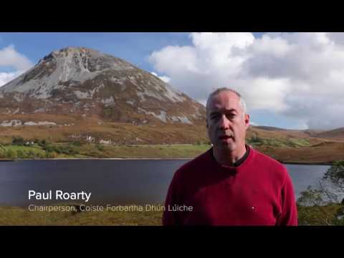
Promoting responsible recreation at Errigal:

(NPAP, 2021)
Another possible approach that could encourage sustainability is changing the areas that are used. For example, changing the routes that can be used at certain times. Allowing the use of a certain route for a period of time before swapping to a different route allows time for the disused routes to heal as vegetation can regrow and it limits the erosion each area faces when they are in constant use (Thomas and Reed, 2019).
A third possible sustainable approach is limiting the available activities all year round. Having a few activities open at certain times lessens the amount of people traveling to the area which helps to decrease pollution as well as lessening the use of the activity routes. Different activities have different impacts on the area (Thomas and Reed, 2019), and so the activities can be swapped through out the year so that they all stay available whilst limiting how much they are used; this can also help to protect the wildlife in the area. Lundy is partly doing this already, they close certain areas and climbing routes during the nesting season for the birds to allow them to be undisturbed whilst they are nesting. (Landmark Trust, 2021, E)
Flora and fauna are a fourth possible sustainable approach to the use of landscape for recreation. ‘Fauna is a group of indigenous animals of any given geographical region.’ (Conserve Energy Future, 2021) and flora is the same but for the plants of the area. Overuse of an area can damage the indigenous plants of the area and scare away the animals. By replacing and protecting the native fauna and flora to an area helps to restore the natural presence that was there.
Both Lundy Island and Cheddar gorge are places of landscape interest, they each have unique historic backgrounds. The areas have been developed to best suit what is in the area which has led to success for both landscapes. It is important to understand landscapes as this allows for a better understanding of how we can use more sustainable approaches to continue enjoying the use of the landscape whilst not damaging the area and preserving it for the future, allowing future generations to connect to these places and experience all the experiences these places have to offer.
Word count: 2470
References:
Conserve Energy Future. (2021). What is Flora and Fauna: Importance and Various Examples. [online] Available at: <https://www.conserve-energy-future.com/what-are-flora-and-fauna.php> [Accessed 29 January 2021].
Cresswell, T. (2008) Place: a short introduction. Blackwell. Oxford. Pp.15-51 Available at: https://moodle.uwtsd.ac.uk/pluginfile.php/412029/mod_resource/content/1/Cresswell%2C%20T%20%282008%29%20Place%3B%20A%20short%20introduction%2C%20chapter%202.pdf
Dictionary.cambridge.org. (2021). recreation. [online] Available at: <https://dictionary.cambridge.org/dictionary/english/recreation> [Accessed 29 January 2021].
Endless Distances. (2021). 15+ Things to do in Cheddar Gorge on a Weekend Break. [online] Available at: <https://www.endlessdistances.com/things-to-do-in-cheddar-gorge-on-a-weekend-break/> [Accessed 27 January 2021].
Grayston, G., (2018). Cheddar Gorge and Caves. [online] Get Out With The Kids. Available at: <https://www.getoutwiththekids.co.uk/daysout/days-out-england/days-out-in-somerset/cheddar-gorge-and-caves/> [Accessed 25 January 2021].
Healy, R., (1994). The “common pool” problem in tourism landscapes. Annals of Tourism Research, [online] 21(3), pp.596-611. Available at: <https://www.sciencedirect.com/science/article/abs/pii/0160738394901228> [Accessed 28 January 2021].
Hepworth Adventures. (2021). Sea Cliff Camping - Hepworth Adventures. [online] Available at: <https://hepworthadventures.co.uk/sea-cliff-camping> [Accessed 29 January 2021].
Ibáñez, I., Katz, D., Peltier, D., Wolf, S. and Connor Barrie, B., (2014). Assessing the integrated effects of landscape fragmentation on plants and plant communities: the challenge of multiprocess-multiresponse dynamics. Journal of Ecology, [online] 102(4), pp.882-895. Available at: <https://besjournals-onlinelibrary-wiley-com.ezproxy.uwtsd.ac.uk/doi/pdfdirect/10.1111/1365-2745.12223> [Accessed 28 January 2021].
Landmark Trust (2021) E. Climbing. [online] Available at: <https://www.landmarktrust.org.uk/lundyisland/discovering-lundy/activities/climbing/> [Accessed 24 January 2021].
Landmark Trust. (2021) A. History. [online] Available at: <https://www.landmarktrust.org.uk/lundyisland/discovering-lundy/history/> [Accessed 20 January 2021].
Landmark Trust. (2021) B. Day trips. [online] Available at: <https://www.landmarktrust.org.uk/lundyisland/day-trips/> [Accessed 21 January 2021].
Landmark Trust. (2021) C. Discover Lundy. [online] Available at: <https://www.landmarktrust.org.uk/lundyisland/discovering-lundy/> [Accessed 21 January 2021].
Landmark Trust. 2021) D. The Landmark Trust. [online] Available at: <https://www.landmarktrust.org.uk/lundyisland/discovering-lundy/accessibility/accessibility/> [Accessed 23 January 2021].
Lewis, J., 2010. Interethnic Preferences for Landscape Change: A Comparison of First Nations and Euro-Canadian Residents. Landscape Journal, [online] 29(2), pp.215-231. Available at: <https://moodle.uwtsd.ac.uk/pluginfile.php/412025/mod_resource/content/0/Interethnic_Preferences_for_Landscape_Change.pdf> [Accessed 28 January 2021].
McCool, S. and Kline, J., (2020). A Systems Thinking Approach for Thinking and Reflecting on Sustainable Recreation on Public Lands in an Era of Complexity, Uncertainty, and Change. [ebook] Igniting Research for Outdoor Recreation: Linking Science, Policy, and Action. Available at: <https://www.fs.fed.us/pnw/pubs/pnw_gtr987_Selin_Chap11.pdf> [Accessed 29 January 2021].
Merriam-webster.com. (2021). Definition of LANDSCAPE. [online] Available at: <https://www.merriam-webster.com/dictionary/landscape> [Accessed 29 January 2021].
National Society. (2011). landscape. [online] National Geographic Society. Available at: <https://www.nationalgeographic.org/encyclopedia/landscape/> [Accessed 29 January 2021].
National Trust. (2021) A. Cheddar Gorge walk. [online] Available at: <https://www.nationaltrust.org.uk/cheddar-gorge/trails/cheddar-gorge-walk> [Accessed 28 January 2021].
National Trust. (2021) B. Cheddar Gorge. [online] Available at: <https://www.nationaltrust.org.uk/cheddar-gorge#Facilities%20and%20access> [Accessed 28 January 2021].
Natural England (2013). National Character Area profile: Mendip Hills. [ebook] Available at: <http://publications.naturalengland.org.uk/publication/5370593> [Accessed 29 January 2021].
Natural England (2014). Lundy Island total landscape and history document. [PDF] Natural England. Available at: <http://www.naturalengland.org.uk> [Accessed 25 January 2021].
Northern Periphery and Artic Programme, (NPAP)., (2021). Preserving paths to the summit. [online] Interreg-npa.eu. Available at: <https://www.interreg-npa.eu/projects/online-map/preserving-paths-to-the-summit/> [Accessed 29 January 2021].
Simon, S., (2019). Opinion: Earth Has Survived Extinctions Before, It's Humans Who Are Fragile. [online] Npr.org. Available at: <https://www.npr.org/2019/09/07/758448991/opinion-earth-has-survived-extinctions-before-its-humans-who-are-fragile?t=1611956986927> [Accessed 29 January 2021].
Skyflicks Media, 2015. Cheddar Gorge by Drone April 2015. [video] Available at: <https://www.youtube.com/watch?v=PAb8Djf7YMY> [Accessed 24 January 2021].
Smart, M., (2020). Lundy Island is officially plastic free. [online] North Devon Gazette. Available at: <https://www.northdevongazette.co.uk/news/lundy-island-plastic-free-status-6052000> [Accessed 29 January 2021].
Thomas, S. and Reed, S., (2019). Entrenched ties between outdoor recreation and conservation pose challenges for sustainable land management. [PDF] IOP Science. Available at: <https://iopscience.iop.org/article/10.1088/1748-9326/ab4f52/pdf> [Accessed 29 January 2021].
Wylie, J., (2009). Landscape, absence and the geographies of love. Transactions of the Institute of British Geographers, [online] 34(3), pp.275-289. Available at: <https://rgs-ibg-onlinelibrary-wiley-com.ezproxy.uwtsd.ac.uk/doi/pdfdirect/10.1111/j.1475-5661.2009.00351.x> [Accessed 28 January 2021].
Appendix:
Appendix 1: Map of cheddar gorge
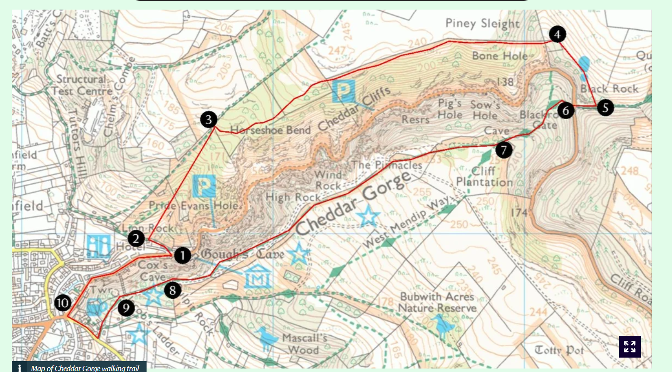

Appendix 2: Map of Lundy


