

Is Digitisation the key to the Student Mental Health Crisis?

by
Shannon Boulting

Supervisor: Tim Bashford
Second Marker: Nik Whitehead

Project submitted as part of the requirements for the award of BSc (Hons) Applied Computing

April 2020

DECLARATION

I, Shannon Boulting declare that I am the sole author of this Project; that all references cited have been consulted; that I have conducted all work of which this is a record, and that the finished work lies within the prescribed word limits.

This work has not previously been accepted as part of any other degree submission.

Signed :SYBoulting

Date : . 20/04/2020

FORM OF CONSENT

I Shannon Boulting hereby consent that my Project, submitted in candidature for the B.Sc.(Hons) Applied Computing degree, if successful, may be made available for inter-library loan or photocopying (subject to the law of copyright), and that the title and abstract may be made available to outside organisations.

Signed : SYBoulting.

Date : 20/04/2020

Abstract
This project examined the current student mental health crisis with the aim of exploring and demonstrating how technology could improve student interaction with universities wellbeing services. The research fulfils the following objectives:
- Establish the effectiveness of student wellbeing services at present
- Determine how the effectiveness of student wellbeing services can be improved
- Explore how digitisation of student wellbeing services can bridge the shortcomings identified through the project
- Deliver informed guidance for universities to incorporate digitisation into their Wellbeing Services
These objectives were achieved using a holistic approach which utilised student and wellbeing staff perspectives on University Wellbeing Services through a literature review, survey and interview. The results showed a concerning gap between the poor supply of wellbeing services and the increasing demand from students on these services. It was shown through the creation of a prototype mobile application, called ‘SOS Student’, that wellbeing services and students alike would greatly benefit from the implementation of further digitisation and mobile technology. ‘SOS Student’ was endorsed by students through hands on testing of its usability and wellbeing support. Furthermore, the documentation of the design and requirements of this prototype provides universities with guidelines and advice on how to implement this digital solution in order to better support student wellbeing.

Contents
Abstract 3
List of Tables 6
List of Figures 6
1.Introduction 9
1.1 Background Information 9
1.2 Rationale 11
1.3 Aims and Objectives 11
2. Literature Review 12
2.1 Overview 12
2.2 Current state of Wellbeing Services in Universities 12
2.3 Current Impact of Social Media on Student Mental Health 13
2.4 Existing Wellbeing Applications 14
2.5 Universities Role in Supporting Student’s Mental Health 17
2.5.1 Policies in Place 17
2.5.2 Improvements 17
2.5.3 How Technology Can Help 18
2.6 The Role of Applications in Wellbeing Services 19
2.6.1 Advantages of Wellbeing Apps 19
2.6.2 Disadvantages of Mental Health Apps 20
2.7 The Future of Wellbeing Services in Universities 21
2.7.1 The Importance of Working Collaboratively 21
2.7.2 Current Technology Implemented across Universities 21
2.8 Application Design Considerations 22
2.8.1 Usability 22
2.8.2 Data Protection & Security 22
2.8.3 Policy & Regulations 23
2.9 Application Platform Selection 24
2.10 Research Method &Data collection techniques 24
2.10.1 Participants 24
2.10.2 Research Methods 25
2.11 Conclusion 26
3. Methodology 27
3.1 Overview 27
3.2 Project Plan 27
3.3 Methodological Approach 27
3.4 Data Collection Methods 28
3.3.1 Interview 28
3.3.2 Survey 28
3.3.3 Wellbeing Application - Trial and Case Study 29
3.5 Pilot Study 29
3.6 Data Processing and Analysis 30
3.7 Limitation and Weaknesses 30
3.8 Ethics 31
4. Results and Analysis 32
4.1 Introduction 32
4.2 Wellbeing Services Staff Interview 32
4.3 Student Wellbeing Survey 32
4.3.1 Sample 32
4.3.2 Demographical Analysis 33
4.3.3 Mental Health 35
4.2.2 Wellbeing Services 37
4.3.5 Digitisation in Wellbeing Services 39
4.3.6 Student Wellbeing Survey Summary 40
4.3 SOS Student – Prototype Testing 42
4.3.1 Overview 42
4.3.1. Usability - Testing Results 42
4.3.2 Meeting Wellbeing Needs – Testing Results 46
4.3.3. Prototype Testing Summary 48
5.Application Design and Requirements 49
5.1 Requirements 49
5.1.1 ‘Must have’ MosCow Requirements 49
5.1.3 ‘Could have’ MosCow Requirements 51
5.1.4 ‘Won’t have’ MosCow Requirements 52
5.2 Design 54
5.2.1 UML (Unified Modelling Language) Diagrams 54
5.2.2 UI Design 56
5.2.3 Database 58
5.3 Implementation 58
5.3.1 Errors Encountered 58
5.3.2 Feature Driven Development 60
5.3.3 Feature Driven Development Implemented 61
5.3.3.1 Tables 61
5.3.3.2 Views 61
5.3.3.3 Login Page 62
5.3.3.4 URL implementation for help pages 63
5.3.3.5 Database Connectivity 64
5.3.3.5 Slider implementation for Wellbeing & Academic Pages 65
5.3.3.6 Critical button implementation and display alerts 66
5.3.3 Testing 66
6.Conclusion & Recommendations 67
7. Reflection 70
8. References 71
References 71
Appendix A: Ethics Form completed 79
Appendix B: Interview Questions with Valerie Harding 82
Appendix C: Student Survey on Wellbeing Services 83
Appendix D: Student Survey on Wellbeing Services Responses 90
Appendix E: Prototype Application Survey 95
Appendix F: Prototype Application Survey Responses 99
Appendix G: Paper Prototype 101
Appendix H: UML Case Diagrams 104
Appendix I: SOS Student Demonstration File 106

List of Tables
Table 1: Wellbeing Applications 15
Table 2: Wellbeing Application Reviews 16
Table 3: Analysis of Wellbeing Ratings 39
Table 4: Feedback scoring 42
Table 5: Further analysis of Usability Feedback Statements 43
Table 6: Application Usability Matrix Results 44
Table 7: Application Wellbeing Results Matrix 46
Table 8 Further analysis of Wellbeing Feedback Statements 47
Table 9: Must have MosCow Requirements 51
Table 10: Should have MosCow Requirements 51
Table 11: Could have MosCow Requirements 52
Table 12: Won’t have MosCow Requirements 53

List of Figures
Figure 1: Gantt Chart showing Project Timeline 27
Figure 2: Graph of gender of participants 33
Figure 3: Graph of age of participants 33
Figure 4: Graph of country of university 34
Figure 5: Pie Chart of university courses studied byparticipants 35
Figure 6: Graph of pariticpants who have suffered from poor mental health 36
Figure 7: Graph showing gender of participants who suffered from mental health 36
Figure 8: Pie Chart of university wellbeing services 37
Figure 9: Frequency of usability responses 38
Figure 10: Pie Chart showing availability of online resources 39
Figure 13 47
Figure 14: Use case diagram 54
Figure 15: Sequence diagram 54
Figure 16: ER diagram 55
Figure 17: State machine diagram 55
Figure 18: Logo design 56
Figure 19: Slider design 56
Figure 20: Emoji page design 57
Figure 21: Additional help page design 57
Figure 22: Accredited Webpage (Anxiety UK) 57
Figure 23: Code for critical button 58
Figure 24: Error in critical button code 59
Figure 25: Critical button prototype 59
Figure 26: Critical button implementation 59
Figure 27: Popup Error 59
Figure 28: Error for conversion 59
Figure 29: Wellbeing Class 60
Figure 30: MySQL Connection Error 60
Figure 31: Wellbeing Table 61
Figure 32 Wellbeing Rating List View Code 62
Figure 33: Code Implementation for storing data 62
Figure 34: UI Display for responses saved 62
Figure 35: StudentReg Table 63
Figure 36: XAML code implementation for registration page 63
Figure 37: C# Code implementation for registration page 63
Figure 38: UI Display for login failed 63
Figure 39: XAML Code design for web page 64
Figure 40: UI Display of help page 64
Figure 41: C# Code implementation for web page 64
Figure 42: UI Display for web page 64
Figure 43: Database Connection 64
Figure 44: XAML Code Implementation for help pages 65
Figure 45: C# Code Implementation for emojis 65
Figure 46: XAML Code for wellbeing slider 65
Figure 47: UI Display of wellbeing slider 65
Figure 48: DC# Code to display rating 65
Figure 49: C# Code Implementation for critical button 66
Figure 50: UI Display critical display alert 66
Figure 51: Example of Wellbeing Data Analysis measuring demand for Wellbeing Services 68
Figure 52: Future Application Logo Ideas 69
Figure 53: Start-up screen & user registration 101
Figure 54: User profile & wellbeing hub 101
Figure 55: Emoji Page 102
Figure 56: Wellbeing Page 102
Figure 57 Academic rating and question page 103
Figure 58: Critical Button 103
Figure 59: Login Use Case Diagram 104
Figure 60: Emoji Page Use Case Diagram 104
Figure 61: Wellbeing Page Use Case Diagram 104
Figure 62: Academic Page Use Case Diagram 105
Figure 63 Question Page Use Case Diagram 105
Figure 64 Critical Button 105

1.Introduction

1.1 Background Information
Transition to university life can be exciting yet overwhelming, particularly for young adults. It presents its own difficulties as a result of academic and social pressures, on top of transitioning to adulthood. Furthermore, there are increased concerns of the stresses and financial burden of student loans, which barely cover the rising cost of accommodation, let alone general living expenses [2]. Student life presents a whole host of new challenges and pressures, which alongside the increasing negative impacts of living in a digital and social media focused age, unsurprisingly puts students at high-risk of mental health issues. In 2016-17, 49,265 of the 2.3 million students studying at universities within the UK unveiled a mental health illness. This figure only reflects students who have disclosed their experience with mental health and there could be many more who suffer in silence [3].
The UK Psychiatric Morbidity Survey reveals a significant increase in levels of anxiety and depression in 16-24 year olds [4]. Recent research reveals that there has been a rise in numbers of student suicides; in the 12 months prior to July 2017, 95 student suicides were recorded within England and Wales, resulting in a suicide rate of 4.7 deaths per 100,000 students [5]. The extent of the mental health crisis is also reflected in statistics where, in 2015/16, 15,000 first-year students across UK universities disclosed they were experiencing symptoms of mental health issues in comparison to 2006, where approximately 3,000 reported mental health issues. This can also be seen in the rise for the need for counselling services within higher education which stands at 94% [3]. However, this ‘increase’ may also be the result of the stigma surrounding mental health being reduced [3]. Either way, there is evidently still a long way to go in improving poor mental health statistics among students.
A case study which can be used to highlight the student mental health crisis in the current climate involves two Bristol-based universities; University of the West of England and the University of Bristol. It is believed that twelve students have taken their own lives within the past eight years. Tragically, of these students, all twelve of them had reached out to mental health services in the weeks leading up to their death and, in three cases, they sought support from their lecturers or other academic staff. Half of these students had either submitted an extenuating circumstances form or had to re-sit an exam as well as experiencing financial difficulties. Furthermore, the deaths occurred in the months between January and April, where academic pressure has been shown to be high. Students have raised concerns with regards to the mental health provisions set out at their universities describing it as ‘inadequate’ and, in response to this, the universities have highlighted the importance of effective data sharing. If a student is omitted to hospital for attempting suicide or drug/alcohol overdose the universities are not aware unless the student opts to discuss it with them. Universities are faced with the dilemma of adult data protection rights and, therefore, students need to feel as though they can disclose mental health struggles without judgement and with the appropriate support in place. It is also highlighted that students need to be advised on the impact that drugs and alcohol have on them, especially if the students are experiencing difficulty sleeping, suffering from malnutrition or lack of exercise, all of which impacts their mental health in a negative way [1].
Poor mental health within students can understandably result in poor academic performance; students are unable to efficiently manage the stress and pressure which affects their academic ability to undertake tasks and complete the required work [6]. This can be linked to the increased dropout levels amongst students with mental health illnesses, which has risen by a staggering 210% [3]. This, in turn, has a negative impact on the university as poor academic performance and unhappiness among students could impact the universities position on league tables, result tables, student wellbeing surveys and, ultimately, impact their funding and the ability to attract new students. Therefore, it is in the interest of multiple stakeholders to tackle this mental health ‘crisis’.
Most universities now have a department called ‘Student Services’ or ‘Wellbeing Services’, where support is offered to the students who reach out. These departments generally provide support on:
- Retrieving student finance evidence
- Finding accommodation
- Applying for bursaries and hardship funds (if available)
- Accessing counselling and other emotional support networks
Some universities also provide access to specialist support to help estranged students, where they assign a named person who the student can turn to for advice and guidance throughout their studies. In some cases, if a student thinks their personal circumstances can affect their academic achievement, they can approach their course tutor about their situation. Their tutor can then support them academically to manage their workload and explain the rules surrounding extenuating circumstances in relation to assignments [7] [8].
Currently, to reduce the risk of student suicide, universities in England and Wales are developing numerous mental health strategies, including a ‘Suicide Safer Strategy’, which should include suicide prevention, intervention and postvention. Clear ambition and objectives should be set out and created in partnership with staff, students, and external stakeholders.

1.2 Rationale
It is evident that, although Universities are attempting to adapt and play ‘catch-up’, students’ mental health needs are not currently being met and has been shown to have permanent damaging consequences. In response, this project aims to gain new insights into this issue and suggest informed, digital solutions to help University Wellbeing Services to better meet student mental health needs.
Effective Wellbeing Services are vital for both students and universities, as it is imperative for universities to identify early signs for students who may be at risk and provide them with the correct support to achieve their potential. The academic success of students (and therefore universities) can be severely hindered by poor mental health, so the implications of this project have multiple benefits for multiple stakeholders.

1.3 Aims and Objectives
The aim of this project is to explore how technology can improve student interaction with University Wellbeing Services. This will be fulfilled through the following objectives:
- Establish the effectiveness of student wellbeing services at present
- Determine how the effectiveness of student wellbeing services can be improved
- Explore how digitisation of student wellbeing services can bridge the shortcomings identified through the project
- Deliver informed guidance for universities to incorporate digitisation into their Wellbeing Services
Furthermore, the following research question (forming the hypothesis) will be tested: ‘Digitisation of Wellbeing Services; specifically monitoring, signposting support and early intervention, can improve the Wellbeing of University Students’.
The project will be conducted by employing a holistic approach. Firstly, the literature review will provide an in-depth examination of the topic and help to narrow down the scope of the issue. This will inform the methodology which will set out how the issue will be explored. The data gathered from this will undergo data analysis and a prototype digital solution will be developed. This will then undergo a review by a student sample and, finally, a set of guidelines and principles will be developed to help universities implement the identified digital solution.

2. Literature Review

2.1 Overview
This chapter provides an in-depth review of current literature, predominantly based in the UK as this is where the study is set, on the topic of student mental health and a comprehensive evaluation of the use of applications to provide support for mental health conditions.

2.2 Current state of Wellbeing Services in Universities
Universities have a responsibility to their students and as a minimum requirement are required to provide a basic welfare service for students, such as providing guidance and support confidentially regarding disability and health, as it can impact their progression in their current academic studies [9]. Universities UK has provided universities with Guidelines on Student Mental Health Policies and Procedures [10].
Nowadays, one in four students suffer from mental health issues, for example anxiety and depression. A recent mental health survey in 2019 revealed 50.3% of students had reported self-harm and 87.7% struggled with anxiety [11]. Student suicide rates have peaked, and dropouts tripled. Due to the reducing mental health stigma, there has been an uplift in students disclosing mental health conditions and reaching out for help. This can be seen in the amount of students disclosing mental health concerns, which is now five times more and a rise of 15% in referrals crisis and mental health teams [12].
Furthermore, the psychological health and wellbeing needs of students are not always met due to the rise of students accessing support. This has a negative impact on students as they can become lost in the system and long waiting lists can affect students’ academic performance as well as psychological deterioration which can have an impact on their mental health long-term. If a student experiences stress it can affect their sleep quality and result in inadequate exercise and malnutrition. Poor mental health can also be linked to procrastination, alcohol consumption, emotional eating, social withdrawal, and negative self-talk. In some cases, there can also be suicidal thoughts [13].
Due to the rise of students disclosing mental health issues universities are struggling to keep up; staffing levels being a quarter to a third for what is required. Recently, a decrease of two hundred full-time mental health doctors and a drop of three thousand six hundred nurses has had an impact on students receiving help. There are long waiting lists times (up to five weeks in some cases for one-on-one counselling sessions) and individuals are therefore relying on alternative resources such as applications for support. These long waits can lead to deterioration of a student’s mental health. [12] [14]. This has all contributed to the student mental health crisis which has wide-ranging and long-term impacts; it is a crucial issue which needs to be better addressed.
A report published by Student Minds puts forward some of the barriers for students in accessing mental health services, such as long waiting times and reduced service provision. A questionnaire on students’ personal experiences of accessing mental health services revealed that students would like to see the following changes: drop-in sessions and access to support without the requirement of booking an appointment and changes to the length of support sessions as some felt they were not long enough. A student commented that the support services were inadequate and one stated “unfortunately, my university are not particularly good at supporting these issues. It’s good that they had a student services, but the appointments were difficult to book, and communication was poor” [15]. Generally, student feedback on current university wellbeing services is negative; the initiative is there but not employed effectively.
There are considerable numbers of anxious students compared to other young people and, in response to this, the Office for Students are funding projects to investigate solutions and innovative ways to improve student wellbeing. The responses were mainly dependant on technology with explorations on how to use the data collected to identify students at risk and research whether mental health applications have a positive impact. It is said that technology can provide only part of the solution as students experience different stresses meaning they require various types of support such as debt counsellors or cognitive behavioural therapy (CBT). It is believed that students should be involved in developing the appropriate support measures for their mental health instead of responding [16].

2.3 Current Impact of Social Media on Student Mental Health
A recent report by the BBC reveals a major increase in suicide rates amongst young adults. It is advised by the Charity, YoungMinds, that young adults can feel suicidal as a result of past experiences in relation to bullying, academic pressure, abuse, bereavement, difficult relationships (both with family and friends) and appearance. Each of these can influence and have a damaging impact on an individual’s mental health. It is evident that further investment into the NHS mental health services is vital as young people require intervention much earlier to prevent them from reaching crisis point [17].
Despite several advantages, social media platforms such as Facebook, Twitter and Instagram have been proven to have a negative impact on mental health. The sites allow for its users to be connected 24/7. By 2021 it is estimated that social media will have 3 billion active users monthly highlighting the important role social media has in our lives. Furthermore, 5% of young people are addicted to social media with further research indicating that social media can be as addictive as both alcohol and cigarettes. [18]. The statistics specifically impact students as students are largely made up of the age group who most frequently utilise social media; for instance, 74% of Facebook users attend a college or more with 75% being female [19].
Excessive use of social media can be linked to lower life satisfaction, low self-esteem and self-image and has been proven to have an impact on sleep quality. This is evident in young people (especially women) as they are provided with unrealistic expectations of how to look and behave, which is damaging as these expectations cannot be met. This is mirrored in a study by the Royal Society of Public Health, which found that nine out of ten women were not happy with how they look. Furthermore, a study performed by the University of Glasgow concluded that social media usage at night-time increased levels of anxiety due to ‘fear of missing out’ (FOMO). This was also linked to low mood and a decrease in life satisfaction as users felt the need to stay constantly connected and kept up to date [18].
To summarise, social media has been shown to have a negative impact on student mental health as it can affect sleeping patterns, increase anxiety and feelings of loneliness (both linked to validation and fear of missing out) as well as leading to low self-esteem and image consciousness. Any digital solutions should consider the negative implications technology can have.
2.4 Existing Wellbeing Applications
Mobile devices are an ideal platform for mental health applications as they are capable of handling and processing vast amounts of data, provide users with instant feedback and can share the data collected with health care services and researchers [20].
Over two billion individuals have access to a mobile phone, with an estimated ten thousand mental health and wellbeing applications available to download. However, evidence suggests that most mental health applications are rarely utilised or only opened a few times after being downloaded, even though recent research reveals that the average mobile phone user every day spends on average three hours and fifteen minutes [21] [22].
Below are some examples of widely available and well-known wellbeing applications for various mental health conditions.

Application Type/ Purpose | Application Name | Application Description
Suicide prevention | notOK | Free application providing support if user is feeling vulnerable to emotional or physical harm. Upon registration, the user is required to select trusted contacts and group them into a ‘support group’. If the user requires support, then they open the application and press the red “notOK” button which contacts the support group [23].
Anxiety Support | SAM (self-help for anxiety management) | The application supports the user to improve their understanding and manage their anxiety through monitoring and providing self-help exercises and reflection. The application was developed alongside the University of the West of England (UWE) research team [24].
Mindfulness and Meditation | Headspace | This application provides the user with guided meditation with the aim of reducing stress and improving sleep through practicing regular mindfulness [25].
General Mental Wellbeing Support | What’s up | The application utilises CBT (Cognitive Behavioural Therapy) methods to manage depression, anger, anxiety and stress [26].
Wellbeing Communication (led by The Student Room alongside Northumbria University) | Enlitened | This application takes the approach of asking students questions regarding their wellbeing, learning experience and connectedness. Feedback is provided to the university to improve their experience. The application also uses signposting and targeted content in response to the user’s feedback [27].
Table 1: Wellbeing Applications
The applications listed above have features in common such as providing their users with support through coping mechanisms or signposting them to support. User reviews for each app, where available, are below:
Application | General Feedback | Review rating out of 5
notOK | Users like the concept of the application, as help is just a button click away. However, there are usability issues with signing up, such as the verification code not being received immediately [28]. | 3.8
SAM | Users advise the app is helpful and tools are varied, able to support various individuals. Users have advised that a private messaging service would be beneficial. One user has described the application as patronising [29]. | 4
Headspace | Users have described the application as helpful as it provides support with anxiety, stress, health and sleep. Users learn the art of mediation and answer questions about how their day is going [30]. | 4.9
What’s Up | It provides the user with quick and clear help but mostly anxiety related. User-friendly and has a chat forum allowing the user to ask for advice and to express how they are feeling [31]. | 4.5
Table 2: Wellbeing Application Reviews
The reviews are highly positive and evidence that applications have a positive impact on their users by providing support through coping strategies and tools, chat forums etc. Also highlights that users like quick access to help e.g. a button to click if immediate support is required. It is important to note that none of the applications researched use ‘emojis’ (digital icons) as a way for their users to express their feelings. The research also highlights that usability is highly valued by users.
The Kaleidoscope Plus Group have developed a suicide prevention text messaging application for men of all ages across the UK, available 24/7. The aim of this service is to encourage men to share their feelings and seek necessary help. The application operates by the user transmitting a text which a trained volunteer will receive and reply to, ensuring the user is kept safe and signposting them to support services. The application is designed to overcome one of the key barriers; the user believing they will be judged [32].
Overall, there are various applications available on both the App Store and Google Play Store providing students with support and coping strategies to better manage and/or alleviate their mental health issues. These applications have a number of positive features and have been shown to be beneficial to large numbers of students, but they are not without their limitations. Therefore, further research and application development is required in order to make these online support platforms more suited to the needs of the user. It is key that the user (in this case, students) are directly involved in this research and development.

Universities Role in Supporting Student’s Mental Health

2.5.1 Policies in Place
UK Step Change is a framework helping to improve mental health services in universities through the implementation of local strategies and action plans, as well as working collaboratively with the NHS. Its key focus is on student mental health and suicide prevention [15].
Universities have a duty of care to support students, which includes pastoral support in protecting their health, safety, and wellbeing. Staff members who support students with mental health issues (counsellors or student support workers) are required to be sufficiently knowledgeable in their roles and responsibilities as well as having the awareness of when to ask for specialist help. Staff members require clear and accessible policies and procedures when dealing with referrals and appropriate training for spotting danger signs.
In accordance with the Health & Safety at Work Act, universities must adhere to the appropriate steps to guarantee the health and safety of both the students and staff, as well as their wellbeing and mental health. The appropriate systems must be in place to support and manage students with mental health issues such as policies, procedures, information and counselling services [33].

2.5.2 Improvements
Supporting students to achieve their full potential, both academically and personally, requires more investment into counselling networks. This should be embedded in the universities policies and procedures as well as providing training and a consistent approach for best practice. This is best achieved through engagement with students who have confirmed mental health illnesses, as this can assist in improving the planning and co-ordination to support their needs. Universities should provide supporting evidence to prove that the support available meets the standards by law.
It is advised that student timetables are flexible and free periods are increased to support students, especially those who have had time off due to mental health issues. Feedback surveys which are distributed regularly are a beneficial method in monitoring and measuring the effectiveness of current services in place [33].
Furthermore, to combat poor mental health, students require clear knowledge of what support is available and how/where to access support if in crisis. Universities are advised to promote and implement healthy behaviours and recommend advice on sleep, physical activity, nutrition, coping strategies and stress management. They can also assist students in carrying out the advice provided in practice [13].
Mental health experts have provided the following advice to university administrators: (1) campuses should support positive wellbeing such as access to nutritious food which is low-cost as it promotes healthy eating habits, (2) the development of mindful curriculums such as making reasonable modifications when students are unable to attend lectures or submit their work due to mental health issues, (3) libraries should not be open 24/7, as it has a negative impact on mental health and wellbeing and this will assist students in structuring and managing their time, (4) living conditions in halls can be improved in terms of their quality such as noise, facilities and the number of students in one corridor, (5) academic staff should have training on discussing mental health problems as well as communication skills, (6) developing relationships with local healthcare services as well as communicating clearly to students about what help is available if they are struggling and (7) allowing students to provide feedback on the support offered and if it is working for them [34]. These are key points which should also be considered in any wellbeing measures employed, where applicable.

2.5.3 How Technology Can Help
Phil Richards, Chief Innovation Officer for Jisc believes that technology can identify mental health issues assisting with early intervention through learning analytics. He advises a collective, working together approach as data can be collected and shared amongst organisations (such as education facilities and health care) providing a holistic form of support, rather than the isolated support system which is currently in place. This has been seen at Nottingham Trent University through the implementation of a wellbeing-focused dashboard which alerts the relevant tutor if a student has not attended classes for fourteen consecutive days, prompting the tutor to intervene and reach out [11].
The goal of mental health applications is to encourage students to take opportunities for early intervention, prevention and treatment [35]. These applications have helped to reduce the barrier to mental health services and expanded treatment options. It is believed that mental health applications can be an effective way to help reduce the issue of demand outpacing supply, in terms of the growing number of students accessing mental health services.
In conclusion, it is believed that technology can help to identify mental health issues and provide an additional level of support. Data analytics can help identify those students at risk by alerting student support services or tutors and promoting early intervention through communication.

2.6 The Role of Applications in Wellbeing Services
To bridge the current gap in provision, universities are promoting the use of mental health applications to offer support and guidance to students. A Wellbeing Officer has described the applications as empowering as they teach students to manage their own wellbeing. In addition, different applications can be used for different purposes such as ‘Self-help for Anxiety Management’ (SAM) be used to manage anxiety and ‘Enlitened’ can offer academic advice [36].
This approach has been widely accepted by students as many express that reaching out to a mental health expert can be daunting and if you are able to access support from an online platform, you have the benefit of anonymity. In addition, the use of these applications can support autistic students as they may feel more comfortable communicating via a phone compared to face-to-face. Mental health applications are designed to support the strain on mental health support services and, therefore, the use of technology can assist with this problem [36].

2.6.1 Advantages of Wellbeing Apps
Research has demonstrated that mental health applications can have a positive impact on issues anxiety, depression, and stress. The applications provide the user with a platform to self-monitor their behaviour and symptoms whilst simultaneously providing motivational support and feedback.
Furthermore, applications can be used within the comfort of the user’s home (which is especially beneficial if a user has a physical disability or services are inaccessible due to their location). They can also be used ‘on the go’ meaning there is flexibility in treatment [37]. Applications allow for instant access and provide anonymity for those who do not want to reach out to mental health services, as well as being compact and transportable. Moreover, if a user is uncomfortable in reaching out for help, the stigma is reduced and use of an application can be seen as their first step towards receiving help [14]. Applications also provide support to those who have low income and cannot afford treatment, as well as providing self-help for those on waiting lists for face-to-face treatment. They enable students to receive early intervention and the opportunity for those with less severe mental health conditions to access an effective support platform, helping to reduce the demand on mental health services [38].
In addition, mental health applications can provide a consistent approach as the same treatment and advice is available to all users. Data can also be collected such as location, movement, phone usage and timestamp which can later be used for statistical analysis or could help the individual if they are in danger [39]. As previously discussed, there are various applications available on the App Store and Google Play which target users wishing to better improve their mental health [20].

2.6.2 Disadvantages of Mental Health Apps
Mental health and wellbeing applications are not without their shortcomings. Notably, there are gaps in research on the effectiveness of using mental health applications; though this may be because mental health applications are a relatively novel idea. Secondly, there are also concerns and poor understanding as to whether applications can benefit all individuals for all mental health conditions, as needs vary significantly between different individuals and for different conditions.
A study published by the University of Liverpool concluded that the majority of mental health applications are inadequately evidenced, have limited effectiveness and have insufficient scientific credibility. There may be inadequate expert input, lack in involvement of academic institutions and no government funding. In addition, concerns have also been raised with regards to privacy and confidentiality, as personal data may be utilised without the users consent or knowledge which could expose their anonymity. It is believed that around 70% of mental health applications do not have a privacy policy which is accessible to the users [38] and further studies reveal that the use of some mental health applications can result in the user becoming reliant on them and can lead to increased anxiety as a result of self-diagnosis. A solution to this would be developing an application which is well-informed, credible, evidenced based and peer reviewed. However, the sudden increase in the creation of wellbeing applications, is outweighing the rate at which the applications can be assessed, evaluated and declared fit for purpose. Assessment is a lengthy process, due to the requirements of pilot studies, observations and participants being selected and randomised takes much longer in comparison to applications which only take a few days to be created [37].
There are further common risks related to technology constraints such as unstable internet, battery failure or problematic devices. In addition, there could be the risk of theft or loss of the device which increase vulnerability levels of falling victim to an attack as the personal data becomes at risk [40].
Moreover, data sharing can pose a high risk, especially with regards to vulnerable users. Suicide is a sensitive issue and if a user is experiencing suicidal ideation and their data is shared, they may receive unwelcome messages, marketing content or phone calls which are deemed inappropriate and increasing the user’s vulnerability. Users with suicidal ideation can find it hard to discuss their feelings face-to-face with a counsellor, thus an application can be used as an alternative form of support for individuals, prior to acting on suicidal intentions. It is recommended that developers for mental health applications include information regarding emergency contacts, suicide and personal safety [38].
A further shortcoming is, that there is no guarantee of the privacy of its users, as multiple applications have experienced security breaches and hackers can use the health and financial information contained in medical records for financial gain [41]. Research shows that Android, an open-source platform supported by Google which is the most common operating system [42], attracts more malware attacks than iOS. Questions are raised as to who is regulating the data generated and if the application can deliver what is promised [43]. This can impact the user further by causing negative feelings, as a result of the application not fulfilling the user’s expectations.

2.7 The Future of Wellbeing Services in Universities

2.7.1 The Importance of Working Collaboratively
As the research shows, students are an exceptionally vulnerable group as mental health issues usually surface during early adulthood. It is therefore imperative that mental health organisations and universities work collaboratively (sharing data, resources and communicating) and support students during term time as well as outside of the academic year. During transition to university, students’ GP notes may not transition with them to university so, in order to improve the transition, it is recommended that universities register their students automatically to local surgeries which will bridge the issue of communication with GPs at home [12].

2.7.2 Current Technology Implemented across Universities
Universities collect various pieces of personal data about their students, such as attendance at meetings, lectures and data on academic submissions, which are stored in various systems [44]. After a suicide at the University of Manchester four years ago, one of their lecturers created ‘StudentCRT’; a programme which provides personal tutors access to student’s data. A score is generated allowing at-risk students to be identified quickly, supporting early intervention through initiating conversation as soon as possible. This conversation is vital as tutors can understand reasons for the student’s absence or struggle. Since the software has been introduced, they have seen a decrease of students accessing counselling services in comparison to other universities who have seen an increase [44].
University of the West of England developed ‘Solutionpath’ in response to their increased demand for counselling services. Solutionpath collects data to assess student engagement and help quickly identify students at risk. Since its implementation, Solutionpath has identified an increase in rates of student anxiety between January to early March 2019, highlighting months where academic pressure is high. Universities can respond to this data and further support students during this period in an attempt to reduce levels of stress and bridge the gap between supply and demand [44].
Furthermore, Nottingham Trent University has implemented an alert feature which is triggered when a student has not attended classes for fourteen days and allows for attendance and work submission to be monitored. The system has revealed that students who suffer with mental health issues are likely to trigger an alert compared to others. Once triggered, the student’s personal tutor will contact the student and the tutor will be equipped with details on the student’s engagement which provides them with background knowledge on the student prior to their first discussion. Furthering this concept, Northumbria University are leading a £2m project to develop a system which will use various data to forecast students who are most at-risk of experiencing a mental health crisis. This uses prevention rather than reaction and has the aim of being implemented by 2021 [44].

2.8 Application Design Considerations

2.8.1 Usability
The User Interface (UI) is the user interaction with an application, therefore it is imperative it is user-friendly. Usability is vital in the user’s experience; an application should be easy to use, visually appealing and well-structured. It is believed that if an application has poor usability it can hinder the user’s usage, whether it be technical or quality related issues, and can prevent and discourage the user from further using it [20].
UI design requires consistency throughout, allowing the user to become familiar with the interface elements and how they interact within the interface. Interface elements can consist of input controls, informational components and navigational components. Overall, a successful UI design will have consistency, use of common UI elements, strategic use of colour and pages that are not overcrowded with information. This will ensure efficiency, user satisfaction and support task completion [45]. It is important to note that UI design should appeal to different age groups as well as various technology knowledge levels and literacy abilities. It should consider customisation, usability, and interactivity [46]. Usability evaluations should be undertaken on both the initial and updated version. Application credibility is also advised as it will increase users trust through the implementation of security features to protect their personal data [20].
To conclude, usability measures the levels of effectiveness, efficiency and user satisfaction. It is vital that UI design to only display task-relevant information and the use of appropriate language.

2.8.2 Data Protection & Security
Mental health applications collect a vast amount of data about their users over an extended period. There can include the user’s activities, lifestyle, physical activity, eating habits, location tracking and social interactions [42]. The following guidelines are recommended to support vital compliance to data protection and security standards; personal data stored on mobile devices should be encrypted and privacy and security guidelines should be created to set a baseline to protect users. In terms of user agreements, various applications require users to share their personal information through agreeing to its privacy policy. These policies, in most cases, are accessible to the users via a URL link or visible when the application is initiated. However, the transmission of the user’s personal data is out of their control and not visible. Users can become concerned if an application requests a lot of detailed personal information when registering an account. The users may deem this information as unnecessary and this can result in trust issues or authenticity of the application and the user terminating their registration. Therefore, it is important to only request the necessary information and the user should be aware of what will happen to their data and have the option to opt-in or out as well as having full disclosure [20].
In some cases, mental health applications may rely on advertising for funding and, in exchange for this, share personal data to third party sites. This data may be transmitted over an insecure network connection which is unencrypted. In some cases, they may allow advertisement networks to track users which puts the privacy and confidentiality of the user’s information at risk [40].

2.8.3 Policy & Regulations
It is believed that most governmental regulations, such as those for mental health applications, primarily focus on the use and functional aspects. The information privacy and security policies are barely addressed and do not provide a clear analysis of how mental health applications are distinguished from common applications. In relation to privacy policies of mental health applications, there are often no regulations in place to protect the security and privacy of the personal health data collected and there is the issue of sensitive information being made public on social media; especially as users possess little or no control over it [40]. Clear information in the applications privacy policy is required and this must be legible to different literacy abilities; this reassures the user their data is secure and increases levels of trust. This can also be improved through the implementation of security features, such as application lock features [20].
To conclude, it is difficult to have a full understanding of information security and privacy implications regarding mental health applications due to the vast number of applications available. More research is required to investigate the potential impact mental health applications have on their users through the infractions of information security and privacy policies. The ‘one-size-fits-all’ approach is often used for information privacy and security of mental health applications, which is not suitable [47]. It is important to maintain consistency throughout the UI design to ensure the information security and privacy is available to all users to read and make sure only necessary personal information is collected. Design decisions should consider usability, interactivity and literacy skills of its users. Finally, users should be knowledgeable about what they are agreeing to, including as how their personal data will be used by the application [42].

2.9 Application Platform Selection
Choosing the correct platform for application development is crucial as it increases the levels of efficiency throughout the process and the effectiveness of the finished product [48]. The chosen platform is Xamarin as it is a cross platform and supports the development of both iOS, Android and Windows applications in a single shared codebase, meaning the business logic is written in a single language whilst achieving native performance and packages (.apk (Android) and .ipa (iOS)) [49].
‘Xamarin.Forms’ is an open-source user interface framework created in XAML, where the code behind is C#. C# is a modern, object orientated language with simple syntax and also comes equipped with an advanced code editor and debugger [48] . Xamarin is a .NET platform extension providing the required tools and libraries allowing for the development of an application [50].
Alternatively, there are other platforms which can utilised for application development such as Android Studio, Appy Pie and Appery.IO. In the case of Android Studio, its use requires learning Java and understanding the platform. Whereas, Xamarin utilises Visual Studio and the programming language is C# alongside XAML, which fits the available resources for this project (the researcher already has previous knowledge around C#) [51]. Furthermore, in regards to Appy Pie and Appery.IO, payment is required to use the software and Appy Pie is a no-code application development platform while Appery.IO uses JavaScript or CSS. Again, the project scope does not allow for this as it would require learning a new programming language and understanding a new software [52] [53].
Overall, Xamarin provides its users with native UI, performance, and specific device features. As the codebase is shared, this increases levels of efficiency as less time is needed to recode resulting in a decrease in bugs. Xamarin also provides memory and garbage collection as it is running in a managed environment. Xamarin is backed with Microsoft technology and has an estimated 1.4million developers within its community [54] [55].

2.10 Research Method &Data collection techniques

2.10.1 Participants
When participants are invited to participate in research, it should be entirely their choice and based on accurate understanding of the research including the risks, benefits and methods, allowing for an informed decision to be made. They should be able to easily withdraw at any given point. The research should be conducted in a manner with the objective of providing an answer to the research question through transparent, clear, valid and feasible methods. Risks should always be minimised and in order to comply with ethical standards, participant information is required to be kept private and confidential [43].

2.10.2 Research Methods
The data collection process involves obtaining information from relevant sources to test the research objectives, evaluate the outcomes and reach a conclusion. The data collected can be quantitative or qualitative. Qualitative data includes elements which are non-quantifiable and subjective such as that from interviews, case studies and questionnaires and provides an in-depth level of understanding whereas quantitative data produce numerical data which is easier to analyse [56].
Surveys will be conducted to test the research objectives; this is a common data collection method utilised in this research area. A survey is a sample of individuals from a selected population where a small of amount of data is collected which provides information from the participants’ perspective and is then is analysed to reach a conclusion. Surveys can provide ‘snapshots’ providing a view of things at a given time [57]. To design an effective survey, it is crucial to understand what it is you wish to gain insight into, as they are designed to answer a question. In addition, it is important to understand how long the data collected will be required and how it will be used. The questions must be clear, non-biased, concise and normalised statements are recommended. If open responses are used, they generally require additional time to analyse as they provide more flexibility to the respondents [58]. A target group must be defined at the beginning and a large sample is preferred as it provides the opportunity for more in-depth analysis [59].
Overall, it is vital to check the quality of the data collected and to check if data is missing, as this will impact the quality of the research outputs. Hence the saying, ‘garbage in, garbage out’. The following questions can be applied when checking: has the appropriate method been applied? Has any bias been taken into consideration and have preventative measures been applied? Have participants given their consent? [60]. Lastly, ethics must always be considered as it is a vital element when undertaking research into mental health.

2.11 Conclusion
The literature review has provided a wealth of knowledge on the topics of student mental health, the state of University Wellbeing Services, and what is currently being done to alleviate the increase in poor mental health among students. Key findings to consider are:
- Technology can help bridge the current gap between the low supply and high demand of Wellbeing Services in Universities by relieving the strain and support students during long waiting times for face-to-face services
- Mobile applications have multiple benefits as they easily accessible, widely available and can provide wide-ranging wellbeing support
- Utilising technology has downfalls and the risks of using mobile applications must be addressed to promote confidence among users; including security and privacy. There remains a stigma around mental health and it is therefore crucial that user data on this subject is kept confidential and securely
- Data analytics can be used within universities to quickly identify at-risk students and promote early intervention
- The UI design of applications must be well-thought out, consistent and carefully consider the requirements of targeted users in terms of interactivity, usability and literacy ability. It is imperative the UI design is user-friendly and only contains target-relevant information
- Both students and university wellbeing staff should have direct involvement in the development of applications to ensure they are relevant and informed.

3. Methodology

3.1 Overview
Outlined below is the methodological approach to the research project, considering the findings of the literature review and highlighting improvements made after the pilot study.

3.2 Project Plan
Planning and organisation were key in completing this project effectively; the Gantt chart below provides a visual representation of the project timeline (Figure 1).
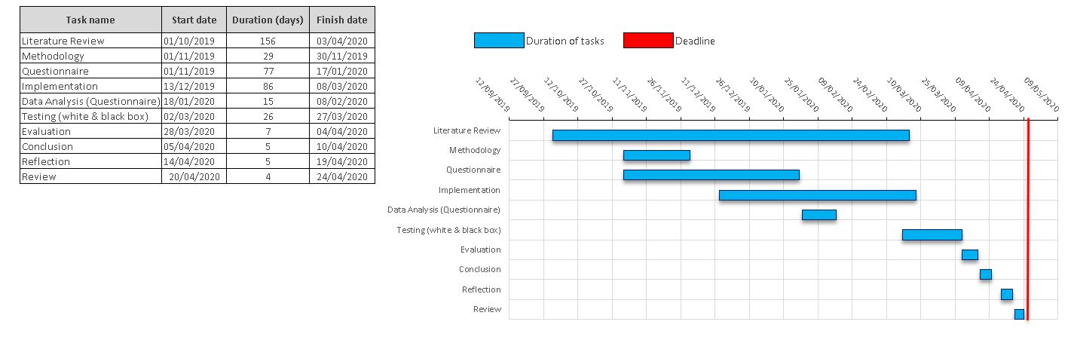
Figure 1: Gantt Chart showing Project Timeline

3.3 Methodological Approach
To fulfil the aim and objectives set out in Section 1, the following five step approach will be applied:
- Interview University wellbeing staff to gain insights into advantages and shortcomings of University Wellbeing Services
- Create an online student survey to gain information on student experiences of mental health and Wellbeing Services at their Universities
- Using knowledge gained from tasks 1 and 2 above, design and develop a prototype wellbeing application
- Trial the prototype application among a group of student participants and gain feedback on the applications wellbeing benefits and general usability. The prototype application is called ‘SOS Student’ as its main purpose is to support students in need.
- Based on learnings and knowledge from tasks 1 to 4, develop criteria/set of guidelines for Universities to utilise a wellbeing mobile application

This approach provides a holistic answer to the research question by utilising different perspectives on University Wellbeing Services. It provides both numerical and contextual data which can be interpreted to provide an in-depth insight into the specific concepts. Developing a prototype wellbeing application provides a testing ground of the potential of the application for future prospects. It also provides areas of further development and improvement as well as a basis for assessing the impact it has on students’ wellbeing. In-depth research is crucial since the Literature Review reinforced that any Wellbeing application must be evidenced and well-informed.

3.4 Data Collection Methods
The methods implemented to conduct the research utilised primary sources, as referred to in the Literature Review, in the format of an interview, survey and a mixed method approach. Data was collected through quantitative and qualitative methods:

- Qualitative data was collected through a face-to-face, semi-structured interview with a member of staff from student wellbeing services at University of Wales Trinity Saint David (UWTSD) Swansea Bay Campus
- Quantitative data was collected through a questionnaire which was distributed online to students through the Google Forms platform
- The mixed method approach was undertaken in the form of a prototype wellbeing application, to assess whether digitisation can improve student engagement in Wellbeing Services.

3.3.1 Interview
The interview provides a more holistic perspective on student wellbeing services, by including the experiences and opinions of a member of staff and, therefore, reducing the risk of any bias by solely considering student views. The data gathered was used to cross-reference with opinions of students on the same subjects. The interview was face-to-face and collected rich qualitative data, it was semi-structured where open ended questions were asked whilst also allowing for discussion and follow up questions. The interview was conducted at 10am on the 23/10/2019. The duration was approximately an hour and notes were taken during the interview. The interview comprised of 12 questions (Appendix B).

3.3.2 Survey
The survey was used to collect feedback about students’ experiences and opinions of wellbeing services at University (Appendix C). As mentioned in the literature review surveys provide a snapshot providing a view of the wellbeing services at a given time.
The survey has the following characteristics:
- Comprises mainly of multiple choice and rating scale questions, chosen to limit answer response (multiple choice and rating scale) to ensure analysis of the data is easier, as it limits the responses, increases data validity and reduces risk of input data errors
- Some free text questions are also included for topics where answers are difficult to categorise and to collect richer data
- Distribution was through public social media student groups and those students who wish to answer the questionnaire can i.e. the participants will be a self-selecting sample
- Hosted on Google Forms platform, answered online by clicking the link distributed on social media
- Open to respondents for 3 months from November 2019 to January 2020
- Aim was to collect a minimum of 50 respondents.

3.3.3 Wellbeing Application - Trial and Case Study
The prototype application was developed for Android devices using Visual Studio Xamarin (detailed in Literature Review) tested as a Case Study in a real University which will gather user experiences and feedback on the application. The users were a self-selected sample of 12 students at the selected University; UWTSD. The feedback questionnaire (Appendix E) was created in Google Forms and distributed to participants after a ten-minute period of use of the prototype. There is a demonstration file at the end of the document of the application in use. The questionnaire comprised of scoring users’ level of agreement or disagreement with 14 statements about the application. Two key elements, deemed crucial in the literature review for creating a successful mental health application, were tested through these statements:

- The effectiveness in meeting wellbeing needs of students through a digital method
- The usability of the mobile application itself

3.5 Pilot Study

A Pilot Study provides the groundwork of research and helps to identify any issues in the research prior to implementation. It tests data collection methods, protocols and research techniques in preparation for full implementation [61].
Through an initial paper prototype (Appendix G) various designs were explored for the layout of the various screens. Various software prototypes were developed as milestones were overcome during the Feature Driven Development stages; for example, a pop-up when the user scored below 5 has now been converted into ‘critical button’; reflecting the need for easily accessible quick help. Furthermore, it was not possible to implement a database using a REST API and instead data is stored locally. Therefore, design decisions had to accommodate this. This altered the research methodology as the software development cycle being applied was changed from iterative development to FDD. The Interim Viva demonstrated the importance of the interim survey results which stressed the current student mental health crisis and highlighted that students favoured a technological solution which can be accessed anytime and anywhere.
Due to resource limitations, the limits of the project scope and the timescale involved in developing design iterations of the application prototype, it was decided after the Pilot Study that a fully finished application was not feasible. Therefore, a new strategy was implemented which was to develop the ‘SOS Student’ application to a prototype stage so that it could be tested by students and utilised as a case study to provide evidence-backed guidance on how universities could develop a successful wellbeing application.

3.6 Data Processing and Analysis
Quantitative data from the surveys were checked and prepared before analysing; it was entered into a spreadsheet to check for missing data, outliers and transforming variables as this reduces the risk of errors and ensures data validity, accuracy and consistency. The data was then processed and analysed using Excel as it is an effective platform to generate reports and visualise the data in an easy to read format, efficiently. The research question forming the hypothesis, ‘Digitisation of Wellbeing Services; specifically monitoring, signposting support and early intervention, can improve the Wellbeing of University Students’, was tested using mean, median, mode and standard deviation calculations of the survey responses.
Data analysis of qualitative data was by means of content analysis. This consists of analysing and categorising themes and ideas within the data gathered. This data will be compared to the survey data to check for any major discrepancies, where the university and students may have differing opinions or understandings.

3.7 Limitation and Weaknesses
Naturally, as with all research, the study will face limitations and uncover weaknesses; for instance, if the survey data has numerous outliers or asymmetric distribution it will not provide an accurate result for a decision to be based upon. To overcome this, the questionnaire uses predominantly restricted questions.
In terms of testing the research question, it is important to be wary of the common errors such as the placebo effect which happens when participants wrongly assume a specific result and perceive or attain said results. The other is the Hawthorne effect which occurs when participants are being studied and are aware of this so results can be distorted [62]. To overcome this, the questionnaire contains limited and general information on the study to limit a placebo effect or any participant bias.
Content analysis can only describe data and a deeper understanding, meaning or explanation cannot be obtained for the patterns that have arisen. The study does not intend to be an in-depth, qualitatively rich analysis but aims to indicate if digitisation and technology is likely to improve student experience of Wellbeing Services. In order to do this, it must make use of a large, representative student population rather than examine individual and personal experiences.

3.8 Ethics
The ethical considerations, as discussed in the literature review, were taken very seriously and addressed as follows:
- Survey was kept anonymous and confidential; participation was optional and could be withdrawn at any time
- Data collected remains private and confidential
- Questions around mental health were not made compulsory and a ‘prefer not to say’ option was included. No detail was asked for on the individuals personal experience with mental health, the survey only intended to establish their opinions and experiences of using their universities wellbeing service
- Participants were informed of necessary details through a description of the study before the survey commenced and contact details were provided if the participant has any queries or concerns. Their survey could be withdrawn upon request
- All data gathered from the survey was stored securely and participants data was not analysed on an individual basis.
The criteria for validity and rigorousness in this type of research was maintained as the qualitative data was informed by both the students and a member of staff from Wellbeing Services. In addition, this data is informed by the results of the wellbeing application.

4. Results and Analysis

4.1 Introduction
This section will analyse the results from the Wellbeing Services Staff Interview, the Student Wellbeing Survey and the Student Protype Testing of ‘SOS Student’. The findings will be examined alongside research outlined in the Literature Review. Limitations of the results and suggested improvements will also be examined.

4.2 Wellbeing Services Staff Interview
The key findings from the interview were:
- University wellbeing services are under pressure and waiting times for Wellbeing Services are on average 5 weeks.
- The majority of the student referrals are self-referrals, which as evidenced in the literature review, shows there has been a decrease in stigma surrounding mental health issues.
- Feedback on the university’s services can be given via completion of a survey.
- Improvements to services are constantly being applied however, there is no current plan to become more digitised.
- The only resource provided online is Whitewall offering safe, anonymous online support 24/7. It provides anxiety management, online courses and tips, promotes positive thinking and weight management. They are always counsellors online to moderate and provide additional support [63].
These findings are in-line with the results from the student survey, agreeing that there are long waits for face-to-face services, digital services are minimal and wellbeing staff are outnumbered by the demand for services.

4.3 Student Wellbeing Survey

4.3.1 Sample
A total of 66 participants took part in the ‘Student Wellbeing Survey’ which explored student experiences of mental health whilst studying at University and specifically if Wellbeing services effectively met their mental health needs. This is a satisfactory sample size for this research; it is unlikely to be large enough to represent the entire student population of the UK, but it is large enough to provide insights into the student population in general.

Demographical Analysis
Percentages are rounded to 0dp.

4.3.2.1 Gender
Females made up 62% of the sample, males 36% and 2% preferred not to state their gender. Since the literature highlights that female students are more likely to suffer from poor mental health, the size of these groups is appropriate for this research because it’s aim is to better support individuals suffering from poor mental health [64].
Figure 2: Graph of gender of participants

4.3.2.2 Age Group
Most participants (68%) fell into the 18-25 age group, while 23% were aged between 26 and 35. The age profile of participants is representative of the general student population.
Figure 3: Graph of age of participants

4.3.2.3 University Location
The largest proportion of participants were studying in Universities in England (42%), followed by Wales (36%) and Scotland (12%). This is not representative of the various countries, but since this study is looking at universities in general, it should not have a significant impact on results.

Figure 4: Graph of country of university
Therefore, the ‘typical’ demographic profile of a participant in this research is a female, aged between 18-25, studying in England. This is a common demographic in the general student population, so this is suitable for the purpose of this research.

4.3.2.4 University Course
The top 5 most common course categories that participants are studying were:
- Computing (17%)
- Engineering, Architecture, Building and Planning (12%)
- Education, Health & Social (9%)
- Geography, Geology and Environmental Management/Science (9%)
- Psychology, Sociology and Criminology (9%).
Overall, there is a widespread variety of courses and therefore any conclusions will not just be applicable to one university course.

Figure 5: Pie Chart of university courses studied byparticipants

Mental Health
Over two-thirds of the sample (76%) stated that they have suffered from poor mental health whilst studying at university (Figure 5). This broadly means that for every student who has not suffered from mental health, three other students have. This reiterates the message from previous research discussed in the Literature Review; poor mental health is growing among students and needs to be addressed [14].

Figure 6: Graph of pariticpants who have suffered from poor mental health
Within the sample, females were more likely to suffer from mental health whilst studying; 62% compared to 38% of males. Once again, this supports previous research which has found a relationship between gender and poor mental health in students [64].

Figure 7: Graph showing gender of participants who suffered from mental health

Across age groups, 70% of those suffering from mental health were aged between 18 and 25. However this age group also made up most of the sample and makes up the majority of the student population in the UK, so it is unlikely to mean a link between age group and mental health among students.
Most of the students suffering from mental health in the sample were studying in Wales (42%) and England (42%). However, again, these groups made up most of the sample, so this is not surprising. Although different countries may have different policies on mental health so this would be worth researching further.

Wellbeing Services

Approximately 62% of participants reported that they had access to a Wellbeing Service at their university, 33% stated they did not and 5% were not sure. These are not encouraging statistics since all universities are now expected to set up services to support student mental health [9].
Although this survey is self-reported (i.e. the answers are the student’s interpretation and not necessarily the truth), it is just as discouraging if the visibility of the Universities Wellbeing Service is so poor that a student is convinced in saying that they do not have access to a Wellbeing Service.
Where there was not a Wellbeing Service, 96% of students stated that they would benefit from having one, indicating how important these are to students.

Figure 8: Pie Chart of university wellbeing services

Of the students studying in England, 49% confirmed they had access to a Wellbeing Service, compared to just 32% of students in Wales and 15% studying in Scotland.
Of the students who had access to a Wellbeing service, only 32% had made use of it at least once whilst studying at university. Those who did not use their university Wellbeing service had various reasons for not doing so; including that they didn’t feel they needed to, but also including 1 in 5 students (20%) who didn’t feel comfortable in doing so. This is a major problem because if students are not comfortable using their own Wellbeing Service when they are suffering from poor mental health then it is not meeting their needs and is not fit for purpose. This may also be because most services provided are face-to-face, which are not suited to all students, digital solutions would help here because they allow anonymity.
Figure 9 and Table 3 show the overall scoring of Wellbeing Services by students who had made use of them. Availability of wellbeing staff had the lowest average rating (mean) of 3.1; indicating that there are not enough staff to meet the demands and needs of students. All of the average ratings (means) fell below 3.9; meaning that overall, Wellbeing Services were not deemed to perform ‘well’ in terms of accessibility, quality, availability or being effectively advertised. Digitisation can assist in improving all of these aspects; a mobile application can be made accessible to all user types and needs, the quality can be ensured through usability testing, the application would be available 24/7 unlike relying on wellbeing staff and there are far more options for advertisement through digital platforms (email, social media, website, etc.). There is a lot of variation in these results (indicated by the standard deviations) indicating that services may not be consistently provided; perhaps dependent on how busy the staff are.
5
4
3
2
1
1
6
3
4
3
6
1
2
4
How effectively advertised are the Wellbeing Services?
How accessible are the Wellbeing Services?
How would you rate the quality of the Wellbeing Services?
How would you rate the availability of the Wellbeing Services?
Ratings of Wellbeing Services
Wellbeing Services
X
5
Frequency of response
Very well
2
3
1
3
2
1
2
3
Very poorly
Figure 9: Frequency of usability responses

Table 3: Analysis of Wellbeing Ratings
 | How effectively advertised are the Wellbeing Services provided at University? | How accessible are the Wellbeing Services provided at University? | How would you rate the quality of the Wellbeing Services at University? | How would you rate the availability of the Wellbeing Services staff?
Mean | 3.4 | 3.8 | 3.7 | 3.1
Mode | 4 | 3 | 5 | 4
Median | 4 | 4 | 4 | 3
Standard Deviation | 0.96 | 1.01 | 1.44 | 1.38

4.3.5 Digitisation in Wellbeing Services
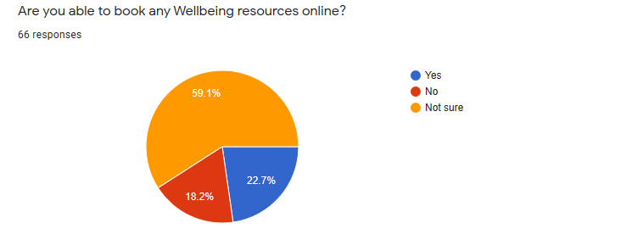
The results from the survey are not encouraging in terms of the use of digitisation and technology being utilised to provide Wellbeing Services. Figure 10 shows that only 23% of students were able to book Wellbeing Services online; this is something that should be widely available; especially since it has already been indicated that availability of Wellbeing Staff is poor. Digital services can provide support to students during these times in order to bridge the availability shortage.
Figure 10: Pie Chart showing availability of online resources
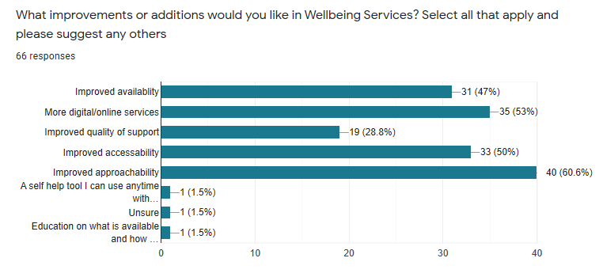
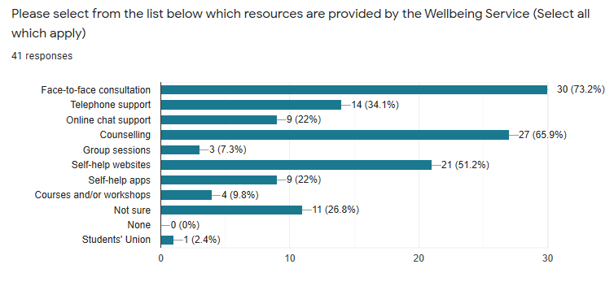
Furthermore, Figure 11 shows that online and digital services are among the least common resources available (i.e. online chat and self-help applications). Approximately 53% of participants selected that they would like more digital/online services included in Wellbeing Services, so this indicates a large discrepancy between what students need and what student services are providing.
Figure 12: Graph showing improvements that could be made
Figure 11: Graph showing resources available (above) and resources desired (below)

4.3.6 Student Wellbeing Survey Summary
The results indicate that ultimately university Wellbeing Services are not currently meeting the mental health needs of students. The results also support the literature’s indication that poor mental health is a big issue among students. These results clearly evidence that traditional wellbeing services are not working and require major improvements to meet mental health needs in Universities. Significantly, even though only 32% of the sample made use of their Wellbeing Service; one of the results was that availability of Wellbeing Staff is poor. This echoes the findings from the staff survey, both students and staff agree on this.
Further deteriorating this is the lack of digital solutions which by their very nature are more accessible and available than traditional face to face methods. The results show that online and digital services are some of the least common wellbeing services available at present, even though students express than they would like these provided. It is clearly worth investigating how digitisation can alleviate the current downfalls of Wellbeing Services; wellbeing Services are for students, so taking on board their feedback is essential.

SOS Student – Prototype Testing

4.3.1 Overview
A prototype application was built after identifying the shortcomings of University Wellbeing Services through the Student Wellbeing Survey. The survey contained 14 Statements which participants rated their agree/disagreement with through standardised responses. Two key elements were tested:
- The effectiveness in meeting wellbeing needs of students through a digital method
- The usability of the mobile application itself
A scoring scale from 1 to 5 was applied to the results; whereby 5 is the most positive feedback, 1 is the most negative feedback and 3 is neither positive or negative (neutral). A Red-Amber-Green (RAG) colouring system was developed to clearly categorise and assess the results (Table 4).
Two negatively framed statements were included in the survey to ensure there was not a positive bias (these are denoted by a * throughout this section), however for the scoring to reflect positive or negative feedback the scores for the responses to these two statements were reversed. For example, strongly disagreeing with the negative statement was scored the same way as strongly agreeing with a positive statement.

Feedback | Colour | Score | Description
Very Positive | Dark Green | 5 | Extremely positive feedback
Positive | Green | 4 | Positive feedback
Neutral | Amber | 3 | Neither positive nor negative feedback
Negative | Light Red | 2 | Negative feedback
Very Negative | Red | 1 | Extremely negative feedback
Table 4: Feedback scoring

4.3.1. Usability - Testing Results
The mean score for the usability of the application was 4.5 out of a maximum possible score of 5. The full matrix of results are displayed in Tables 5 and 6; showing that the overwhelming majority of feedback was positive. Figure 13 shows the frequency of positive, negative and neutral responses.
Two statements which received the very positive feedback are regarding how confident and comfortable the participant felt using the system. These are important results because if a user doesn’t feel encouraged about using the system then ultimately, they’re not going to use of it.
There are only two statements which received some negative feedback. The first is to do with frequency of use; in this case stating that the user would use the system weekly and the second states that the user would need technical support to be able to use the system. This indicates that a minority may use the application less often than weekly and perhaps the frequency of use requires further analysis. Realistically, this would require large-scale assessment over a longer trial period. However, it is important that users record their mental health often to allow self-monitoring so it would be worth exploring this issue further. One participant strongly agreed that they would require technical support to use the application. Although this is a minority, the sample is small and therefore this requires some further analysis. It is important that this further analysis includes different age groups as the literature showed that older individuals generally have less technological literacy [65]. This is backed up by the variability in the results for the statement “I would imagine that most people would learn to use this system very quickly”; whereby participants are likely to be thinking of the student population as a whole and not just themselves.
 | Usability Feedback Statements | Mean | Mode | Median | Standard Deviation
1 | I felt confident using the system | 4.8 | 5 | 5 | 0.43
2 | I needed to learn a lot of things before I could get going with this system* | 4.8 | 5 | 5 | 0.60
3 | I would imagine that most people would learn to use this system very quickly | 4.7 | 5 | 5 | 0.62
4 | I felt comfortable using the system | 4.7 | 5 | 5 | 0.47
5 | I thought the user interface remained consistent throughout | 4.6 | 5 | 5 | 0.76
6 | The structure of the application was thought-out | 4.5 | 5 | 5 | 0.65
7 | The system was easy to use | 4.5 | 5 | 5 | 0.65
8 | I think that I would need the support of a technical person to be able to use this system* | 4.3 | 5 | 5 | 1.18
9 | I would use this system weekly | 3.8 | 4 | 4 | 0.90
 | Total for Usability Results | 4.51 | 5 | 5 | 0.78
Table 5: Further analysis of Usability Feedback Statements
Looking at the usability feedback dataset as a whole, the mean is 4.51 and the mode is 5. The mode means that 5, which represents the most positive feedback, is the highest frequent score which is the best possible result the testing could hope to gain. In line with this, the population median is also 5. The standard deviation, describing the variability in the data, is 0.78. However, to be able to apply these results to represent the whole student population, testing would need to be done on a much larger scale.

Table 6: Application Usability Matrix Results
5
4
3
2
1
7
4
1
8
3
5
3
8
2
1
7
4
1
9
1
2
9
2
1
9
10
4
3
1
1
1
1
The system was easy to use
I felt comfortable using the system
Application Usability Feedback
Feedback Score
X
Frequency of response
I would use the system weekly
I think that I would need the support of a technical person to be able to use this system*
The structure of the application was thought-out
I thought the user interface remained consistent throughout
I would imagine that most people would learn to use this system quickly
I felt confident using the system
I needed to learn a lot of things before I could get going with the system*
Usability Statements
Figure 13: Usability frequency of responses

4.3.2 Meeting Wellbeing Needs – Testing Results
The mean result for how well the application met wellbeing needs was 4.35 out of a possible maximum score of 5. This means that the application scored better in terms of usability, but the wellbeing results are nonetheless overwhelmingly positive; this section did not receive any negative feedback. Figure 14 shows the frequency of positive and neutral responses and Table 7 shows further analysis, including the variability in responses.
Table 7: Application Wellbeing Results Matrix
The highest scoring statement was concerning the wellbeing questions and how well they helped users explore their reasons for struggling with mental health (see Table 8). This is a very positive result since the application aims to help users engage with their wellbeing and respond to it when needed. If this statement scored neutrally or negatively then it would mean that the application is not fit for its purpose.
The lowest scoring statement, but still with a positive score overall, was that the use of emojis helped the user quantify how they felt. As identified in the literature review, this is a new technique for measuring emotions and therefore is likely to require further testing to establish which emojis best represent certain emotions.
There was less variability in the wellbeing scores, particularly when it came to the two statements regarding how informative the additional information pages were and how effective the questions were for helping users explore their reasons for struggling with mental health (see Table 8). Both of these statements received consistently positive scores.

 | Wellbeing Feedback Statements | Mean | Mode | Median | Standard Deviation
1 | The questions asked helped me to explore reasons why I may be struggling | 4.5 | 4 | 4.5 | 0.5
2 | The additional information pages provided sufficient support for coping strategies | 4.4 | 4 | 4 | 0.5
3 | The system helped me to engage with my feelings | 4.4 | 5 | 4.5 | 0.6
4 | Quantifying my emotions helped me to better understand my mental health | 4.3 | 4 | 4 | 0.7
5 | The use of emojis helped me to quantify how I feel | 4.2 | 4 | 4 | 0.7
 | Total for Wellbeing Results | 4.35 | 4 | 4 | 0.63
Table 8 Further analysis of Wellbeing Feedback Statements
Examining the wellbeing feedback dataset as a whole, the mean is 4.35 and the mode is 4. The mode means that 4, which represents positive feedback, is the highest frequent score which is a very positive result. The population median is also 4. The standard deviation, describing the variability in the data, is 0.63. However, as with the usability results, to verify these results as a representation of the entire student population, testing would need to be done on a much larger scale.
Figure 14: Wellbeing frequency of responses
Quantifying my emotions helped me to better understand my mental health
The additional information pages provided sufficient support for coping strategies
The questions helped me to explore reasons why I may be struggling
The use of emojis helped me to quantify how I feel
Wellbeing Statements
Feedback Score
5
4
3
2
1
6
5
1
5
5
5
7
6
6
4
6
2
The system helped me to engage with my feelings
Application Wellbeing Feedback
X
Frequency of response
2
Figure 13

4.3.3. Prototype Testing Summary
Across the board, the wellbeing results from the prototype testing were far more positive than those from the review of existing wellbeing services. It is important to note that the prototype testing was completed by a small group of researcher-selected participants, however these results can still be used as an indication of which elements in the application work well and which elements need improvement. The results were very positive and more importantly, highlighted which areas required further in-depth analysis; the usability for all age groups, the frequency of use and the implementation of emojis to quantify wellbeing

5.Application Design and Requirements
The following section provides an overview of the application design, the feature requirements and implementation of ‘SOS Student’.
5.1 Requirements
The requirements for SOS Student were determined through the application of MosCoW. It is a prioritisation process which allows for the requirements to be ranked; where the most important requirements are focused on [66]. The prioritisation technique follows the structure outlined below:
- Must: these requirements are compulsory (i.e. required to be satisfied) for the final solution to be operational.
- Should: high priority requirements which will be implemented if time allows within the delivery time frame.
- Could: requirements which are desirable, but the software will still be operational if these requirements are not implemented.
- Won’t/ would: requirements which are desired but since the delivery time frame does not allow, they will not be implemented in this version of the software [66].

5.1.1 ‘Must have’ MosCow Requirements

Must have | Description
Log in/sign up | This requires the student to complete a registration form which collects the following data: first and last name, email address, username and password. The login page requests the user to input their username and password. The user will not be able to login through existing social media accounts. GDPR (General Data Protection Regulation) is met because the user is unable to register through their social media accounts and the application will not have access to personal data on the individual’s profile [67]. Therefore, it is the most secure and safe method for registration.
Track wellbeing | This is implemented via a slider scale which asks the student to rate their wellbeing on a scale from 0-10; 0 signifying the user is not ok and 10 that the user is doing very well.
Track academic performance | This follows the same process for tracking wellbeing. However, it tracks their academic performance to determining if the student is coping well or not.
Help pages | These are provided to the students for additional help. It provides them with web links to credited, professional pages which provide coping strategies for mental health issues such as anxiety or depression.
Question page | The students are provided with questions linked to mental health concerns raised in the Literature Review allowing students to explore their feelings and/or struggles. The questions are implemented in this format as the literature review found that text is the preferred method of communication, 90% of 16-24-year olds communicate via texts at least once a day. The total time spent on a mobile phone is 124 billion minutes. These statistics reflect how face-to-face communication is no longer the favoured way to communicate [68].
Emoji pages | The student is provided with a screen of various emojis which will help them engage with how they feel. Emojis can be interpreted in various ways and have different meanings for different individuals. The student will be required to select the emoji which best represents their current mood. It is said that emojis help an individual to express sentiment without the need to express it in words which often result in vagueness or complicated sentences. However, there can be misunderstandings between two parties as individuals can have their own interpretations of a given emoji [69]. It is believed that emojis are a way of expressing a user’s identity and personality [70].
Table 9: Must have MosCow Requirements
5.1.2 ‘Should have’ MosCow Requirements

Should have | Description
Critical button | The student is asked if they are in a critical state or not. If it is decided that they are, the student is provided with details to contact the Samaritans. This will only be implemented on the wellbeing slider page when they rate their wellbeing as less than 5 out of 10.
User home page | Students are provided with a personalised user profile where they can access their data collected through a central dashboard.
Table 10: Should have MosCow Requirements

5.1.3 ‘Could have’ MosCow Requirements

Could have | Description
Database | A future implementation to connect SOS Student to the university database so all the data gathered is stored in one place and notifications can be sent to tutors when students score under 5 and are in a critical state.
Chat forum | This could be beneficial as a platform to allow students to discuss their mental health issues with others (anonymous can be an option), offering peer-led support. Students can share experiences and coping skills. However, it is advised for chat rooms to be moderated to prevent abusive behaviour. Furthermore, students need to be wary of triggers and to be cautions to solely build healthy and genuine relationships. Predators may take advantage of vulnerable students making them feel uncomfortable or ashamed of their illness. Therefore, a reporting mechanism is advised. However, consideration of the ethical issues which may arise must be considered, such as the content being shared as it might be private. Sharing content has its risks of exposure and privacy being breached and some students may use the forum as a bullying platform [71].
Graphs | These could be created from the data collected to quickly communicate important trends or patterns. Data analytics can be applied to the results gathered from the sliders and be used to produce reports to see if at certain times of the year mental health issues peak as a result of academic pressure. It can help the university to adopt plans to support students in response to the data they are analysing, and to also balance supply and demand as the study found this to be a big issue.
Table 11: Could have MosCow Requirements

5.1.4 ‘Won’t have’ MosCow Requirements

Won’t | Requirement
Diagnostic | This will not be implemented as there is no peer-reviewed or expert evidence in the development of the application. Students will be provided with credible links to seek appropriate credible coping strategies or help. SOS Student supports students and does not provide expert evidence, although there could be the option to partner with an accredited charity in the future.
Own counselling support | This will not be implemented. However, this could be a future implementation. Help could be provided via online chat, telephone or email with the aim of taking pressure off lecturers, wellbeing services and help the students who may need additional support, someone to talk to or just advice. As the literature showed, it is vital to intervene as soon as possible therefore urgent counselling support would be beneficial.
Professional certified advice | This will not be provided as it is costly and mental health services are currently being stretched and under a lot of strain and pressure and therefore it is not feasible. There are long waiting lists to access services which also has a negative impact on students.
Monitor student’s attendance | This will not be implemented as there are already technologies which have been developed which can carry out this requirement as evidenced in the literature review.
Table 12: Won’t have MosCow Requirements
5.2 Design
The design of ‘SOS Student’ is a key component as it needs to fulfil the research question and objectives. Therefore, outlined below are the design phases involved in the development of SOS Student.

5.2.1 UML (Unified Modelling Language) Diagrams
UML allows for architecture, design and implementation of software systems to be visually represented [72]. Use case diagrams are vital for the process of software requirements as they specify the expected behaviour [73]. Use case diagrams for help pages, critical button and sliders can be found in Appendix H. Use case diagrams have been implemented in the design phases of SOS Student and a selection of these are outlined below.
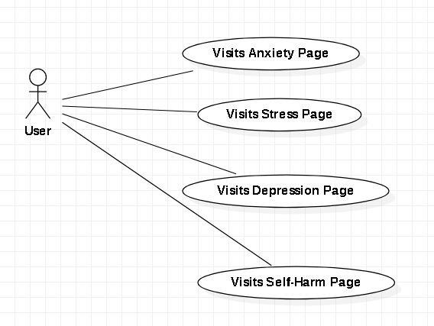  Figure 14: Use case diagram | The use case diagram for the anxiety help page (Figure 14) demonstrates the user interacting with the additional help pages.
A sequence diagram shows the interaction of objects in a sequence order. In other words, it shows the interactions in the order they take place [74]. A use case example has also been applicationlied and can be found in Appendix H. An example of this within SOS Student is seen below.
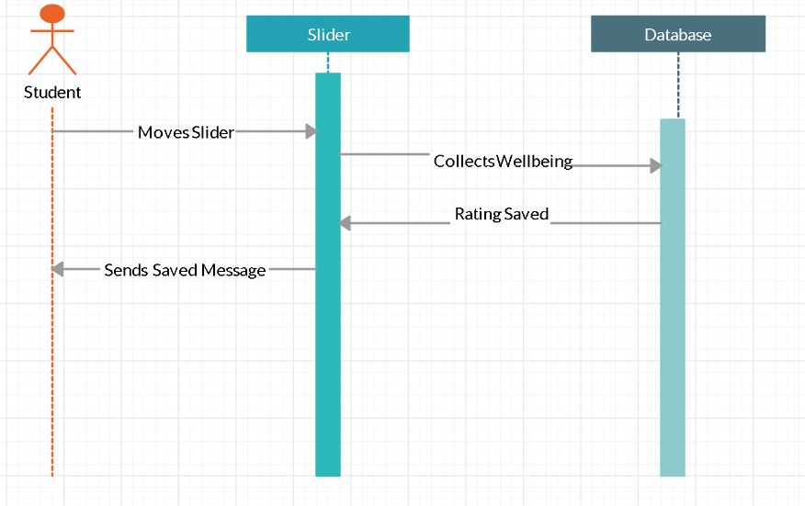  Figure 15: Sequence diagram | The sequence diagram (Figure 15) depicts the users interaction with the slider. The user simply moves the slider to which ranking best reflects their current (wellbeing/academic state) and the rating is submitted and a save message is returned.

An Entity Relationship (ER) diagram shows entity relationships within a database[75]. Therefore, ER diagrams allow for the logical structure of a database to be illustrated. Below is the ER diagram for SOS Student.
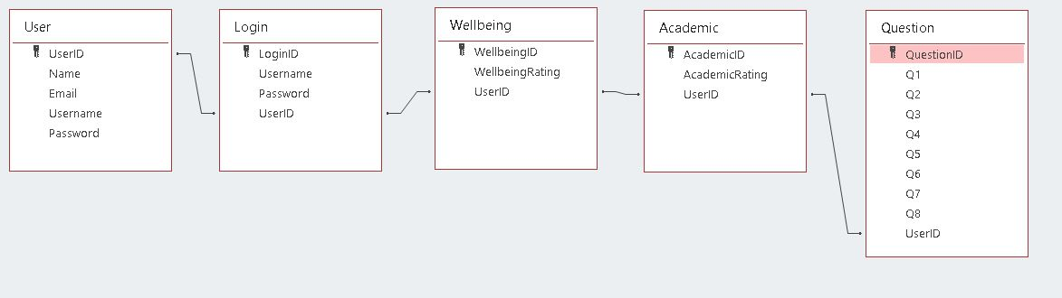
Figure 16: ER diagram
The ER diagram (Figure 16) shows the data which SOS Student will be collecting from its users and their relationships (one to one).
State machine diagrams also known as state diagrams depict the various states of an entity. They can also depict how an entity reacts to different events [76]. A use case example has also been applicationlied and can be found at appendix H. An example of a state diagram implemented in SOS Student can be seen below (Figure 17).
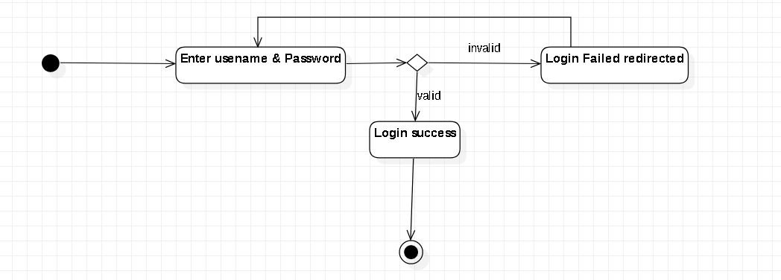
Figure 17: State machine diagram
Figure 17 shows the login state for SOS student. It depicts how the user enters their username and password. If successful, the user proceeds to the next page. However, if unsuccessful they are redirected to attempt to login again.

5.2.2 UI Design
SOS Student follows a simplistic design ensuring it is user-friendly and, as emphasised in the literature review, it caters to all user abilities. It displays only target-relevant content and is easy to navigate, as the user-feedback confirmed. The following are some of the key design aspects found within the application.
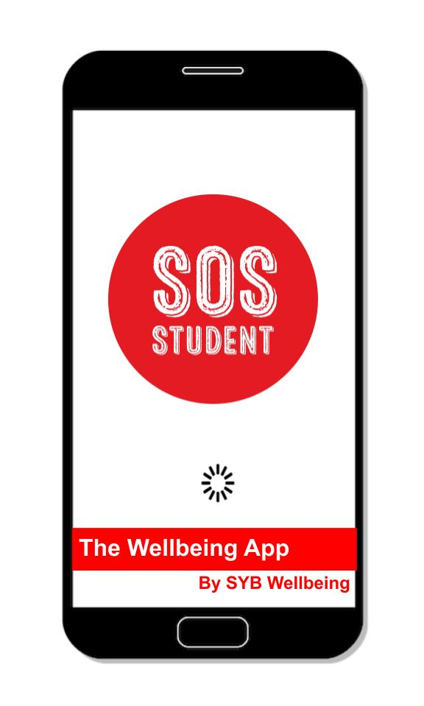  Figure 18: Logo design | The logo design (Figure 18) of the application plays a key role in the application design. The colour red is used throughout ensuring consistency is maintained and familiarity is created. The logo is initially used as a button upon the application being opened which the user taps on to either register or login.

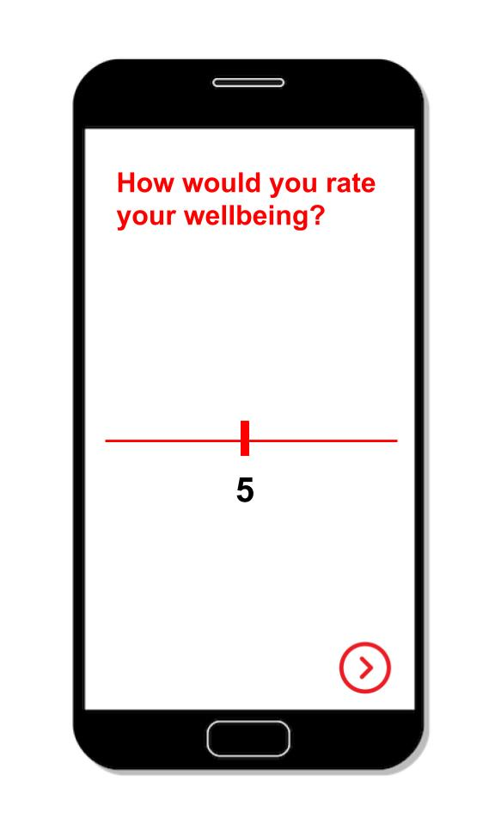  Figure 19: Slider design | The slider (Figure 19) is a simplistic tool with the numbering shown at the bottom of the page so the user is aware of their current wellbeing/academic score.

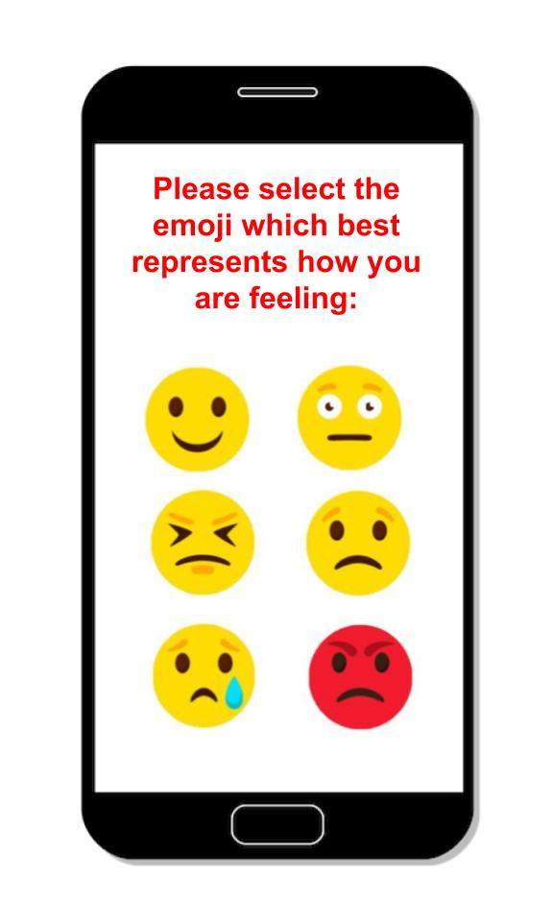  Figure 20: Emoji page design | The emoji page (Figure 20) is again simplistic with the emojis implemented within a grid format. Each emoji represents a different mood. The emojis are open to the users own interpretation. As the feedback indicated this is a new and effective tool, but requires further research.

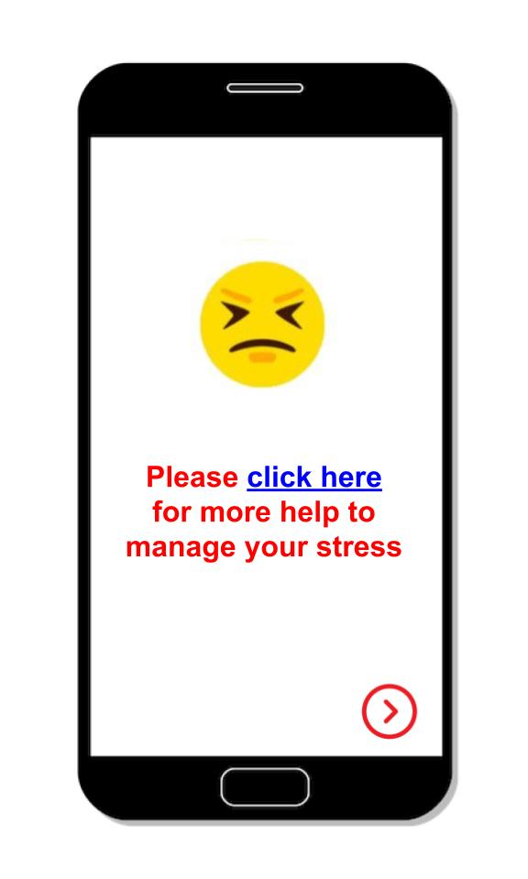  Figure 21: Additional help page design | 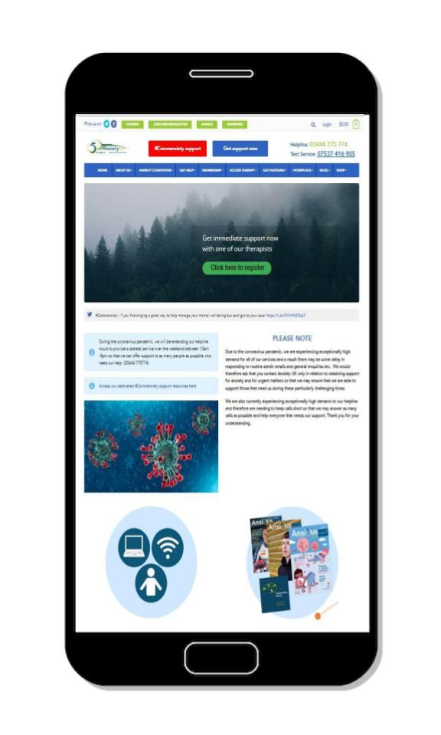  Figure 22: Accredited Webpage (Anxiety UK)
The additional help pages (Figures 21 & 22) are designed with the emoji the user clicked on prior and links at the bottom of the screen to navigate the user to the additional credited page for further information and coping strategies.

5.2.3 Database
As evidenced in the Literature Review, Xamarin was the most suitable platform to utilise for the application development. Xamarin supports database driven applications utilising SQLite database engine which allows for objects within the shared code to be saved and loaded. Xamarin Forms supports applications utilising SQLite.NET to read and write data [77].
Xamarin.Forms code can be run on various platforms but each has its own filesystem. Therefore, the process of reading and writing files is required to be performed utilising each platform native file APIs. This is carried out by using the System.IO classes allowing for access to each platforms file system. The class allows for files to be created, deleted and read [77].
The file path for each platform can be determined using Environment.SpecialFolder found in the .NET Standard library. Environment.GetFolderPath method can be combined with a filename using the Path.Combine method [77].
In terms for Xamarin.Forms local databased SQLite.Net shared code is used to store and retrieve information within a local database. This requires installing SQLite NuGet package: sqlite-net-pcl to the shared code project [78].
A tables folder is than created to define the student class. An ID property is marked with a PrimaryKey attribute so each student case within the SQLite.NET database has a unique id [78].
Overall, SQLite.Net database will be implemented as it is supported by Xamarin Forms and allows for data to be retrieved and read.

5.3 Implementation

5.3.1 Errors Encountered
When implementing the ‘below 5’ critical button, the following errors were encountered in the code (Figure 23). The error suggests that a stack trace is being dumped which would be the most efficient way to debug.
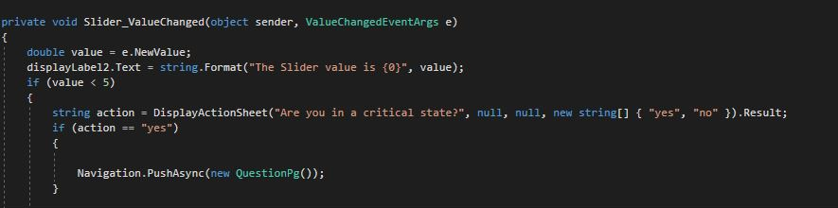
Figure 23: Code for critical button
The solution (see Figures 24 & 26) to the error was implementing a critical button error as a display alert (Figure 25).
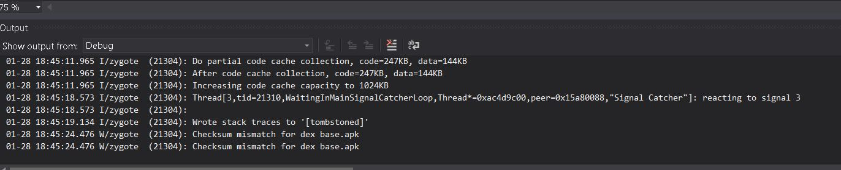
Figure 24: Error in critical button code
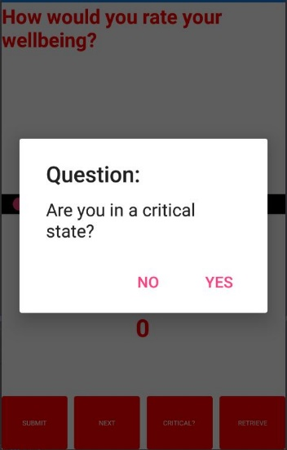  Figure 25: Critical button prototype | 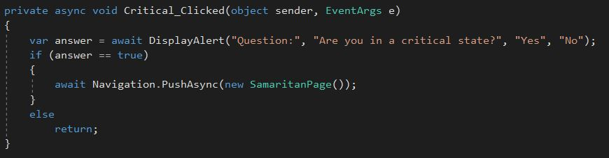  Figure 26: Critical button implementation

Furthermore, implementing the “are you in a critical state?” as a popup resulted in an error (Figure 27).
Figure 27: Popup Error
Additionally, further errors were encountered when trying to display the data stored in the tables (Figure 28).
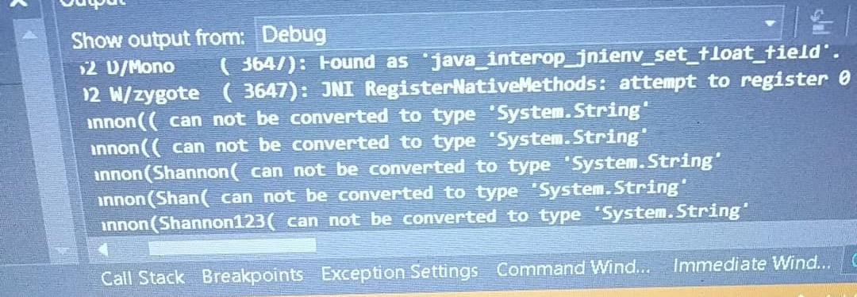
Figure 28: Error for conversion

This was resolved by applying an implicit conversion, as seen below (Figure 29) [79].
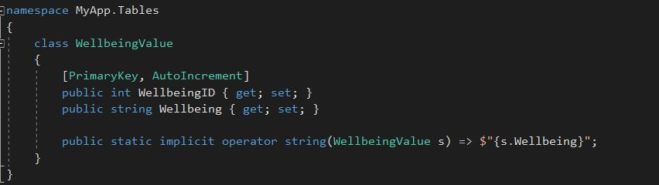
Figure 29: Wellbeing Class
Moreover, the first prototype version of SOS Student contained an implementation of a MySQL database. However, after continous errors and extensive research it was discovered that MySQL is not supported by Xamarin, as a local database as it is not secure. It requires REST services or a web API [78] [80] (Figure 30).
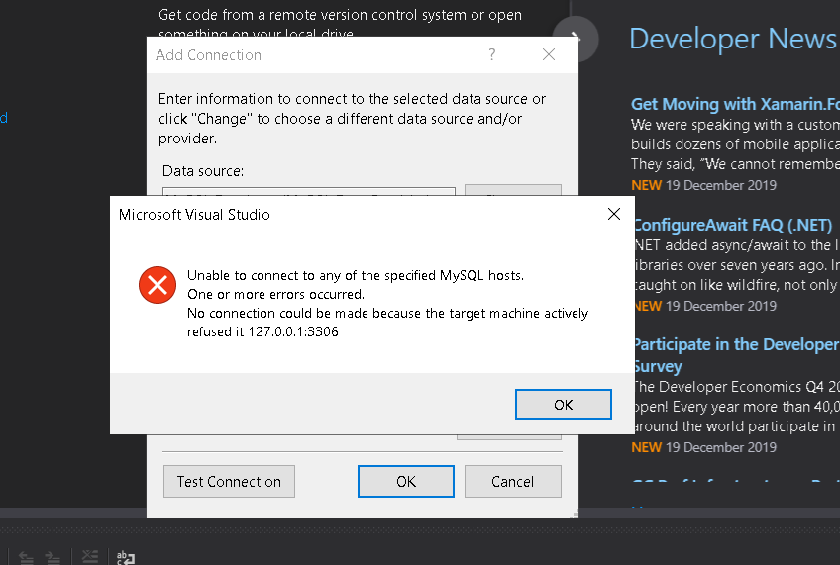
Figure 30: MySQL Connection Error

5.3.2 Feature Driven Development
Feature Driven Development (FDD) primary focus is developing features within short iterations. It also allows for configuration management meaning it identifies source code for the features and documents any changes. FDD consist of the following 5 phases [81] [82]:
- The development of an overall model which outlines the desired software which will solve the problem identified [82].
- The development of a features list where each feature is required to be developed within two weeks [82].
- A plan by feature which involves ordering the features to be developed and implemented.
- Design by feature involves defining the features priorities [82].
- Build by feature where the feature development is executed including the UI design and testing the feature and approving it. If approval is given the feature is ready to be added to the main build and released [82].
FDD is applied to the MoSCoW requirements and each requirement will be a feature in the model. It is important that the requirements are clearly defined and understood so that development can be efficient and if errors are encountered, changes and solutions can be applied within a timely manner. Leeway is important to apply when determining deadlines. Testing against the requirements is crucial to ensure all the requirements have been met in a feature so that the feature functions accordingly. Changes in requirement; if changes are implemented leeway is required when discussing deadlines for each feature. The consequences of not knowing when the development will be finished can be mitigated by applying deadlines to when each feature is required to be completed by, which in this case is 2 weeks. This will consider one final test of the completed project. Black box and white box testing is applied to mitigate risks.
Advantages are that the features are condensed down into smaller manageable ones. This provides an understanding of a project’s context and scope. Furthermore, it provides regular iterative releases allowing for coding errors to be fixed efficiently which in-turn reduces risk. Risks are mitigated as each iteration allows for its own series of tests and debugging [82]. On the other hand, there are disadvantages such as the iterations (features) may not be as clearly defined compared to which can have an impact if it is applied to existing systems which do not have models [82].

5.3.3 Feature Driven Development Implemented

5.3.3.1 Tables
The implementation of SOS student was achieved by creating tables (Figure 31) for student registration, wellbeing rating, academic rating and questions.
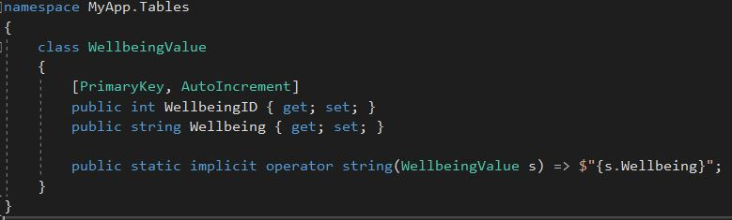
Figure 31: Wellbeing Table

5.3.3.2 Views
Views were also created to retrieve the wellbeing, academic and question results. The views were created using a list view (Figures 32 & 33). The list view is used to display the users input for their ratings and answers to questions. For the data to be retrieved in a list view an implicit string converter is implemented (Figure 33). The same process is applied to both the academic rating and question pages.
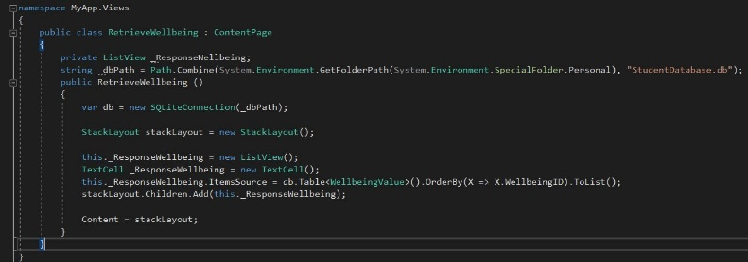  Figure 32 Wellbeing Rating List View Code |   Figure 33: Wellbeing ListView Displayed
To store the results, a similar process is applied where a database connection is established and the data is stored within the tables (Figures 34 and 35). It is stored in descending order in accordance with its wellbeing ID.
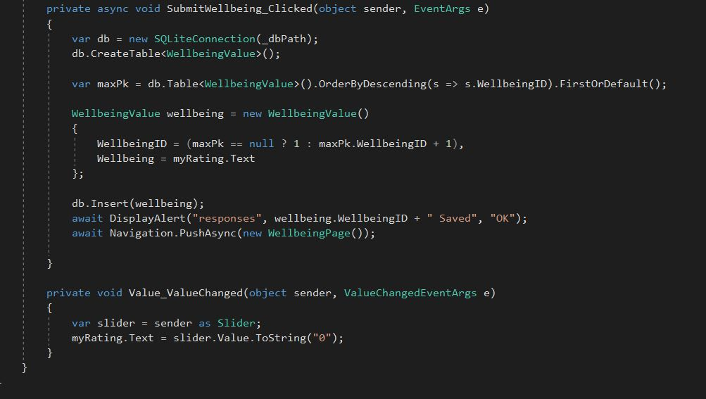  Figure 34: Code Implementation for storing data | 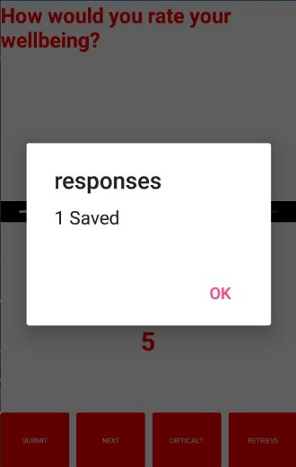  Figure35: UI Display for responses saved

5.3.3.3 Login Page
The login page was implemented through the creation of a table to store the student registration details (Figure 36). XAML code was implemented to design the layout of the login page (Figure 37). A database connection was established for the login click event (Figure 38). The login registration data is stored within the StudentReg table.
If the registration details match, then the user is navigated to the next page. If the login details do not match up, they are presented with an error (Figure 39).
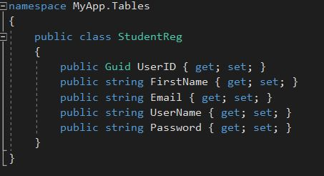  Figure 36: StudentReg Table | 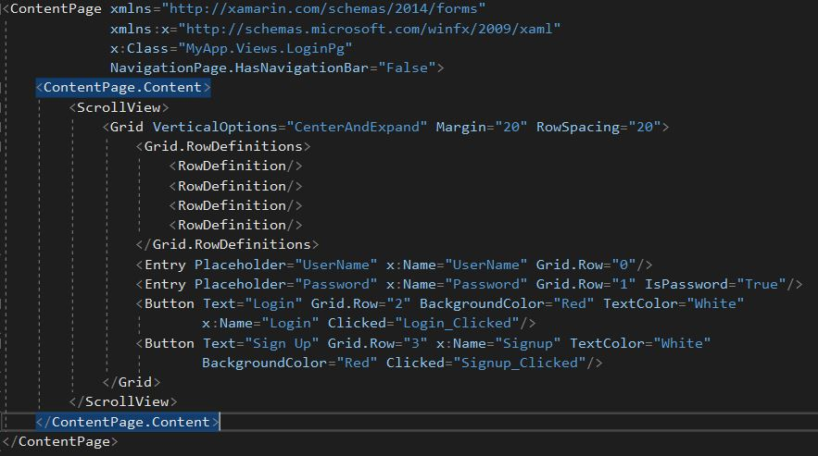  Figure 37: XAML code implementation for registration page
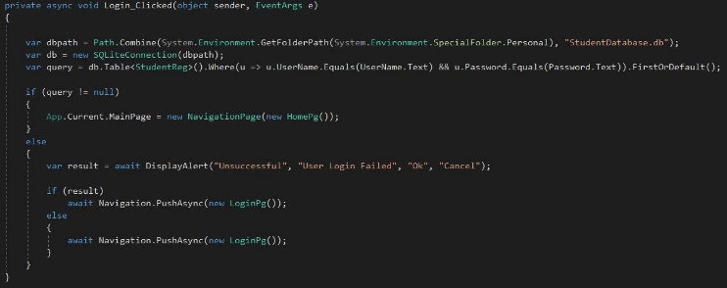  Figure 38: C# Code implementation for registration page | 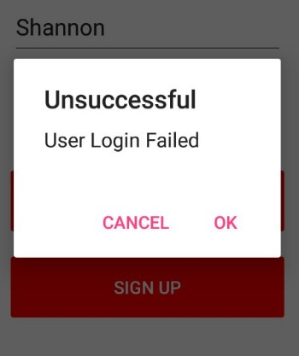  Figure 39: UI Display for login failed

5.3.3.4 URL implementation for help pages
The XAML code shows the design implementation of the help pages (Figure 40). A formatted string was implemented with combined text and a TapGestureRecognizer. The formatted string allowed for “here” to be underlined and coloured blue as a cue for the user to click the link (Figure 41). A TapGestureRecognizer event was implemented (Figure 42) to navigate the user to relevant coping strategy sources (Figure 43).
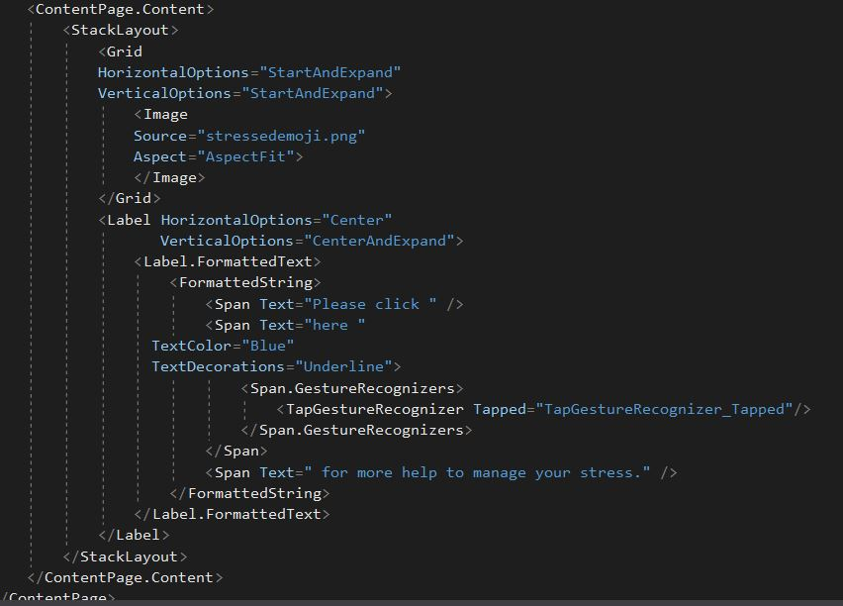  Figure 40: XAML Code design for web page | 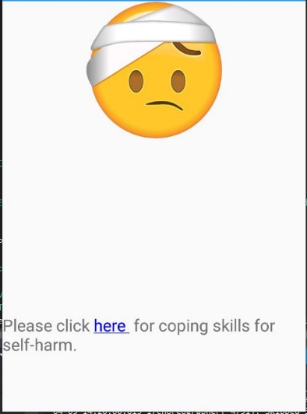  Figure 41: UI Display of help page
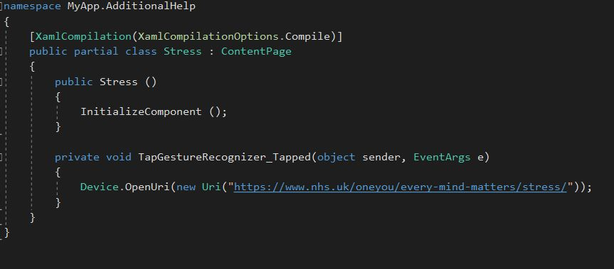  Figure 42: C# Code implementation for web page | 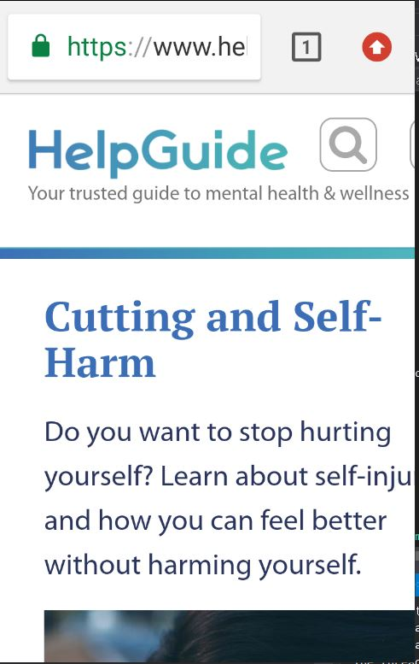  Figure 43: UI Display for web page

5.3.3.5 Database Connectivity
To ensure connectivity to the database, the following piece of code is used within the views (Figure 44):
string _dbPath = Path.Combine(System.Environment.GetFolderPath(System.Environment.SpecialFolder.Personal), "StudentDatabase.db") [83];
Figure 44: Database Connection
Buttons (emojis and logo) were implemented using images via the ImageSource instance which display the image. The images were placed in the resource/drawable directory with the Build Action: AndroidResource (figure 45) [84]. The TapGestureRecognizer is used to recognise tap detection and is implemented via a the TapGestureRecognizer class. It allows for a user interface element; in this case an image clickable (Figure 46). This ultimately creates a TapGestureRecognizer instance which is handled by a Tapplicationed event which adds a new gesture recognizer within the GestureRecognizers collection on the image button (Figure 45) [85].
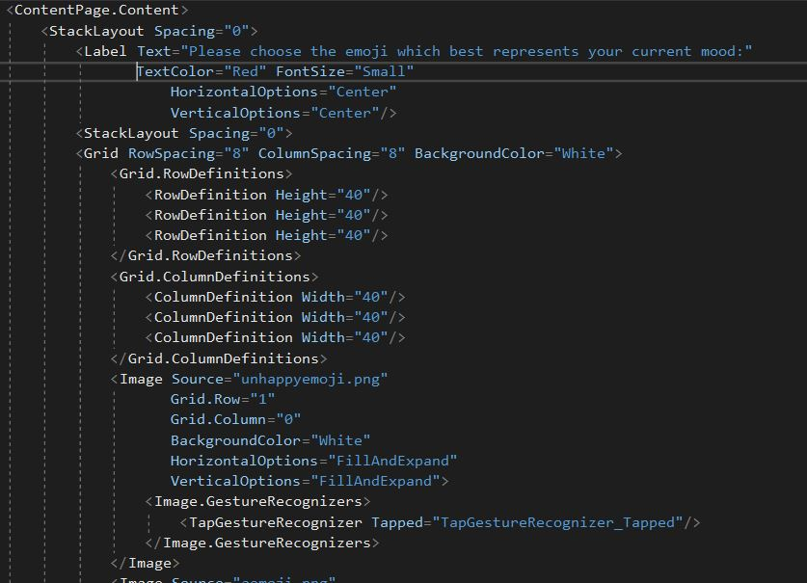  Figure 45: XAML Code Implementation for help pages | 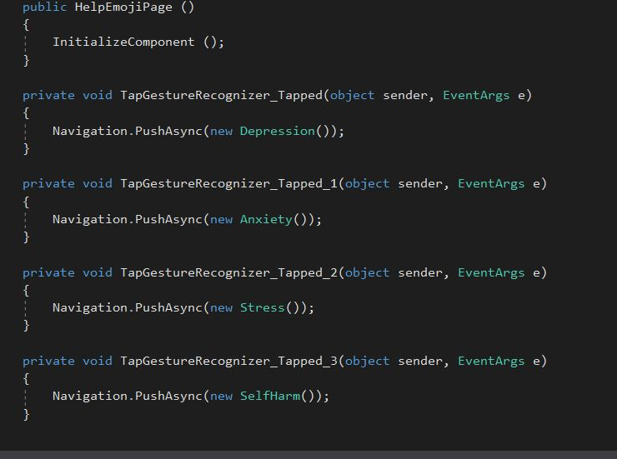  Figure 46: C# Code Implementation for emojis

5.3.3.5 Slider implementation for Wellbeing & Academic Pages
The wellbeing slider (Figure 48) is implemented using a ValueChanged event which is triggered when the value property changes (Figure 47). The slider is set with both a minimum and maximum value. A label is used to display the value which starts when the ValueChanged event is initiated (Figure 49) [86].
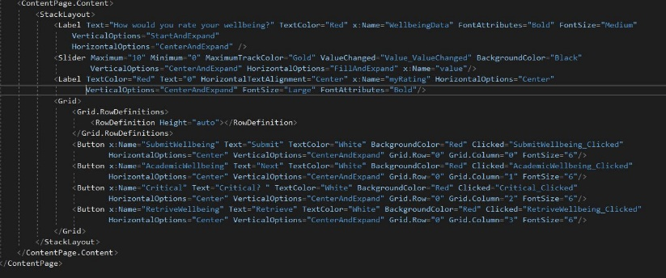  Figure 47: XAML Code for wellbeing slider | 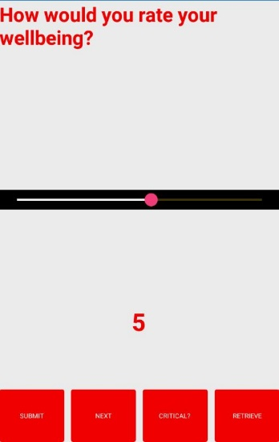  Figure 48: UI Display of wellbeing slider
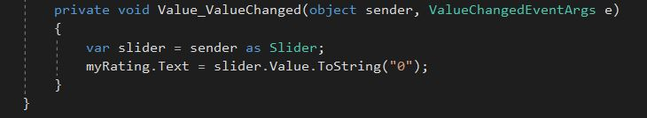
Figure 49: C# Code to display rating

5.3.3.6 Critical button implementation and display alerts
Display alerts (Figure 51) present an alert dialog to the user providing an accept and cancel button. They contain the following:
DisplayAlert (string title, string message, string accept, string cancel):
Figure 50: C# Code Implementation for critical button | 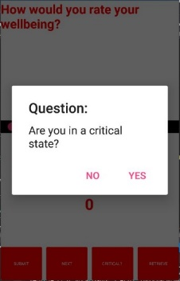  Figure 51: UI Display critical display alert
With the string title being the title of the alert dialog, string message containing the body text of the alert dialog, string accept being the ‘ok’ button and string cancel being the ‘cancel button’(Figure 50) [87].

5.3.3 Testing
Testing has been carried throughout the whole development process. Each feature has been tested during its development as described as part of the FDD process, and in the above section the implementation & associated figures show the functioning features. Furthermore, the system works as a whole and has had white box and black box testing undertaken prior to acceptance testing being completed.
Acceptance testing has been applied through the feedback survey whereby 12 students tested the prototype application and completed a usability survey on their experience. As discussed in the results section, the overwhelming response was positive in terms of both usability and the wellbeing support elements.

6.Conclusion & Recommendations

To conclude, the objectives of the research were met through the following means:
- The effectiveness of student wellbeing services was established through the literature review as well as a survey exploring the views of students and an interview with a member of wellbeing staff. These combined revealed a large gap between supply and demand; wellbeing staff were overwhelmed and outnumbered by students requesting support, long waiting lists were the norm, digital solutions were largely not implemented and ultimately student wellbeing needs were not being met.
- The research determined that wellbeing services could be improved by utilising available digitisation and technology. The literature review and survey established that a mobile application was the best solution due to its advantages in terms of availability, accessibility and the wide-ranging wellbeing support it can provide. The survey results indicated that this was a solution backed by students.
- The prototype application, ‘SOS Student’, was endorsed by students through ‘hands on’ testing. The feedback on this proposed solution was predominantly positive in terms of both usability and wellbeing support, and importantly, the feedback highlighted where improvements could be made.
- The application design and requirements, particularly the MosCow requirements, provide universities with instructions and advice on how to implement this solution and the testing and results justifies that it is fit for the purpose of supporting student wellbeing
There are some limitations of this research that must also be considered. In particular, the prototype testing was conducting through a small sample of researcher-selected participants in one case-study university. For SOS Student to be fully endorsed as a real-life application as part of a Wellbeing Service, it must undergo large-scale testing which will inform further iterations of this application. However, the prototype clearly shows the benefits of mental health applications being used as a support mechanism, which was also evidenced within the literature review.
Overall, the research delivered the answers expected, as it has demonstrated that technology can bridge the shortcomings that occur with traditional methods. The implementations of applications can support early intervention which is crucial to prevent worsening mental health; it is imperative to have that first conversation with the student at an early stage to support them. Furthermore, digitisation of wellbeing services can help to identify the times of the year where mental health issues peak so that additional support can be provided at these times, such as exam periods and deadlines. This is done through supporting the use of data analytics, as highlighted in the literature review.
The future recommendations for this project would be:
- To implement an alternative database solution, as storing the database locally is unsecure. Therefore, an alternative database such as SQL Server would be beneficial.
- To implement and test the application for iOS devices, as despite using Xamarin Forms as it is cross platform, further coding is required to develop SOS Student for iOS users.
- To implement spatial analysis using GIS as the results indicated less wellbeing services in Welsh universities; this requires analysis of specific locational data.
- Further research is required on which emojis are best used to quantify wellbeing.
- Implementation of an accredited counselling service directly provided by the application.
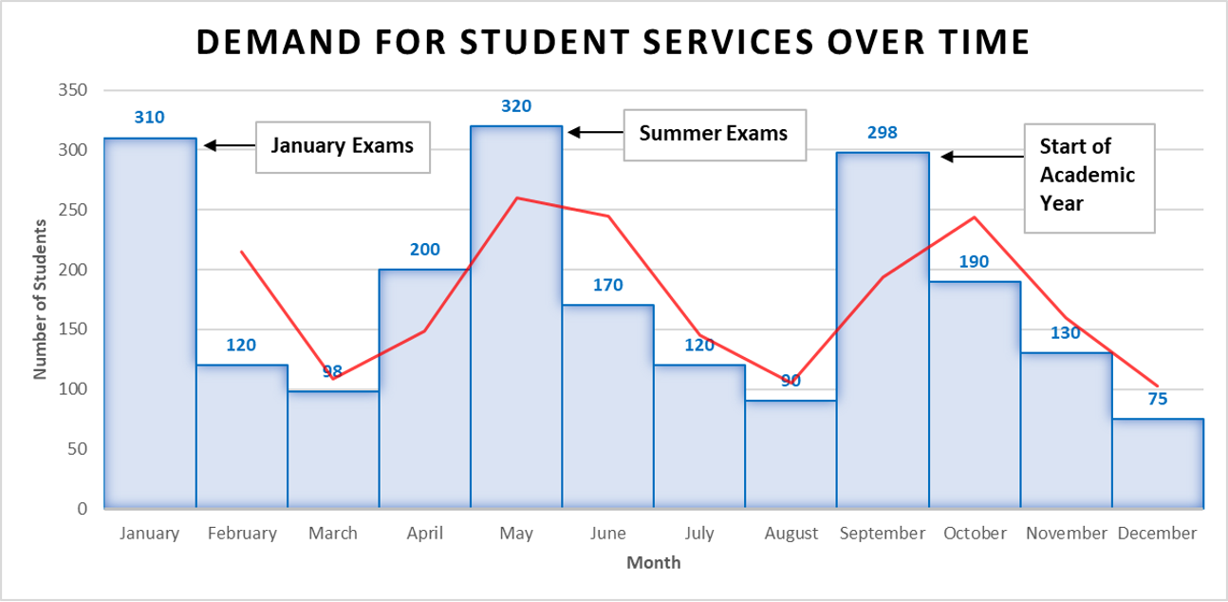
- To incorporate data analysis of wellbeing data and produce charts to highlight themes and patterns to Universities so that they can improve their wellbeing service delivery (as demonstrated in Figure 52).
Figure 52: Example of Wellbeing Data Analysis measuring demand for Wellbeing Services
- A pop-up containing privacy information security for the users. This is to inform the users on what their data will be used for if their consent is provided.
- Further increase user-friendliness of the UI; continuing the theme of simplicity and clarity. A specific example being that the emojis need to be sized equally and the grid to be centralised.

The project demonstrates wide-ranging potential for this prototype application to be used in other environments (Figure 53). For instance, as a suite of tailored wellbeing applications for various organisations. This strategy could begin with ‘SOS Employee’; a wellbeing application for employees.
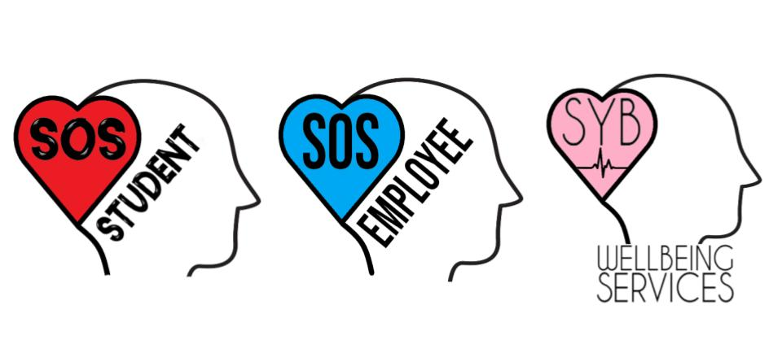
Figure 53: Future Application Logo Ideas
The ultimate message from this research is that digitisation is key to the student mental health crisis and delivers many benefits over traditional face-to-face based wellbeing services, if it is implemented correctly and after undergoing exhaustive testing.

7. Reflection
Through completing this project, I have undergone personal and academic growth in many areas; documentation, coding and time management skills in particular. I have utilised a new software (Xamarin) and developed my C# knowledge further. This will no doubt be very useful in my professional pursuits. Furthermore, the literature review has extended my knowledge enormously and it has highlighted the important role social media has in our lives and the negative impacts it can also have, specifically on our mental health.
Whilst undertaking the project I encountered many technical challenges and various issues with the emulator within Visual Studio whilst testing the application. Therefore, I feel I would have benefited from a more powerful laptop, as I could have utilised an alternative software such as Android Studio (where MySQL database is supported). However, due to hardware issues and the requirement to learn Java, this was not feasible within the given time limit. Furthermore, more research should have been undertaken regarding database choices, as I initially attempted to implement MySQL database but later found out Xamarin does not support MySQL. If in-depth research was initially carried out this error could have been prevented as valuable time was lost. However, I do feel this was a valuable lesson.
Overall, I am pleased with my time-management skills. Leeway was implemented in the Gannt Chart so that challenges, like those above, could be overcome without impacting the project delivery. This can be seen in the database issue where there was enough time to rectify the issue. Furthermore, I feel I have developed my personal skills as I have gained experience developing and documenting an operational application by following a software development methodology. My coding skills have developed through using a new software environment and storing data locally on a database.
I feel I have further developed my knowledge surrounding the current student mental health crisis, the support which is currently in place and what improvements should be completed. This is a subject which I have always been passionate about so it was useful to have the opportunity to explore this further and suggest something which could help.
In summary, I have developed a variety of personal and technical skills as well as knowledge which will further assist me in in the future. These meant that I was able to further enhance my research, coding, software development lifecycle, data analysis skills and time management skills as a whole.

8. References

References

[1] | B. Weatherby, “UWE report reveals 12 student suicides at the univerity,” Bristol Live, 11 April 2019. [Online]. Available: https://www.bristolpost.co.uk/news/bristol-news/uwe-report-reveals-12-student-2746985. [Accessed 31 March 2020].
[2] | C. Thorley, “IMPROVING STUDENT MENTAL HEALTH IN THE UK’S UNIVERSITIES,” IPPR, 2017.
[3] | J. Yap, “The declining state of student mental health in universities and what can be done,” Mental Health Foundation, 2 October 2018. [Online]. Available: https://www.mentalhealth.org.uk/blog/declining-state-student-mental-health-universities-and-what-can-be-done. [Accessed October 2019].
[4] | A. Macaskill, “The mental health of university students in the United Kingdom,” British Journal of Guidance and Counselling, vol. 41, no. 4, pp. 426-441, 2012.
[5] | BBC, “University student suicide rates revealed,” BBC, 25 June 2018. [Online]. Available: https://www.bbc.co.uk/news/health-44583922. [Accessed October 2019].
[6] | B. Andrews and J. M. Wilding, “The relation of depression and anxiety to life‐stress and achievement in students,” British Journal of Psychology, vol. 95, no. 4, pp. 509-521, 2020.
[7] | UCAS, “Support from universities and colleges,” UCAS, 2019. [Online]. Available: https://www.ucas.com/undergraduate/student-life/getting-student-support/support-universities-and-colleges. [Accessed November 2019].
[8] | A. Ciobanu, “The Role of Student Services in the Improving of Student Experience in Higher Education,” Procedia Social and Behavioral Sciences , vol. 92, pp. 169-173, 2013.
[9] | AMOSSHE, “Where’s the line? How far should universities go in providing duty of care for their students?,” AMOSSHE, 2020. [Online]. Available: https://www.amosshe.org.uk/futures-duty-of-care-2015. [Accessed 18 April 2020].
[10] | U. UK, “Student Mental Wellbeing in Higher Eucation,” 2000.
[11] | Jisc, “Can we tackle the student mental health challenge using data analytics?,” Jisc, 13 March 2019. [Online]. Available: https://www.jisc.ac.uk/news/can-we-tackle-the-student-mental-health-challenge-using-data-analytics-13-mar-2019. [Accessed October 2019].
[12] | G. Raddi, “Universities and the NHS must join forces to boost student mental health,” The Guardian, 15 February 2019. [Online]. Available: https://www.theguardian.com/education/2019/feb/15/universities-and-the-nhs-must-join-forces-to-boost-student-mental-health. [Accessed November 2019].
[13] | B. Bewick and H. Stallman, “How universities can combat the student mental health crisis,” Independent, 11 September 2018. [Online]. Available: https://www.independent.co.uk/news/education/university-mental-health-students-depression-anxiety-suicide-alcohol-a8526051.html. [Accessed October 2019].
[14] | E. Anthes, “Mental health: There’s an app for that,” Nature, 6 April 2016. [Online]. Available: https://www.nature.com/news/mental-health-there-s-an-app-for-that-1.19694#/mobile. [Accessed October 2019].
[15] | S. Bhardwa, “Students identify the biggest barriers to mental health services in the UK,” The World University Rankings, 4 September 2017. [Online]. Available: https://www.timeshighereducation.com/student/news/students-identify-biggest-barriers-mental-health-services-uk. [Accessed October 2019].
[16] | H. Swain, “Snake oil or panacea: can technology improve student mental health?,” The Guardian, 27 June 2019. [Online]. Available: https://www.theguardian.com/education/2019/jun/27/snake-oil-or-panacea-can-technology-improve-student-mental-health. [Accessed 31 March 2020].
[17] | BBC, “Suicide rate rises for first time since 2013,” BBC, 3 September 2019. [Online]. Available: https://www.bbc.co.uk/news/health-49563827. [Accessed October 2019].
[18] | R. Edmonds, 2019. [Online]. Available: https://www.centreformentalhealth.org.uk/blog/centre-mental-health-blog/anxiety-loneliness-fear-missing-out-social-media.
[19] | J. Chen, “Social media demographics to inform your brand’s strategy in 2020,” Sprout Social, 2020. [Online]. Available: https://sproutsocial.com/insights/new-social-media-demographics/. [Accessed 18 April 2020].
[20] | F. Alqahtani and R. Orji, “Insights from user reviews to improve mental health apps,” Health Informatics Journal, 2020.
[21] | J. Torous, H. Wisniewski, G. Liu and M. Keshavan, “Mental Health Mobile Phone App Usage, Concerns, and Benefits Among Psychiatric Outpatients: Comparative Survey Study,” NCBI, vol. 5, 16 November 2018.
[22] | A. Matei, “Shock! Horror! Do you know how much time you spend on your phone?,” The Guardian, 21 August 2019. [Online]. Available: https://www.theguardian.com/lifeandstyle/2019/aug/21/cellphone-screen-time-average-habits. [Accessed November 2019].
[23] | notOK, “Download Now!,” notok, 2019. [Online]. Available: https://www.notokapp.com/download. [Accessed October 2019].
[24] | S. App, “Anxiety Management on your Mobile,” SAM App, 2019. [Online]. Available: http://sam-app.org.uk/. [Accessed October 2019].
[25] | Headspace, “How it works,” Headspace, 2019. [Online]. Available: https://www.headspace.com/how-it-works. [Accessed November 2019].
[26] | A. A. Store, “What's Up? - A Mental Health App,” Apple, 2019. [Online]. Available: https://apps.apple.com/gb/app/whats-up-a-mental-health-app/id968251160. [Accessed October 2019].
[27] | Enlitened, “How Enlitened began,” Enlitened, 2019. [Online]. Available: https://enlitened.org/about/. [Accessed November 2019].
[28] | G. Play, “notOK,” Google Play, 2019. [Online]. Available: https://play.google.com/store/apps/details?id=com.robinlucas.notok&hl=en&showAllReviews=true. [Accessed 18 April 2020].
[29] | G. Play, “SAM,” Google Play, 2020. [Online]. Available: https://play.google.com/store/apps/details?id=com.uwe.myoxygen&hl=en_GB&showAllReviews=true. [Accessed 18 April 2020].
[30] | A. S. Preview, “Headspace: Meditation & Sleep,” App Store Preview, 2019. [Online]. Available: https://apps.apple.com/us/app/headspace-meditation-sleep/id493145008. [Accessed 18 April 2020].
[31] | J. Tempra, “What's Up? - A Mental Health App,” App Store Preview, 2019. [Online]. Available: https://apps.apple.com/us/app/whats-up-a-mental-health-app/id968251160. [Accessed 18 April 2020].
[32] | BBC, “World Mental Health Day: Suicide prevention text service start,” BBC, 10 October 2019. [Online]. Available: https://www.bbc.co.uk/news/uk-england-birmingham-49987757?intlink_from_url=https://www.bbc.co.uk/news/health&link_location=live-reporting-story. [Accessed October 2019].
[33] | O.-L. Analysis, “Duty to care for student mental health has legal implications for universities,” Pinsent Masons, 17 October 2018. [Online]. Available: https://www.pinsentmasons.com/out-law/analysis/duty-to-care-student-mental-health-legal-implications-universities. [Accessed October 2019].
[34] | E. Goddard, “Universities Must Confront the Student Mental Health Crisis,” Vice , 8 October 2019. [Online]. Available: https://www.vice.com/en_uk/article/ywabdy/student-mental-health-expert-advice-universities. [Accessed 31 March 2020].
[35] | E. G. Lattie, S. K. Lipson and D. Eisenberg, “Technology and College Student Mental Health: Challenges and Opportunities,” Front Psychiatry, 2018.
[36] | C. Stokel-Walker, “Too few counsellors on campus: why students are turning to mental health apps,” The Guardian, 27 February 2020. [Online]. Available: https://www.theguardian.com/education/2020/feb/27/too-few-counsellors-on-campus-why-students-are-turning-to-mental-health-apps. [Accessed 31 March 2020].
[37] | E. Reynolds, “How effective are mental health apps?,” Wired, 8 May 2017. [Online]. Available: https://www.wired.co.uk/article/mental-health-apps. [Accessed October 2019].
[38] | J. Marshall, D. Dunstan and W. Bartik, “Smartphone psychology: New approaches towards safe and efficacious mobile mental health apps.,” Professional Psychology, 2019.
[39] | N. I. o. Health, “Guiding Principles for Ethical Research,” NIH, 2019. [Online]. Available: https://www.nih.gov/health-information/nih-clinical-research-trials-you/guiding-principles-ethical-research. [Accessed November 2019].
[40] | K. G. Giota, “Mental Health Apps: Innovations, Risks and Ethical Consideratons,” E-Health Telecommunication Systems and Networks, pp. 19-23, September 2014.
[41] | M. Bauer, T. Glenn, J. Geddes, M. Gitlin and P. Grof, “Smartphones in mental health: a critical review of background issues, current status and future concerns,” NCBI, vol. 8, no. 2, 2020.
[42] | D. He, M. Naveed, C. Gunter and K. Nahrstedt, “Security Concerns in Android mHealth Apps,” NCBI, pp. 645-654, 2014.
[43] | N. I. o. M. Health, “Technology and the Future of Mental Health Treatment,” NIH, 2019. [Online]. Available: https://www.nimh.nih.gov/health/topics/technology-and-the-future-of-mental-health-treatment/index.shtml. [Accessed November 2019].
[44] | S. Mathieson, “Universities use data analytics to tackle student mental health,” Computer Weekly, 9 July 2019. [Online]. Available: https://www.computerweekly.com/feature/Universities-use-data-analytics-to-tackle-student-mental-health. [Accessed November 2019].
[45] | Usability.gov, “User Interface Design Basics,” Usability.gov, 2019. [Online]. Available: https://www.usability.gov/what-and-why/user-interface-design.html. [Accessed October 2019].
[46] | S. D.Birkhoff and H. Moriarty, “Challenges in mobile health app research: Strategies for interprofessional researchers,” Journal of Interprofessional Education & Practice, vol. 19, 2020.
[47] | T. Dehling, F. Gao, S. Schneider and A. Sunyaev, “Exploring the Far Side of Mobile Health: Information Security and Privacy of Mobile Health Apps on iOS and Android,” JMIR Publications, vol. 3, no. 1, 2019.
[48] | Microsoft, “Introduction to the C# language and the .NET Framework,” Microsoft, 2019. [Online]. Available: https://docs.microsoft.com/en-us/dotnet/csharp/getting-started/introduction-to-the-csharp-language-and-the-net-framework. [Accessed November 2019].
[49] | Microsoft, “What is Xamarin?,” Microsoft, 16 September 2019. [Online]. Available: https://docs.microsoft.com/en-us/xamarin/get-started/what-is-xamarin. [Accessed November 2019].
[50] | Microsoft, “What is Xamarin?,” Microsoft, 2019. [Online]. Available: https://dotnet.microsoft.com/learn/xamarin/what-is-xamarin. [Accessed November 2019].
[51] | Developers, “About the platform,” Android, 2020. [Online]. Available: https://developer.android.com/about. [Accessed 14 April 2020].
[52] | AppyPie, “No-Code platform for building digital products,” AppyPie, 2020. [Online]. Available: https://www.appypie.com/. [Accessed 18 April 2020].
[53] | Appery.IO, “The leading cloud-based, rapid development environment for building mobile and responsive apps,” Appery.IO, 2020. [Online]. Available: https://appery.io/appbuilder/. [Accessed 18 April 2020].
[54] | A. Hales, “Top 10 Best Mobile App Development Frameworks in 2020,” Medium, 1 July 2019. [Online]. Available: https://medium.com/hackernoon/top-10-best-mobile-app-development-frameworks-in-2019-612b95cf930f. [Accessed 18 April 2020].
[55] | R. Shroff, “5 reasons why Xamarin is the king of cross platform development,” Softweb Solutions, 4 November 2014. [Online]. Available: https://www.softwebsolutions.com/resources/5-reasons-why-xamarin-is-cross-platform-development-king.html. [Accessed November 2019].
[56] | R. Methodology, “Data Collection Methods,” Research Methodology, 2019. [Online]. Available: https://research-methodology.net/research-methods/data-collection/. [Accessed November 2019].
[57] | K. Kelley, B. Clark, V. Brown and J. Sitzia, “Good practice in the conduct and reporting of survey research,” International Journal for Quality in Health Care, vol. 15, no. 3, pp. 261-266, 1 May 2003.
[58] | T. Jones, M. Baxter and V. Khanduja, “A quick guide to survey research,” NCBI, pp. 5-7, January 2013.
[59] | Nielsen, “Target group and sample selection,” Nielsen, 2019. [Online]. Available: https://www.nielsen-admosphere.eu/products-and-services/research-services/target-group-and-sample-selection/. [Accessed November 2019].
[60] | N. Daykin and M. Attwood, “DATA COLLECTION AND SAMPLING,” 2013. [Online]. Available: http://creativeandcredible.co.uk/wp-content/uploads/2015/07/CreativeCredible_Data-Collection-and-sampling.pdf. [Accessed November 2019].
[61] | Z. Abu Hassan, P. Schnattner and D. Mazza, “Doing A Pilot Study: Why Is It Essential?,” Malaysian Family Physician, vol. 1, pp. 70-73, 2006.
[62] | S. N. Talamas, K. I. Mavor and D. I. Perrett, “Blinded by Beauty: Attractiveness Bias and Accurate Perceptions of Academic Performance,” US National Library of Medicine, vol. 11, no. 2, 2016.
[63] | NHS, “Big White Wall,” NHS, 2020. [Online]. Available: https://www.nhs.uk/Services/Trusts/Overview/DefaultView.aspx?id=102312. [Accessed 23 April 2020].
[64] | M. H. Foundation, “Mental health statistics: men and women,” Mental Health Foundation, 2020. [Online]. Available: https://www.mentalhealth.org.uk/statistics/mental-health-statistics-men-and-women. [Accessed February 2020].
[65] | E. Vaportzis, M. G. Clausen and A. J. Gow, “Older Adults Perceptions of Technology and Barriers to Interacting with Tablet Computers: A Focus Group Study,” Frontiers in Psychology, 2017.
[66] | B. Techniques, “MoSCoW : Requirements Prioritization Technique,” Business Analyst Learnings, 05 March 2003. [Online]. Available: https://businessanalystlearnings.com/ba-techniques/2013/3/5/moscow-technique-requirements-prioritization. [Accessed 23 11 2019].
[67] | J. Curiel, “15 steps to developing GDPR-compliant apps,” TechBeacon, 2019. [Online]. Available: https://techbeacon.com/security/15-steps-developing-gdpr-compliant-apps. [Accessed 23 November 2019].
[68] | D. T. Reporter, “Texting more popular than face-to-face conversation,” The Telegraph, 18 July 2012. [Online]. Available: https://www.telegraph.co.uk/technology/9406420/Texting-more-popular-than-face-to-face-conversation.html. [Accessed 18 November 2019].
[69] | P. World, “Do Emoticons Help Us To Better Communicate Emotions?,” Psychologist World, 2019. [Online]. Available: https://www.psychologistworld.com/emotion/emoticons-emojis-emotion-psychology. [Accessed 24 November 2019].
[70] | L. Kaye, “Why psychology needs to start taking emoji seriously,” The British Psychological Society, 06 March 2018. [Online]. Available: https://www.bps.org.uk/blogs/linda-kaye/why-psychology-needs-start-taking-emoji-seriously. [Accessed 15 November 2019].
[71] | N. Schimelpfening, “Joining a Chat Room to Help With Depression,” Very Well Mind, 04 September 2019. [Online]. Available: https://www.verywellmind.com/depression-chat-rooms-1067331. [Accessed 23 November 2019].
[72] | L. C. Team, “Introducing Types of UML Diagrams,” Lucidchart, 2020. [Online]. Available: https://www.lucidchart.com/blog/types-of-UML-diagrams. [Accessed 19 April 2020].
[73] | V. Paradigm, “What is Use Case Diagram?,” Visual Paradigm, 2020. [Online]. Available: https://www.visual-paradigm.com/guide/uml-unified-modeling-language/what-is-use-case-diagram/. [Accessed 1 April 2020].
[74] | V. Paradigm, “What is Sequence Diagram?,” Visual Paradigm, 2020. [Online]. Available: https://www.visual-paradigm.com/guide/uml-unified-modeling-language/what-is-sequence-diagram/. [Accessed 1 April 2020].
[75] | Smartdraw, “Entity Relationship Diagram,” smartdraw, 2020. [Online]. Available: https://www.smartdraw.com/entity-relationship-diagram/. [Accessed 1 April 2020].
[76] | V. Paradigm, “What is State Machine Diagram?,” Visual Paradigm, 2020. [Online]. Available: https://www.visual-paradigm.com/guide/uml-unified-modeling-language/what-is-state-machine-diagram/. [Accessed 1 April 2020].
[77] | Microsoft, “Xamarin.Forms Local Databases,” Microsoft, 12 May 2019. [Online]. Available: https://docs.microsoft.com/en-us/xamarin/xamarin-forms/data-cloud/data/databases. [Accessed 2 April 2020].
[78] | Xamarin, “Store Data in a Local SQLite.NET Database,” Xamarin, 1 April 2019. [Online]. Available: https://docs.microsoft.com/en-us/xamarin/get-started/quickstarts/database?pivots=windows. [Accessed 3 April 2020].
[79] | S. Overflow, “Cannot bind to System.String in Xamarin,” Stack Overflow, 2020. [Online]. Available: https://stackoverflow.com/questions/59250129/cannot-bind-to-system-string-in-xamarin. [Accessed February 2020].
[80] | S. Overflow, “SQL_ERROR: The type initializer for 'MySql.Data.MySqlClient.MySqlConnectAttrs' threw an exception,” Stack Overflow, 2019. [Online]. Available: https://stackoverflow.com/questions/55190350/sql-error-the-type-initializer-for-mysql-data-mysqlclient-mysqlconnectattrs-t. [Accessed February 2020].
[81] | A. Firdaus, I. Ghani and N. I. Mohd Yasin, “Developing Secure Websites Using Feature Driven Development (FDD): A Case Study,” Clean Energy Technologies, vol. 1, no. 4, 2013.
[82] | L. C. Team, “Why (and How) You Should Use Feature-Driven Development,” Lucid Chart, 2020. [Online]. Available: https://www.lucidchart.com/blog/why-use-feature-driven-development. [Accessed 3 April 2020].
[83] | Microsoft, “Using SQLite.NET with Android,” Microsoft, 18 April 2018. [Online]. Available: https://docs.microsoft.com/en-us/xamarin/android/data-cloud/data-access/using-sqlite-orm. [Accessed February 2020].
[84] | Microsoft, “Images in Xamarin.Forms,” Microsoft, 12 April 2019. [Online]. Available: https://docs.microsoft.com/en-us/xamarin/xamarin-forms/user-interface/images?tabs=windows. [Accessed March 2020].
[85] | Microsoft, “Adding a tap gesture recognizer,” Microsoft, 21 01 2016. [Online]. Available: https://docs.microsoft.com/en-us/xamarin/xamarin-forms/app-fundamentals/gestures/tap. [Accessed March 2020].
[86] | Microsoft, “Xamarin.Forms Slider,” Microsoft, 27 February 2019. [Online]. Available: https://docs.microsoft.com/en-us/xamarin/xamarin-forms/user-interface/slider. [Accessed March 2020].
[87] | Microsoft, “Page.DisplayAlert Method,” Microsoft, 2020. [Online]. Available: https://docs.microsoft.com/en-us/dotnet/api/xamarin.forms.page.displayalert?view=xamarin-forms. [Accessed March 2020].
[88] | A. Parecki, “An open protocol to allow secure authorization in a simple and standard method from web, mobile and desktop applications.,” OAuth, 2019. [Online]. Available: https://oauth.net/. [Accessed 23 November 2019].
[89] | teamgantt, “What Is a Gantt Chart?,” teamgantt, 2020. [Online]. Available: https://www.teamgantt.com/what-is-a-gantt-chart. [Accessed 4 April 2020].
[90] | Xamarin, “MySQL (or alternate) non-local DB?,” Xamarin, 2013. [Online]. Available: https://forums.xamarin.com/discussion/3229/mysql-or-alternate-non-local-db. [Accessed February 2020].
[91] | T. I. -. P. Examples, “Xamarin : How to **Create a Simple Complete App** using Xamarin | Full CRUD Operation Xamarin,” Youtube, 26 June 2018. [Online]. Available: https://www.youtube.com/watch?v=aabHAgY5VXo. [Accessed 14 February 2020].
[92] | U. UK, 5 September 2018. [Online]. Available: https://www.universitiesuk.ac.uk/policy-and-analysis/reports/Pages/guidance-for-universities-on-preventing-student-suicides.aspx.
[93] | Transformations, “Pros and Cons of Mental Health Apps,” Transformations, 07 April 2019. [Online]. Available: https://www.mytransformations.com/post/pros-and-cons-of-mental-health-apps. [Accessed 23 November 2019].
[94] | TutorialsPoint, “SDLC - Iterative Model,” TutorialsPoint, 2019. [Online]. Available: https://www.tutorialspoint.com/sdlc/sdlc_iterative_model.htm. [Accessed 26 November 2019].
[95] | M. Health, “Digital mental health,” Mental Health Foundation, 2019. [Online]. Available: https://www.mentalhealth.org.uk/a-to-z/d/digital-mental-health. [Accessed November 2019].
[96] | Youtube, [Online]. Available: https://www.youtube.com/watch?v=8JQSd9sF3X. [Accessed 20 February 2020].

Appendix A: Ethics Form completed
PROJECT RESEARCH Applicationroval Form (Ethics)

Have you considered whether there are any problematic ‘ethical issues’ in your proposed research project? If not, you really should talk to your Course Tutor or Supervisor to discuss if there are any issues you need to address.

If you have already completed an ‘Ethics Approval Form’ within your Faculty/School, you do not need to complete this form. However, you haven’t considered the ethics issues in your proposal, you need to complete this form.

Not all details necessarily apply to your area of study, so you may leave some boxes blank, but do try and complete it as fully as you can. All sections deal with potential ethical issues which need careful consideration before you commence your research, to ensure you deal with them properly (in accordance with the law, for example). You may find it easier to complete the form with assistance from your tutor/supervisor.

Name: | Shannon Boulting
Project/Research Title: | How can technology improve student engagement in University Wellbeing Services? (TBC)
Name of Supervisor: | Dr Tim Bashford
School/Dept. | Academic Portfolio of Computing
Faculty: | Welsh Institute of Science and Art
Proposed Start Date: | 30th Sept 2019 | End Date: | 27th April 2020

1. Summary of planned research please indicate briefly below the purpose of your planned project/research, together with your aims, main research questions and research design – you can continue onto a separate sheet if necessary
The purpose of the research is to establish the quality of Student Wellbeing Services at present and look into how they can be improved, focusing on the implementation of better technology. The study will assess how digitisation and the use of technology can bridge the shortcomings of Student Wellbeing Services, which will be investigated using a student survey, and increase student engagement in these services.

2. Methodology you need to be clear about the methodology you intend to use in your study; this could include any number of methods, so either tick those shown below (where appropriate) or put the details in the box marked *

X | Interviews |  | Participant Observation | X | Use of personal data
 | Focus groups | X | Questionnaire |  | Literature Review
 | Performance |  | Presentation |  | Other (state below)*

3. Participants - Does your proposed project/research involve human participants?

X | 1. Yes, as a primary source* |  | 2. Yes, as a secondary source* |  | No- go to section 4

*If you have ticked yes, you are likely to need an Advanced CRB check before undertaking your study

If yes, indicate who your participants are:

 | Early years/Pre-School children | X | Adults - give details below
 | School age children | X | Vulnerable people - give details below
 | Young People aged 17-18 | Though this survey will not be aimed specifically at individuals who have experienced poor mental health, it will look at students as a whole and this will inevitably include people who experience poor mental health.
 | Unknown at this stage

4. Other Ethical issues (tick all that may apply to your research)

 | Administration of drugs incl. alcohol |  | Deprivation
 | Unpleasant stimuli in any manner or form |  | Active deception or withholding information
 | Collection of highly personal information |  | Payment

5. Are there any ethical concerns other than those listed above?

There is a risk, as with any survey on the topic of mental health, that this subject may evoke negative emotions

6. If there are any ethical concerns, please state how you intend to minimise any risk of harm or distress that could be caused

The survey is anonymous and confidential, participation is optional and can be withdrawn at any time. Questions around mental health are not compulsory and a ‘prefer not to say’ option will be included. No detail is asked for on the individuals personal experience with mental health, the survey only intends to establish their opinions and experiences of using their universities wellbeing service. Participants will be informed of these details before the survey commences and contact details will be provided if the participant has any queries or concerns, and their survey can be withdrawn upon request. All data gathered from the survey will be stored securely and participants data will not be analysed on an individual basis.

You should enclose the research proposal form, together with any materials (e.g. questionnaire, interview schedule) when submitting this form to your tutor/supervisor.

Student Signature __SYBoulting______________Date___16/10/19____________

**********************************************************************************
Supervisor’s Signature __T Bashford________________________Date 21/10/19

X | Ethics clearance given at Faculty Level
 | Clearance not given at Faculty level – forwarded for discussion at the next meeting of the University Ethics Committee. Details below:
Comments:

Chair’s Initials |  | Date

Details on this form will be always be dealt with in accordance with the terms of the Data Protection Act 1998. The completed form will be retained on the student’s file after approval (for audit purposes) and may be forwarded firstly to the Faculty Board and thereafter to the University Ethics Co

Appendix B: Interview Questions with Valerie Harding

- What services do you provide?
They receive referrals from various sources however, most are self-referral.
- How many/ what percentage of students used the wellbeing services?
It is a large number and is growing year on year.
- How many staff do you employ? How many work in mental health/wellbeing?
They have 9 mentors and at the Swansea campus they are not full time. They also have a mental health advisor.
- Do you work with any external organisations to provide mental health support?
If a student is better placed in statutory services, then they will be referred.
- How much funding is provided for mental health services?
Did not provide an answer.
- What is the waiting time for mental health support? Is there a system of monitoring students while they wait?
The longest wait is 5 weeks.
- Is mental health support provided all year round?

There are counsellors available all year round.

- Is there any common feedback from students about the mental health services?
Students can fill in a survey which is anonymous and there is the option to provide voluntary feedback.
- Are any mental health services provided digitally i.e. online or through a mobile application? Are there any plans for this?
Whitewall.
- Does the university have a long-term strategy for improving mental health services? Is it available to students?
They are constantly trying to improve the services but not online.
- Has the university ever asked the students what they would like provided for mental health? Any surveys done?
They have asked for feedback via a survey.
- Would there be anything that the university would like me to ask in my survey?
Did not provide answer.

Appendix C: Student Survey on Wellbeing Services

Below is the survey extracted from Google Forms. However, when participants completed the survey through this platform, each section was a new webpage and their answers in some cases would distinguish which questions they would be presented with.
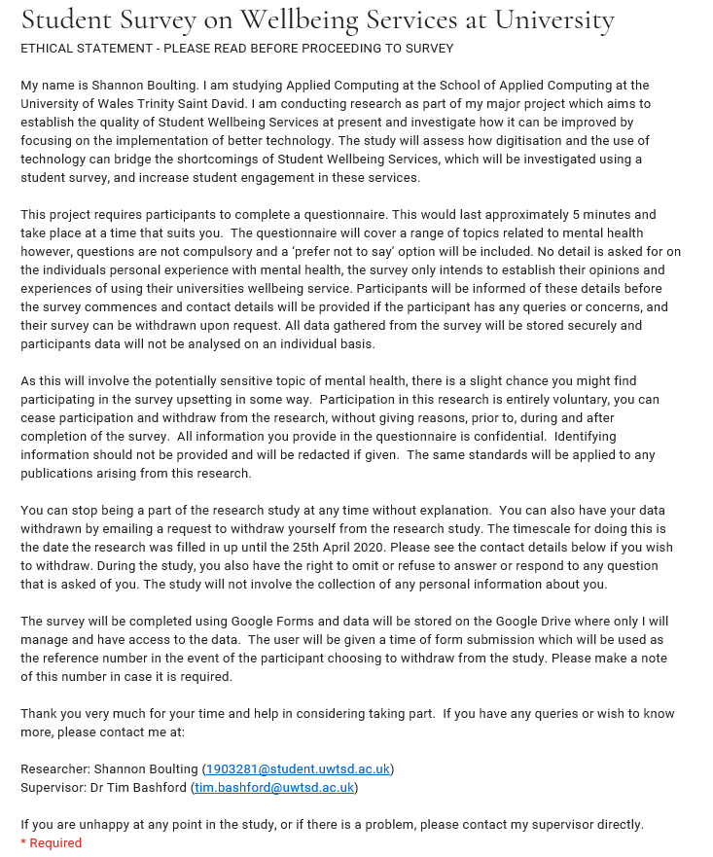

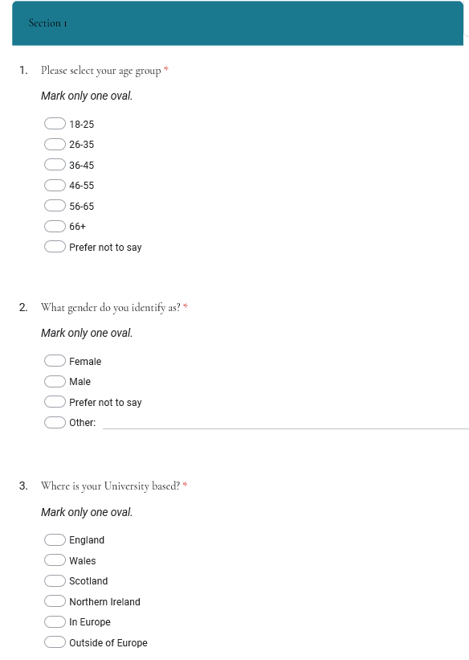

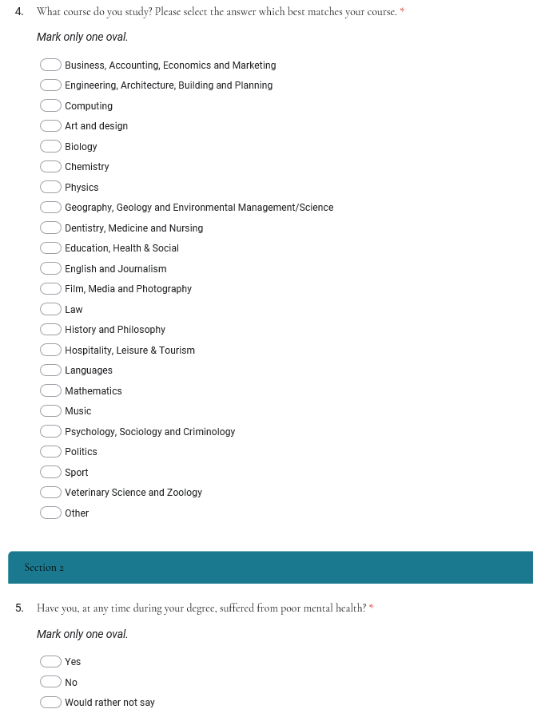

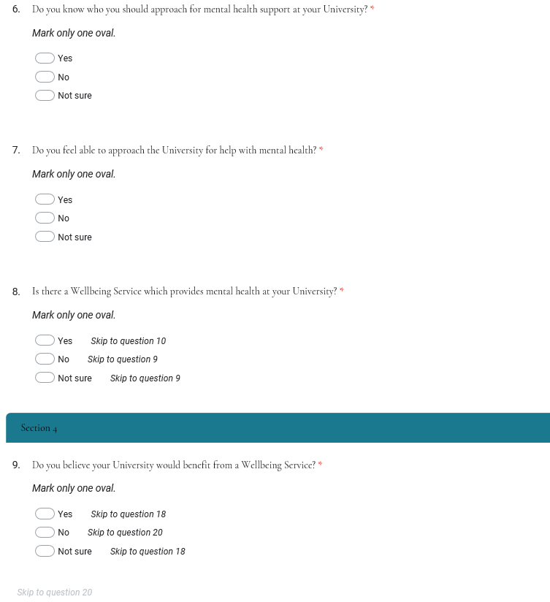
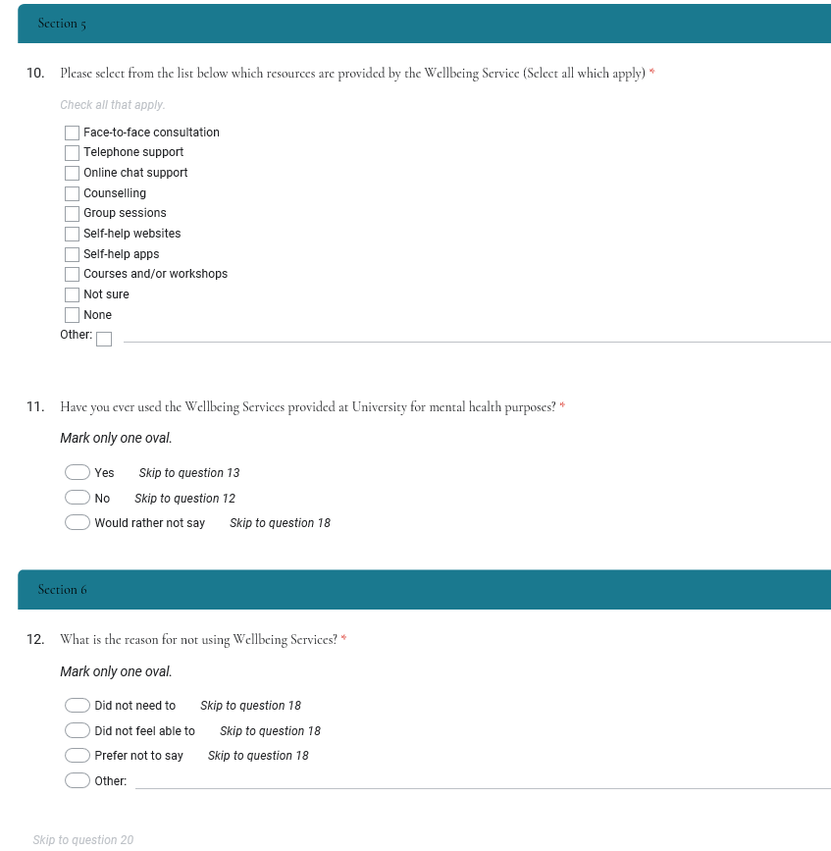

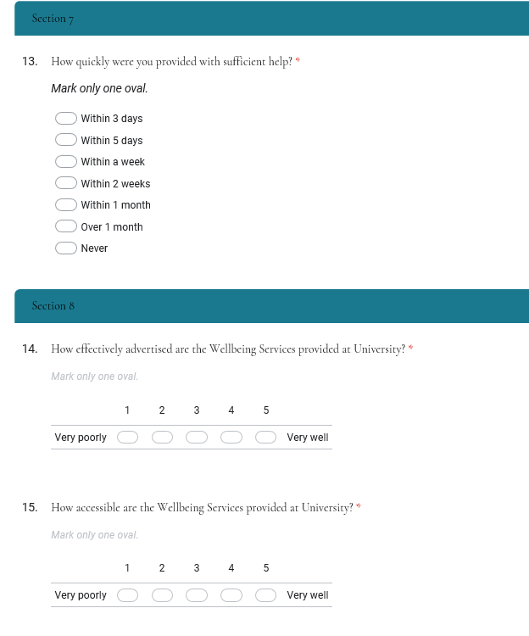

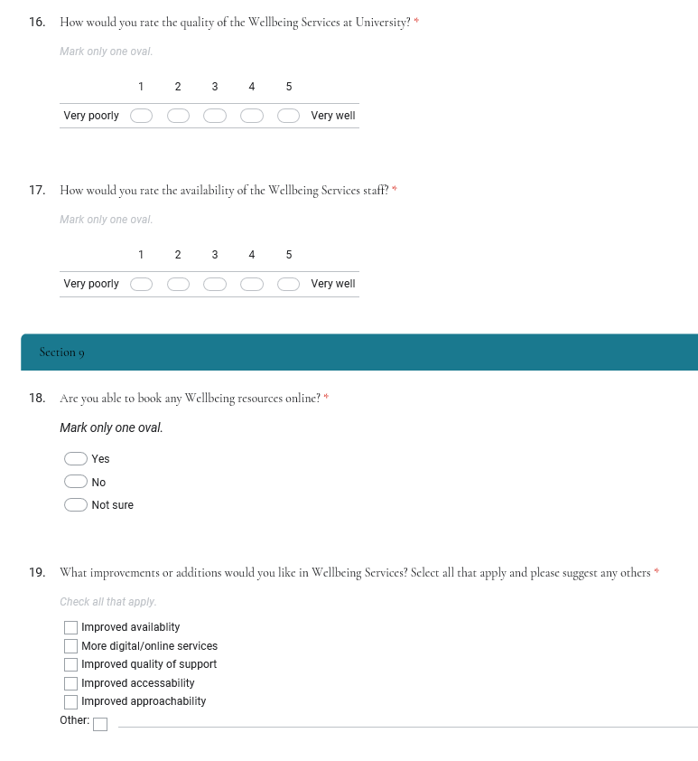
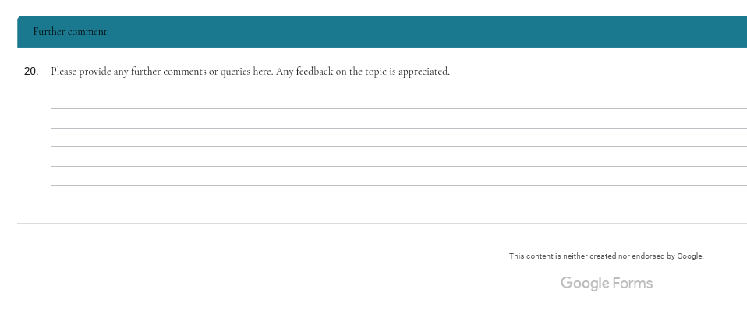

Appendix D: Student Survey on Wellbeing Services Responses
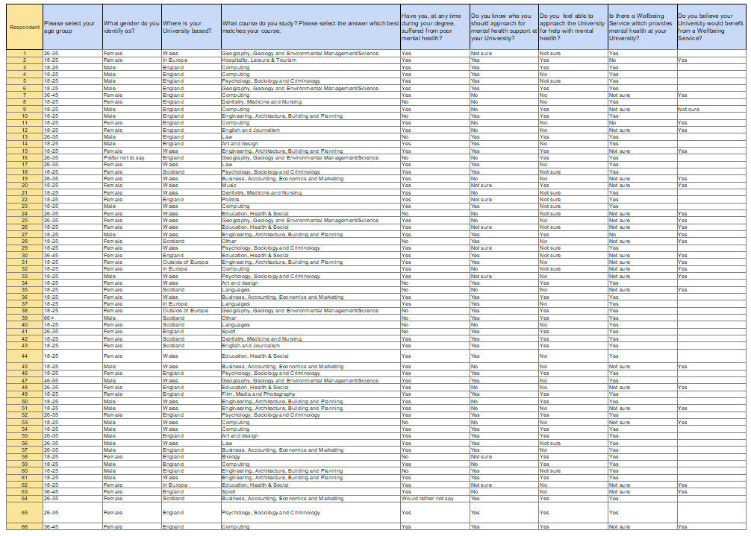

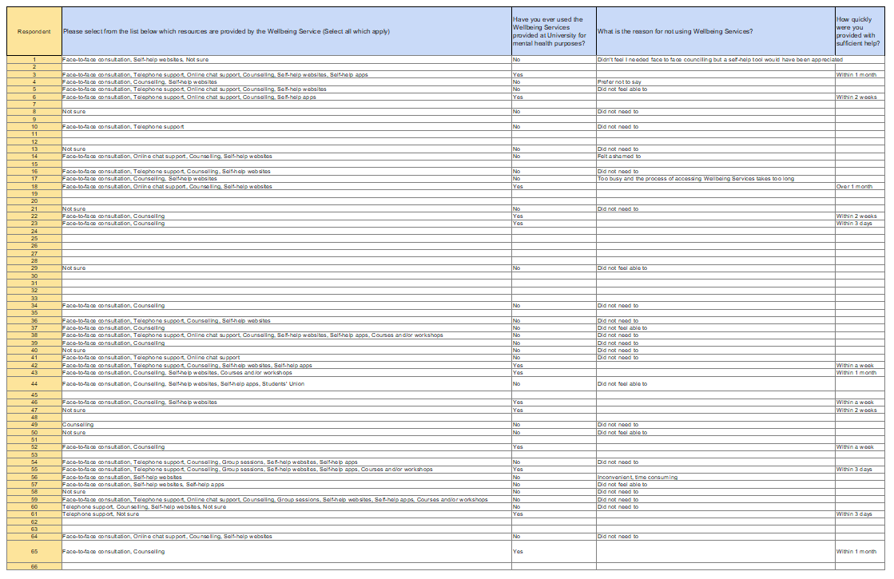

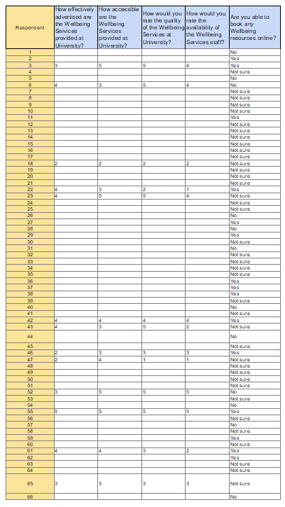
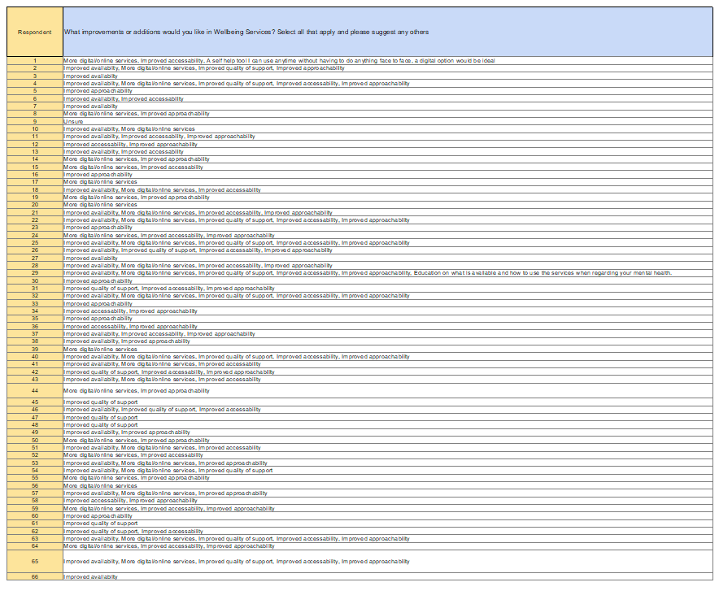
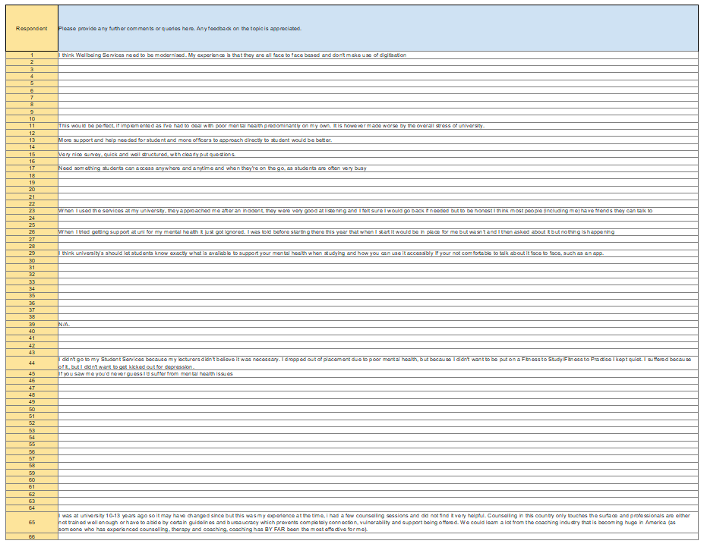

Appendix E: Prototype Application Survey

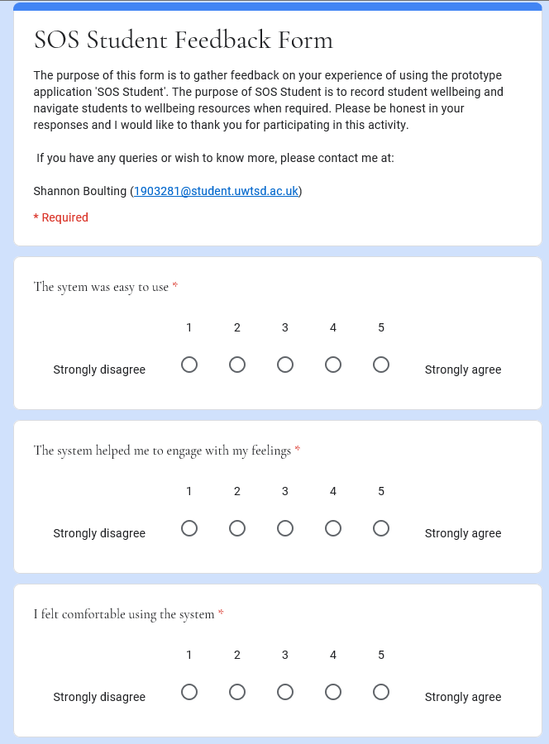

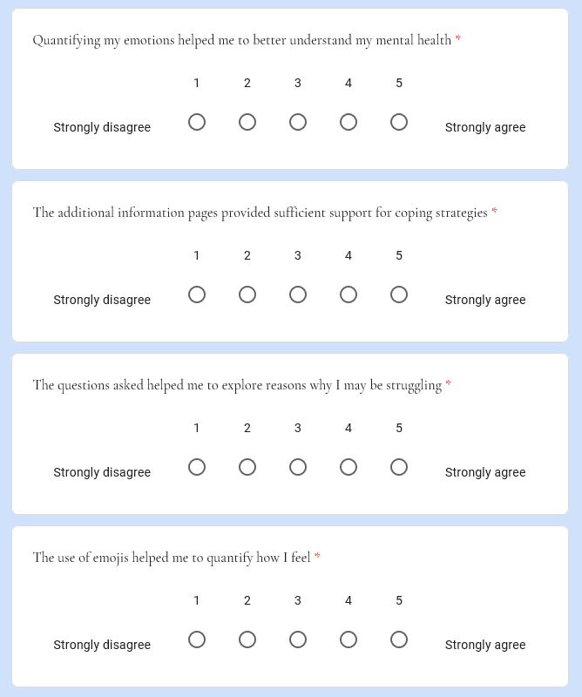

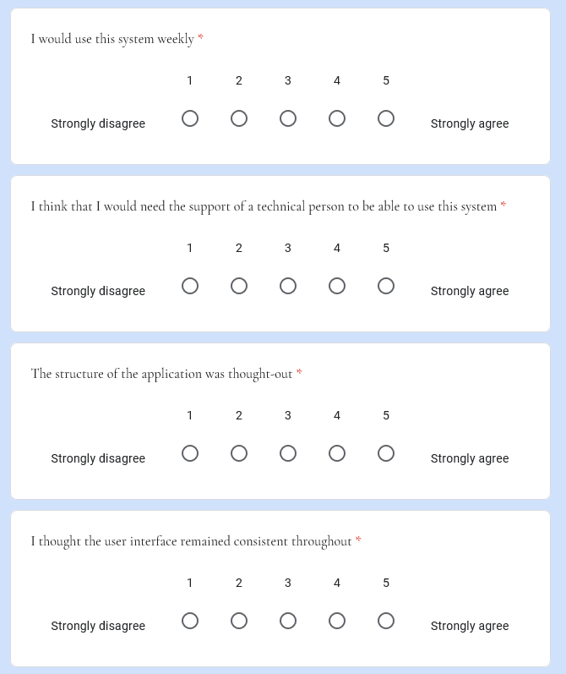

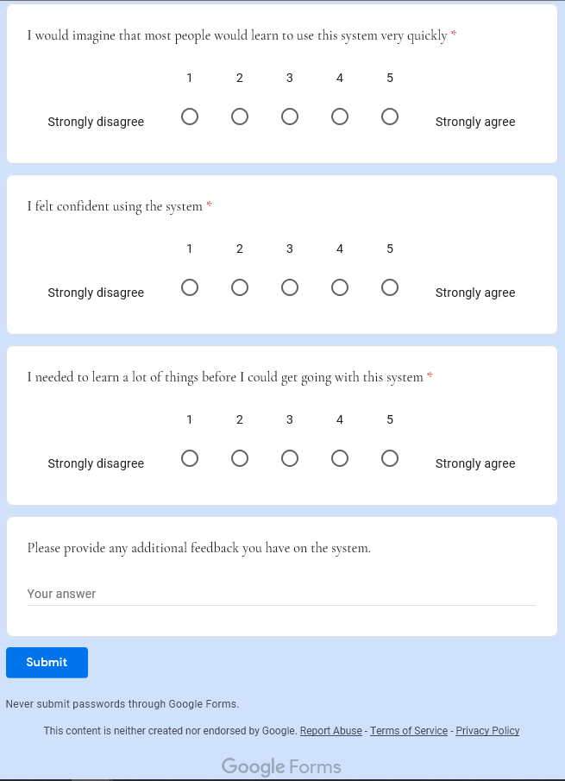

Appendix F: Prototype Application Survey Responses

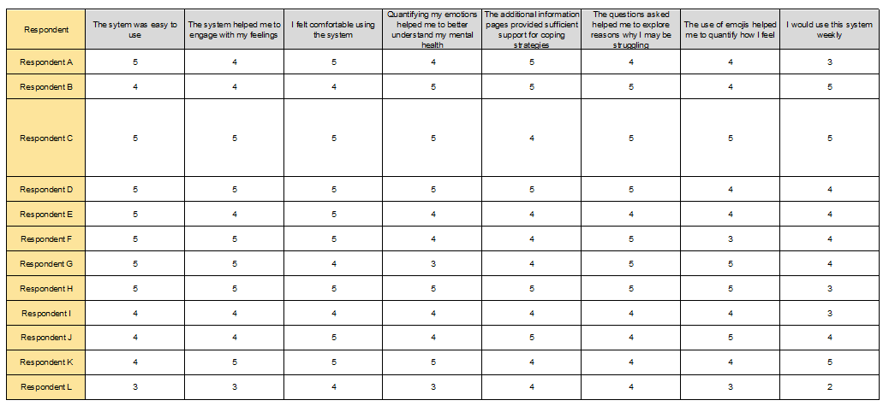

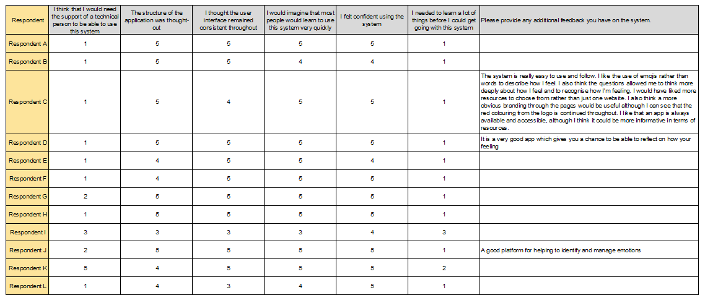

Appendix G: Paper Prototype
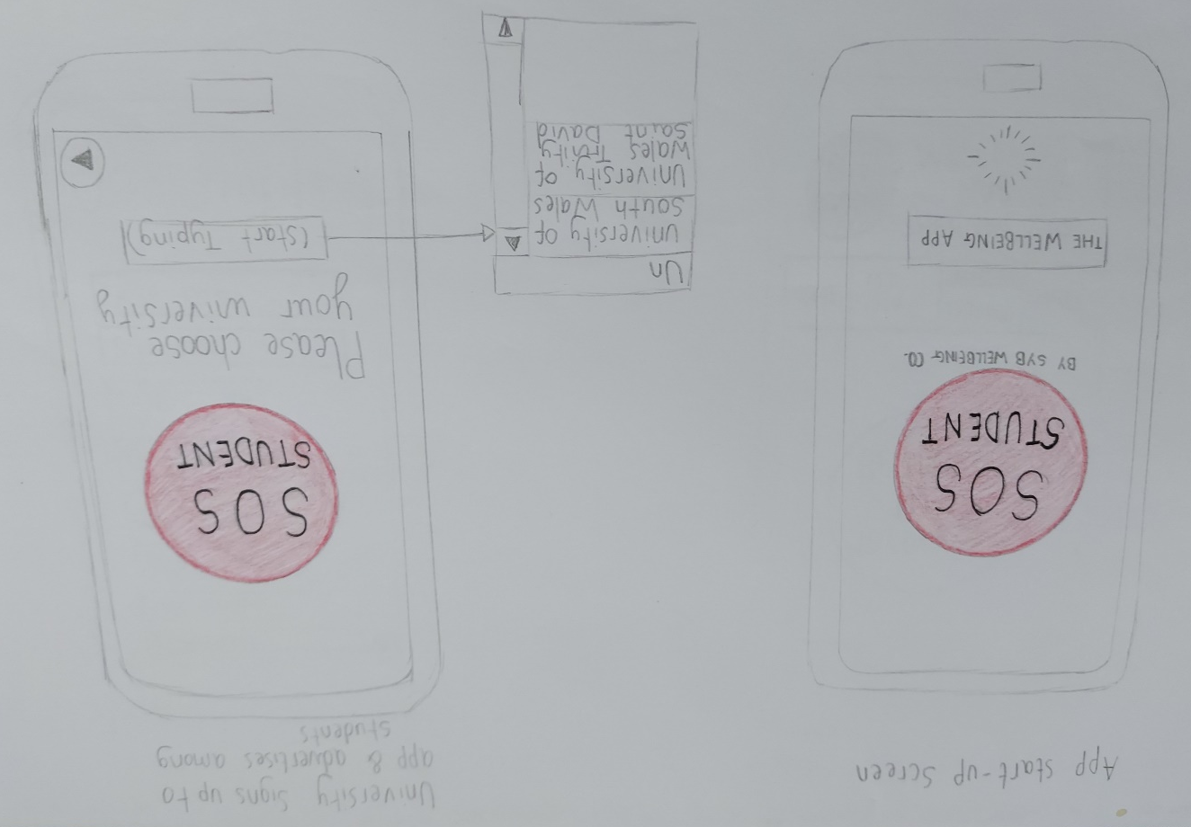
Figure 54: Start-up screen & user registration
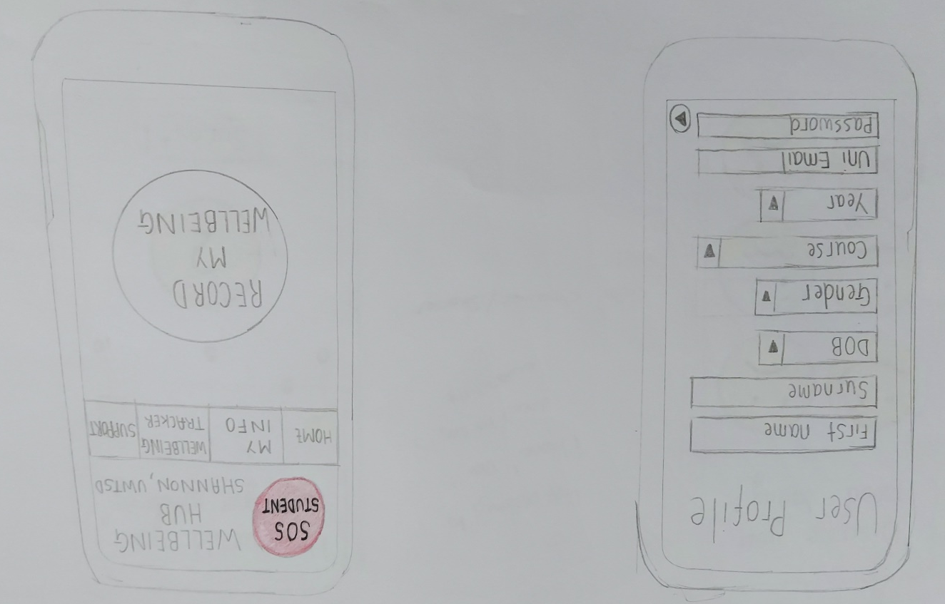
Figure 55: User profile & wellbeing hub
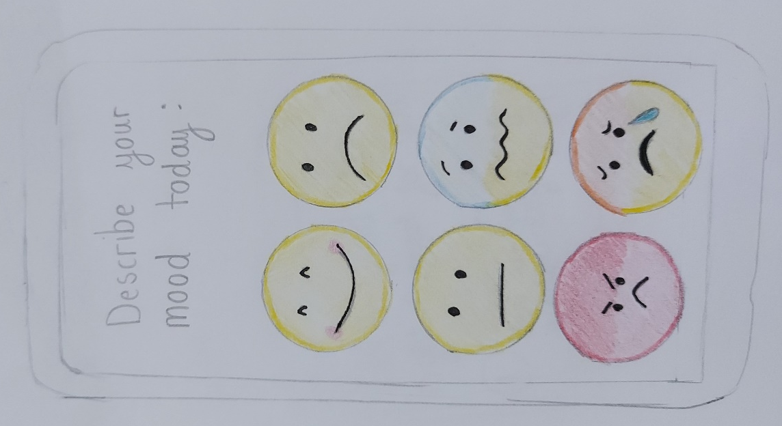  Figure 56: Emoji Page | 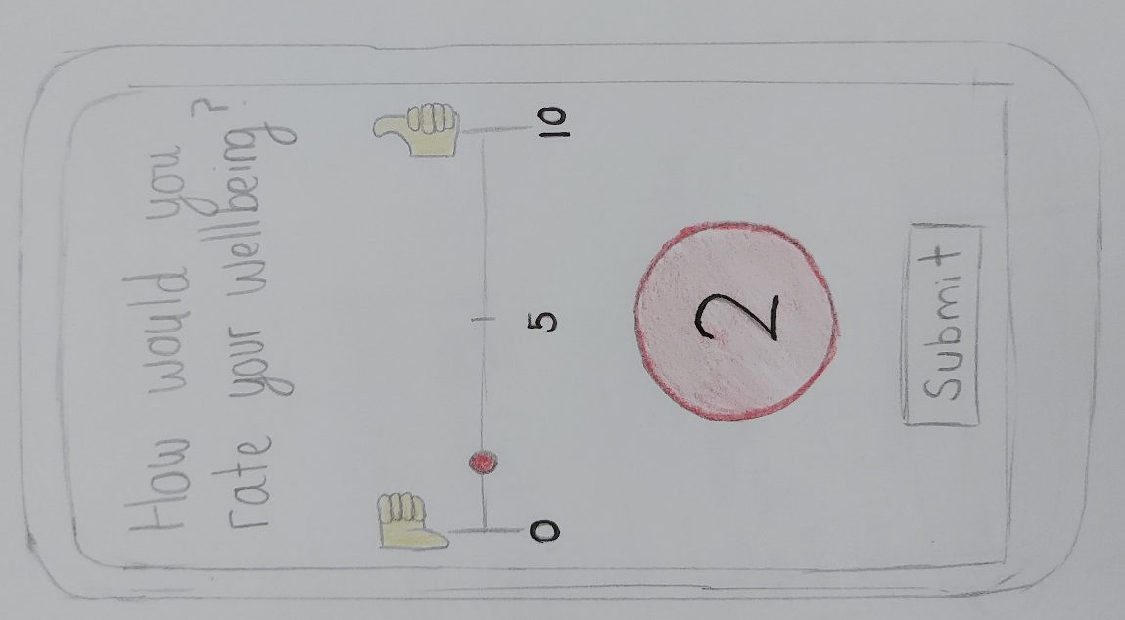  Figure 57: Wellbeing Page

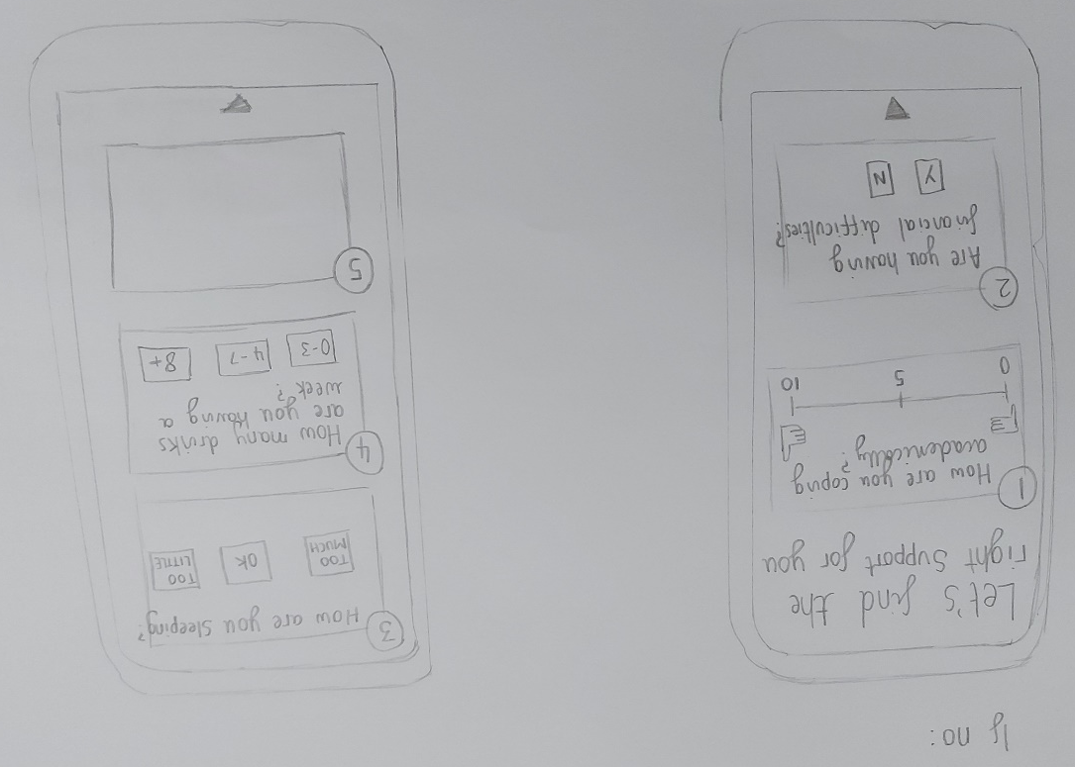
Figure 58: Academic rating and question page
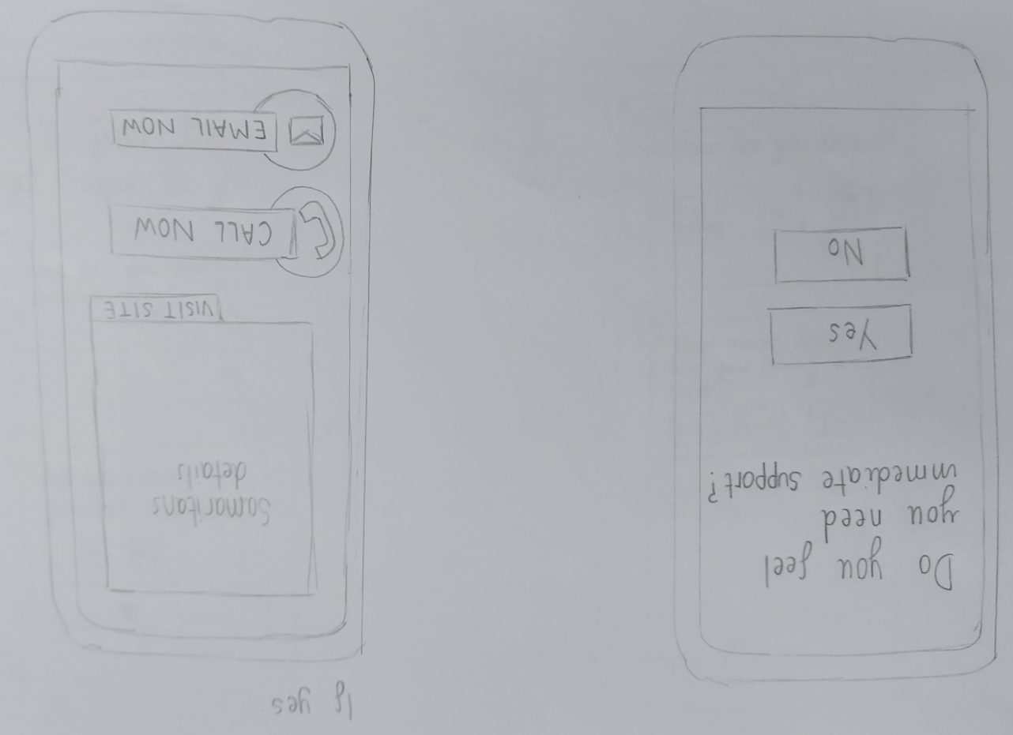
Figure 59: Critical Button

Appendix H: UML Case Diagrams
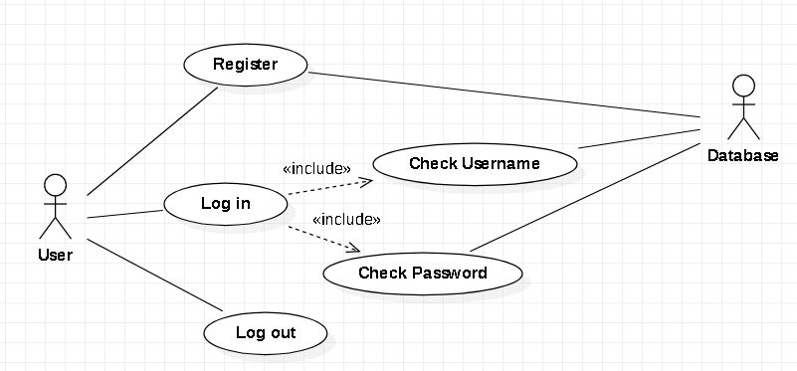
Figure 60: Login Use Case Diagram
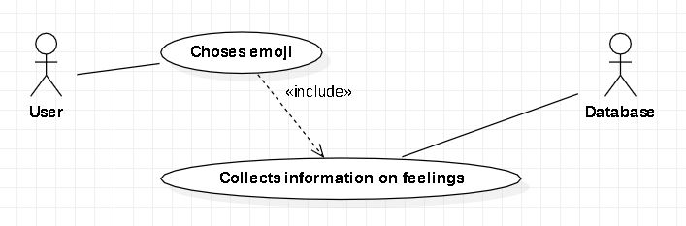
Figure 61: Emoji Page Use Case Diagram
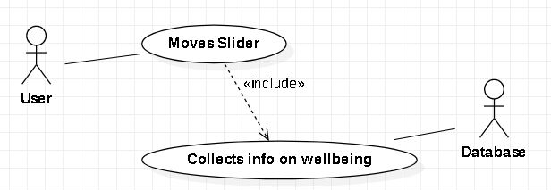
Figure 62: Wellbeing Page Use Case Diagram
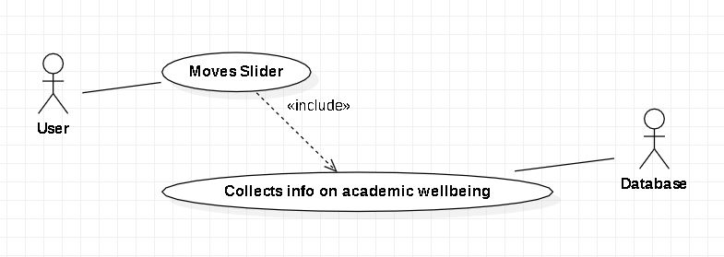
Figure 63: Academic Page Use Case Diagram
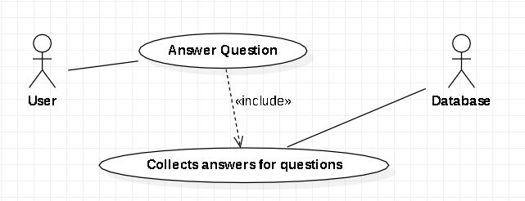
Figure 64: Question Page Use Case Diagram
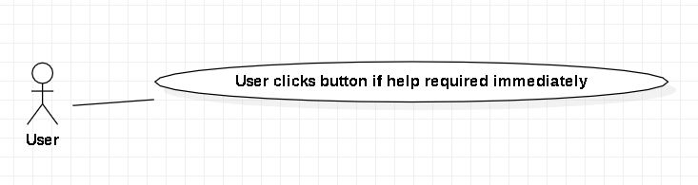
Figure 65: Critical Button

Appendix I: SOS Student Demonstration File

