Programme: MSc Public Health and Social Care in Practice
Module: Community Care and Management of Longer-term Conditions
Module code: LCHS7003
Lecturer: Muhammed Khan Internal Verifier: Dr Hamdi Hussain
JAHANVI SODHA
STUDENT ID 2530085
Assignment Title: Component 1 Information Booklet of Long-term Condition Management Chronic kidney disease (CKD)
WORDS: 3094
Table of Contents
1. Introduction 3
2. Requested History of Long-term Condition 3
3. Etiology Diseases and Presancies (Causes and Risk Factor) 3
4. Effects of the Long-term Condition 3
5. Treatment and Management Law in the UK 4
6. Theoretical Perspectives and Models 4
7. Policies and Guidelines 4
8. Person-Centred Care 5
9. Self-Management 5
10. Recommendations 5
11. Conclusion 5

1. Introduction
Definition
Chronic Kidney Disease (CKD) is a long-term disorder that is chronic in nature and is manifested by the demise of a kidney as days go by. It has been a significant health issue in the world because of its high prevalence rate, relationship with other chronic ailments, and effects on mortality and quality of life. CKD is frequently asymptomatic and manifests itself only in secondary stages and therefore, early diagnosis and treatment are requisite. Strategic management of CKD revolves around the reduction in the rate of disease development, control of disease-related complications, and enhancing the quality of life of patients with the help of the medical process and self-management (Borg et al., 2023; Francis et al., 2024).

2. Requested History of Long-term Condition
The definition procedure of CKD is the abnormality of the structure or functioning of the kidney that extends beyond three months, which has health implications. The disease is stage five depending on the glomerular filtration rate (GFR), and stage five is kidney failure that demands dialysis or transplantation. CKD is present in the global population in the range of 10% and is constantly growing because of ageing and the growing rates of diabetes and hypertension (Jadoul et al., 2024; Francis et al., 2024). CKD is a serious health concern of the population that impacts the rising healthcare expenses and hospitalisation. Such a condition is also linked with cardiovascular disease which is the cause of death of the greatest number of CKD patients (Borg et al., 2023).
In the past, kidney diseases have not been well understood and were usually diagnosed when they were in severe states. The previous methods of medical work mainly involved treating kidney failure but not preventing the development of kidney damage. Gradually, medical science and diagnostics technologies enabled medical practitioners to gain deeper insights into the way kidney functions deteriorate over a long period of several years. Laboratory testing, that includes blood creatinine evaluation to detect the damage caused by kidney disorders and urine examination, allowed detecting those issues earlier than the formation of serious symptoms.
In the late twentieth century, medical studies came to identify more and more chronic kidney disease as a long-term progressive condition and not an isolated organ disorder (Thorp et al. 2023). This knowledge resulted in the development of the stages of CKD dependent on the amount of kidney functions as well as assisted physicians in identifying the level of the disease severity.
Health care systems over the past decades have focused on early diagnosis and long term management of CKD particularly in the persons suffering other illnesses like diabetes and high blood pressure (Borg et al. 2023). The history of CKD management thus implies the shift towards the proactive management of the disease instead of reactive management of kidney failure and its purpose to slow down the progression and enhance patient health.

3. Etiology Diseases and Presancies (Causes and Risk Factor)
Diabetes mellitus, hypertension and cardiovascular disease are the major causes of CKD. The conditions hurt the blood vessels in the kidneys, making them inefficient in the sale of the waste products. Obesity, smoking, ageing, and genetic predisposition are other risk factors that are important (Mallamaci and Tripepi, 2024).
CKD is also associated with metabolic syndrome as one of its major causes (Scurt et al., 2024). Also, liver disorders like metabolic-associated steatotic liver disease (MASLD) have also become widely understood as risks of the CKD progression (Bilson et al. 2024). The above linked conditions underscore the need of a holistic approach to CKD in its prevention and management.
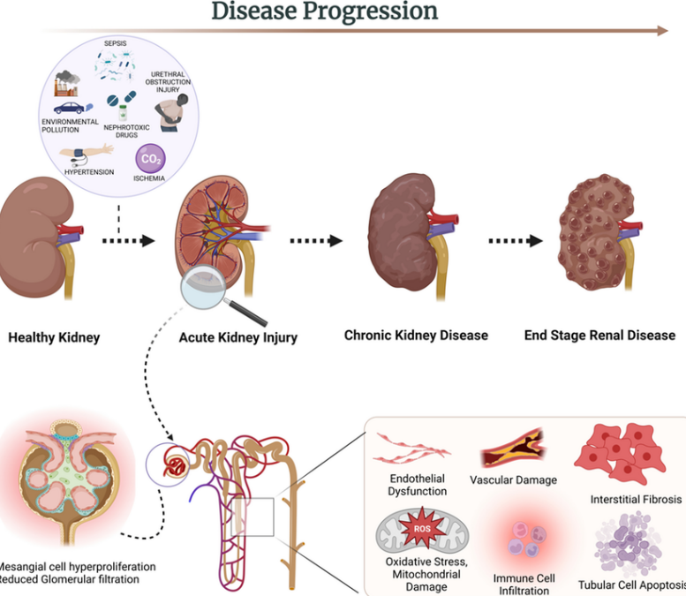
Figure 1: Chronic kidney disease (CKD)
(Source: Tu et al. 2022)
Besides the systematic medical factors that are typically recognised, there exists a number of other health conditions that are capable of contributing to the formation of chronic kidney disease (Scurt et al. 2024). Kidney infections or prolonged inflammation of kidney tissues may take time to damage kidney tissues and limit their efficiency in filtering waste materials in the blood (Nalesso et al. 2024). Some autoimmune diseases, such as the immune system attacking the healthy tissues, can also contribute to damaging kidneys in the long term. Such immune-related diseases may intervene with the normal functioning of the kidneys and damage the small filtering units.
Kidney damage is also likely to occur due to long-term use of some medications (LaForge et al. 2023). Certain pain relievers, especially those consumed in large doses or during a long time, can have adverse effects on the well being of the kidneys (Chatha et al. 2023). On the same note, environmental exposure to adverse toxins, heavy-metals, or chemicals can weaken the kidney functions over time (Ohiagu et al. 2022). When this occurs, a person in an environment where they are exposed to industrial chemicals would then be at a greater risk when they do not observe proper safety measures.
The lifestyle behaviours are also significant in the cause of chronic kidney disease (Luo et al. 2022; Cardol et al. 2022). A diet that is unhealthy like consuming a lot of salt, fats, and processed foods can serve as a factor leading to high blood pressure and other metabolic issues which ultimately influence the kidney functions. The conditions that can contribute to the risk include obesity and insulin resistance which are caused by a deficiency of physical activity and increased weight with time.
The other relevant cause is lack of access to healthcare services or routine health check ups. In most instances, one can be unaware of having early kidney damage as the symptoms are negligible or non-existent (Corkery and Schifano, 2022). The disease can go undetected as one does not go to the doctor regularly until the kidney is seriously impaired (Vassalotti et al. 2025). The socioeconomic risks can also affect the probability of early diagnosis and treatment such as income level, education and health awareness.
The broad spectrum of causes and risk factors related to chronic kidney disease and the significance of the approach toward the prevention of the disease is based on the aspect of adopting a healthy lifestyle, frequent healthcare examination, and early-stage therapy.

4. Effects of the Long-term Condition
There are profound physical, psychological, and social manifestations of CKD in patients and their families.
Physiological
Physiologically, the patients might have fatigue, fluid retention, breathlessness, and limited physical functioning. Later on in the course of the disease, complications like pain in anaemia and bone illness can occur (Borg et al., 2023).
The chronicity of the disease and lifetime therapy establish a connection with CKD on a psychological level as the ailment induces anxiety and depression. This condition is characterised by low-quality-of-life and distress in patients under dialysis (Francis et al., 2024).

Social
CKD may impact on employment, relationships, and daily activities socially. Caregiving is usually a community role played by the family members and thus may create a strain on the purse and also an emotional weight. Hospital visits and treatment may also affect the family normal routines as it requires regular visits and treatment routines (Jadoul et al., 2024).

Psychological

In addition to the physical and psychological effects, chronic kidney disease may have a serious impact on a wide range of the daily life of a person. CKD patients usually have to continuously alter their day-to-day practices so as to adapt to their illness (Yapa et al. 2024). Such modifications can involve highly limited food intake, frequent drug therapy, and constant medical examinations. These lifestyle changes can be very difficult to maintain in long term periods, and may lead to frustration and dependency on health systems.
The condition can as well impact on the extent of independence of an individual. As the kidneys deteriorate, the patient might have decreased energy levels and fail to carry out the normal daily duties like working, exercising or even handling the household chores (Kushwaha et al. 2023). At later phases of the disease, dialysis treatment with frequency up to a number of times per week may severely reduce the freedom and mobility of a patient to travel or engage in socialisation.
There is also a risk of many individuals and families dealing with chronic kidney disease to experience financial difficulties (Powathil and Kr, 2023). Request expenses of long-term treatments, medicine, commuting to medical facilities as well as special meals can develop further duty on family units. There are instances where the patients are forced to work less or even quit the job given the physical inability that the sickness or treatment period imposes. Such income deprivation may cause additional pressure to the family members and to the patient.
family
The relationships and family dynamics may also be affected by the long-term character of the disease. The family members usually have a significant role to play in offering emotional support and in helping with day to day care requirements. Although the support is necessary, it is at times considered to cause caregiver burnout, especially when the family members need to strike a balance between care giving duties and employment as well as other individual related duties.
The other beneficial effect of CKD is associated with an increased threat of other health problems (Borg et al. 2023). With diminishing kidney performance, the body no longer can take care of the fluid balance, control blood pressure, and eliminate toxins in the body. This can lead to complications with other organs and systems and way of health management increases the complexity of the overall. Consequently, patients having CKD frequently need constant healthcare advice and interaction of various healthcare providers to remain stable and avoid being further contraindicated.

5. Treatment and Management Law in the UK
The management of CKD in the UK aims at preventing the acceleration of disease development and the management of complications. The first-line interventions suggested are the changes in the lifestyles (recommended to be dietary changes, smoking cessation, and the exercise) and changes in the way of living. Therapies involve antihypertensive drugs and glucose reducing ones. Empagliflozin is a SGLT2-inhibitor that has been proved to slow down the progression of CKD and the risk of cardiovascular events (EMPA-Kidney Collaborative Group, 2023). The advanced CKD can necessitate renal replacement therapy such as dialysis or kidney transplants. Another diagnostic method is the conservative kidney management of patients who cannot undergo dialysis, which entails symptom control and quality of life (Chawla et al. 2025).
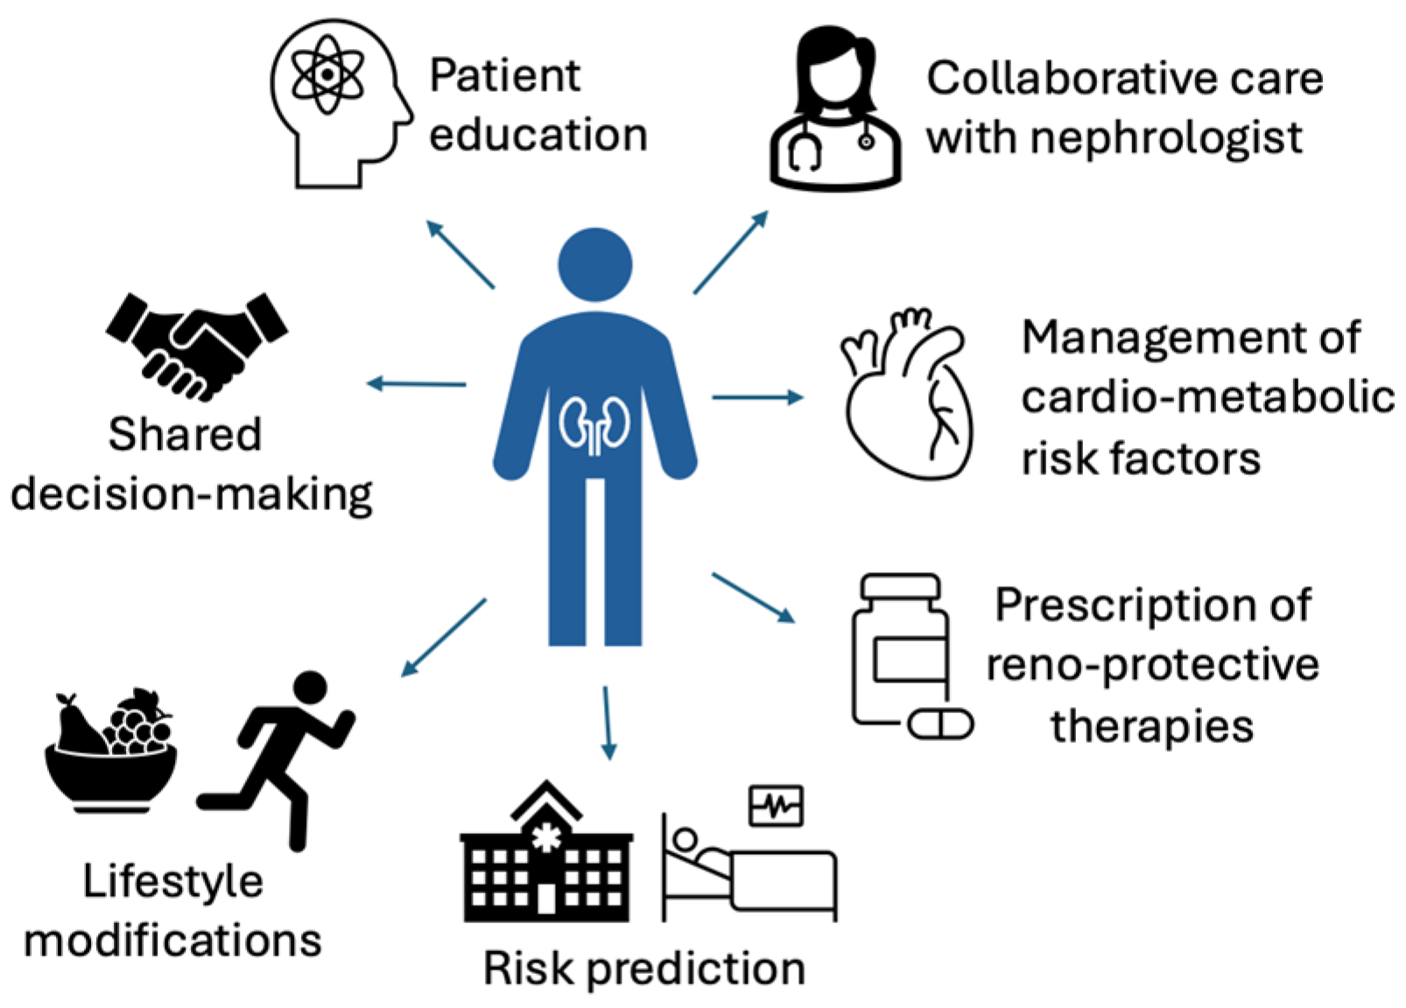
Figure 2: Care of adults with CKD
(Source: Shrestha et al. 2024)
Chronic kidney disease management within the United Kingdom works within a legal and regulatory framework, which is aimed at the achievement of safety, effectiveness, and equity in healthcare provision (Johnston-Webber et al. 2025). The healthcare providers should adhere to the national standards of healthcare that will encourage the timely detection, proper treatment, and constant observation of persons with long-term health conditions. These legal systems help in upholding the rights of patients to high-quality care besides holding healthcare professionals responsible for clinical practice.
Healthcare legislation within the UK incorporates patient security and safety. Legal regulations on patient consent and consent also mandate medical practitioners to assure that a person should have complete information on the available treatment, the possible risk, and the anticipated results before a medical procedure is carried out (Pallocci et al. 2023). It is a principle, according to which, patients can have an active role in making a decision on dialysis, transplantation or conservative treatment methods. The laws of confidentiality and data protection also protect patients personal medical information as it guarantees that the medical records of patients are stored safely and only disclosed to people who are involved in the treatment and possess authorisation.
Equality act is also a significant aspect to the management of chronic conditions like CKD. It guarantees that people who are chronically sick are not marginalised during the process of obtaining health services, workplaces, or even social services. This law helps healthcare organisations to make reasonable accommodation to anyone whose daily functioning is impaired by chronic disease.

6. Theoretical Perspectives and Models
The models of chronic disease management focus on multidisciplinary and coordinated care of the CKD patients. With the help of these models, the collaboration between healthcare professionals in the effort to help patients can be emphasised.
International models emphasise the importance of early detection and prevention measures, and multidisciplinary care models are meant to meet the complicated needs of CKD patients. Such practice is conducive to whole care and enhances the outcome in the long run (Neuen et al., 2023). The chronic kidney disease has a number of theoretical perspectives and healthcare models that can assist in its effective management. The chronic care approach is one of the significant concepts in the treatment of long-term conditions where continuous and coordinated care is the basis and not the short-term treatment of symptoms. This model focuses on proactive healthcare planning, frequent monitoring and coordination of healthcare professionals and patients towards achieving improved health outcomes.
The biopsychosocial approach is another perspective that is pertinent to the case of CKD since the condition is identified as chronic, and is caused by a complex of biological, psychological and social factors (Musthofa, 2024). This model has it that effective management of any disease cannot only be realised through medical help, but also psychological support and social help that should address the wider effect of the ailment on the lives of patients.
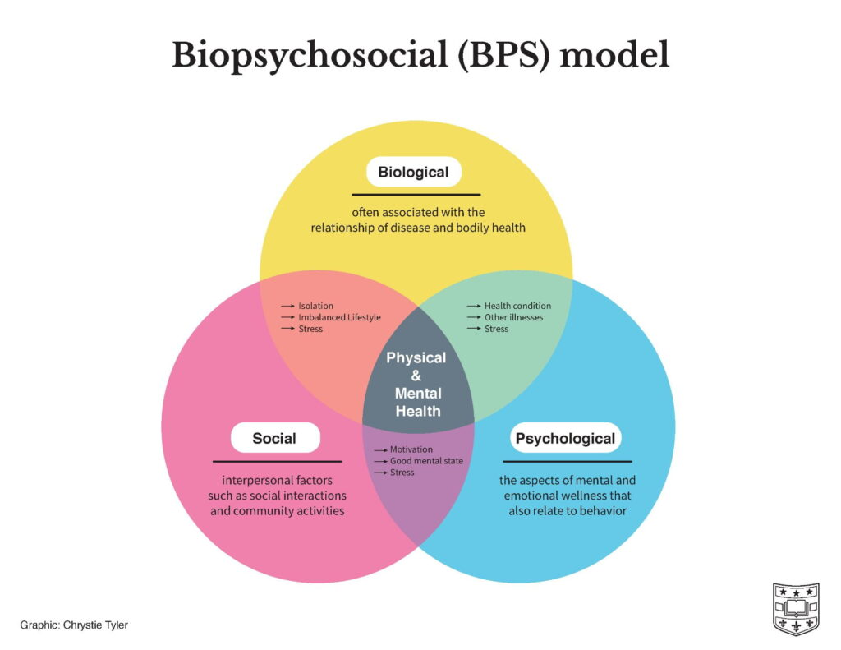
Figure 3: BPS
(Source: Megan, 2021)
Behavioural change theories play an important role as well in motivating patients to change their lifestyles to healthier ones and stay on top of treatment. Education, encouragement and continued support enables the patients to acquire the knowledge and confidence they need to cope with their condition. These theoretical viewpoints are the ones which substantiate the holistic and patient-centred approach to long-term disease management.

7. Policies and Guidelines
The management of CKD is sustained by both national and international health policies focusing on enhancement of early treatment and detection. International policies focus on the screening of groups at the risky level and access to treatment (Francis et al., 2024).
Health policies are also aimed at the reduction of inequalities in CKD care and the enhancement of access to the dialysis and transplantation services. The national kidney health programmes strive to enhance the healthcare systems and the patient outcomes (Neuen et al., 2023). Clinical guidelines and healthcare policies are crucial in the process of guaranteeing steady and quality management of chronic kidney disease within healthcare systems. The policies will help to offer early diagnosis, effective management and long-term follow-up to the kidney disease patients. They give healthcare providers systematic advice regarding how to diagnose CKD, how to screen the development of the disease, and how to control the complications related to the impaired kidney functioning.
The target in national healthcare strategies usually touches on detection of patients, who have high risks of contracting kidney disease (Stewart et al. 2024). The screening programmes on individuals with cases like diabetes and hypertension are promoted so that the kidney issues are identified at an early stage. With early intervention, the disease may be greatly mitigated and be able to achieve better health outcomes in the long-run.
There are other integrated policies such as the integration of care systems that connect the hospital services with that of the primary care providers and community support organisations. This is a synchronised strategy to help the patients get continuous care in the various healthcare environments. Principles promote employing the multidisciplinary teams to meet the medical, psychological, and social concerns of people with CKD.

8. Person-Centred Care
The person-centred approach is necessary when managing CKD because the patients need long-term care and lifestyle modification. This is a practice that entails the use of shared decision-making and individualised treatment involving preferences and needs of the patients. Person-centred care can enhance compliance with treatment and patient satisfaction in addition to promoting improved health outcomes (Borg et al. 2023).

9. Self-Management
Self-management and CKD are essential in CKD care.
Patients are advised to check blood pressure, diet and take drugs as they have been given.
Support programmes and education enable the patients to acquire skills of effective management of their condition.
It has been demonstrated that self-management strategies lead to better health outcomes and less hospitalisation (Francis et al., 2024).

Table 1: Self-management steps
(Source: Self developed)

10. Recommendations
To ameliorate the disease progression, there is the need to improve the early detection of CKD by way of screening programmes. Self-management and adherence to treatment can be improved with additional education and support that a patient receives. Medical systems ought to advocate interdisciplinary care and the accessibility of medical care. Health inequalities also should be addressed by policies and equitable access to CKD care should be guaranteed (Neuen et al. 2023).
In order to manage chronic kidney disease, it is necessary to pay more attention to managing prevention, early diagnosis, and coordinating healthcare services. The awareness of kidney health needs to be promoted by the public health initiatives and the people who are at high risk need to be encouraged to take the health screenings, especially on the cases that have a known predisposing factor (Tannor and Calice-Silva, 2022). The healthcare systems are supposed to enhance multidisciplinary collaboration so that the patient acquires all-encompassing care that is based not only on medical care but also on social care. Enhancing patient education can be achieved through more patient education programmes which will lead to enabling patients to take part in their conditions management as well as ensuring healthy lifestyles. Also, healthcare policies are still required to concentrate in order to decrease inequalities in access to treatment and provide all patients with timely and effective care of their kidneys.

11. Conclusion
Chronic Kidney Disease is a major health issue in the world with severe physical, psychological, and social consequences. Management entails early detection, multidisciplinary care and patient engagement. Healthcare systems are able to lessen CKD burden and enhance patient outcomes by enhancing prevention tactics as well as person-based treatment methods.On one hand, chronic kidney disease is a major health issue, a long-lasting problem, which gives human beings a physical, psychological, and social burden. Early detection, regular medical attention and effective working relationships between patients and health care professionals are essential in effective management. The joint efforts are needed to reduce disease progression and increase the quality of life through a combination of correct treatment, favourable healthcare policies, and patient engagement. The health burden of chronic kidney disease can be mitigated through the promotion of person-centred care, enhanced healthcare systems, and self-management strategies. Further commitment to prevention, education, and equal access to healthcare services will be an important factor in enhancing the postnatal outcomes of those affected by this condition.

References
Bilson, J., Mantovani, A., Byrne, C.D. and Targher, G., 2024. Steatotic liver disease, MASLD and risk of chronic kidney disease. Diabetes & metabolism, 50(1), p.101506.
Borg, R., Carlson, N., Søndergaard, J. and Persson, F., 2023. The growing challenge of chronic kidney disease: an overview of current knowledge. International Journal of Nephrology, 2023(1), p.9609266.
Borg, R., Carlson, N., Søndergaard, J. and Persson, F., 2023. The growing challenge of chronic kidney disease: an overview of current knowledge. International Journal of Nephrology, 2023(1), p.9609266.
Borg, R., Carlson, N., Søndergaard, J. and Persson, F., 2023. The growing challenge of chronic kidney disease: an overview of current knowledge. International Journal of Nephrology, 2023(1), p.9609266.
Cardol, C.K., Boslooper-Meulenbelt, K., Van Middendorp, H., Meuleman, Y., Evers, A.W. and Van Dijk, S., 2022. Psychosocial barriers and facilitators for adherence to a healthy lifestyle among patients with chronic kidney disease: a focus group study. BMC nephrology, 23(1), p.205.
Chawla, N., Teerawattananon, Y., Yongphiphatwong, N., Thamcharoen, N., Aryani, H., Tun, Y.M., Butani, D.H., Ngam-Prukwanit, R. and Anothaisintawee, T., 2025. Policy strategies to enhance uptake of conservative kidney management in advanced chronic kidney disease: a systematic review and meta-analysis. BMC nephrology, 26(1), p.388.
Corkery, J.M. and Schifano, F., 2022. First death involving 4-fluoroethylphenidate (4F-EPH): case report, user experiences, and review of the related literature. Academic forensic pathology, 12(4), pp.149-166.
EMPA-Kidney Collaborative Group, 2023. Empagliflozin in patients with chronic kidney disease. New England Journal of Medicine, 388(2), pp.117-127.
Francis, A., Harhay, M.N., Ong, A.C., Tummalapalli, S.L., Ortiz, A., Fogo, A.B., Fliser, D., Roy-Chaudhury, P., Fontana, M., Nangaku, M. and Wanner, C., 2024. Chronic kidney disease and the global public health agenda: an international consensus. Nature Reviews Nephrology, 20(7), pp.473-485.
Jadoul, M., Aoun, M. and Imani, M.M., 2024. The major global burden of chronic kidney disease. The Lancet Global Health, 12(3), pp.e342-e343.
Johnston-Webber, C., Bencomo-Bermudez, I., Wharton, G., van Kessel, R., Barone, S., Muntó, F.B., Chadban, S., Sanchez, J.J.G., Kocks, J.W., Obolensky, K. and Sandow, P., 2025. A conceptual framework to assess the health, socioeconomic and environmental burden of chronic kidney disease. Health Policy, 152, p.105244.
Kushwaha, R., Vardhan, P.S. and Kushwaha, P.P., 2023. Chronic kidney disease interplay with comorbidities and carbohydrate metabolism: a review. Life, 14(1), p.13.
LaForge, J.M., Urso, K., Day, J.M., Bourgeois, C.W., Ross, M.M., Ahmadzadeh, S., Shekoohi, S., Cornett, E.M., Kaye, A.M. and Kaye, A.D., 2023. Non-steroidal anti-inflammatory drugs: clinical implications, renal impairment risks, and AKI. Advances in therapy, 40(5), pp.2082-2096.
Luo, W., Gong, L., Chen, X., Gao, R., Peng, B., Wang, Y., Luo, T., Yang, Y., Kang, B., Peng, C. and Ma, L., 2022. Lifestyle and chronic kidney disease: A machine learning modeling study. Frontiers in nutrition, 9, p.918576.
Mallamaci, F. and Tripepi, G., 2024. Risk factors of chronic kidney disease progression: between old and new concepts. Journal of Clinical Medicine, 13(3), p.678.
Megan, 2021. Three aspects of health and healing: The biopsychosocial model in medicine. Washington University in St. Louis, Department of Surgery. Available at: Three aspects of health and healing: The biopsychosocial model in medicine (Accessed: 9 March 2026).
Musthofa, W., 2024. Biopsychosocial-Spiritual: A Proposed Holistic Approach To Ckd Patient Mental Health. PROSIDING RELIGION, PSYCHOLOGY AND ENVIRONMENT, pp.9-15.
Nalesso, F., Garzotto, F., Cattarin, L., Bettin, E., Cacciapuoti, M., Silvestre, C., Stefanelli, L.F., Furian, L. and Calò, L.A., 2024. The future for end-stage kidney disease treatment: Implantable bioartificial kidney challenge. Applied Sciences, 14(2), p.491.
Neuen, B.L., Bello, A.K., Levin, A., Lunney, M., Osman, M.A., Ye, F., Ashuntantang, G.E., Bellorin-Font, E., Gharbi, M.B., Davison, S. and Ghnaimat, M., 2023. National health policies and strategies for addressing chronic kidney disease: data from the International Society of Nephrology Global Kidney Health Atlas. PLOS Global Public Health, 3(2), p.e0001467.
Odoma, V.A., Pitliya, A., AlEdani, E., Bhangu, J., Javed, K., Manshahia, P.K., Nahar, S., Kanda, S., Chatha, U., Mohammed, L. and AlEdani, E.M., 2023. Opioid prescription in patients with chronic kidney disease: a systematic review of comparing safety and efficacy of opioid use in chronic kidney disease patients. Cureus, 15(9).
Ohiagu, F.O., Chikezie, P.C., Ahaneku, C.C. and Chikezie, C.M., 2022. Human exposure to heavy metals: toxicity mechanisms and health implications. Material Science & Engineering International Journal, 6(2), pp.78-87.
Pallocci, M., Treglia, M., Passalacqua, P., Tittarelli, R., Zanovello, C., De Luca, L., Caparrelli, V., De Luna, V., Cisterna, A.M., Quintavalle, G. and Marsella, L.T., 2023. Informed consent: legal obligation or cornerstone of the care relationship?. International journal of environmental research and public health, 20(3), p.2118.
Powathil, G.G. and Kr, A., 2023. The experience of living with a chronic illness: a qualitative study among end-stage renal disease patients. Journal of Social Work in End-of-Life & Palliative Care, 19(3), pp.190-208.
Scurt, F.G., Ganz, M.J., Herzog, C., Bose, K., Mertens, P.R. and Chatzikyrkou, C., 2024. Association of metabolic syndrome and chronic kidney disease. Obesity reviews, 25(1), p.e13649.
Scurt, F.G., Ganz, M.J., Herzog, C., Bose, K., Mertens, P.R. and Chatzikyrkou, C., 2024. Association of metabolic syndrome and chronic kidney disease. Obesity reviews, 25(1), p.e13649.
Shrestha, S., Haq, K., Malhotra, D. and Patel, D.M., 2024. Care of adults with advanced chronic kidney disease. Journal of Clinical Medicine, 13(15), p.4378. Available at: https://www.mdpi.com/2077-0383/13/15/4378 (Accessed: 9 March 2026).
Stewart, S., Kalra, P.A., Blakeman, T., Kontopantelis, E., Cranmer-Gordon, H. and Sinha, S., 2024. Chronic kidney disease: detect, diagnose, disclose—a UK primary care perspective of barriers and enablers to effective kidney care. BMC medicine, 22(1), p.331.
Tannor, E.K. and Calice-Silva, V., 2022. Kidney health for all—Efforts in low-income settings to enhance community engagement, kidney health awareness, and screening. Kidney International Reports, 7(3), pp.359-362.
Thorp, K.E., Thorp, J.A., Northrup, C., Thorp, E.M., Scott-Emuakpor, A. and Kepros, J.P., 2023. Energy dynamics in chronic heart failure, chronic kidney disease & the cardiorenal syndrome: a new causal paradigm. dialysis and transplantation, 5, p.6.
Tu, C., Wang, L., Wei, L. and Jiang, Z. (2022) The role of circular RNA in diabetic nephropathy. Available at: https://www.researchgate.net/figure/Illustration-of-the-kidney-diseases-pathogenesis-and-disease-development_fig1_378106074 (Accessed: 4 March 2026).
Vassalotti, J.A., Francis, A., Soares dos Santos Jr, A.C., Correa-Rotter, R., Abdellatif, D., Hsiao, L.L., Roumeliotis, S., Haris, A., Kumaraswami, L.A., Lui, S.F. and Balducci, A., 2025. Are your kidneys ok? Detect early to protect kidney health. Nephron, 149(11), pp.691-700.
Wang, Y., Feng, Y., Li, M., Yang, M., Shi, G., Xuan, Z., Yin, D. and Xu, F., 2022. Traditional Chinese medicine in the treatment of chronic kidney diseases: theories, applications, and mechanisms. Frontiers in pharmacology, 13, p.917975.
Yapa, H.E., Chambers, S., Purtell, L. and Bonner, A., 2024. Impact of chronic kidney disease on everyday life: A descriptive qualitative study. Journal of Renal Care, 50(3), pp.201-211.

