

BMMB7027 and BMMB7027D
Strategic and Agile Business Management

Strategic Agility and Personalised Customer Care at Marks & Spencer

Submitted By: Mohammad Sajadul Haque
ID: 2511320

Executive Summary
This report recommends that the senior management of Marks and Spencer Group plc revise their strategic focus and enhance personalised customer care. The report is based on strategic and agile business management, given the fact that M&S deals with a fast-moving retail business where the business environment changes rapidly due to customer demand, technology and economic conditions. The key strategic issue is that M&S has to safeguard its reputable brand and quality identity and get more agile, digital and customer-oriented. External forces would comprise inflation, low consumer confidence, online competition, sustainability expectations, political uncertainty and cyber risk. These influence the customer care as customers have become conscious of value, convenience, personalisation, speed and trust in all the channels. Customer service is no longer a service in the store. It encompasses the experience in the application, the reliability of delivering, the privacy of data, loyalty, customer responsiveness, ethical practice and ethics in business. The internal analysis shows that M&S has important strengths. These are robust brand heritage, reputation of quality food and goods, the Sparks loyalty program, a network of stores nationwide, digital transformation development and supply chain rejuvenation. Nevertheless, there are also risks associated with cybersecurity, the lack of stable omnichannel service and the necessity to conduct customer data responsibly, which also threatens the company. There are three alternative strategic options that are assessed in the report. These include AI-based customised customer care, customer experience enhancement and improvement and sustainable customer care. The best alternative is an ethical AI-enabled personalised customer care with Sparks, facilitated by digital channels, store service, cybersecurity and nimble data-driven decision-making. This approach is suggested as it links customer insight and highly personalised value, accelerated service recovery and increased loyalty. The anticipated result will be enhanced customer loyalty, greater resilience, enhanced customer trust and sustainable competitive advantage. Nevertheless, care should be taken in implementation. M&S must secure customer information, educate staff, enhance online trust and reliability and make sure that personalisation enhances customer value but does not seem to be intrusive.

Table of Contents
Executive Summary 2
1. Introduction 4
1.1 Background of Marks & Spencer 4
1.2 Strategic Challenge 4
1.3 Aim and Scope of the Report 5
2. Main Findings of Strategic Analysis and Critical Evaluation of Strategic Options 6
2.1 External Strategic Analysis 6
2.2 Internal Strategic Analysis 9
2.3 SWOT/TOWS Summary 13
2.4 Critical Evaluation of Strategic Options for Personalised Customer Care 14
2.5 Strategic Option Selection Using SAF 15
2.6 Wider Organisational Implications 17
3. Conclusions 19
4. Recommendations 20

1. Introduction

1.1 Background of Marks & Spencer
Marks and Spencer Group plc, often referred to as M&S, is one of the most well-known retailers in the United Kingdom. It has operations in food, clothing, home and beauty. The company boasts a long history of retail in Britain, and its brand is closely associated with quality, trust, reliability and customer service. This is a key strategic strength. But it also brings with it high expectations since the customers have placed high expectations on M&S to maintain its traditional standards but transform into quicker, more digital and more customised.
M&S is multipurposely changing its business by reforming its stores, digitalising, enhancing its supply chain, developing products and gaining better customer loyalty with the help of the Sparks programme. Marks and Spencer has recorded large group sales of £14.2 billion in 2025/26 without considering Ocado Retail, indicating its huge market share and the significance of customer retention (Marks and Spencer, 2026). Customer care has become a strategic concern to M&S. Retail customers do not demand to be served in stores only politely anymore. Their values, convenience, personalisation, speed, digital access with ease and trust in the use of their data are also expected.

1.2 Strategic Challenge
M&S is a company that competes in a competitive retail sector. Inflation, an increase in the labour cost, uncertainty in the supply chain, political instability and evolving customer behaviour put pressure on the company. Most customers have become tight in their spending due to the pressure on the cost-of-living. Meanwhile, they also desire quality products, reasonable prices and hassle-free shopping. This presents M&S with a strategic challenge. It needs to defend its luxury quality image and, at the same time, demonstrate that it knows value and convenience.
There is also stiff competition. M&S has competition in food with supermarkets and upscale food retailers. It also competes with fashion retailers, online, department stores and discount brands in clothing, home and beauty. Hence, M&S cannot rely solely on heritage or on product quality. It requires a customer- care strategy that is fast, data-driven and hard to replicate by any competition. According to Porter, competitive advantage is attained when a company can generate unique value and defend against the competition (Okafor et al., 2026). In the case of M&S, it entails leveraging brand trust, stores, online platforms and rewards information to create more intimate customer care.
Reliability of websites, app performance, accuracy of delivery, returns and responding to complaints, loyalty points and personalised offers are now part of customer care. The report will thus offer advice to senior management on strategic direction that enhances resilience, fostering customer trust and sustainable competitive advantage.

1.3 Aim and Scope of the Report
This report will provide an external strategic and internal strategic analysis of M&S, and consider strategic alternatives to a more personalised customer care approach. The report is based on the idea of how M&S can leverage strategic and agile business management to be more resilient in the future and achieve sustainable competitive advantage.
External analysis, internal analysis, strategic options, broader organisational implications, findings and recommendations are within the scope. PESTLE and Porter's Five Forces will be used to analyse the external environment in the report. It will also use VRIO, the Resource-Based View, SWOT/TOWS and dynamic capabilities to assess internal strengths, weaknesses and strategic potential. Dynamic capabilities are applicable since the companies have to feel the change in the market, to take opportunities and reorganise resources in the unpredictable landscapes (Teece, 2018). The stakeholder theory is not unimportant as M&S should enable a balance between customer value and employee capability, relations with suppliers, shareholder expectations, sustainability responsibility and data ethics (Gutterman, 2023). The evaluation and the selection of the most appropriate strategic option will be supported by Porter's generic strategy, Ansoff Matrix and SAF analysis.

2. Main Findings of Strategic Analysis and Critical Evaluation of Strategic Options

2.1 External Strategic Analysis
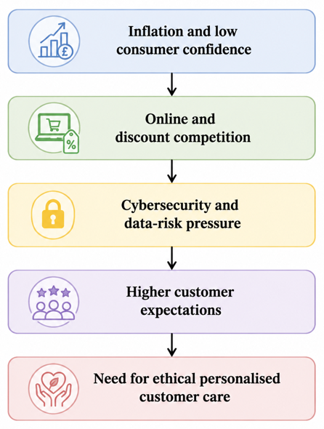
Figure 1 External Pressures on M&S
Source: (Self-Made)
The external analysis indicates that M&S is in a challenging retail environment. According to PESTLE and the Five Forces by Porter, M&S can not primarily compete based on price. Customer care, which is differentiated in terms of quality, trust, personalisation and omnichannel convenience, is its more strategic route.
PESTLE Analysis
Political factors: UK regulation, food policy, labour policy and post-Brexit complexity of supply chain impact M&S. The retailers who import foods, clothing and raw materials have been subjected to more customs and sourcing pressure due to Brexit. This impacts customer care in the sense that customers want the products when assured. Should there be stock gaps or delays due to the disruption of supply, the customers can take it as bad service. Thus, M&S should have more agile supplier planning, improved forecasting and enhanced logistics visibility. PESTLE can be helpful in this case as it connects the outer pressure and the inner strategic reaction (Rashid, 2023).
Economic factors: M&S and customers are under pressure due to inflation, wage increases, energy prices and decreasing disposable income. The inflation of food and non-alcoholic drinks in the UK was 5.1% in August 2024, which indicates that the affordability issue is a significant concern for households (Amélia et al., 2024). This generates a strategic conflict. M&S enjoys a high-end brand, yet the customers are demanding value. M&S can compromise its quality image by lowering prices excessively. Unless it takes affordability into account, its customers could move to supermarkets or discounters. Personalised value with Sparks offers, specific rewards and a more transparent price communication is a more appropriate response.
Social factors: Customer expectations are evolving. Customers desire convenience, healthier products, ethically produced products, inclusive fashion and personalised service. These expectations vary according to the customer group. Younger consumers might like to receive app-based rewards, quick delivery and online recommendations. Store service, quality and easy returns might be appreciated by long-term customers. M&S thus requires segregated customer care. Personalisation should, however, be assistance, not obtrusive. The core of it is trust, since customers will not accept personalisation when they believe that their information is used in an unjust manner.
Technological factors: M&S has a big chance to enhance customer care due to technology. Personalised offers, stock accuracy, quicker service recovery and mobile apps and supply chain analytics can be backed by AI, loyalty data, e-commerce and mobile apps. M&S is also financially strong to invest since its profit before tax, and adjusting items increased by 22.2 per cent to reach an amount of 875.5 million in 2024/25 (Marks and Spencer, 2026). Technology however, is a source of risk. Digital trust has become an aspect of customer care, as demonstrated in the 2025 cyber incident. Online service, reliability of apps and data security will not be segregated by customers. Thus, the personalisation secured by AI should be backed by effective cybersecurity.
Legal Factors: M&S has to comply with data protection laws, consumer laws, employment, food safety and packaging regulations. This is significant since personalised customer care relies on customer data. Personal information should be utilised in a legal, fair and transparent way (Khan, Akter and Kalam, 2020). M&S must not consider this as mere compliance. Trust can be enhanced by clear consent, straightforward privacy settings and transparent communication.
Environmental factors: M&S is under pressure to minimise emissions, food waste, packaging and unsustainable sourcing. Sustainability may contribute to customer care when it becomes realistic and apparent. As an illustration, M&S might provide more environmentally friendly meal recommendations, more transparent sourcing policies, recyclable fashion and incentives for responsible purchasing. The threat is greenwashing. Its claims should be quantifiable and associated with actual customer value.
Factor | Key Issues for M&S | Strategic Implications for Customer Care
Political | Post-Brexit trade complexity, labour regulations, food standards and sourcing requirements | Requires agile supply chains, reliable product availability and effective service communication
Economic | Inflation, rising wages, energy costs and reduced consumer spending power | Customers expect stronger value, targeted rewards and personalised offers without sacrificing quality
Social | Growing demand for convenience, ethical products, health-conscious choices and personalised experiences | Customer care must be tailored to different customer segments and shopping preferences
Technological | AI, customer analytics, e-commerce growth, mobile apps and cybersecurity challenges | Enables personalised services and faster support but requires strong digital trust and data security
Legal | GDPR, consumer protection legislation, employment law and food safety requirements | Personal customer data must be managed legally, transparently and ethically
Environmental | Sustainability expectations, carbon reduction targets, packaging concerns and waste reduction pressures | Creates opportunities for sustainable customer engagement and ethical brand differentiation
Porter’s Five Forces
Force | Strength | Strategic Meaning for M&S
Competitive rivalry | High | M&S competes with Next, Zara, Primark, Sainsbury’s, Waitrose, Tesco and online retailers. Differentiation is essential.
Buyer power | High | Customers compare price, delivery, reviews and returns easily. Personalised care can reduce switching.
Supplier power | Moderate | M&S relies on quality suppliers. This supports quality but can increase costs.
Threat of substitutes | High | Customers can choose discounters, fast fashion, food delivery and online platforms.
Threat of new entrants | Moderate | Digital brands can enter quickly, but scale, trust and supplier depth are harder to copy.
The model by Porter reveals that M&S is under intense market pressure (Whittington et al., 2020). Competition is intense since the UK retail sector is saturated. Aldi had approximately 11.1 of the UK grocery market in 2025, and it demonstrates the power of value-based competition (Savills, 2025). The buyer's power is also strong as switching costs are not high. The power of suppliers is moderate as M&S relies on quality partners. Substitutes are powerful due to the presence of numerous options that are digital and low-cost to customers. On the whole, M&S needs to compete based on credible quality, customised service and convenience of the omnichannel, rather than just price.

2.2 Internal Strategic Analysis
Internal analysis will reveal the resources and capabilities M&S can marshal to help it in personalised care of customers. The Resource-Based View asserts that companies benefit when they possess control over resources that are valuable, rare, difficult to replicate, and well organised (Lynch, 2018). In the case of M&S, the question of the resources being strong is not the fundamental concern. It clearly does. Even more important is whether these resources are utilised in an agile and combined manner.
RBV and VRIO Analysis
Resource/Capability | Valuable | Rare | Difficult to Imitate | Organised to Exploit | Strategic Judgement
Brand heritage | High | Medium | High | High | Strong source of trust, but must be modernised.
Food quality reputation | High | Medium/high | Medium | High | Supports differentiation from low-cost competitors.
Sparks loyalty data | High | Medium | Medium | Medium | Useful only if converted into ethical personalisation.
Store network | High | Medium | Medium | High | Supports service, convenience and local access.
Digital platforms | High | Low/medium | Medium | Medium | Needed for omnichannel care, but not unique.
Supplier relationships | High | Medium | Medium/high | High | Supports quality, innovation and availability.
Sustainability reputation | High | Medium | Medium | Medium/high | Can support ethical differentiation if the evidence is clear.
One of the strongest internal assets of M&S is its brand heritage. It builds confidence, emotional bond and closeness. It is important since part of customer care lies in confidence. By trusting the brand, customers will be more likely to share their data by using loyalty tools and accepting personalised offers. But it is not just heritage. Making M&S too reliant on tradition can make it look lagging behind digital-first retailers. Hence, its tradition should be associated with contemporary service, expedited delivery and enhanced online experiences.
Another key capability is food quality. It assists M&S in not having to compete directly with supermarkets and discounters on price. This helps in the differentiation strategy as the customers can be willing to pay high prices when they are certain about quality, freshness and trust (De Smet, Lurie and St George, 2018). Nonetheless, this strength is strained. There is now a greater variety of options in premium supermarket ranges and food delivery services. M&S should hence connect the quality of food with convenience and customised value. As an illustration, family offers, or food with less waste, could be suggested using Sparks data, as it could be used to recommend healthier meals.
Sparks loyalty data is strategically useful as it is capable of aiding in customer insight and personalisation. But not yet completely rare. There are numerous loyalty programs and customer applications by many retailers. This implies that Sparks does not necessarily generate sustainable advantage. It can only be useful when M&S utilises it more than the competitors. The greater chance is to integrate Sparks and ethical AI, service recovery and appropriate rewards. This may help to make customer care more personal without making it a mere discount. Another direction M&S has come into concerns more personalised Sparks model, which indicates that the loyalty is starting to become core in its customer strategy (Marks and Spencer, 2026).
Another resource is the store network. It enables M&S to offer physical service, local convenience, returns service and assurances to customers. Online-only competitors can find it hard to replicate this at scale. Nevertheless, the stores should be linked with online platforms. In the event that the app, web and store experience are not cohesive, the store network is weaker. A customer needs to be capable of getting individualised offers online, examining inventory, gathering goods, sending back products with ease and convenient staff support in a single linked experience.
The digital platforms are worthwhile, yet not that rare. Apps, websites, delivery systems and customer analytics are also invested in by competitors. The digital capability of M&S will bring advantage only if it is reliable, secure and connected to stores (Denning, 2019). This is noteworthy following the 2025 cyber incident, as digital trust is now a customer care aspect. The company needs to demonstrate that convenience and data security can co-evolve.
The relations with suppliers contribute to the quality reputation of M&S. They aid the company in preserving the product standards and creating new ranges. This is significant since customer care does not just entail communication. It is also dependent on the availability of products and their consistency. The customers will feel this as poor service in case stock gaps or poor quality are caused by the weaknesses of the supply chain (Kern, 2018). The relationships that M&S has with its suppliers are hence having a strategic importance, but need to be backed up with enhanced forecasting and nimble supply chain systems.
Sustainability reputation is good as well. The identity of Plan A implemented by M&S can promote ethical differentiation, particularly in situations when customers are concerned about sourcing, packaging, waste and circular fashion. Sustainability needs to be measurable, however. Where claims are non-specific, the customers might regard them as greenwashing. Thus, the process of sustainability should be integrated into individualised customer service, including product disclosure, the possibility of repairing, reducing waste and rewarding responsible shopping.
Dynamic Capabilities
Dynamic capabilities provide a basis to understand how companies respond to changing environments by adjusting resources. They are oriented on noticing change and grasping opportunities and restructuring resources (Kotter, Akhtar and Gupta, 2021).
Sensing: M&S should determine the changes in customer behaviour, affordability, online habits and sustainability anticipations. This involves the utilisation of data from Sparks, stores, online shopping, complaints and market trends. Sensing, however, should not be regarded as merely gathering data. It should also entail the interpretation of weak signals. Affordability pressure may, e.g., be indicated by a lower basket size. A greater number of returns can indicate a product or sizing issue. Increased numbers of app complaints can indicate a failure of digital services. M&S needs to convert these signals into strategic insight.
Seizing: M&S needs to transform knowledge into action. These are customised deals, enhanced delivery capabilities, enhanced functionality of the apps, more precise information about the goods and quicker response to complaints. Where most companies fail is in seizing (Mason, 2018). They gather customer information and fail to enhance customer experience to a satisfactory degree. In the case of M&S, the question to be tested is whether or not customers believe that Sparks and digital tools enable them to find shopping easier, more relevant and more rewarding. Firms can build better relationships by using data to drive stronger relationships, which can build customer lifetime value, not just short-term sales.
Reconfiguring: M&S should restructure personnel capability, supply chains, data systems and cyber security. Only the marketing team could not offer personalised customer care. It requires integrated efforts in IT, stores, operations, HR and governance. Employees require e-confidence and service. Supply chains should be improved in demand forecasting (Slater, 2022). Ethical rules are vital in data teams. Top officials must consider cyber resilience as a customer care, rather than a technical problem.
On the whole, M&S possesses considerable internal resources, yet VRIO analysis reveals that not all of them are unique and difficult to replicate. These resources will be combined to create a sustainable advantage. The optimal solution is to combine brand trust, Sparks data, store service, supplier quality and sustainability into a single agile customer-care system. The ability of M&S to adapt rapidly without losing the support of its customers is critical.

2.3 SWOT/TOWS Summary
SWOT can be used to help to summarise the strategic position of M&S, though should not be considered a basic list. What it is worth is demonstrating what can be done with internal strengths in relation to external pressures. Resources are high in M&S, and the sustainable advantage of the resources lies in their organisation and utilisation (Wade, Joshi and Teracino, 2021).
Strengths | Weaknesses
Trusted brand, strong food quality, Sparks loyalty scheme, store network, transformation progress. | Higher price perception, digital disruption risk, cyber vulnerability, and inconsistent omnichannel experience

Opportunities | Threats
AI personalisation, loyalty growth, sustainability, online growth, and younger customers | Inflation, competitors, cyberattacks, supplier disruption, and low-cost retailers
The SWOT reveals that M&S has a sound differentiated customer care foundation. It has credibility due to its brand trust, store network, and the quality of its food. It also has Sparks loyalty scheme, which offers personalised information. But these strengths alone are not sufficient. There are also numerous competitors who have loyalty programs, applications and web-based services. M&S therefore has to utilise its resources more effectively than its competitors.
The TOWS logic indicates four strategic directions:
SO strategy: M&S can leverage the brand trust and Sparks data to design personalised premium-value customer care. This will enable the company to provide appropriate value without turning into a value-reducer.
WO strategy: M&S needs to enhance digital reliability and service recovery. It can easily destroy a good brand when the online orders, delivery or complaints are attended to in a bad manner.
ST strategy: M&S ought to build on quality, trust and sustainability as a defence against price-led competition. The reason is that low price should not be the key competitive strategy of M&S.
WT strategy: M&S ought to enhance cybersecurity and resilience. This is vital since M&S uncovered that personal customer data was stolen through the 2025 cyber attack (Marks and Spencer, 2026).

2.4 Critical Evaluation of Strategic Options for Personalised Customer Care
Option 1: AI-enabled Sparks personalisation
Based on this choice, Sparks data and AI will be used to deliver personalised offers, reminders, product recommendations, follow-up of complaints and loyalty rewards. It is strategically appealing as it is based on an existing M&S capability. In 2025/26, M&S posted group sales of £14.2 billion (excluding Ocado Retail) and therefore any slight enhancement in loyalty and repeat purchasing would have a significant commercial impact (Marks and Spencer, 2026).
The primary advantage is enhanced customer relevance. Promotions may be provided to the customers according to their purchasing patterns, dietary requirements, clothing choices or previous service concerns. This may enhance customer satisfaction and insight, as well as loyalty. It would also assist M&S to shift towards general promotions to more individual value. This is significant as consumers are increasingly becoming price-conscious, but M&S cannot hurt its premium brand by general discounting.
There are, however, grave dangers associated with this option. AI personalisation relies on customer information. In case it seems unclear or intrusive, data use can make customers lose trust. Also, there is a threat of algorithm bias, unsuitable suggestions and cyber insecurity. According to the rules of data protection, personal information is supposed to be legally used, reasonably and without any secrets (Mishova, 2025). Hence, this alternative can be used only in case M&S develops explicit consent, ethical AI policies and effective cybersecurity. The judgement made is that this is the most appropriate choice, though it is only through transparent governance.
Option 2: Omnichannel customer care transformation
This alternative would enhance the consistency of the app, the website, the stores, delivery, returns and customer support. It is significant as customers are currently encountering the brand in a variety of touchpoints. Failure of one touchpoint makes the entire customer journey feeble.
The advantage is that there is increased convenience and service recovery. As an example, a customer can now check stock, redeem Sparks offers, get orders, make returns, and solve complaints without having to reenter the information (Lovett, 2025). This would render M&S more trustworthy and convenient.
Its weakness lies in the fact that the improvement of omnichannels is costly and complicated. It requires integration of the system, employee training and discipline. It is obligatory, yet it might not be unique since numerous retailers are also enhancing omnichannel service. As such, it ought to favour the AI-enabled personalisation and not be seen as an independent entity.
Option 3: Sustainability-led customer care strategy
This alternative would incorporate sustainability into the customer care in terms of ethical sourcing, less food waste, responsible packaging, repair or reuse and transparent product information. It is appropriate for the brand of M&S since the customers tend to associate M&S with quality and responsibility. This broader responsibility towards customers, employees, suppliers, communities and shareholders is supported by the stakeholder theory (Awa, Etim and Ogbonda, 2024).
The benefit is trust and ethical differentiation. The customers could appreciate transparent sourcing and responsible shopping decisions. Nevertheless, there is a restriction to this alternative, too. The sustainability might increase expenses, and not only that, some customers may opt to use cheaper alternatives in times of inflation. Vague claims also have a risk of greenwashing. Thus, long-term legitimacy is significant due to sustainability-led care, whereas it alone is insufficient to address the issues of loyalty and digital services.

2.5 Strategic Option Selection Using SAF
SAF analysis is helpful as it is a test of the suitability, acceptability, and feasibility of every option. In the case of M&S, the most effective strategy should be able to meet the expectations of the customers, guard against the trust and be realistic to be adopted.
Strategic Option | Suitability | Acceptability | Feasibility | Overall Judgement
AI-enabled Sparks personalisation | High | Medium/high | Medium/high | Best option
Omnichannel care transformation | High | High | Medium | Strong supporting option
Sustainability-led care | Medium/high | High | Medium | Important supporting theme
AI-enabled Sparks personalisation is the best option. It is appropriate since it is a response to the demand of value, convenience and personalised service. It also leverages an existing M&S capability, instead of creating a new model out of nothing. The level of acceptability is medium/high since the customers can be receptive to the relevant rewards and enhanced service recovery. But trust is required. Following the 2025 cyber incident, where M&S confirmed that some personal customer data had been stolen, the customers might be even more sensitive regarding data usage (Race, 2025). Medium/high feasibility but needs AI skills, CRM integration, staff training and cyber controls.
Omnichannel care change is appropriate and tolerable since the customers want the stores, app, web, delivery, returns and service division to collaborate. Nevertheless, the feasibility is medium as it demands system integration and a change of operation. It is important, yet less unique without personalisation.
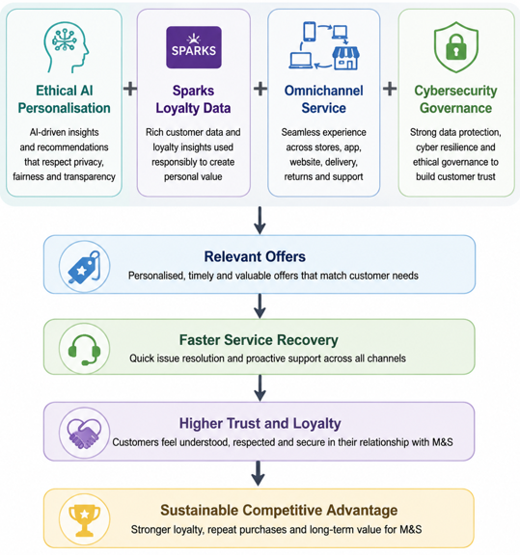
Figure 2 Recommended Strategic Model
Source: (Self-Made)
The theme that is appropriate is sustainability-led care. It aligns with the ethical brand and stakeholder expectations of M&S. This broader responsibility to the customer, employees, suppliers and communities is encouraged by stakeholder theory (Freeman and Menghwar, 2024). Nevertheless, it can become more expensive and might not address the immediate loyalty issues.
Thus, the proposed solution is ethical AI-powered personalised customer care, which is guided by the principles of omnichannel improvement and sustainability.

2.6 Wider Organisational Implications
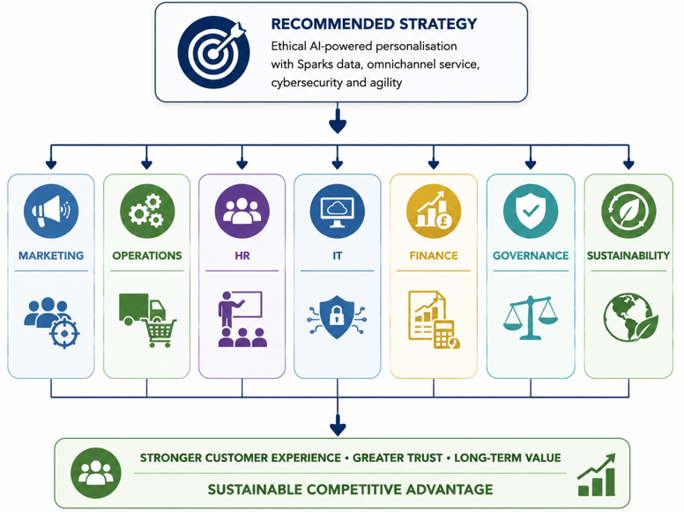
Figure 3 Wider Organisational Implications
Source: (Self-Made)
Recommended strategy influences the entire organisation. It is not to be considered as a marketing campaign alone.
Marketing: M&S would switch to more customised campaigns, loyalty programmes and product suggestions. This can enhance relevance, but over-targeting should not be used since this can be intrusive.
Operations: Operations have to enhance the visibility of stock, the reliability of delivery and service recovery. One-to-one recommendations will not work when there are no products or when there is a delay in product delivery.
HR: The staff should be trained on the use of digital tools, customer empathy and data-driven service. Salespeople at the store should know about Sparks promotions, online travel and refunds. This is to guard the human aspect of service.
IT: AI systems, CRM, improving apps, cybersecurity and data quality all need to be supported in IT. The theory of dynamic capabilities states that companies have to reorganise their resources in response to a change (Teece, 2018). In the case of M&S, this implies that technology should be used to support the day-to-day customer care, and not as a standalone feature.
Finance: The plan entails an investment in systems, people, and cyber protection. There can be an increase in the short-term expenses, yet customer lifetime value can be enhanced by a higher level of loyalty and repeat purchase.
Governance and sustainability: Governance should include data ethics, privacy control, AI accountability and cyber resilience. The personal data should be employed in a way that is legal, fair and transparent (Cloudian, 2023). Personalised nudges like lower-waste food and repair offers or responsible shopping credits can also be added to promote sustainability.
Area | Strategic implication
Marketing | More personalised Sparks campaigns and product suggestions.
Operations | Better stock visibility, delivery reliability and service recovery.
HR | Staff training in digital tools and personalised service.
IT | Stronger AI, CRM, app reliability and cybersecurity systems.
Finance | Investment needed in data, systems, cyber protection and training.
Governance | Clear AI ethics, privacy controls and data accountability.
Sustainability | Personalised low-waste, repair, reuse and ethical product options.

3. Conclusions
M&S is exposed to a challenging and unstable retail environment. Its future strategy is influenced by inflation, digital disruption, competition, sustainability requirements and cyber risk. Inside, M&S possesses great assets, such as brand trust, reputation for quality, loyalty of Sparks, stores and transformation capability. But these strengths have to be applied in a more nimble and combined manner.
Pure cost competition is not the most effective strategic alternative. M&S ought to compete based on value differentiation to customers. The most appropriate way would be ethical AI-based customer care as it links to customer insight, agility, loyalty, and service enhancement. But this has to be carried out cautiously. Customer data abuse, incompetence with cybersecurity or digital reliability may hurt trust. Thus, M&S ought to integrate AI personalisation and open governance, omnichannel service and sustainability philosophy.

4. Recommendations
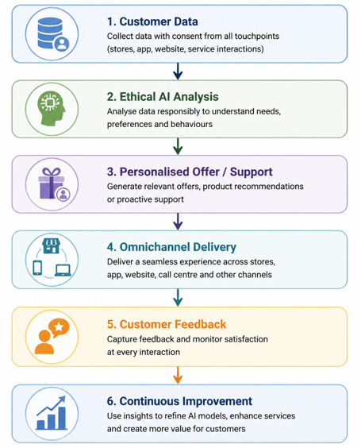
Figure 4 Personalised Customer Care Journey
Source: (Self-Made)
First, M&S needs to plan ethical AI-based Sparks personalisation. Sparks data should be used to offer rewards and product recommendations, service reminders and personalised support to the company. This is not to be restricted to promotional discounts. It must also make customers save time, find appropriate products and get quicker assistance following service issues. This has the ability to enhance customer satisfaction, loyalty and repeat purchases.
Second, M&S ought to enhance cybersecurity and data governance. Customer data is essential to personalised customer care, and therefore, trust needs to be maintained. M&S ought to establish clear data policy, AI ethics policies, regular cyber audits and easy customer privacy controls. This is essential following the cyber incident since customers might be more sensitive to how their personal information is utilised. Good governance will decrease reputational risk and make personalisation to be more acceptable.
Third, M&S ought to develop a care system that is integrated. The stores, the site, the mobile application, the delivery service, the returns and complaints should be linked into a single customer perspective. This would enable customers to transfer across channels without having to reiterate information. It would also assist the staff to solve problems in a quicker way. This is a significant recommendation since customer care has become reliant on the entire experience, rather than just the in-store experience.
Fourth, M&S needs to train its personnel in nimble customer support. Employees should be educated on the use of digital tools, emotional intelligence, dealing with complaints and personalised service. The employees of the store must know Sparks promotions, order through the internet and perform functions and returns work on the app. This will allow M&S to retain the human touch to its brand and enhance digital service. Customers who are either older or less digitally confident can also be supported by better-trained staff.
Fifth, M&S needs to connect personalisation and sustainability. The company is expected to give individualised low-waste food recommendations, ethical product data, repair/reuse possibilities and accountable shopping bonuses. This would render sustainability attainable by the customers as opposed to being abstract. It would also help M&S maintain its moral brand image and generate long-term difference.
In general, these suggestions are to be carried out in stages. M&S ought to begin by piloting, gauge customer feedback, refine the system and subsequently expand it to the business. Some of the key measures that should be taken are Sparks engagement, repeat purchases, time of resolving complaints, customer satisfaction over time, using the app, data incidence and sustainability-related engagement.

References
Ahlbäck, K., Fahrbach, C., Murarka, M. and Salo, O. (2017) ‘How to create an agile organisation’, McKinsey and Company. Available at: https://www.mckinsey.com/business-functions/people-and-organizational-performance/our-insights/how-to-create-an-agile-organization (Accessed: 22 June 2026).
Amélia, M., Riva‐Souza, E.M., Azevedo, C., Volpi, P.S., Fonseca, A., Ferrão, R.G., Montagnon, C. and Felipe, L. (2024). Robust and smart: Inference on phenotypic plasticity of Coffea canephora reveals adaptation to alternative environments. Crop Science. doi:https://doi.org/10.1002/csc2.21298.
Awa, H.O., Etim, W. and Ogbonda, E. (2024). Stakeholders, Stakeholder Theory and Corporate Social Responsibility (CSR). International Journal of Corporate Social Responsibility, 9(1), pp.1–14. doi:https://doi.org/10.1186/s40991-024-00094-y.
Cloudian (2023). Data Protection Principles: 7 Core Principles of the GDPR. [online] Cloudian. Available at: https://cloudian.com/guides/data-protection/data-protection-principles-7-core-principles-of-the-gdpr/.
De Smet, A., Lurie, M. and St George, A. (2018) ‘Leading agile transformation: The new capabilities leaders need to build 21st-century organisations’, McKinsey and Company. Available at: https://www.mckinsey.com/business-functions/people-and-organizational-performance/our-insights/leading-agile-transformation-the-new-capabilities-leaders-need-to-build-21st-century-organizations (Accessed: 22 June 2026).
Denning, S. (2019) ‘How Amazon became agile’, Forbes. Available at: https://www.forbes.com/sites/stevedenning/2019/06/02/how-amazon-became-agile/ (Accessed: 22 June 2026).
Freeman, R.E. and Menghwar, P.S. (2024). Stakeholder Theory and Communities. Routledge eBooks, [online] pp.43–55. doi:https://doi.org/10.4324/9781003388227-4.
Gutterman, A.S. (2023). Stakeholder Theory. [online] ResearchGate. Available at: https://www.researchgate.net/publication/369194606_Stakeholder_Theory.
Kern, J. (2018) ‘Agile in the context of a holistic approach’, InfoQ. Available at: https://www.infoq.com/articles/agile-holistic-approach/ (Accessed: 22 June 2026).
Khan, N.A., Akter, S. and Kalam, Md.Abul. (2020). Personalization and Consumer Privacy: Balancing Targeted Marketing with Trust. Journal of Business and Management Studies, 2(1), pp.68–86. doi:https://doi.org/10.32996/jbms.2020.2.1.7.
Kotter, J.P., Akhtar, V. and Gupta, G. (2021) ‘Is your organization surviving change or thriving in it?’, Harvard Business Review. Available at: https://hbr.org/2021/08/is-your-organization-surviving-change-or-thriving-in-it (Accessed: 22 June 2026).
Lovett, C. (2025). Ecommerce return policy best practices for retailers 2025. [online] Signifyd. Available at: https://www.signifyd.com/blog/ecommerce-return-policy/.
Lynch, R. (2018) Strategic Management. 8th edn. Harlow: Pearson.
Marks and Spencer (2026). Marks and Spencer Group plc Annual Report and Financial Statements 2026. [online] Available at: https://corporate.marksandspencer.com/sites/marksandspencer/files/marksandspencer/annual-report/m-and-s-annual-report-and-financial-statements-2026.pdf.
Mason, L. (2018) ‘Amazon culture: Staying agile’, YouTube. Available at: https://www.youtube.com/watch?v=ESBJ_oxNC_Y (Accessed: 22 June 2026).
Mishova, A. (2025). Lawfulness, Fairness and Transparency: GDPR Principles - GDPR Local. [online] GDPR Local. Available at: https://gdprlocal.com/lawfulness-fairness-and-transparency-gdpr-principles/.
Okafor, U.G., Sylvanus Ikechukwu Nwodo, Onyeokoro, S.C. and Dike, O.N. (2026). Competitive Advantage Theory: A Critical Review of Michael Porter’s Framework and Its Strategic Implications in Organizations. European Journal of Innovative Studies and Sustainability, [online] 2(3), pp.1–12. doi:https://doi.org/10.59324/ejiss.2026.2(3).01.
Race, M. (2025). M&S says personal customer data stolen in recent cyber attack. BBC. [online] 13 May. Available at: https://www.bbc.com/news/articles/c62v34zv828o.
Rashid, C.A. (2023). PESTEL Analysis and Porter’s Five Forces as Marketing Tools to Evaluate Morrison’s Performance and Strategy. Journal of Global Social Sciences, 4(15), pp.75–83. doi:https://doi.org/10.58934/jgss.v4i15.187.
Savills (2025). Spotlight: UK Grocery Report – 2025. [online] Savills.co.uk. Available at: https://www.savills.co.uk/research_articles/229130/379213-0.
Slater, D. (2022) ‘Leading and innovating with leadership principles’, Amazon Web Services. Available at: https://aws.amazon.com/executive-insights/content/leading-and-innovating-with-leadership-principles/ (Accessed: 22 June 2026).
Teece, D.J. (2018). Business models and dynamic capabilities. Long Range Planning, [online] 51(1), pp.40–49. doi:https://doi.org/10.1016/j.lrp.2017.06.007.
Wade, M., Joshi, A. and Teracino, E.A. (2021) ‘6 principles to build your company’s strategic agility’, Harvard Business Review. Available at: https://hbr.org/2021/09/6-principles-to-build-your-companys-strategic-agility (Accessed: 22 June 2026).
Whittington, R., Regnér, P., Angwin, D., Johnson, G. and Scholes, K. (2020) Exploring Strategy: Text and Cases. 12th edn. Harlow: Pearson.

