Name: Olly Overton
Student number: 1910610
Module: Scientific Principles of OME Design
Module code: ACDA6008
Lecturer: Gareth Collett
Assignment title: The theory and application of fuel-air explosions.

Contents:
3) Abstract
3) Introduction
4) The phenomena of fuel/air explosions
5) Where was the phenomena discovered
5) The science behind a fuel/air explosive
6) Military applications
8) Differences between conventional explosives and fuel/air explosives in military applications
8) Conclusion
9) References

Abstract:
The typical explosive contains the elements carbon, oxygen and nitrogen. This means that when undergoing combustion the explosive produces highly stable substances such as (CO, CO2 and N2) [1]. The rapid formation of said substances creates strong bonds; this releases significant volumes of hot gas and high temperatures. Essentially a great deal of energy is produced [2].
Fuel-air explosions differ from the conventional explosive; this is because they use the surrounding environment as their oxygen source/supply. Because of this they essentially have much more fuel to react with, therefore causing a much larger more powerful event, releasing more energy than the equivalent NEQ (Net Explosive Quantity) of a typical explosive.
The following report will outlie the phenomena of a fuel-air explosive event, its military applications, its intended targets, its history and how they differ from modern IM (Insensitive Munitions) explosives such as RDX.

Introduction:
In order to understand the complex phenomena of fuel-air explosions, it is important to understand how a conventional explosive event occurs. Essentially explosives are substances that undergo a rapid oxidation reaction with the formation of large volumes of gas and heat. The oxidation reaction that takes place is exothermic, which is why heat is released from the process.
As previously mentioned explosives are organic chemicals, often containing only four types of elements: Carbon (C), Hydrogen (H), Oxygen, (0), and Nitrogen (N). It is important to note that military explosives contain their own source of oxygen in order to allow the combustion process to occur. The chemical makeup of these 4 separate atomic structures align to provide themselves with large amounts of potential energy [3]. This is potential chemical energy. However, in order to activate the reaction a smaller amount of energy is needed first, this is known as the activation energy, and varies between different explosives due to the bond angles and formations. Depending on bond angles and the formation of the bonds, a different energy output and input is required [4].
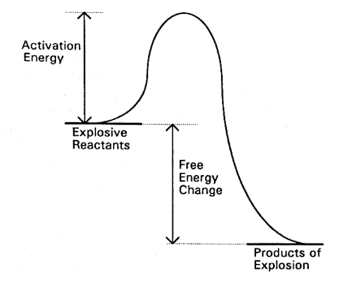
For the explosive TNT (Trinitrotoluene) the activation energy in the gas phase is ~62 kcal/mol, and in the condensed phase is 40.9 kcal/mol [5]. Once supplied with this threshold of energy, a rapid chain reaction will occur. The energy can be provided by two means; the build up of energy from a small heat source (deflagration to detonation transition) and a near instantaneous shock to detonation (as a result of a detonator triggering).
Simple graph showing the initial energy requirement in order to start a reaction [15].

The deflagration to detonation process occurs when a burning front wave propagates via the diffusion of heat from burning material to the reactants ahead. The combustion of material constantly releases gas, which cannot escape the system. This increases the pressure within the material. The pressure causes the material to get hotter; causing it to expand and push closer together, resulting in faster burning. Eventually the wave reaches supersonic speed which again compresses the material even more. The shockwave propagates into unburnt material and initiates via means of shock. This process is often accidental and unwanted, such as the Beirut explosion.
On the other hand, a purposeful ignition of explosive material tends to come from the shockwave emitted from a detonator.

The phenomena of fuel/air explosions:
Having looked at the basics of a self-sourced explosive, we can now look into the principles of a fuel/air explosive. A fuel/air explosive also goes by the names; thermobaric bomb, aerosol bomb and vacuum bomb. All of these have the same common principle of using surrounding air (oxygen) as their fuel, to generate a high-energy explosive event. Nearly 100% of a thermobaric bomb is fuel, meaning they produce much more energy than equivalent explosives that don’t rely on their surrounding environment for fuel [6].
Because fuel/air explosives do not have any initial oxygen source, they are heavily limited by the environments in which they can be used. For example, they would not function at high altitude, nor underwater, as oxygen supplies would not sustain such an event. However, they are incredibly effective at ground level and especially in enclosed spaces such as trenches, caves and buildings [7] [8].
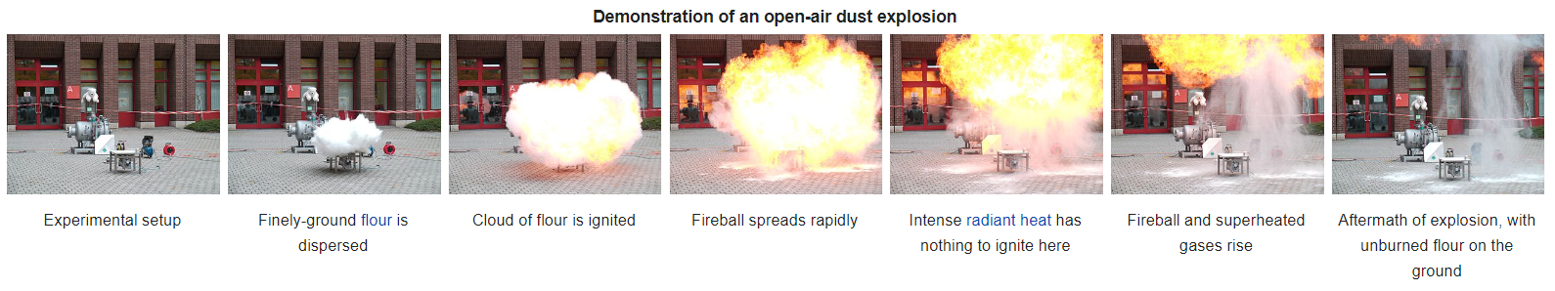
When a thermobaric bomb initially detonates, it spreads the fuel as a cloud/mist into the nearby vicinity. To achieve this a central burster is used. A central burster is a conventional explosive to rapidly accelerate the fuel into nearby areas. A timed delay allows this cloud to spread and diffuse into confined spaces, before it is then ignited. This results in a fireball that spreads quickly due to the rapid expansion of gases from the intense heat. In the early stages of ignition, there is a plentiful oxygen supply, allowing the fireball to grow and become more intense. Eventually this reaches such a speed that it becomes supersonic and propagates a shockwave trough the now oxygen depleted environment. This then removes the air from the detonation zone, meaning no further reaction takes place. The hot cloud then rises above the cooler air as it is less dense.
Scaled down experiment using flour as the fuel to demonstrate the spread and ignition of a fuel/air explosive [14].

A typical thermobaric weapon does not use flour, but instead consists of a container packed with a fuel substance, the centre of which has a small explosive "scatter charge", with the purpose of fragmenting the fuel as a cloud. The fuel is chosen on the basis of the exothermicity of their oxidation, ranging from powdered metals, such as aluminium, to organic materials, possibly with a self-contained partial oxidant. Although this is different to conventional explosives, the principle of adding metals for their delocalised electrons in outer shells is still a technique shared across the two concepts. The added metals increase the power and brisance of the explosive effects [9], however the most desirable effect is the increase in the heat of explosive.

Where was the phenomena discovered initially?
Before thermobaric weapons were designed, fuel/air explosions would still occur ‘naturally’. They would often occur in flourmills, but more significantly, they occurred in coalmines.
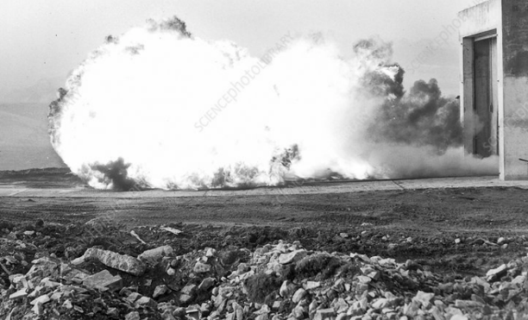
Although methane explosions commonly occurred in coalmines, so did coal dust explosions. These coal dust explosions were more lethal. This is because the dust explosions would originate from the methane explosions. The pressure wave produced by a small methane explosion would scour the mine entry, blowing coal dust up into the air. Once this dust was elevated, particulates would spread more easily as frictional forces were reduced as a result of being in air. This dust would then be ignited by the intense heat; causing a chain reaction effect. The fireball would consume any available fuel and oxygen, in turn generating large volumes of toxic gases. Under certain conditions such as a restricted tunnels, both methane and coal dust explosions have the potential to accelerate and transition into a detonation.
Controlled coal dust explosion showing the entrance as a vent hole for the fireball [16].

The science behind fuel/air explosions:
In 2003, the US tested a 9.8 tonne bomb, nicknamed the “mother of all bombs”. This created an explosion equivalent to a 11-tonne conventional bomb. To this day, it is the largest non-nuclear weapon ever to detonate. But how was this achieved?
The bomb itself was able to achieve such an effect purely because of its size. The MOAB (Mother of all bombs) is 9.1885 metres. This is considered to be a massive weapon in comparison to other devices. However, the effect was not dependent on its size but also its chemical makeup. The bomb contained H6, a new explosive at the time that consisted of RDX, TNT and Aluminium. The purpose of the aluminium was to increase the detonation velocity and also the heat given off [10]. Fuel/air explosions suffer from reduced detonation velocities, in comparison to standard high explosive weapons, therefore the Aluminium is added.
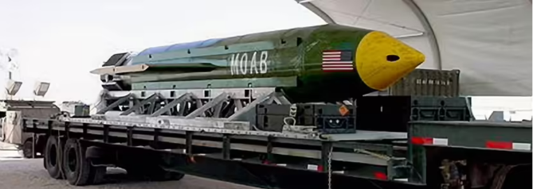

The MOAB loaded on a transporter, showing the true extent of its size [10].

Another factor, which contributes to the overall effect of the bomb, is how it is detonated. A detonation wave is often more powerful when it reflects off a hard surface. This is because the air it is pushing compresses upon a hard surface, causing a more intense pressure build up. When this wave reflects, it has less air resistance because the air has been removed from the environment. This event is known as a mach-stem.

To calculate the power of a reflected detonation wave, the following equation can be used:
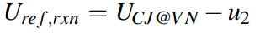
Where UCJ@VN is the Chapman–Jouguet speed for a gas initially at the von Neumann conditions behind the detonation front and u2 is the fluid velocity behind the detonation [11]. The von Neuman conditions are used, because an explosive event emits intense heat, which results in an adiabatic boundary between the high and low-pressure air zones [12].
In order to produce the event of a mach stem, above ground detonation is required. This is called an airburst. However, the height at which you detonate determines whether a mach stem will form:
Height of burst above ground (m)
Cube root of charge mass (Kg)
If the value obtained from this equation is less than 10, a mach wave forms. However, if greater than 10, a mach wave will not form [13].
Coming back to the MOAB, these calculations would’ve been done before it was dropped from the MC-130 cargo doors on Afghanistan in 2017. Therefore, the outcome would’ve been maximised by ensuring a mach stem event would take place. Although the overall output of the MOAB was its size, the airburst effect and the chemical payload. The major contribution to its output was the fact it was a fuel air explosive.

Military applications:
To understand the military applications of the fuel/air explosive technique, its advantages and disadvantages need to be considered.
Advantages:
- Fuel/air bombs are highly effective against buildings/infrastructure. This is because the fuel can spread before ignition to confined spaces within.
- For the same reason as above, they are effective against enemy troops taking cover in caves, trenches etc.
- They have a higher output than the equivalent NEQ of a standard HE (high explosive).
- They often cause more causalities.
- They produce a large fireball, which causes more causalities and damage. As well as causing secondary effects of fires.

Disadvantages:
- Due to the nature of the event, it is not uncommon for incomplete combustion to occur, leaving behind some of the fuel. This is typically the metallic fuel left behind. Therefore, you essentially have wasted payload, but it also means the enemy can obtain evidence to run forensics on.
- You are limited by the oxygen supply, therefore you cannot use a fuel/air explosive at high altitude where air is thinner, nor underwater where oxygen is never an alone atom due to its high association with hydrogen.
- They are considered inhumane. Although fuel/air devices are not illegal on military targets, the United Nations Convention (UNC) have banned their use on civilian populations and infrastructure.
- It is complex to create a mach stem due to fuel/air explosives having a reduced detonation velocity, and the fact that the height of explosive needs to be calculated against the payload weight, to get a value under 10.
- You need to add metals. Metals are added to increase the heat of explosion and thus power. Aluminium is a popular choice as one of its characteristics is a high heat of combustion.
- A complex time delay is required in order for the fuel to spread.
- A central burster is required to evenly spread the fuel, this is hard to implement during manufacturing.
From the advantages, you will see that a military application could be effective on terrorist forces commonly found in the Middle East. In 2017, the US dropped a MOAB in Eastern Afghanistan to target ISIS. The specific target was a tunnel network that was expected to be used by ISIS forces. It was expected 90 enemies were killed from the MOAB, which considering its size is maybe not as high as you would initially expect. In fact sources showed that just 100 metres from the drop zone trees were still standing.
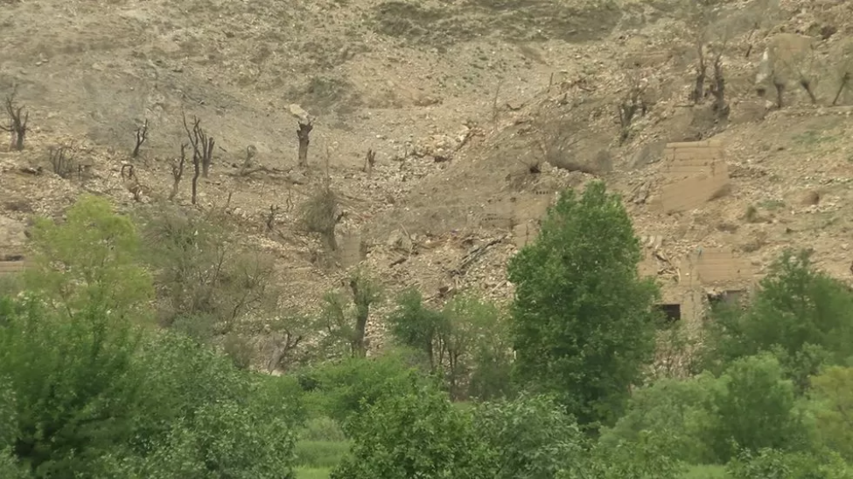
Image showing the destruction from the MOAB, but also the standing unaffected trees [17].

Another use of fuel/air bombs has been recent in the Ukraine/Russia war. Although Russia denies all knowledge of using thermobaric weapons, there have been images released suggesting otherwise. The weapon expected to be used was the TOS-2, a truck mounted missile launcher. It fires a fuel/air missile that has a heavy focus on incendiary effects. As it is a relatively new design, only displayed back in 2020 by Russian forces, there is not a lot of knowledge on the materials used in this device.
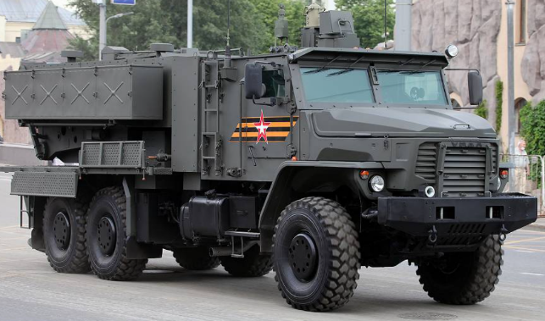
TOS-2 missile launcher [18].

Differences between conventional explosives and fuel/air explosives in military applications:
The differences between the two explosives were touched on briefly in their standard chemical format. However when used in military applications, the differences extend further. Once the organic elements for an explosive are used in military weapons, they are implemented with other elements used as binders, plasticizers and stabilisers. The purpose of these is to prevent the degradation over time. A stabiliser will prevent the build-up of nitric acid within the crystalline structure of the explosive. This in turn prevents the build-up of hotspots and also reduces the risk of accidental ignition. A fuel/air explosive will not contain a stabiliser (other than in the central burster). Therefore, in a conventional explosive the stabiliser is found throughout (this can vary depending on manufacturing processes), whereas in the fuel/air explosive it is localised to just the central burster.
Other differences include the casing in which they are confined. A conventional explosive will have two main effects, those being blast and fragmentation. The case thickness can be altered to increase/decrease the amount of fragmentation but also to increase/decrease the blast overpressure. In certain examples such as hand grenades the casing can be spalled to pre-shape the fragmentation sizes upon blast. Fuel/air explosive munitions differ from this as the casing has less of an effect. Firstly, they don’t rely on the case to produce any fragmentation. Secondly, the case on a fuel air explosive can get away with being thicker than typically found on a conventional munition. This is because the peak pressure produced form a fuel/air explosive is typically 1.5 times higher than that of the same NEQ for a conventional munition. Therefore, case size doesn’t reduce the blast output as significantly as it does with the conventional weapons. This means the case can be thicker to increase the pressure from the added confinement, which in turn increases the distance the fuel can be spread.

Conclusion:
When comparing explosives, the utter-most significant effect is the impulse from an explosive. The impulse is the most lethal effect associated with an explosion, and is what causes; buildings to fail thus making them collapse; people getting sucked out from around corners, resulting in exposure to fragmentation; and injuries to internal organs due to harsh pressure changes. The impulse is solely dependent on two factors; the peak overpressure and the duration the shockwave lasts.
For a conventional explosive, the impulse tends to look like this (black line):
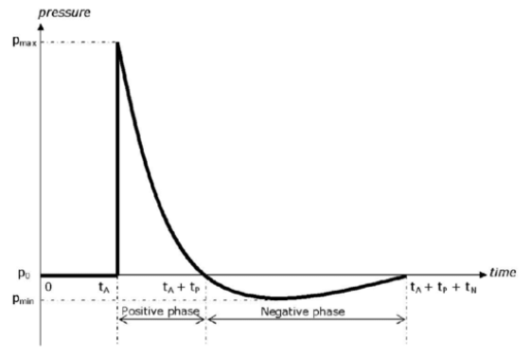
To increase the impulse, increasing the time a shockwave wave lasts (or slowing the rate of exponential decay) is the most impactful way of making an explosive more deadly. This is what a fuel/air explosive manages to achieve (red line). It does this by increasing the heat of explosion. The fuel/air shockwave is able to last longer as it continues to react with air once ignited, this stage doesn’t occur with a conventional explosive as it is not dependent on the available oxygen in the environment.
Friedlander curve [19]
Impulse (area under graph)
Fuel/air explosives are a great discovery in terms of increasing the effect of blast and impulse without the addition of more explosive material. In the future, I believe that fuel air explosions (if moderated) could be applied outside of defence, especially in the mining industry because fuel/air explosions are highly effective in caves/tunnels etc. This could reduce the amount of explosive used in the mining industry, which means a reduced effect on the environment. Overall, I think small-scale fuel/air explosions are overlooked and more research should go into them. I believe there may be a way of speeding up the time it takes a car airbag to inflate when a car crashes. Another way it could be used on a small scale is in firework displays at concerts etc.
In summary, I don’t think many new fuel/air munitions will be designed. This is because they are against many conventions and are frowned upon by environmentalists. It is this reason I believe their application should be looked at on a smaller scale.

References

[1] | S. a. Heathcock, in Introduction to Organic Chemistry, MacMillan, 1981.
[2] | P. Atkins, in Molecules, Oxford, W H Freeman, 1988, p. 176.
[3] | J. C. Oxley, "The Chemistry of Explosives," in Explosive Effects and Applications, Springer.
[4] | J. Akhavan, The Chemistry of Explosives, Cambridge: Royal society of chemistry.
[5] | A. Turner, in Thermal Decomposition of TNT: Use of 1-Nitropropene To Model the Initial Stages of Decomposition, 1984.
[6] | D. Andr, "MUNITIONS – Thermobaric Munitions and their Medical Effects!," Australasian Military, [Online]. Available: https://jmvh.org/article/munitions-thermobaric-munitions-and-their-medical-effects/. [Accessed 29 10 2022].
[7] | MoD, JSP 333.
[8] | "What is a thermobaric or vacuum bomb?," BBC, [Online]. Available: https://www.bbc.co.uk/news/business-60571395. [Accessed 29 10 2022].
[9] | J. D. Sullivan, "High explosive disseminator for a high explosive air bomb," in Nanofuel/Oxidizers For Energetic Compositions, 1994.
[10] | J. Donovan, "The Mother of All Bombs Is Big But It's No Nuke," How stuff works, [Online]. Available: https://science.howstuffworks.com/the-mother-all-bombs-is-big-its-no-nuke.htm. [Accessed 30 10 2022].
[11] | J. Damazo, "Reflected Detonation Waves: Comparing Theory," Madison, 2013.
[12] | S. Mazumder, "The Finite Difference Method," in Numerical Methods for Partial Differential Equations, 2016.
[13] | G. Collet, "Air bursts".
[14] | "Thermobaric weapon," [Online]. Available: https://en.wikipedia.org/wiki/Thermobaric_weapon. [Accessed 29 10 2022].
[15] | S. Varis, "MOLECULAR MODELLING OF SOME EXPLOSIVES AND PROPELLANTS," ResearchGate, [Online]. Available: https://www.researchgate.net/figure/4-A-diagram-for-the-reaction-profile-of-chemical-explosives-1_fig4_277891051. [Accessed 29 10 2022].
[16] | Safety in Mines Research Board (SMRB), Buxton, Derbyshire, 1940s.
[17] | "The Mother of All Bombs: How badly did it hurt IS in Afghanistan?," BBC, [Online]. Available: https://www.bbc.co.uk/news/world-asia-39705128. [Accessed 31 10 2022].
[18] | Military recognition, [Online]. Available: https://www.armyrecognition.com/ukraine_-_russia_conflict_war_2022/russia_deploys_in_ukraine_its_new_tos-2_thermobaric_rocket_launcher_system.html. [Accessed 31 10 2022].
[19] | M. Philippens, "Physics of IED blast shock tube simulations of mTBI research," 2011.

