HPV Guardian AI: A Digital Health Innovation to Improve HPV Vaccination Uptake among Adolescents in the UK

Student name: Nilesh Ambalal Patil
Student ID: 2523930
Tutor Name: - Dr. Diola Bijlhout

Module Name: - Population Health and Digital Health Promotion
Module Code:-LCHS7009
Module Name: - MSc Public Health and Social Care in Practice

Contents | Page No.
Blog 1: Existing Digital Health Technologies – The Role of Digital Reminder Systems in Improving HPV Vaccination Uptake | 2
Introduction | 2
Current Digital Health Technologies Supporting HPV Vaccination in the UK | 3
Critical Evaluation of Existing Digital Health Technologies | 4
Future Directions for Digital Health Promotion | 5
References | 6
Blog 2: Proposed Digital Health Technology – HPV Guardian AI | 7
Introduction | 7
HPV Guardian AI: Proposed Digital Health Innovation | 8
Expected Public Health Impact | 9
Critical Evaluation and Implementation Challenges | 10
References | 11

Blog 1- Existing Digital Health Technologies (The role of digital reminder systems in improving HPV vaccination uptake)
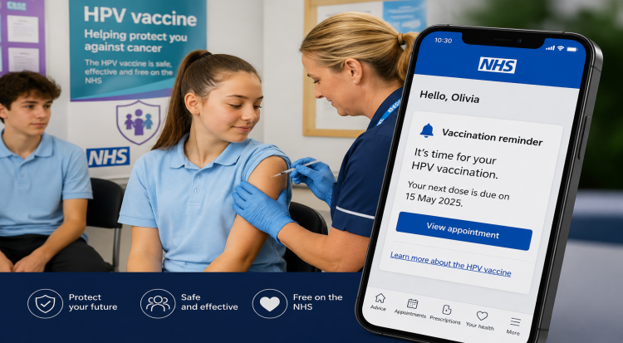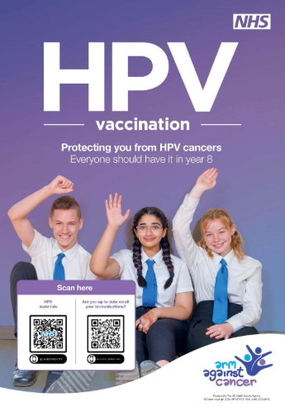
Digital reminders support timely HPV vaccination
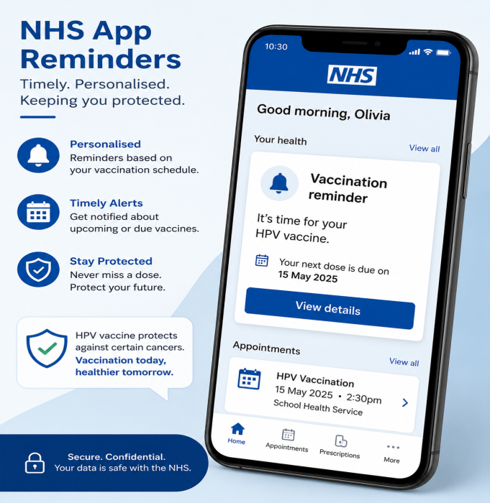
One of the most prevalent sexually transmitted infections in the world, HPV causes nearly all cancers of the cervix and some anal, penile, and oropharyngeal cancers. The UK has a school-based HPV vaccination programme available for adolescents, which provides HPV vaccines for free, but uptake is not reaching the World Health Organisation (WHO) recommended 90% target (WHO, 2026). The uptake among year 8 girls was around 72.9%, and among boys around 67.7%; vaccination against HPV during the 2023–2024 school year was still lower than pre-pandemic levels (GOV, 2025). This highlights a continuing public health problem to be addressed with creative approaches to enhance vaccine uptake and delivery.

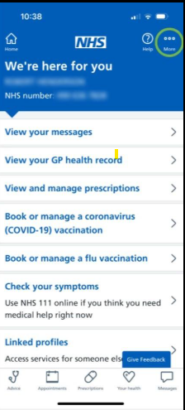

NHS reminders encourage vaccine attendance

Aim of this blog
this blog explores how current digital health technologies support HPV vaccination uptake among adolescents in the UK. It critically evaluates their strengths and limitations while considering how digital innovation can further improve public health outcomes.

Current digital health approaches supporting HPV vaccination delivery in the UK

Digital health technologies are now key assets in promoting HPV vaccination. Current interventions include social media health campaigns, NHS websites, school immunisation management systems, electronic consent platforms, SMS reminder systems, and NHS App notifications. These technologies seek to enhance awareness, streamline consent forms, decrease missed appointments, and deliver information to counteract vaccine misinformation that is based on facts. Reminder-based digital interventions consistently and effectively increase vaccination uptake. In a recent systematic review by Chandeying and Thongseiratch (2023), digital reminder systems for parents and healthcare professionals were shown to be effective in achieving measurable improvements in HPV vaccination rates, especially when they include both reminders and education.
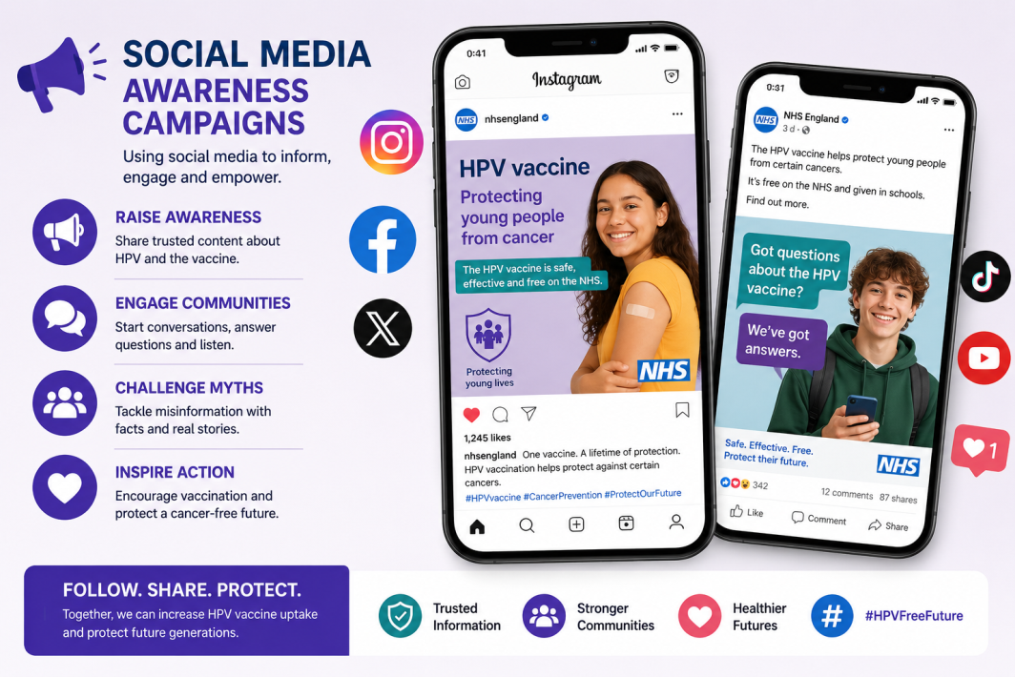
Social media promotes HPV vaccine awareness
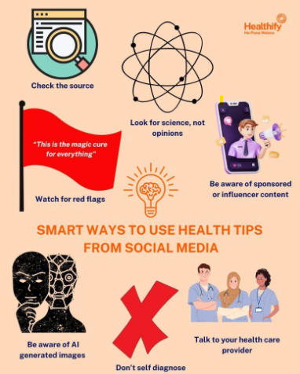

Critical Perspective: Are Current Technologies Enough?
Did you know that almost one in three eligible adolescents in England still miss their HPV vaccination despite free NHS vaccination programmes?
The current digital technologies have revolutionised vaccine promotion, providing scalable, cost-effective communication and access to trustworthy information. Automated reminders decrease missed appointments, and electronic platforms allow for quick sharing of new instructions (Chandeying and Thongseiratch, 2023). These also reduce the administrative burden for health care providers and improve the provision of preventive care. However, there are considerable restrictions; many interventions use one-way communication and provide general reminders that do not necessarily support specific concerns or vaccine hesitancy. Digital exclusion is also problematic because some families lack internet access, are less digitally literate than others, and may be less likely to reap the same benefits. In addition, digital systems are not inherently effective at increasing vaccination uptake, especially if there is a lack of readiness support during implementation (Tobaiq and MacLure, 2024).

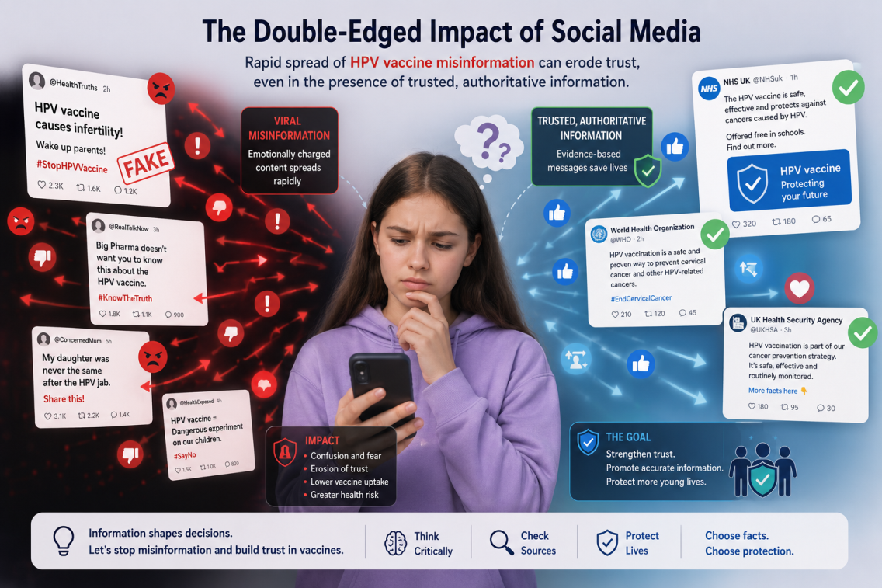
Online misinformation fuels vaccine hesitancy
Other concerns include the rapid dissemination of HPV vaccine misinformation via social media platforms that may erode trust even in the face of trusted, authoritative online information (Oh et al. 2023). Current technologies tend to offer static information rather than an interactive, personalised conversation that can correct misconceptions on the spot.
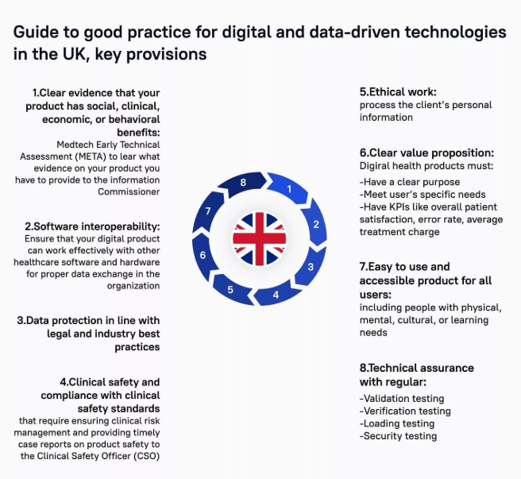
The next steps for digital health
Digital interventions must go beyond reminders and become personalised health promotion based on artificial intelligence (AI). The integration of conversational AI, behavioural nudges, multi-lingual support and bespoke education may help to enhance engagement for adolescents and parents and complement existing healthcare services in the NHS. These innovations could help address some of the challenges of the existing HPV digital tools and support improved uptake of HPV vaccines in the UK.

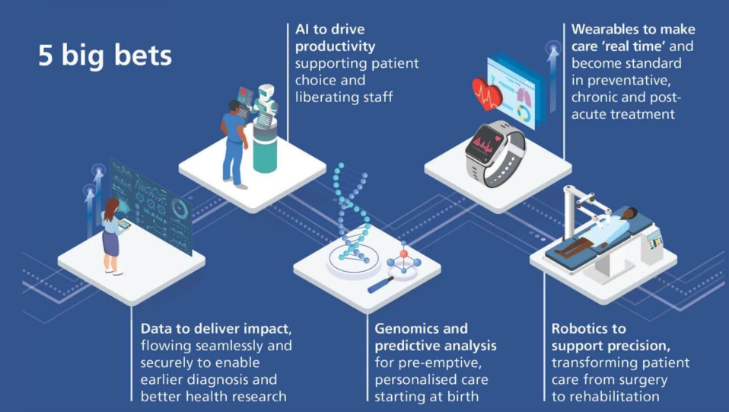

Key Takeaways
- Digital reminders improve vaccination attendance.
- Social media can both educate and spread misinformation.
- Existing technologies need more personalised communication.
- AI may help improve future HPV vaccine uptake.

References
• Chandeying, N. and Thongseiratch, T. (2023) ‘Systematic review and meta-analysis comparing educational and reminder digital interventions for promoting HPV vaccination uptake’, npj Digital Medicine, 6(1), p. 162. Available at: https://www.nature.com/articles/s41746-023-00912-w (Accessed: 17 July 2026).

• GOV.UK (2025) Young people urged to catch up on missed HPV vaccines. Available at: https://www.gov.uk/government/news/young-people-urged-to-catch-up-on-missed-hpv-vaccines (Accessed: 17 July 2026).

• Oh, S.H., Lee, C.J. and Park, A. (2023) ‘Trust matters: The effects of social media use on the public’s health policy support through (mis)beliefs in the context of HPV vaccination’, Health Communication, 38(12), pp. 2628–2639. Available at: https://doi.org/10.1080/10410236.2022.2123576

• Tobaiqy, M. and MacLure, K. (2024) ‘A systematic review of human papillomavirus vaccination challenges and strategies to enhance uptake’, Vaccines, 12(7), p. 746. Available at: https://www.mdpi.com/2076-393X/12/7/746

• World Health Organization (2026) Cervical Cancer Elimination Initiative. Available at: https://www.who.int/initiatives/cervical-cancer-elimination-initiative (Accessed: 17 July 2026).

Blog 2- Proposed New Digital Health Technology

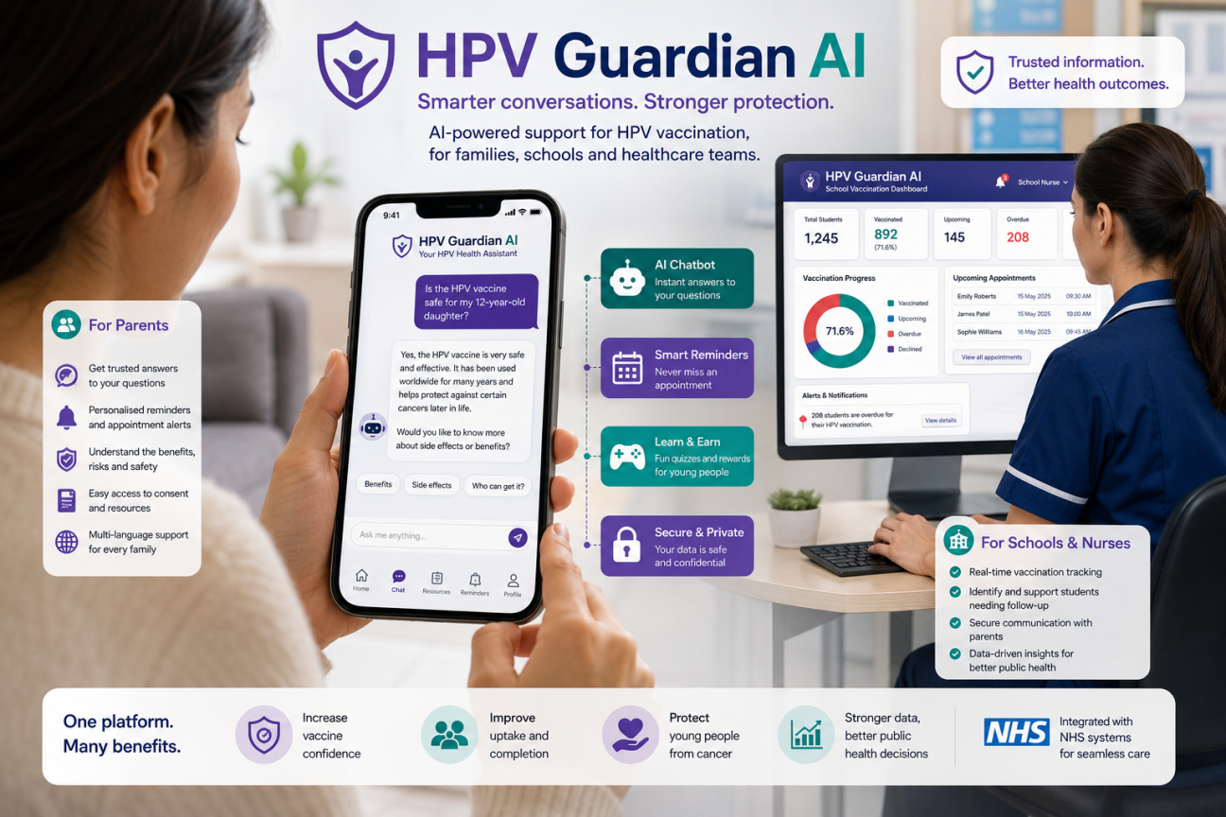
AI transforming personalised HPV vaccination support

Despite the presence of electronic reminder systems, NHS online reminders and school-based systems of electronic vaccination consent, HPV vaccination levels in the UK are still short of the WHO’s target of 90% (WHO, 2026; GOV, 2025). Current technologies tend to offer general reminders and static information, but generally, those technologies do not personalise and engage with individual concerns, vaccine hesitancy or misinformation. For addressing this, an innovative digital health intervention, HPV Guardian AI, is presented. This is a combination of AI and behavioural science for providing personalised support for adolescents, parents, schools, and healthcare professionals.
Aim of this blog
this blog introduces HPV Guardian AI, a proposed digital health innovation designed to improve HPV vaccination uptake among adolescents in the UK. It explains how the technology could address current limitations in existing digital interventions and contribute to more personalised health promotion.

HPV Guardian AI
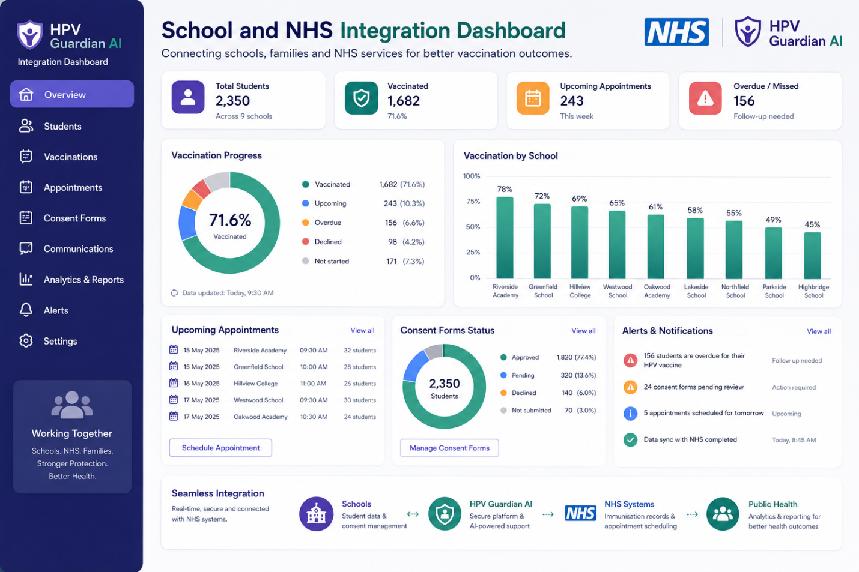
Integrated dashboard for vaccination monitoring
HPV Guardian AI is an intelligent and personalised health communication AI application across mobile and web platforms that supports HPV vaccination. The platform is fully integrated with NHS digital services and school immunisation programmes, and automatically assesses age, vaccination status, and communication preferences of users to give evidence-based guidance at the right time, ensuring compliance with the UK General Data Protection Regulation (GDPR) (GOV, 2026).
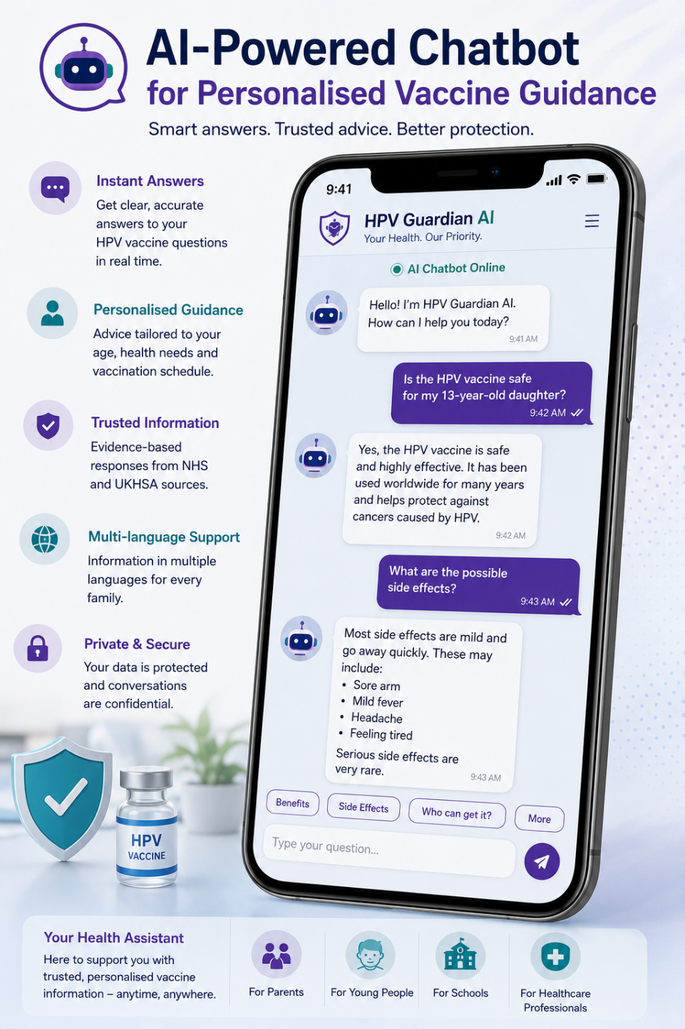
Personalised AI guidance builds vaccine confidence
HPV Guardian AI's approach is interactive rather than one-way notifications, unlike current reminder systems. It has an AI chatbot that responds to queries based on accurate NHS guidance and the guidance from the UK Health Security Agency (UKHSA), giving users the information they need to understand the benefits, eligibility, safety and potential side effects of vaccines. Multilingual educational resources and digital consent forms are available for parents and young people to receive age-appropriate content in a quiz format, through short videos and gamified learning activities, which involve the active use of the content.
HPV Guardian AI improves Public Health
The platform uses principles of behavioural science to identify barriers to vaccination at an individual level and send customised interventions rather than general messages. It is expected that personalised reminders, dispelling misconceptions, and educational conversations will help to improve health literacy, build vaccine confidence and minimise missed vaccination visits. Linking to school immunisation systems would also allow health care professionals to determine where uptake is lower and provide targeted health promotion campaigns to tackle health inequalities (Sackey et al. 2022).
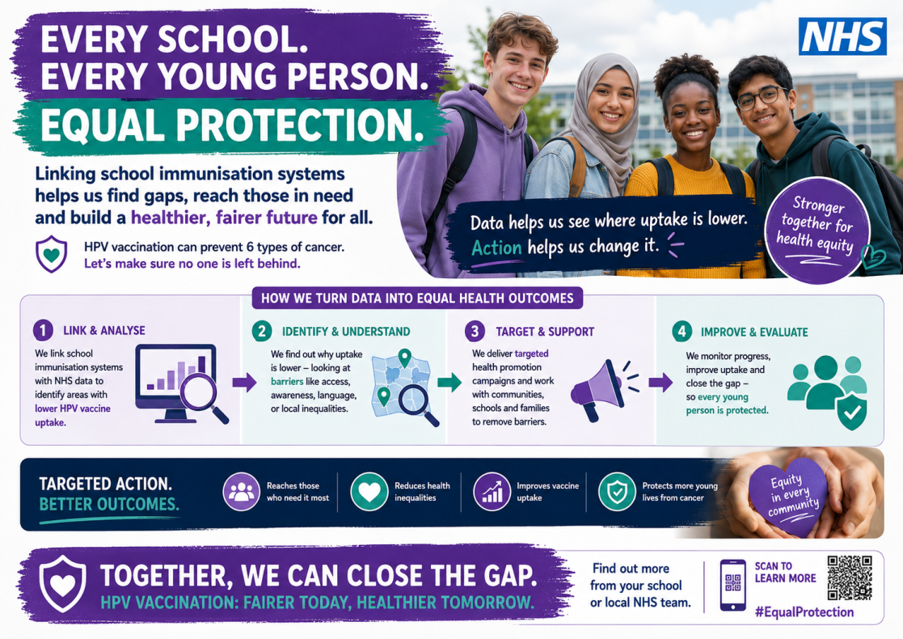
Targeted campaigns to reduce vaccination inequalities
Additionally, the anonymised and aggregated data collected through the platform could help inform public health surveillance to track trends in vaccine uptake, enabling local NHS organisations to target interventions with evidence-based strategies more effectively.
Critical Evaluation

Strong cyber security safeguards sensitive health data
While HPV Guardian AI has many benefits, there are some challenges to consider when implementing it. Ongoing clinical governance is needed for the accuracy, unbiased nature, and consistency of recommendations provided by AI systems, while also keeping them up-to-date with changing immunisation guidelines. Issues of data protection, cybersecurity, and public trust also need to be addressed with great care, especially with regard to handling adolescent health data. Moreover, unequal access to smartphones or digital literacy can potentially exacerbate existing health disparities if there are no other communication options (Moon et al. 2022). HPV Guardian AI should supplement existing healthcare services, not replace them, to overcome these drawbacks.

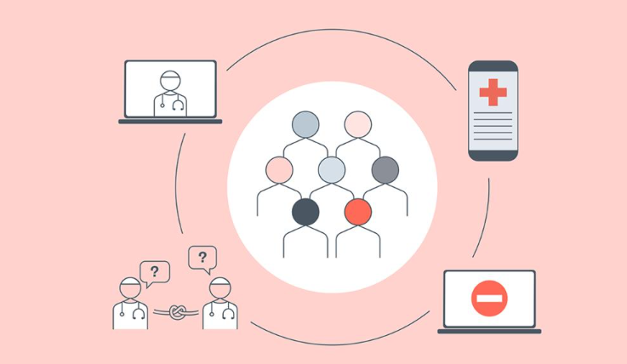What happens next?
HPV vaccination is one of the most effective ways to prevent several cancers. Digital innovations such as HPV Guardian AI should complement existing NHS services to improve vaccine confidence, reduce health inequalities and help more young people make informed decisions about vaccination.

References
• GOV.UK (2025) Young people urged to catch up on missed HPV vaccines. Available at: https://www.gov.uk/government/news/young-people-urged-to-catch-up-on-missed-hpv-vaccines (Accessed: 17 July 2026).

• GOV.UK (2026) The UK's data protection legislation. Available at: https://www.gov.uk/data-protection (Accessed: 17 July 2026).

• Moon, Z., Zuchowski, M., Moss-Morris, R., Hunter, M.S., Norton, S. and Hughes, L.D. (2022) ‘Disparities in access to mobile devices and e-health literacy among breast cancer survivors’, Supportive Care in Cancer, 30(1), pp. 117–126. Available at: https://link.springer.com/article/10.1007/s00520-021-06445-4 (Accessed: 17 July 2026).

• Sackey, M.E., Markey, K. and Grealish, A. (2022) ‘Healthcare professionals’ promotional strategies in improving human papillomavirus (HPV) vaccination uptake in adolescents: A systematic review’, Vaccine, 40(19), pp. 2656–2666.
Available at:https://doi.org/10.1016/j.vaccine.2022.03.042 (Accessed: 17 July 2026).

• World Health Organization (2026) Cervical Cancer Elimination Initiative. Available at: https://www.who.int/initiatives/cervical-cancer-elimination-initiative (Accessed: 17 July 2026).

