EMPL 4012: Researching and Analyzing Data

“Always treat your employees exactly as you want them to treat your best customers.”
- Steven R. Covey, author of The Seven Habits of Highly Effective People

Executive Summary
Petronela Nica
1605536
Patient care and staff engagement have become priority in health care sector. National Health Service (NHS) is one of the largest provider of state health care and is also one of the largest employer in the world. Given its size and importance, it is essential that the trust is able to provide quality health care. One of the important part of providing quality customer care is in looking after the welfare of its staff. Staff engagement is thus an important part of NHS function.
Recognising the importance, NHS conducts annual survey, which is one of the important source of data for the analysis. the research conducted by Kings Fund and NHS patient satisfaction survey also forms important part of the secondary data used in the research. The data is analysed and key findings are summarised.

Table of Contents

Introduction 4
Company Background 4
Importance of Staff Engagement 4
Research Objective 4
Research Method 5
Analysis and Findings 5
Conclusion 7
References 8
Appendix 1: NHS Staff Survey: Five-year Question Data 10
Appendix 2: Occupation proportions by organisation type 11
Appendix 3:Range Scores for overall indicators of staff engagement by organisation type 12

Introduction

Staff satisfaction is an important ingredient to an organisations success. When the organisation is involved in a service sector, the importance of staff satisfaction becomes even more important as happier staff leads to better customer service (Wagner, 2017). The staff experience or staff satisfaction refers to variety of factors including staff engagement, morale and work pressure (Dawson D. J., 2014). The link between happy staff and improved customer service is a long term association and organisations recognise this as an important part of their business strategy (Service Culture: Happy Employees Mean Happy Customers, 2016). In a health care sector, this becomes even more critical factor for success (Michie & West, 2004).
The link between staff engagement and patient satisfaction was the object of meta-analysis conducted by Lee et al (2012), established impact of training, perceived organsiational support, communication to their motivation and patient care and support. It found that the staff engagement had impact on overall patient care. Many researches also show link between greater patient satisfaction emerge out of quality staff engagement (King, 2013).

Company Background
The National Health Service (NHS) was established on the 5th July, 1948 with an ambitious plan to provide access to good health care to the public (The history of the NHS in England, 2015). Its central principles were to provide quality health service funded entirely through taxation. Since its beginning, NHS has evolved into a large organisation and if the fifth largest employer in the world and only British employer in the world's top 10 list (NHS is fifth biggest employer in world, 2012) (McCarthy, 2015). With growing pressure on the British economy, NHS is facing funding cuts and pressure of staffing. NHS funding was also one of the key point of discussion during the Brexit campaigns and was highlighted by the 'leave' campaigners.

Importance of Staff Engagement
There is growing evidence from various researches conducted around the world that links staff engagement to patient satisfaction (Dawson D. J., 2014). For NHS, staff well-being and staff health is a priority that is under pressure in the current economic circumstances. The NHS trust is facing challenging savings target and lack of staffing is a direct result of this situation (King, 2013).

Research Objective
As largest provider of healthcare and under immense pressure caused by funding cuts, the morale of NHS staff is under significant scrutiny (Vize, 2017) and the workforce crisis could soon expected to become more serious than funding crisis itself. the primary objective of the research is to examine if engaged NHS staff leads to better patient care. The research will also aim to understand if patients benefit from engaged staff and if staff could be motivated by better results.

Research Method
This research was carried out using secondary data. Secondary data are those data that have been already collected and readily available from variety of sources such as research publications, websites and past surveys. Primary data are original data that are specifically collected for that particular research (Dawson D. C., 2009).
the main reason for use on only secondary data for this research is due to the ethics and data protection rules surrounding the collection and storage of primary data. The limitation and scope of the research also restricts the necessity and use of primary data.

Analysis and Findings
It is important to statistically test the relationship between staff engagement and the patient care. NHS, recognising the importance of understanding this, has annual survey on the staff satisfaction. The annual reports is the main source of secondary data in this research.
NHS staff satisfaction survey results for 2016 (Focused on staff experience, 2017) indicates that the overall staff engagement from 2016 shows steady growth since 2012 and has reached a score of 3.79 (Graph provided below in figure 1 - source data in Appendix 1).

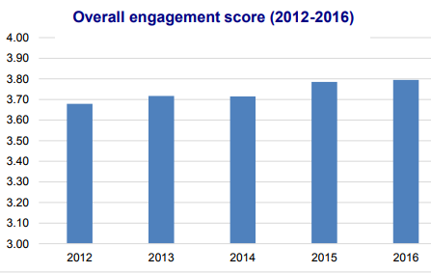
Figure 1 Overall engagement score (Source: http://www.nhsstaffsurveys.com/Caches/Files/20170306_ST16_National%20Briefing_v6.0.pdf)
Given the importance of overall staff engagement and patient care NHS focuses on the improvement in staff engagement by focusing on different aspects of the trust types as well as by occupations. This is shown is figures 2 and 3 given below. As shown in the figures, it is evident that the NHS staff who were part of a well structured appraisal system appear to be far more engaged than the staff who were not. Greater engagement comes from letting the NHS staff know where they are performing well and providing constructive feedback on the limitations with effort to provide suitable training (West & Dawson, 2012). The tables with data used for the charts below is provided in the appendices 2 and 3. The figure also indicates at nearly 30% of the workers are engaged by their measure and it is still lower among the nursing staff who are the important part of patient-hospital contact.
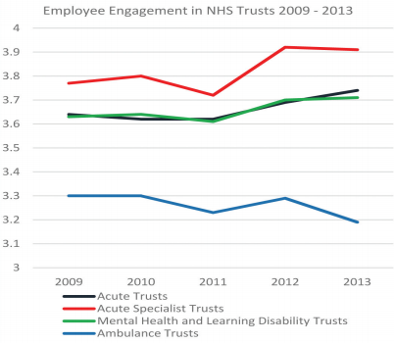
Figure 2 Engagement by Type (Adapted from: https://www.kingsfund.org.uk/sites/default/files/employee-engagement-nhs-performance-west-dawson-leadership-review2012-paper.pdf)
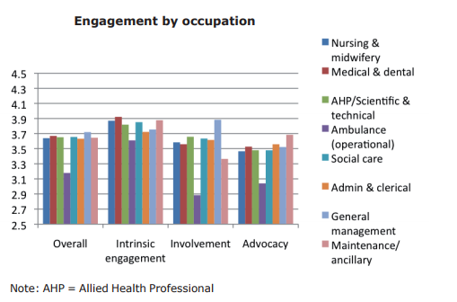
Figure 3 Engagement by Occupation (source: https://www.kingsfund.org.uk/sites/default/files/employee-engagement-nhs-performance-west-dawson-leadership-review2012-paper.pdf)
The link between staff engagement and patient care is not restricted just to the NHS or health care in England, but this is an ongoing research that is being discussed globally. As patient satisfaction is seen as one of the key performance indicator and more closely tied to a healthcare organizations’ reimbursement from health insurance companies, the hospital systems in the United States are also examining the quality of patient care and their overall financial results. their research showed that improved patient care can be achieved by identifying the staff engagement as a Critical Success Factor and the overall staff satisfaction rating as one of the Key Performance Indicators (Sherwood, 2013). Research conducted by Becker's Hospital Review in association with CX Solutions identified this to be an important part of steps taken in improving patient care globally. (Engaged, Empowered and Enthused: The Link Between Employee Engagement and the Patient Experience, 2014). The research by Becker's Hospital review and CX Solutions also showed that in addition to improving the patient care, the improved results is also a key motivating factor for health staff. When the NHS staff see positive result from their effort and as the result the patient satisfaction, it becomes an important part of their motivational aspects and a rewarding experience (Michie & West, 2004).
In the NHS annual survey, the key finding included Appraisal and development, job satisfaction, patient care and experience. The report also found link between staff engagement to errors and incidents.

Conclusion
In conclusion, it could be summarised that analysis of data (appendix 1 / figure 1) indicates the staff engagement has remained stable overall with increase in 2016. This is evident in the overall satisfaction levels (figure 2, 3 / appendices 2, 3). the lower engagement among the nursing staff is a key area that needs to be addressed and this is primarily due to the staff shortages resulting in nursing staff having to work longer hours and under extreme stress.
Patient care and patient satisfaction forms an important aspect of any health care organisations. National Health Service being one of the largest state health care service and also being one of the largest employer, the magnitude is much more.NHS recognising the importance between the staff engagement and quality of patient satisfaction, involved in various way of improving staff motivation. Their annual staff survey is one of the important steps in that direction. The key findings show that there is statistical link between the patient care and staff engagement. Given the importance of evidence showing the necessity of employee engagement in the NHS, it is little wonder that NHS is increasingly see staff engagement as priority to enhance patient care. This is not just applicable to the United Kingdom and NHS. This is a global factor and many countries have implemented steps to improve staff engagement.

References
Dawson, D. C. (2009). Introduction to Research Methods 4th Edition : A Practical Guide for Anyone Undertaking a Research Project (4th Revised ed. ed.). London: Little, Brown Book Group.
Dawson, D. J. (2014, July). NHS Employers. Retrieved November 23, 2017, from Staff Expereince and Patient Outcomes: What do we Know?: http://www.nhsemployers.org/~/media/Employers/Publications/Research%20report%20Staff%20experience%20and%20patient%20outcomes.pdf
Engaged, Empowered and Enthused: The Link Between Employee Engagement and the Patient Experience. (2014, January 9). Retrieved November 29, 2017, from Becker's Hospital Review: https://www.beckershospitalreview.com/hospital-management-administration/engaged-empowered-and-enthused-the-link-between-employee-engagement-and-the-patient-experience.html
Focused on staff experience. (2017, March 07). Retrieved November 23, 2017, from NHS Staff Surveys: http://www.nhsstaffsurveys.com/Caches/Files/NHS%20Staff%20Survey%20-%20Making%20Sense%20of%20Your%20Staff%20Survey%20Data_v3.pdf
King, J. (2013, March 4). Happier, more engaged NHS staff lead to better patient care. Retrieved November 19, 2017, from The Guardian: https://www.theguardian.com/healthcare-network/2013/mar/04/happier-nhs-staff-better-patient-care?INTCMP=ILCNETTXT3487
Lee, S. M., Lee, D., & Kang, C. Y. (2012). The impact of high-performance work. Service Industries Journal , 32 (1), 17-36.
McCarthy, N. (2015, June 23). The World's Biggest Employers. Retrieved November 20, 2017, from Forbes: https://www.forbes.com/sites/niallmccarthy/2015/06/23/the-worlds-biggest-employers-infographic/#8acb3d4686b5
Michie, S., & West, M. A. (2004). Managing people and performance: an evidence based framework applied to health service organizations. International Journal of Management Reviews , 5 (2), 91-111.
NHS is fifth biggest employer in world. (2012, March 20). Retrieved November 19, 2017, from The Telegraph: http://www.telegraph.co.uk/news/uknews/9155130/NHS-is-fifth-biggest-employer-in-world.html
Service Culture: Happy Employees Mean Happy Customers. (2016, January 4). Retrieved November 20, 2017, from FieldAWare: https://www.fieldaware.com/blog/posts/service-culture-happy-employees-happy-customers/
Sherwood, R. (2013, October 30). Employee Engagement Drives Health Care Quality and Financial Returns. Retrieved November 29, 2017, from Harvard Business REview: https://hbr.org/2013/10/employee-engagement-drives-health-care-quality-and-financial-returns
The history of the NHS in England. (2015, July 6). Retrieved November 19, 2017, from NHS: https://www.nhs.uk/NHSEngland/thenhs/nhshistory/Pages/NHShistory1948.aspx
Vize, R. (2017, June 20). The NHS must act to tackle its looming workforce crisis. Retrieved November 23, 2017, from The Guardian: https://www.theguardian.com/healthcare-network/2017/jun/20/nhs-act-tackle-looming-workforce-crisis
Wagner, R. (2017, February 27). Happy Employees Equal Happy Customers? Well, Yes, But It's Complicated. Retrieved November 23, 2017, from Forbes: https://www.forbes.com/sites/roddwagner/2017/02/27/happy-employees-equal-happy-customers-well-yes-but-its-complicated/#71c253e37c6e
West, M. A., & Dawson, J. F. (2012). Employee Engagement and NHS Performance. Retrieved November 29, 2017, from Kings Fund: https://www.kingsfund.org.uk/sites/default/files/employee-engagement-nhs-performance-west-dawson-leadership-review2012-paper.pdf

Appendix 1: NHS Staff Survey: Five-year Question Data


Appendix 2: Occupation proportions by organisation type
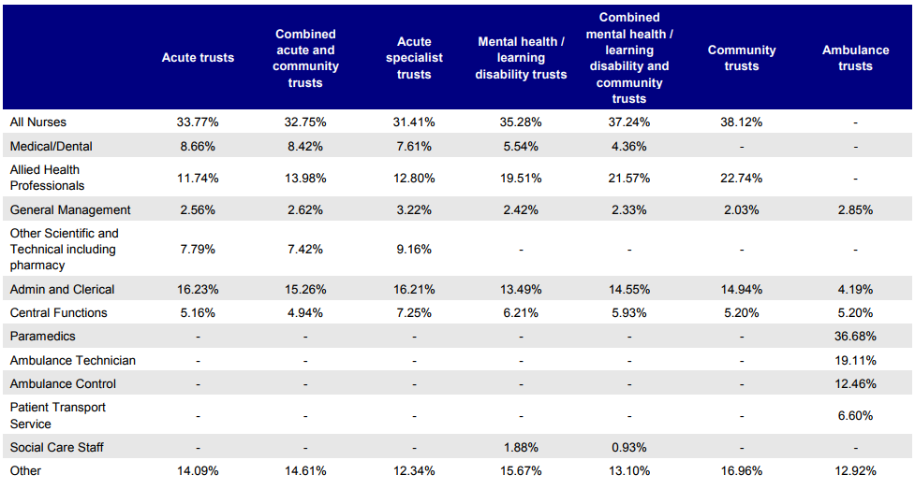

Appendix 3:Range Scores for overall indicators of staff engagement by organisation type


