

ASSESSMENT COMPONENT 1: INDIVIDUAL REPORT

Student name: MOHD SAIF
Student ID number: 2431762
Module code: LCMB7023
Lecturer: Gladius Kulothungan (London)

Executive Summary
This report looks at how technology, population changes, and world events are changing the job market throughout the world and changing the roles of Human Resource Management (HRM) and International HRM (IHRM). The research shows how AI, automation, and digital platforms make things more efficient and flexible, but they also bring up new moral and social issues. It looks at how older people are becoming more common in affluent nations, how young people are having trouble finding work in developing areas, and how geopolitical instability influences the movement of talent and the management of the global workforce. Data-driven hiring, ongoing learning, and talent analytics are examples of strategic HRM approaches that are said to be important for closing skill gaps and keeping important employees. To make sure that people can stay employed in the long term, it is important for industry, education, and policy to work together. The introspective part shows that one is ready to work in a multicultural, technology-driven setting by showing that one has better leadership, negotiating, and digital skills. The research says that HR can only be successful in the future if it uses ethical innovation, lifelong learning, and working together with people from all around the world.

Table of Contents
1. Technological Advancements and Their Implications for HRM and IHRM 4
1.1 Introduction to Technological Transformation in Labour Markets 4
1.2 Impact of AI, Automation, and Digital Platforms on Employment Patterns 4
1.3 Strategic Implications for HRM Practices (Recruitment, Training, Performance) 4
1.4 Strategic Implications for IHRM (Global Teams, Virtual Work, Cross-Cultural Leadership) 5
1.5 Ethical and Inclusion Challenges in Technology-Driven HR 6
2. Demographic and Geopolitical Influences on Employment Markets 6
2.1 Global Demographic Shifts and Workforce Implications 6
2.2 Generational Diversity and Changing Employee Expectations 6
2.3 Migration, Global Mobility, and Labour Supply Challenges 7
2.4 Geopolitical Instability and Its Impact on HR Policy and Talent Flow 7
2.5 HR Challenges in Managing Diverse and Distributed Workforces 7
3. Addressing Skills Gaps and Talent Shortages through Strategic HRM 8
3.1 Overview of Skills Shortages in Critical Sectors 8
3.2 Role of Strategic HRM in Talent Development and Retention 8
3.3 Workforce Planning, Learning, and Continuous Development 9
3.4 Collaboration Between Industry, Education, and Policy to Close Gaps 9
3.5 Use of Analytics and Employer Branding in Tackling Shortages 10
4. Reflective Report: Readiness to Work in an International and Technological Environment 10
4.1 Introduction to Self-Reflection and Global Employability Context 10
4.2 Self-Assessment 11
4.3 Strengths and Areas for Improvement 12
4.4 Action Plan for Professional and Personal Development 12
4.5 Conclusion: Leveraging Strengths for Global Career Growth 13
References 14

1. Technological Advancements and Their Implications for HRM and IHRM

1.1 Introduction to Technological Transformation in Labor Markets
AI, automation, and digital connection are leading a technological change that is changing the how, where, and by whom work is done in global labor markets (Pan and Froese, 2023). This digital transformation boosts productivity, makes work more flexible, and forces HR directors to change their workforce strategies to find a balance between innovation, human worth, and long-term job structures.

1.2 Impact of AI, Automation, and Digital Platforms on Employment Patterns
AI and automation have made repetitive tasks easier, which has led to a shift towards jobs that need more skills, analysis, and technology. As ordinary occupations go away, the need for digital marketers, AI engineers, and data scientists is growing. Digital labour platforms like Upwork and Fiverr have also helped the gig economy grow, making jobs more flexible but less reliable (Budhwaret al., 2022). As a result, global labour markets are becoming more polarised, rewarding people with talents that require a lot of knowledge while pushing low-skilled workers to the side. This change means that HR has to be ready for job redesigns, including lifelong learning frameworks, and encourage workers to be flexible in businesses where technology is always changing.

1.3 Strategic Implications for HRM Practices (Recruitment, Training, Performance)
New technology has made HRM more data-driven and able to make predictions. AI-based screening techniques are increasingly used in hiring to improve the quality and speed of candidates. Training has moved towards digital learning environments that include gamified microlearning and virtual simulations. More and more, performance management systems use real-time data to connect individual results with the objectives of the business. But HR professionals need to find a balance between efficiency and justice (Prikshatet al., 2023). They need to make sure that AI technologies don't make prejudice worse or destroy trust. The strategic challenge for HRM is to build digital skills while maintaining a fair, people-centered culture that appropriately welcomes new technologies.
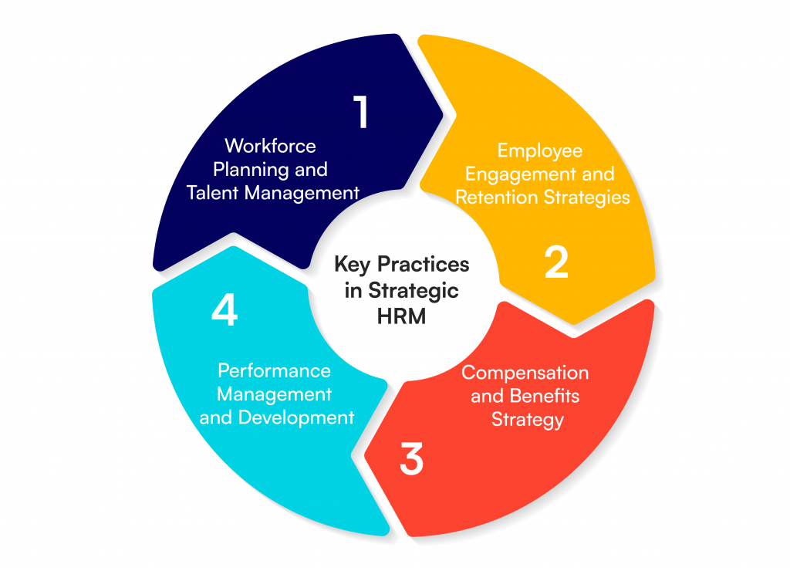
Figure: Strategic Implications for HRM Practices
(Source: Springer, 2024)

1.4 Strategic Implications for IHRM (Global Teams, Virtual Work, Cross-Cultural Leadership)
IHRM today works in a world where people may work together without borders thanks to cloud platforms and remote technology. To lead virtual teams, one needs to be able to adapt to different cultures and use digital communication tools well. Managing performance across several time zones, values, and laws is hard for typical expatriate models. IHRM needs to improve global employee engagement by using virtual mentorship, programs that promote inclusiveness, and cross-cultural learning (Malik et al., 2023). The new strategic emphasis is on creating a single global culture that uses diversity as a competitive edge and making sure that digital workforce systems function in different countries and follow different employment rules.

1.5 Ethical and Inclusion Challenges in Technology-Driven HR
Combining AI and analytics with HR makes things more complicated from an ethical point of view. If the data isn't diverse or clear, automated decision-making in hiring or performance reviews may lead to prejudice and discrimination. Digital monitoring devices can make people worry about their privacy and freedom. HR professionals need to make sure that AI policies are ethical, check algorithms, and make sure that data protection rules are followed. Moreover, digital change may deepen gaps between technologically adept and unskilled people (Bos‐Nehleset al., 2023). So, inclusive HRM strategies should put a lot of emphasis on making sure that everyone has equal access to digital upskilling, clear rules, and fair ways to judge people in tech-driven workplaces.

2. Demographic and Geopolitical Influences on Employment Markets

2.1 Global Demographic Shifts and Workforce Implications
In advanced countries, the population is becoming older, which is causing a lack of workers, especially in healthcare, education, and skilled crafts. At the same time, developing countries have to deal with young people who want to work throughout the world. This demographic mismatch forces businesses to rethink how they hire people, encourage people to work later in life, and hire people from other countries. HRM must also deal with skill gaps across generations by retraining workers and using automation (Ogedengbeet al. 2024). By mixing experienced workers with tech-savvy young people, one can keep information flowing and encourage new ideas while keeping productivity high in global labor markets that are made up of people from different generations and backgrounds.

2.2 Generational Diversity and Changing Employee Expectations
Generational diversity, from Baby Boomers to Generation Z, has changed the ideals of the workplace. Millennials and Gen Z appreciate flexibility, purpose, sustainability, and technical empowerment, whereas older workers seek stability and a clear path to advancement. This change makes HRM change how it leads, rewards, and talks to people based on their different incentives. Companies now use hybrid work models, offer personalized benefits, and train their leaders to be more inclusive. Aligning the requirements of people from different generations boosts engagement and retention, as well as psychological safety and creativity in fast-paced, tech-driven organizational settings.

2.3 Migration, Global Mobility, and Labor Supply Challenges
Migration is still an important way to move talent around, but harsher immigration regulations, political populism, and visa limitations are making it harder. Disruptions to global movement, like those that happened during the epidemic, showed how much healthcare, logistics, and agriculture relied on migrant workers (Prikshatet al., 2023). HRM and IHRM need to come up with flexible ways to staff their overseas offices, such as virtual assignments and partnerships for sharing talent. To make sure that both the workforce stays the same and the foreign labour supply chains stay strong, it is now very important to hire people ethically, teach them about the culture, and follow local labour laws.

2.4 Geopolitical Instability and Its Impact on HR Policy and Talent Flow
Geopolitical instability, which is caused by wars, trade wars, and changing policies, has a direct effect on the job market and the talent pipeline for businesses. Sanctions, conflicts between regions, and protectionist policies make it harder for people to move around, for supply chains to work, and for people to work across borders. So, HRM has to improve risk management, find new sources of talent, and make strategies for moving workers in case of an emergency. IHRM policies are putting more and more emphasis on geopolitical information, scenario preparation, and following the law to keep businesses running. Stable HR frameworks that anticipate these kinds of problems help workers stay strong and manage their job in a fair way in a world that is always changing.

2.5 HR Challenges in Managing Diverse and Distributed Workforces
Now, global companies have to deal with workers from different cultures, time zones, and sets of rules. This variety makes people more creative, but also makes it harder to communicate, include everyone, and evaluate performance. HR specialists have a hard time balancing the company's ideals with the needs of the employees while yet keeping everyone on the same page (De et al., 2022). Technology makes it easier for people to work together from different places, but it may also make them feel disconnected and cut off from their culture. For HRM to work well, leaders need to be inclusive, communication training has to be ongoing, and digital involvement regulations need to be fair. Making managers culturally smart ensures that teams that are spread out across a wide area and have a wide range of backgrounds work well together, are fair, and are productive.

3. Addressing Skills Gaps and Talent Shortages through Strategic HRM

3.1 Overview of Skills Shortages in Critical Sectors
The global job market has a constant lack of workers with the right skills in technology, healthcare, and hospitality. This is because of the fast pace of digitalization, changes in demographics, and not enough training programs. These shortages might hurt production and creativity, therefore businesses need to use proactive HRM techniques to find, train, and keep talented employees for the long term.

3.2 Role of Strategic HRM in Talent Development and Retention
Strategic HRM uses Talent Management Theory to make sure that the skills of the people who work for a company are in line with the company's aims. This idea says that to stay ahead of the competition, companies should systematically find, develop, and retain high-potential individuals. In industries where there aren't enough skilled workers, HRM uses succession planning, mentoring, and skills forecasting to build up a pool of talented people inside the company (Ateeqet al., 2024). Structured career pathways, customised learning, and competency-based development frameworks all make people more motivated and committed. Also, data-driven HR analytics help make smart investments in learning and engagement. Companies make sure they can adapt, lower turnover, and create a culture of continual development by making people management a part of their company plan. In the end, strategic HRM turns a lack of talent into an opportunity by developing people who can adapt to new situations and are ready for the future. These personnel can handle changing technical and global issues.
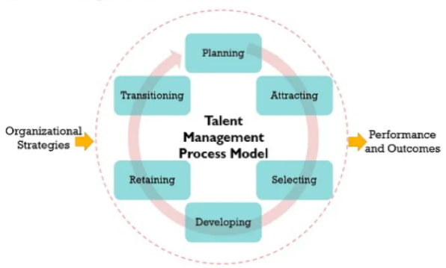
Figure: Talent Management Process
(Source: IoP, 2023)

3.3 Workforce Planning, Learning, and Continuous Development
Workforce planning ensures that the appropriate people with the correct capabilities are available when they are needed. Micro learning, e-learning, and AI-driven training platforms are all examples of continuous learning programs that assist staff keep up with changes in technology and the market (Mer and Virdi 2023). Strategic HRM creates cultures of lifelong learning by connecting performance management with skill development and sharing information, which makes the workforce more flexible over time.

3.4 Collaboration Between Industry, Education, and Policy to Close Gaps
Employers, schools, and politicians need to work together to fill skills shortages. Partnerships between businesses and schools ensure that curriculum keeps up with new employment needs, especially in STEM, digital, and service fields. Internships, apprenticeships, and certifications guided by employers help people become better at real-world skills. Governments are very important because they provide incentives for people to learn new skills and vocational programs that help those who are at risk. HRM is a bridge that connects the requirements of businesses with changes in education and labour legislation. Collaboration across these three sectors makes sure that everyone has access to job opportunities, boosts employability, and helps the economy stay strong in the face of technological and demographic changes.

3.5 Use of Analytics and Employer Branding in Tackling Shortages
HR analytics gives one data-driven information on how many people are available, how likely they are to leave, and how they usually perform, which lets one estimate what the workforce will require. HR can find important gaps and plan successful interventions by looking at data on hiring, engagement, and career advancement (Prikshatet al., 2023). At the same time, a great employer brand attracts rare talent by showing off the company's values, culture of innovation, and chances for professional progression. Modern professionals want clear information about diversity, sustainability, and flexibility. Analytics and branding work together to establish a twin strategy—quantitative foresight and emotional connection—to fill skill gaps and keep the workforce competitive over the long term.

4. Reflective Report: Readiness to Work in an International and Technological Environment

4.1 Introduction to Self-Reflection and Global Employability Context
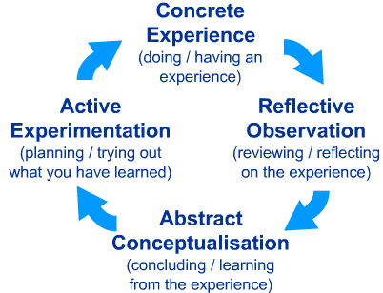
Figure: Kolb’s Reflective Cycle
(Source: Research Gate, 2024)
Concrete Experience: Working in a fast-paced, multicultural academic and professional setting has given me a lot of experience with digital technologies, virtual cooperation, and working with people from other cultures. These experiences have helped me grasp what it takes to be employable throughout the world at a time where AI and international travel are common.

Reflective Observation: Thinking about these circumstances lets me see how well I adapt to different team dynamics, utilize technology to get things done, and deal with cultural differences. It also shows me where I need to do better, like being more present as a leader and being more confident with modern digital platforms.

Abstract Conceptualisation: Kolb's model helps me connect these thoughts to theoretical ideas about global employability, which stress the importance of being adaptable, having cultural intelligence, being digitally literate, and always learning (Malik et al., 2023). Knowing what these skills are makes it clearer what is expected of professionals in globalised job marketplaces.

Active Experimentation: Using what I've learnt, I may establish specific objectives for my growth and use new tactics in future school and job assignments. This makes sure that I keep learning the skills I need to do well in multinational, tech-driven jobs.

4.2 Self-Assessment
Competency Area | Current Level | Evidence/Example | Development Need
Technological Skills | Good | Use of AI tools, data analytics in coursework | Broaden coding and automation skills
Communication | Strong | Presented cross-cultural business case studies effectively | Improve negotiation and persuasion
Teamwork | Excellent | Collaborated on international MBA group projects | Enhance conflict resolution techniques
Leadership | Moderate | Led a small virtual project team | Strengthen strategic decision-making
Self-Directed Learning | Excellent | Continuous online upskilling and reflective journaling | Maintain long-term learning discipline
Table: Self-Assesment
(Source: Self-Created)
The evaluation shows that the person is ready to work with people from all over the world since they are good at working together, talking to each other, and learning. But to be a good manager, I need to improve my leadership and advanced technical abilities. Structured study and real-world application in these areas will help me feel competent working in a variety of foreign job contexts that use technology.

4.3 Strengths and Areas for Improvement
Strengths: I am very good at working with others, communicating, and learning on my own. I work well in teams with people from different cultures, and I typically help with coordination and clarity on group initiatives. Being digitally literate makes it easier to utilise collaborative tools like MS Teams, Trello, and data analysis platforms. Also, a proactive approach to learning makes it easier to adapt to new technology and global problems as they come up (Bos‐Nehleset al., 2023).

Areas for Improvement: I have the potential to be a leader, but I need to become better at making decisions and giving tasks to others to manage bigger groups of people. To be competitive in digital contexts, I also need to improve my technical skills using automation and AI-driven technologies. Enhancing my skills in negotiation and persuasion will make me even more effective at work, particularly in situations where I work with clients or across borders, where empathy and persuasion are key.

4.4 Action Plan for Professional and Personal Development
Objective | Action Steps | Timeline | Expected Outcome
Strengthen leadership capability | Attend leadership workshops; take mentorship from senior managers | 3–6 months | Improved confidence in team and project leadership
Advance digital and AI-related skills | Enroll in online AI/automation certification (e.g., Coursera) | 6 months | Enhanced technical and analytical competence
Improve negotiation and persuasion skills | Join professional communication courses and practice role-plays | 3 months | Better stakeholder engagement and influence
Maintain self-directed learning consistency | Continue reflective journaling and quarterly goal tracking | Continuous | Sustained professional growth and adaptability
Table: Action Plan
(Source: Self-Created)

The action plan combines formal instruction with hands-on practice. Leadership and communication objectives make me a better manager, while technological certificates make me more employable in a global industry that is becoming more digital. Reflective methods help me better myself all the time and hold myself accountable, which gets me ready to work well in culturally diverse, technology-driven professional contexts.

4.5 Conclusion: Leveraging Strengths for Global Career Growth
When I think about my skills, I see that I have a good mix of communication, collaboration, and adaptation skills, which are all important for doing well in foreign settings. By actively working on my leadership and technology skills, I can turn these weaknesses into strengths that will help me in my career (Ogedengbeet al., 2024). My willingness to work with others and my desire to keep learning will help with cross-cultural integration and global mobility. As digital transformation speeds up, the best professionals will be those who can combine emotional intelligence with data-driven insight. My long-term goal is to become a globally competent leader who uses innovation, inclusion, and ethical behavior to make a lasting difference in a world of work that is changing quickly and is propelled by technology.

References
- Ateeq, A., Al-Refaei, A.A.A., Alzoraiki, M., Milhem, M., Al-Tahitah, A.N. and Ibrahim, A., 2024. Sustaining organizational outcomes in manufacturing firms: the role of HRM and occupational health and safety. Sustainability, 16(3), p.1035.
- Bos‐Nehles, A., Townsend, K., Cafferkey, K. and Trullen, J., 2023. Examining the Ability, Motivation and Opportunity (AMO) framework in HRM research: Conceptualization, measurement and interactions. International Journal of Management Reviews, 25(4), pp.725-739.
- Budhwar, P., Malik, A., De Silva, M.T. and Thevisuthan, P., 2022. Artificial intelligence–challenges and opportunities for international HRM: a review and research agenda. The InTernaTIonal Journal of human resource managemenT, 33(6), pp.1065-1097.
- De Alwis, A.C., Andrlić, B. and Šostar, M., 2022. The Influence of E-HRM on modernizing the role of HRM context. Economies, 10(8), p.181.
- Malik, A., Budhwar, P. and Kazmi, B.A., 2023. Artificial intelligence (AI)-assisted HRM: Towards an extended strategic framework. Human Resource Management Review, 33(1), p.100940.
- Mer, A. and Virdi, A.S., 2023. Navigating the paradigm shift in HRM practices through the lens of artificial intelligence: A post-pandemic perspective. The adoption and effect of artificial intelligence on human resources management, Part A, pp.123-154.
- Ogedengbe, D.E., Oladapo, J.O., Elufioye, O.A., Ejairu, E. and Ezeafulukwe, C., 2024. Strategic HRM in the logistics and shipping sector: Challenges and opportunities. International Journal of Science and Research Archive, 11(1), pp.2000-2011.
- Pan, Y. and Froese, F.J., 2023. An interdisciplinary review of AI and HRM: Challenges and future directions. Human resource management review, 33(1), p.100924.
- Prikshat, V., Islam, M., Patel, P., Malik, A., Budhwar, P. and Gupta, S., 2023. AI-Augmented HRM: Literature review and a proposed multilevel framework for future research. Technological forecasting and social change, 193, p.122645.
- Prikshat, V., Malik, A. and Budhwar, P., 2023. AI-augmented HRM: Antecedents, assimilation and multilevel consequences. Human Resource Management Review, 33(1), p.100860.

