ACMA6012

Computational Methods

Arnaud Marotin

Barrie John

1811176

Contents.
- Figures and tables list.........................................................................................2
- Introduction.......................................................................................................3
- The governing equation of the problem............................................................4
- Initial boundary conditions................................................................................5
- Explicit finite equation.......................................................................................6
- Stability criteria..................................................................................................8
- Codes details and explanations..........................................................................8
- Validation of the code........................................................................................16
- Sensitivity analysis of the code...........................................................................16
- Main model’s limitations....................................................................................18
- Suggested improvements and future developments.........................................20
- Conclusion..........................................................................................................20
- Bibliography.......................................................................................................21
- Appendix (script)................................................................................................22

1.Figures and Tables list.
- Mathematical definition for the heat equation.
- 2D example of aluminium plate.
- Example of the Taylor series equation.
- The Forward difference derivation.
- The Backward difference derivation.
- The Central difference derivation.
- Explicit finite equation.
- Fourier number equation.
- Code to Re-set the workspace.
- Code for the Properties of aluminium.
- Code for the Dimensions of plate along with grid spacing.
- Code to Check if grid spacing fits.
- Code to set the Time step in seconds and check to see if the inputted number fits into the Fourier Number.
- Code to Set the matrix dimension.
- Code to set the boundary conditions.
- Code to calculate thermal equilibrium.
- Code to plot the final temperature distribution graph.
- Final temperature distribution graph.
- Code to check the analytical solution.
- Code to plot the graph showing the analytical solution.
- Graph showing the analytical solution.
- Code to plot the graph displaying the difference between the numerical and analytical check.
- Graph showing the difference of temperature distribution between the analytical and numerical.
- Code to calculate the time taken to reach thermal equilibrium.
- Graph showing the effect of grid spacing.
- Graph showing the effect of the time step.
- graph showing the effect of the tolerance.
- Graph showing the difference of temperature distribution between the analytical and numerical when the grid spacing is reduced.
- Result of entering a time step that dose not fit the code.

2.Introduction.
This report compiled by Barrie John looks at calculating the temperature distribution within an aluminium plate over a period. This is done by following the Explicit Finite Difference Method (EFDM). The EDFM is a way of bringing a numerical solution to a partial differential equation. To achieve this a code will be completed using MATLAB programming. This programme will allow the user to define grid spacing and time steps that will them to investigate the accuracy of the model to be discussed.
The report will include looking at what the Explicit Finite Difference Method (EFDM) is and why it is important when solving heat distribution calculations. This will include a description of the numerical method chosen.
The code will be validated against an analytical solution of the temperature at thermal equilibrium to prove the code is valid.
The report will also include a detailed explanation of the code at each step to understand the expected actions and outcomes.
The report will analysis the codes result and discuss the limitations along with considering any improvements that could be made.

3.The governing equation of the problem.
Heat diffusion.
Heat diffusion can be considered as the natural flow of energy from a concentrated area to an area of lesser concentration. In a metal plate this is considered as the transmission of heat through the metal over time and can be subject temperature over any given point within a set grid spacing.
The heat transfer equation is a differential equation that describes the distribution of temperature in a particular region over given time as shown below. (Mathworks, 2024)
Q=-k∇u
Q=rate of heat flowing per unit are as a function of time
k=material conductivity
∇u=temperature gradient

What is the Explicit Finite Difference Method (EFDM)?
The Explicit finite difference method is a way to solve a governing partial differential equation into numerical solutions in a heat transfer system. To do this, we use approximation to replaces the partial derivatives with finite differences. This allows for value at each grid point in the domain allowing for a numerical approximation of the differential equation at each grid point. (Cadence CFD, 2023)

Why is the Explicit Finite Difference Method (EFDM) important?
The differential heat conduction equations derive from the application of Fourier's law of heat conduction. If Fourier's equation is applied to a simple, isotropous solid in Cartesian coordinates and if the thermal conductivity is constant, the equation for the temporary conservation of thermal energy due to conduction of heat in a solid can be considered shown in figure 1 below, (Greene, 2023)
One method for analytical solution of partial differential equations called the finite difference method. (Powell, 2002)
The mathematical definition for a 2D geometry with no heat source term can be seen below in figure 1.

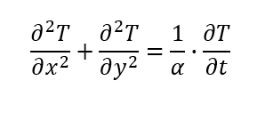Figure 1.

4.Initial Boundary Conditions.
A thermal boundary condition is the set of conditions describing a temperature or heat flux conditions at the inside wall of the metal under consideration. The outlying average heat transfer flux is greatly dependent on the thermal boundary condition in the laminar flow. (R.K. Shah, 1978)
The initial boundary conditions will be considered as follows:
- A square plate of aluminium [0, 6] × [0, 6] will be used.
- An initial temperature of T = 0 degrees C will be considered.
- A constant temperature of 50 degrees C will be placed at the 4m point at the top of the plate.
- The grid spacing and time will be entered by program user.

The Aluminium properties to be considered are:
• Conductivity: k = 143 W/m.C
• Density:  = 2.8  103 kg/m3
• Specific Heat: c = 795 J/kg.C

Figure 2 below shows a 2D image of the plate to be used:
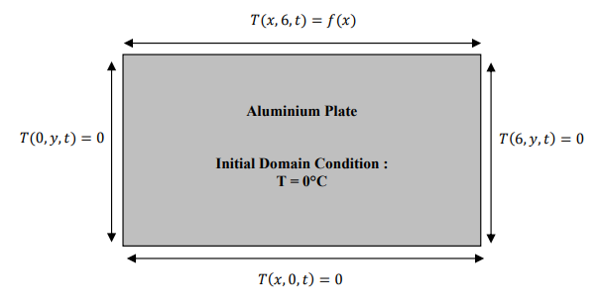 Figure 2.

5.Explicit finite equation.
We start by looking at the Taylor series when considering the explicit finite equation as these are substituted into the equation. What is the Taylor series?
The Taylor series is a polynomial which has infinite terms allowing for approximation of a non-polynomial analytic function.
It represents a series of a function as an infinite sum of terms that are calculated from the values of the function's derivatives from a single point.
The Taylor series was formulated by a Scottish mathematician James Gregory who was formally introduced by the English mathematician Brook Taylor in 1715. If the Taylor series can be cantered at zero, this series is also known as a Maclaurin series, which has been named after the Scottish mathematician Colin Maclaurin, he extensively used the Taylor series in the 18th century. (Maplesoft, 2024)

Figure 3 below shows an example of the Taylor series equation.
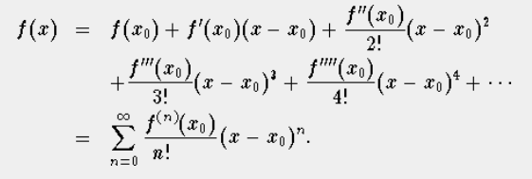 (Knaust, 1996)
Figure 3.

It is considered that there are three derivations of the Taylor series.
The Forward difference which can be seen in figure 4 below.
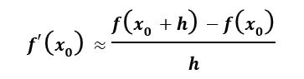
Figure 4.

The Backward difference which can be seen in figure 5 below.
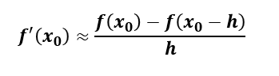
Figure 5.

The Central differences which can be seen in figure 6 below.
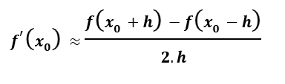Figure 6.

The explicit finite equation replaces the first and second derivatives in the heat equation with the forward and central differences in the heat equation.

Figure 7 below shows the explicit finite equation.
$$T_{P}^{t+∆t}=F_{0}\left(T_{E}^{t}+T_{W}^{t}+T_{N}^{t}+T_{S}^{t}-\left(4-\frac{1}{F_{0}}\right).T_{P}^{t}\right)$$
Figure 7.

Fourier’s number
A key part of the heat equation is the Fourier number. What is the Fourier number?
The Fourier number, also known as Fo, is considered as a dimensionless parameter used in the field of heat transfer analysis. It has a fundamental role in how the rate of heat conduction is characterised within material over time. The Fourier number allows scientists and engineers to understand how over time temperature changes through a material when subject to different temperatures. (Testbook, 2023)
Figure 8 below shows the Fourier number equation.
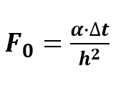Figure 8.

6.Stability criteria.
The stability criteria will be considered as satisfied when the numerical solution remains stable over time. Achieving stability can be considered as crucial to obtain reliable and accurate results from the modelling.
Stability will be considered as achieved when thermal equilibrium has been achieved across the whole plate.
What is thermal equilibrium?
Thermal equilibrium is achieved when two objects in contact no longer exchange heat, creating a uniform temperature between the two objects. This balance is fundamental not just in physics but in everyday life. (All the Science, 2024)

7.Codes details and explanations.
Below are the coding details along with explanations of the expectations of each code step.
Figure 9 below is the command to clear and re-set the window, The reason for this is to ensure any previous operations have been closed, all previous text from the command window has been erased and that the workspace is cleared. This allows MATLAB to operate as efficiently as possible.
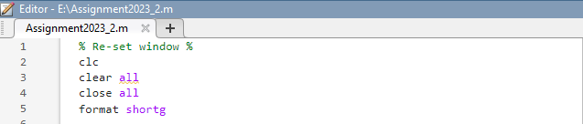
Figure 9.

Figure 10 below is the command to enter the values of density, conductivity and specific heat of the aluminium plate to be considered. Line 11 shows the calculation to determine the materials thermal diffusivity.
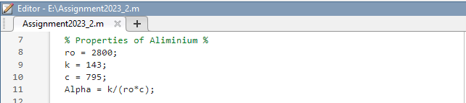
Figure 10.

Figure 11 below is the command that allows the user to enter the dimension of the plate and enter the grid spacing of each node. This is prompted by the programme for the user to input.
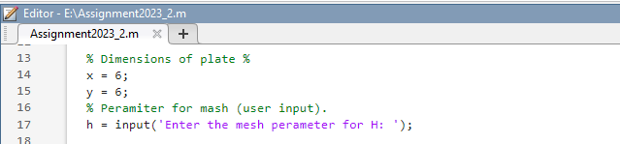
Figure 11.

.
Figure 12 below is the command to check that the H value inputted by the user meets the programmes requirements. This needs to be greater than 0 and can be divided by 6. If these requirements are not met the programme will prompt the user to enter a different value,
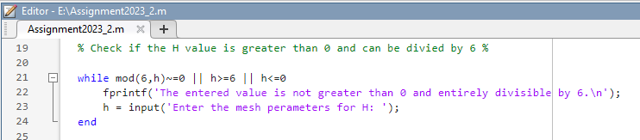
Figure 12.

Figure 13 below shows the command that shows the Fourier’s number solution. This is done by establishing the maximum permissible time step. The model asks the user to input their desired time step which is assessed against conditions which are stated in the two ‘While’ loops that proceed. The First ‘While’ loop prompts the user to re-enter a valid time step duration for as long as that duration remains greater than the maximum permitted duration (taken from the previous line of code), the second ‘While’ loop performs a similar function, but this time will check that the time step is not too small. to the time step in seconds and looks to see if the inputted number fits into the Fourier Number.
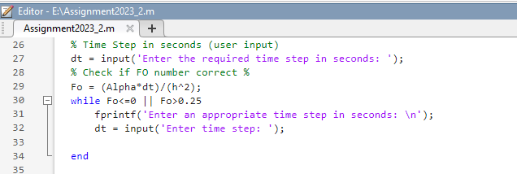
Figure 13.

Figure 14 below shows the command that is used to check the matrix dimensions.
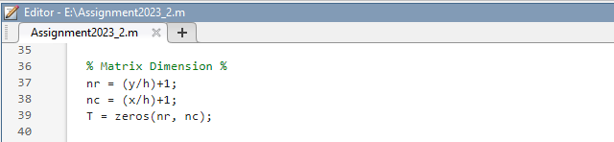

Figure 14.
Figure 15 below shows the command that sets the boundary conditions of the plate. The function of the ’For’ loop in this section of the code is to repeat the implanted ‘If’ function of the code in steps of 1 for however number of columns there are in the vector.
There are two rules that determined which formular was used to calculate each value, the implanted ‘If’ function of this section performed the calculation of each cell in conjunction with the iteration number of the ‘For’ loop.
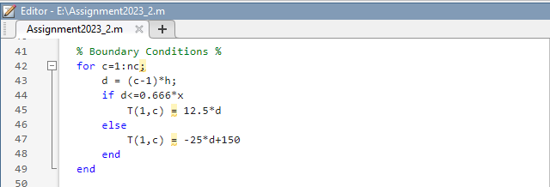
Figure 15.

Figure 16 below shows the command to calculate thermal equilibrium. This is achieved by calculating the temperature at each `step. Calculations of the temperature at each grid step during each time step is made. The code translates the discretised equation into code using a ‘Counter’, a ‘While’ loop, two ‘For’ loops and an ‘If’ loop.
The second matrix created in this section of code is used to populate the values calculated of rows and columns, this is done by two ‘For’ loops one of which has been placed within the second, the first ‘For’ loop, is for distinguishing the correct row of the matrix, while the second looks for correct column.
The ’If’ loop compares the most recently calculated matrix with the first. Providing the difference between each matrix is less than 0.01°C, the user shall be told that; thermal equilibrium has been reached and, the ‘break’ operation will stop the ‘While’ loop.
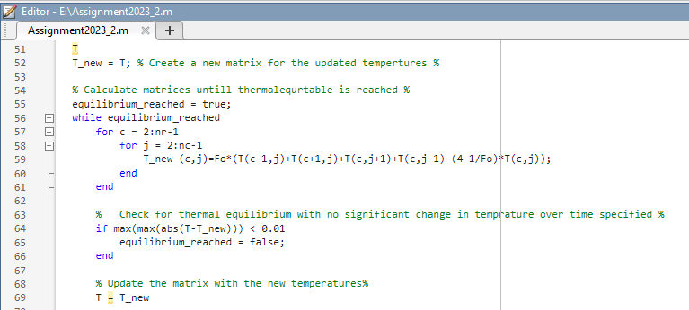
Figure 16.

Figure 17 below shows the command to plot the final temperature distribution graph. This dose so by plotting a contour map which shows how the heat has spread throughout the Aluminium plate for the numerical solution.
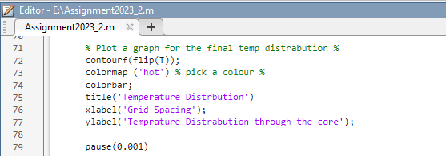
Figure 17.

Figure 18 below shows the final temperature distribution graph that is produced because of the commands shown in figure 17.
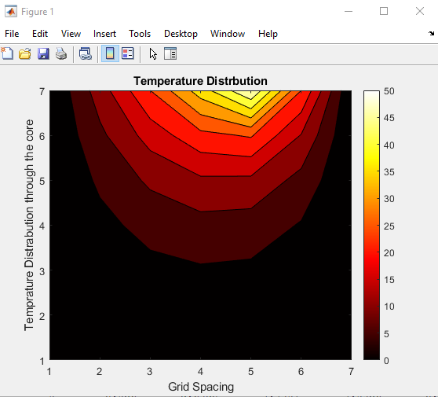
Figure 18.

Figure 19 below shows the command to check the analytical solution for the code. This was done by using the Analytical equation provided in the brief to compare against the numerical solution.
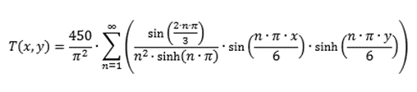 (Marotin, 2024)
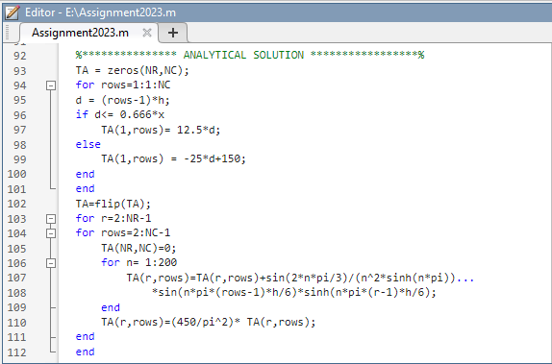
Figure 19.

Figure 20 below shows the command to plot the final temperature distribution graph. This dose so by plotting a contour map which shows how the heat has spread throughout the Aluminium plate for the analytical solution.
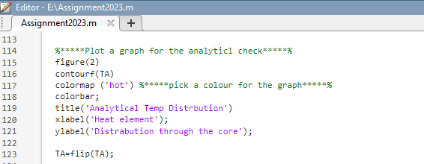
Figure 20.

Figure 21 below shows the final temperature distribution graph that is produced because of the commands shown in figure 20.
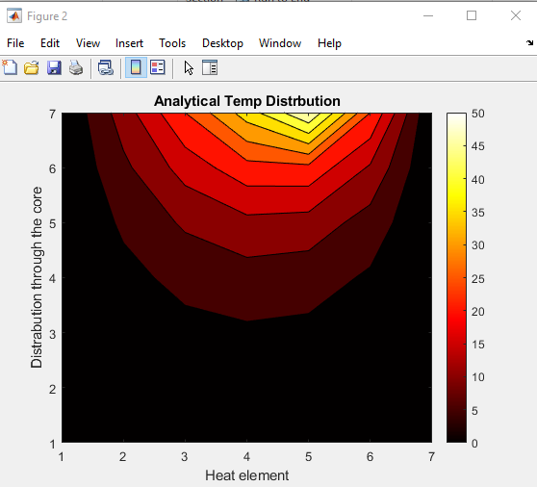
Figure 21.

Figure 22 below shows the command to plot the graph displaying the difference between the numerical and analytical check.
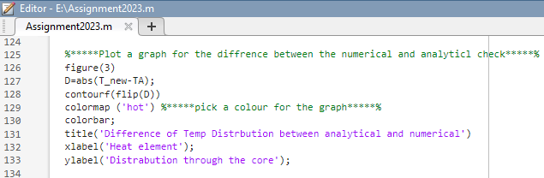
Figure 22.
Figure 23 shows the graph that displays the difference of temperature distribution between the analytical and numerical.
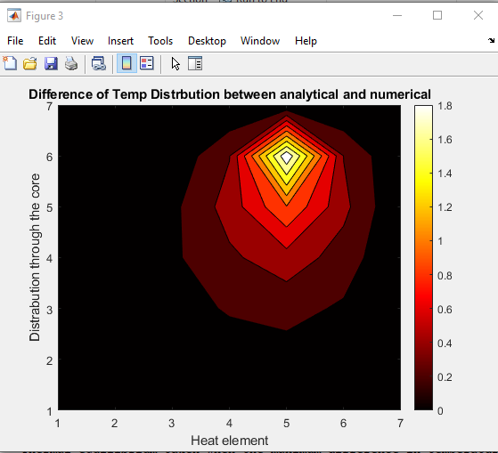
Figure 23.
Figure 24 below shows the command to calculate the time taken to reach thermal equilibrium. This uses the IF command to calculate if thermal equilibrium under one second or display the time taken in hours, minutes and seconds.
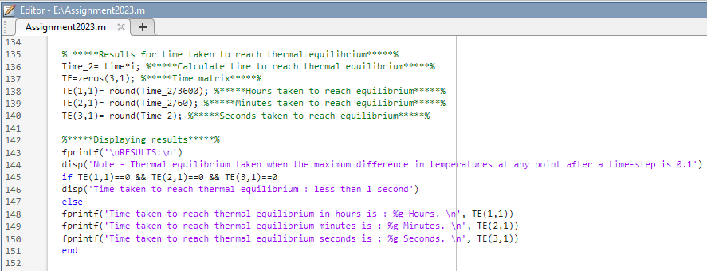
Figure 24.

8.Validation of the code.
Looking at figure 18 & 21 there is minimal difference between the numerical and analytical models. Figure 23 considers the difference between the two models and this difference is within 1.6 degrees between the two codes and it is fair to say that with such a minor difference the code could be considered valid.
The error between models (1.6degrees) is located largely around the heat source and could be considered as part of the roundoff or the truncation error.

9.Sensitivity analysis of the code.
Looking at Figure 23 that shows both the analytical and numerical solutions at thermal equilibrium they can be believed to be comparable. Therefore, more analysis of the modelling is needed to determine its sensitivity. By focusing on the time taken to reach thermal equilibrium better analysis of the model can be achieved. Three different tests will be carried out to determine what the effects of altering the code will have on the model. These tests will be to the grid spacing, the time step, and the tolerance of the model.
Firstly, a test was carried out looking at the effect of different grid spacings effect on the time taken to reach thermal equilibrium. As you can see in figure 25 below a reduction in the grid spacing reduces the time taken to reach thermal equilibrium. A reduction in the spacing would improve the model’s sensitivity and accuracy.

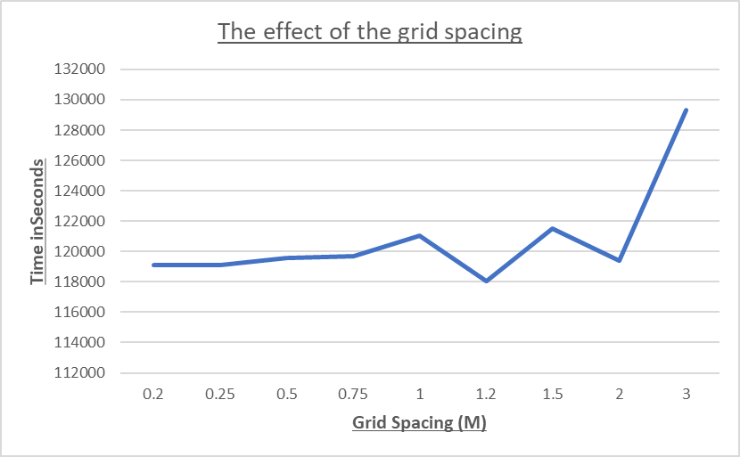
Figure 25

The second trail looks at the effect of the time step of the code. Figure 26 below shows an exponential increase of the time taken to reach thermal equilibrium when the time step is increased. This can be considered that by increasing the time step the sensitivity of the model is reduced and a loss of accuracy occurs.

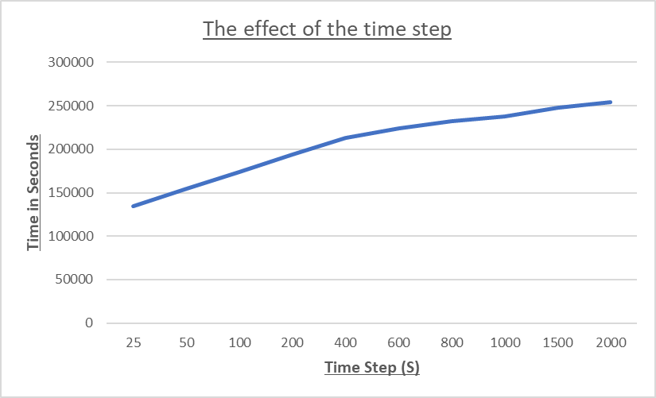
Figure 26.

The third trail looks at what effect the tolerance constant has on the code. Figure 27 below shows effects of the time taken to reach thermal equilibrium when adjustments were made to the tolerance constant of the code. The effect of this can be seen as being linear, when the tolerance constant is reduced the time taken to reach thermal equilibrium is increased. While the time to reach thermal equilibrium increases so does the accuracy of the model.

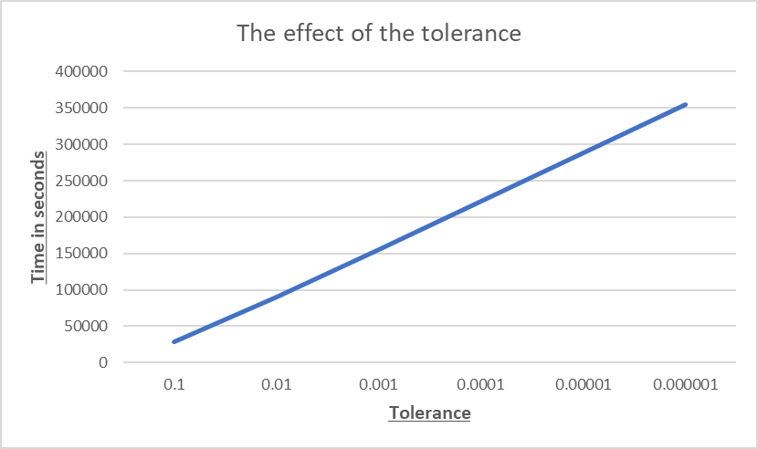
Figure 27.

10.Main model’s limitations.
The application of FDM method can occur two different forms of errors:
Firstly, Truncation errors: The truncation error is a measure of the accuracy that considers a range of problems but does not automatically provide a correct comparison of the accuracy of processes for one problem. (G.M. PHILLIPS, 1996)
Secondly, rounding errors: A Round-off error is a kind of inaccuracy that happens by taking a selected number of decimal places instead of taking the entire number. These errors occur due to the degree of accuracy and approximation in a solution. (Ricardo, 2021)
Based on the analysis of the sensitivity of the code it could be said that one of the limitations of the code is that there is a link between the gid spacing, time step and tolerance when considering the effects, they have on the model.
The key element of the grid spacing is that it must fit the plate dimensions (6X6) and be divisible by this.
Having a wide grid spacing will work but reduces the accuracy of the code. Using a tight grid spacing however increases the accuracy of the of the code. Figure 28 below shows the result difference between the numerical and analytical if the grid spacing is reduced to 0.5.

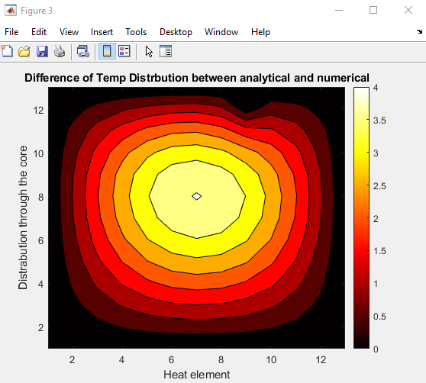
Figure 28.

The time step is also limited by the code as is must fit into the Fourier number equation to be correct. Figure 29 below shows the effect of trying to enter a random into the time step.

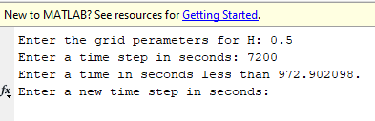
Figure 29.

While the tolerance has an effect on the time taken to reach thermal equilibrium there dose not seem to be any limitaions thar would stop the code from working. Infact it could be suggested that setting a greater tolerance will reduce the round-off error.

11.Suggested improvements and future developments.
Could there be improvements that can be made to the code for future development?
One possibility could be to substitute The Finite-Difference Method (FDM) with the Finite-Volume Method (FVM)
What is the Finite-Volume method (FVM)?
The finite-volume method is based on physical laws relating around what goes into one cell on one side needs to leave the same cell on another side. With this hypothesis you achieve a formulation that consists of flux conservation equations that are defined in an averaged sense over the cells.
What is the difference between FDM and FVM?
There are similarities between both methods in that each method represents a systematic numerical method for solving PDEs. A key difference is around the ease of implementation. There is a general opinion is that the finite-difference method is the easiest to implement. (Bjorn Sjodin, 2016)
Substituting the FDM with the implicit FDM would be another possible way to improve future code as it could reduce time lag.
What is the Implicit FDM?
The Explicit FDM is a simple and fast way to calculate solutions as they can be easily calculated instantaneously from the solutions at the previous instant. One key limitation is the grid size as this can cause serious numerical instability problems. (L.H. Yam, 1993)

12.Conclusion.
The aim for the and objectives of this report was to create a code that could be used in MATLAB software to calculate the time taken to reach thermal equilibrium in a plate of aluminium of preset dimensions. The code had to use the Explicit Finite Difference Method (EFDM) when calculating the results. These results would then be tested against an analytical solution to validate the code.
In conclusion this has been achieved as the code can provide a graph that shows the heat distribution throughout the plate (figure 18). This is then tested against the analytical solution with the variance between the two compared (figure 23). There was 1.6 degrees between the two methods showing the code to be close enough to be considered a viable way to calculate heat distribution over time.
An accurate approximation of the of the temperature at any point in the plate can be made providing there is stability in the methods used in the solution. By reducing the time step and grid spacing a greater accuracy in the result can be achieved.
The report also looks at what the EFDM is and why it is important to developing a code to calculate the results along with testing the limitations of the code. Truncation and rounding off errors could be considered as two key limitations of the code.
Future improvements of the code have also been investigated in this report by comparing The Finite-Difference Method (FDM) with the Finite-Volume Method (FVM) and looking at the advantage of substituting the Finite-Volume Method (FVM) into the coding. Reduction in time lag could be considered as the key difference between the two methods.

13.Bibliography.

All the Science. (2024). What is Thermal Equilibrium? Retrieved from allthescience.org: https://www.allthescience.org/what-is-thermal-equilibrium.htm
Bjorn Sjodin. (2016, April 18). What’s The Difference Between FEM, FDM and FVM? Retrieved from machinedesign.com: https://www.machinedesign.com/3d-printing-cad/fea-and-simulation/article/21832072/whats-the-difference-between-fem-fdm-and-fvm
Cadence CFD. (2023). Explaining the Finite Difference Method and Heat Transfer. Retrieved from cadence.com: https://resources.system-analysis.cadence.com/blog/msa2022-explaining-the-finite-difference-method-and-heat-transfer
G.M. PHILLIPS, P. T. (1996). ORDINARY DIFFERENTIAL EQUATIONS. Theory and Applications of Numerical Analysis (Second Edition).
Greene, G. A. (2023). Heat transfer. Encyclopedia of Physical Science and Technology (Third Edition).
Knaust, H. (1996, July 14). Taylor Series. Retrieved from sosmath.com: http://www.sosmath.com/calculus/tayser/tayser01/tayser01.html
L.H. Yam, W. C. (1993). Finite Difference Method. Retrieved from sciencedirect.com: https://www.sciencedirect.com/topics/engineering/finite-difference-method
Maplesoft. (2024). What is the Taylor series? Retrieved from maplesoft.com: https://www.maplesoft.com/ns/math/taylor-series.aspx
Marotin, A. (2024). ACMA6012 Computational Methods Assignment. Swansea: University of Wales Tinity st Davids.
Mathworks. (2024). Heat transfer. Retrieved from mathworks.com: https://www.mathworks.com/help/pde/heat-transfer-and-diffusion-equations.html
Powell, A. (2002, 03 13). Finite Difference Solution of the Heat Equation. Retrieved from dspace.mit.edu: https://dspace.mit.edu/bitstream/handle/1721.1/35256/22-00JSpring-2002/NR/rdonlyres/Nuclear-Engineering/22-00JIntroduction-to-Modeling-and-SimulationSpring2002/55114EA2-9B81-4FD8-90D5-5F64F21D23D0/0/lecture_16.pdf
R.K. Shah, A. L. (1978). Differential Equations and Boundary Conditions. Laminar Flow Forced Convection in Ducts.
Ricardo, H. J. (2021). The numerical approximation of solutions. A Modern Introduction to Differential Equations (Third Edition).
Testbook. (2023, Nov 7). What is Fourier Number? Retrieved from testbook.com: https://testbook.com/mechanical-engineering/fourier-number

14.Appendix (script).
Below is the script used to write the code.
%*****Re-set window***** %
clc
clear
close all
format Shortg

%*****Properties of Aluminium***** %
ro = 2800;
k = 143;
rows = 795;
alpha = k/(ro*rows);

%*****Dimensions of plate***** %
x = 6;
y = 6;

%*****Ask the user to define the grid reference (user input)***** %
h = input('Enter the grid perameters for H: ');

% *****Check if the entered value is greater than 0 and entirely divisible by 6*****%

while rem(6,h)~=0 || h>=6 || h<=0
fprintf('The entered value must be greater than 0 and also entirely divisible by 6.\n');
h = input('Enter the grid perameters for h: ');
end

%*****Enter the time step in seconds (this is a user input)*****%
time = input('Enter a time step in seconds: ');

%*****Check if FO number is correct using the time step inputed*****%
Fo = alpha*time/h^2;
while Fo<=0 || Fo>0.25
fprintf('Enter a time in seconds less than %f. \n',h^2/(4*alpha));
time = input('Enter a new time step in seconds: ');
Fo = alpha*time/h^2;
end

%*****Set the matrix dimensions*****%
NR=y/h+1;
NC=x/h+1;
T = zeros(NR,NC);

%*****Set the boundary conditions*****%
for rows=1:1:NC
d = (rows-1)*h;
if d<= (2/3)*x
T(1,rows)= 12.5*d;
else
T(1,rows) = -25*d+150;
end
end
T;
T_new = T; %***** Create a new matrix for the updated tempertures*****%

%*****Calculate matrices untill thermal equilibrium is reached*****%
equilibrium_reached = true;

i=0; %*****Set Loop Counter*****%
while equilibrium_reached
for rows = 2:NR -1
for Columns = 2:NC-1
T_new (rows,Columns)=Fo*(T(rows-1,Columns)+T(rows+1,Columns)+T(rows,Columns+1)+T(rows,Columns-1)-(4-1/Fo)*T(rows,Columns));
end
end

%*****Check for thermal equilibrium with no significant change in temprature*****%
if max(max(abs(T-T_new))) < 0.01
equilibrium_reached = false;
end

% *****Update the matrix with the new temperatures*****%
T = T_new;

%*****Plot a graph for the final temp distrabution*****%
contourf(flip(T));
colormap ('hot') %*****pick a colour for the graph*****%
colorbar;
title('Numerical Temp Distrbution')
xlabel('Heat element');
ylabel('Distrabution through the core');

pause(0.001)

%*****Calculate maximum difference between matrices*****%
diffT=T_new-T; %*****Generates difference matrix*****%
maxdiff=max(diffT,[],'all'); %*****evaluates maximum difference*****%

i=i+1; %*****Loop counter*****%
end
T_new;

%*************** ANALYTICAL SOLUTION *****************%
TA = zeros(NR,NC);
for rows=1:1:NC
d = (rows-1)*h;
if d<= 0.666*x
TA(1,rows)= 12.5*d;
else
TA(1,rows) = -25*d+150;
end
end
TA=flip(TA);
for r=2:NR-1
for rows=2:NC-1
TA(NR,NC)=0;
for n= 1:200
TA(r,rows)=TA(r,rows)+sin(2*n*pi/3)/(n^2*sinh(n*pi))...
*sin(n*pi*(rows-1)*h/6)*sinh(n*pi*(r-1)*h/6);
end
TA(r,rows)=(450/pi^2)* TA(r,rows);
end
end

%*****Plot a graph for the analyticl check*****%
figure(2)
contourf(TA)
colormap ('hot') %*****pick a colour for the graph*****%
colorbar;
title('Analytical Temp Distrbution')
xlabel('Heat element');
ylabel('Distrabution through the core');

TA=flip(TA);

%*****Plot a graph for the diffrence between the numerical and analyticl check*****%
figure(3)
D=abs(T_new-TA);
contourf(flip(D))
colormap ('hot') %*****pick a colour for the graph*****%
colorbar;
title('Difference of Temp Distrbution between analytical and numerical')
xlabel('Heat element');
ylabel('Distrabution through the core');

% *****Results for time taken to reach thermal equilibrium*****%
Time_2= time*i; %*****Calculate time to reach thermal equilibrium*****%
TE=zeros(3,1); %*****Time matrix*****%
TE(1,1)= round(Time_2/3600); %*****Hours taken to reach equilibrium*****%
TE(2,1)= round(Time_2/60); %*****Minutes taken to reach equilibrium*****%
TE(3,1)= round(Time_2); %*****Seconds taken to reach equilibrium*****%

%*****Displaying results*****%
fprintf('\nRESULTS:\n')
disp('Note - Thermal equilibrium taken when the maximum difference in temperatures at any point after a time-step is 0.1')
if TE(1,1)==0 && TE(2,1)==0 && TE(3,1)==0
disp('Time taken to reach thermal equilibrium : less than 1 second')
else
fprintf('Time taken to reach thermal equilibrium in hours is : %g Hours. \n', TE(1,1))
fprintf('Time taken to reach thermal equilibrium in minutes is : %g Minutes. \n', TE(2,1))
fprintf('Time taken to reach thermal equilibrium in seconds is : %g Seconds. \n', TE(3,1))
end

