INTERNATIONAL BUSINESS COMMUNICATION
LCBB6001
Assessment 1
Student name : IOANA RAIRA MOSU
Student ID : 2019296
Lecturer name : AFZAL MUNNA
Executive Summary
The international business communication approach plays a crucial role in business to get success in the global market. British Airways service various countries where they need to deal with several employees from different backgrounds and cultures. An inclusive environment helps the organisation to bring them together to work effectively. Cultural sensitivity plays a vital role in it to bring effectiveness to the organisation by providing employees equal opportunities. Different cultural theories had been evaluated to see how the culture of the UK impacts the business. Besides this, different communication barriers have been evaluated in an elaborate manner. Additionally, there were strategies and recommendations to overcome the barriers to build an inclusive place where employees from all backgrounds are treated well and communicated with each other in a good manner.

Table of Contents
1.0 Introduction 4
2.0 Overview of British Airways 4
3.0 Intercultural and international communication theories based on the UK 5
3.1 Hofstede’s Cultural Dimension Theory 5
3.2 Samovar Theory of Intercultural Communication 7
3.3 Jandt's Intercultural communication theory 7
4.0 Critical evaluation of cultural sensitivity in the UK 8
5.0 Evaluation of different cultural barriers 10
6.0 Appropriate Strategies and recommendations 12
6.1 Strategies 12
6.2 Recommendations 13
7.0 Conclusion 13
Reference List 15

1.0 Introduction
The term inclusive communication is defined as the way through which information is shared equally so that everyone can understand. In the workplace of the UK ensure that all employees are treated well and get equal respect with the help of inclusive communication approaches. Inclusive communication is necessary for the workplace to bring a positive culture where organisations that align with international businesses can run the business successfully. The communication style of the British is mixed of direct and indirect as they like to avoid conflict and take necessary measures for it. The selected organisation, in this case, the study is British Airways and the present report is going to discuss the inclusive business culture of the organisation. In this context, the overview of the organisation will be discussed further. Therefore, different cultural and communication theories such as Jante, samovar and Hosfstede's theory will be evaluated in an elaborate manner. Furthermore, cultural sensitivity and different communication barriers along with strategies and recommendations to mitigate the barriers will be discussed here.

2.0 Overview of British Airways
British Airways flag carrier airline of the UK, which was founded in 1919 and has headquarters in Harmondsworth, UK. The airline has served its excellent service for more than 100 years in more than 200 destinations within 80 countries (British Airways, 2023a). Based on fleet size, it is the second-largest airline in the UK. During the pandemic the airline faced financial shock despite this it provided 13% high pay to the 16000 workers as per their efforts to show care for employees (Theguardian, 2022). The inclusive culture of British airways follows the inclusive communication of the UK. It values employees for their contribution and treats them equally. Employees from all backgrounds and gender get equal pay and opportunities to make career growth in this place (British airways, 2023b). It can be observed that the inclusive culture motivated employees to perform their best to give the business an environment where it can get the opportunity to develop.

Figure 1: Logo of British Airways
(Source: British airways, 2023)

3.0 Intercultural and international communication theories based on the UK

3.1 Hofstede’s Cultural Dimension Theory
Intercultural communication is necessary for the workplace to break the culture's barriers to bring improvement in business. According to Steinfatt and Millette, (2019), intercultural communication builds a positive environment through self-awareness and enhances communication skills. The role of international and intercultural communication in the business of British Airways is going to be discussed based on the UK market. The UK gets a lower rank in the power distance index which is 35 which indicates the UK's emphasis on minimising inequalities among people. British Airways follow this to maintain equality in its workplaces. Besides this, the country scores 66% for masculinity which determines growth and success (Hofstede-insights, 2023). According to this, British Airways trained its employees properly and encouraged them to bring innovation to make organisational growth in this competitive market.
Apart from this, the UK scored 89% for individualism which indicates that the country highly maintains privacy and people love to live and think for themself rather than family or relatives. The route to happiness is self-fulfilment and they like to contribute individually to the nation (Jackson, 2020). Employees of British Airways also contribute individually and live for themselves to be happy. The UK received a 35% score for the uncertainty avoidance index which shows that the country is always ready to deal with unpredictable situations in an efficient manner. Similarly, British Airways always train their employees ready to deal with uncertain situations according to the UK's culture. I do not fear dealing with uncertain situations but like to deal with the situation to learn something new from the situation. A high score indulgence shows the carefree behaviour of the UK and a positive attitude to enjoy life (Hofstede-insights, 2023). It is followed by the organisation as well as they also like to provide employees flexibility and encourage them to show creativity and reduce the work burden to enjoy their lives in their own ways. Hence, the culture of the UK influences the business of British Airways from different perspectives and allows intercultural communication in the workplace to achieve organisational growth.
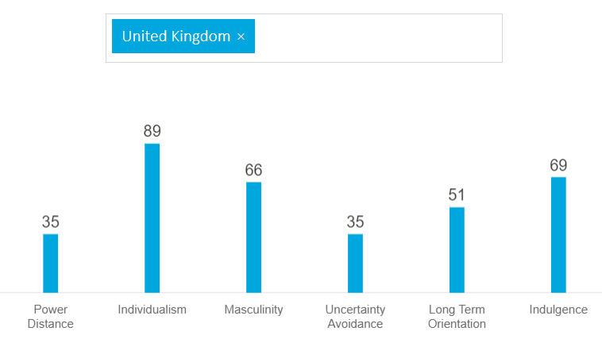
Figure 2: UK’s Culture Analysis through Hofstede’s Cultural Dimension
(Source: Hofstede-insights, 2023)

3.2 Samovar Theory of Intercultural Communication
According to Idris and Muftia, (2021), American culture tends to talk to the point of communication and concisely and respects individual boundaries and freedom highly. According to the theory, there are some particular methods for verbal and non-verbal communication to deliver positive communication to bring inclusiveness. During verbal communication, the culture of the UK indicates direct and simple ways to communicate along with politeness, voice volume and silence. Besides this, during non-verbal communication people of the UK follow eye contact and focus on body gestures, smiles, physical contact, and basic etiquette (Idris and Muftia, 2021)). Moreover, planning and punctuality provide more impact on their communication method to bring inclusive culture. In this context, British Airways also follows this culture to bring intercultural communication in its place for flourishment in business (Britishairways, 2023b).

3.3 Jandt's Intercultural communication theory
Jandt determines the factors that associate with intercultural communication in his intercultural communication theory. The theory shows that ineffective communication can lead to conflict in the workplace which can negatively affect organisational performance (Mgogo and Osunkunle, 2020). It indicates social issues such as gender issues, refugees, social identification and others. British Airways also evaluate these issues and allow all people based on their talent to work with it and provide equal opportunities. Women also get equal rights in workplaces to make growth in their careers. British Airways value its employees and treat them as an assent that contributes to achieving business goals. British Airways analyse the power of diversity and support employees to balance their physical, emotional and mental health. The organisation makes a network of 150 people to help employees where they are required. The organisation supports a 30% club to promote women for leadership roles in business (Britishairways, 2023b). The organised 24-hour helpline and health checkup facilities for the employees to motivate them in order to establish intercultural communication. Hence, following Jandt's theory, the organisation can bring success to its business.

4.0 Critical evaluation of cultural sensitivity in the UK
Cultural sensitivity is defined as the ability or set of skills that helps to evaluate the cultures of others and teach to respect others' cultures. The cultural sensitivity of a workplace depends on its policy and behaviour. Cultural sensitivity plays a significant role in bringing opportunities in business from various perspectives such as it creates a safe working environment where employees work without any fear (Turkelson et al., 2021). Besides this, another opportunity it provides is to reduce biased activities and bring diversification by gathering skilful employees in one place. This promotes employee satisfaction which inspires employees to bring creativity and innovation to make business competitive. Another significant role of it is it helps to enhance collaboration as effective collaboration enhances intercultural communication in the workplace.
Apart from this, the UK welcomes students and employees from all backgrounds to study and work here and provides equal opportunities for UK citizens to make growth in academic and professional life. The UK is a country where people from different nations like Germany, India, China, and others can come and establish their careers in a good manner. For example, British Airways also provides opportunities to all people rather than checking their nationality or background (British airways, 2023b). The people of the UK are well-mannered, well educated and self-aware which helps to enhance their abilities. Shaking hands with new people or maintaining eye contact or proper body gesture is the culture of the UK which is followed by the people. Besides this, punctuality plays a significant role which helps to make people learn the importance of time and makes them more responsible for their work (Curtis et al., 2019). In this context, British Airways also maintains punctuality which helps the employees of the organisation to make a work-life balance which is beneficial for their mental and physical health as well. Here, employees get an inclusive environment where they can shape their abilities for future growth.
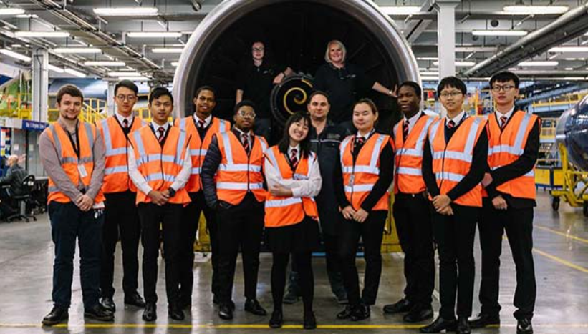
Figure 3: Inclusion and cultural sensitivity in British Airways
(Source: Britishairways, 2023b)
Apart from this, it can be observed that British Airways follow the intercultural nature of the UK where they empower females and promote them and provide them with the same facilities as other male employees based on their work efforts. The organisation represents inclusion and diversity and its importance in business to the global world. The organisation supports people from all backgrounds to promote a positive working environment to provide a positive impact on society (Britishairways, 2023b). Therefore in this culture, the airline provides flexible working opportunities for all employees and encourages and praises them for their hard work. British Airways breaks the racism or colour issues and brings opportunities for all and trains them equally so that they can contribute equally to the success of the business.
On the other hand, Due to a lack of cultural awareness or ineffective training, the workplace might face various challenges such as friendly communication cannot be built among employees and it negatively affects the culture of the workplace (Kaihlanen et al., 2019). Therefore, many people from different backgrounds cannot adjust to new cultures easily and they went through various challenges such as mental stress, poor performance at workplaces and others (Kaihlanen et al., 2019. Hence it can be said that cultural awareness can be the key element of international businesses to build effective communication in order to perform excellent performance in the global market.

5.0 Evaluation of different cultural barriers
Language barriers: It is one of the effective barriers that create obstacles in the workplace and as a consequence people cannot share their thoughts and ideas with others. People from different backgrounds have different languages and working in multinational companies can face language issues (Schouten et al., 2020). Miscommunication of communication gap creates poor performance and negatively impacts organisational progress. In this context, British Airways also adopts employees from different cultures, as a consequence they also face similar situations as well which need to be figured out with effective strategies.

Figure 4: Language Barrier
(Source: Communicationtheory, 2023)
Unconscious Bias: Unconscious bias can be formed in the workplace due to a lack of cultural awareness. Unconscious bias can happen based on various factors such as gender, culture, race, religion and others (Harappa, 2021). It indicates that the society of the UK accepts its own cultural people more than others and also follows masculinism. Besides this, it can be observed that in Uk culture also, males have more power than females in more places and have various differences which are happening due to a lack of cultural awareness and ineffective tanning. For example, at British Airways, the gender pay gap can be seen which is 10% (Parliament, 2018).
Value and Beliefs: The value of a person depends on the belief they have and that is the reason they behave in a particular way. For example, shaking hands is a cultural belief in the UK but some other countries do not appreciate touching (Harappa, 2021). British Airways recruits employees from various cultures and the belief and the different beliefs can make trouble for employees to collaborate in a positive way.
Body language, signs and symbols: respect towards others' culture can be done through effective body language or non-verbal signs or symbols but lack of proper gestures can be rude and disrespectful which can bring conflict among team members and bring challenges in the collaboration process (Liu, 2021). Many employees in British airways face such kinds of issues which highly impact their performances.
Cultural norms and values: Values and norms also determine the culture of a country and highly influence organisational performance. For example, Asiatic countries believe in collectivism rather than individualism because they love to stay with family and think about them (Liu, 2021). On the other hand, countries like the UK support individuals where people live for themself. These differences can be observed due to differences in cultural norms and values.
Hence different cultural barriers can bring mental and physical stress among employees which can be harmful to the growth of the business and need to be considered by the organisation for further development.

6.0 Appropriate Strategies and recommendations

6.1 Strategies
Effective communication system: Organisations need to make open places for communication so that employees can share their valuable thoughts without hesitation (Harappa, 2021). It will help to encourage and motivate them which is beneficial to establish a positive environment to get success in business.
Cultural awareness: Organisations have to teach employees the significant role and benefits of cultural awareness and establish cultural awareness to increase self-awareness which is essential to respect all cultures and bring effective communication (Harappa, 2021).
Employee diversity training: Businesses have to train employees to establish diversity in the workplace where employees from all backgrounds can work peacefully with effective collaboration and communication (Haller et al., 2019).
Work rules and regulations: another effective way is to maintain rules and regulations at workplaces which helps make an inclusive environment for all employees (Haller et al., 2019). Besides this, various challenges associated with communication also can be mitigated.

Figure 5: Strategies to bring Inclusive Environment
(Source: Communicationtheory, 2023)

6.2 Recommendations
Learn about different cultures: It helps employees to earn and enhance cultural knowledge which helps them to collaborate with people of different cultures easily. It is beneficial for businesses to mitigate the communication gap (Chrysos, 2023). It helps to make a good environment where all kinds of people work with equal respect which increases productivity and helps to meet business objectives.
Respect for other cultures: Organisations need to teach how to respect other cultures which are necessary to build effective communication in international business (Chrysos, 2023). People who are from different backgrounds can respect each other and work with each other as a team to represent a business in the global market.
Appropriate language in the workplace: Businesses need to make a proper language for the workplace which employees need to follow and this will help to reduce different language issues (Chrysos, 2023). In this way, they can collaborate efficiently to bring efficiency to organisational performance.
Active Listening: Listening to others while communicating is helpful as it enhances the understandability of employees which helps to establish cultural awareness in the workplace.

7.0 Conclusion
Inclusive communication plays a crucial role in multinational business in the UK. The selected organisation was British Airways, one of the leading airlines of the UK and operated the global market. That is the reason it hires employees from the global market who are from different backgrounds and cultures./ inclusive communication approaches help the airline organisation to build a positive workplace where employees can work positively to bring organisational goals. In this context, different types of cultural theory such as Hofstefes's theory, Jandt's theory and Samovar's theory had been evaluated in an elaborate manner to understand the business culture in the UK context. Besides this, the significant role of cultural sensitivity has been evaluated which is essential to do business in the UK market. Moreover, several cultural barriers had been analysed along with effective strategies and recommendations to overcome the barriers such as active listening, effective learning, open communication and others.

Reference List
Britishairways, (2023a). Airbus A380-800. Available at https://www.britishairways.com/en-gb/information/about-ba/fleet-facts/airbus-380-800, [Accessed on 30/03/2023]
Britishairways, (2023b). PEOPLE. Available at https://www.britishairways.com/en-gb/information/about-ba/ba-better-world/people, [Accessed on 30/03/2023]
Chrysos, (2023). Effective Cross-Cultural Communication. Available at https://www.chrysos.org.uk/blog/top-ten-tips-for-effective-cross-cultural-communi, [Accessed on 30/03/2023]
Communicationtheory, (2023). Cultural Barriers of Communication. Available at https://www.communicationtheory.org/cultural-barriers/, [Accessed on 30/03/2023]
Curtis, E., Jones, R., Tipene-Leach, D., Walker, C., Loring, B., Paine, S.J. and Reid, P., (2019). Why cultural safety rather than cultural competency is required to achieve health equity: a literature review and recommended definition. International journal for equity in health, 18(1), pp.1-17.
Haller, P.M., Naegele, U. and Berger, S., (2019). Bridging Cultural Barriers. Management for Professionals.
Harappa, (2021). Cultural Barriers to Communication: Meaning, Examples and How to Overcome Cultural Barrier. Available at https://harappa.education/harappa-diaries/cultural-barriers-to-communication/, [Accessed on 30/03/2023]
Hofstede-insights, (2023). COUNTRY COMPARISON. Available at https://www.hofstede-insights.com/country-comparison/the-uk/, [Accessed on 30/03/2023]
Idris, N.S. and Muftia, S.N., (2021), November. Verbal and Nonverbal Communication in American Culture and Its’ Implications for BIPA Teacher’s Intercultural Competence. In Fifth International Conference on Language, Literature, Culture, and Education (ICOLLITE 2021) (pp. 525-530). Atlantis Press.
Jackson, T., (2020). The legacy of Geert Hofstede. International Journal of Cross Cultural Management, 20(1), pp.3-6.
Kaihlanen, A.M., Hietapakka, L. and Heponiemi, T., (2019). Increasing cultural awareness: qualitative study of nurses’ perceptions about cultural competence training. BMC nursing, 18(1), pp.1-9.
Liu, W., (2021). Analysis of cross-cultural barriers in Sino-US business communication: annotation to master's thesis.
Mgogo, Q. and Osunkunle, O., (2020). Intercultural Communication Challenges and Its Effect on Students’ Interpersonal Relationships at a South African University. J Hum Ecol, 72(1-3), pp.36-47.
Parliament, (2018). Written evidence from British Airways. Available at https://committees.parliament.uk/writtenevidence/89800/pdf/#:~:text=The%20BA%20Gender%20Pay%20Gap&text=For%20BA%2C%20the%20median%20gender,a%20median%20of%20%2D19%25, [Accessed on 30/03/2023]
Schouten, B.C., Cox, A., Duran, G., Kerremans, K., Banning, L.K., Lahdidioui, A., van den Muijsenbergh, M., Schinkel, S., Sungur, H., Suurmond, J. and Zendedel, R., (2020). Mitigating language and cultural barriers in healthcare communication: Toward a holistic approach. Patient Education and Counseling, 103(12), pp.2604-2608.
Steinfatt, T.M. and Millette, D.M., (2019). Intercultural communication. In An integrated approach to communication theory and research (pp. 307-320). Routledge.
Theguardian, (2022). Thousands of British Airways workers to get pay rise of up to 13%. Available at https://www.theguardian.com/business/2022/aug/15/thousands-of-british-airways-workers-to-get-pay-rise, [Accessed on 30/03/2023]
Turkelson, C., Cooper, D., Creech, C., Schellenberg, K. and Behnke, L., (2021). Using Simulation to Enhance Nurse Practitioner Students Cultural Sensitivity, Communication, and Empathy with Vulnerable Populations. Clinical Simulation in Nursing, 56, pp.108-116.

