

Dissertation Proposal

Student Name: Magdalena Urbanska

Student ID: 2245520

Module: Dissertation Proposal

Module Code: LCMB7020

Superviser’s Name: Tushara Balendran

Submitted on: 31.03.2024

The Table of Contents

1. Introduction.........................................................................................................................3
1.1 The Research Title.......................................................................................................3
1.2 The Summary of The Study.........................................................................................3
1.3 The Rationale of The Study.........................................................................................3
1.4 The Research Aims......................................................................................................4
1.5 The Research Objectives.............................................................................................4
1.6 The Research Questions.............................................................................................4

2. A Brief Literature Review....................................................................................................4

3. The Research Methodology................................................................................................9
3.1 The Research Methods................................................................................................9
3.2 The Sample Size........................................................................................................11
3.3 The Sample Type.......................................................................................................11
3.4 The Sampling Method................................................................................................11
3.5 The Data Collection Method.......................................................................................11
3.6 The Data Analysis Method.........................................................................................11
3.7 The Research Ethics..................................................................................................11

4. Resources and Planning...................................................................................................11
4.1 The Timeline..............................................................................................................12

5. Presentation......................................................................................................................12

6. References........................................................................................................................13

1. Introduction

1.1 The Research Title

The impact of customer satisfaction and brand image on the brand loyalty of Marks and Spencer plc in London at Cardinal Place, Victoria and in Westfield Stratford City.

1.2 The Summary of The Study

The research examines in depth three main themes: customer satisfaction, brand image and brand loyalty.

When it comes to customer satisfaction, it is believed that ‘brands are more likely to be loved when they are connected to something deep, such as self-actualisation, close interpersonal relationships or religious or cultural identities. They provide psychological states such as happiness, which are perceived as being part of using the product.’ (Remy, 2013)

When referring to a brand image, Aaker, Keller and Millward Brown commonly agree that ‘the power of a brand is in what resides in the minds of customers.’ However, ‘the models contrast in their model concepts and definitions.’ (Remy, 2013)

According to Aaker, ‘brand loyalty can be considered both a dimension of brand equity and an outcome of brand equity’. (Steenkamp, 2019, p.8) Aaker adds that ‘brand loyalty can be influenced by brand awareness, perceived quality and brand association dimensions, but these asset dimensions do not always explain brand loyalty, since brand loyalty can occur independently from these dimensions.’ (Steenkamp, 2019, p.8) Whereas, for Keller, ‘brand loyalty and brand equity are distinct constructs and loyalty is a sub-dimension of the brand resonance pyramid, which builds brand knowledge that feeds into brand equity. Loyalty is a characteristic of strong brand equity.’ (Steenkamp, 2019, p.8) At the same time, Kingsnorth (2022) stresses the importance of the concept of the ladder of loyalty. He claims there are five main stages of the ladder ‘(...) that a customer steps through to become loyal to a brand.’ (Kingsnorth, 2022, p.326) The steps are: suspect, prospect, customer, client and advocate. According to Kingsnorth, ‘other steps can be added to the ladder such as members, evangelists, shoppers. (...) In order to guide the customer up this ladder you will need to be successful in all areas of your strategy, from targeted acquisition and personalized content strategy through to social CRM and analytics.’ (Kingsnorth, 2022, p.327)

1.3 The Rationale of The Study

How is my research useful for Marks and Spencer plc?

The research of the customer satisfaction and brand image on the brand loyalty of Marks and Spencer plc in London at Cardinal Place, Victoria and in Westfield Stratford City is of a huge significance for the company as a whole. The reason behind conducting the survey in the Marks and Spencer plc London stores at Cardinal Place, Victoria and Westfield Stratford City is to help study the situation is a medium sized store and a big store, both is very busy areas of the capital. The quantitative data gained through conducting the survey among Marks and Spencer plc customers in London at Cardinal Place, Victoria and in Westfield Stratford City will help the company gain an even better insight into customers’ level of satisfaction and perception of the brand image and show the impact they have on the brand loyalty. By adapting some possible recommended changes, adjustments or improvements, such as cutting costs or optimisation, the company is likely to benefit and increase their revenue in a long run.

1.4 The Research Aims

The main aim of this research is to determine the impact of customer satisfaction and brand image on the brand loyalty of Marks and Spencer plc in London at Cardinal Place, Victoria and in Westfield Stratford City.

1.5 The Research Objectives

- To determine the current brand image of Marks and Spencer plc.
- To analyse the current strategies utilised by Marks and Spencer plc to gain customer satisfaction and loyalty.
- To determine the opportunities and challenges of Marks and Spencer plc by implementing customer satisfaction and loyalty strategies.
- To investigate the impact of customer satisfaction and brand image on the brand loyalty of Marks and Spencer plc.

1.6 The Research Questions

- What is the current brand image of Marks and Spencer plc?
- What are the current strategies utilised by Marks and Spencer plc to gain customer satisfaction and loyalty?
- What are the opportunities and challenges of Marks and Spencer plc by implementing customer satisfaction and loyalty strategies?
- What is the impact of customer satisfaction and brand image on the brand loyalty of Marks and Spencer plc?

2. A Brief Literature Review

The Customer Satisfaction

According to Pennington (2016, p.145), the customer satisfaction ‘measures a customer’s ‘rational’ perception of the company against their expectations of a specific product or service experience. It is a practical measure, ideal for identifying and targeting specific problems and enabling teams to be targeted and held responsible for change.’

At the same time, when Barrow, Barrow and Brown (2021, p.47) talk about the customer satisfaction and behaviour, they stress that ‘even firms that adopt customer satisfaction, or even delight, as their maxim often find it a more complex goal than it at first appears’ and, therefore, ‘until you have clearly defined the needs of your market(s) you cannot begin to assemble a product or service to satisfy them.’

The Brand Image

Kotler, Keller and Chernev (2022, p.169) define the brand image, in other words, brand positioning is the following: ‘(...) the act of designing a company’s offering and image to occupy a distinctive place in the minds of the target market. (...) Unlike the value proposition, which articulates all benefits and costs of the offering, the positioning zeroes in on the key benefits that will provide consumers with a reason to choose the company’s offering.’

Whereas, according to Wheeler (2023, p.218), the brand image – the brand positioning ‘(...) should describe your target customer, the market you are playing in, what you are promising in terms of emotional and rational benefits, and the facts that prove why you are a better choice than your competitors. (...) brand position is what you stand for.’
Ogilvy (2023, p.9) in his international bestseller Ogilvy on Advertising states that when deciding ‘(...) what ‘image’ you want for your brand’, the ‘image means personality.’ He elaborates that ‘products, like people, have personalities, and they can make or break them in the market place.’
The Brand Loyalty

Michael (2023, p.13) says that the brand loyalty occurs, when ‘(...) customers are more likely to show loyalty toward a brand they have a strong relationship with, which many equate to loving a brand’.

Similarly, Fournier and Lee (2013, pp.136-7) support the fundamental idea in strategic marketing that ‘(...) consumers are actually people, with many different needs, interests, and responsibilities. A community-based brand builds loyalty not by driving sales transactions but by helping people meet their needs.’

The Current Brand Image of Marks and Spencer plc

For Marks and Spencer plc the brand image – positioning – is ‘quality at affordable price’. This is the ‘Remarksable Value: M&S quality. Everyday low price’. (Marks and Spencer plc ‘UK’ Corporate Website, 2024). Other elements of marketing mix such as product, price, place and promotion, compliment it. One of the most known slogans associated with the Marks and Spencer plc brand is ‘This is not just food...This is M&S Food.’ (Vizard, 2019)

The Current Strategies Utilised by Marks and Spencer plc to Gain Customer Satisfaction and Loyalty

Marks and Spencer plc has been applying a series of innovative branding strategies inside their business such as range branding, brand personality or brand extension, to name a few. Range branding includes The Marksologist – ‘a premium collection of ready-to-drink cocktails’ (Packaging of The World, 2023), Good Gut, High Protein, Made Without, Taste Buds, Count on Us, Plant Kitchen, Eat Well (Marks and Spencer plc ‘UK’ Corporate Website, 2024) as well as a Classic Collection or Autograph in the clothes section. A great example of a Good Gut range branding is M&S Food X ZOE Gut Shot – a drink ‘packed with over five billion live cultures and high in fibre’ created with Professor Tim Spector The Co Founder of ZOE. (Marks and Spencer plc ‘UK’ Corporate Website, 2024) Marks and Spencer plc uses brand personalities successfully. They involve the nation’s favourite Percy Pig and Colin the Caterpillar. (Marks and Spencer plc ‘UK’ Corporate Website, 2024) The brand extension covers a wide selection of furniture, clothes and even involves a wide selection of financial services. (Marks and Spencer plc ‘UK’ Corporate Website, 2024)

The Opportunities and Challenges of Marks and Spencer plc by Implementing Customer Satisfaction and Loyalty Strategies

The Impact of Customer Satisfaction and Brand Image on The Brand Loyalty of Marks and Spencer plc

There has been strong impact of the high level of satisfaction of Marks and Spencer plc’s customers favouring the brand image of the company, resulting in the high brand loyalty. The customers’ responses and reviews found on social media sites, including Trustpilot, Review Centre and Google reviews are the evidence.

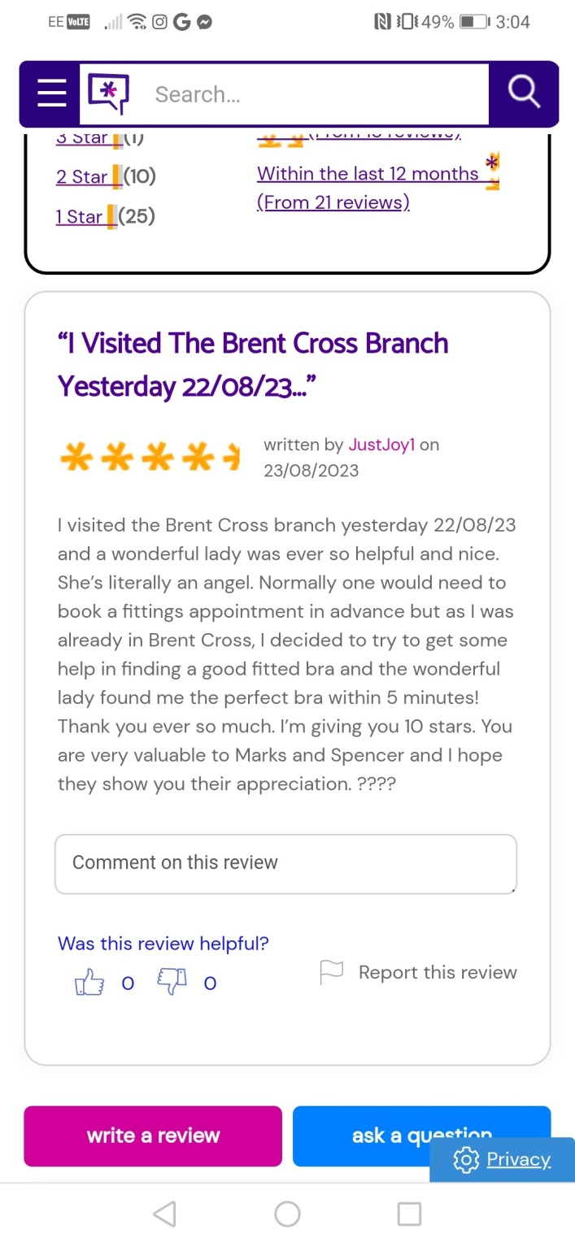

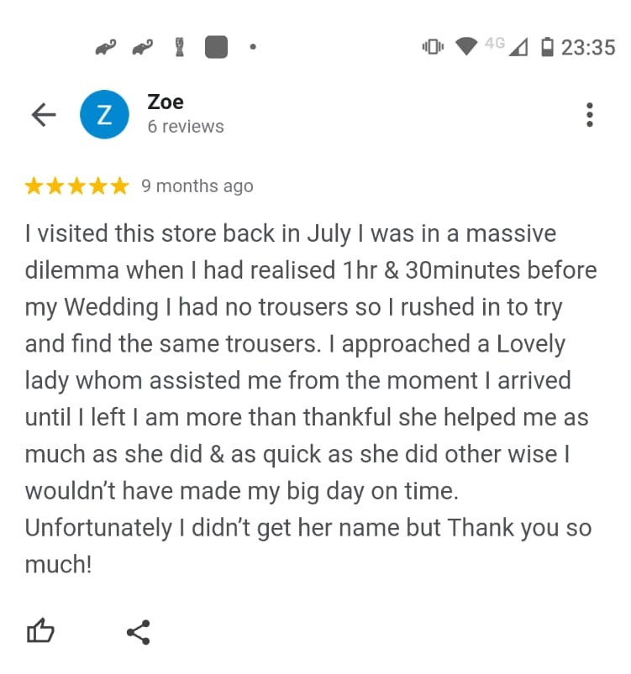

A Theoretical Literature Review

The Keller’s Brand Equity Model

The Keller’s Brand Equity Model was designed by the Professor of Marketing Kevin Lane Keller. ‘The Keller model is a pyramid shape and it shows businesses how to build a strong foundation of brand identity upwards towards the holy grail of brand equity resonance. This is where customers are in a sufficiently positive relationship with a brand to be advocates for it.’ (Mupeti, 2022)

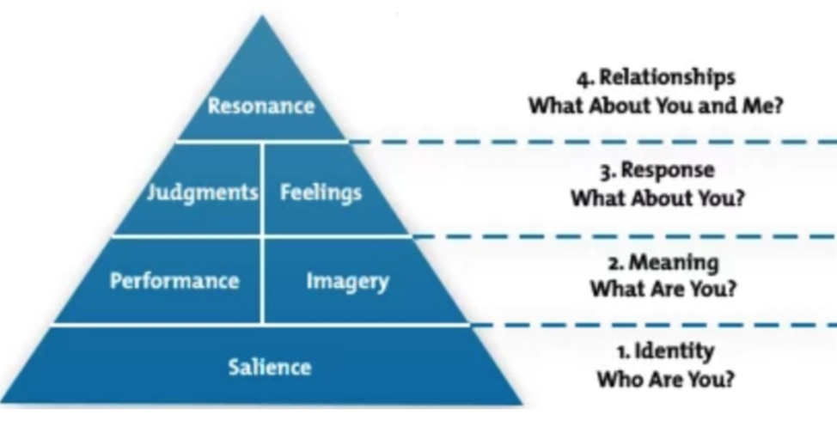

The Keller’s Brand Equity Model and Loyalty

Source: Hershberger, 2020

There are four stages of the Keller’s Brand Equity Model. The value of the brand increases with every stage of the pyramid model from the bottom level to the top.

Stage 1: Brand Identity – Who are you?

The brand identity is the positioning strategy of a brand, in other words – a brand image.

Stage 2: Brand Meaning – What are you?

The brand meaning gives a meaning and purpose to a brand.

Stage 3: Response – What about you? How is the brand perceived?

The response is the customers’ feedback.

Stage 4: Relationships – What about you and me? How are you connected with the audience?

The relationships illustrate how a brand is connected with its customers.

3. The Research Methodology

3.1 The Research Methods

The Research Onion Model

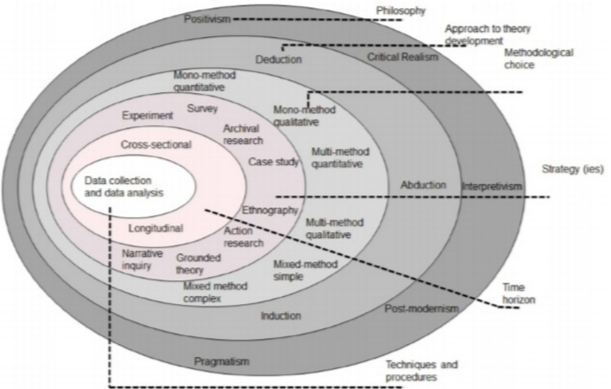

The Research Onion Model

Source: Seuring, Stella and Stella, 2021, p.4

The Research Onion Model covers all the stages of the research strategy.

The techniques and procedures such as the data collection and data analysis as well as the choices such as the mono method quantitative research will be applied. The plan of the survey will be presented.

The Techniques and Procedures – The Data Collection and Data Analysis

Quantitative Research

Quantitative research ‘employs structured data collection methods to produce data that can be transformed into useable statistics’. (Tambun, 2023)

Qualitative Research

Qualitative research ‘aims to understand and interpret social interactions by focusing on the more subjective aspects of human activity.’ (Tambun, 2023)

While conducting the survey, the quantitative data will be collected.

The Choices – The Mono Method Quantitative Research

In the study, the mono method quantitative research will be conducted.

3.2 The Sample Size

The survey will be conducted face to face among 50 customers of Marks and Spencer plc London stores at Cardinal Place, Victoria and in Westfield Stratford City. The paper forms with 8-10 close ended questions will be presented to the respondents and 10 minutes will be given to them to answer the questions.

3.3 The Sample Type

Demographic

The respondents’ data such as age, gender and social class will be collected and analysed.

Geographic

The respondents’ data such as the area of residence in London will be collected and analysed.

3.4 The Sampling Method

The survey will be conducted among the customers of Marks and Spencer plc, therefore, convenience sampling will be chosen and applied.

3.5 The Data Collection Method

The survey will be conducted among 50 customers of Marks and Spencer plc London stores at Cardinal Place, Victoria and in Westfield Stratford City. The A4 paper forms with 8-10 close ended questions will be presented to the respondents and 10 minutes will be given to them to answer the questions. The data will be gathered during April and May 2024 at various times during the day, before and after midday, on weekdays and at weekends.

3.6 The Data Analysis Method

The quantitative data will be analysed using Microsoft Excel. Graphs and tables will be created.

3.7 The Research Ethics

‘Research ethics encompasses norms of conduct and concomitant discourse pertaining to the delineation of good or acceptable from bad or unacceptable behaviour in research.’ (Elsevier B.V., 2024)

The primary data collected will be kept private and confidential in accordance with The Data Protection Act.

4. Resources and Planning

4.1 The Timeline

The Tasks for The Gantt Chart

- Introduction – week 1
- Literature review – week 2-4
- Research methodology – week 4
- Creating the questionnaire – week 5
- Data collection – week 6-8
- Data analysis – week 9-11
- Data discussion/ interpretation – week 12-13
- Conclusion and recommendations – week 14-15
- Discussion with superviser – week 1-16

The Gantt Chart

Time Prospects of The Research

 | W  1 | W  2 | W  3 | W  4 | W  5 | W  6 | W  7 | W  8 | W  9 | W  10 | W  11 | W  12 | W  13 | W  14 | W  15 | W  16
1. Introduction
2. Literature review
3. Research methodology
4. Creating the questionnaire
5. Data collection
6. Data analysis
7. Data discussion/ interpretation
8. Conclusion and recommendations
9. Discussion with superviser

The Gantt Chart

Source: Author’s Creation

The Budget

The total cost of printing of 50 copies of A4 questionnaires and travelling to Marks and Spencer plc London stores at Cardinal Place, Victoria and in Westfield Stratford City is estimated to be approximately £100.

5. Presentation

The correct spelling, grammar and punctuation as well as the structure and flow of narrative will be applied.

6. References

Barrow, C., Barrow, P. and Brown, R. (2021) The Business Plan Workbook: A Step-By-Step Guide to Creating and Developing a Successful Business. 10th ed. London: Kogan Page, p.47.

Elsevier B.V. (2024) ‘Research Ethics’. Available at https://www.sciencedirect.com/topics/social-sciences/research-ethics (Accessed: 29 March 2024).

Fournier, S. and Lee, L. (2013) ‘Getting Brand Communities Right’, HBR’s 10 Must Reads on Strategic Marketing. Boston: Harvard Business School Publishing Corporation, pp.136-7.

Hershberger, S. (2020) ‘Keller’s Brand Equity Model & Loyalty’, LinkedIn, 9 January. Available at
https://www.linkedin.com/pulse/kellers-brand-equity-model-loyalty-steven-hershberger/ (Accessed: 15 March 2024).

Kingsnorth, S. (2022) Digital Marketing Strategy: An Integrated Approach to Online Marketing. 3rd ed., London: Kogan Page Limited, pp.326-7.

Kotler, P., Keller, K. L. and Chernev, A. (2022) Marketing Management. 16th ed., global ed. Harlow: Pearson Education Limited, p.169.

Marks and Spencer plc (UK) Corporate Website (2024). Available at https://www.marksandspencer.com/c/food-to-order/not-just-any-food/food-news/remarksable (Accessed: 20 March 2024).

Marks and Spencer plc (UK) Corporate Website (2024). Available at https://corporate.marksandspencer.com/sustainability/our-products/health-wellbeing (Accessed: 14 March 2024).

Marks and Spencer plc (UK) Corporate Website (2024) ‘M&S Food X Zoe Gut Shot’. Available at https://www.marksandspencer.com/c/food-to-order/health/zoe (Accessed: 20 March 2024).

Marks and Spencer plc (UK) Corporate Website (2024) ‘The wonderful world of Percy Pig’, Available at https://www.marksandspencer.com/c/food-to-order/percy-pig (Accessed: 11 March 2024).

Marks and Spencer plc (UK) Corporate Website (2024) ‘Collin the Caterpillar gifts’, Available at https://www.marksandspencer.com/l/gifts/colin-the-caterpillar-gifts (Accessed: 11 March 2024).

Marks and Spencer plc (UK) Corporate Website (2024). Available at https://www.marksandspencer.com/ie/c/women (Accessed: 2 March 2024).

Marks and Spencer plc (UK) Corporate Website (2024) ‘M&S Bank’, Available at https://bank.marksandspencer.com/ (Accessed: 2 March 2024).

Michael, L. (2023) Brand Love: Building Strong Consumer-Brand Connections. 1st ed. London: Kogan Page Limited, p.13.

Mupeti, L. (2022) ‘Building brand equity using Keller’s model’, Business Weekly, 8 April. Available at https://www.businessweekly.co.zw/building-brand-equity-using-kellers-model/ (Accessed: 15 March 2024).

Ogilvy, D. (2023) Ogilvy on Advertising. London: Welbeck Non-Fiction Limited, p.9.

Packaging of The World (2023) ‘‘The Marksologist’ premium cocktail range from Marks and Spencer’, 30 January. Available at https://packagingoftheworld.com/2023/01/the-marksologist-premium-cocktail-range-from-marks-and-spencer.html (Accessed: 9 March 2024).

Pennington, A. (2016) The Customer Experience Book: How to Design, Measure and Improve Customer Experience in Your Business. 1st ed. Harlow: Pearson Education Limited, p.145.

Remy, A. (2013) ‘Ava’s Impression...Brand Equity’, Blog at WordPress.com., 9 November. Available at https://avaremy.wordpress.com/2013/11/09/brand-equity/ (Accessed: 30 March 2024).

Seuring, S., Stella, M. and Stella, C. (2021) ‘Developing and Publishing Strong Empirical Research in Sustainability Management - Addressing the Intersection of Theory, Method, and Empirical Field’, Frontiers in Sustainability, pp.1-9. Available at https://www.researchgate.net/publication/349083776_Developing_and_Publishing_Strong_Empirical_Research_in_Sustainability_Management-Addressing_the_Intersection_of_Theory_Method_and_Empirical_Field (Accessed: 12 March 2024).

Steenkamp, P. (2019) ‘Aaker versus Keller's models: much ado about branding’, ResearchGate, pp.1-13. Available at: https://www.researchgate.net/publication/341909107 (Accessed: 29 August 2023).

Tambun, T. (2023) ‘Semi-Final Stop: Saunders’ Research Onion’, LinkedIn, 12 September. Available at https://www.linkedin.com/pulse/semi-final-stop-saunders-research-onion-toronata-tambun (Accessed: 10 March 2024).

Vizard, S. (2019) ‘M&S brings back ‘This is not just food’ campaign after a 12-year absence’, Marketing Week, 2 April. Available at https://www.marketingweek.com/ms-brings-back-this-is-not-just-food-campaign-after-a-12-year-absence/ (Accessed: 10 March 2024).

Wheeler, J. (2023) The Digital-First Customer Experience: Seven Design Strategies from The World’s Leading Brands. 1st ed. London: Kogan Page Limited, p.218.

