DS 1 Template – Masum Chowdhury 2533886

My Screenshots/Photos

Screenshot/Photo 1
[Insert Photo/Screenshot below] – Screenshot of my Laptop
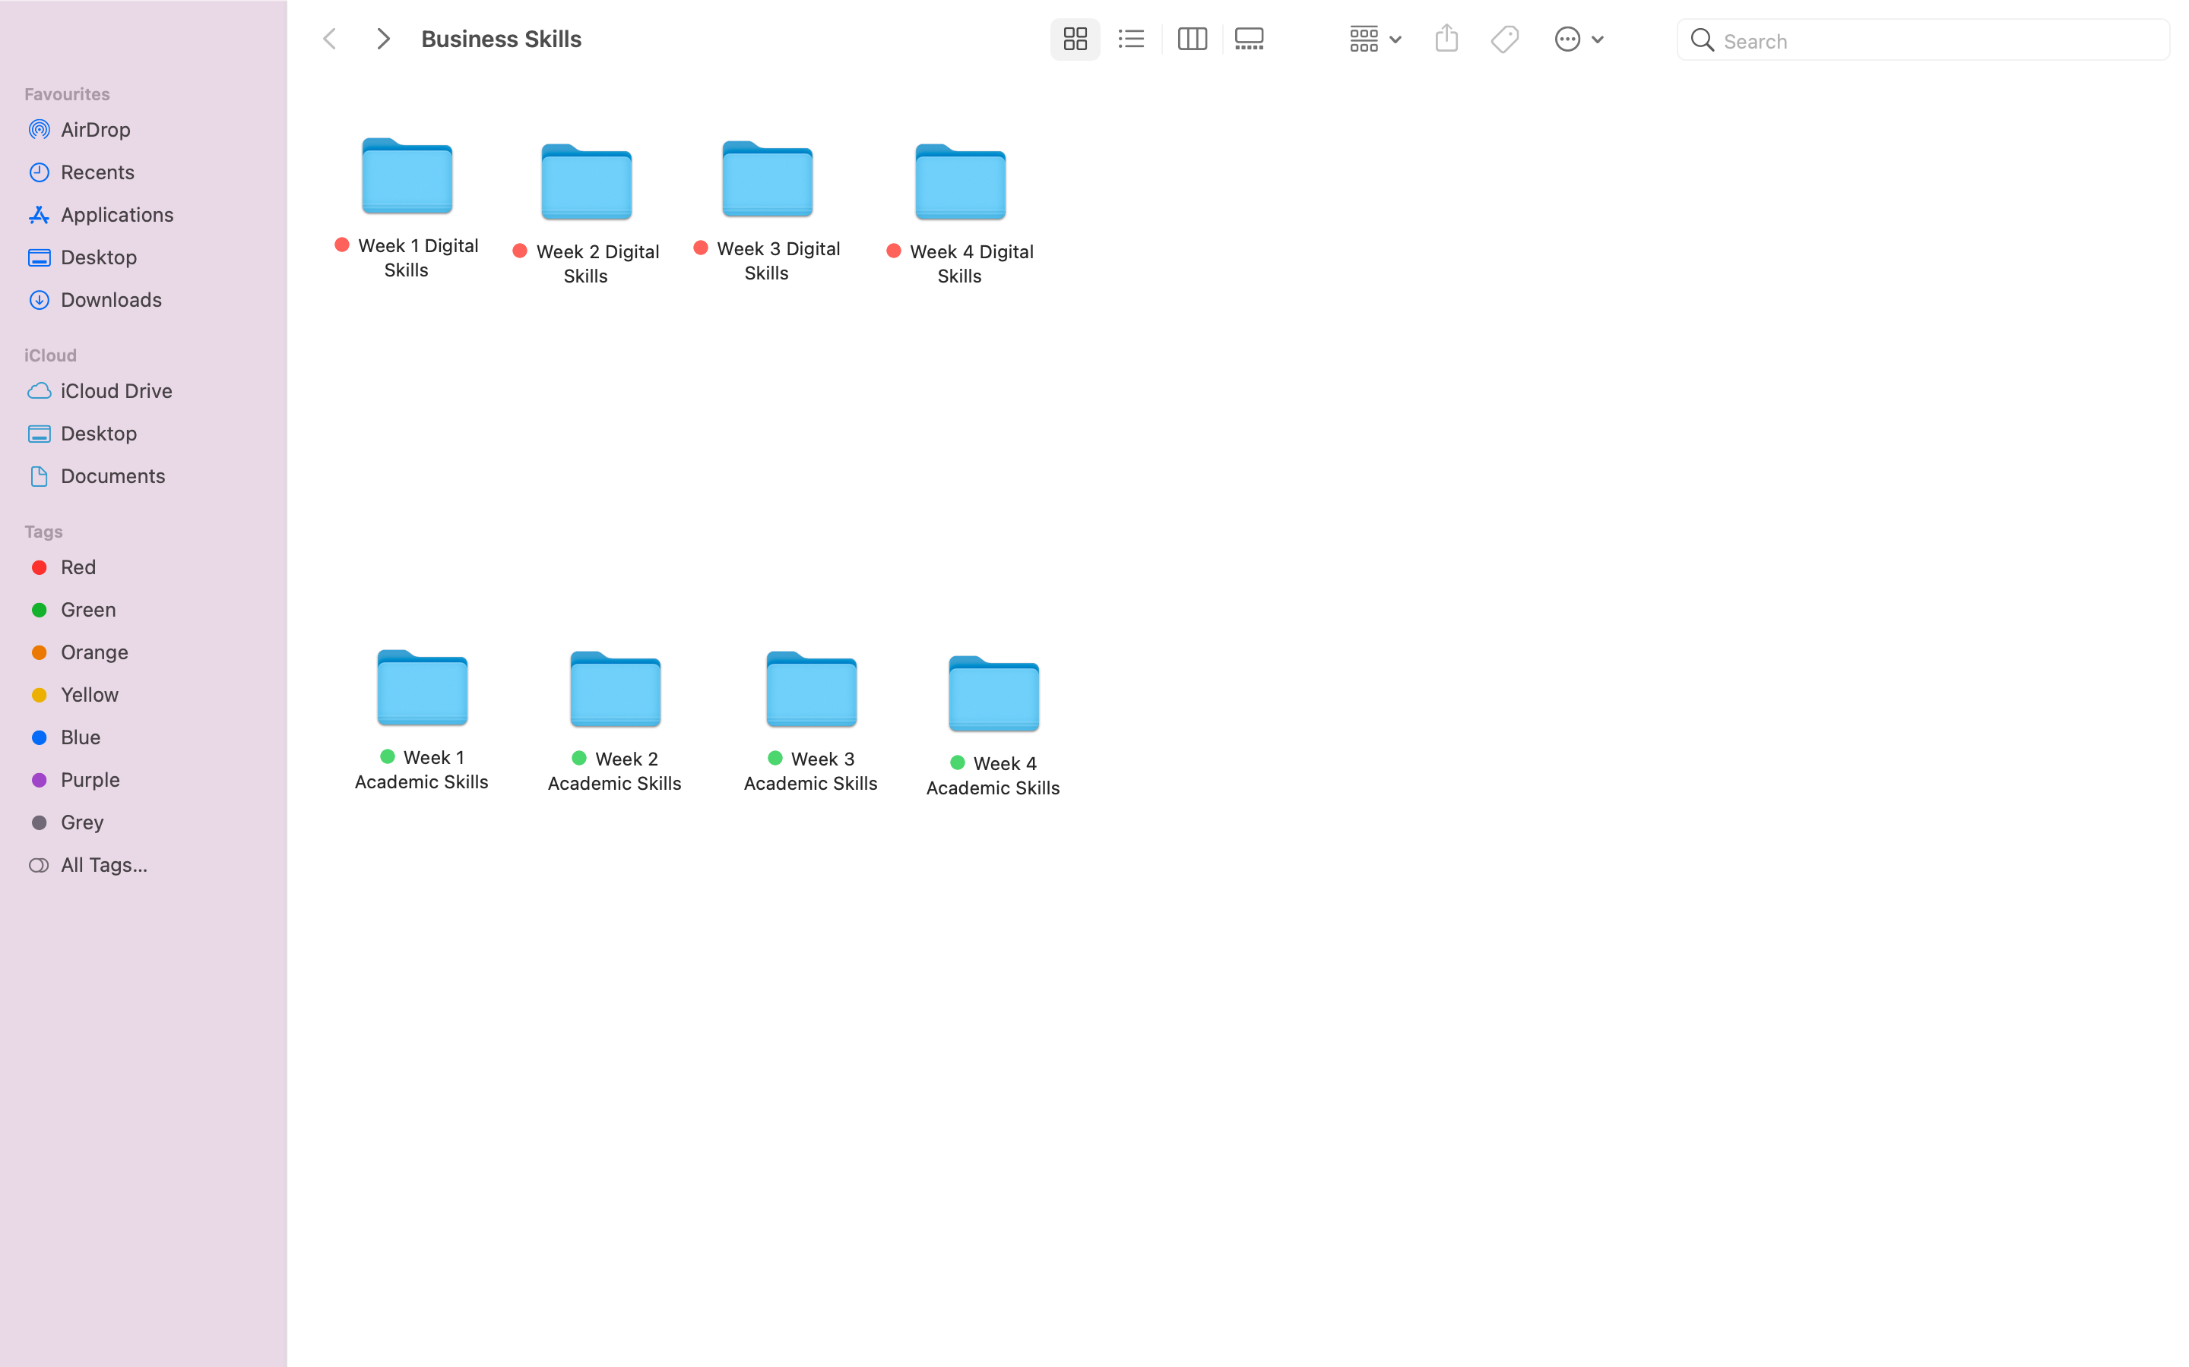
This is a screenshot of the folders I have organised for myself on my personal laptop in order to maintain and keep up with the classes and my own personal development. This is so that I am able to save the class materials, revise and work on them at my own pace and this is an easier way keeping myself organised.

Screenshot/Photo 2
[Insert Photo/Screenshot below] – Moodle Dashboard
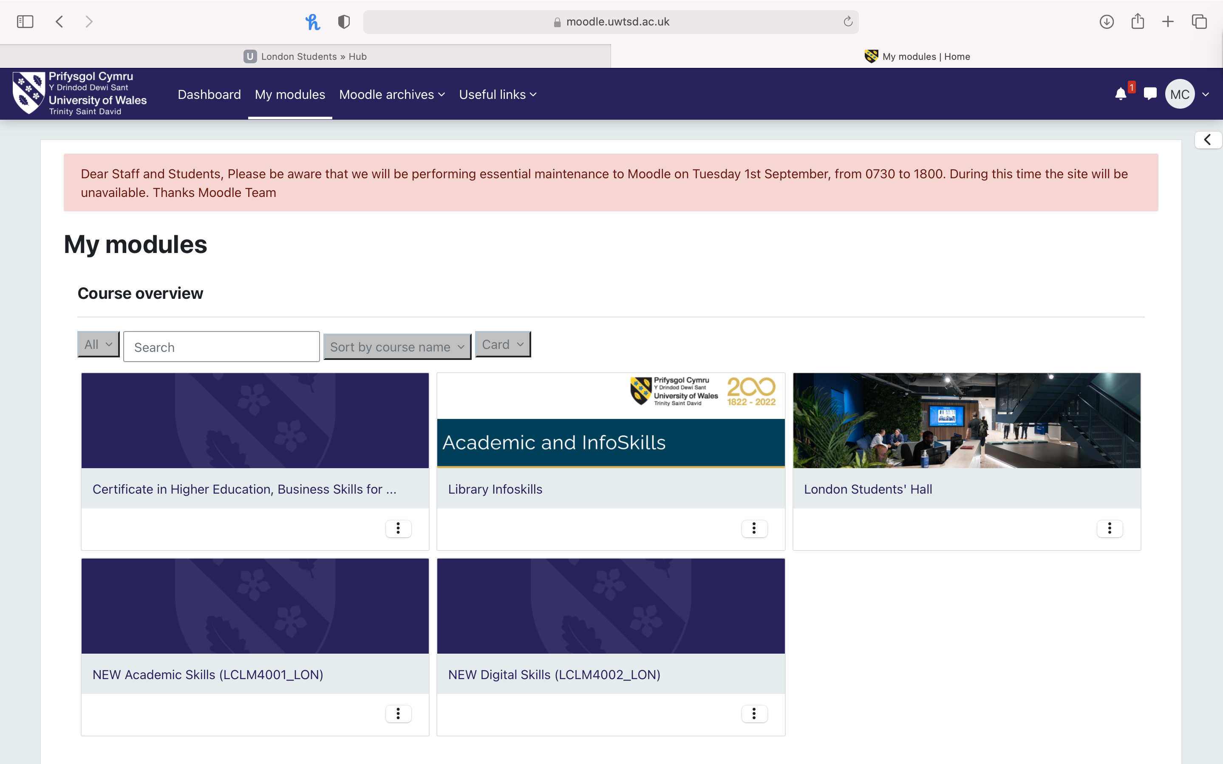
This screenshot clearly indicates the general use of Moodle which assists me in gaining further knowledge on the content before arriving to class. I am able to click on the necessary folders in order to search for information that will assist me in either my readings or to look back on information or content that I did not fully grasp during the classes.

Screenshot/Photo 3
[Insert Photo/Screenshot below] – Screenshot of Student Hub
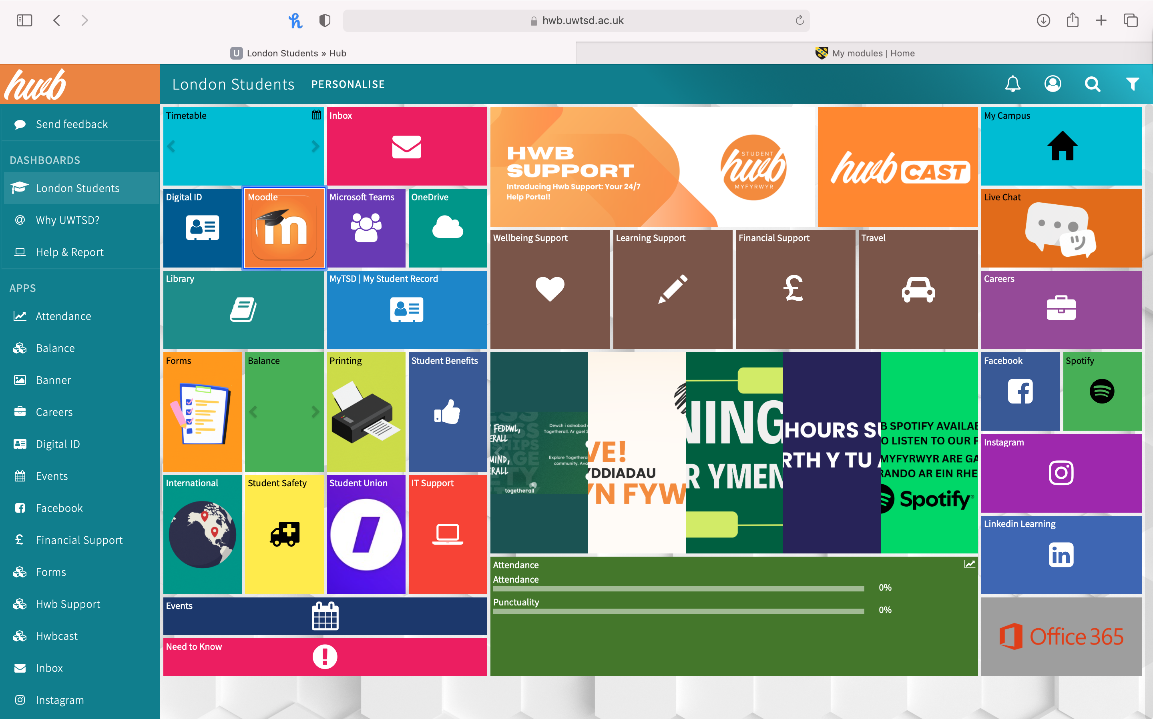
This screenshot is the foundation of my university life, which shows the Student Hub. Student Hub has been the crux of my development of Digital Skills as it has enabled me to have access to assist me in not just my academic development, but also other support in relation to updating my social media, gaining further support from the university in regards to personal issues.

Screenshot/Photo 4
[Insert Photo/Screenshot below] – Screenshot of my emails
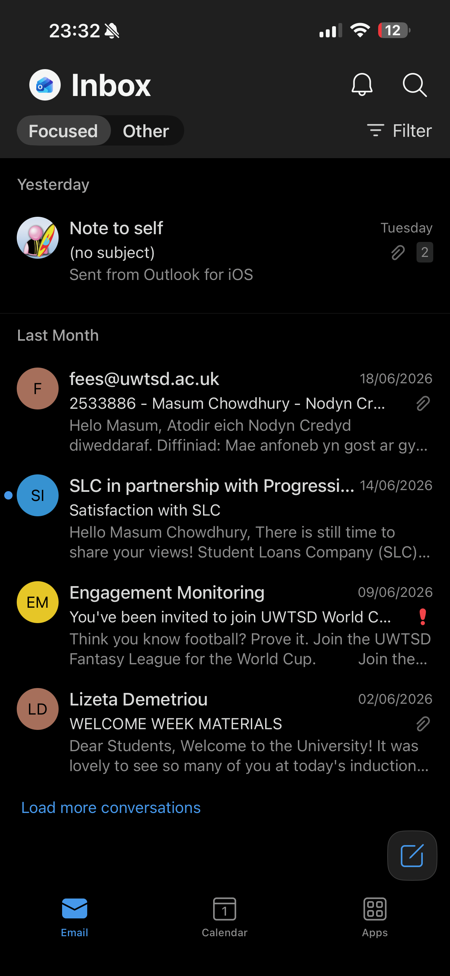
This screenshot is the my outlook emails that I use I order to receive daily updates and it’s an app that I use to assist me in updating lecturers.

Screenshot/Photo 5
[Insert Photo/Screenshot below]

[Write what this shows of your digital life]

Screenshot/Photo 6
[Insert Photo/Screenshot below]
[Write what this shows of your digital life]

My Short Reflection
- Write 5–8 simple sentences about your digital life.
- You can use the sentence starters below if helpful.
Ever since I started this course I have started to use digital skills in my life on more regular basis, this is particularly helpful when it comes to my organisation skills. For example, in relation to my folders that I keep for my subjects I keep Digital Skills in a red folder and Academic Skills in green so that I am able to clearly differentiate them.
Prior to this course, I used to note information using pen and paper, however since starting the new classes I have developed my organisation skills by opening folder and using apps such as Word to do my work rather than relying on outdated methods of studying such as pen and paper.
I feel confident when using Moodle instead of directly asking the lecturers for assistance. I am able to go on Moodle and find out what I am looking for this helps me become more independent on finding information on my own and gaining a sense of achievement after I have done so.
I sometimes feel nervous when I am not able to relate to some of the digital tools that are spoken about in class, however I take into consideration that this subject is to develop the skills so that I am able to keep in improving the use of digital skills in my life.
I hope this module will help me continue to build my confidence using digital tools and hopefully to the point where I can use this in my own personal life.

Sentence starters
- I use digital tools to …
- I feel confident when I …
- I want to improve …

Submission Checklist
Before you submit, please check:
​​​ ☒ I added 4–6 screenshots
☒ I wrote short sentences for each screenshot
☒ I wrote my short reflection
☒ My work is my own
☒ My file opens correctly
​​☒ My file opens correctly

