
ACCA7027 — Cloud Engineering Principles and Practice
Virtualisation, Containerisation, and Cloud Computing:
An End-to-End Analysis of Docker Deployment and Cloud Service Models
Student Name: Hiral Jitubhai Jasoliya
Student ID: 2507162
Programme: MSc Cybersecurity and Digital Forensics
Institution: University of Wales Trinity Saint David (UWTSD), London Campus
Module Tutor: Renuga Jayakumar

Table of Contents
Video Demonstration 3
1. Introduction 4
2. Virtualisation and Containerisation 5
2.1. Principles of Virtualisation 5
2.2. Principles and Benefits of Containerisation 6
2.2.1. Docker Architecture 6
2.3. Docker Images and Publishing 7
2.4. Container Volumes 9
2.4.1. A Volume Is Tied to Data, Not a Specific Container 9
2.5. Container Networking 11
2.6. End-to-End Worked Example 12
3. Cloud Computing Concepts: Load Balancing, Scalability and Application Gateways 13
3.1. Chosen Application/Scenario Overview 13
3.2. Cloud Provider's Approach: Microsoft Azure 13
3.2.1. Load Balancing 13
3.2.2. Scalability 13
3.2.3. Application Gateways 13
3.3. Why Load Balancing and Scaling Are Complementary 14
3.4. Benefits of Combining All Three 15
4. Driving Forces Behind Cloud Expansion 16
4.1. Key Drivers 16
4.2. Serverless Computing (FaaS) 16
5. Conclusion 18
References 19

Video Demonstration
Video Title: ACCA7027 Docker Deployment — End-to-End Demonstration
Video URL: https://youtu.be/HBBbi68vI0w
Purpose: This recording provides a narrated, end-to-end walkthrough of the Docker deployment exercise described in Section 2 of this report, demonstrating that each stage of the pipeline was executed and independently verified rather than assumed to have succeeded.
The demonstration covers:
- Dockerfile authoring and a discussion of the nginx:latest tagging trade-off
- Image build and tagging (docker build, docker images)
- Container execution on port 8080 with the volume and network attached from the moment the container starts
- The volume persistence proof described in Section 2.4
- The network name-resolution proof described in Section 2.5
- Publishing the image to Docker Hub

Introduction
Cloud computing has changed the way computing infrastructure is provided, used, and paid for. In the past, organisations usually had to buy physical hardware in advance and keep it for several years. Cloud computing has made it possible to use resources when they are needed and release them when they are no longer required. The NIST definition describes cloud computing through five main characteristics: on-demand self-service, broad network access, resource pooling, rapid elasticity, and measured service [1]. Armbrust et al. also describe cloud computing as a utility model, where computing resources are used and paid for based on consumption [2]. This shows that cloud computing is not just one technology, but a different way of providing and managing computing resources.
Along with cloud computing, there has also been a move from virtual machines (VMs) towards containers. Virtual machines allow different workloads to run separately on the same physical hardware. Containers work differently by packaging an application together with its required libraries and dependencies. This makes it easier to run the same application across development, testing, and production environments. Containers also normally use fewer resources than full virtual machines. However, containers and VMs are not direct replacements for each other, as they solve different problems and work at different levels.
This report first looks at the main differences between virtualisation and containerisation and then explains a complete Docker deployment. The practical work also considers the reasons behind different configuration choices and their disadvantages. Section 3 then looks at Microsoft Azure and explains how load balancing, auto-scaling, and application gateway services can be used for an e-commerce application. Section 4 discusses serverless computing, particularly Function-as-a-Service (FaaS), and compares it with containerisation.
Overall, the report focuses on the balance between control and abstraction. Virtualisation, containers, and serverless computing all have different advantages and limitations, so the most suitable option depends on the requirements of the workload.

Virtualisation and Containerisation

Principles of Virtualisation
In traditional virtualisation, hypervisors provide an abstraction of physical hardware and present individual Virtual Machines (VMs) with their own CPU, memory, disk, and network interface [3]. Type 1 (native) hypervisors run directly on physical hardware and include examples such as VMware ESX and Microsoft Hyper-V. Type 2 (hosted) hypervisors, such as VMware Workstation and Oracle VirtualBox, run on top of a host operating system [4]. Type 1 hypervisors generally provide better performance and fewer vulnerabilities than Type 2, but they are typically used in data centres because they support greater consolidation and are less convenient for users who only want to run a few VMs.
With each VM running a full guest OS, complete with its own kernel and system processes, memory usage, disk space, and boot times increase significantly compared to containers. However, because each VM has its own kernel, there is less overlap between them, so an error or security compromise in one VM will generally not affect the others. Boot times for a VM can be tens of seconds due to the amount of the OS, including the entire kernel, that must be initialised. In contrast, container boot times are typically much shorter.
The actual distinction is that the hypervisor virtualises hardware and gives the guest OS the impression that it is running on bare metal. The guest cannot tell that the hardware is shared among multiple instances. Because the separation occurs below the OS level, this makes VMs appropriate for multi-tenant scenarios, such as public cloud environments where different customers share the same underlying physical machine.
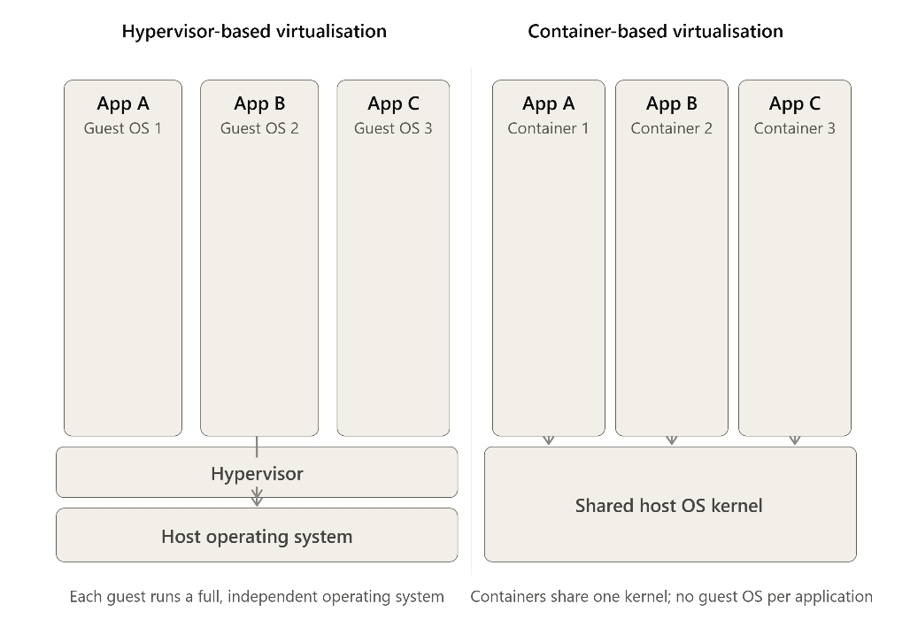
Figure 1. VMs with separate OSs vs containers sharing a host kernel.

Principles and Benefits of Containerisation
Containers remove the duplicated guest OS. Instead, they use lightweight processes that run directly on the shared host kernel, rather than having each workload emulate its own hardware [4]. On Linux, this relies on two main kernel features. Namespaces provide isolation for things such as process IDs, networking, and user accounts, while control groups (cgroups) monitor and control resources such as CPU and memory. As a result, each container can act as a self-contained environment on its own computer, while actually sharing the same kernel with other containers on the host [5].
This is fundamentally different from virtualisation. Containers provide isolation at the operating system and process level, while VMs provide isolation through the hypervisor at the hardware level. This difference explains why containers are generally lighter and faster than VMs, but their security isolation is also weaker because containers share the host kernel.
The three most important real-world benefits of removing the duplicated kernel come directly from this architectural difference [6]:
- Efficiency: because there is no guest kernel to boot and maintain, containers have significantly lower memory overhead than virtual machines. They can also start in tens or hundreds of milliseconds rather than the tens of seconds required by a VM, as starting a container simply means starting a process in a new namespace rather than booting an entire OS.
- Portability: A container image packages an application and its exact dependencies, including libraries and interpreter versions, into one versioned unit. The same image can then run consistently on a developer’s desktop, QA environment, or production data centre. This reduces “it works on my machine” problems by keeping the application and its dependencies the same across environments.
- Density: Since containers have much lower overhead than VMs, more containers can run on the same host. This reduces resource usage and makes containers more efficient than running the same number of VMs.
A critical qualification, however, is essential here. The efficiency of containers comes at the cost of more limited isolation than that achieved with hypervisors. Because multiple containers on a host share the same kernel, a severe kernel vulnerability could allow one process to escape its container and affect the host or other containers. This is significantly more difficult with a VM.
Consequently, additional security mechanisms are used in production environments, such as running containers as non-root users, using read-only filesystems whenever possible, and applying seccomp or AppArmor security profiles. Such mechanisms reduce the risk, but they also demonstrate that containers are not always equivalent to VMs in terms of isolation.
This has led to technologies such as gVisor and Kata Containers, which provide greater isolation while keeping most of the benefits of containers [7]. gVisor intercepts and handles system calls in user space, while Kata Containers runs containers inside lightweight micro-VMs. Both introduce a virtualisation layer to bridge the security gap created by shared-kernel containers while maintaining acceptable performance and resource usage.

Docker Architecture
Docker implements this abstraction through four key components:
- Docker daemon (dockerd): Runs as a background service on the host and is responsible for building images, running containers, and managing network interfaces and volumes.
- Docker Engine API: A REST API through which the Docker daemon is controlled. It can be accessed through the Docker client, a UI, or an orchestration system such as Kubernetes.
- Images: Read-only, layered templates built using the instructions in a Dockerfile.
- Containers: Writable and runnable instances of an image that are created when the docker run command is executed.
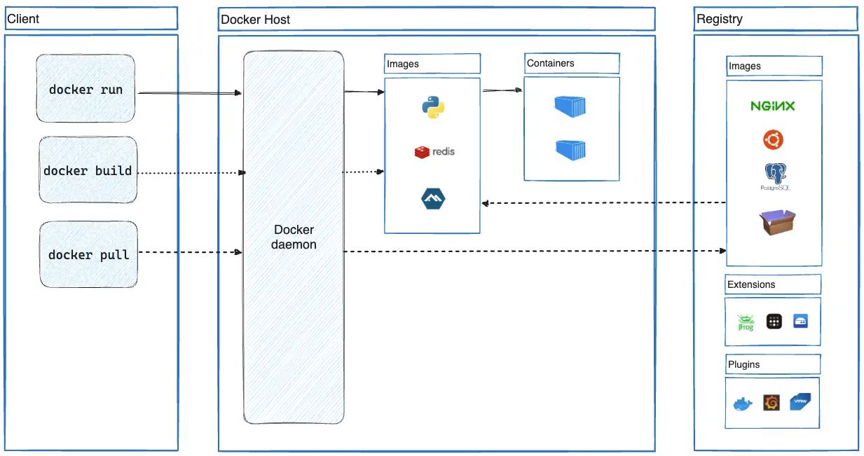
Figure 2. Docker architecture, showing the client/CLI, the daemon and Engine API, the layered image/container relationship, and the registry used for publishing and distribution. Source: Adapted from Docker Documentation (2024).
The layered image model is one reason Docker builds can be very fast, even for large applications. For each Dockerfile instruction, Docker checks whether the instruction and its relevant build context have changed. If not, it reuses the cached layer instead of rebuilding it.
This creates an important design rule: instructions that change less often, such as installing operating system packages, should come before instructions that change frequently, such as copying application source code. If this order is reversed, even a small code change can invalidate later layers and force Docker to rebuild them.
This can have a major impact in teams with frequent code changes. A poorly ordered Dockerfile can turn a short build into a much longer process, even when the actual code change is very small.

Docker Images and Publishing
For the practical component of this report, a minimal static web application (a personal portfolio page) was containerised using Nginx as the serving layer. The Dockerfile used is intentionally short:
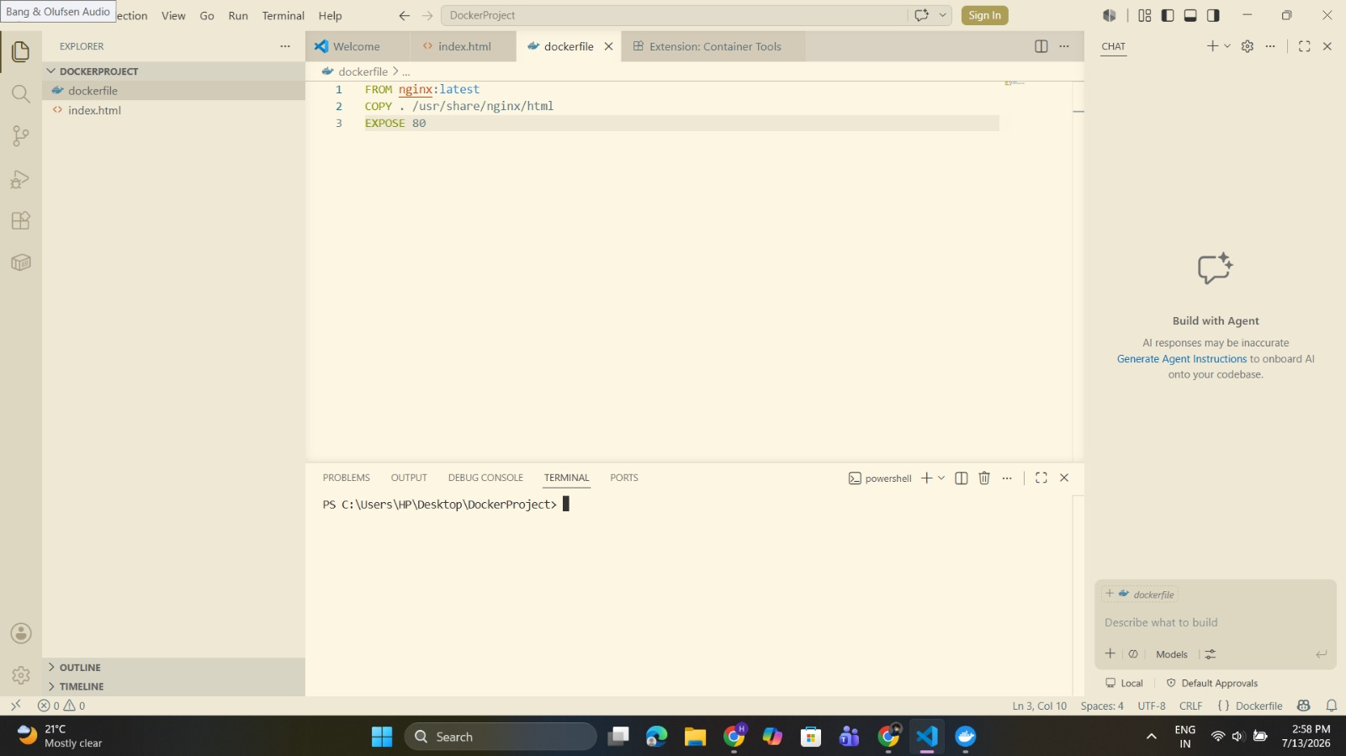
Figure 3. Dockerfile open in the code editor, showing the full file content.
nginx:latest was chosen to make the demo easier to understand, although it has some disadvantages. Since latest is a “floating” tag that can pull a newer image version, it may cause reproducibility issues because a future build could use a different version. It can also create supply-chain security concerns because the image does not refer to a specific version.
For real-world use, it is better to use a specific version, such as nginx:1.27-alpine. The Alpine image is smaller than the default image, which allows faster image transfers and contains fewer packages, reducing the possibility of software vulnerabilities.
The image was built and tagged with an explicit version:
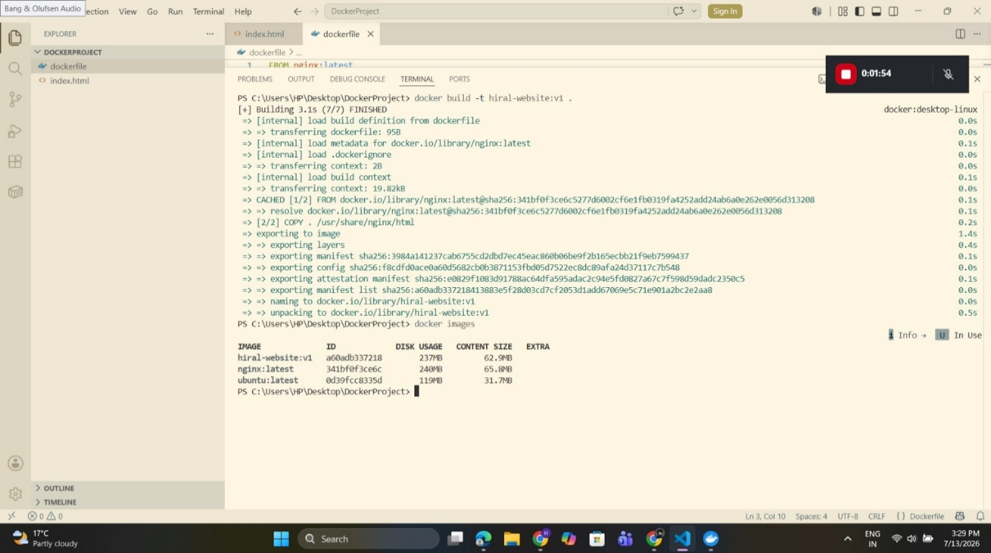
Figure 4. `docker images` output, confirming the tagged image.
Publishing the built image to a registry makes it available beyond the local machine:
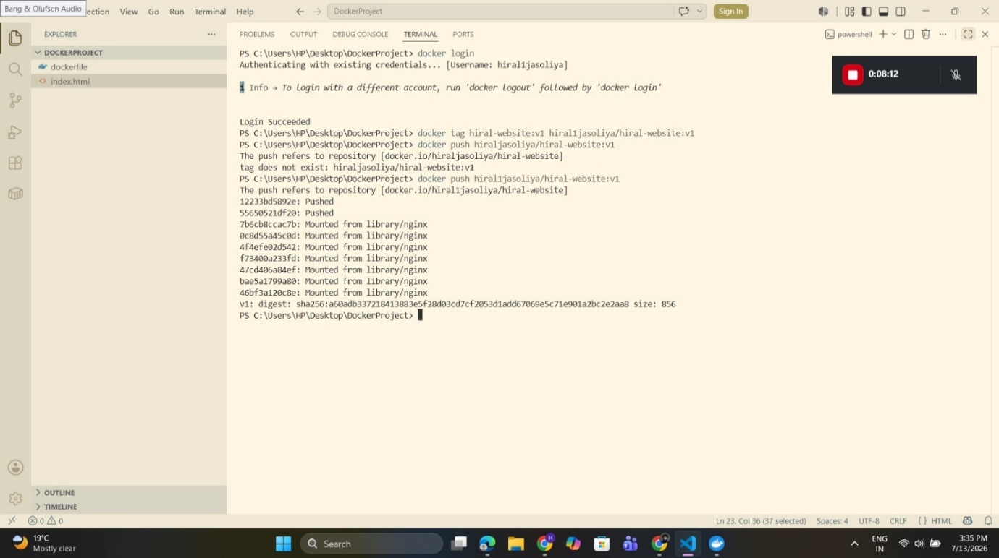
Figure 5. Terminal output confirming `docker login` and `docker push` of hiral1jasoliya/hiral-website:v1 to Docker Hub.
The ability to push a container image is more than just a convenience; it provides the portability described in Section 2.2. The same image can be pushed to a registry once and then pulled by any system with Docker installed, without requiring local build tools or specific environment settings. This provides a practical solution to the “it works on my machine” problem.

Container Volumes

A Volume Is Tied to Data, Not a Specific Container
The writable layer of a container is temporary; it exists only while the container is running and is removed when the container is deleted. Volumes separate persistent data from the container’s lifecycle, allowing the data to remain available even when the container is replaced. In this example, a named volume was created and mounted into the running container to demonstrate data persistence beyond the container.
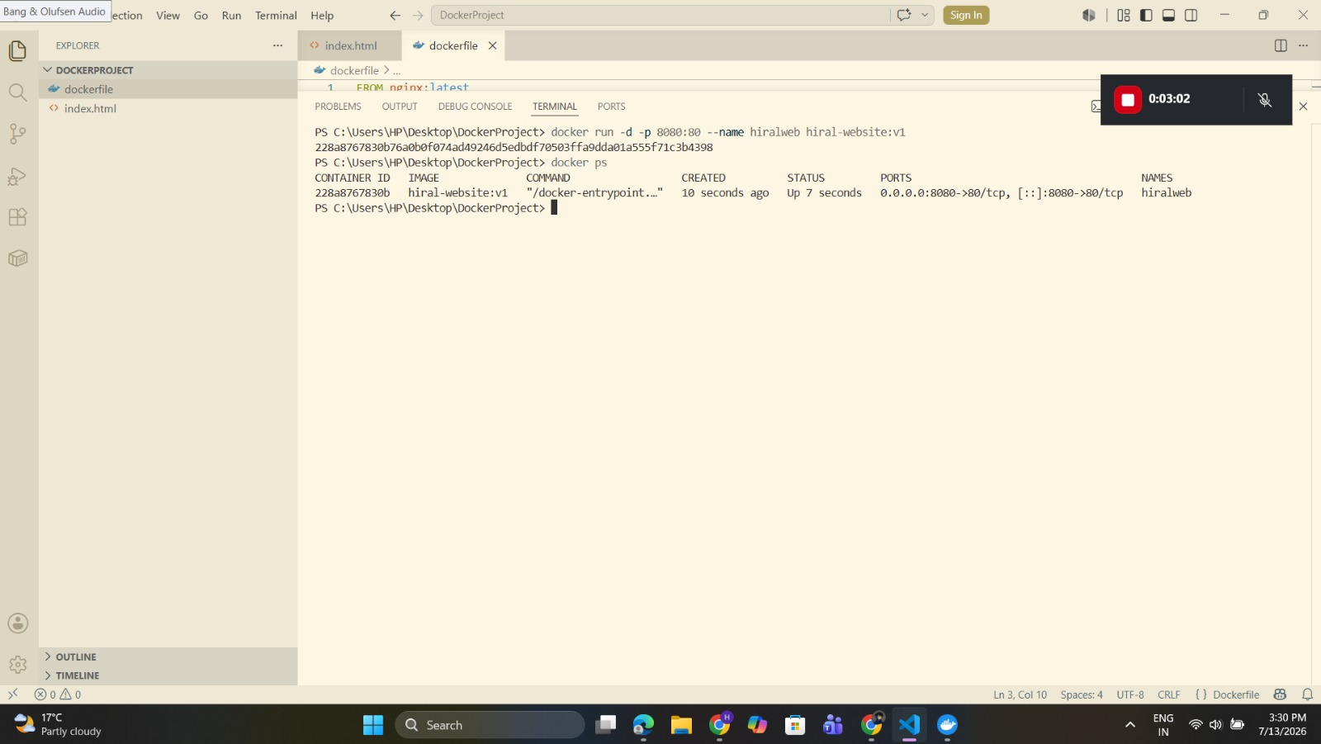
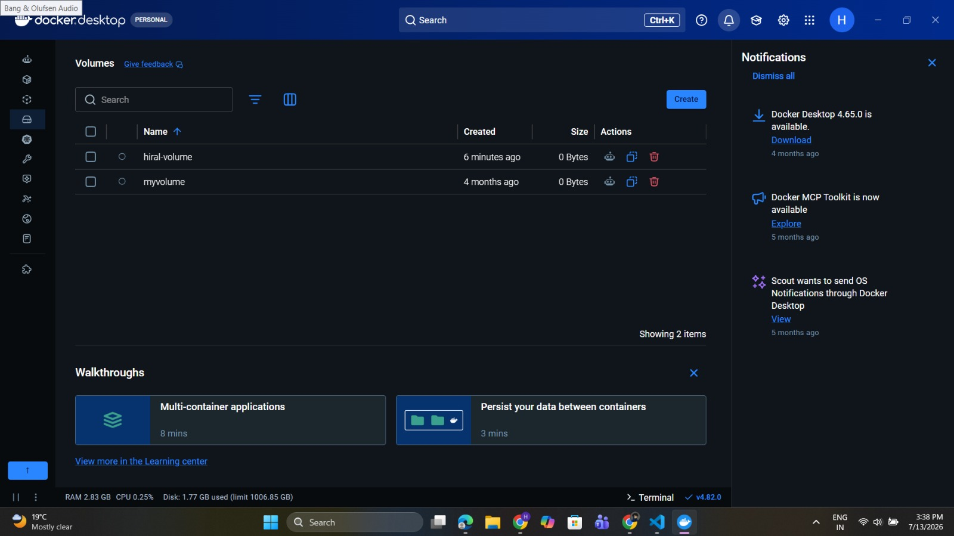
Figure 6. Terminal output confirming the container was started with `docker run` and is running on port 8080 (`docker ps`), and the Docker Desktop Volumes panel confirming creation of the hiral-volume volume.
To prove that the mounted volume genuinely persists data independently of the container's own lifecycle — rather than simply asserting that it does — a file was written into the mounted path, the container was deleted entirely, and a replacement container was started against the same volume:
docker exec hiralweb sh -c "echo 'test data' > /usr/share/nginx/html/data/test.txt"
docker exec hiralweb cat /usr/share/nginx/html/data/test.txt
docker stop hiralweb
docker rm hiralweb
docker run -d -p 8080:80 -v hiral-volume:/usr/share/nginx/html/data --name hiralweb hiral-website:v1
docker exec hiralweb cat /usr/share/nginx/html/data/test.txt
Figure 7. Terminal output showing test.txt surviving container deletion and recreation.
The same file was readable from the new container even though the original container had been deleted. This provides clear evidence that the volume, rather than the container, stores the data. Simply creating a volume without using it would only show that the feature works, not that it provides data persistence. Creating, deleting, and then re-creating the container demonstrates this persistence in a clear and verifiable way.

Container Networking
A container on the default bridge network can communicate with another container only through its IP address, as there is no automatic service discovery or DNS lookup. A user-defined bridge network solves this by allowing containers on the same network to discover each other by container name, while Docker’s built-in DNS resolves the name to the container’s current IP address.
To demonstrate this, the network was created before starting the web container, and a second container was started on the same network to show DNS-based service discovery.
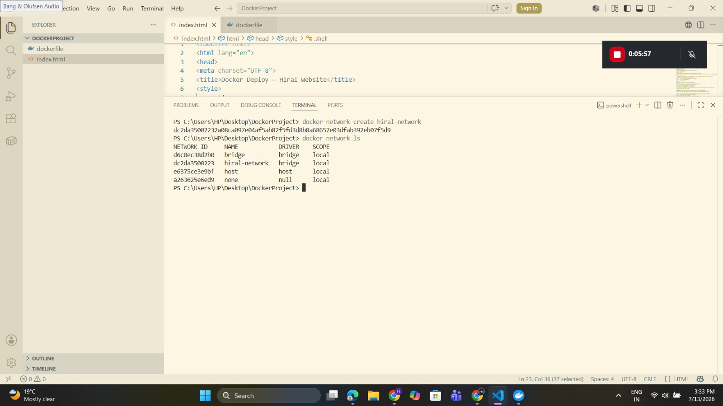
Figure 8. `docker network ls` output, plus `getent hosts` output showing hiralweb resolving backend-service by name.
The hiralweb container successfully resolved backend-service to an IP address using only the container name, without either container knowing the other’s address in advance. The address also does not need to remain fixed after restarts. This demonstrates the benefit of user-defined networks, where containers can discover each other by name. In a real application, a reverse proxy could use this method to find and forward traffic to an application container, similar to service discovery in platforms such as Kubernetes.

End-to-End Worked Example
The video demonstration covers Dockerfile creation, the nginx:latest trade-off, image building, container execution with volume and network, persistence and DNS tests, and publishing to Docker Hub.
Overall, the pipeline demonstrates the complete Docker workflow. The unpinned nginx:latest image was a deliberate choice for demonstration. In production, a fixed image version, non-root user, and docker-compose.yml would provide better security and management.

Cloud Computing Concepts: Load Balancing, Scalability and Application Gateways

Chosen Application/Scenario Overview
Consider a mid-sized e-commerce business with three customer-facing services: a web front end, a product and catalogue API, and a checkout service. The business experiences normal daily traffic with sudden spikes during promotions, flash sales, and holidays. This combination of steady and burst traffic makes load balancing and auto-scaling a suitable choice.
If the platform is sized for peak traffic, resources will be wasted during normal days. However, if it is sized for normal traffic, it may struggle or fail during major sales and holiday events.
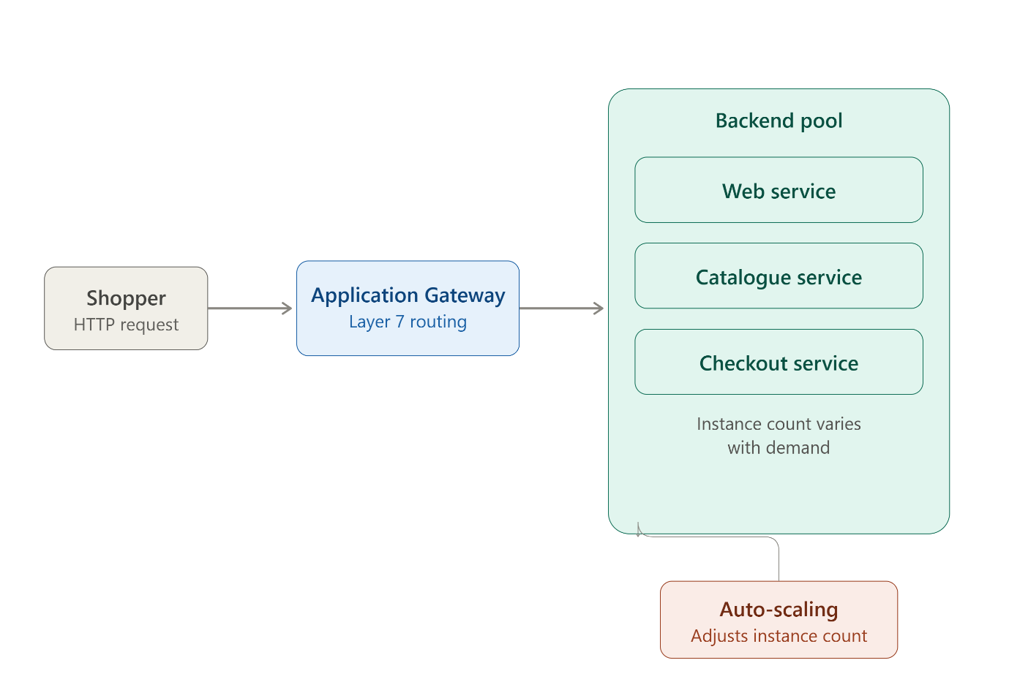
Figure 9. E-commerce architecture showing a shopper’s request passing through Azure Application Gateway to web, catalogue, and checkout services, with auto-scaling controlling the backend capacity.

Cloud Provider's Approach: Microsoft Azure

Load Balancing
Azure Load Balancer operates at Layer 4 of the OSI model and distributes TCP or UDP connections across a backend pool using IP address and port information. It does not inspect the HTTP content of requests. In contrast, Azure Application Gateway operates at Layer 7 and is designed for web traffic [8]. It can inspect HTTP headers, cookies, and URL paths to make routing decisions.
For the e-commerce scenario in Section 3.1, this Layer 7 capability is useful. Requests for /checkout and /catalogue can be sent to different backend pools while using one public endpoint and IP address. This allows each service to be scaled, updated, and monitored independently. Application Gateway can also use cookie-based session affinity to keep a shopper connected to the same backend instance during checkout. This helps prevent session data, such as basket contents or payment details, from being lost if the request moves between different backend instances.

Scalability
Azure Virtual Machine Scale Sets, or, for a containerised deployment, Azure Container Apps combined with KEDA-based event-driven scaling, allow the backend pool serving each of the three services to grow and shrink automatically in response to defined metrics such as CPU utilisation, memory pressure, or request queue length [9]. This converts what would otherwise be a manual capacity-planning exercise — in which an engineer must guess peak load in advance and provision permanently for it — into a runtime, metric-driven decision the platform makes continuously and automatically.
The trade-off this convenience carries is scaling latency, and it is worth being specific about why this matters rather than treating auto-scaling as an unqualified solution. New instances, whether virtual machines or container replicas, take a measurable amount of time to provision, boot, and warm up before they can serve production traffic. Auto-scaling therefore responds well to sustained, gradually building load — traffic ramping up steadily over the course of a promotional morning — but it cannot instantaneously absorb an extreme, sudden spike, such as a flash-sale link shared simultaneously across a large social-media audience. Where such instantaneous spikes are anticipated, they are typically addressed by pre-warming capacity ahead of the known event, rather than by relying on reactive auto-scaling alone — a distinction that is frequently glossed over in introductory treatments that present auto-scaling as a complete substitute for capacity planning, when it is more accurately a complement to it.

Application Gateways
Beyond its routing role, Azure Application Gateway also provides Web Application Firewall (WAF) functionality, TLS termination at the edge, and, where required, end-to-end encryption maintained through to the backend pool [8]. For a customer-facing checkout flow that necessarily handles payment-related data, the WAF capability is not merely a convenience feature but a compliance-relevant control: it filters common web exploitation patterns, such as SQL injection and cross-site scripting attempts, before they ever reach application code — a meaningful part of demonstrating the defence-in-depth that payment-card compliance regimes expect, and one that materially reduces the burden placed on application-level input validation alone.

Why Load Balancing and Scaling Are Complementary
It is instructive to consider what specifically breaks if only one of these two mechanisms is present, because doing so makes the complementary relationship concrete rather than asserted.
- Scaling without load balancing: new instances are correctly provisioned in response to rising load, but with no mechanism to distribute incoming requests across them, traffic may continue to be directed at the original, already-overloaded instance while the newly created capacity sits idle and unused.
- Load balancing without scaling: incoming traffic is distributed evenly across a fixed-size pool of backends, which delays the point of overload but does not prevent it; once the entire pool is saturated, load balancing simply ensures every instance in the pool fails at approximately the same moment, rather than allowing one instance to absorb a disproportionate share of the failure.
The two mechanisms are therefore complementary in a precise, not merely rhetorical, sense: load balancing solves the problem of distributing traffic given a pool of backends of some size, while scaling solves the separate problem of correctly sizing that pool in the first place. Neither mechanism, applied alone, solves the problem the other is designed to solve — which is precisely why production architectures deploy them together rather than treating either as a substitute for the other.

Benefits of Combining All Three
Layering Application Gateway's path-based routing and Web Application Firewall protection on top of scale-driven backend capacity produces a service with properties none of the three mechanisms could deliver alone. Auto-scaling absorbs a promotional traffic spike by growing the backend pool; Application Gateway's session affinity keeps each shopper's checkout session coherent even as that pool grows and individual instances come and go; and the WAF filters malicious or exploitative requests before they ever consume backend compute capacity at all. This last point has a practical consequence worth stating explicitly: because malicious traffic is filtered at the gateway rather than allowed through to the backend, the scaling budget available at any given moment is spent almost entirely on legitimate customer traffic, rather than being partly consumed by attack traffic that the platform would otherwise have had to scale out to absorb — meaning the WAF is, indirectly, also a cost-control mechanism, not solely a security one.

Driving Forces Behind Cloud Expansion

Key Drivers
Industry surveys of enterprise IT spending identify cost optimisation, operational flexibility, and scalability as major reasons for continued cloud adoption [10]. Moving from capital expenditure (CapEx) to operating expenditure (OpEx) is also an important factor, as organisations can pay for computing resources based on usage instead of buying physical servers upfront.
However, cloud is not always cheaper. For workloads with steady and predictable demand, well-utilised on-premises infrastructure can sometimes have a lower total cost over several years. Cloud providers include the cost of elasticity, redundancy, and management in their pricing, so a workload that does not need these benefits may continue paying for unused flexibility.
Therefore, the financial benefits of cloud are strongest for workloads with variable, seasonal, or unpredictable demand. Organisations should consider whether a workload actually benefits from cloud elasticity rather than assuming that moving everything to the cloud will automatically reduce costs.

Serverless Computing (FaaS)
Serverless computing, and specifically Function-as-a-Service (FaaS) platforms such as AWS Lambda and Azure Functions, take the abstraction described throughout this report one step further than containers do [11]. Rather than deploying a long-running container that continuously listens for requests, code is deployed as discrete, individually invocable functions. Each function is triggered by a defined event — an HTTP request, a message arriving on a queue, a file being uploaded to storage — is billed per invocation and per unit of execution time rather than for continuous uptime, and is automatically scaled down to zero instances, and therefore to zero cost, when it is not being invoked at all.
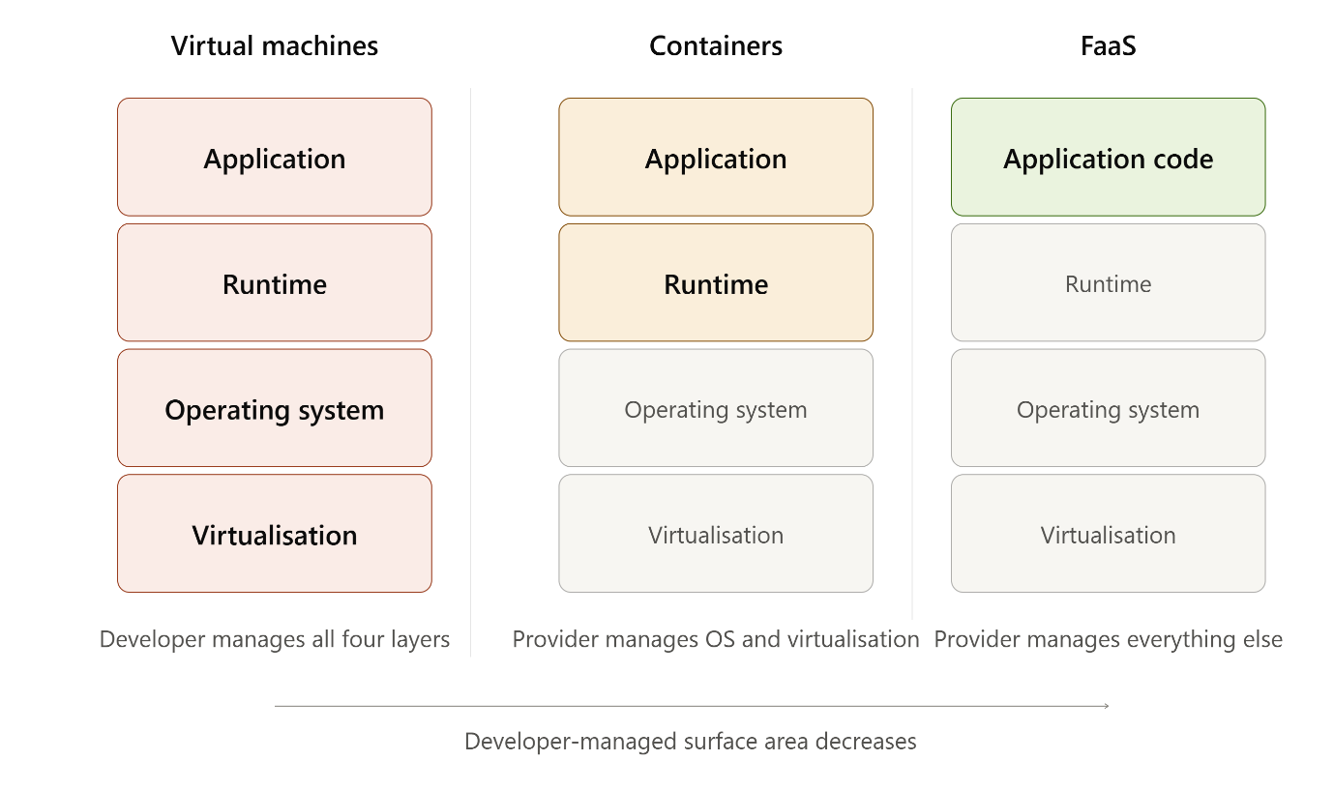
Figure 10. Comparison of the developer-managed surface area across virtual machines, containers, and Function-as-a-Service, showing the layer of responsibility that decreases at each step.
Cost: FaaS bills only for actual invocation time, down to a fine-grained unit of measurement, which is highly efficient for spiky, intermittent workloads, but can become considerably more expensive than an equivalent container running at sustained high utilisation, since a continuously busy function is, in effect, paying a serverless premium for capacity it uses around the clock [12].
Operational overhead: FaaS removes almost all infrastructure management responsibility from the development team — there is no host operating system to patch and no container orchestration layer to maintain — but this convenience comes at the direct cost of losing control over the underlying runtime environment, including the specific language runtime version and operating-system patch level, both managed entirely by the provider. This is a genuine loss of control, not merely a neutral simplification: an organisation with strict compliance requirements around patch timing, for instance, may find this loss unacceptable regardless of the operational convenience gained.
Cold starts: a function scaled down to zero incurs a cold-start penalty on its next invocation, during which the provider must provision an execution environment before the function's code can begin running; this penalty can add anywhere from tens of milliseconds to, in the worst observed cases, several seconds of added latency, and is a genuine limitation for latency-sensitive, user-facing workloads that cannot tolerate an occasional multi-second delay [13].
Vendor lock-in: FaaS platforms are typically far more tightly coupled to a specific provider's proprietary event model, trigger configuration, and surrounding managed services than a Docker container is to any single provider, since a container image can, in principle, run unmodified on any compliant container runtime, whereas a function written against one provider's event schema usually requires non-trivial rewriting to run on a different provider's platform [14]. This is arguably the most commercially significant of the four dimensions, since it affects an organisation's long-term negotiating position with its cloud provider far more than any single cost or latency figure.
Taken together, these four dimensions show that the choice between containerisation and serverless computing is not a simple question of which technology is more modern, but a question of which workload shape is being served. A steady, continuously utilised backend service is generally better served by a container, where sustained utilisation is billed efficiently and cold starts are irrelevant because the process never stops running. An intermittent, event-driven workload with long idle periods is generally better served by a function, where the ability to scale to zero directly translates into cost savings that a continuously running container cannot match. Treating this as a binary “which is better” question, as much introductory material does, misses the point: the correct question is always “better for which workload”, and the answer changes depending on the traffic shape being served — precisely the same lesson drawn in Section 2 about virtualisation versus containerisation.

Conclusion
This report has traced a single recurring theme across three seemingly distinct topics: the ongoing engineering trade-off between control and abstraction that runs through every layer of modern cloud infrastructure. At the deployment layer, containerisation abstracts away the duplicated guest operating system that virtual machines require, gaining efficiency, portability, and density, but at the cost of a weaker, shared-kernel isolation boundary that must be actively compensated for through non-root execution, read-only filesystems, and mandatory access-control profiles. At the platform layer, Azure's combination of load balancing, auto-scaling, and Application Gateway abstracts away the need for manual, human-driven capacity and routing decisions, gaining resilience and elasticity, but at the cost of scaling latency that limits how instantaneously the platform can respond to the most extreme, unplanned traffic spikes. At the execution-model layer, serverless computing abstracts away the runtime environment almost entirely, gaining near-total operational simplicity and precise, invocation-based billing, but at the cost of control over that runtime, portability between providers, and consistently low latency on every single invocation.
None of these abstractions strictly replaces what came before it in the sense of rendering the earlier technology obsolete; each instead fits a specific workload shape more closely than the alternatives do. A security-sensitive, multi-tenant workload may still justify the stronger isolation of a full virtual machine over any container-based alternative. A steady, continuously utilised backend service is generally best served by a container. An intermittent, event-driven workload with substantial idle time is generally best served by a function. The practical skill this report has attempted to demonstrate, both in its written analysis and in the accompanying Docker exercise, is not simply naming these technologies but reasoning explicitly — and critically — about which trade-off a given workload can, and cannot, afford to make.

References
[1] Mell, P. and Grance, T. (2011) The NIST Definition of Cloud Computing, NIST Special Publication 800-145. Gaithersburg, MD: National Institute of Standards and Technology.
[2] Armbrust, M., Fox, A., Griffith, R., Joseph, A.D., Katz, R.H., Konwinski, A., Lee, G., Patterson, D.A., Rabkin, A., Stoica, I. and Zaharia, M. (2010) 'A view of cloud computing', Communications of the ACM, 53(4), pp. 50–58.
[3] Barham, P., Dragovic, B., Fraser, K., Hand, S., Harris, T., Ho, A., Neugebauer, R., Pratt, I. and Warfield, A. (2003) 'Xen and the art of virtualization', SOSP '03, pp. 164–177.
[4] Morabito, R., Cozzolino, V. and Ding, A.Y. (2015) 'Hypervisors vs. lightweight virtualization: A performance comparison', IEEE International Conference on Cloud Engineering, pp. 386–393.
[5] Bernstein, D. (2014) 'Containers and cloud: From LXC to Docker to Kubernetes', IEEE Cloud Computing, 1(3), pp. 81–84.
[6] Pahl, C. (2015) 'Containerization and the PaaS cloud', IEEE Cloud Computing, 2(3), pp. 24–31.
[7] Casalicchio, E. (2019) 'Container orchestration: A survey', in Systems Modeling: Methodologies and Tools, pp. 221–235. Cham: Springer.
[8] Microsoft (2024) Azure Application Gateway documentation. Microsoft Learn. Available at: https://learn.microsoft.com/en-us/azure/application-gateway/ (Accessed: 13 July 2026).
[9] Microsoft (2024) Azure Virtual Machine Scale Sets documentation. Microsoft Learn. Available at: https://learn.microsoft.com/en-us/azure/virtual-machine-scale-sets/ (Accessed: 13 July 2026).
[10] Flexera (2024) State of the Cloud Report. Flexera.
[11] Baldini, I., Castro, P., Chang, K.S.-P., Cheng, P., Fink, S.J., Ishakian, V., Mitchell, N., Muthusamy, V., Rabbah, R., Slominski, A. and Suter, P. (2017) 'Serverless computing: Current trends and open problems', in Research Advances in Cloud Computing. Singapore: Springer, pp. 1–20.
[12] Al-Ali, Z., Goodarzy, S., Hunter, E., Ha, S., Han, R., Keller, E. and Rozner, E. (2018) 'Making serverless computing more serverless', IEEE International Conference on Cloud Computing, pp. 456–459.
[13] Eismann, S., Scheuner, J., van Eyk, E., Schwinger, M., Grohmann, J., Herbst, N., Abad, C.L. and Iosup, A. (2021) 'Serverless applications: Why, when, and how?', IEEE Software, 38(1), pp. 32–39.
[14] Wang, L., Li, M., Zhang, Y., Ristenpart, T. and Swift, M. (2018) 'Peeking behind the curtains of serverless platforms', 2018 USENIX ATC, pp. 133–146.

Appendix A — Figure Placement Summary
- Figure 1 — Hypervisor vs container diagram — Section 2.1 (included)
- Figure 2 — Docker architecture diagram — Section 2.2.1 (included)
- Figure 3 — Dockerfile screenshot — Section 2.3
- Figure 4 — docker build and docker images output — Section 2.3
- Figure 5 — Docker Hub login/push terminal output — Section 2.3
- Figure 6 — docker run / docker ps output and Docker Desktop Volumes panel — Section 2.4
- Figure 7 — Volume persistence proof (terminal commands and output) — Section 2.4
- Figure 8 — docker network ls output — Section 2.5
- Figure 9 — Scenario architecture diagram — Section 3.1 (included)
- Figure 10 — VM/Container/FaaS comparison diagram — Section 4.2 (included)

