

Module Code: LCBB5000

Module Name: Data Handling & Business Intelligence
Assessment 2

Data Analysis and Visualization

Lecturer: Amitave Banik

Student Name: Vladimir Bara

Student ID: 2110942

Table of Contents:
Introduction……………………………………………………………………………………3
Part 1……………………………………………………………………………………….….4
  - Change in average room price:.…………………………………………………………..4
  - MS Excel in Analysing the Data: ………………………………………………………..7
    - Pivot Tables …………………………………………………………………………..7
    - VLOOKUP / HLOOKUP / XLOOKUP: …………………………………………….8
    - IF ……………………………………………………………………………………..9
Part 2…………………………………………………………………………………………10
2.1. How many students are male and female? …………………………………………...…10
2.2. How many students qualifies and does not qualify for reduced/free lunch? ……………11
2.3. What are the mean and median of students who qualifies and does not qualify for reduced/free lunch? ………………………………………………………………………….12
2.4. What are the mean and median differences of student’s pre-test and post-test scores? ….13
2.5. Using the dataset Student_Score.csv provided in conjunction with SPSS, give a specific example of Clustering (ex. K-Means Clustering). Show your workings with screenshots and clearly explain your results. …………………………………………………………………14
2.6. With real world (practical) examples, explain minimum 5 most common data mining and text mining methods for each that can be used in the contemporary business. ………………
2.7. Discuss the advantages and disadvantage of using SPSS and Excel using relevant practical examples and present your discussions in a table. ………………………………………….

Conclusion ………………………………………………………………………………….
References …………………………………………………………………………………..

Introduction:

In the actual business world, the quickest and best decision-making process is based on analysed data from various relevant sources. Therefor the business intelligence is based on set of mathematical models and analysis methodologies that used data to generate the best information for the decision-making process (Reinschmidt, 2000).
This essay has two parts and will reveal the way of using data. The first part consists in using Microsoft Excel to evaluate the evolution of room reservation price of a hotel over five years period. The second part, revel the role of data analyst to evaluate the data collected on 2133 school students by using MS and SPSS tools. All those two parts will evidence the importance of analysing data and the power of data visualization throw comparative tables.

Part 1:

This essay first part will evaluate the role of data analyst in analysing and visualising the dataset provided form a Hotel Reservation.

  - Change in average room price:

As a data analyst, we will determine first the average room reservation price evolution from 2017 to 2021. We have a large Excel database of 36275 booking ID and 19 columns, like we could see in the first picture bellow:
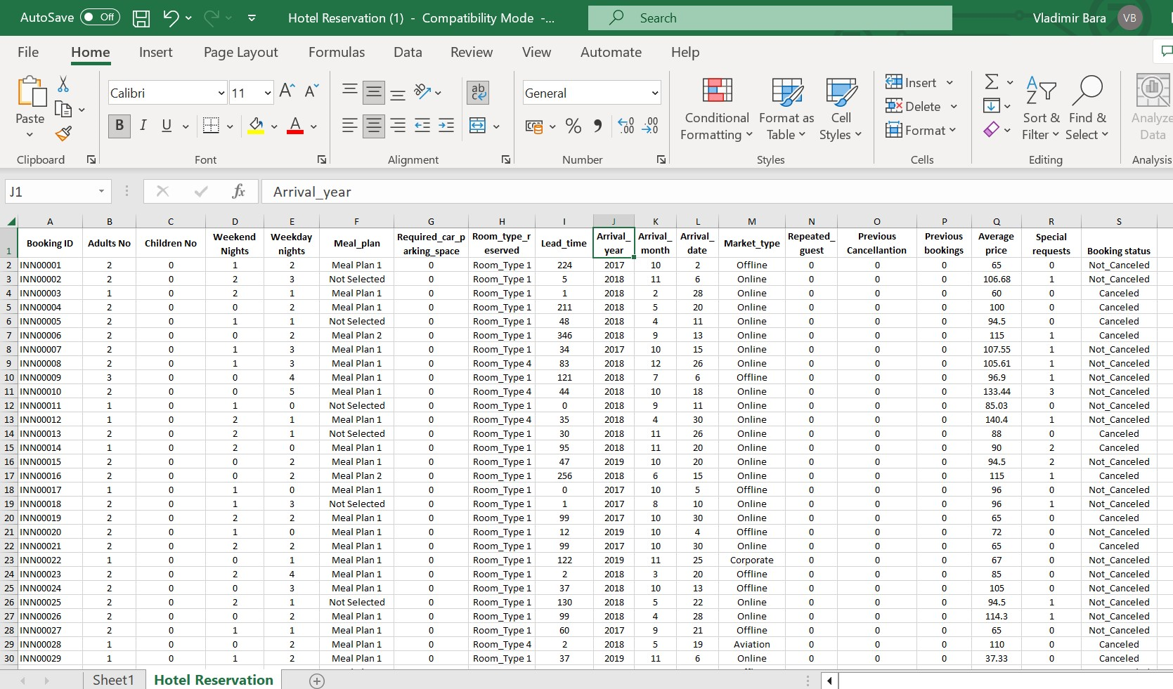
Figure 1: Original dataset in MS Excel (Author: Vladimir Bara – 2110942)
Our main request is to find the evolution in average room price from 2017 to 2021. For this aim we will use Pivot Tables function from MS Excel, as we need to rearrange the dataset. In order to rearrange the dataset, first of all, we prep the data: we make sure we have the necessary headers on the columns and no empty columns or empty rows. Secondly, we make sure that all the data has an officially Excel table: we go into insert table on top or press CTRL+T.
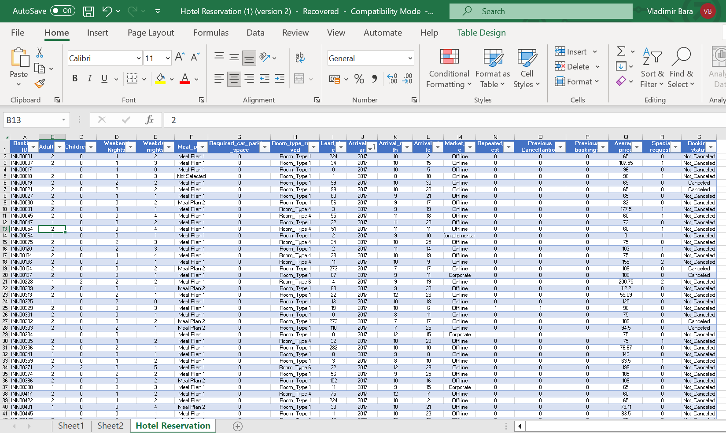
Figure 2: MS Excel dataset ready for analysed (Author: Vladimir Bara – 2110942)
Then a new Excel sheet was created where we will put the selected data set for the Pivot table: ‘arrival year’ and ‘average price’. Not at least, we create a graphic visualisation of the data, under charts form; like in the picture bellow:
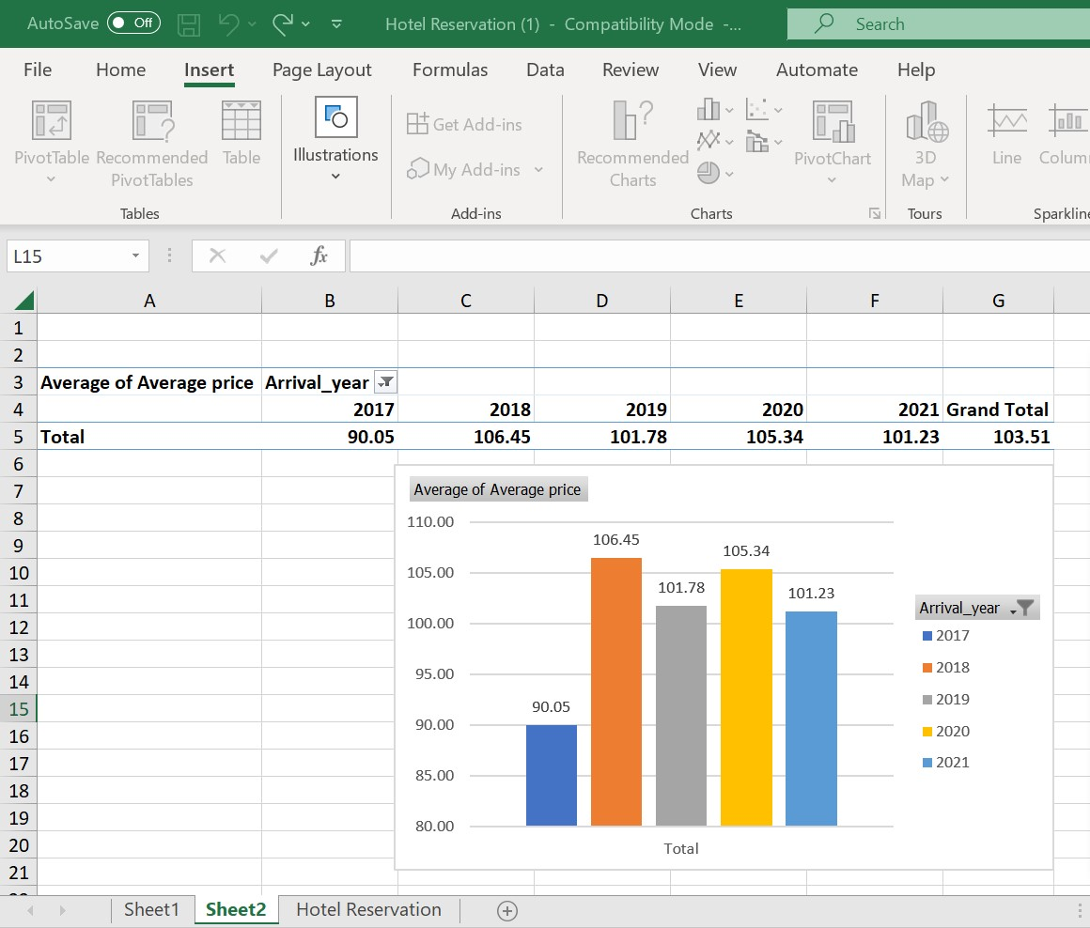
Figure 3: Analyse in MS Excel Pivot table and graphic visualisation of dataset: average room evolution price from 2017 to 2022 (Author: Vladimir Bara – 2110942).
All in all, using MS Excel Pivot table, in few minutes a data analyst could show the evolution of average hotel rooms price by years: in 2017 there was a price of 90.05 monetary units, in the year 2018 the average room price raise by +18.22%, reaching 106.45 monetary units, then in the year 2019 the average room price drop by -4.39% in comparation with year 2018, reaching 101.78 monetary units. The next year of 2020, in comparation with year 2019, the average room price raised by +3.5%, reaching 105.34 monetary units. Then we could observe that the room price in year 2021 decrease by -3.9% reaching 101.23 monetary units, in comparation with year 2020. We can conclude that the lowest average price room was in year 2017 at 90.05 monetary units, and the higher average price room was next year, in 2018 at 106.45 monetary units. The bellow figure will visualise the average Hotel rooms price by years:
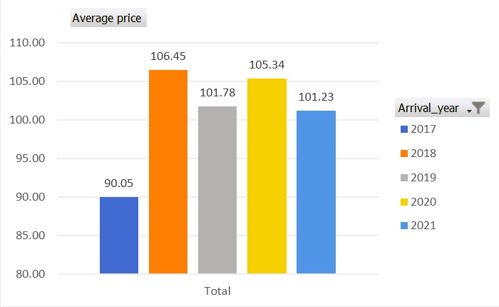
Figure 4: Graph of evolution of the Hotel room price from year 2017 to year 2021 (Author: Vladimir Bara – 2110942)

  - MS Excel in Analysing the Data:

Using MS Excel’s function Pivot Tables, we demonstrate the fluctuation of the average room price of the hotel in the previous point. In this point of the essay, we will use different functions of MS Excel, namely IF, VLOOKUP, PIVOT TABLE in order to go in debt with our analyse (Connolly, T.M. and Begg; C.E., 2015, p. 304).
    - Pivot tables:
Once we found out the fluctuation of the hotel room price over the years, we are interested, from a business perspective, to find out what are the category of people that use the hotel service much often. This information is crucial for the marketing perspective, in order to target that category of people in the marketing campaign, and to create marketing campaign for other categories as well. For that reason, we will select in PivotTable Fields the headings: ‘adults no’, ‘children no’ and ‘arrival_year’. And MS Excel will show us the numbers. As the MS Excel results has a big range of numbers, we will use the percentage view from the total number. In that case, we observe that the service of the hotel is use mainly by adults with no children. From the total reservation number, a majority of 65.39% of reservation is occupy by 2 adults’ category. Also, a single adult category of reservation is the next group of people in the total number of reservations: 20.82%. On third place from the total number is place the category of 3 adults with 6.32% from the total reservation numbers. The graphic bellow show how we analysed in Pivot Table and the outcome describe above:
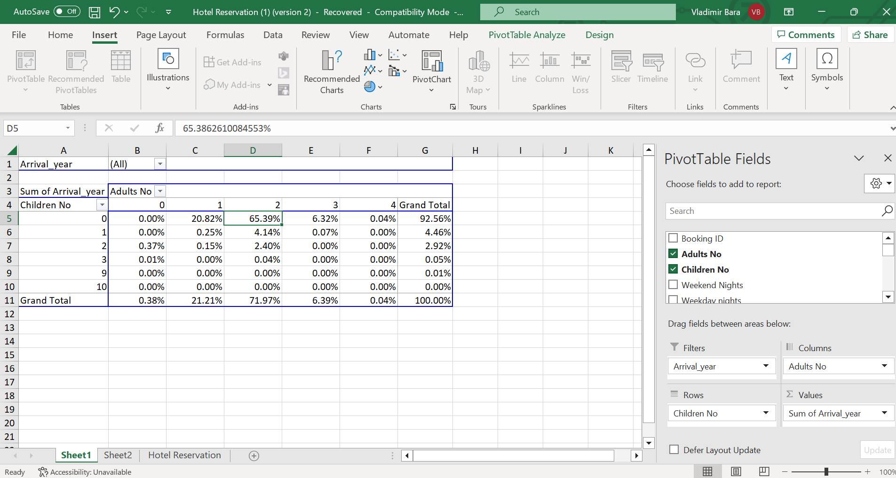
Figure 5: Pivot Table analyse showing which group of people reserved more often the rooms in the Hotel. (Author: Vladimir Bara – 2110942)
As we observed till this point, Pivot Table represent one of the most important functions in MS Excel for a data analyst that need to show quick results to the managerial team in order for them to found important information into a dataset and structure that information to take relevant decision and actions. Graphic visualisation of the relevant data from Pivot table function in MS Excel is also a positive aspect for business intelligence and business decisions.
    - VLOOKUP / HLOOKUP / XLOOKUP:
VLOOKUP is another popular function in MS Excel that a data analyst could use. As Howson, 2017 sate that VLOOKUP means vertical look-up of data and information from a wide range of dataset. We will be exemplified the using of VLOOKUP in order to find the ‘meal plan’ of the ‘booking ID INN00100’. First, we will insert the VLOOKUP formula into ‘fx’ case. Secondly, we select the values and the entire dataset of hotel reservation. Thirdly, we select ‘Meal_plan’ column. Nevertheless, the exact match is shown to reveal the meal plan for booking id ‘INN00100’The picture bellow shows the VLOOKUK formula:
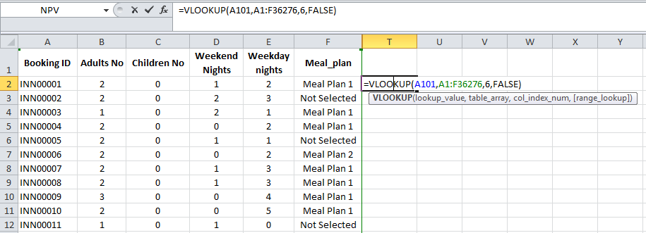
Figure 6: Table showing VLOOKUP formula in order to find the meal plan of ‘booking ID INN00100’ (Author: Vladimir Bara – 2110942)
HLOOKUP mean horizontal look-up of data and information from a wide range of dataset.
XLOOKUP reunite vertical and horizontal look-up of information from a wide range of dataset.
Those Excel functions – VLOOKUP, HLOOKUK, XLOOKUP – allow data analyst to revel a specific data that they search in a big dataset.
    - IF:
In MS Excel we have the function IF that help us to define a range of values that we want to analyse by predefine IF that value is True than we categorise under a good value. If is False than we categorise under a value that need further investigation.

In order to conclude the first part of our essay, as a data analyst we demonstrate the evolution of room price range using Pivot table and graphic representation of this evolution. This MS Excel function it’s very important for us as data analyst as help us time and allow us to arrange all the necessary data to be clearly view by decision factors.

Part 2:

In the Part 2 of our essay, we assist a local school as a data analyst to analyse data collected in a survey. We will use MS Excel and a free copy of the open-source SPSS.

2.1. How many students are male and female?

In order to respond to the school demands we organised the datasets and put the necessary filters to MS Excel database, like we show in the picture bellow:
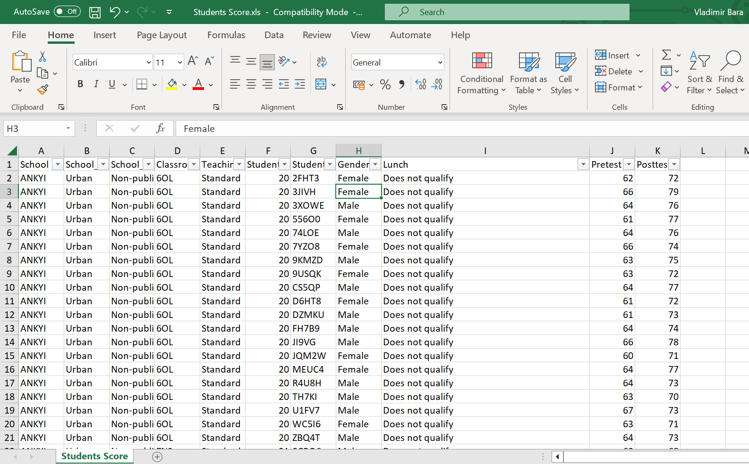
Figure 7: Table represent the school survey dataset after we apply the filters in order to be able to analyse it (Author: Vladimir Bara – 2110942)

We received a dataset of 2133 students. After we analyse this dataset, we found out that there are 1077 male students, that represent 50.49% from the total number of respondents, and 1056 female students that represent 49.51% from the total number of the respondents to the school survey.
Count of Gender
Gender | Number of students | Percentage
Male | 1,077 | 50.49%
Female | 1,056 | 49.51%
Grand Total | 2,133 | 100%
Figure 8: Table represent students gender representation to the survey: male – 1,077; female – 1,056 (Author: Vladimir Bara – 2110942)
As a data analyst, we present the results under graphic view:

Figure 9: Graphic of student’s gender representation to the survey: male – 1,077; female – 1,056 (Author: Vladimir Bara – 2110942)

2.2. How many students qualifies and does not qualify for reduced/free lunch?

Using the dataset provided in MS Excel, we analyse the column ‘Lunch’ to see how many students qualifies or not for reduced / free lunch. As a data analyst we produce the following data reunite in the table below:
The number of students who qualify or do not qualify for reduced/free lunch.
Lunch | Count of Lunch | Percentage
Qualifies for reduced/free lunch | 918 | 43.04%
Does not qualify | 1,215 | 56.96%
Grand Total | 2,133 | 100.00%
Figure 10: Table with students that qualifies – 918 students; 43.04% - and does not qualify for reduced / free lunch – 1,215 students; 56.96% (Author: Vladimir Bara – 2110942)
As we could observe from the dataset output, 918 students, that represent 43.04% from the total number of students, qualifies for reduce / free lunch. The majority of the students, 1,215 from a total of 2,133 students does not qualify for reduce / free lunch; this represents 56.96% of the students.
Bellow, we made a pie chart that show the reality of students that have access to paid or unpaid lunch:

Figure 11: Pie chart with students that qualifies – 918 students; 43% - and does not qualify for reduced / free lunch – 1,215 students; 57% (Author: Vladimir Bara – 2110942)

2.3. What are the mean and median of students who qualifies and does not qualify for reduced / free lunch?
As a data analyst, to answer to this question, we will quickly define the mean and median from a statistical point of view. As Bakker 2006 underline, mean is the average number from a set of numbers, and it’s calculated by the sum of those set of number divided by how many numbers are in that specific set. The median represents the middle number from an ordinated set of number from the least to the greatest value of that particularly set.
In our report to the local school, we will present the mean of the students that are qualifies for reduced / free lunch as the average number of 45.25; the mean of the students that does not qualify is 62.29. The median number of students who qualify for reduced / free lunch is 44, and the median of students that does not qualify for a reduce / free lunch is 62.
Qualifiers | Mean = Average | Median
Qualifies for reduced/free lunch | 45.25 | 44
Does not qualify | 62.29 | 62
Figure 12: Table of Mean and Median for students who qualified or not qualified for free lunch (Author: Vladimir Bara – 2110942)
Also, our report will present the bellow graph representing the mean (=average) and medium for the students who qualified or not qualified for reduced / free lunch.

Figure 13: Graph representing the Mean (=Average) and Median for students who qualified or not qualified for free lunch (Author: Vladimir Bara – 2110942)

2.4. What are the mean and median differences of student’s pre-test and post-test scores?
In order to show those data, a data analyst will report them into a multidimensional table with 3 categories – ‘pre-test’, ‘post-test’, and ‘differences’ – each category subdividing to two aspects: mean and median.
Qualifiers | Pre-test |  | Post-test |  | Differences
Qualifiers | Mean | Median | Mean | Median | Mean difference | Median difference
Qualifies for reduced / free lunch | 45.25 | 44 | 57.48 | 55 | 12.23 | 11
Does not qualify | 62.29 | 62 | 74.38 | 74 | 12.08 | 12
Figure 14: Table of Mean and Median differences of student’s pre-test and post-test scores. (Author: Vladimir Bara – 2110942)
The mean for pre-test students who qualifies for reduce / free lunch is 45.25 and the median for the same category of students is 44. The mean for post-test students who qualifies for reduced / free lunch is 57.48 and the median for the same category of students is 55. This signifies the fact that the mean difference increases by 12.23 points to the post-test students, and the median difference increase by 11 points to the same category of students.
The mean for pre-test students who does not qualify for reduce / free lunch is 62.29 and the median for the same category of students is 62. The mean for the post-test students who does not qualify for reduce / free lunch is 74.38 and the median for the same category of students is 74. This shows the fact that the mean difference increases by 12.08 points to the post-test students, and the median difference increase by 12 points to the same category of students.

2.5. Using the dataset Student_Score.csv provided in conjunction with SPSS, give a specific example of Clustering (ex. K-Means Clustering). Show your workings with screenshots and clearly explain your results.
SPSS is a software and mean Statistical Package for the Social Sciences. SPSS group the data based on similarities and reactions of the students, that are our respondents. Han (2019) showed that the two measures used in clustering analysis are based on the coefficient of similarity and dissimilarity. Data analyse widely use K-Means Clustering in social scientises and business intelligence.
The following pictures represents the screenshots used while we have analysed the database Student_Score.cvs in SPSS:
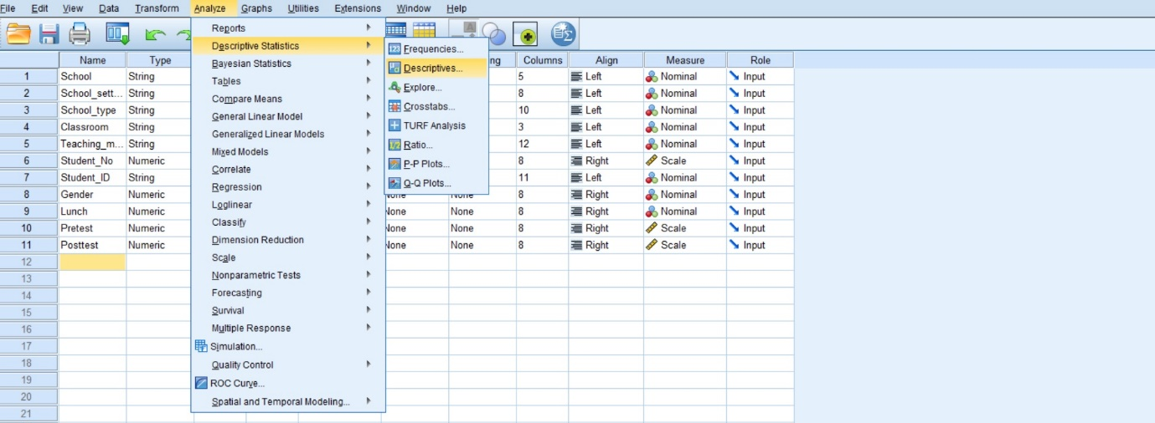
Figure 15: Printscreen1 - SPSS table data impute for analyse K-Means Cluster. (Author: Vladimir Bara – 2110942)
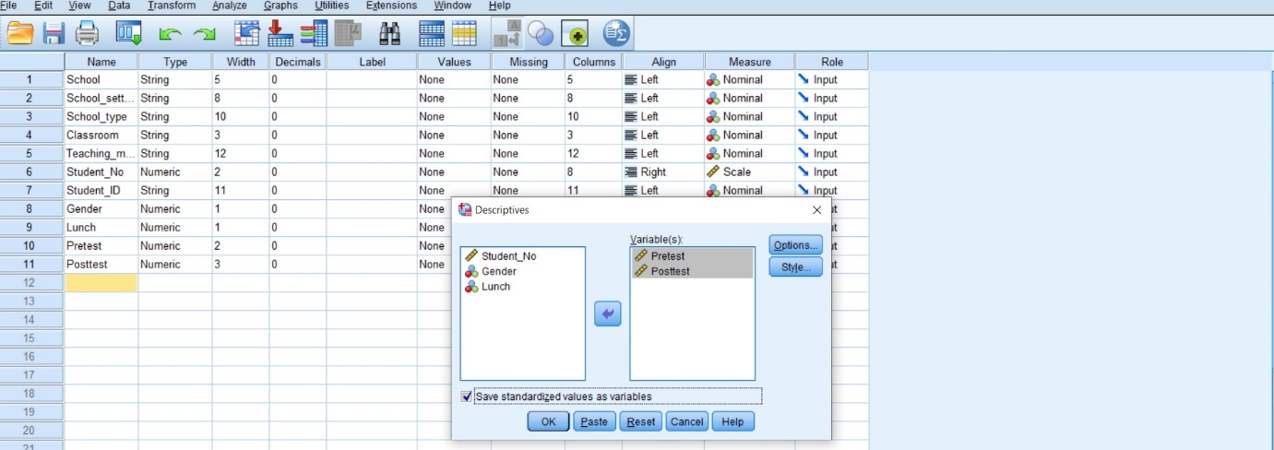
Figure 16: Printscreen2 - SPSS table data impute for analyse K-Means Cluster. (Author: Vladimir Bara – 2110942)
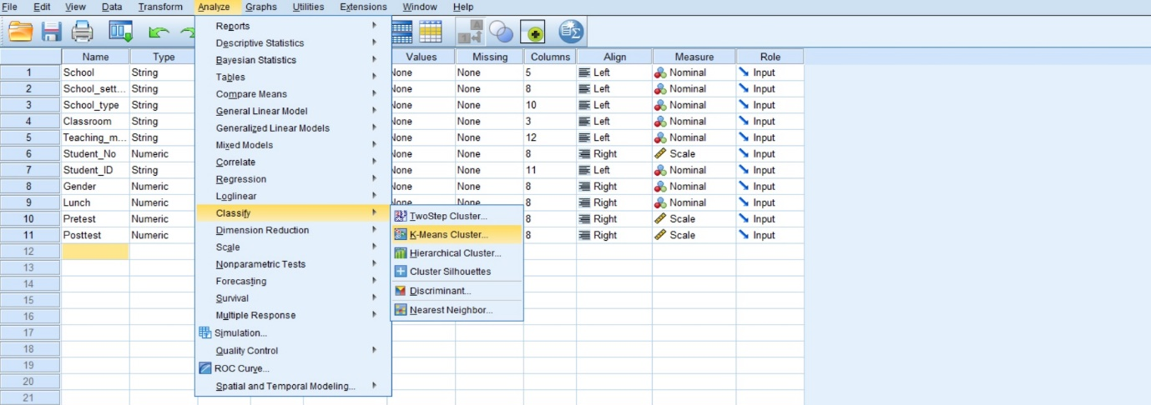
Figure 17: Printscreen3 - SPSS table analyse K-Means Cluster. (Author: Vladimir Bara – 2110942)
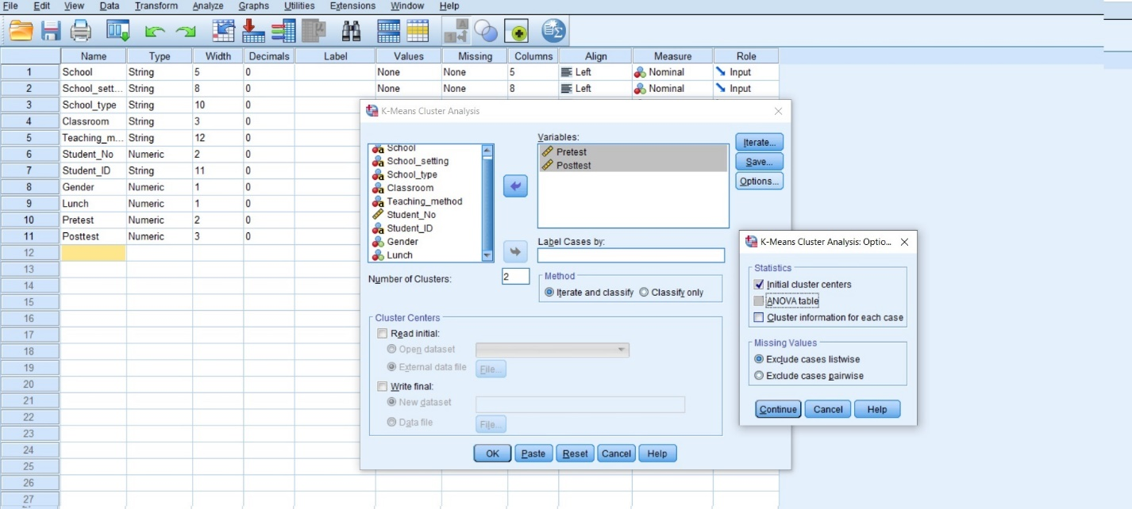
Figure 18: Printscreen4 - SPSS table analyse K-Means Cluster. (Author: Vladimir Bara – 2110942)
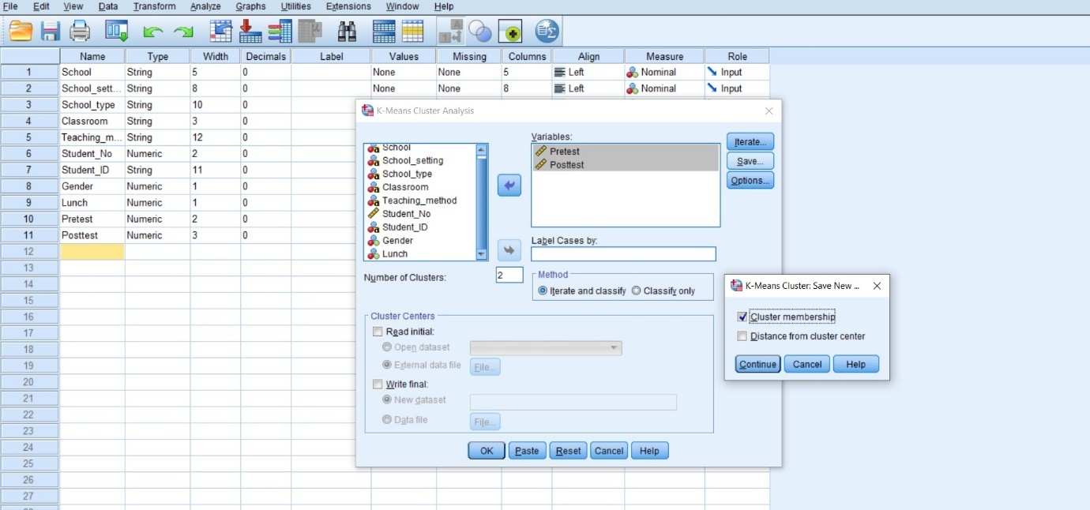
Figure 19: Printscreen5 - SPSS table analyse K-Means Cluster. (Author: Vladimir Bara – 2110942)

The following figures represent the SPSS outputs:
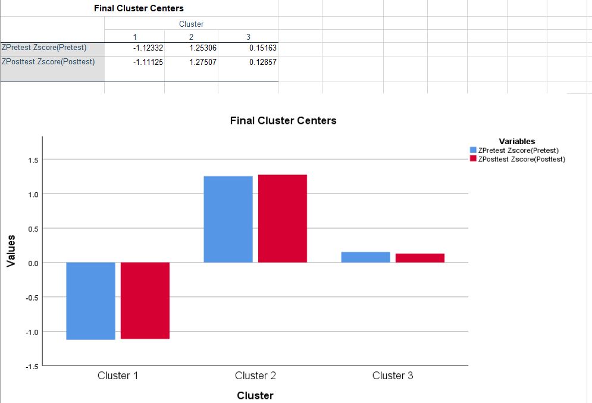
Figure 20: Printscreen6 - SPSS table analyse K-Means Cluster: Final Cluster Centers. (Author: Vladimir Bara – 2110942)
As we can clearly see from the SPSS analyse the scores are very close one to each other.

2.6. With real world (practical) examples, explain minimum 5 most common data mining and text mining methods for each that can be used in the contemporary business:
As Shmueli (2018) revel, data analysis is based on data mining and text mining. We present minimum five common data mining methods:
2.6.1. Data cleaning and preparation: represent the vital part of data mining process, as reassure about the data quality. A good practical example is offered by Palantir Technologies Inc. (stock market ticker PLTR), that is an application software company who is specialised in data cleaning, preparation and data analysis solution for large corporation and government agencies.
2.6.2. Clustering: represent the classification of data under similarities. One good example is SPSS K-Means Cluster.
2.6.3. Outliner detection technique: it’s used in fraud detection software that analysed big data volumes. Like Turintin university software filter.
2.6.4. Information extraction: involves mining big unstructured data. For example, social media people searching history.
2.6.5. Retrieval of information: specific keywords could form pattern that are analysed by hight quality algorithms; like Google and Yahoo searching engine.
2.6.6. Bonus: Learning of associated rules: This data mining method identify hidden pattern from large set of data (Han J. et al., 2019).

2.7. Discuss the advantages and disadvantage of using SPSS and Excel using relevant practical examples and present your discussions in a table:

