Week six session one tutorial question case Answer
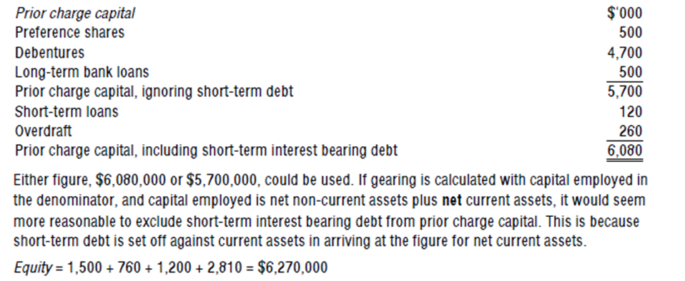
The gearing ratio is calculated as follows


