Laura Lewis
Student Number: 2420151
CIPD Membership Number: 9000694
Unit: Professional Behaviours and Valuing People
Word Count: 3554

What it means to be a people professional (AC1.1)
Smith and Mitchell (2022) suggest that a profession is distinct from a mere occupation, requiring well-defined knowledge and skills, along with formal training and education. Professional status is achieved upon joining a professional body and failure to adhere to its standards can lead to expulsion.
The CIPD Profession Map (2024a) defines people professionals as individuals who apply expertise in human resources (HR), Learning and Development (L&D) and organisational design, creating value for both employees and businesses by adhering to core behaviours of ethical practice, valuing people, working inclusively and professional courage and influence. These attributes promote fairness, transparency, and inclusivity in decision-making, enabling professionals to address unethical practices and cultivate a workplace focused on employee wellbeing and performance. Furthermore, people professionals can help inform and drive strategic decisions by demonstrating knowledge in areas such as workforce planning, analytics, talent management and employment law.
Boxall and Purcell (2022) emphasise that effective HR professionals must align people management strategies with the organisation’s long term business objectives to drive productivity and a competitive advantage, while simultaneously ensuring fairness, engagement, and development opportunities for employees. Performance and retention rates can increase within environments where employees feel valued, supported and motivated.
Employee engagement and development is one of the key areas people professionals can add value. The world economic forum (2025) highlights the importance of continuous learning, stating that 39% of current skill sets will become either outdated or transformed by 2030. Thus, emphasising the need for people professionals to implement effective L&D programmes to either reskill or upskill employees, as well as develop their own personal agility and digital literacy to help manage workforce transformations.
Additionally, people professionals contribute by ensuring compliance with employment legislation and mitigating risks associated with workplace disputes. Promoting fairness in recruitment, performance management and employee relations encourages ethical practices, therefore reducing legal and reputational threats (Armstrong and Taylor 2023).
Both the CIPD’s profession map and Barends, Rousseau and Brinder (2014) emphasise the importance of evidence-based practise, ensuring initiatives and practices are informed by data rather than intuition or outdated fads. Using analytics and critical thinking skills in this manner helps cultivate an increased body of knowledge, reducing wasted resources and money through ill-informed assumptions (Gifford, Young and Barends, 2023). Beyond technical knowledge, Goleman (2020) underscores the importance of emotional intelligence in managing relationships. It is therefore a crucial skill for people professionals, reinforcing the CIPD's emphasis of valuing people by supporting a positive workplace culture.
The actual role of a people professional is multifaceted, adaptive and has evolved to suit the changing needs of organisations and society. The traditional human resource (HR) function has transitioned from administrative tasks and advocating for employees to include more strategic and change management responsibilities (Kramer and Steane 2012). In conclusion, being a people professional requires the use of ethical, inclusive and strategically aligned HR practices which help sustain organisational growth and success by balancing business objectives with employee support.

Personal and Ethical Values (AC1.2)
Personal values are individual beliefs and principles that guide decision making, assess others and situations, and rationalise activities (Roccas and Sagiv, 2018). Whereas ethical practice involves integrating moral principles into organisational behaviour with the intent to shape culture and guide decision making, as well as ensuring transparency with stakeholders (Young, 2024a). Ethical values often stem from theories like utilitarianism, which focuses on achieving the greatest good by justifying actions based on their outcomes (CEBE, no date). Alternatively, Deontology emphasises moral duty and assesses whether actions are inherently right or wrong, irrespective of their consequences (Reuter, 2023).
Working within the environment of people practise, my personal value of kindness and ethical value of integrity guide my professional interactions. My belief in kindness means I treat colleagues with empathy and respect. For instance, when handling employee queries or concerns, I actively listen and provide compassionate responses. Castrillon (2024) suggests that active listening is an essential skill to promote inclusion and respect, aiding conflict prevention and resolution by helping others understand alternative viewpoints. Demonstrating kindness to colleagues can help build trust and contributes to a supportive workplace culture (Sharma, 2024).
It is important to balance kindness with professional integrity, which involves honesty, accountability and consistent applications of rules/policies (National Institute of health, no date). Compassion may challenge HR professionals to overlook policy violations, but demonstrating integrity ensures that policies are upheld fairly.
Handling confidential employee records and sensitive HR matters requires me to act with discretion and professionalism. By maintaining confidentiality and ensuring fair administrative practices, I contribute to a trustworthy and compliant workplace. Integrity not only aligns itself with the moral responsibility of deontology but also connects with the character lens of the CIPD's eight ethical lenses. This lens emphasises the importance of virtue, moral character, and consistent ethical behaviour (Clark, 2015). Integrating both kindness and integrity into my work allows me to foster strong working relationships, which enhance collaboration and professionalism.

The importance of people professionals influencing others effectively (AC 1.3)
Clear, knowledgeable, and confident communication is central to effective influence. Handy (1993) defines influence as an active process enabled by power, emphasizing that both must work together. People practitioners possess a certain level of power; however, this has limitations due to the advisory nature of their role. Clear and confident communication is therefore essential to foster collaboration and drive change (CIPD, 2024a). When People professionals fail to assert themselves, they risk being seen as merely administrative, weakening both their credibility and influence (Adams, 2021).
Knowledge underpins effective communication. People Practitioners must understand employment law to ensure compliance and avoid legal risks (Taylor & Wilkinson, 2022). Additionally, familiarity with best practices in diversity, inclusion, and well-being allows them to promote ethical and impactful policies (Stokes & Woodhams, 2022). Understanding power dynamics and psychology is equally crucial. Karpman’s drama triangle offers insights into conflict resolution. Developing increased awareness of the roles of victim, persecutor, or rescuer can help promote healthier interactions and constructive solutions (Condon, 2014). Belbin’s team roles also highlight the importance of diverse strengths when influencing others. For example, a ‘shaper’ may challenge ideas to drive progress, while a ‘coordinator’ ensures collaboration. Practitioners must adapt their communication style to engage different personalities effectively (Belbin, 2010).
Trust is also vital for influence. According to Handy (1993) influence can be exacted overtly or covertly. Murdoch and Scutt’s (2003) advocate for overt action, suggesting that any proposals should be explained honestly, and evidence provided to avoid perceptions of manipulation. Demonstrating a willingness to accept other viewpoints can help build trust. Armstrong and Taylor (2021) further argue that confident communication signals expertise and builds trust, while lack of confidence may result in failure to acquire leadership support.
As well as confident, communication must be clear and informed to help communicate data-driven arguments. Without effective communication employees may resist organisational changes such as restructuring (Kotter, 2012). Furthermore, HR professionals function as a bridge between employees and management. Failure or unwillingness to articulate employee concerns clearly can lead to dissatisfaction, lower engagement, and higher turnover (Adams, 2021)
Without clear, informed, and confident communication, people practitioners lose influence. Failure to advocate for fair policies, lack of confidence or knowledge risks missed opportunities to improve workplace practices or drive organisational change. This can lead to higher turnover and disengaged employees. Effective communication and expertise navigating complex workplace dynamics can shape positive outcomes.

Reacting to unethical and illegal matters. (AC 1.4)
Ethical behaviour is fundamental to maintaining trust and accountability in the workplace, while legal compliance ensures adherence to laws and regulations (Crane and Matten, 2016). Unethical behaviour typically involves actions that, while not unlawful, breach professional or moral standards. For example, failing to follow medication procedures such as neglecting to double-check controlled drug dosages. This oversight risks patient safety and breaches NHS policies and professional standards. Such incidents must be formally recorded and reported to the head of nursing and workforce. The employee would need to reflect on the event, participate in an initial assessment of facts interview, and may face additional training for repeated violations. (Hywel Dda University Health Board, 2017). Depending on the severity of the misconduct a disciplinary investigation may be required to collect further evidence and interview witnesses. Outcomes range from formal warnings to dismissal (HDUHB, 2019).
Illegal action should be reported to the appropriate legal authorities, for instance if a nurse is suspected of physically abusing a patient. Physical abuse constitutes assault and is a criminal offence (Crown Prosecution Service, 2022). After the immediate reporting to the employee’s manager, workforce advisors should ensure the incident is reported to the hospital safeguarding team and the police. A disciplinary investigation cannot commence before a safeguarding risk assessment has been conducted and advice received from the police or head of safeguarding (HDUHB, 2023). Once an investigation commences, the employee must be informed of the process, allegations, and have access to support and representation (RCN, no date). Depending on the severity of the misconduct, the employee may be suspended or receive temporary restrictions to their duties (Hughes, not published). Additionally, misconduct such as abuse necessitates reporting to the Nursing and Midwifery Council (NMC). The NMC's fitness to practise process evaluates whether the nurse is fit to continue practising ( NMC, 2024). An internal disciplinary investigation will proceed regardless of NMC judgement (HDUHB, 2019).
Both ACAS (2024) and the CIPD (2024b) stress the importance of whistleblowing policies protecting employees who report workplace wrongdoing, both criminal or unethical, and ensure a safe environment to voice concerns. In both cases, acting against unethical or illegal behaviour upholds integrity, legal compliance, and trust.

The benefits of feeling valued, inclusively and fairly treated (AC 2.1)
Workplace Inclusion, fairness and recognition are critical to improve well-being and organisational success (Suff, 2024). Different theoretical perspectives highlight the benefits of fostering these principles.
Maslow's hierarchy of needs presents a humanistic perspective suggesting that employees require a sense of belonging and esteem, which are fundamental to motivation. Feeling valued and included can lead to higher engagement and productivity (Pichere and Cadiat, 2015). Similarly, Herzberg’s two factor theory distinguishes between extrinsic hygiene factors which discourage frustration, and intrinsic motivators that enhance job satisfaction (Nickerson, 2025) Hygiene factors encompassing fair treatment of wages or working conditions promote contentment, preventing deterioration of engagement but do little to motivate. Enhancements of motivators like recognition and achievement increase an individual's capacity to grow and develop, improving performance (Hershey, blanchard and Johnson, 2001). Equity theory argues that when employees perceive unfairness in rewards and recognition their productivity and job satisfaction decrease (Armstrong and Taylor, 2023).
David rock’s SCARF theory provides a neurological perspective highlighting five social domains - Status, Certainty, Autonomy, Relatedness, and Fairness - that drive motivation (Mullins and McLean, 2019). Rock (2009) argues that when employees feel valued, have clear expectations, control their own work, strong social connections, and perceive equity, they are more engaged and perform better. Conversely, when these factors are threatened employees experience stress, disengagement and reduced productivity.
Classical perspectives such as Taylor's scientific management theory prioritises efficiency and productivity over employee emotions, advocating for structure and standardised performance metrics over subjective fairness (Mind tools, no date).
While classic theories propose risk to efficiency, recent evidence highlights the strategic benefits of inclusion, fairness, and recognition. Maslow and Herzberg provide convincing evidence that fair treatment and recognition enhance motivation and performance, while the SCARF model emphasizes that inclusive workplaces foster psychological safety, boosting well-being and business success. The CIPD's Good Work Index 2024 underscores the link between job quality and well-being, demonstrating that skill development, autonomy, recognition, and work-life balance improve performance and commitment (Young, 2024b). Research by Gallup (2025) supports this, suggesting that organisations who actively value and support employee well-being increase their retention rates through employee loyalty. Whereas employers who disregard risks to mental health and stress leave themselves open to costly compensation claims (Hasson and Butler, 2020). Ultimately encouraging inclusive and Fair Work environments not only enhances employee engagement, motivation and retention rates but also increases job satisfaction, innovation, and mental well-being, all of which improve business performance (Torrington et al, 2020).

How to design and check the inclusivity of people practice initiatives (AC 2.2)
Designing inclusive people practice initiatives requires thoughtful planning and collaboration to ensure all employees feel valued and supported. The process begins with analysis of workforce data, such as employee demographics, engagement surveys and performance metrics to identify specific challenges or opportunities within the organisation (Armstrong and Taylor, 2023). It is important to collect data through a variety of methods, however holding focus groups or interviews with underrepresented groups can provide more specific details regarding barriers or solutions required to meet their needs (Woodhams and Perkins 2022).
Once any needs have been identified clear objectives must be established. Boxall and Purcell (2022) stress the importance of aligning goals with overall business strategy and HR priorities such as equality, diversity and inclusion. Collaboration from a wide range of stakeholders is required to ensure the initiative reflects the needs of all employee groups. Therefore, consultations should be held with employees, leaders and their representatives. An action plan can then be created detailing steps for implementation, including staff engagement, monitoring processes, recording results, evaluating effectiveness, identifying changes and assigning responsibilities with timelines to ensure the initiative works in practice. It is also imperative to identify and address any potential bias or inequalities. For example, consideration should be given to the accessibility of employees with disabilities, cultural/religious sensitivities, and diverse working arrangements (ACAS, no date).
To check inclusivity after implementation data can be gathered using qualitative and quantitative measures (Woodhams and Perkins, 2022). For example, employee surveys can assess perceptions of belonging, while demographic data can track diversity in hiring, promotions or pay equity. Benchmarking data against the wider industry can also provide valuable insight. It is also essential to regularly review data and policies to ensure the initiative remains relevant and adaptable to any evolution in organisational needs (CIPD, 2022).

Ability to work inclusively (AC 2.3)
I have used a combination of my personal reflections, self-assessment responses and colleague feedback contained in table 1 to provide insights into my ability to work inclusively and positively with others. The information obtained demonstrates a solid foundation with areas for growth. Both my self-assessment and my colleague’s feedback emphasise strengths such as reliability, communication and active listening. My colleague has praised me for building relationships, handling criticism and encouraging diverse opinions. All of which highlight my capacity to act as a collaborative and inclusive team member.
I believe the differences between myself assessment and my colleague’s feedback regarding my ability to build purposeful working relationships and collaborate with others arise from the fact that, although I feel comfortable and confident developing relationships within my immediate team, I rarely interact with colleagues from other sites or departments. This is an area I could expand upon to increase collaboration and build connections beyond my familiar environment. Additionally, being the lowest ranking team member, I feel I lack confidence to help colleagues as I am often seeking help from others in more complex situations. Despite this, I recognise that my colleagues feel comfortable sharing their ideas with me. This Indicates they see potential which can be built upon.
One of my key strengths is my ability to follow up on requests promptly. This reliability builds trust and helps create an environment where people feel supported, strengthening working relationships further. To improve, I plan to connect with more external colleagues and actively seek their input. Hopefully by fostering these connections, increasing my confidence, and encouraging openness, I can align myself assessment more closely with the positive feedback I received and become an even more effective and inclusive team member.
Questionaire responses regarding working inclusively and positively with others
Key: 4: Very well / Very quickly / Very often
3: Somewhat well / Somewhat quickly / Somewhat often
2: Not very well / Not quickly / Not often
1: Never
question | Self-Assessment | Colleague Feedback
How well do I get to know people as individuals? | 3 | 4
How well do I actively seek and listen to diverse views and opinions? | 3 | 4
How well do I build purposeful working relationships and collaborate with colleagues? | 2 | 4
How well do I handle criticism? | 3 | 4
How well do I communicate with others? | 3 | 4
How well do I follow up on requests? | 4 | 4
How often do I ask for opinions when making decisions? | 3 | 4
Do I encourage others to recognize when they need help or share concerns and ideas? | 2 | 4

Table 1: Inclusivity assessment results

How the people practitioner role is evolving (AC 3.1)
The people practitioner's role is evolving, driven by technology, workplace changes, and a focus on well-being, inclusion, and engagement. Practitioners must adopt a strategic role rather than administrative. As employee voice and loyalty become increasingly important, emphasis should be placed on initiatives creating a climate of corporate responsibility, ethical practices and credible career development (Payne, 2021). Pomies (2025) strengthens this argument by discussing the impact of Gen Z's influence on workplace culture and technology. Not only are younger employees becoming more selective of employers based on corporate reputation, they also value personal and professional growth. Employees now expect accessible progression paths plus opportunities to acquire new skills.
The spotlight on employee well-being accelerated during the COVID-19 pandemic. During this time companies pivoted towards remote/hybrid working as a response to restrictions. The resulting well-being issues created by virtual environments demonstrated a need to renew the ‘human’ element of HR. Persistent expectations for flexibility and work-life balance emphasize the need for responsive policies, with diversity, equality, and inclusion strategies now essential for maintaining a competitive edge (Batrum, 2023).
Technological advancements, such as AI and data analytics are also reshaping HR functions, with an expectation for practitioners to develop analytical skills and embrace digital transformation (Mohdzaini, 2022).
To counterbalance the increasing use of AI in routine HR tasks, people practitioners should focus on developing competencies such as emotional intelligence. As AI handles more technical tasks, skills like empathy and relationship building become increasingly important. As does ethical oversight to establish guidelines for transparency, fairness and human values (Bradford, 2024). This is especially useful in employee relations where skills of conflict resolution are required (Ayling and Suff, 2024).
To meet demands from the altering social and technological environment practitioners must upskill in digital tools, strategic decision making and inclusivity to address modern organisational challenges (Green, Peters and Young, 2020).
Continuous professional development (CPD) is crucial for adapting to these changes. Accordingly, I have revised my CPD plan to include targeted upskilling activities, detailed in Appendix 1.

Development Assessment (AC3.2)
My assessment was carried out against the job description of a Workforce Advisor within Hywel Dda University Health board. The process involved assessing my skills, experience, and areas for development in relation to the role's criteria and responsibilities. Table 2 summarizes both my self-assessment and colleague feedback, with the job description provided in Appendix 1.
My strengths provide a solid foundation which align well with the requirements of the workforce advisor role. I have gained significant experience within HR, including supporting employee relations cases by typing interview transcripts, logging and updating disciplinary details onto the electronic staff record (ESR), and gaining first-hand exposure to disciplinary hearings. Additionally, I readily advise on HR policies and procedures regarding maternity and annual leave, demonstrating my ability to handle these core aspects of the role. This experience directly corresponds with the job’s focus on employee relations, advising on contracts and ensuring efficient administrative support.
Colleague feedback has further highlighted my strengths, emphasising my ability to work within employee relations, and provide guidance on policies and terms and conditions. However, the assessment also identified areas for improvement. My knowledge of employment law needs strengthening, particularly regarding protected characteristics. I lack experience in supporting redeployment processes and require greater confidence in advising on sickness absence beyond review meetings. Furthermore, my familiarity with the NHS Respect and Resolution policy needs enhancement, as does my ability to analyse management information to identify absence trends.
To address these gaps, I aim to prioritise improving my knowledge of employment law and NHS policies. Strengthening my skills in excel and data analysis is also crucial. Attending training sessions, shadowing colleagues and finishing my CIPD level 5 qualification will ensure my professional development continues in line with the role’s expectations.
Category | Self-Assessment | Colleague’s Feedback
Key Strengths | - Experience working within a HR environment. | - Experience of working within HR or similar area of work.
 | - Experience of employee relations issues: typing interview transcripts, logging disciplinary details into ESR. | - Supporting employee relations matters: listening to transcripts, discussing cases, inputting disciplinary data into ESR.
 | first-hand experience of hearings, required time frames, documentation and process order. | - Advising on HR policies, procedures, and Terms and Conditions for maternity leave, annual leave, etc.
 | - Regularly providing advice on policies/procedures regarding maternity leave, annual leave, and special leave.
Weaknesses | - Require improved knowledge of employment law. | - Management information to understand absence trends or hot spots.
 | - Lack experience supporting the redeployment process. | - Advising/supporting or managing sickness absence.
 | - Lack confidence advising on sickness absence. Require increased exposure beyond review meetings with managers | - Creating positive working relationships with managers and colleagues for issue resolution/Respect and Resolution.
 | - Require improved knowledge/experience of Respect and Resolution process.
Areas for Development | - Improve knowledge of protected characteristics and employment law. | - Absence: Attend a deep dive.
 | - Familiarise myself with the long-term sickness absence process & shadow meetings (1st, 2nd, and 3rd meetings). | - Shadow long-term sickness absence meetings.
 | - Improve knowledge of Respect and Resolution policy. | - BI Reports: individual absence, 12-month trends, etc.
 | - Gain experience shadowing colleagues during redeployment processes.
Goals to work towards | - Complete CIPD Level 5 qualification | - Finish CIPD Level 5
 |  | - Evidence of continuing professional development.
 |  | - Investigation training.
Skills to Improve | - Improve knowledge of Microsoft Excel and other I.T packages. | - Excel.
 | - Improve ability to analyse data to spot patterns/trends. | - Confidence in self to answer queries accurately.

Table 2 – assessment against workforce Advisor job description

Ongoing learning (AC 3.3)
Based on information learnt from colleague feedback and my own self-assessment, I have identified development activities to support my ongoing learning within an employee relations role. Focusing on improved knowledge of policies, employment law and enhancing my digital skills, the areas have been included within my CPD plan, which is presented in Appendix 2.

Reflective practice (AC3.3)
Appendix 2 consists of entries to my continuous professional development record, containing reflections on three past exercises.

Bibliography
Adams, L. (2021) HR Disrupted: It’s time for something different. Great Britain: Practical Inspiration Publishing.
Armstrong, M. and Taylor, S. (2023) Armstrong's Handbook of Human Resource Management Practice. 16th edn. London: Kogan Page.
ACAS (no date). Equality, diversity and inclusion: Making your workplace inclusive. Available at: https://www.acas.org.uk/improving-equality-diversity -and-inclusion/making-your-workplace-inclusive (accessed 16 March 2024).
ACAS (2024). Whistleblowing at work. Available at: https://www.acas.org.uk/whistleblowing-at-work (Accessed: 18 February 2025).
Ayling, L. and Suff, R. (2024). Employee relations: an introduction. Available at: https://www.cipd.org/uk/knowledge/factsheets/relations-employees-factsheet/ (Accessed: 18 March 2025).
Barends, E., Rousseau, D.M. and Briner, R.B. (2014) Evidence-Based Management: The basic Principles. Amsterdam: Center for Evidence-Based Management. Available at: ttps://cebma.org/assets/Uploads/Evidence-Based-Practice-The-Basic-Principles.pdf (Accessed 11 February 2025).
Bartrum, F. (2023). ‘Major Trends Impacting People Management In 2023’. Workforce Management (Time and Attendance) Excellence Essentials (March). Available at: https://www.proquest.com/magazines/major-trends-impacting-people-management-2023/docview/3035061753/se-2?accountid=130472 (Accessed: 18 March 2025)
Belbin, R.M. (2010) Management teams: why they succeed or fail. 3rd ed. Amsterdam: Butterworth-Heinemann.
Boxall, P. and Purcell, J. (2022). Strategy and Human Resource Management. London: Bloomsbury Academic.
Bradford, N. (2024). Prioritize Human Factors: The Hidden Key to AI Project Success. Available at: https://www.shrm.org/mena/topics-tools/flagships/ai-hi/prioritize-human-factors--the-hidden-key-to-ai-project-success#:~:text=Here's%20what%20HR%20professionals%20and,management%20capabilities%2C%20and%20leadership%20acumen. (Accessed: 17 March 2025).
Castrillon, C. (2024) Why Kindness In The Workplace Is More Important Than Ever. Available at: https://www.forbes.com/sites/carolinecastrillon/2024/11/26/why-kindness-in-the-workplace-is-important/ (Accessed: 6 March 2025).
CIPD (2022) Inclusion at work 2022. 8297. Available at: https://awww.cipd.org/globalassets/media/knowledge/knowledge-hub/reports/2023-pdfs/inclusion-at-work-exec-summary_tcm18-112951.pdf (Accessed: 16 March 2025).
CIPD (2024a). The profession Map. Available at: https://www.cipd.org/globalassets/media/comms/the-people-profession/profession-map-pdfs/full-standards-download-a4-2024/ (Accessed: 13 February 2025).
CIPD (2024b) Whistleblowing: UK employment law. Available at: https://www.cipd.org/uk/knowledge/employment-law/whistleblowing/ (Accessed: 19 February 2025).
Clark, S. (2015) Ethical decision-making: Eight perspectives on workplace dilemmas. 7069. London: CIPD. Available at: https://www.cipd.org/globalassets/media/knowledge/knowledge-hub/reports/ethical-decision-making-2015-eight-perspectives-on-workplace-dilemmas_tcm18-9564.pdf (Accessed 7 March 2025)
Condon, L. (2014) ‘Untangling the Drama Triangle Using the Circle of Restoration’, Journal of Group Psychotherapy, Psychodrama and Sociometry, 62(1), pp. 79–89.
Concise Encyclopaedia of Business Ethics [CEBE] (no date) Ethical Theory: Utilitarianism. Available at: https://conciseencyclopedia.org/entries/ethical-theory-utilitarianism/ (Accessed 5 March 2025).
Crane, A. and Matten, D. (2016) Business Ethics: Managing Corporate Citizenship and Sustainability in The Age of Globalization. 4th edn. Oxford: Oxford University Press.
Crown prosecution service (2022). Offences against the Person, incorporating the Charging Standard. Available at: https://www.cps.gov.uk/legal-guidance/offences-against-person-incorporating-charging-standard (Accessed: 18 February 2025).
Gallup (2025). What Is Employee Wellbeing? And Why Does It Matter?. Available at: https://www.gallup.com/workplace/404105/importance-of-employee-wellbeing.aspx.aspx#ite-404129 (Accessed: 13 February 2025).
Gifford, J., Young, J. and Eric Barends (2023) Building an evidence-based people profession. Available at: https://www.cipd.org/en/views-and-insights/thought-leadership/insight/evidence-based-profession/ (Accessed: 12 February 2025)
Goleman, D. (2020). Emotional Intelligence: Why it Can Matter More Than IQ. 2nd edn. London: Bloomsbury Publishing PLC.
Green, M., Peters, R. and Young. J. (2020). People Profession 2030 A collective view of future trends. 8073. Available at: https://www.cipd.org/globalassets/media/knowledge/knowledge-hub/reports/234people-profession-2030-report-compressed_tcm18-86095.pdf (Accessed: 16 March 2025).
Handy, C. (1993). Understanding Organizations. 4th edn. London: Penguin Adult.
Hasson, G. and Butler, D. (2020). Mental Health and Wellbeing in the Workplace: A Practical Guide for Employers and Employees. Chichester: Wiley.
Hersey, P., Blanchard, H. and Johnson, D. (2001). Management of Organizational Behavior: Leading Human Resources. 8th edn. New Jersey: Prentice Hall.
Hywel Dda University Health Board [HDUHB] (2017). Management of Nursing and Midwifery Medication Errors/Near Misses Policy. Available at: https://hduhb.nhs.wales/about-us/governance-arrangements/policies-and-written-control-documents/policies/management-of-nursing-midwifery-medication-errors-near-misses-policy/#:~:text=Hywel%20Dda%20University%20Health%20Board%20(HDUHB)%20encourages%20a%20sensitive%20response,and%20circumstances%20surrounding%20the%20incident. (Accessed: 17 February 202).
HDUHB (2019). All Wales Disciplinary Policy and Procedure. Available at: https://hduhb.nhs.wales/about-us/governance-arrangements/freedom-of-information/disclosure-log/disclosure-log-appendices/3-domestic-abuse-policies-pdf-1-083kb/ (Accessed: 17 February 2025).
HDUHB (2023). Managing Safeguarding Allegations and Professional Concerns raised against Hywel Dda University Health Board Staff Policy. Available at: https://hduhb.nhs.wales/about-us/governance-arrangements/policies-and-written-control-documents/policies/managing-safeguarding-allegations-and-professional-concerns-raised-against-hduhb-staff-policy/ (Accessed: 17 February 2025).
Hughes, l. (No date). Suspension Checklist. Hywel Dda University Health board. Unpublished.
Kotter, J.P. (2012) Leading Change. 2nd edn. Boston: Harvard Business Review Press.
Kramar, R. and Steane, P. (2012) ‘Emerging HRM skills in Australia’, Asia-Pacific Journal of Business Administration, 4(2), pp. 139–157. Available at: https://doi.org/10.1108/17574321211269289.
Mullins, L.J. and McLean, J.E. (2019) Organisational behaviour in the workplace. 12th edn. Harlow, United Kingdom: Pearson Education Limited.
Murdock, A. And Scutt, C.N. (2003) Personal effectiveness. 3rd edn. Oxford: Butterworth-Heinemann.
National Institutes of Health [NIH] (no date). Professional Integrity. Available at: https://hr.nih.gov/working-nih/competencies/competencies-dictionary/professional-integrity (Accessed: 6 March 2025).
NMC (2024). Aims and principles for fitness to practise. Available at: https://www.nmc.org.uk/ftp-library/understanding-fitness-to-practise/using-fitness-to-practise/ (Accessed: 18 February 2025).
McIntyre, K. (2021). Why wellbeing in the workplace is so important. Available at: https://www.peoplemanagement.co.uk/article/1744109/why-wellbeing-workplace-important (Accessed: 25 February 2025).
Mindtools (no date). Frederick Taylor and Scientific Management. Available at: https://www.mindtools.com/anx8725/frederick-taylor-and-scientific-management (Accessed: 12 March 2025).
Mohdzaini, H. (2022). Redefining the role of people professionals in the digital era. Available at: https://www.cipd.org/uk/views-and-insights/thought-leadership/insight/people-professionals-digital-era/ (Accessed: 18 March 2025).
Mullins, L.J. and McLean, J.E. (2019) Organisational behaviour in the workplace. 12th edn. Harlow, United Kingdom: Pearson Education Limited.
Murdock, A. And Scutt, C.N. (2003) Personal effectiveness. 3rd edn. Oxford: Butterworth-Heinemann.
Nickerson, C. (2025) Herzberg’s Two-Factor Theory Of Motivation-Hygiene. Available at: https://www.simplypsychology.org/herzbergs-two-factor-theory.html (Accessed: 21 March).
Payne, E. (2021). ‘Taking the lead: The evolving role of HR professionals. BenefitsPRO (May). Available At: https://www.proquest.com/trade-journals/taking-lead-evolving-role-hr-professionals/docview/2528275870/se-2?accountid=130472 (Accessed 14 March 2025).
Pichère, P. and Cadiat, A.-C. (2015). Maslow’s hierarchy of needs. Translated by C. Probert. Namur: Lemaitre Publishing.
Pomies, P. (2025). Benefits Think Employers can meet Gen Z's expectations in 2025. Available at: https://www.benefitnews.com/opinion/employers-can-meet-gen-zs-expectations-in-2025 (Accessed: 14 March 2025).
Royal College of Nursing [RCN] (no date). Statements, investigations and discipline. Available at: https://www.rcn.org.uk/Get-Help/Statements-Investigation-and-discipline (Accessed: 18 February 2025).
Roccas, s. and Sagiv, L. (2018) ‘What Personal Values Are and What They Are Not: Taking a Cross Cultural Perspective’, in Roccas, s. and Sagiv, L. (eds) Values and Behavior: Taking a Cross Cultural Perspective. (2018). Gewerbestrasse: Springer International Publishing.
Rock, D. (2009). ‘Managing With the Brain in Mind’, Strategy + Business (56). 09206. Available at: https://www.psychologytoday.com/sites/default/files/attachments/31881/managingwbraininmind.pdf (Accessed 27 February 2025).
Rueter, S, (2023) Understanding Deontology: Ethics and Principles. Available at: https://www.philosophos.org/ethics-deontology?form=MG0AV3 (Accessed 5 March 2025).
Sharma, S, (2024) Why it’s time for organisations to unleash a new weapon: kindness. Available at: https://www.peoplemanagement.co.uk/article/1863309/why-its-time-organisations-unleash-new-weapon-kindness#:~:text=Converging%20evidence%20suggests%20that%20kindness,kindness%20is%20fundamental%20to%20leadership (Accessed: 6 March 2025)
Smith, J. and Mitchell, J. (2022). ‘The Behaviour of The People Professional’, in Taylor, s. and Woodams, C. (eds) Studying Human Resource Management: A guide to the study, context and practice of HR. 3rd edn. London: Kogan Page.
Stokes, M. and Woodhams, C. (2022) ‘Equality, diversity and inclusion’, in Taylor, s. and Woodams, C. (eds) Human Resource Management: People and Organisations. 3rd edn. London: Kogan Page.
Suff, R. (2024). CIPD Factsheet: Wellbeing at work. Available at: https://www.cipd.org/uk/knowledge/factsheets/well-being-factsheet/#what-is-wellbeing-at-work (Accessed 13 March 2025).
Swinand, A. (2023) Why Kindness at Work Pays Off. Available at: https://hbr.org/2023/07/why-kindness-at-work-pays-off (Accessed: 10 March 2025).
Taylor, S. and Wilkinson, K. (2022) ‘Employment law’, in Taylor, s. and Woodams, C. (eds) Human Resource Management: People and Organisations. 3rd edn. London: Kogan Page.
Torrington, D., Hall, L., Taylor, S. and Atkinson, C. (2020). Human Resource Management. 11th edn. Harlow: Pearson Education Limited.
Waite, K., Beevers, K., Small, N., Tomlinson, K. and Hussain, S. (2021) People Practice: A complete guide. London: Kogan page
Woodhams, C. and Perkins, G. (2022). ‘Research and Evidence-based Practice in HRM’, in Taylor, s. and Woodams, C. (eds) Studying Human Resource Management: A guide to the study, context and practice of HR. 3rd edn. London: Kogan Page.
World Economic forum (2025) Future of Jobs Report 2025. Available at: https://reports.weforum.org/docs/WEF_Future_of_Jobs_Report_2025.pdf (Accessed 20/2/25)
Young, J. (2024a) Ethical practice and the role of people professionals. Available at: https://www.cipd.org/uk/knowledge/factsheets/ethics-role-hr-factsheet/#what-is-ethical-practice-in-organisations (Accessed 4 March 2025).
Young, J. (2024b). CIPD Good Work Index 2024: Summary report. London: Chartered Institute of Personnel and Development.

Appendix 1 – Workforce Advisor job description

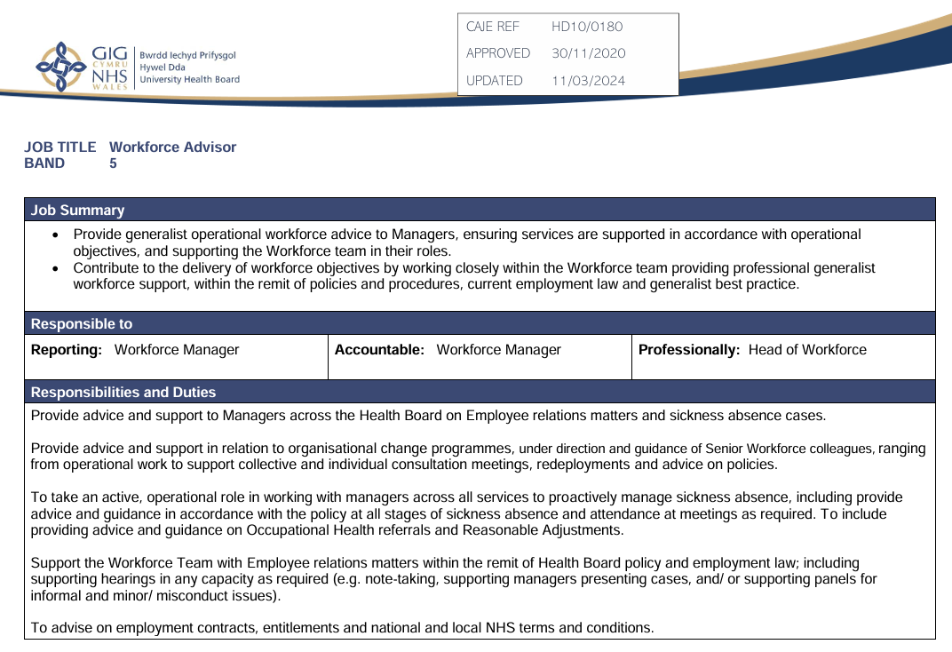
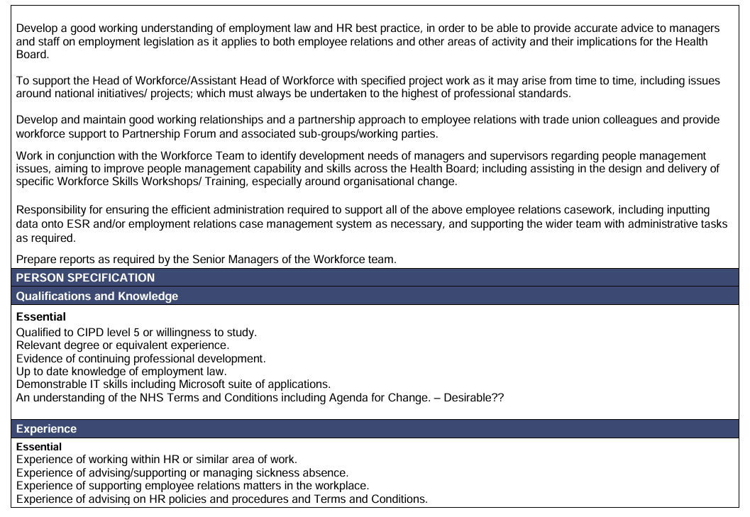

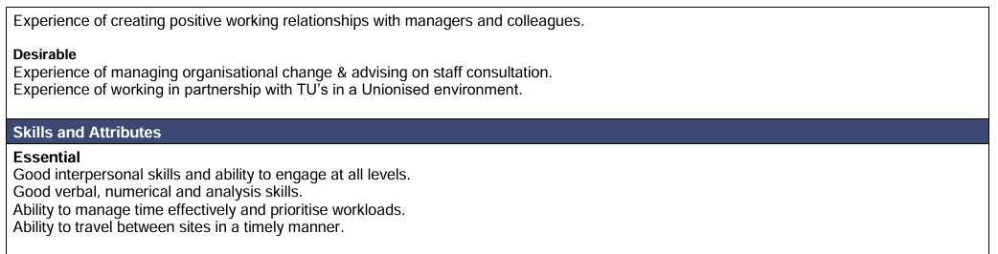

Appendix 2 – Continuous development plan

Development plan

COVERING THE PERIOD FROM: | March 2025 | TO: | February 2026

What do I want / need to learn? | What will I do to achieve this? | What resources or support will I need? | What will my success criteria be? | Target dates for review and completion
(AC 3.1)  Improve my knowledge on inclusive and equitable workplace environments, including best practice to ensure diverse perspectives are valued and listened to. | Attend in house training on ‘Religion and belief’ to improve understanding of differences between religion and belief and how they face discrimination.  Complete CIPD introductory course ‘working inclusively’  Complete CIPD introductory course ‘Valuing People’.  Engage in informal discussions with colleagues | Managers approval to attend course and time needed for attendance.  Possible mentorship from colleagues  Access to online resources | Confidence to deal with diversity-related queries, improved team cohesion, and positive feedback from colleagues on inclusivity efforts. | Review May 2025  Completion target August 2025
(AC 3.1)  Understand legal requirements and responsibilities around reasonable adjustments, including the range of adjustments employers can consider. | Attend in house training course ‘Making reasonable adjustments’  Engage in informal discussions with colleagues and shadow advisor’s meetings regarding this issue.  Review past examples of | Managers approval to attend course and time needed for attendance.  Access to details of past cases for real-life examples and better understanding.  Support from colleagues for practical insights. | Ability and confidence to provide effective advice and guidelines for managers dealing with reasonable adjustment requests.  Positive feedback from colleagues regarding approach and advice given. | Review July 2025  Completion target October 2025
(AC 3.1)  Improve my understanding of AI in the workplace. | Explore CIPD informal resources such as their podcast on ‘how do advances in AI impact HR practice and L&D.  Read case studies on AI integration in organisations for practical insights.  Reach out to colleagues within recruitment and L&D to enquire the extend that AI is used within their departments. | Access to online resources  Co-operation from wider colleagues. | Confidence in my understanding of how AI is used in my organisation. | Review May 22025  Completion target July 2025
(AC 3.1)  Develop a better understanding of reflective practice so that it feels more natural. | Read the book ‘Reflective Practice: Writing and Professional Development’ by Gillie Bolton  Maintain an informal reflective journal to document experiences and insights. | Access to Health board Library  Time to read through resources or write entries in the journal. | Consistently using reflective practices, showing better self-awareness, and seeing noticeable improvements in how I perform at work. | July 2025  Completion target ongoing
(AC 3.1 and AC 3.3)  Enhance theoretical and practical knowledge of people analytics. | Practice using the business intelligence tool to produce data in regard to sickness absence for individuals and departments.  Read CIPD factsheet on people analytics.  Listen to CIPD Podcast ‘Driving performance with people analytics.  Practice using analytical tools, such as Microsoft Excel and Power BI | Access to online resources.  Access to Business intelligence report functions to run reports.  Mentorship/training from colleagues to improve knowledge of in-house practices. | Ability to analyse HR data and generate actionable insights.  Positive feedback from colleagues on the use of analytics in improving HR processes. | Review August 2025  Completion target December 2025
(AC 3.1 and AC 3.3)  Improve proficiency and confidence in utilising digital software commonly used within the department, as well as tools expected to see increased usage in the future. | Enrol on 6-month Microsoft 365 training provided by Pembrokeshire College and select modules for Excel, BI analytics and forms. | Managers approval to enrol on course and study leave to complete modules.  Informal practice using software. | Effective use of Excel for complex tasks, creating insightful BI dashboards, and improved data-driven decision-making. | Review November 2025  Completion target February 2026.
(AC 3.3)  Improve working knowledge of employment law. | Read CIPD employment law updates released in March 2025  Attend in house training session on unconscious bias to help identify issues that could potentially lead to acts of discrimination, particularly in regard to protected characteristics  Read through new policy guidance for pregnancy loss before 24 weeks and neonatal care leave. | Access to online material  Managers approval to enrol on course | Demonstrating a clear understanding of the latest employment law changes and their implications for workplace policies and practices. | Review May 2025  Completion target August 2025
(AC3.3)  Improve understanding of disciplinary process beyond areas I presently support | Attend in house Investigation training designed for investigation officers | Managers approval to attend day long course | Gain familiarity with the proper steps and protocols for conducting effective investigations, as well as demonstrate an increased understanding of the laws, regulations, and organisational policies governing disciplinary investigations.  Gain confidence on how to collect, analyse, and document evidence systematically and impartially.  Learn to create comprehensive and unbiased investigation reports | Completion target May 2025
(AC 3.3)  Improve understanding and application of commonly used employee relations policies | Read through the following policies: Respect and resolution, Capability, Redeployment and Managing attendance at work  Attend Managing attendance at work policy core training  Attend a long term sickness absence deep dive meeting with management.  Shadow colleagues during a respect and resolution process | Mentorship / support form colleagues | Demonstrate a clear grasp of the principles and guidelines within each policy and implement policies effectively in real-world scenarios  Receive positive feedback from colleagues or management about the application of policies | Review August 2025  Completion target January2026
(AC 3.3)  Improve confidence and influence productive outcomes from conversations with colleagues | Attend in house training seminars on ‘The Art of Conversation’ and ‘Effective Communication’ | Managerial permission and time to attend course | Be able to identify any personal barriers to effective communication and apply learned skills to overcome them.  Gained more confidence addressing managers when advising on policy guidelines. | Review October 2025  Completion target January 2026

Appendix 3 – CPD Reflective record


