Targedau / Targets | Sut rydych wedi gweithio ar hwn /  How you have worked on this | Ceir enghraifft ar /  An example can be found on.
Targed/Target 1 | Proof read your assignment | I proof read this assignment several times
Targed/Target 2 | Referencing | I used a full stop after et al rather than a comma.
Targed/Target 3 | More academic tone | I have tried to use a better use of academic vocabulary

Research Project: Case Study based on an Electives Experience.
An Exploratory Case Study Arising from Practice (noticing) and investigated further `through Identified Research tools. The Assignment Concludes with the Identification of an Intervention which can be Piloted throughout Professional Teaching Experience and Evidenced through Reflection in the Professional Learning Standards.
By Kelly Ellis – 2103419.

This small-scale action research study investigates the impact of parental engagement strategies on learners and their grown-ups, implemented by a school. The study is based on an elective school over a five-day period collaboration took place with educational professionals to further the researcher’s knowledge of parental engagement. This reaches the Professional Networks and Communities strand of the Qualified Teacher Status (QTS) Standards (See appendix 1) (Welsh Government, 2019). The school, teaching staff, all learners’ and their grown-ups remain anonymous and fictionally portrayed for the duration of the report. The school will be referred to as the elective school. This provides protection to all participants in accordance with BERA (2018) guidelines. The elective school has 520 registered learners. Over 50% of learners’ families live in poverty.

In 2021 in a school, during a Professional Teaching Experience (PTE), the researcher firstly encountered parental engagement activities the school had implemented. This sparked interest to explore how likely families were to interact when parental engagement was offered. Barriers families may have that prevent them interacting. Learners’ feelings regarding their grown-ups being, or indeed not being involved in their learning. More recently attending the elective school, realising the school was situated in a deprived area enriched the thirst to understand the barriers to parental engagement for low-income families. Equally, the strengths and limitations of the strategies offered by the school.

A research proposal was designed (Appendix 2) and a research question (RQ) posed, ‘What Strategies do KS2 Teachers use to Promote Parental Engagement in their Child’s Learning, and What are Learners’ Perceptions of this?’ However, due to the vast number of strategies implemented by the school, the researcher has refined the findings to two strategies, Springboard, and the Lighthouse Hwb. Narrowing the field of research may gain depth rather than breadth to the conclusion (Cohen et al. 2002). Hence, allow recommendations for future professional practice, therefore, reach the Enabling Improvements strand of the QTS Standard to further my professional development (Welsh Government, 2019). The aim is to explore the strategies using questionnaires, observations, and focus group discussion, to gain qualitative data. After working closely with practitioners at the elective school, there was an expectation to design a presentation and present to the practitioners (Appendix 3). This included providing a recommendation to the elective school for further improvements to strategies they currently have to offer. This reached the Supporting and Developing Others QTS Standard (Welsh Government, 2019).

According to the Welsh Government (2015), if schools seriously collaborate with families as partners in education, they will gain leverage in order to improve standards, learning outcomes and positive wellbeing for learners. The curriculum of Wales takes a holistic approach to teaching and learning (Welsh Government, 2023), where learners gain holistic support (Williams, 2017). Manzon et als’ (2015) research agrees that holistic support is gained through parental engagement in education. Williams (2017) expresses the seriousness of parental engagement with a rationale to ‘raise standards and improve wellbeing’. His rationale focused on raising the attainment of learners through engaging parents who may or may not have access to the resources required to enhance learning opportunities for their children, hence gain equity among learners. The holistic approach inspires practitioners and learners to be the best versions of the Four Purposes of the National Curriculum in their current and future lives. This may suggest key features of an ethical Curriculum may be reached through successful parental engagement with positive learning outcomes achieved through a holistic approach (Welsh Government, 2020).

According to Manzon et al. (2015), there is evidence that suggest ‘family factors’ can determine the achievements of learners. Parental engagement objectives are diverse and differ in schools globally. They express how the government may consider their accountability; improving public image may be the focus of rationale for parental engagement. Likewise, the rationale of schools and teaching techniques, where teachers take accountability for their positionality and responsibility considering the need to gain a solution to equity dilemmas for low-income families. Manzon et al. (2015) explore Hoover-Dempsey and Sandler’s model (1995), consisting of six levels. Level one, the parents’ efficacy to be involved in their child’s learning, parents’ perceptions of invitation from the school, and parents’ lifestyle which include time and energy, personal knowledge and skills, access to community and finances. The elective school use many strategies to encourage parents’ participation in their child’s learning. Sheldon and Turner-Vorbeck (2018) agree with Manzon et al. (2015), this model suggests the family’s engagement begins by the family’s decision to be involved encouraging better outcomes for their children. If there is an aspect of the first level of the model that is ineffective, it may suggest a possible negative impact on the decisions parents make to initially engage.
In view of the need for effective strategic opportunities and parents’ positive motivational decision-making, Garbacz et al. (2017) article may suggest Bronfenbrenner’s (1979) Ecological Systems Theory seems vital. Management of transitions between the bidirectional links may be key when behaviour, educational performance, and whole development may be affected by transitional ineffectiveness; similar to Hoover-Dempsey and Sandlers’ model (1995). The elective school’s knowledge of possible barriers, use of positive language and encouragement may be key to encouraging parents transition to the second level of Hoover-Dempsey and Sandler’s’ model (1995) hence, participate in activities to aid their child’s learning. Likewise, the third level, the parent’s attitude during engagement to positively influence their child’s learning when instructing, encouraging, and modelling reinforcement. This level may closely link to level four, the child’s perception of their parents’ engagement, where the child may then be influenced by their perceptions of the decisions and behaviours of their parents. Therefore, positively, or indeed negatively impact on level five which include self-academic efficacy, intrinsic motivation to learn, self-regulatory strategy, knowledge and use, and social self-efficacy relating to teachers. Hence, determine level six the learner’s achievement outcomes (Sheldon and Turner-Vorbeck, 2018).
It may be ethical to consider the barriers parents may face when receiving invitations from the elective school to participate in parental engagement activities. As suggested in level one of Hoover-Dempsey and Sandler’s’ model (1995), parents’ perceptions of invitations from the school or the concept of parental engagement in general may vary. This may negatively influence a parent’s decision for self-efficacy towards their interaction with the strategy offered (Emerson et al. 2012). Equally, parents’ perception of school and education may vary based on their own past experiences. Parents faith in their own ability and learning capacity plays a huge role in their belief of whether they can or would be willing to contribute appropriately to their child’s learning for them to gain better outcomes (Gonzalez, 2019). There may be opportunities for not merely the practitioner and the grown-up being a More Knowledgeable Other (MKO). For learners whose grown-up requires upskilling in areas the learner is more knowledgeable on, the learner may be the grown-up’s MKO (Abtahi, 2017).

Maslow’s (1943) theory focuses on fulfilling basic human needs such as, breathing, food, water, shelter, clothing, and sleep. He believed it is essential to satisfy lower order needs to gain opportunities to reach higher orders. Higher order needs include safety, love, belonging, self-esteem and achievement, and self-actualisation. Considering over 50% of the learners and their families in the elective school are living in poverty, their lower order needs may be at a higher risk of not being met. This may suggest poorer learning outcomes, lower motivation, and decrease in self-regulation. Maslow’s theory expresses that behaviours are underpinned by meeting lower order needs (Berelson and Thoron, 2014). This may suggest that these learners and their families are vulnerable and have a greater need to access parental engagement opportunities. According to Goodall (2017) statistics show there is a general pattern suggesting deprived children living are more likely to be low achievers later in life. Goodall’s (2017) findings may support the assumption of vulnerability and a greater need for parental engagement to support both the learner and the family in this deprived bracket. Targeting these families may provide better outcomes for the child and further learning for the families.

The researcher used a case study approach for the research study. Primarily, to gain a deeper understanding of the elective school, practitioners, learners, and the surrounding community; gathering evidence to provide clarity on a parental engagement. According to Hamilton and Corbett-Whittier (2012), Stenhouse (1978,1979) believed a case study approach encapsulates complexity; data gained may be used to enrich decision-making however, the case studies must be verifiable. Their further research explains how Yin (1983), describes in his book Yin (2009), three forms of case study: exploratory, descriptive, and explanatory. Exploratory, discovering patterns or sequences in data. Descriptive, considering theories scaffolding the study gaining focus through questioning. Explanatory, using the prior steps to conclude the study. Hamilton and Corbett-Whittier’s (2012) research further expressed how Merriam’s (1988) explained case study to be a holistic intense analysis and description social units. Further described as being more focused on a process as a whole or an outcome rather than describing the process. Like Yin (1983), Merriam’s (1988) theory focused on three elements to a case study, particularistic, descriptive, and heuristic. Particularistic, a specific focus being investigated. Descriptive, a literal description of the focus. Heuristic, an understanding of what is being investigated, how the variables affect one another with an intention to lead to a potential discovery and conclusion. Stake’s (1975) description of case study links closely with Yin (1983) and Merriam (1988) describing case study as a choice of what focus is being investigated rather than a focus on a method. An opportunity to shape a unique case giving readers an understanding of the chosen focus. A provision of depth to uncover new discovery using the power of interpretation. Stake (1975) emphasises an opportunity to use multiple approaches in a single case study to create definition and provide the best process of investigation and understanding. However, according to Yazan (2015), Yin (1983) primarily based his description of case study on social sciences, Merriam’s (1988) description is based more generally as a research method and how her description can be applied to a case study. Stakes’ (1975) description of case study is most fitting to the researcher’s field of research as he directed hs research at students using methodology in their research study. In view of this it may be worthy to consider the strengths of each description of case study in different fields or scenarios of study. Yin (1983), Merriam (1988), and Stakes’ (1975) work seems to have a qualitative bias due to their background in the qualitative research field, potentially narrowing their views and strengths of case study as an approach. In this report the researcher has conducted a research study to gather qualitative data in an educational setting. The participants are practitioners, learners, and their grown-up’s; Stake’s (1975) description of case study was most suited with consideration and use of Yin (1983) and Merriam’s (1988) descriptions were applied if required.

The researcher began their study designing a RQ underpinned by parental engagement as a focus. The aims of the study were to explore the strategies offered by the school and the learners’ perceptions of parental engagement. Communication was made with the elective school via email (Appendix 4) prior to the visit to identify key professionals in the field of parental engagement. Requesting to meet with them to gather knowledge on what they do, why they do it, and the intended impact. The professionals included the elective school’s Community Focused School Manager, Attendance Officer, Springboard Advisor, and the year 5 and 6 teacher leads. A questionnaire was sent to all practitioners in KS2 via Microsoft Forms a day before arrival (see appendix 5). This was to gain a deeper understanding of the impact of the strategies implemented. According to Cohen et al. (2002) and correlating with this study, questionnaires are the preliminary stage of the study. This seems to be supported by Busetto et al. (2020) who agrees the purpose of a questionnaire is underpinned with the RQ as the title then the questions scaffolded around the RQ. There were open ended questions to gain qualitative feedback on multiple strategies of parental engagement deciding what works well and why; equally, what may not work well and why not (Busetto et al. 2020). Cohen et al. (2002) explain the second stage of the process is identifying the sub-topics relating to the RQ. This study was identifying the strategies used, the level of response from the families, strengths and limitations, possible barriers, provision in place to tackle the barriers, and the educational and behavioural impact on learners and their families. The final stage was identifying and itemising the topics which required narrowing the research for more specific data into Springboard and the Lighthouse Hwb. This stage was supported from the communications made with the key professionals who gave more in-depth discussions around the questions posed in the questionnaires. There were a range of questionnaire methods used throughout, beginning with a dichotomous question that requested a yes/no response. Multiple-choice questions to provide a variety of choice to gain a more than one response if necessary. A rating scale was used to create differentiation between practitioners and year groups. Open-ended questioning was the most used to gain more personal answers with an element of honesty (Cohen et al. 2002). However, questionnaires may bare limitations such as, misinterpretation by the readers, lack of responses, the issue of if the same questions were asked to a different group of practitioners would the results be different (Young, 2015). Having only had three responses this may have been a limitation for the researcher as there was very little data to analyse.

Secondly, as a non-participant an observation of a Springboard session for 30 minutes (Appendix 6) gaining insight of the techniques and activities the agency provided. The participants consisted of the Springboard advisor, the learners, and their grown-ups. The observation enabled a deeper contextualised understanding of the behaviours and engagement in the Springboard setting (Clarke et al. 2020). Being in the same setting as the participants allowed the researcher to monitor the physical, human, interactional, and programme setting. Assessing and recording data regarding the environment, organisation of people, levels and behaviours of interaction, and resources (Appendix 6). Taking into consideration the identified and narrowed sub-topics from the questionnaire. Observation in the live setting may give an experience in that moment reducing the risk of missed opportunities for recording data (Cohen et al. 2002). Extensive consideration was made of the limitations of observation in relation to the study during the Springboard session. All humans have their own views and opinions on topics being researched. Being bias towards your own knowledge and opinions must be avoided during observation. Moreover, consideration of the session only being 30 minutes, recording the behaviours of participants who the researcher has never met and has no idea of their personal circumstances beyond the session (Kawulich, 2012).

Finally, a small group discussion prompted with open-ended questions. The participants were two year four learners and two year five learners. The researcher intended to have one learner from each year group in KS2 however, years three and year six were unavailable for this study. Located in a quiet area providing confidentiality, comfort for the learners participating moreover, protection for the researcher. The researcher designed a script (see appendix 7) and an observation schedule to record the data from the discussion (see appendix 8). This was designed with relevance to the focus of the study, and to capture an array of feedback during discussion with a consistent format for all participants (Rizvi, 2010). To begin the discussion, the researcher wanted to connect with the learners due to them meeting an unfamiliar adult discussing potentially sensitive topics. Vital the researcher did not assume there were no vulnerable participants. According to Bates (2021) these learners may feel at risk around a new adult and may perform differently in terms of this study, potentially answer questions dishonestly due to feeling insecure. It is vital all learners to feel safe which is why the researcher wanted to build an initial connection for an increased opportunity of engagement and accuracy of discussion. This was done by fully explaining the purpose of the visit followed by playing a game of who am I? Secondly, asking the learners to draw a picture that symbolise how they feel about parental engagement. The researcher opted for a small focus group to gain shared and factual experiences from the experts being the participants (Busetto, 2020). The script had an order of the discussion and semi-structured format to provide flexibility and opportunity to adapt the questions (Kallio et al. 2016) avoiding missing opportunities to obtain more accurate data. The discussion may support the research study by exploring the learners’ perceptions of parental engagement considering their own experience or lack of experience with strategies used by the school. They may express if they feel there are strengths or limitations to the strategies and how they believe it impacts their wellbeing with their experience of parental engagement. To avoid quieter participants being overshadowed by more dominant participants the learners were each given resources that allowed them to be heard (see Appendix 9). This gave all learners the opportunity for discussion potentially gaining more accuracy of data. When one learner shares their idea, it may prompt another in the group to elaborate or build on what the previous learner shared; or help them remember points they would like to discuss leading to a positive flow of discussion. Additionally, there was a resource for if anyone did not wish to speak when asked a question if the topic was too sensitive for them. Once the discussion had taken place each learner then had the opportunity to discuss their drawing. The purpose of this was to accommodate the limitation for any participant who had not been able to engage vocally. They may have preferred to engage through the language of drawing what they would like to express (Edwards et al. 2011). For both questionnaire and focus group method, ensuring to avoid the limitation of asking leading questions, complex questions mainly for the focus group, using negatives in the questions to encourage negative feedback, and asking questions that may be too sensitive was key for an increased chance of engagement (Cohen et al. 2002).

To give the data credibility and trustworthiness the researcher adopted a triangulation approach, using a variety of research tools to locate identifiable sequences in data (Stahl and King, 2020). Moreover, additional analytical methods within the procedures. The questionnaire not only had written feedback but graphical representation of the data. According to Sadiku et al. (2016), representation of data from multiple sources is effective using graphical representation. Equally, makes easier sense of data allowing comprehension of information, discovery of pattern, and formation of opinion. The observation was not only live analysis of the Springboard session but complimented by thick descriptive notes. According to Younas et al. (2023) thick description provides a thorough report of the participants overall reality in the session such as, their understanding, views, motives, and circumstances. Finally, the focus groups’ observation schedule was accommodated by the picture drawn by the participants at the beginning of the session. This provided raw visual material for data presentation. Coinciding with the researcher recording feedback from questions posed to participants on the observation schedule. This helped provide clarity for the researcher to identify a pattern in the data. Therefore, possibly gaining transferability and confirmability to the data being analysed giving the data presentation trustworthiness.

Reporting data accurately may be vital to achieve credibility for this report therefore, Braun and Clarke (2006) would argue thematic analysis the most effective method for locating patterns in data. However, Boyatzis (1998) would disagree with thematic analysis being a method but rather a tool for dissecting data. When thematically analysing data, the researcher was mindful of their positionality and did not give voice to their participants avoiding any bias views (Braun and Clarke, 2006). Maguire and Delahunt (2017) are inspired by Braun and Clarkes’ (2006) six phase framework of thematic analysis which was used for this report. To analyse the data, the researcher read through the questionnaire responses, observation notes, and observation schedule numerous times to gain familiarity with the data. The data was then organised and refined using the knowledge of the strategies implemented by the school, through the meetings with key professionals, versus the interaction and behaviour of participants at the Springboard session, and feedback from the learners in the focus group. The researcher identified themes in the data collected from the triangulation that revealed an interesting pattern in the efforts of the school and the needs of the learners and their families. The themes were each separately reviewed and concluded on the PowerPoint presentation. This allowed refinement to essentially capture the essence of the efforts the school is making, and areas parental engagement is most needed. Equally, the explicit impact parental engagement is having on the learners and their families. Moreover, what could further improve the school’s efforts for the learners and their families in this deprived area (Maguire and Delahunt, 2017). It was vital for the researcher not to confuse the questions being posed for themes and risk a lack of analysis but rather summarisation and organisation of data (Javadi and Zarea, 2016).

The researcher made ethical considerations throughout the study. The participants were fully informed of the nature of the study via the documents sent to the school prior to the study. A yes/no option box and description at the beginning of the questionnaire (Appendix 5), and verbal description of the right to withdrawal, confidentiality, and anonymity at the beginning of the focus group (Appendix 7). Along with the research proposal (Appendix 2) and letter to the school (Appendix 4), there was a letter for the parents, and a form to consent to their child’s participation; also assent forms (Appendix 10) for the learners participating (BERA, 2018). It was important in this study to uphold Article 12 of the United Nation Conventions of the Rights of the Child (UNCRC), which states all children have the right to voice their feelings, views, and desires of the experiences that affects them. These views were highly considered throughout their participation. Moreover, the participants would be made aware that Article 16 of the UNCRC their right to keep aspects of their life private and confidential would be honoured (UNICEF, 1989). This was vital due to the nature of the focus on their family life which may contain sensitive data. However, if there was any feedback that was deemed to be a safeguarding issue this would have to be shared with the appropriate key professional for the safety of the learner.

To permit the researcher access to the elective school a secure procedure was essential to follow. A comprehensive, extensive, National Ethics Application Form (NEAF) (Appendix 11) was completed and submit prior to the elective school visit. The structured NEAF gave in-depth details of the research proposal such as the purpose and aims of the elective week. The process and information provided to all participants. An explanation of how all participants rights will be protected by anonymity and confidentiality. Data protection measures, data management, direct data and raw material being destroyed. The plan in place for analysing, storing, and sharing data. How feedback would be shared with participants once research had been analysed (Liaw and Tam, 2015).

Through analysis of data compiled using the triangulation of research methods for investigation, there is a consensus of the need for parental engagement in education. Springboard supports learners and their family with education. The Lighthouse Hwb supports low-income families in gaining access to basic humanitarian essentials for their day-to-day living.

Firstly, the researcher analysed the data collected regarding Springboard. It was clear most of the focus group had been to Springboard in the past and had highly regarded memories. One of the participant’s spoke of how their Mum went on from attending Springboard to volunteering in the school and is now employed as a cleaner by the school. This may suggest Springboard may have supported the learner’s grown-up through collaborating with the school possibly building their confidence, self-value, and self-belief. The sessions may have given them the foundation required providing improvements to their current skill level guiding them towards employment through volunteering opportunities (Paine et al. 2013). When the researcher observed the Springboard session (Appendix 6), It was evident how enthusiastic the Springboard tutor was. Likewise, it was clear most of the participants were elated to have their grown-up in school. There were lots of happy faces and one participant sitting on their grown-up’s lap having a cuddle. However, the objective of the session was to create a PowerPoint of their experiences throughout the Springboard term. Each table had a slide with a different title. One table had the title ‘discovery’ and had to insert images and text about what they had discovered during a trip to St Davids Cathedral. One grown-up was getting very frustrated as they could not understand how to do the given ICT task, and was clear they had little, if no ICT skills at all. They seemed to be struggling to comprehend the word ‘discovery’ and began to raise their voice using negative vocabulary. The more the grown-up was getting frustrated the learner was mirroring their behaviour, repeating the words of their grown-up. The tutor used positive language to deescalate the situation. This may support Garbacz et al. (2017)’s views on the importance of bi-directional transitions and level three of the Hoover-Dempsey and Sandlers’ model (1995) (Sheldon and Turner-Vorbeck, 2018). According to Ghilay and Ghilay, (2015) the grown-up may have felt a feeling of failure due to their inability to help their child which may give weight to (Gonzalez, 2019) views of inferiority. However, it may be more important for this grown-up to have the opportunity of Springboard to further their ICT skills and gain confidence which may radiate to their child.

There seems to be a pattern in the practitioners’ perception of the benefits of parental engagement. The pattern shows the learner and their grown-up; the family and the school pulling closer together collaborating, raising the confidence of the learner in the classroom. The learners' perceptions seem favourable, which suggests an improvement to their wellbeing. Moreover, the support on offer from the Lighthouse Hwb may undoubtedly be a lifeline for a deprived, given over half of the school are living in poverty. Learners’ families have sourced beds, electric tokens, clothing, toiletries, and much more. Supporting the parents with lower order needs may only impact positively on the learners' ability to function more effectively in school (Berelson and Thoron, 2014). For example, if a learner has no bed to sleep on and is sleeping on the floor or in the bath, how can they possibly be ready for learning in the morning. Moreover, builds positive, trusting relationships between the school and the learners' families making engagement more likely. Goodall (2017) may suggest a possibility in a raise in attainment levels when basic needs are met hence, learners may then be ready for learning.

It is evident that strategies the teachers use in school to promote parents' engagement with their child's learning is very effective and has a positive impact on the wellbeing of the learners. Likewise, the potential educational progression of their grown-ups leading to the possibility of employment, which may improve family life for the learner. Equally, the positive impact the pastoral support, with a holistic approach (Welsh Government, 2020) has on learners and their families in a deprived area, providing equity among learners (Williams, 2017). It may require wider, more complex research to gage positive learning outcomes for the learners in terms of raise in attainment. Likewise, how much parental engagement provides improvements of the wellbeing of all participants. There were only three responses to the questionnaires. The focus group consisted of 4 learners which may not provide the most accurate results when considering the school has 520 registered learners. Although the results may be fairly consistent with so many learners in the school and such a diverse culture, there may need to be a larger sample size of participants to draw on a more valid conclusion (Memon et al. 2020). For future research development the researcher would like to open the research study to the whole school. This may allow a wider range of participant age groups, and a better response rate from practitioners, for better data opportunities.

The researcher understands the importance of collaboration to give further opportunities to a well-oiled vision enabling school effectiveness, and development (Muckenthaler et al. 2020). Taking into consideration the response from the 4 learners in the focus group, when asked what the school could do to help bring learners and their grown-ups together to support their learning (more access to sport, homework, Maths, Literacy, and Science). Then considering the possibility of lack of resources in the home setting and the need to extend some parents skills (Lamb et al. 2020). The researcher recommends Successful Kinaesthetic Instruction for Primary schoolers (SKIP), for its impact on tackling developmental delay among disadvantaged and vulnerable learners. Additionally, understanding and interlinking the need to further whole family’s education with encouragement of all participants being an MKO in collaboration with each other in areas of the SKIP gardens they excel more at (Abtahi, 2017). SKIP will allow parents and learners to learn together participating in several Areas of Learning (AoLE’s) in the same session using school resources (Altunsoz and Goodway, 2015). If there is an opportunity to provide an after-school session for learners and their families to come together to participate in the SKIP garden sessions. This may meet all four of the learners', and their grown-up’s needs in one session.

Reference List
Abtahi, Y. (2017). The ‘More Knowledgeable Other’: A Necessity in the Zone of Proximal Development?.. for the learning of mathematics, 37(1), pp.35–39.
Altunsöz, I.H. and Goodway, J.D. (2015). SKIPing to motor competence: the influence of project successful kinesthetic instruction for preschoolers on motor competence of disadvantaged preschoolers. Physical Education and Sport Pedagogy, 21(4), pp.366–385. doi:https://doi.org/10.1080/17408989.2015.1017453.
Bates, A. (2021). ‘Miss, I don’t give a sh*t’ engaging with challenging behaviour in schools. Los Angeles: SAGE, pp.35–36.
BERA (2018). Ethical Guidelines for Educational Research, Fourth Edition (2018). [online] Bera.ac.uk. Available at: https://www.bera.ac.uk/publication/ethical-guidelines-for-educational-research-2018-online#privacy.
Boyatzis, R.E. (1998). Transforming qualitative information: Thematic analysis and code development. Thousand Oaks, Ca: Sage Publications.
Braun, V. and Clarke, V. (2006). Using thematic analysis in psychology. Qualitative Research in Psychology, 3(2), pp.77–101. doi:https://doi.org/10.1191/1478088706qp063oa.
Burleson, S. and Thoron, A. (2014). Maslow’s Hierarchy of Needs and Its Relation to Learning and Achievement 1. [online] Available at: http://knowen-production.s3.amazonaws.com/uploads/attachment/file/2007/Maslow_E2_80_99s%2BHierarchy%2Bof%2BNeeds%2Band%2BIts%2BRelation%2Bto%2BLearning.pdf.
Busetto, L., Wick, W. and Gumbinger, C. (2020). How to Use and Assess Qualitative Research Methods. Neurological Research and Practice, [online] 2(1), pp.1–10. doi:https://doi.org/10.1186/s42466-020-00059-z.
Clark, J.S., Porath, S., Thiele, J. and Jobe, M. (2020). Collecting Data in Your Classroom. [online] kstatelibraries.pressbooks.pub. Available at: https://kstatelibraries.pressbooks.pub/gradactionresearch/chapter/chapt5/.
Cohen, L., Manion, L. and Morrison, K. (2002). Research Methods in Education. Routledge, pp.248–305.
Edwards, C., Gandini, L. and Forman, G. (2011). The Hundred Languages of Children: The Reggio Emilia Experience in Transformation. [online] Google Books. Bloomsbury Publishing USA. Available at: https://books.google.co.uk/books?hl=en&lr=&id=MQjJEAAAQBAJ&oi=fnd&pg=PT7&dq=Reggio+Emilia+drawing+as+a+language&ots=ejAu6Gp_Ky&sig=aXjTjrJvWkTB32gWCXwJMr5bbS4&redir_esc=y#v=onepage&q=Reggio%20Emilia%20drawing%20as%20a%20language&f=false [Accessed 3 Jan. 2024].
Emerson, L., Fear, J., Fox, S. and Sanders, E. (2012). Parental engagement in learning and schooling: Lessons from research. A report by the Australian Research Alliance for Children & Youth for the Family-School and Community Partnerships Bureau. [online] Available at: https://www.communityhubs.org.au/wp-content/uploads/2017/10/Parental_engagement_in_learning_and_schooling_Lessons_from_research_BUREAU_ARACY_August_2012.pdf.
Garbacz, S.A., Herman, K.C., Thompson, A.M. and Reinke, W.M. (2017). Family engagement in education and intervention: Implementation and evaluation to maximize family, school, and student outcomes. Journal of School Psychology, 62, pp.1–10. doi:https://doi.org/10.1016/j.jsp.2017.04.002.
Ghilay, Y. and Ghilay, R. (2015). PISMS: Parental Influence on Student Motivation and Self-esteem in Primary Education. Journal of Studies in Education, 5(4), p.165. doi:https://doi.org/10.5296/jse.v5i4.8510.
Gonzalez, C. (2019). The Role of Parents in Education Transformation: A Needs Assessment Guide. [online] hundred.org. Available at: https://hundred.org/en/articles/the-role-of-parents-in-education-transformation-a-needs-assessment-guide#:~:text=In%20turn%2C%20a%20parent%27s%20sense [Accessed 21 Dec. 2023].
Goodall, J. (2017). Narrowing the Achievement Gap: Parental Engagement with Children’s Learning. [online] Google Books. Taylor & Francis. Available at: https://books.google.co.uk/books?hl=en&lr=&id=MiQlDwAAQBAJ&oi=fnd&pg=PP1&dq=parental+engagement+and+poverty&ots=MiIUabtIMk&sig=P89JeszX2tpUZIh-PGVLMUKYeNg&redir_esc=y#v=onepage&q=parental%20engagement%20and%20poverty&f=false [Accessed 21 Dec. 2023].
Hamilton, L. and Corbett-Whittier, C. (2012). Using Case Study in Education Research. [online] Google Books. SAGE. Available at: https://books.google.co.uk/books?hl=en&lr=&id=h5tzhDcQ0CoC&oi=fnd&pg=PP1&dq=what+is+a+case+study+approach+to+research+in+education&ots=8Jtg3vJXlA&sig=1mL8iC6OLfv6WWCB00k7SbPt66s#v=onepage&q=what%20is%20a%20case%20study%20approach%20to%20research%20in%20education&f=false [Accessed 2 Jan. 2024].
HWB (2023). Enabling learning - Hwb. [online] hwb.gov.wales. Available at: https://hwb.gov.wales/curriculum-for-wales/designing-your-curriculum/enabling-learning.
Javadi, M., and Zarea, K. (2016). Understanding Thematic Analysis and Its Pitfall. [online] ResearchGate. Available at: https://www.researchgate.net/publication/307179806_Understanding_Thematic_Analysis_and_its_Pitfall.
Kallio, H., Pietilä, A.-M., Johnson, M. and Kangasniemi, M. (2016). Systematic Methodological review: Developing a Framework for a Qualitative semi-structured Interview Guide. Journal of Advanced Nursing, 72(12), pp.2954–2965.
Kawulich, B. (2012). Collecting Data Through Observation. [online] ResearchGate. Available at: https://www.researchgate.net/publication/257944783_Collecting_data_through_observation.
Lamb, S., Maire, Q., Doecke, E., Macklin, S., Noble, K. and Pilcher, S. (2020). Impact of learning from home on educational outcomes for disadvantaged children: brief assessment.
Liaw, S. and Tam, C., W.M., (2015). Research ethics and approval process: A guide for new GP researchers. PubMed, 44(6), pp.419–22.
Maguire, M. and Delahunt, B. (2017). Doing a thematic analysis: A practical, step-by-step guide for learning and teaching scholars. Doing a Thematic Analysis: A Step-by-Step Guide for Learning and Teaching Scholars, 9(3).
Manzon, M., Miller, R., Hong, H. and Khong, L. (2015). Parent Engagement in Education NIE Working Paper Series No. 7. [online] Available at: https://repository.nie.edu.sg/server/api/core/bitstreams/7dc4698c-229c-493c-8484-c3efa30677e4/content.
Memon, M.A., Ting, H., Cheah, J.-H., Thurasamy, R., Chuah, F. and Cham, T.H. (2020). Sample Size for Survey Research: Review and Recommendations. Journal of Applied Structural Equation Modeling, 4(2), pp.i–xx. doi:https://doi.org/10.47263/jasem.4(2)01.
Muckenthaler, M., Tillmann, T., Weiß, S. and Kiel, E. (2020). Teacher collaboration as a core objective of school development. School Effectiveness and School Improvement, 31(3), pp.1–19. doi:https://doi.org/10.1080/09243453.2020.1747501.
Owen, R. (2018). REDUCING THE IMPACT OF POVERTY ON EDUCATIONAL ACHIEVEMENT. [online] Gwegogledd Cymru. Available at: https://www.gwegogledd.cymru/wp-content/uploads/2018/03/Case-Study-St-Mark%E2%80%99s-Church-in-Wales-VA-Primary-School-Pembrokeshire.pdf.
Paine, A.E., McKay, S. and Moro, D. (2013). Does volunteering improve employability? Insights from the British Household Panel Survey and beyond. Voluntary Sector Review, 4(3), pp.355–376. doi:https://doi.org/10.1332/204080513x13807974909244.
Rahman, M. (2019). Advantages and disadvantages of questionnaires | howandwhat. [online] howandwhat. Available at: https://www.howandwhat.net/advantages-disadvantages-questionnaires/.
Rizvi, M. (2010). Development of a classroom observation schedule for measuring the efficacy of a teacher development programme. Procedia - Social and Behavioral Sciences, 2(2), pp.654–660. doi:https://doi.org/10.1016/j.sbspro.2010.03.079.
Sadiku, M.N.O., Shadare, A.E., Musa, S.M. and Akujuobi, C.M. (2016). DATA VISUALIZATION | International Journal of Engineering Research and Advanced Technology (ijerat). ijerat.com, [online] 2(12). Available at: https://ijerat.com/index.php/ijerat/article/view/191/197.
Sheldon, S.B. and Turner-Vorbeck, T.A. (2018). The Wiley Handbook of Family, School, and Community Relationships in Education. [online] Google Books. John Wiley & Sons. Available at: https://books.google.co.uk/books?hl=en&lr=&id=6zeBDwAAQBAJ&oi=fnd&pg=PA421&dq=hoover+and+dempsey+model&ots=sGyc3QRIT1&sig=nTjXgjyOBNFmEIlP1x6O10wbl-Q&redir_esc=y#v=onepage&q=hoover%20and%20dempsey%20model&f=false [Accessed 21 Dec. 2023].
Stahl, N. and King, J. (2020). (PDF) Expanding Approaches for Research: Understanding and Using Trustworthiness in Qualitative Research. [online] ResearchGate. Available at: https://www.researchgate.net/publication/346425936_Expanding_Approaches_for_Research_Understanding_and_Using_Trustworthiness_in_Qualitative_Research.
UNICEF (1989). Convention on the Rights of the Child. [online] Unicef. Available at: https://www.unicef.org/child-rights-convention/convention-text.
Welsh Government (2016). FaCE the challenge together: Family and community engagement toolkit for schools in Wales Main guidance Family and community engagement toolkit. [online] Available at: https://www.gov.wales/sites/default/files/publications/2018-12/face-the-challenge-together-family-and-community-engagement-toolkit-for-schools-in-wales-main-guidance.pdf.
Welsh Government (2019). Professional Standards for Teaching and Leadership. [online] Available at: https://hwb.gov.wales/api/storage/19bc948b-8a3f-41e0-944a-7bf2cadf7d18/professional-standards-for-teaching-and-leadership-interactive-pdf-for-pc.pdf.
Welsh Government (2020). Developing a vision for curriculum design - Hwb. [online] hwb.gov.wales. Available at: https://hwb.gov.wales/curriculum-for-wales/designing-your-curriculum/developing-a-vision-for-curriculum-design.
Yazan, B. (2015). Three Approaches to Case Study Methods in Education: Yin, Merriam, and Stake. The Qualitative Report, 20(2), pp.134–152. doi:https://doi.org/10.46743/2160-3715/2015.2102.
Yin, R.K. (2009). Case Study Research: Design and Methods. [online] Google Books. SAGE. Available at: https://books.google.co.uk/books?id=FzawIAdilHkC&printsec=frontcover#v=onepage&q&f=false [Accessed 2 Jan. 2024].
Younas, A., Fàbregues, S., Durante, A., Escalante, E.L., Inayat, S. and Ali, P. (2023). Proposing the ‘MIRACLE’ Narrative Framework for Providing Thick Description in Qualitative Research. International Journal of Qualitative Methods, 22, p.160940692211471. doi:https://doi.org/10.1177/16094069221147162.
Young, T. (2015). Questionnaires and Surveys. [online] ResearchGate. Available at: https://www.researchgate.net/publication/316228107_Questionnaires_and_Surveys.

Appendix

Appendix 1 – Professional Experience Template

Please give a title to your experience....
Elective Week for Assignment 6010

Professional Experience

This template is intended to help you reflect upon your professional experiences and, if you choose, to link and reflect upon the experiences in relation to the professional standards. Professional experiences can include a wide range of activities including working with individual learners or groups, being observed and receiving feedback, observing good practice, collaboration with colleagues, coaching and mentoring, action research and other professional learning activities. You can choose to attach relevant materials using the dedicated field below. Alternatively, you can attach relevant materials within your narrative - simply highlight the relevant word, sentence or paragraph and select link, then asset, from the toolbar which pops up and follow the on-screen prompts.

If you’re an NQT and you’re looking for help on completing the experience template, you can access the Consortia’s guidance here.
When was this experience?
From:

To:
Single date Add an end date Ongoing

What did you do and why?

Describe your professional experience. You may wish to refer to your role or involvement, why you had engaged in this experience and the intended outcomes. You can also mention any particular professional standards you had chosen to focus on (see below).
Professional Networks and Communities
I attended an elective school to conduct a research study to gather data to analyse and conclude which would allow me to write an assignment. This small-scale action research study investigates the impact of parental engagement strategies on learners and their grown-ups, implemented by the school. I collaborated with educational professionals to further my knowledge of parental engagement.

Enabling Improvements
A research proposal was designed and a research question (RQ) posed, ‘What Strategies do KS2 Teachers use to Promote Parental Engagement in their Child’s Learning, and What are Learners’ Perceptions of this?’ However, due to the vast number of strategies implemented by the school, refined the findings to two strategies, Springboard, and the Lighthouse Hwb. Narrowing the field of research may gain depth rather than breadth to the conclusion (Cohen et al. 2002). Hence, allow recommendations for future professional practice.

Supporting and developing Others
There was an expectation to deliver a presentation at the end of elective week to the practitioners. At the end of the presentation I had to make recommendations for the schools further development.

What have you learned?

You might want to consider some of the following: why is this experience important or relevant? How does it relate to your overall learning, development and/or use of the standards (see below)? Did it meet the intended outcomes? Any lessons learned? What are the implications for colleagues and learners? How will you share what you’ve learned?
Professional Networks and Communities
It is important through collaboration with other practitioners to make adaptions and improvements to what already works or what may not be working so well. Working together can help inspire each other with a variety of views and new found knowledge of the views of others.
Enabling Improvements
Listening to the key professionals gave me an insight into strategies that I can use in my future teaching practice and allowed me to make my voice heard through analysing and concluding what I had seen and heard from their practitioners, the parents, and the learners. The experience enabled me to write a 4500 word essay on what I had discovered and concluded. I discovered how learners mirror the actions of their grown-ups which I can take with me and consider when conducting parental engagement activities in my own practice and make good use of positive language at all times.
Supporting and developing Others
Through research it is possible to make discovery into what I do not know and gain a deeper understanding of what I already know. Without the experience of electives week I would not have the intense knowledge and understanding of parental engagement sourced first hand from the participants, the experts. This experience will allow me to instil that knowledge into my peers and use the new strategies gained on my learners in the future.

Linking to the professional standards

You may wish to reflect on how your experience links to your professional standards. This will feed into your standards workbook (available on your dashboard) and create a record of your professional experiences in relation to your standards.

You can use the blue buttons below to explore the standards relevant to you or link your experience to them.

Professional standards for teaching and leadership

Professional Learning
- Professional networks and communities

Collaboration
- Supporting and developing others
- Enabling improvement

Professional standards for FE & Work-Based Learning

Professional standards for assisting teaching

Youth Work

What next?

Is there anything you intend to do as a result of this experience? You might want to consider some of the following questions: Are there any specific actions that you will take? What would you do in similar circumstances in the future? Is there anything you intend to change? Do you have plans for any further learning or development opportunities? If so, who or what can help - using the standards, people, written resources, online materials, workshops etc? How will you share what you’ve learned?
Professional Networks and Communities
I will continue to collaborate with all practitioners and other schools wherever possible to gain thoughts and ideas from others. If I was to conduct research again, I would have a larger sample. There were only three responses to the questionnaires. The focus group consisted of 4 learners which may not provide the most accurate results when considering the school has 520 registered learners. Although the results may be fairly consistent with so many learners in the school and such a diverse culture, there may need to be a larger sample size of participants to draw on a more valid conclusion (Memon et al. 2020). For future research development the researcher would like to open the research study to the whole school. This may allow a wider range of participant age groups, and a better response rate from practitioners, for better data opportunities.
Enabling Improvements
I would like to keep an open mind of what works in terms of strategies I will implement and collaborate with learners and fellow practitioners through research tools in my future practice. I would like to adopt my own recommendation if I have the opportunity in my future professional practice and use Springboard and provide access such as the Lighthouse Hwb for families too.
Supporting and developing Others
I would like to draw on my experience and give advice to anyone who may benefit from my experience in the future. I believe reflection is key to progression and allows me to question what went well and what I need to do to make changes to fit the goal I am aiming to achieve. I next would like to use my new knowledge to make improvement to the lives of learners and their families through collaboration and providing resources needed to live daily that many take for granted. I will use further research to achieve my goal of gaining a richer knowledge of what I have learnt from this experience.

Relevant materials or supporting evidence

Attach here any relevant materials such as documents, images, video clips, examples of learners' work etc.
Before uploading a file, you must remove or anonymise any personal data (that does not belong to you) contained in the file to ensure that no individual(s) can be identified from the information. Your organisation’s (school/institution/employer) data protection policies and procedures must also be followed together with any other relevant policies.

Appendix 2 – Research Proposal

ECAD6010

What strategies do KS2 teachers use to promote parental engagement in their child’s learning and what are learners’ perceptions of this?

The rational.

There is evidence that suggests ‘family factors’ can determine the achievements of learners. Parental engagement is enforced in schools worldwide however, the objectives are diverse and differ in each school. The government may consider their accountability where improving public image may be the focus of rationale for parental engagement in schools. This may also be like the rationale of schools and teaching techniques; where teachers take accountability for their roles and responsibilities when considering the need to gain a solution to equity dilemmas. A vast array of schools promotes communicative and often in person engagement between teachers and parents, additionally more heavily between parents and their children in and out of the school setting. This is a bidirectional vision between the maesosystem and macrosystem of Bronfenbrenner’s ecological systems. A parent’s main rationale for their engagement may be to make improvements to the consistency of the microsystem and to aid their child’s progress. However, there is a possibility of critique when considering the resources available to children in their own environment away from the school and the parent’s willingness to engage (Manzon et al, 2015).
The curriculum of Wales takes a holistic approach to teaching and learning (HWB, 2023) where the learners gain holistic support (Williams, 2017). This links with Manzon et als’ (2015) research that expresses holistic support is gained through parental engagement in education. Williams (2017) also expresses the seriousness of parental engagement with a rationale to ‘raise standards and improve wellbeing’. His rationale focused on raising the attainment of the learners through parental engagement who may and may not have access to the resources required to enhance learning opportunities, hence gain equity among learners.

The researcher would like to explore the strategies used by a school, the level of response of engagement from learners and their families and how the learners feel about their experience or lack of experience of parental engagement.

The aim of the research study is to explore what strategies a school has implemented to encourage parents’ engagement with their child’s learning. To explore the learners’ thoughts and opinions of parental engagement. This study will allow the researcher to answer the above research question once analysis has taken place. The researcher will spend five days at a school to execute the following elements of study:

Identify:
To identify a lead member of staff who implements parental engagement strategies used by the school. The researcher will gain knowledge of each strategy used and what impact each strategy has on the learners and their family. Moreover, the level of engagement with the strategies from the learners and their families. The researcher will also discuss the positive attributes and the limitations of each strategy.

Questionnaires:
A structured online questionnaire will be sent to all staff in KS2 on google forms to gather data to help with the researcher’s analysis. The questionnaires will begin with broad questions for example, how important do you feel parental engagement is for a learner’s progression, and if they use parental engagement strategies for the learners in their cohort. Toward the end of the questionnaire will narrow in more focused on the strategies the school implements and how effective teachers believe they are. The questionnaires and the identify element of the study will allow the researcher to gain more accuracy when analysing which strategies are used to promote parental engagement. The questionnaires will be sent prior to attending the school.

General Observation:
The researcher will conduct a non-participant observation with each class in KS2. This will merely be an observation to get familiar with the learners and observe them working in the classroom environment alongside their peers.

Small Focus Group Discussion:
There will be an opportunity for four learners to participate in a small focus group discussion. This will take place in a quiet room or area (for confidentiality) with the door open (for comfort and ease of learners and protection for the researcher). The researcher will start by asking the learners to draw a picture that symbolise how they feel about parental engagement. The researcher has opted for a small focus group method aiming to allow the learners to discuss their thoughts and experiences with each other with the researcher prompting them with open ended questions. The focus group will consist of semi-structured questions allowing flexibility and adaption throughout the discussion to avoid missing opportunities to obtain more accurate data. The discussion may support the research study by exploring the learners’ perceptions of parental engagement considering their own experience or lack of experience with strategies used by the school. They may express if they feel there are strengths or limitations to the strategies and how they believe it impacts their wellbeing with their experience of parental engagement. The learners will each be given a talking spoon when a question is asked, they may raise their talking spoon to make discussion. If their talking spoon has not been selected, they must wait their turn. The learners are only allowed to use their talking spoon three times for each question. This will give all learners the opportunity for discussion gaining more accuracy of data. When one learner shares their idea, it may prompt another in the group to elaborate or build on what the previous learner shared; or help them remember points they would like to discuss leading to a positive flow of discussion. Once the discussion has taken place each learner then can discuss their drawing if they want to.
The selection of the participants: A request will be made to KS2 teachers to select one learner from each class (3, 4, 5, and 6). Year 3 and 5 being learners who do not have the opportunity to engage in the strategies, and year 4 and 6 learners who do get the opportunity to engage with the strategies. This will allow the researcher to gain more accuracy when analysing the data gathered from the research study.

Small Focus Group Observation:
An observation schedule will be created for the researcher to take notes of the feedback given to the questions asked and any key points raised by each of the learners that may support the study. This observation schedule will allow for an analysis to be made of the learners’ perceptions of parental engagement.

Fully informed participation:
On the questionnaire to the staff the first question will give the option to not participate in the research study. There will also be a small paragraph that outlines the questionnaires will remain confidential and any data collected will be used. The paragraph will highlight the reason for the study is to collect data to analyse and therefore answer a research question in the form of a written assignment. All data will uphold anonymity of all participants and all data will be destroyed once the assignment is complete.

Similarly, all participants being observed and participating will be made fully aware of their rights to confidentiality, anonymity, and their rights to withdraw at any point in the research study. They will also be made aware of the data being destroyed.

Any raw data will be destroyed once records have been made and made anonymous.

Appendix 3 – PowerPoint Presentation

(Please See One Drive if no Access through the Link)
/Users/kellyellis/Documents/Electives - Presentation.pptx

Appendix 4 – Email/letter to Elective School

Dear Gemma,
I’m very much looking forward to attending your school for the Electives Experience the week commencing the 27th November 2023.
During that week I am hoping to gain a deeper understanding of the strategies a school has implemented to encourage parents’ engagement with their child’s learning. To explore the learners’ thoughts and opinions of parental engagement. (please refer to the attached research proposal).
My Research Question is: What strategies do KS2 teachers use to promote parental engagement in their child’s learning and what are learners’ perceptions of this?
Ideally, I would like to create data surrounding this topic using a range of research methods including observations, and small focus group questioning, and I would greatly appreciate your support in facilitating these experiences where possible.
As part of the research project, I will need to collect parental consent in order for children to participate. Please could you advise me on the school’s policy regarding communication with parents and how best to achieve this. I have attached the information sheet and consent form that I would need to distribute beforehand.
As part of the research, I would also like to capture the perspectives of staff using an online questionnaire. Can I kindly ask if you would be willing to distribute this to staff prior to the Electives week so that I can make a prompt start on day 1.
I am really looking forward to working alongside you and trialling the research methods that I have designed during the module ECAD6010: Researching the Learning.
If you require any further information, please do not hesitate to contact me.

Kind regards
Kelly Ellis - 2103419
BA3
Network - Pembroke Dock
Personal Tutor - Kathryn Edwards
Professional Tutor - Diane Thomas

Appendix 5 – Questionnaire
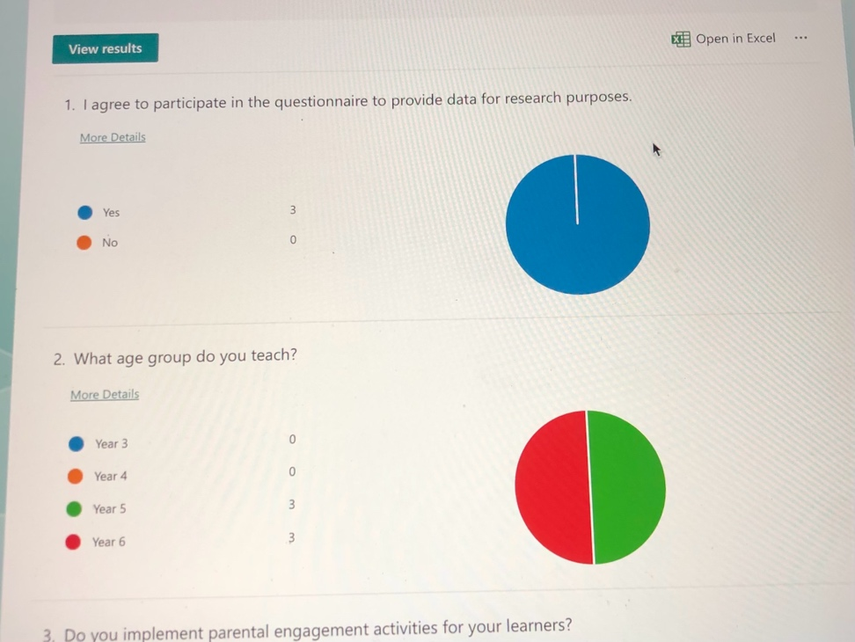
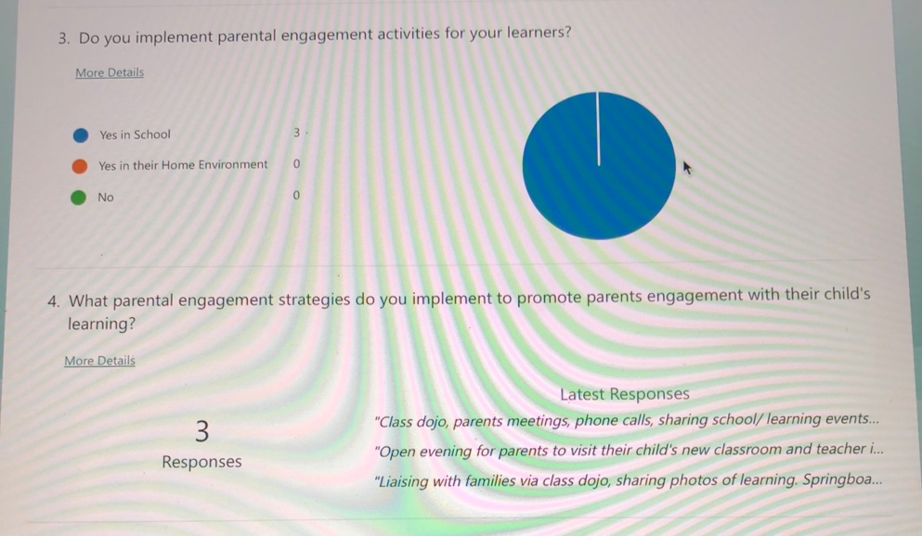
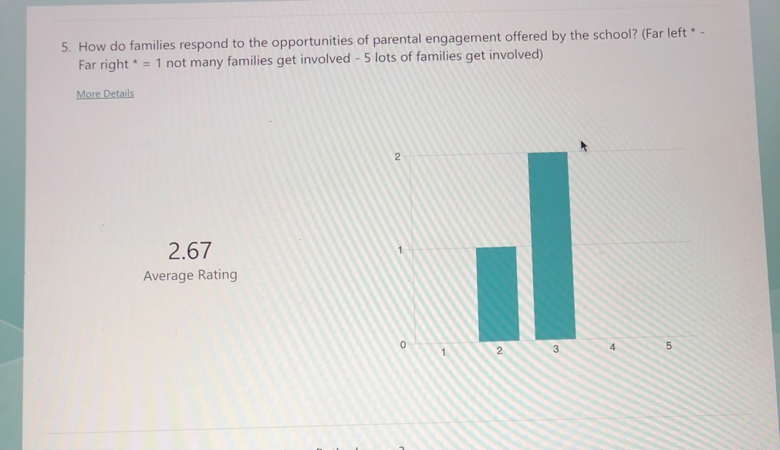
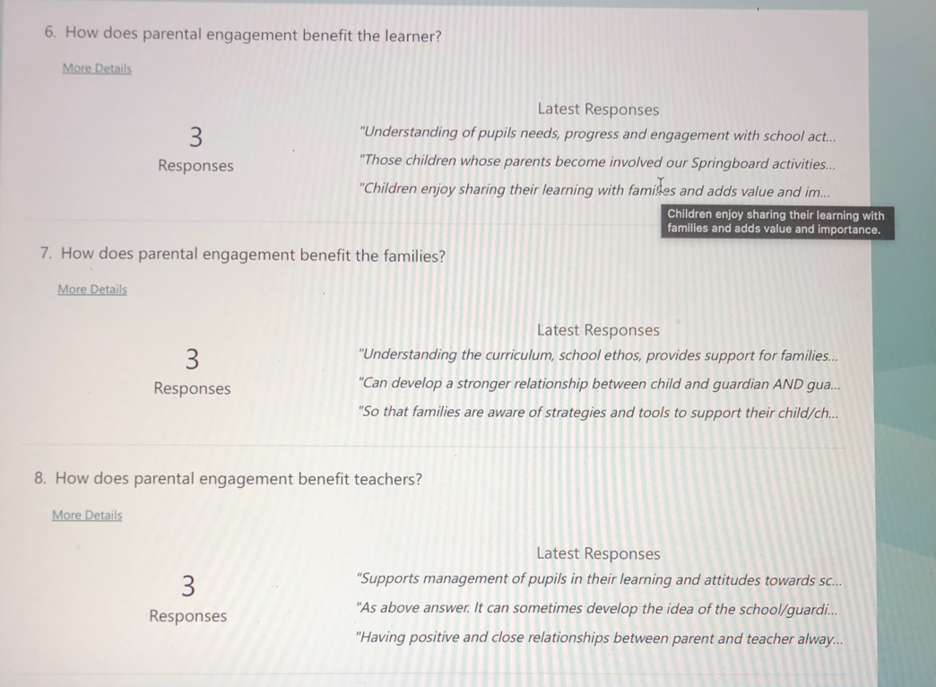
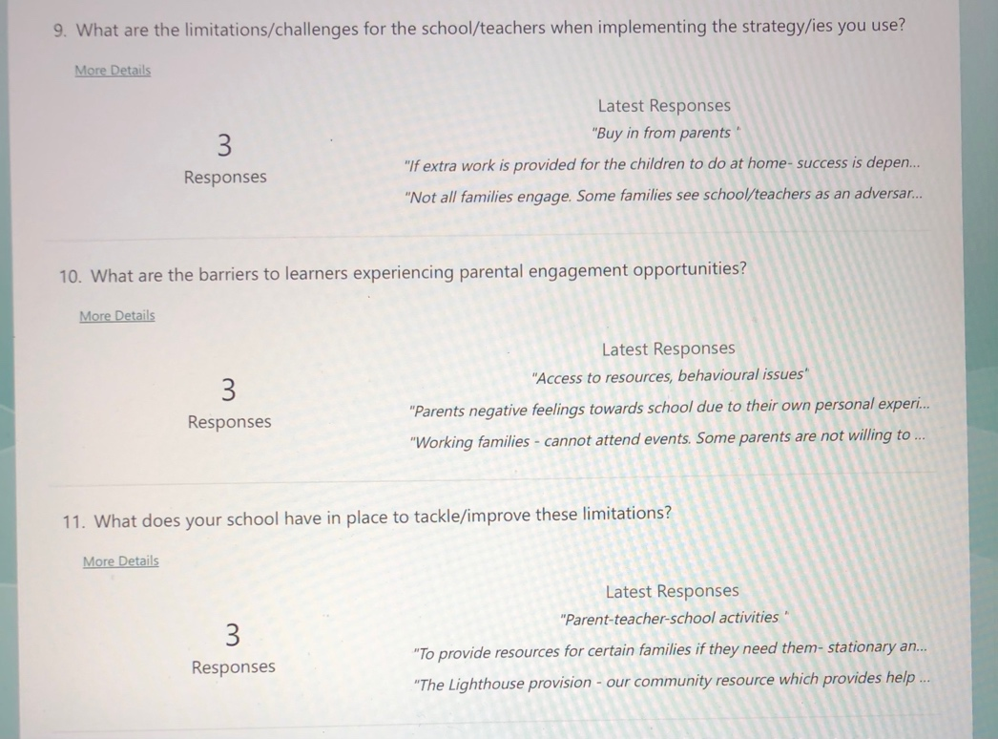
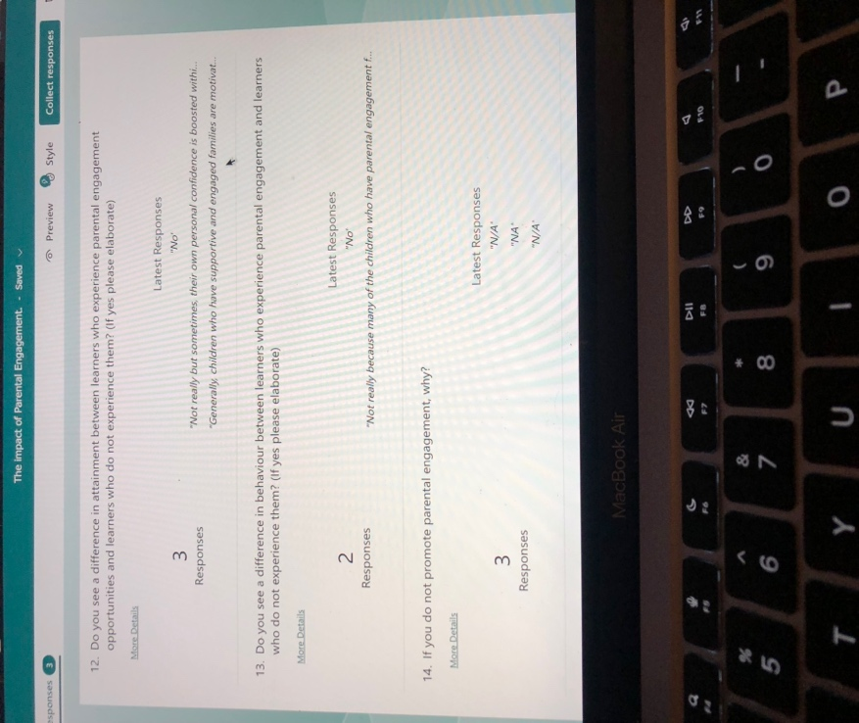

Appendix 6 – Observation Notes

Observation Notes of a Springboard Session.

Focus: Parental Engagement | Research Question: What are KS2 teachers’ perceptions of the impact of parental engagement on children’s learning during covid and how have learners experienced this?
Date: 29/11/2023  Time:  11.00 – 11.30am | Duration: 30 minutes
Tutor | Notes:  All participants are happily communicating with the other families on their tables.  The Springboard tutor was providing the participants with an objective for the session. They are to create a PowerPoint focused on the trip they have been on during the Springboard term. Each table would input onto a slide with a specific heading. They were to insert a picture and text.  The tutor was happy, supportive, down-to-earth, encouraging, and supportive to all in the session.  This section overlaps into the learners and grown-ups section.
Learners and Grown-up | Notes:  All learners and their grown-ups are initially engaged. The learners are all very excited to have their grown-ups in their school environment. Smiling, laughing, and one learner sitting on their grown up’s lap having a cuddle. The level of interaction is very good. However, there is a distinctive requirement for support for two tables. One table needs basic guidance where the learner seems to be of some support for the parent. The other table requires full assistance not knowing what to do at all. Their heading is discovery, and the grown-up or learner cannot seem to understand the definition of the word discovery or have any ICT skills whatsoever. Initially, the grown-up is trying to work it out however, is getting more and more frustrated at their lack of ability/skills. There is a vast amount of negative language being used towards the tutor and the given task such as, I don’t even know what I am supposed to be doing!’. ‘I don’t even know how to use PowerPoint!’. ‘I didn’t even discover anything; I didn’t learn anything!’. Unfortunately, the more the grown-up is getting frustrated, the same frustration and negative attitude began to mirror from the learner. Currently, the tutor is at the table trying to support and reassure the grown-up, however the more frustrated the grown-up is getting the more frustrated the learner is getting, repeating the words of their grown-up in a high volume. The rest of the participants seem to be getting on with the task in hand and maybe trying to avoid fairly loud distraction. The Springboard advisor has joined the tutor to deescalate the situation. The advisor offered to finish the slide for the grown-up, but the grown-up has rejected.  All efforts seem to have been put in by the Springboard professionals to alleviate the grown-up’s discomfort.  At this point the thirty minutes were exhausted and so I left the session.
Meeting with Springboard Advisor Prior to Observation  10.30am | Notes:  Springboard is offered to all in the school and their families. However, Springboard try to target families whose children require extra support and families that will benefit from furthering their own education. The application process is simple. The Springboard advisor will pass on a leaflet displaying their contact number to the school who post it out to all parents via Class DoJo. The learners’ grown-ups’ contact the advisor if they wish to participate in the sessions. The participants will be selected in priority order ensuring Springboard meet those who are most in need. The sessions tend to be full of the majority of the participants fully engaged and satisfied with the experience.  The benefits Springboard sessions have to offer are many experiences some families may not have access to in their home environment such as, ICT skilled activities, activities that involve resources or a garden, and trips away from the school (Evolve form completed for this). Springboard always have plenty of resources to support the learners and their grown-up.  A tutor will encourage the learners and their grown-ups to work together to reach a learning objective. This helps them feel they have achieved a goal together. Several of the learners’ grown-ups have moved onto participating in adult courses provided by the school to further their own education gaining employment from the opportunity. There are adult participants who have gone on to volunteer for the school leading to employment. Families have brought in flowers, chocolate, and thank you card voicing how grateful they are for the experience. One mum had participated with her children for thirteen years. The sessions were the motivation every week and said ‘if it wasn’t for Springboard, I wouldn’t have been able to get her child up in the morning. The advisor expressed the impact Springboard sessions has on anxious learners. Having their parents present really helps them build their confidence and helps reassure parents the school has measures in place to support the needs of their loved ones.  The limitations of Springboard are the difficulty recruiting hard to reach or working parents. Some grown-ups have had poor experiences of their educational journey meaning they expect their children will experience the same. It also means their knowledge may be limited and ICT skills basic or non-existent. This can make them frustrated and apt to use negative language towards efforts being made during the sessions.  Challenges the Springboard advisor faces when implementing the sessions are the aspect of confidentiality between the school and Springboard. Highly respecting the rights of the school and the learners comes with its challenges. It may be extremely helpful to know if the participant has specific needs to allow the Springboard professionals to be prepared prior to the sessions and equip to further support these learners and their grown-up. Likewise, if participants have medical problems that need serious consideration during the session. Most likely the biggest challenge is the breakdown in communication between the school and Springboard if participants are not attending due to private home issues. Again, this may lean heavily on confidentiality which must be respected however, this is extremely challenging with the school being the middle link between the family and Springboard if information of absence is not being communicated. It can also be highly embarrassing if Springboard reach out to the absent family who respond with their child being absent from school due to a serious family issue.

Appendix 7 – Small Focus Group Script

Small Group Discussion with 4 learners.

What strategies do KS2 teachers use to promote parental engagement in their child’s learning and what are learners’ perceptions of this?

Resources
Paper x 12
Pencils x 4
Colouring pencils
Hands up card x 2 - I am talking
Zip emoji x 6 – I do not want to answer

Greet the learners.

Introduce myself as a student.

Thank you for participating in my research study.

Why am I here?
I am here to research and explore your experience of parental engagement in your learning (simplify this) and to gather feedback from you so I can write an assignment for my teaching degree.

Reminder of rights to withdraw at any point during the session.

Confidentiality - Data will be securely stored and disposed of when data has been recorded.

Anonymity - names will be disguised by made up names to keep learners anonymous.

Firstly, I would like you to relax there this is a very laid-back discussion with fellow members of your school and not in any way a test. There are no right or wrong answers. This is just us having a conversation about your experience of your grown-ups being involved in your learning. This should be enjoyable for you.

Draw a picture that tells me anything about a time when your grown-up has been involved with you and your school or your schoolwork.

How would it make you feel if your grown up asked you ‘How was your day?’ and ‘What did you do in school today?’ when they pick you up after a long day in school?

What do you think about events or activities your school put on for you and your grown-up in school (Feelings?)

Grown-ups are such busy people aren’t they!!

How do you get on with learning at home?

What would you like your grown-up to do to help you with your learning?

What would you like your school to do to help you and your grown-up work together?

To finish, I want us to go back to our wonderful drawings. They are so amazing; I would love you to tell me all about what they tell me?

Thank you once again for helping me with my research study! You have been super stars!!

Appendix 8 - Observation Schedule

What are KS2 teachers’ perceptions of the impact of parental engagement on children’s learning during covid and how have learners experienced this?

Observation Schedule for Focus Group

Number of pupils in the group: 4 | Activity: Focus Group Discussion
Focus: Pupils experience | Goal: Pupils thoughts and feelings of parental engagement during Covid.
Date: 30/11/2023  Time: 10.30am | Duration: 20 minutes
Name: Owell  Year Group: 5  Owell was a very chatty dominant member of the group. He was very confident in telling me he recently learnt to tell the time! He also had no worries telling me he was aware is writing is not tidy.  He listed lots of people in his family and that he goes to many sports clubs including rugby, cricket, bowling, tennis, cricket, and most of the other sports you can think of. He also, said he soes not go to football anymore.  He was proud in telling me that he used to go to Springboard joined by his Mum who then started to volunteer and now works in the school as a cleaner.  He has a fond memory of holding a hedgehog at Springboard and spoke of this a lot.  - He does not experience his being asked how his day has been after school however, it would make him happy if he was asked.  - He feels the strategies used by the school are good.  - He doesn't experience support with his work at home although does do some Maths with his cousin sometimes.  - He would love his grown-ups to help him improve his writing.  - He would love the school to give him and his family more access to sport.  Owell's picture was of him at Springboard holding the hedgehog. His picture had him and 2 hedgehogs with big smiles. | Name: Jeff  Year Group: 4  Jeff was not so chatty but still fairly confident and told me how he lives with his Mum, and he has an older sister and an older brother. He told me he has a dad who is no longer with us.  He told me he goes to Springboard with his Mum and that his Nan goes along as his Mum needs support.  - He sometimes experiences being asked how his day has been and likes it when that happens.  - He thinks events and activities provided by the school are good, but they do it too much.  - He does not experience learning at home but plays video games.  - He would like his grown-up to help him improve his writing.  - He would like the school to help him help his grown-up with his homework.  Jeff drew a picture of parents evening with his mum and drew his teacher with a smiley face and Springboard.
Name: Rosie  Year Group: 5  Rosie told me she has 4 people in her house: a twin brother, Mum, Dad. She also has 2 half siblings that don't live with her. She enjoyed telling me of the sports she does out of school, ballet, swimming, acrobats, and her brother doing rugby, football, and swimming. She says she has a very busy week.  - She said when she is asked how her day has it makes her feel cared for and loved.  - The events and activities provided by the school are good, entertaining, and fun.  - She does not have help with her learning at home but practices her writing on her own.  - She would like her parents to help her improve her Maths at home.  - She would like her school to encourage her grown-up to play Maths, and Literacy games at home.  Her picture tells me how her Mum works in the school and how when she was poorly one day her mum supported her by calling for her to picked up which made her feel better. She drew a picture of her Mum. | Name: Chloe  Year Group: 4  Chloe was the quietest member of the group who enjoyed telling me that has 4 siblings, Mum, and Dad, and 2 brothers that don't live with her. She enjoyed telling me her Mum joined her at Springboard and at the end they went to Oakwood.  - She told me it makes her happy when she is asked how her day has been.  - When the school put on events/activities for her to do with her grown-up it makes her feel happy.  - She plays Maths games with Mum at home.  - She does not desire more help from her grown-ups with her learning.  - She would like the school to provide more opportunities for her grown-up to be involved in her Maths, Literacy, and Science.  Chloe's picture told me her Mum went to Springboard and they did loads of stuff. She drew a picture of her and her Mum with big smiles.

Appendix 9 – Small Focus Group Resources


Appendix 10 – Parent letter, consent and assent forms

CONSENT FORM – Parent/Guardian

PROJECT TITLE: What strategies do KS2 teachers use to promote parental engagement in their child’s learning and what are learners’ perceptions of this?

Name of Researcher: Kelly Ellis

Please initial box

1.I confirm that I have read and understand the information sheet dated 20/11/2023 for the above study.

2. I understand that my child’s participation is voluntary and that I am free to withdraw my child from the study at any time, without giving any reason.

3. I understand that my child can choose to withdraw at any time, without giving a reason.

4. I understand that the information given by my child will be used in a university assignment.

5. I understand that my child’s name will not appear at any time.

6. I agree for my child to take part in the above study.

_____________________ _____________________________ __________
Child’s name Parent signature Date

CONSENT FORM - Participants

PROJECT TITLE: What strategies do KS2 teachers use to promote parental engagement in their child’s learning and what are learners’ perceptions of this?

Name of Researcher: Kelly Ellis

Please initial box

1.I confirm that I have read and understand the information sheet dated 20/11/2023 for the above study.

2. I understand that my participation is voluntary and that I am free to say ‘I do not want to continue’ at any time, without giving any reason.

3. I understand that the information given by me will be used in a university assignment.

4. I understand that my name will not appear at any time.

5. I agree to take part in the above study.

_____________________ _____________________________ __________
Child’s name Signature Date

When completed, please return in the envelope provided to …Class teacher……………. by the …28th…….. of ……November 2023……….. (date)

Thank you.

INFORMATION sheet

PROJECT TITLE: What strategies do KS2 teachers use to promote parental engagement in their child’s learning and what are learners’ perceptions of this?

Date 20/11/2023.

Dear Parent / Guardian,

My name is Kelly Ellis, and I am studying for a BAEd qualification at Yr Athrofa, University of Wales Trinity Saint David. I am currently a student teacher within Gelliswick VC Primary School and am observing in your child’s class.

I would like to invite your child to participate in my research project. The title of the project is 'What strategies do KS2 teachers use to promote parental engagement in their child’s learning and what are learners’ perceptions of this?’. I aim to explore the strategies used by a school, why the strategies are used. Moreover, the areas of impact on learners, their families, teachers themselves, and education. I will also explore the perceptions learners have on parental engagement and what their experiences are. Did they engage with parental engagement opportunities? If not, why not? How do they feel this helped support their learning? Are there any barriers that affect the implementation of the strategies in place for home learning, or learners being able to access them?

All schools strive to achieve equity and high levels of learning with a closure between attainment gaps. I will explore the benefits of the strategies and the impact they have on the learners’ potential.
Through your child’s participation, I hope to ascertain data to analyse in the hope to expose the impact of parental engagement in education.
I will be conducting my research in a small focus group discussion which will be recorded. A small focus group consisting of 4 participants will allow smooth flow of communication. Participants will be asked to draw a picture to express their perception of parental engagement which will be discussed at the end of the session. The participants will be prompted with questions related to my research study. I will take notes of key points raised by the learners in the group that will support my study.
All names will be kept strictly confidential and will only be known by myself and my research partner. Your child’s participation in this study is completely voluntary so you or your child can withdraw from the study at any stage. Your child will also be asked to give their assent before the beginning of the study. This information letter will be given to all learners in Key Stage 2 as each of these classes will be observed to gain familiarity between the learners and myself. One learner from each class will be selected to participate in the small focus group discussion.

After careful and precise analysis of the data obtained from the lesson observation and group interview, I would be happy to provide you with a copy of the findings at your request. The results of the research will be discussed in a university assignment that will contribute to my PBA ed’s QTS course. The results of this study will be stored on a laptop and all raw data will be destroyed once the assessment has been marked.

I thank you in advance for your time. If any questions do arise, feel free to contact me at your convenience.

Yours sincerely,

Kelly Ellis

Appendix 11 – NEAF
APPLICATION FOR ETHICAL APPROVAL

RESEARCH STUDENTS
This form is to be completed by the student within SIX months for full-time students and TWELVE months for part time students, after the commencement of the research degree or following progression to Part Two of your course.

Once complete, submit this form via the MyTSD Doctoral College Portal at (https://mytsd.uwtsd.ac.uk).

This document is also available in Welsh.

RESEARCH STAFF ONLY
All communications relating to this application during its processing must be in writing and emailed to pgresearch@uwtsd.ac.uk , with the title ‘Ethical Approval’ followed by your name.

STUDENTS ON UNDERGRADUATE OR TAUGHT MASTERS PROGRAMMES should submit this form (and receive the outcome) via systems explained to you by the supervisor/module leader.

In order for research to result in benefit and minimise risk of harm, it must be conducted ethically. A researcher may not be covered by the University’s insurance if ethical approval has not been obtained prior to commencement.

The University follows the OECD Frascati manual definition of research activity: “creative work undertaken on a systematic basis in order to increase the stock of knowledge, including knowledge of man, culture and society, and the use of this stock of knowledge to devise new applications”. As such this covers activities undertaken by members of staff, postgraduate research students, and both taught postgraduate and undergraduate students working on dissertations/projects.

The individual undertaking the research activity is known as the “principal researcher”.

Ethical approval is not required for routine audits, performance reviews, quality assurance studies, testing within normal educational requirements, and literary or artistic criticism.

Please read the notes for guidance before completing ALL sections of the form.

This form must be completed and approved prior to undertaking any research activity. Please see Checklist for details of process for different categories of application.

SECTION A: About You (Principal Researcher)
1 | Full Name: |  | Kelly Ellis
2 | Tick all boxes that apply: |  | Member of staff: | ☐ | Honorary research fellow: | ☐
 | Undergraduate Student | ☒ | Taught Postgraduate Student | ☐ | Postgraduate Research Student | ☐

3 | Institute/Academic Discipline/Centre: | University of Wales Tinity St David
4 | Campus: | Carmarthen
5 | E-mail address: | Kelly.ellis85@icloud.com
6 | Contact Telephone Number: | 07950852335
 | For students:
7 | Student Number: | 2103419
8 | Programme of Study: | BA ed module 6010
9 | Director of Studies/Supervisor: | Julia Holloway

SECTION B: Approval for Research Activity
1 | Has the research activity received approval in principle?  (please check the Guidance Notes as to the appropriate approval process for different levels of research by different categories of individual) |  | YES | ☒ | NO | ☐
 |  |  |  |  | Date
2 | If Yes, please indicate source of approval (and date where known): Approval in principle must be obtained from the relevant source prior to seeking ethical approval | Research Degrees Committee |  | ☐
2 |  | Institute Research Committee |  | ☐
2 |  | Other (write in) |  | ☐ | 16/11/23

SECTION C: Internal and External Ethical Guidance Materials
 | Please list the core ethical guidance documents that have been referred to during the completion of this form (including any discipline-specific codes of research ethics, location-specific codes of research ethics, and also any specific ethical guidance relating to the proposed methodology). Please tick to confirm that your research proposal adheres to these codes and guidelines. You may add rows to this table if needed.
1 | UWTSD Research Ethics & Integrity Code of Practice | ☒
2 | UWTSD Research Data Management Policy | ☒
3 | [List any other relevant documents here] | ☐

SECTION D: External Collaborative Research Activity
If there are external collaborators then you should gain consent from the contact persons to share their personal data with the university. If there are no external collaborators then leave this section blank and continue to section E.
1 | Institution
2 | Contact person name
3 | Contact person e-mail address
4 | Is your research externally funded? |  | YES | ☐ | NO |  | ☒
5 | Are you in receipt of a KESS scholarship? |  | YES | ☐ | NO |  | ☒
6 | Are you specifically employed to undertake this research in either a paid or voluntary capacity? | Voluntary | YES | ☐ | NO | ☒
7 |  | Employed | YES | ☐ | NO | ☒
8 | Is the research being undertaken within an existing UWTSD Athrofa Professional Learning Partnership (APLP)? | If YES then the permission question below does not need to be answered. | YES | ☐ | NO |  | ☒
9 | Has permission to undertake the research has been provided by the partner organisation? | (If YES attach copy)  If NO the application cannot continue | YES | ☐ | NO |  | ☒

Where research activity is carried out in collaboration with an external organisation
10 | Does this organisation have its own ethics approval system? | YES | ☐ | NO | ☒
 | If Yes, please attach a copy of any final approval (or interim approval) from the organisation (this may be a copy of an email if appropriate).

SECTION E: Details of Research Activity
1 | Indicative title: | Research Project Case Study based on an Electives Experience.  An exploratory case study arising from practice (noticing) and investigated further through identified research tools. The assignment concludes with the identificationof an intervention which can be piloted throughout Professional Teaching Experience and evidenced through reflection in the Professional Learning Standards.
2 | Proposed start date: | 27/11/2023 | Proposed end date: | 01/12/2023
Introduction to the Research (maximum 300 words per section)
Ensure that you write for a Non-Specialist Audience when outlining your response to the points below:
- Purpose of Research Activity
- Proposed Research Question
- Aims of Research Activity
- Objectives of Research Activity
Demonstrate, briefly, how Existing Research has informed the proposed activity and explain
- What the research activity will add to the body of knowledge
- How it addresses an area of importance.
3 | Purpose of Research Activity  There is evidence that suggests ‘family factors’ can determine the achievements of learners. Parental engagement is enforced in schools worldwide however, the objectives are diverse and differ in each school. The government may consider their accountability where improving public image may be the focus of rationale for parental engagement in schools. This may also be similar to the rationale of schools and teaching techniques; where teachers take accountability for their roles and responsibilities when considering the need to gain a solution to equity dilemmas. A vast aray of schools promote communicative and often in person engagement between teachers and parents, additionally more heavily between parents and their children in and out of the school setting. This is a bidirectional vision between the maesosystem and macrosystem of Bronfenbrenner’s ecological systems. A parents main rationale for their engagement may be to make improvements to the consistency of the microsystem and to aid their child’s progress. However, there is a possibility of critique when considering the resources available to children in their own environment away from the school and the parents willingness to engage (Manzon et al, 2015).  The curriculum of Wales takes a holistic approach to teaching and learning (HWB, 2023) where the learners gain holistic support (Williams, 2017). This links with Manzon et als’ (2015) research that expresses holistic support is gained through parental engagement in education. Williams (2017) also expresses the seriousness of parental engagement with a rationale to ‘raise standards and improve wellbeing’. His rationale focused on raising the attainment of the learners through parental engagement who may and may not have access to the resources required to enhance learning opportunities, hence gain equity among learners.  The researcher would like to explore the strategies used by a school, the level of response of engagement from learers and their families and how the learners feel about their experience or lack of experience of parental engagement.  Reference list  - HWB. “Enabling Learning - Hwb.” Hwb.gov.wales, 2023, hwb.gov.wales/curriculum-for-wales/designing-your-curriculum/enabling-learning.  - Manzon, Maria, et al. Parent Engagement in Education NIE Working Paper Series No. 7. 2015.  - Williams (2015) “Active Learning Through Family Engagement. Improving Family Engagement Through a Process of Reflexive Action Research”. UWTSD, 2015, https://www.uwtsd.ac.uk/media/uwtsd-website/content-assets/documents/research/fec/family-engagement.pdf  (this box should expand as you type)
4 | Research Question  What strategies do KS2 teachers use to promote parental engagement in their child’s learning and what are learners’ perceptions of this?  (this box should expand as you type)
5 | Aims of Research Activity  The aims of the researchers study is to explore the strategies used by a school, the reasons teachers feel the startegies are used. Moreover, the areas of impact on learners, their families, teachers themselves, and education. The researcher will also explore the perceptions learners have on parental engagement and what their experiences are. Did their families engage with parental engagement opportunities? If not, why not? How do they feel this helped support their learning? Are there any barriers that affect the implementation of the strategies in place for home learning?  All school’s strive to achieve equity and high levels of learning with a closure between attainment gaps. The researcher will explore the benefits of the strategies and the impact they have on the learners.  (this box should expand as you type)
6 | Objectives of Research Activity  The researcher will visit a school for the duration of five days carrying out research using methods to help answer the research question posed. A range of metods will be used to gain as much data as possible to support the research study. An assignment will be written using the data collected.  (this box should expand as you type)
Proposed methods (maximum 600 words)
Provide a brief summary of all the methods that may be used in the research activity, making it clear what specific techniques may be used. If methods other than those listed in this section are deemed appropriate later, additional ethical approval for those methods will be needed. You do not need to justify the methods here, but should instead describe how you intend to collect the data necessary for you to complete your project.
7 | Identify:  To identify a lead member of staff who implements parental engagement strategies used by the school. The researcher will gain knowledge of each strategy used and what impact each strategy has on the learners and their family. Moreover, the level of engagement with the strategies from the learners and their families. The researcher will also discuss the positive attributes and the limitations of each strategy.  Questionnaires:  A structured online questionnaire will be sent to all staff in KS2 on google forms to gather data to help with the researcher’s analysis. The questionnaires will begin with broad questions for example, how important do you feel parental engagement is for a learner’s progression, and if they use parental engagement strategies for the learners in their cohort. Toward the end of the questionnaire will narrow in more focused on the strategies the school implements and how effective teachers believe they are. The questionnaires and the identify element of the study will allow the researcher to gain more accuracy when analysing which strategies are used to promote parental engagement. The questionnaires will be sent prior to attending the school.  General Observation:  The researcher will conduct a non-participant observation with each class in KS2. This will merely be an observation to get familiar with the learners and observe them working in the classroom environment alongside their peers.  Small Focus Group Discussion:  There will be an opportunity for four learners to participate in a small focus group recorded discussion. This will take place in a quiet room (for confidentiality) with the door open (for comfort and ease of learners and protection for the researcher). The researcher will start by asking the learners to draw a picture that symbolise how they feel about parental engagement. The researcher has opted for a small focus group method aiming to allow the learners to discuss their thoughts and experiences with each other with the researcher prompting them with open ended questions. The focus group will consist of semi-structured questions allowing flexibility and adaption throughout the discussion to avoid missing opportunities to obtain more accurate data. The discussion may support the research study by exploring the learners’ perceptions of parental engagement considering their own experience or lack of experience with strategies used by the school. They may express if they feel there are strengths or limitations to the strategies and how they believe it impacts their wellbeing with their experience of parental engagement. The learners will each be given a talking spoon when a question is asked, they may raise their talking spoon to make discussion. If their talking spoon has not been selected, they must wait their turn. The learners are only allowed to use their talking spoon three times for each question. This will give all learners the opportunity for discussion gaining more accuracy of data. When one learner shares their idea, it may prompt another in the group to elaborate or build on what the previous learner shared; or help them remember points they would like to discuss leading to a positive flow of discussion. Once the discussion has taken place each learner then can discuss their drawing if they want to.  The selection of the participants: A request will be made to KS2 teachers to select one learner from each class (3, 4, 5, and 6). Year 3 and 5 being learners who do not have the opportunity to engage in the strategies, and year 4 and 6 learners who do get the opportunity to engage with the strategies. This will allow the researcher to gain more accuracy when analysing the data gathered from the research study.  Small Focus Group Observation:  An observation schedule will be created for the researcher to take notes of the feedback given to the questions asked and any key points raised by each of the learners that may support the study. This observation schedule will allow for an analysis to be made of the learners’ perceptions of parental engagement.  (this box should expand as you type)
Location of research activity
Identify all locations where research activity will take place.
8 | Medium sized primary school in an urban area in South West Wales  (this box should expand as you type)
Research activity outside of the UK
If research activity will take place overseas, you are responsible for ensuring that local ethical considerations are complied with and that the relevant permissions are sought. Specify any local guidelines (e.g. from local professional associations/learned societies/universities) that exist and whether these involve any ethical stipulations beyond those usual in the UK (provide details of any licenses or permissions required). Also specify whether there are any specific ethical issues raised by the local context in which the research activity is taking place, for example, particular cultural and/or legal sensitivities or vulnerabilities of participants. If you live in the country where you will do the research then please state this.
9 | N/A  (this box should expand as you type)

10 | Use of documentation not in the public domain: Are any documents NOT publicly available? | NO | ☒
10 |  | YES | ☐
11 | If Yes, please provide details here of how you will gain access to specific documentation that is not in the public domain and that this is in accordance with the current data protection law of the country in question and that of England and Wales.  (this box should expand as you type)

 | Does your research relate to one or more of the seven aims of the Well-being of Future Generations (Wales) Act 2015? | YES | NO
12 | A prosperous Wales | ☒ | ☐
13 | A resilient Wales | ☒ | ☐
14 | A healthier Wales | ☒ | ☐
15 | A more equal Wales | ☒ | ☐
16 | A Wales of cohesive communities | ☒ | ☐
17 | A Wales of vibrant culture and thriving Welsh language | ☐ | ☒
18 | A globally responsible Wales | ☐ | ☒
19 | If YES to any of the above, please give details:
 | (this box should expand as you type)

SECTION F: Scope of Research Activity
 | Will the research activity include: | YES | NO
1 | Use of a questionnaire or similar research instrument? | ☒ | ☐
2 | Use of interviews? | ☒ | ☐
3 | Use of focus groups? | ☒ | ☒
4 | Use of participant diaries? | ☐ | ☒
5 | Use of video or audio recording? | ☒ | ☐
6 | Use of computer-generated log files? | ☒ | ☐
7 | Participant observation with their knowledge? | ☒ | ☐
8 | Participant observation without their knowledge? | ☐ | ☒
9 | Access to personal or confidential information without the participants’ specific consent? | ☐ | ☒
10 | Administration of any questions, test stimuli, presentation that may be experienced as physically, mentally or emotionally harmful / offensive? | ☒ | ☒
11 | Performance of any acts which may cause embarrassment or affect self-esteem? | ☒ | ☐
12 | Investigation of participants involved in illegal activities? | ☐ | ☒
13 | Use of procedures that involve deception? | ☐ | ☒
14 | Administration of any substance, agent or placebo? | ☐ | ☒
15 | Working with live vertebrate animals? | ☐ | ☒
16 | Procedures that may have a negative impact on the environment? | ☐ | ☒
17 | Other primary data collection methods. Please indicate the type of data collection method(s) below. | ☐ | ☒
 | Details of any other primary data collection method:  (this box should expand as you type) | ☐ | ☒
If NO to every question, then the research activity is (ethically) low risk and may be exempt from some of the following sections (please refer to Guidance Notes).

If YES to any question, then no research activity should be undertaken until full ethical approval has been obtained.

SECTION G: Intended Participants
If there are no participants then do not complete this section, but go directly to section H.

 | Who are the intended participants: | YES | NO
1 | Students or staff at the University? | ☐ | ☒
2 | Adults (over the age of 18 and competent to give consent)? | ☐ | ☒
3 | Vulnerable adults? | ☐ | ☒
4 | Children and Young People under the age of 18? (Consent from Parent, Carer or Guardian will be required) | ☒ | ☐
5 | Prisoners? | ☐ | ☒
6 | Young offenders? | ☐ | ☒
7 | Those who could be considered to have a particularly dependent relationship with the investigator or a gatekeeper? | ☐ | ☒
8 | People engaged in illegal activities? | ☐ | ☒
9 | Others. Please indicate the participants below, and specifically any group who may be unable to give consent. | ☐ | ☐
 | Details of any other participant groups:  (this box should expand as you type) | ☐ | ☐

Participant numbers and source
Provide an estimate of the expected number of participants. How will you identify participants and how will they be recruited?
10 | How many participants are expected? | KS2 learners  There are 4 classes for year 3 and 4.  There are 4 classes for year 5 and 6.  The researcher based the figures on 25 learners per class.  KS2 Staff  The researcher based the figures on 2 teachers per class and the possibility of there being a parental engagement lead member of staff outside of KS2.  Approx 210 – 215  (this box should expand as you type)
11 | Who will the participants be? | All staff and learners in KS2. If there is an opportunity to observe a parental engagement session then the parents will be additional participants.  (this box should expand as you type)
12 | How will you identify the participants? | The researcher will ask members of staff who leads the parental engagement initiative and if it would be possible to speak with them.  The researcher will ask for permission to observe the year 3, 4, 5, and 6 classes (All KS2)  (this box should expand as you type)

 | Information for participants: | YES | NO | N/A
13 | Will you describe the main research procedures to participants in advance, so that they are informed about what to expect? | ☒ | ☐ | ☐
14 | Will you tell participants that their participation is voluntary? | ☒ | ☐ | ☐
15 | Will you obtain written consent for participation? | ☒ | ☐ | ☐
16 | Will you explain to participants that refusal to participate in the research will not affect their treatment or education (if relevant)? | ☒ | ☐ | ☐
17 | If the research is observational, will you ask participants for their consent to being observed? | ☒ | ☐ | ☐
18 | Will you tell participants that they may withdraw from the research at any time and for any reason? | ☒ | ☐ | ☐
19 | With questionnaires, will you give participants the option of omitting questions they do not want to answer? | ☒ | ☐ | ☐
20 | Will you tell participants that their data will be treated with full confidentiality and that, if published, it will not be identifiable as theirs? | ☒ | ☐ | ☐
21 | Will you debrief participants at the end of their participation, in a way appropriate to the type of research undertaken? | ☒ | ☐ | ☐
22 | If NO to any of above questions, please give an explanation
 | (this box should expand as you type)

 | Information for participants: | YES | NO | N/A
24 | Will participants be paid? | ☐ | ☒ | ☐
25 | Is specialist electrical or other equipment to be used with participants? | ☐ | ☒ | ☐
26 | Are there any financial or other interests to the investigator or University arising from this study? | ☐ | ☒ | ☐
27 | Will the research activity involve deliberately misleading participants in any way, or the partial or full concealment of the specific study aims? | ☐ | ☒ | ☐
28 | If YES to any question, please provide full details
 | (this box should expand as you type)

SECTION H: Anticipated Risks

Outline any anticipated risks that may adversely affect any of the participants, the researchers and/or the University, and the steps that will be taken to address them.

If you have completed a full risk assessment (for example as required by a laboratory, or external research collaborator) you may append that to this form.
1 | Full risk assessment completed and appended? |  | Yes | ☒
1 |  |  | No | ☐
2 | Risks to participants  For example: sector-specific health & safety, emotional distress, financial disclosure, physical harm, transfer of personal data, sensitive organisational information
 | Risk to participants:  - There is a risk of lower self-esteem caused by not being picked to participate in the reseach study.  - The selected participants may feel pressured to participate.  - Safeguarding and wellbeing issues.  - Location.  - Anonyminity.  (this box should expand as you type) | How you will mitigate the risk to participants:  - The researcher will be using positive inclusive language such as, the researcher would love to have you all involved in my research study, however due to limited time the researcher will only able to have 4 participants which will be picked at random.  - Each participant will fully assent to their participation prior to any research being conducted. They will also be made aware of their right to withdraw at any point during the study.  - For some this may be a sensitive subject and require a sensitive empathetic approach. The participant will be made fully aware that all the information they provide will be confidential unless the researcher feels any information given needs to be reported for their own safeguarding and protection.  - The location of which the interview/s take place will need to be discreet for confidentiality and to avoid peers passing an wuestioning the participants.  - The researcher will record the data using synonyms to give anonymity to the participants.  (this box should expand as you type)
3 | If research activity may include sensitive, embarrassing or upsetting topics (e.g. sexual activity, drug use) or issues likely to disclose information requiring further action (e.g. criminal activity), give details of the procedures to deal with these issues, including any support/advice (e.g. helpline numbers) to be offered to participants. Note that where applicable, consent procedures should make it clear that if something potentially or actually illegal is discovered in the course of a project, it may need to be disclosed to the proper authorities
N/A

(this box should expand as you type)
4 | Risks to the investigator  For example: personal health & safety, physical harm, emotional distress, risk of accusation of harm/impropriety, conflict of interest
 | Risk to the investigator:  - Allegations made by participants.  - Accusations of favouritism by the learners who are not selected to participate.  - Bias in recording data due to the researcher own belief of the answer to the research question.  (this box should expand as you type) | How you will mitigate the risk to the investigator:  - To avoid this, ideally the researcher would have another adult in the room although if this is not possible, the interview/s will be recorded anyway and will be in a quiet room with the door open.  - The researcher will be using positive inclusive language such as, the researcher would love to have you all involved in my research study, however due to limited time the researcher will only able to have 4 participants which will be picked at random.  - To avoid any bias, the researcher will use a repetitive approach to analysing the data collected. The data will be revisited again and again. A supervisor will be asked to watch the recording and make their own analysis, to form possible criticism of what has been recorded by the researcher. The researcher will evaluate their own positionality and identify the importance of remaining open-minded when considering their own beliefs.  (this box should expand as you type)
5 | University/institutional risks  For example: adverse publicity, financial loss, data protection
 | Risk to the University:  - The need to uphold the good name of the university.  - Not falsifying any data which could impact the representation and standards of the university.  - Not behaving in a way that could impact the relationship between school and university.  (this box should expand as you type) | How you will mitigate the risk to the University:  - Remaining thourough and professional adhering to the university’s guidelines and policies will uphold the good name of the university.  - The researcher must be honest and accurate with the research data adhering to the UNCRC and BERA guidelines to represent the standards of the university.  - The researcher must remain professional at all times and conduct research in a respectful manner when honoring their university.  (this box should expand as you type)
6 | Environmental risks  For example: accidental spillage of pollutants, damage to local ecosystems
 | Risk to the environment:  Health and safety.  (this box should expand as you type) | How you will mitigate the risk to environment  General visual risk assessment of the environment where the interview/s will be taking place will be undertaken. The schools safeguarding and health and safety policy will be read before any research is conducted.  (this box should expand as you type)

 | Disclosure and Barring Service
 | If the research activity involves children or vulnerable adults, a Disclosure and Barring Service (DBS) certificate must be obtained before any contact with such participants. | YES | NO | N/A
7 | Does your research require you to hold a current DBS Certificate? | ☒ | ☐ | ☐
8 | If YES, please give the certificate number. If the certificate number is not available please write “Pending”; in this case any ethical approval will be subject to providing the appropriate certificate number.

SECTION I: Feedback, Consent and Confidentiality

1 | Feedback  What de-briefing and feedback will be provided to participants, how will this be done and when?
When the interview/s are over there will be a general debriefing to allow smooth transition from the interviews back into normal class routine. This will be a general thank you for participating and a reminder that they still have the right to withdraw if they wish. This will also be the time to take the opportunity to provide the participants with a wellbeing check in.

(this box should expand as you type)
2 | Informed consent  Describe the arrangements to inform potential participants, before providing consent, of what is involved in participating. Describe the arrangements for participants to provide full consent before data collection begins. If gaining consent in this way is inappropriate, explain how consent will be obtained and recorded in accordance with prevailing data protection legislation.
Prior to attending the school, the researcher will send the school a proposal of what the research study will entail. There will be a consent form detailed with a fully informed overview of the research process attached to be sent home to all KS2 learners to get fully informed consent to their learners participation. The participants will be made fully aware of their right to withdraw at any point during the research if they do not wish to continue and reassured any data will be destroyed.

The researcher will clearly highlight on the teachers’ questionnaire forms an option to decline participation.

(this box should expand as you type)
3 | Confidentiality / Anonymity  Set out how anonymity of participants and confidentiality will be ensured in any outputs. If anonymity is not being offered, explain why this is the case.
Observation: Any participant or non participant will be made fully aware If they involved in any form of observation during the research study. This may be by informing the class they may be being observed for a research study and highlighting their confidentiality and anonymity will be highly upheld.

The researcher will be honest and accurate with the research data adhering to the UNCRC and BERA guidelines to represent the standards of the university.

The researcher will record the data using synonyms to give anonymity to the participants. All raw data will be destroyed once data has been extracted using the anonymity method outlined.

The data will be kept confidential with passwords for the duration of the research study and used to write an assignment. Then the data will be destroyed.

(this box should expand as you type)

SECTION J: Data Protection and Storage

 | Does the research activity involve personal data (as defined by the General Data Protection Regulation 2016 “GDPR” and the Data Protection Act 2018 “DPA”)? | YES | NO
1 | “Personal data” means any information relating to an identified or identifiable natural person (‘data subject’). An identifiable natural person is one who can be identified, directly or indirectly, in particular by reference to an identifier such as a name, an identification number, location data, an online identifier or to one or more factors specific to the physical, physiological, genetic, mental, economic, cultural or social identity of that natural person. Any video or audio recordings of participants is considered to be personal data. | ☐ | x☐
 | If YES, provide a description of the data and explain why this data needs to be collected:
2 | (this box should expand as you type)
 | Does it involve special category data (as defined by the GDPR)? | YES | NO
3 | “Special category data” means sensitive personal data consisting of information as to the data subjects’ –  (a) racial or ethnic origin,  (b) political opinions,  (c ) religious beliefs or other beliefs of a similar nature,  (d) membership of a trade union (within the meaning of the Trade Union and Labour Relations (Consolidation) Act 1992),  (e) physical or mental health or condition,  (f) sexual life,  (g) genetics,  (h) biometric data (as used for ID purposes), | ☐ | x☐
 | If YES, provide a description of the special category data and explain why this data needs to be collected:
4 | (this box should expand as you type)

 | Will data from the research activity (collected data, drafts of the thesis, or materials for publication) be stored in any of the following ways? | YES | NO
5 | Manual files (i.e. in paper form)? | ☒ | ☐
6 | University computers? | ☐ | ☒
7 | Private company computers? | ☐ | ☒
8 | Home or other personal computers? | ☐ | ☒
9 | Laptop computers/ CDs/ Portable disk-drives/ memory sticks? | ☒ | ☐
10 | “Cloud” storage or websites? | ☒ | ☐
11 | Other – specify: | ☐ | ☒
12 | For all stored data, explain the measures in place to ensure the security of the data collected, data confidentiality, including details of backup procedures, password protection, encryption, anonymisation and pseudonymisation:
There will be passwords for all data and recording stored online. All data will be encrypted and pseudonyms will be used for any participants.
All raw materials will be instantly destroyed once data has been taken with pseudonyms in place and all stored data will be destroyed when assignment has been written.

(this box should expand as you type)

 | Data Protection
 | Will the research activity involve any of the following activities: | YES | NO
13 | Electronic transfer of data in any form? | ☐ | ☒
14 | Sharing of data with others at the University outside of the immediate research team? | ☐ | ☒
15 | Sharing of data with other organisations? | ☐ | ☒
16 | Export of data outside the UK or importing of data from outside the UK? | ☐ | ☒
17 | Use of personal addresses, postcodes, faxes, emails or telephone numbers? | ☐ | ☒
18 | Publication of data that might allow identification of individuals? | ☐ | ☒
19 | Use of data management system? | ☐ | ☒
20 | Data archiving? | ☐ | ☒
21 | If YES to any question, please provide full details, explaining how this will be conducted in accordance with the GDPR and Data Protection Act (2018) (and any international equivalents, where appropriate):
 | (this box should expand as you type)
22 | List all who will have access to the data generated by the research activity:
 | (this box should expand as you type)
23 | List who will have control of, and act as custodian(s) for, data generated by the research activity:
 | (this box should expand as you type)
24 | Give details of data storage arrangements, including security measures in place to protect the data, where data will be stored, how long for, and in what form. Will data be archived – if so how and if not why not.
 | (this box should expand as you type)
25 | Please indicate if your data will be stored in the UWTSD Research Data Repository (see https://researchdata.uwtsd.ac.uk/ ). If so please explain. (Most relevant to academic staff)
 | (this box should expand as you type)
26 | Confirm that you have read the UWTSD guidance on data management (see https://www.uwtsd.ac.uk/library/research-data-management/) | YES | ☒
27 | Confirm that you are aware that you need to keep all data until after your research has completed or the end of your funding | YES | ☒

SECTION K: Declaration
The information which I have provided is correct and complete to the best of my knowledge. I have attempted to identify any risks and issues related to the research activity and acknowledge my obligations and the rights of the participants.

In submitting this application I hereby confirm that I undertake to ensure that the above named research activity will meet the University’s Research Ethics and Integrity Code of Practice which is published on the website: https://www.uwtsd.ac.uk/research/research-ethics/
1 | Signature of applicant: |  | Date: 20/11/2023

For STUDENT Submissions:
2 | Director of Studies/Supervisor: |  | Date:
3 | Signature: |  | Date:

For STAFF Submissions:
4 | Academic Director/ Assistant Dean: |  | Date:
5 | Signature: |  | Date:

Checklist: Please complete the checklist below to ensure that you have completed the form according to the guidelines and attached any required documentation:
☒ | I have read the guidance notes supplied before completing the form.
☒ | I have completed ALL RELEVANT sections of the form in full.
☒ | I confirm that the research activity has received approval in principle
☒ | I have attached a copy of final/interim approval from external organisation (where appropriate)
☒ | I have attached a full risk assessment (where appropriate) ONLY TICK IF YOU HAVE ATTACHED A FULL RISK ASSESSMENT
☒ | I understand that it is my responsibility to ensure that the above named research activity will meet the University’s Research Ethics and Integrity Code of Practice.
☒ | I understand that before commencing data collection all documents aimed at respondents (including information sheets, consent forms, questionnaires, interview schedules etc.) must be confirmed by the DoS/Supervisor, module tutor or Academic Director.

RESEARCH STUDENTS ONLY
Once complete, submit this form via the MyTSD Doctoral College Portal at (https://mytsd.uwtsd.ac.uk).

RESEARCH STAFF ONLY
All communications relating to this application during its processing must be in writing and emailed to pgresearch@uwtsd.ac.uk , with the title ‘Ethical Approval’ followed by your name.

STUDENTS ON UNDERGRADUATE OR TAUGHT MASTERS PROGRAMMES should submit this form (and receive the outcome) via systems explained to you by the supervisor/module leader.

