Classifying Fashion Mnist Dataset Based On Decision Tree And KNN Model

Module | L7 - Artificial Intelligence
Module code | ACCA7026
Student name | Biao Liu
Student ID number | 2200546

Classifying Fashion Mnist Dataset Based On Decision Tree And KNN Model
Biao Liu

Abstract
Artificial intelligence(AI) technology is profoundly changing our lives at an unprecedented rate, leading to the fourth industrial revolution. Machine learning(ML) is one of the most popular directions in the area of AI. Machine learning is subdivided into three capital research directions: unsupervised learning, supervised learning and reinforcement learning(RL). Supervised learning can be subdivided into classification and regression. It requires sample labeling. The quality and scale of the sample determine the complexity and effect of the model. This is also an important reason why artificial intelligence needs big data as support. Supervised learning is currently the most widely used machine learning method, such as our common ad click rate prediction, product recommendation, search ranking, etc. Unsupervised learning can be subdivided into clustering, dimensionality reduction and other directions, which can discover the rules in a large number of unlabeled data. Reinforcement learning is considered to be the closest to human learning behavior and has been widely used in industrial control, robot behavior decision-making and other fields.

Keywords: Fashion mnist, KNN, decision tree,machine learning

1. Introduction

1.1 Development of Artificial Intelligence Technology
In recent years, the introduction and popularization of deep learning have greatly improved some problems that are not well solved in the area of traditional ML. Deep learning is the most active field of artificial intelligence. A large number of models and theories are constantly emerging. For example, the machine painting often reported by the media is the application of the GAN model. The so-called machine poetry, machine writing news, is also based on deep learning RNN model. Deep learning has completely dominated the area of ML for image and speech recognition, and new applications are being explored in the area of NLP. The combination of deep learning and reinforcement learning has greatly affected the field of reinforcement learning. The use of deep networks to transform the function value fitting in RL has achieved excellent outcomes. For example, the well-known Alpha Go and AlphaZero are essentially applications of deep reinforcement learning.
The field of deep learning is still developing rapidly. Back propagation is one of the foundations of deep learning and has been used for decades. However, Hinton, the father of deep learning, recently called for skepticism about back-propagation, and proposed a new Capsule network. In traditional neural networks, each neuron 's input and output are scalars, while the Capsule network is one or a group of vectors, each layer activates a higher-level Capsule through an iterative routing protocol mechanism. This may become a major change in the field of deep learning.

2.Related work

2.1 Evaluation indexes
Evaluation indexes are used to reflect the effect of the model. In the prediction problem, to value the generalization of the model, it is critical to compare the real label Y with the model prediction result f(X), and the evaluation index is defined as the function of f(X) and Y.
score = metric(f(X), Y)
The quality of the model is relative. When comparing the effects of different models, using different evaluation indicators often leads to different conclusions. Usually, machine learning evaluation indicators are used offline, and business indicators are used online. If the offline indicators are different from the online indicators, there may be a phenomenon that the offline indicators become better and the online indicators become worse. Therefore, at the beginning of a new problem, multiple rounds of model iteration will be carried out to explore the offline indicators consistent with the online business indicators, so as to make the trend of offline indicators consistent with the online indicators as much as possible. There is no consistent with the online offline indicators, means that the offline indicators have no reference value, to determine whether the test is effective, only on-line experiment. The cost of the online experiment is much higher than that of the offline experiment. It usually takes a long time for the online experiment and the credibility test (such as t-test) to draw a conclusion, which will inevitably lead to the slow progress of the model iteration.
Evaluation indexes can be classified into classification index, regression index, clustering index and ranking index according to the task type. The following will introduce some commonly used evaluation indicators and their applicable scenarios.
Precision rate(R) and recall rate(P) are mostly used for binary classification problems.The corresponding calculation formula is :
P = TP / (TP+FP)
R = TP / (TP+FN)
Therefore, in different occasions according to actual needs to determine which indicator is more important.
We can draw P-R curve with P as vertical axis and R as horizontal axis . The area under the curve is called the Average Precision Score(AP). Comparing the AP scores of different models can reflect the proportion of high accuracy and recall rate of the model to a certain extent.
In many machine learning models, many model outputs are predictive probabilities. When using indicators such as precision and recall rate for model evaluation, it is also necessary to set classification thresholds for prediction probability.

2.2 Sample Selection
Sample selection is a very important part of data preprocessing. It mainly identifies and selects data with high correlation from massive data as input of machine learning model. There are three main benefits of sample selection :
- when the amount of data is too large, the program sometimes consumes a lot of computing resources and computing time, and sometimes even can not run. Reducing the amount of data can reduce the operation time of the model, making it possible to apply machine learning models due to excessive data.
- all data sets contain a wealth of information, but a specific problem, usually only need to select part of the problem-related information, low correlation data may not help to solve specific problems.
- data will almost inevitably have noise data, which may be the system causes data errors, duplication, etc. By removing noise, the data quality of training set can be improved and the effect of model can be improved.
There are many methods for sample selection. Data denoising and sampling are relatively simple and effective methods, and they are also widely used. Of course, there are many methods that do not rely on sampling, but achieve sample selection by searching the entire data set or using algorithms. These methods can be summarized as Prototype Selection (PS) and Training Set Selection (TSS).

2.3 Data denoising
Data containing noise data is almost inevitable problem. The presence of noise will result in lower data quality, affecting the effectiveness of the model, but by citing in the training set. Human noise data can also improve the robustness of the model. Therefore, the problem of containing noise data is very complex, especially when the selected model is sensitive to noise. To carry out denoising operation, noise identification is a very critical step. After identifying the noise, you can take direct filtering or modify noise data and other practices.
Noise has a significant impact on supervised learning problems, which will change the relationship between features and annotations and affect feature extraction. And the models obtained by the noise training set and the noise-free training set will also be different. Therefore, improving the robustness of the model will make the model less sensitive to noise data. When dealing with noise data, the robustness of the model and the effect of the model are usually weighed.
The noise data may be the characteristic value is not right, such as the characteristic value is missing, beyond the scope of the characteristic value range ;it may also be incorrectly labeled, such as binary positive samples labeled as negative samples. A lot of data denoising is to detect and remove the instances labeled with noise in the training data. Removing such noise data is helpful to the experimental conclusion. The removal of data with noise in features shows that the effect becomes worse in many places. It can be seen that certain information carried by noise features can be used to construct models. For example, when features are missing, it can be considered that no feature is also a feature, which can also describe certain information.

2.4 Sampling
Sampling is a perfect statistical technique to infer from the overall selection of a part. Sampling can overcome the problems caused by high-dimensional features and large amounts of data, help to reduce costs, shorten time, and even improve results. It can also help to balance the sample ratio in imbalanced classification problems. The sampling method and sampling ratio are most concerned when sampling.

Main body

3.1 Prototype selection and training set selection
Prototype selection is an instance-based method. In the process of sample selection, it does not need to train the model, but selects similarity or distance metrics to find the training set with the best classification accuracy and data volume. Most of them use KNN algorithm. Training set selection is a general term for the method of constructing prediction models for sample selection, such as decision tree, ANN and SVM algorithms. There are many sample selection methods for prototype selection and training set selection, but no method can be universal.

3.2 Cross validation
In the offline link, it is necessary to evaluate the model and select the best model according to the evaluation index. The data set used for model training is called the training set, and the data used to evaluate the model is called the test set ; the error on the training set is called training error or empirical error, and the error on the test set is called test error. The test sample is used to test the learning ability of the model for new samples. Therefore, under the assumption that the test data and the real data are independent and identically distributed, the test error can be used as an approximation of the generalization error. The model is very important for the learning ability of new samples. We hope that the model can learn from the existing samples and learn the potential universal laws in the samples as much as possible. If the model works well on the training set, but it works poorly on the test set, this shows that the model regards some rules in the training set as universal rules, so it is over-fitting. Test sets can help prevent overfitting and also help guide model tuning. We call the method of dividing training set and test set as cross validation. There are many methods for cross-validation, and different methods apply to different scenarios.
The more common method is K-fold cross validation. K-fold cross validation is generally evenly distributed so that each data volume is close and the data distribution is very consistent. The value of K is too small experimental stability is still low and the value of K is too large may lead to high experimental costs, K is the most commonly used value of 5 and 10. The resulting knot based on K-fold cross-validation also mutates a commonly used method in the case of class imbalance, called hierarchical K-fold cross-validation (Stratifed K-Fold). This method divides each category by K, so that the data distribution of each category in each data is more consistent with that of the complete data set. For example, the binary classification data is subjected to 5-fold cross-validation. There are 30 data in category 1 and 300 data in category 2.When it is divided into 5 folds, if it is randomly divided into 5 parts, this may lead to a large difference in the amount of data in category 1 among the 5 data, resulting in a large difference in the classification effect of the model trained by each data on category 1, affecting the overall effect. If the hierarchical 5-fold cross-validation, that is, the two categories are divided, so that each data has 6 Category 1 samples, 60 Category 2 samples, each data distribution is consistent with the overall data distribution, the resulting model is more credible and more convincing.

3.3 Fashion MNIST Dataset
The data used are from the Fashion-MNIST data set. The data are from Zalando, Germany, including a training set of 60,000 samples and a test set of 10,000 samples. A total of 70,000 images are used. The samples are clothing, shoes and other clothing images. It is one of the most popular datasets in the world, which can reflect the style of various clothes more comprehensively. At present, all mainstream deep learning libraries have built-in datasets. Each sample is a 28x28 image with 10 categories of labels. The labels and description information contained in the data are represented as follows Fig1. The Fashion MNIST dataset is designed as a direct replacement for the original MNIST dataset to benchmark ML algorithms.
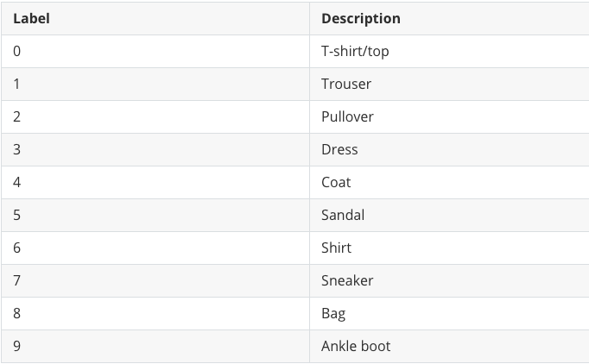
Fig. 1: the labels and description information
As shown in the following figure2, every three rows represent a class :
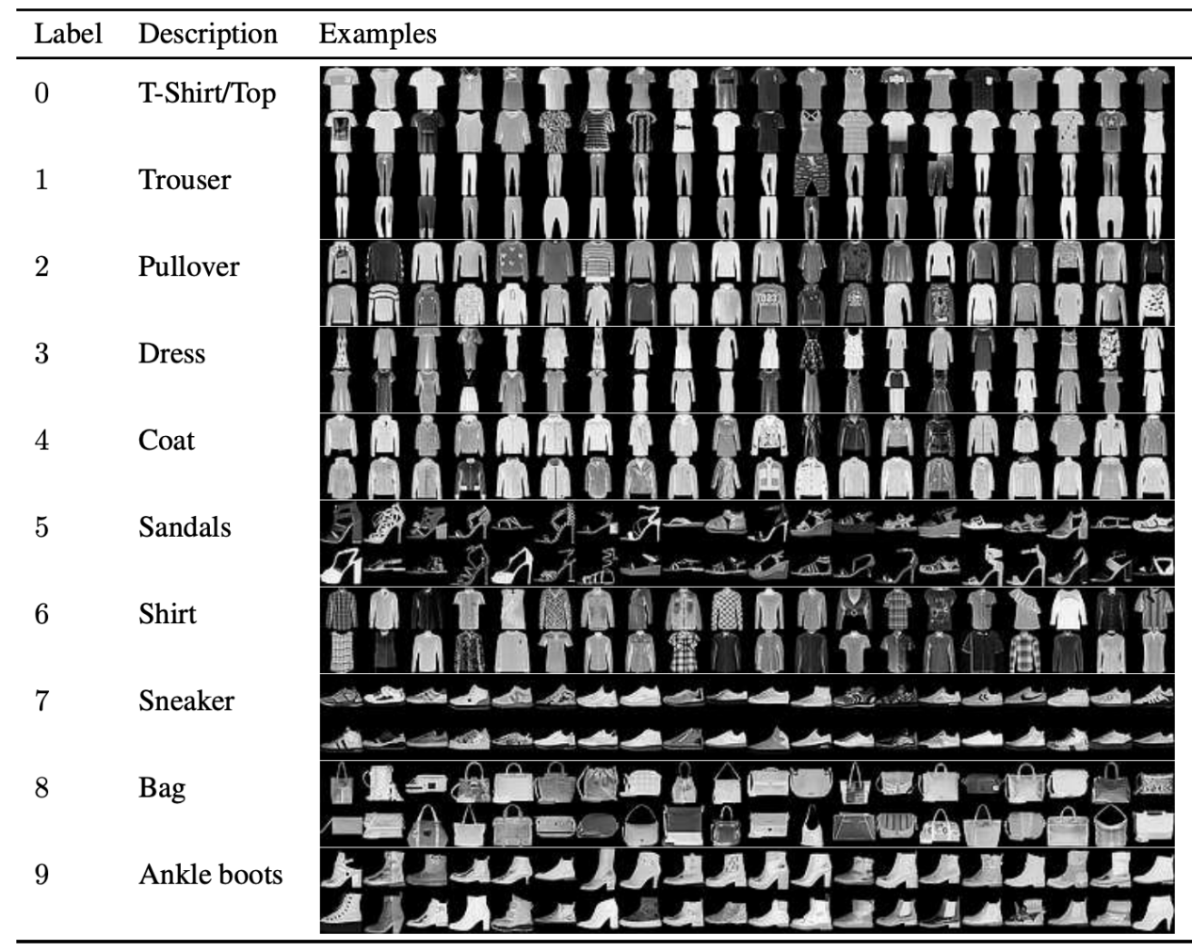
Fig. 2: every three rows represent a class

3.4 KNN

K-nearest neighbors(KNN) is one of base machine learning methods and it is used more and less in our ordinary life. For instance, we can get the point of one’s character by observing the character of the people who he/she contacts most closely.KNN algorithm, namely K-nearest neighbor algorithm, each sample can be represented by K neighbors closest to it. In the K samples closest to the sample to be tested, if most of them belong to a certain class in the feature space, the sample is judged to be of this class and has the same characteristics as the class.But in the practical application of many times do not use, why?Because we often come across samples with more than thousands of features and hundreds of thousands of samples, if we want to predict a small number of test set samples, the time efficiency of the algorithm is very problematic. Therefore, this method is generally called brute force implementation. More suitable for simple models with a small number of samples.

3.5 Decision Tree
Decision tree is a relatively simple and classic ML classification and regression algorithm. It is easy to understand, similar to the way people think, and the constructed tree graph is clear and clear. It is also the basis of other complex machine learning algorithms, such as boost and random forest.
Technically, a decision tree is comprised of a set of branches and nodes, and branches are comprised of nodes and children nodes. In order to use the decision tree to make a decision on a certain case, the attribute value of this case can be used and searched from the root down until the leaf node, which contains the decision result. The following figure3 is a case of decision tree:
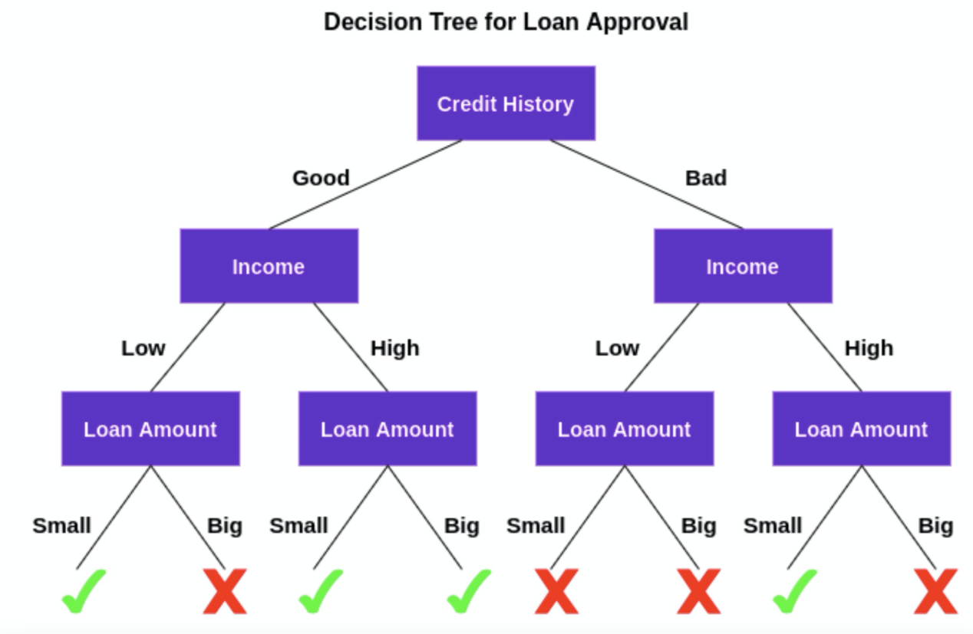
Fig. 3: a case of decision tree
The construction of the decision tree includes the following four steps：（1）Select the calculation method to measure the classification impureness of the set, which generally has three options : entropy, Gini impureness, and misclassification impureness.（2）Traverse each feature of the set, according to the measure to select the best classification attributes to divide the set. (3) Construct the whole decision tree recursively. (4)Using pruning strategy to build decision tree to prevent overfitting.
The decision tree has good mathematical theory support, convenient debugging, and the constructed model is easy to understand and explain, so it is suitable for the recognition of clothing images in Fashion-minist.
Decision forests have almost the same hyperparameters as decision trees. Generally speaking, a tree cannot get effective and desired results. At this time, the concept of random forests is needed. Random forests are an ensemble learning method for classification, regression and other tasks. The following figure4 is a diagram of the decision forest :
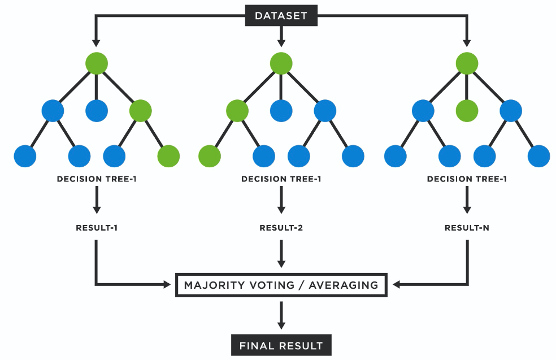
Fig. 4: a diagram of the decision forest
Random forest can be understood as a series of decision trees, which is to aggregate many decisions into a result. It is a tree-based ML algorithm that constructs lots of decision trees during training. When constructing the random forest algorithm model, we must define how many trees to be made and how many variables each node needs. Random decision forests correct the overfitting of decision trees. Random forests are usually superior to decision trees, but their accuracy is lower than gradient boosting trees. More trees will improve performance and make predictions more stable. However, because it is a combination of several decision trees, the random forest algorithm model is more complex, the calculation speed is reduced, and the process of generation and analysis is very time-consuming. If the data set is large or there is no appropriate processing method to process the data, it will take a long time to create a good decision forest, and the final model visualization is poor.

4. Results and discussion
In the experiment, the following Python packages are first introduced. The following explains the role of the introduced Python packages :
- import time : the time used to record the execution of the program;
- from sklearn import metrics : The Python package connotation evaluation index is used to measure the evaluation experiment results;
- from sklearn import tree : sklearn embedded decision tree model;
- from sklearn.metrics import classification _ report : for production classification reports;
- from sklearn.neighbors import KNeighborsClassifier : sklearn embedded KNN model;
- import fashion_mnist_load as mnist_load : for loading fashion mnist dataset;
- import plt_roc as pr : for drawing ROC curves.

Secondly, two functions knn and decision _tree are created. The parameters are training data. The algorithm implements creating model objects and filling the training set into the model, and finally returns the corresponding classifier model.
In the main program, the data set is first loaded, and the training data and test data are changed to float32, single-precision floating point number, thereby improving the computational efficiency of the computer. Because the range of color values is 0-225, the data is divided by 255 to achieve data normalization.
According to the model to predict, return the prediction results.Then,the program output model evaluation report.The first parameter of the classification_report function represents the true value and the second parameter represents the predicted value.Function output parameters include precision, recall,accuracy and so on. Precison_score is the rate of the amount of predicted positives to the amount of predicted positives to measure the accuracy of the prediction.Recall_score is used to calculate the recall rate.Plt_roc is used to plot ROC curves for 10 categories and two averages indexes.
For the KNN model, we take the value of k (the value of n_neighbours) as 3,5,7, respectively.The following table1 is a comparison of the experimental results of the KNN model :
n_neighbours | precision_score | recall_score | accuracy_score
3 | 85.9147% | 85.6100% | 85.6100%
5 | 86.0524% | 85.7700% | 85.7700%
7 | 85.7429% | 85.4100% | 85.4100%
TABLE1: summary of KNN model

As you can see from the figure, when k = 3, the three metrics precision_score, recall_score, and accuracy_score are the highest.
For decision tree model, we take the values of max_depth as 3,10,20, respectively.The following table2 is the comparison of the experimental results of the decision tree model :
max_depth | precision_score | recall_score | accuracy_score
3 | 35.3042% | 50.5600% | 50.5600%
10 | 80.1689% | 80.2300% | 80.2300%
20 | 80.6873% | 80.8400% | 80.8400%
TABLE2: summary of decision tree model

From the figure, we can see that when max_depth=3, the three evaluation indexes of precision_ score, recall_score and accuracy_score are the lowest, and the difference between the second max_depth=20 is much higher.

5. Conclusion
This paper first introduces the development history of artificial intelligence from traditional machine learning to deep learning, and then introduces problem modeling from the aspects of evaluation index, sample selection, data noise reduction, sampling, prototype selection and training set selection. Finally, Fashion Mnist dataset, KNN model and decision tree model are introduced. Then, based on KNN mode and decision tree model, Python script is used to classify and the Fashion Mnist dataset, and the experimental results are given.

6. References
[1] Xiao H, Rasul K, Vollgraf R. Fashion-mnist: a novel image dataset for benchmarking machine learning algorithms[J]. arXiv preprint arXiv:1708.07747, 2017.
[2] Xing W, Bei Y. Medical health big data classification based on KNN classification algorithm[J]. IEEE Access, 2019, 8: 28808-28819.
[3] Dong S, Sarem M. DDoS attack detection method based on improved KNN with the degree of DDoS attack in software-defined networks[J]. IEEE Access, 2019, 8: 5039-5048.
[4] Patro S G K, Mishra B K, Panda S K, et al. A hybrid action-related K-nearest neighbour (HAR-KNN) approach for recommendation systems[J]. IEEE Access, 2020, 8: 90978-90991.
[5] Rabcan J, Levashenko V, Zaitseva E, et al. Application of fuzzy decision tree for signal classification[J]. IEEE Transactions on Industrial Informatics, 2019, 15(10): 5425-5434.
[6] Zhang Q, Yang Y, Ma H, et al. Interpreting cnns via decision trees[C]//Proceedings of the IEEE/CVF conference on computer vision and pattern recognition. 2019: 6261-6270.
[7] Ahmim A, Maglaras L, Ferrag M A, et al. A novel hierarchical intrusion detection system based on decision tree and rules-based models[C]//2019 15th International Conference on Distributed Computing in Sensor Systems (DCOSS). IEEE, 2019: 228-233.
[8] Karasu S, Altan A. Recognition model for solar radiation time series based on random forest with feature selection approach[C]//2019 11th international conference on electrical and electronics engineering (ELECO). IEEE, 2019: 8-11.
[9] Tsai C F, Lin W C, Hu Y H, et al. Under-sampling class imbalanced datasets by combining clustering analysis and instance selection[J]. Information Sciences, 2019, 477: 47-54.
[10] S García, Luengo J , Herrera F . Dealing with Missing Values[J]. Springer International Publishing, 2015.

7. Essential Resources
[1]
https://moodle.uwtsd.ac.uk/pluginfile.php/545466/mod_resource/content/1/Lecture%205-Decision-Trees.pdf
[2] https://moodle.uwtsd.ac.uk/pluginfile.php/546856/mod_resource/content/1/Bagging_Random%20Forest_Boosting%20.pdf

8. Appendices

The following is the source code of the program. See the results and discussion section for specific explanations:


