

Student Name: Ignacia Manaog Tabangco
Student ID: 2415933
Module Code: LCLM5002
Programme: BA (Hons) Leadership and Management skills for the workplace
Module Name: Developing and Managing Individual and Teams
Assignment Name: Individual Report (HR Department in Vauxhall Service Ltd. Based in London Company.
Lecturer Name: Amer Kareem

Table of Contents
INTRODUCTION 3
1.EXPLANATION OF BUSINESS TRANSFORMATION 3
DIGITAL TECHNOLOGY TRENDS 3
FLEXIBLE WORKING 4
2.Leaderships Accountability and Theory 4
3.Evaluation of Contemporary 5
HR PRACTICES 5
4.Evaluation of How Departmental Managers 6
CONCLUSION and RECOMMENDATION 7
REFERENCES: 7

INTRODUCTION

After graduating, I recently joined the HR department of Vauxhall Business Services Ltd, a medium sized London based organisation undergoing significant change. During my first month, I became aware of rising employee grievances linked to workload pressures, communication issues, and uncertainly about organisational changes. My general manager requested that prepare this report to analyse the organisational challenges associated with business transformation, digital technology trends, and flexible working arrangement -three major factors shaping our HR priorities.
The report critically examines these factors, evaluates relevant contemporary HR Practices, and discuss how departmental managers can ensure urgent and effective implementation. Evidence is drawn from current scholarly literature, industry reports, and HR framework. The Aim is to recommended HR strategies that will reduce grievances, support employee wellbeing, and strengthen organizational performance.

1.EXPLANATION OF BUSINESS TRANSFORMATION
Business across the UK is undergoing rapids transformation due to increased competition, economic volatility, and technological disruption. Business transformation involves redesigning business processes, instructors and culture to improve organisational performance. At Vauxhall Business Services Ltd, the transformation focusses on restructuring workflows, adopting new digital tools and moving towards hybrid working. These changes can create uncertainly among employees, explaining the rise early-stage grievances.

DIGITAL TECHNOLOGY TRENDS
Digital Transformation is a major driver of organisation change. It involves adopting digital tools to enhance efficiency, communication, analytics and decision-making. Technology such a cloud-base HR systems, AI-driven recruitment, digital learning platform and real-time data dashboards are now essential to modern HR practice (CIPD.2023). However, the adoption of new digital technology often leads to employee concerns regarding job security, digital capability, workload changes in the speed of implementation. Studies show that digitalisation can increase stress in resistance when employee feel under prepared or excluded form decision-making.
A second major factor is automation. Many administrative HR tasks-such a payroll, absence tracking and performance appraisal-are being automated. While this improves accuracy and frees HR time for strategic work, (Westerman, 2021). it also requires employees and manager to develop no Digital Competencies. The skills gap is therefore a concern for our organisation. Researchers argue that lack of digital readiness is a major barrier to successful transformation.
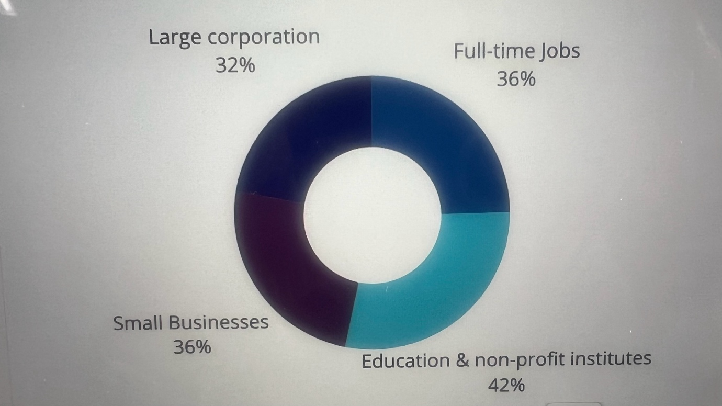jobera.com/ai-job-loss-statistic

FLEXIBLE WORKING
The third factor is the shift towards flexible and hybrid working. Since the covid-19 pandemic, flexible work has become an expectation in many industries. Flexible working includes remote work, compressed hours, part-time roles and job-sharing. The CIPD (2022) highlights that flexible work increases job satisfaction, reduces turn over intention and improves wellbeing. However, it also introduces challenges such as communication gaps, unequal access to opportunities, monitoring difficulty and blurred work-life boundaries. For Vauxhall Business services limited, flexible working arrangement were introduced quickly and without sufficient policy clarity. Some employees work remotely 3 days a week, other only one day, resulting in consistent experience across department. Organisational research shows that poorly implanted flexible working can lead to reduced team cohesion and perceptions unfairness. Another key factor is the cultural change required. Business transformation demands a supportive, open and communicative culture. If employees do not understand the reason for digital and flexible working changes, resistance is likely. Kotter’s change model emphasises the need for communication and employee involvement throughout transformation process, (Kotter, 2022). In our organisation, communication, from senior leaders has been limited, contributing to a confusion and rising grievances.
Finally, employee wellbeing is a critical related factor hybrid work in rapid digital adaptation can lead to “digital fatigue”, increased workloads and work-life imbalance. Studies show that digital intensification contribute to anxiety and burnout when organisation support is insufficient.
In summary, business transformation, digital technology trends and flexible working arrangement as reshaping the way Vauxhall Business Services limited operate. However, without strong HR practises in place, these factors can lead to employee dissatisfaction and operational challenges.

2.Leaderships Accountability and Theory
Effective leadership accountability in HR is essential as digital technologies reshape work and people practices. Leadership at Vauxhall Service Ltd. Must own the strategy, governance, and outcomes of digital HR deployments-ranging from cloud and learning platforms to AI automation and people analytics. Accountability means setting clear objectives (what success look like), defining data and ethical guardrails (how system will be used), and allocating resources for skills and change management so employees adopt new tools rather than resist them (Deloitte, 2024). Transformational leadership theory helps explain hoe HR leader can drive digital change. Transformational leaders articulate a compelling vision for technology-enabled HR, Model continuous learning, and empower staff to innovate-actions that increase buy-in for systems such as AI-driven recruiting or internal talent marketplace.
Additionally, distributed accountability models where HR, IT, line manager and employees share responsibility reduce implementation risk. For, example, HR defines policy and uses cases, IT ensure integration and security, managers embed tools into team’s routines, and employees participate in continuous feedback loops that inform iterative improvement (Insight 222; Gartner, 2024). This shared approach is especially important for ethically sensitive technology such as AI, where trust, transparency and governance framework are required to prevent bias and to maintain employee confidence.
Finally, leaders should apply a theory-driven performance measurement approach: combine leading indicators (tool usage, training completion, AI explainability checks) with outcome metrics (time-to-hire, retention y role, productivity gains). Regularly publishing these metrics reinforce accountability and create a culture where digital investments are transparently aligned to business and people outcomes.

3.Evaluation of Contemporary
To manage Business transformation effectively contemporary HR Practices much prioritise communication-capability building-employee involvement and wellbeing. One widely supported HR Practices strategic change communication. Transparent communication reduces uncertainly, builds trust and increases employee engagement during transformation HR should therefore introduce regular updates, briefings and staff forums to help employees understand the purpose and benefits of organisational changes.

HR PRACTICES
A second HR practices is learning and development (L&D) for digital skills. Research shows that targeted training program’s improved employees’ ability to use digital tools and reduce resistance HR could implement digital literacy workshop, mentoring programmes and online learning modules. This practice ensures the workforce can adapt confidently to new technological system. Third, HR must strengthen each approach to performance management. Contemporary system emphasis continues feedback, development-focus reviews and objective performance indicators supported by digital tools (Armstrong & Taylor, 2020). Modern performance systems also support flexible working by focusing on outcomes rather than physical presence. Another key Practice is employee voice and participation mechanism. This includes surveys, suggestion schemes, joint consultative comites and digital collaboration platforms. Employee voice improve commitment and reduces grievances by giving staff a platform to express concern (Wilkinson et al., 2020). At Vauxhall Service Ltd, strengthening employee voice channel will help identify early signs dissatisfaction. Flexible working policies should be redesign according to best practices. HR must provide clear eligibility criteria, expectation regarding communication and performance standard. Research suggests that well-design flexible working policies significantly improves retention, work-life balance and productivity (CIPD, 2022). Additionally, flexibility should be implanted consistently across department to avoid perception of unfair treatment. Well-being programmes represent another contemporary HR Practice. Digital transformation open increases work intensity, and well-being initiatives such as mental health support, workload reviews and wellbeing champions, mental health first aiders and regular wellbeing surveys.
Furthermore, HR must apply inclusive leadership and diversity practices. Remote and hybrid working disadvantage certain groups, such as parents or new employee. Inclusive leadership practices-such as equitable access to training, inclusive meeting and support for divers working style-are essentials to ensure fairness.HR should also adopt HR analytic to support evidence-based decision-making. Analytics can predict turn over measure engagement and identify skill gap. This data-driven approach is now considered essential for modern HR management Collectively, these contemporary HR practices can significantly reduce grievances and support successful transformation at Vauxhall Business Service Ltd.

4.Evaluation of How Departmental Managers
Department managers play a crucial role in translating HR strategies to operational practice. To ensure urgent implementation, they must adopt effective leadership behaviours, allocate resources and model desired cultural changes.
First, managers must act as change champions. Emphasises that front-line managers are essentials for building momentum during transformation. Managers must communicate key message, explain the purpose of new digital system and encourage employees to adapt new working practices. This involves holding team briefing, offering one-to-one support and reinforcing positive behaviours. Second, managers must prioritise training uptake. Research that digital transformation fails when manager do not allocate time for employee training (Westerman, 2021). Therefore, manager must schedule protected learning time, monitor completion of digital skills courses and support employees struggling with new system. Third, managers must apply fair and consistent management practices, especially regarding flexible working. They should ensure equitable access to hybrid arrangement and apply clear performance expectation. Inconsistent management approaches can lead to grievances, so standard decision is essential. Fourth, manager must strengthen employee engagement. This includes encouraging staff feedback, actively listening to concern and escalating issues early. Study show that engaged employee adapt more easily to organisational change Manager should hold regular teams meeting, conduct pulse survey and facilitate open discussion. Fifth, manager must (Dewe & Cooper, 2020). address well-being risks they should proactively monitor workload distribution, identify sign of digital overload and encourage healthy boundaries around Hybrid work. Manager influence employee well-being more than any order organisational factor.
Finally, (Armstrong & Taylor, 2020). manager must collaborate closely with HR by reporting concern sharing departmental insight and enforcing HR initiatives, they support organisation-wide consistency. When manager and HR work in partnership organisational transformation is more successful.

CONCLUSION and RECOMMENDATION
Business transformation, digital technology trend and flexible working arrangement are significant factor shaping the modern workplace at Vauxhall Services Ltd. While these factors offer major benefit, they also create challenges such as skill gaps communication issues, inconsistent management practices and increased employee grievances. Contemporary HR practices-including strong communication digital skills training, employee voice mechanism well-being programmes-can help address these issues.
To support urgent implementation, manager must champion change, promote fairness, prioritise training and foster a supportive culture.HR and Managements must work collaboratively to ensure successful transformation.

REFERENCES:
Armstrong, M. & Taylor, S. (2020) Armstrong’s handbook of Human Resources Management Practice. 15th ed. London: Kogan Page.
Bailey, C.& Breslin, D. (2021) ‘The COVID-19 pandemic: Implications for work and organisations’, International Journal of Management Reviews, 23(4), pp. 447-452.
CIPD (2022) Flexible Working Practices. Available at: www.cipd.co.uk
Dewe, P. & Cooper, C. (2020) Workplace Wellbeing: A Practical Guide. London: Bloomsbury.
Lewis, L. (2019) Organisational Change: Creating Change Through Strategic Communication. Wiley.
Westerman, G. (2021) Leading digital: Turning Technology into Business Transformation. Harvard Business Press.
Wilkinson, A., Donaghey, J., Dundon, T. & Freeman, R. (2020) Handbook of Research on Employee Voice Edward Elgar.

Deloitte. 2024 HR Technology Trend Predictions / Global Capital Trends (2024/2025).
Insight222. People Analytics / People Analytics Trends Report (2022-2024)

