  Component One:  What are the key skills required when working in the housekeeping team? 750 words (+/- 10%)  Contribution to Overall Module Assessment: 25% | Student No:
 | Module Title:
 | Module Code:
 | Lecturer:
Housekeeping is an essential part of any hospitality industry, and it requires several key skills to be successful. Here are some of the key skills required when working in the housekeeping team
Attention to Detail: A housekeeper needs to pay attention to every detail and ensure that the rooms are clean and tidy and that all items are in their place. Yes, attention to detail is crucial in housekeeping as it is essential to maintain high cleanliness standards in the hospitality industry. Housekeepers need to pay attention to every detail, including cleaning every nook and corner, ensuring all items are in their place, and identifying any areas that need attention. By paying attention to detail, housekeepers can ensure that guests have a comfortable and enjoyable stay, and the hospitality industry can maintain its reputation for cleanliness and quality service.

Time Management: Housekeepers need to manage their time effectively to ensure that they can clean all the rooms within the allotted time. Yes, time management is a crucial skill in housekeeping as it ensures that the cleaning process is completed efficiently and within the allotted time. Housekeeping teams often have a limited time to clean a specific number of rooms or areas, and effective time management skills are necessary to ensure that all tasks are completed within that time frame. By managing time effectively, housekeepers can ensure that they clean each room to the highest standard while completing all tasks on time, ensuring that guests are satisfied with their stay. In addition, time management skills help to improve productivity, reduce stress, and improve overall job satisfaction for housekeeping team members.
Communication: Effective communication skills are essential to coordinate with other team members and management. communication is a crucial skill in housekeeping as it helps to coordinate tasks and ensure that all team members are working effectively together. Effective communication is necessary for housekeeping teams to share information, provide updates, and address any issues that may arise during the cleaning process. For example, if a housekeeper identifies an issue in a room, they need to communicate it promptly to their team leader or supervisor to ensure that the issue is resolved promptly. Clear communication is also essential to ensure that guests' needs and requests are met promptly and efficiently, improving guest satisfaction levels. In addition, effective communication skills help to build trust and promote a positive work environment, improving job satisfaction and productivity among housekeeping team members.

Physical Stamina: Housekeeping involves a lot of physical work, such as standing for extended periods, lifting heavy objects, and performing repetitive tasks. Therefore, a housekeeper needs to have physical stamina. physical stamina is a crucial skill in housekeeping as the work involves a lot of physical labour, including standing for extended periods, lifting heavy objects, and performing repetitive tasks. Housekeeping team members need to have the sufficient physical stamina to ensure that they can complete their tasks effectively and efficiently while maintaining a high level of cleanliness. In addition, maintaining good physical health and fitness is essential for housekeeping team members to reduce the risk of injury, improve overall job satisfaction, and ensure that they can perform their duties consistently at a high level. Overall, physical stamina is an essential skill for housekeeping team members to ensure that they can meet the demands of their job and maintain high cleanliness standards in the hospitality industry.
Adaptability: A housekeeper must be adaptable to changing work environments and schedules.
Initiative: A housekeeper should take the initiative to identify issues and solve them promptly.
Customer Service: Housekeepers must provide excellent customer service and respond to guest requests promptly.
Organizational Skills: A housekeeper needs to have good organizational skills to keep track of cleaning supplies, linens, and other items.
Teamwork: Housekeeping is a team effort, and a housekeeper needs to work well with other team members to ensure that the rooms are cleaned effectively.
Multitasking: Housekeepers need to multitask to complete various cleaning tasks simultaneously, such as making beds, vacuuming floors, and cleaning bathrooms.
Overall, these skills are essential for any housekeeping team member to ensure the highest level of cleanliness and guest satisfaction.

Word Count

Component Two:
Contribution to Overall Module Assessment: 25%
In this scenario – You have just been promoted to the team leader for a floor within the hotel. A guest complains that on their arrival, their room had not been properly cleaned. Create an action plan and answer the following questions.

Problem | Why did it happen? | What are you going to do? | How will you prevent this from happening in the future? | What measures would you introduce to improve team effectiveness?
The problem is the room was put vacant while she has never been checked by a team manager or a team leader to see if it meets the standards for our premises.  Time constraints: Housekeeping staff are often another pressure to clean a large number of rooms in a short amount of time | Someone from the staff put that room is ready to rent in the system but no team leader or team manager checks if is ready to be vacant on the system. | From today date I inform the housekeeping team by leaving a message on teams and I tell them all the rooms must to be checked if they meet the criteria and if they are clean and ready to be vacant on the system and they need to be checked by a team leader or the team manager responsible for the premises on that day and they are responsible to put in the system what type of room is if is clean if everything is working properly by the Hotel rules. | I will prevent this from happening again only by doing a refresher course for each member of the housekeeping team after every 4 months on how to apply the (SSS) Strip Sanitise and Set-up and make sure the team leader and team manager only change the type of room and if she meets the standard of the Hotel. | As I said I will bring a couple of measurements that’ll impact our cleaning team by having more time in each room to make sure they apply all the rules and procedures to maintain and raise the quality. They will achieve this only by having refresher training after every 4 months and online training every 3 months.

Component Three:
Contribution to Overall Module Assessment: 50%
Your task is to create and prepare a presentation following the detailed scenario provided below.

As the floor housekeeping manager and given the recent guest complaints you need to put together a basic training presentation for your colleagues within the housekeeping team to get the best out of them, ensure that brand standard is being achieved and that Health and Safety procedures are also being followed.

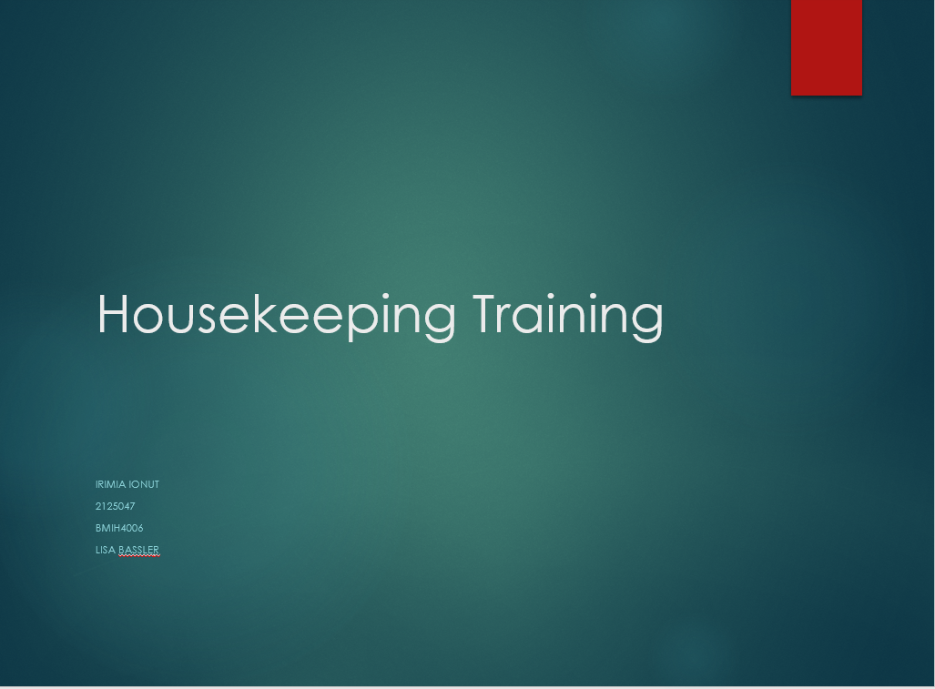

Training Notes:
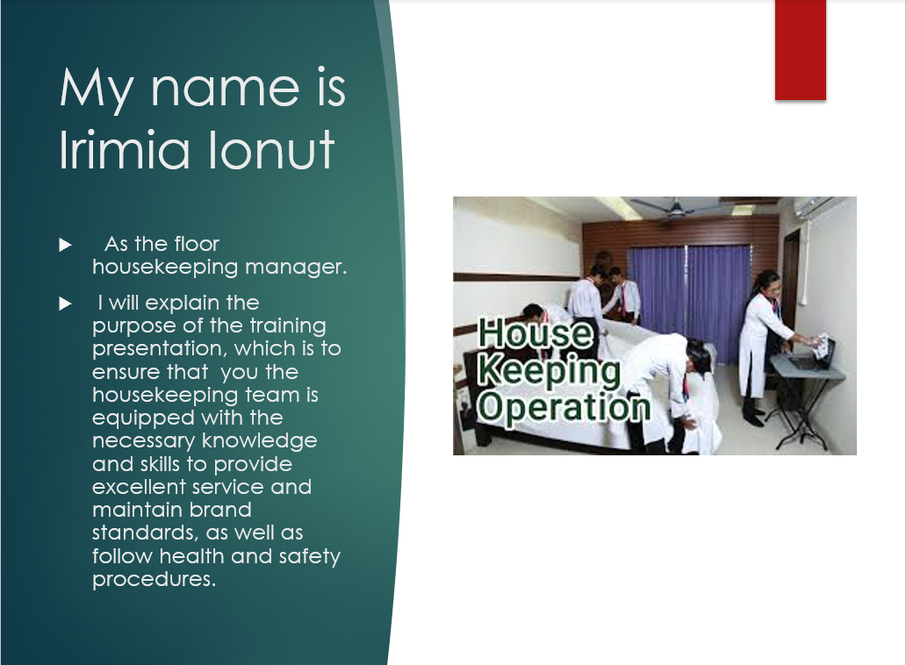

Hello everyone, my name is Irimia Ionut (John) and I am the floor housekeeping manager. As the manager, my role is to oversee the housekeeping team and ensure that guest rooms and public areas are clean, comfortable, and meet the hotel's brand standards. The purpose of today's training presentation is to provide you with the necessary knowledge and skills to provide excellent service to our guests, maintain brand standards, and follow health and safety procedures. By the end of this presentation, you should feel confident in your ability to provide top-notch service while also keeping our guests and team members safe
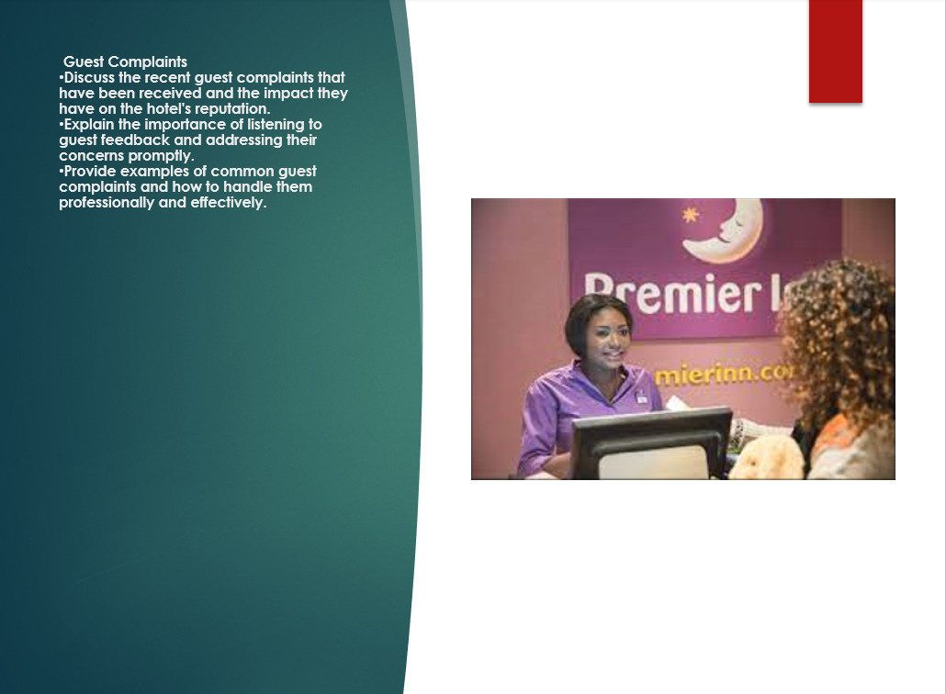

Training Notes: For example, we have recently received several guest complaints about the cleanliness of their rooms. Our goal is to prevent these types of complaints from happening in the future by ensuring that our housekeeping team is equipped with the knowledge and skills to clean guest rooms to the hotel's brand standards. Additionally, by following proper health and safety procedures, we can prevent accidents and injuries in the workplace
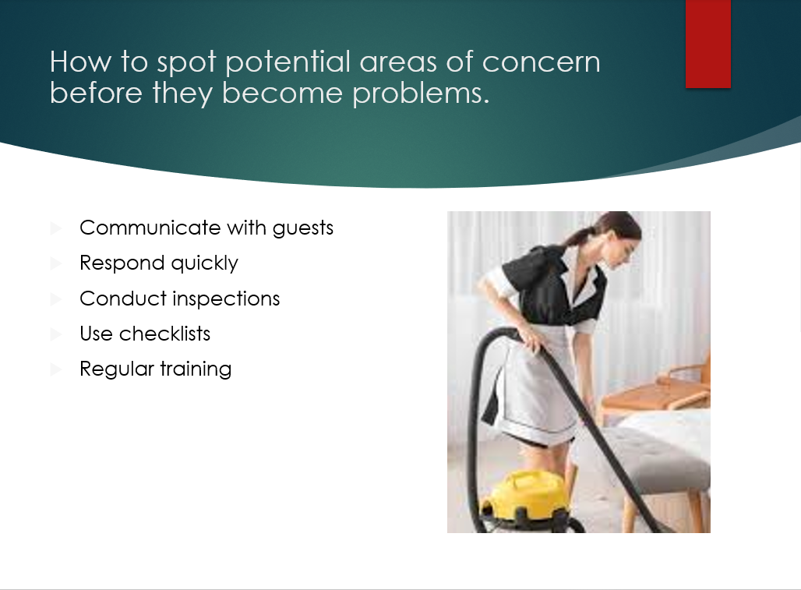

Training Notes: Guest rooms should be arranged in a consistent and efficient manner, with all necessary amenities and supplies readily available. Attention to detail: Housekeeping staff should pay close attention to small details such as dusting, vacuuming, and tidying up, in order to provide guests with a comfortable and welcoming environment. Performing a room inspection
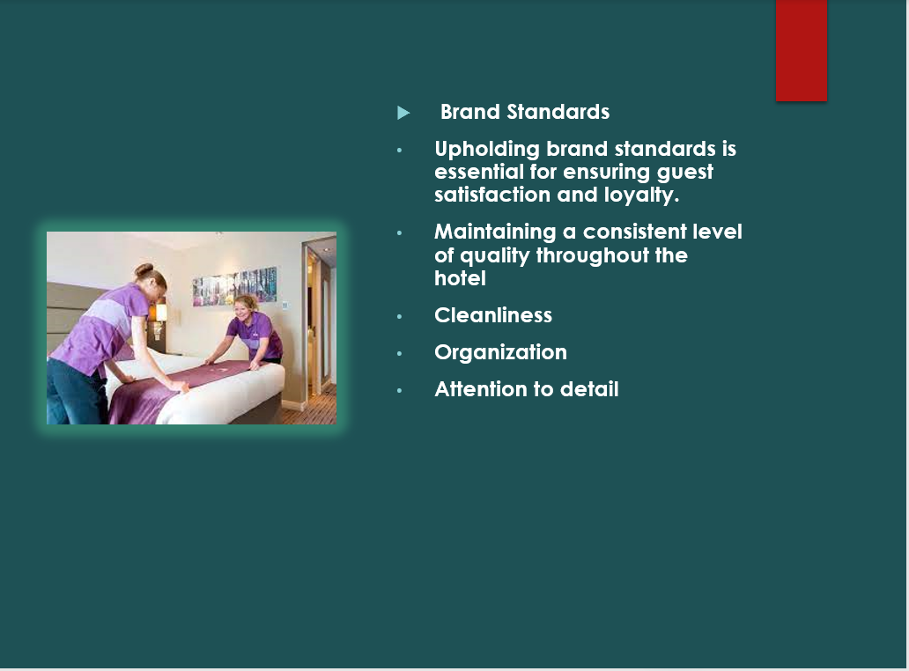

Training Notes:
As a trusted brand that is known for its high standards of cleanliness, comfort, and service. As members of the housekeeping team, it is your responsibility to ensure that these standards are maintained throughout the hotel The importance of adhering to brand standards Upholding brand standards is essential for ensuring guest satisfaction and loyalty. Maintaining a consistent level of quality throughout the hotel helps to establish and reinforce the hotel's reputation. Following brand standards also helps to ensure that the hotel meets legal and regulatory requirements. Examples of brand standards related to housekeeping: Cleanliness: All guest rooms and public areas should be cleaned to a high standard, with particular attention paid to bathrooms, floors, and surfaces. Organization: Guest rooms should be arranged in a consistent and efficient manner, with all necessary amenities and supplies readily available. Attention to detail: Housekeeping staff should pay close attention to small details such as dusting, vacuuming, and tidying up, in order to provide guests with a comfortable and welcoming environment

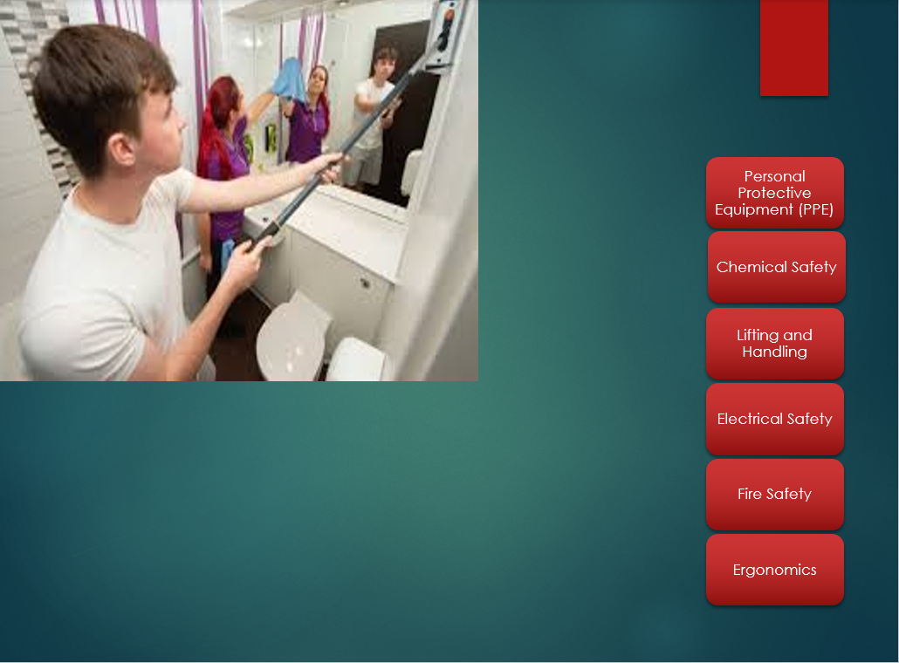

Training Notes: .Personal Protective Equipment (PPE): Housekeeping staff should wear appropriate PPE, such as gloves and aprons, when cleaning guest rooms and handling hazardous materials.Chemical Safety: All cleaning chemicals should be properly labeled, stored in a designated area, and used in accordance with the manufacturer's instructions. Staff should be trained on the safe handling and use of cleaning chemicals.Lifting and Handling: Proper lifting and handling techniques should be used to avoid injury. This includes bending at the knees, keeping the back straight, and using carts or dollies to transport heavy items.Electrical Safety: Electrical appliances and cords should be inspected regularly for damage or wear, and should be used in accordance with manufacturer's instructions. Staff should also be trained on the proper use of electrical appliances.Fire Safety: Staff should be trained on the hotel's fire safety procedures, including how to evacuate guests and how to use fire extinguishers. Smoke detectors and fire alarms should be checked regularly to ensure they are in working order.Ergonomics: Housekeeping staff should be trained on ergonomics, or the science of designing work environments that are safe, comfortable, and efficient. This includes using proper posture and positioning when cleaning or moving items, and taking breaks as needed to avoid repetitive motion injuries
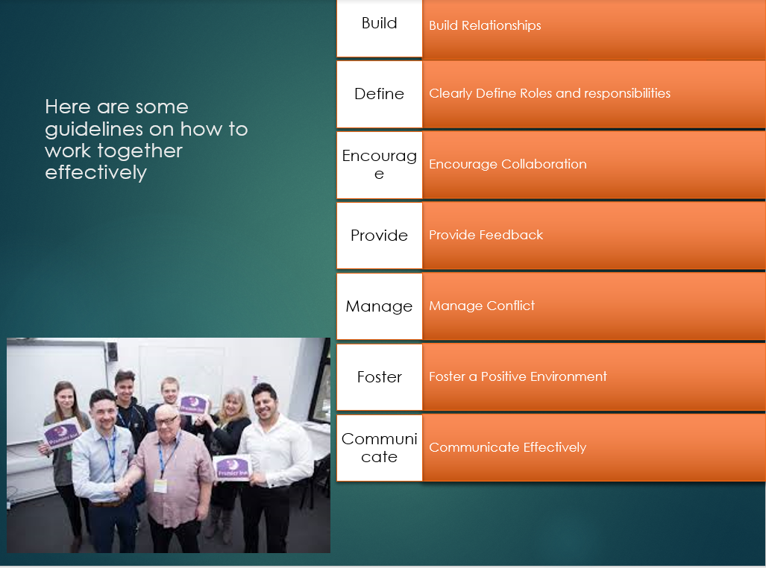

Training Notes: Build Relationships: Create an environment that fosters strong relationships between team members. Encourage open communication and active listening. Consider organizing team-building activities and events to strengthen bonds and foster team spirit. Clearly Define Roles and Responsibilities: Clearly defining roles and responsibilities for each team member ensures that everyone understands what is expected of them. This also ensures that tasks are completed efficiently and effectively. Encourage Collaboration: Encourage collaboration and cooperation between team members. Encourage sharing of ideas, techniques and methods. This can help to improve the efficiency and quality of work. Provide Feedback: Provide constructive feedback on a regular basis to team members. This can be done during performance evaluations, daily meetings, or informal conversations. Feedback should be specific, actionable and focused on improvement. Manage Conflict: Address conflicts quickly and fairly. Encourage open communication and active listening when resolving conflicts. Encourage team members to express their concerns and views and work together to find mutually acceptable solutions. Foster a Positive Environment: Foster a positive and supportive work environment. Encourage team members to recognize and celebrate each other’s successes. Provide support and assistance to team members who may be struggling. Communicate Effectively: Effective communication is essential for a successful team. Encourage open communication, listen actively and ensure that all team members have a clear understanding of expectations, procedures and goals. Ensure that team members are aware of any changes to policies, procedures or expectations. Overall, effective teamwork and communication require ongoing attention and effort. By building strong relationships, defining roles and responsibilities, encouraging collaboration, providing feedback, managing conflict, fostering a positive environment, and communicating effectively, housekeeping teams can work together more effectively and achieve better results
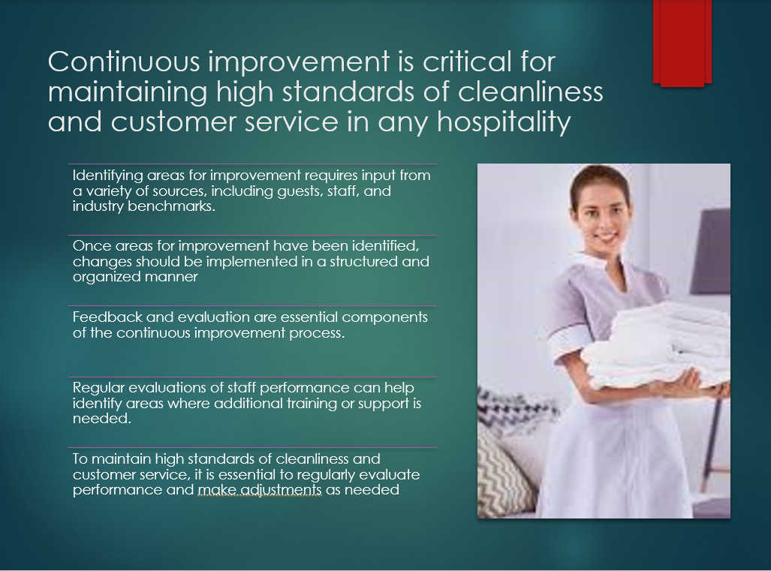

- Training Notes: Encourage them to act by implementing the new procedures and techniques they learned during the training. Here are some examples: Use the new cleaning procedures: Encourage the team to use the updated cleaning procedures and techniques covered in the training to ensure that all rooms and guest areas are maintained to the highest standards. Communicate with each other: Encourage the team to communicate effectively with their colleagues and managers to ensure that everyone is aware of the new procedures and is working together to maintain high standards of cleanliness and customer service. Embrace continuous improvement: Encourage the team to continually seek ways to improve their performance and maintain high standards. This could include regular evaluations, seeking feedback from guests, and tracking industry benchmarks and best practices.

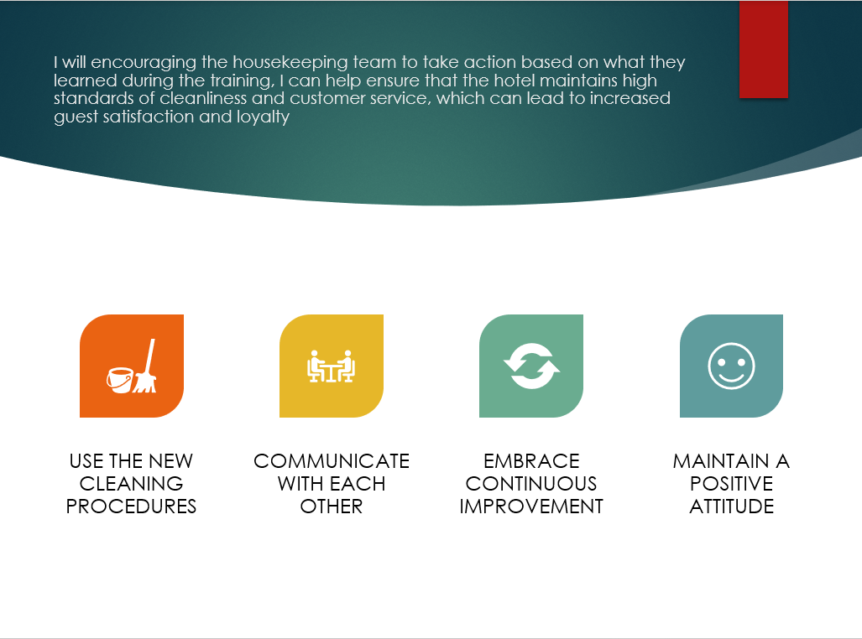

- Training Notes: .Maintain a positive attitude: Encourage the team to maintain a positive attitude and to take pride in their work. A positive attitude can have a significant impact on the guest experience and can help to maintain a positive work environment.By encouraging the housekeeping team to take action based on what they learned during the training, you can help ensure that the hotel maintains high standards of cleanliness and customer service, which can lead to increased guest satisfaction and loyalty.

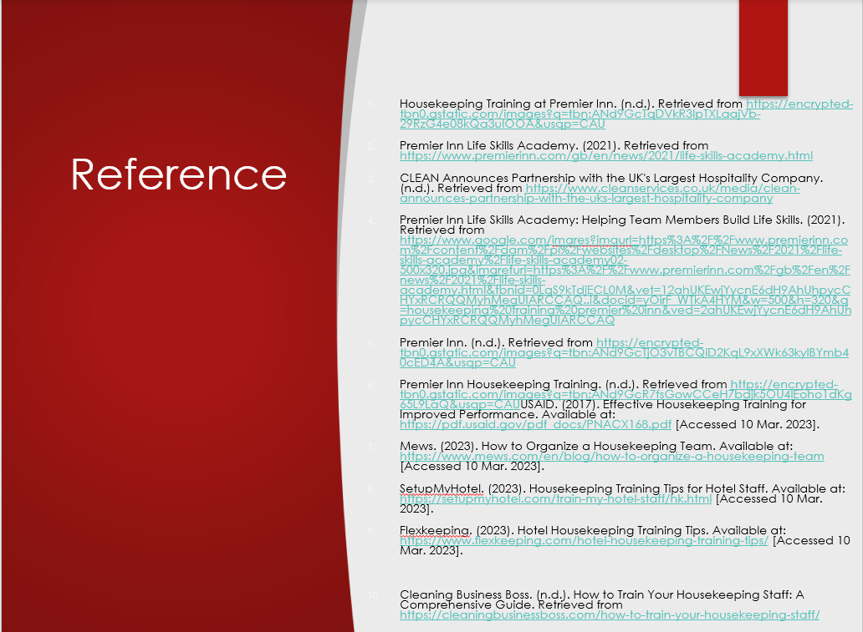

- Training Notes: Housekeeping Training at Premier Inn. (n.d.). Retrieved from https://encrypted-tbn0.gstatic.com/images?q=tbn:ANd9GcTqDVkR3IpTXLaajVb-29RzG4e08kQa3uIOOA&usqp=CAU
- Premier Inn Life Skills Academy. (2021). Retrieved from https://www.premierinn.com/gb/en/news/2021/life-skills-academy.html
- CLEAN Announces Partnership with the UK's Largest Hospitality Company. (n.d.). Retrieved from https://www.cleanservices.co.uk/media/clean-announces-partnership-with-the-uks-largest-hospitality-company
- Premier Inn Life Skills Academy: Helping Team Members Build Life Skills. (2021). Retrieved from https://www.google.com/imgres?imgurl=https%3A%2F%2Fwww.premierinn.com%2Fcontent%2Fdam%2Fpi%2Fwebsites%2Fdesktop%2FNews%2F2021%2Flife-skills-academy%2Flife-skills-academy02-500x320.jpg&imgrefurl=https%3A%2F%2Fwww.premierinn.com%2Fgb%2Fen%2Fnews%2F2021%2Flife-skills-academy.html&tbnid=0LqS9kTdjECL0M&vet=12ahUKEwjYycnE6dH9AhUhpycCHYxRCRQQMyhMegUIARCCAQ..i&docid=yOirF_WTkA4HYM&w=500&h=320&q=housekeeping%20training%20premier%20inn&ved=2ahUKEwjYycnE6dH9AhUhpycCHYxRCRQQMyhMegUIARCCAQ
- Premier Inn. (n.d.). Retrieved from https://encrypted-tbn0.gstatic.com/images?q=tbn:ANd9GcTjO3vTBCQiD2KqL9xXWk63kylBYmb40cED4A&usqp=CAU
- Premier Inn Housekeeping Training. (n.d.). Retrieved from https://encrypted-tbn0.gstatic.com/images?q=tbn:ANd9GcR7fsGowCCeH7bdjk5OU4lEoho1dKg65L9LaQ&usqp=CAUUSAID. (2017). Effective Housekeeping Training for Improved Performance. Available at: https://pdf.usaid.gov/pdf_docs/PNACX168.pdf [Accessed 10 Mar. 2023].
- Mews. (2023). How to Organize a Housekeeping Team. Available at: https://www.mews.com/en/blog/how-to-organize-a-housekeeping-team [Accessed 10 Mar. 2023].
- SetupMyHotel. (2023). Housekeeping Training Tips for Hotel Staff. Available at: https://setupmyhotel.com/train-my-hotel-staff/hk.html [Accessed 10 Mar. 2023].
- Flexkeeping. (2023). Hotel Housekeeping Training Tips. Available at: https://www.flexkeeping.com/hotel-housekeeping-training-tips/ [Accessed 10 Mar. 2023].
- Cleaning Business Boss. (n.d.). How to Train Your Housekeeping Staff: A Comprehensive Guide. Retrieved from https://cleaningbusinessboss.com/how-to-train-your-housekeeping-staff/

References

- Arslan, M. and Çınar, Y. (2021) 'Housekeeping in hotels: A review from the perspective of housekeeping staff', International Journal of Elementary Education, 4(1), pp.50-58. Available at: https://www.ilkogretim-online.org/fulltext/218-1645785401.pdf (Accessed: 10 March 2023).
- Choi, M. and Altinay, L. (2021) 'Employee perceptions of hotel CSR activities during the COVID-19 pandemic', Anatolia, 32(1), pp.139-151. Available at: https://eprints.leedsbeckett.ac.uk/id/eprint/7885/1/EmployeePerceptionsOfHotelCSRActivitiesDuringTheCOVID19PandemicAM-CHOI.pdf (Accessed: 10 March 2023).
- Huang, L., Law, R. and Liang, X. (2020) 'The impact of COVID-19 on hospitality: A global review of research and implications for the future', Journal of Hospitality and Tourism Management, 45, pp.202-214. Available at: https://www.ncbi.nlm.nih.gov/pmc/articles/PMC7528873/ (Accessed: 10 March 2023).
- Kim, H., Lee, M. J. and Choi, S. (2018) 'A systematic review of consumer satisfaction studies in hospitality journals: Conceptual development, research approaches, and prospects', International Journal of Contemporary Hospitality Management, 30(1), pp.17-39. Available at: https://www.researchgate.net/publication/326550663_A_Systematic_Review_of_Consumer_Satisfaction_Studies_in_Hospitality_Journals_Conceptual_Development_Research_Approaches_and_Future_Prospects (Accessed: 10 March 2023).
- Nguyen, T. H., Nguyen, H. T., Nguyen, T. N. and Nguyen, M. T. (2018) 'The impact of hotel room cleanliness on guest satisfaction: An empirical investigation', Journal of Hospitality and Tourism Insights, 1(2), pp.141-149. Available at: https://www.emerald.com/insight/content/doi/10.1108/JHTI-04-2018-0020/full/html (Accessed: 10 March 2023).

