
Programme: Master of Business Administration
Module: Marketing Management
Module code: LCMB7024
Lecturer: Dr Haoran Liu
Assignment Title: Assessment 2: Portfolio: Brand Extension

Student Name :- Sakshi Bipinbhai Kalani
Student ID :- 2423623
Table of Contents
Introduction 3
Purpose of the report 3
New brand extension idea (Apple SmartDesk) 4
Segmentation, targeting and positioning strategies for the new brand extension. 6
Segmentation strategies 6
Targeting strategies (differentiated targeting strategy) 7
Positioning strategies (brand image in the minds of the consumers) 8
Profile of a typical customer 9
Marketing mix strategy for the new brand extension idea 10
Conclusion 13
References: 14

Chosen Organization : Apple

Introduction
Brief overview of the chosen company
On April 1, 1976, Steve Jobs, Steve Wozniak, and Ronald Wayne created Apple in a garage. One of the world's most profitable and prominent IT companies. Apple's iPhone, iPad, Mac, Apple Watch, and digital services like Apple Music and iCloud are known for their sleek, user-friendly designs and cutting-edge technology. Goals include “to bring the best user experience to its customers through its innovative hardware, software, and services,” developing the best products, and helping the world. On April 1, 1976, Steve Jobs, Steve Wozniak, and Ronald Wayne founded Apple Inc. in California. Jobs and Wozniak DIYed the Apple I in a garage. Apple Computer was formed in 1977 and renamed Apple Inc. in 2007 to reflect its consumer electronics focus. Apple's biggest success in 2007 was the iPhone, in 1984 it was the Macintosh. Later, Apple released the iPad, Apple Watch, AirPods, and Apple Vision Pro (2024). In 2024, Apple delivers 2.2 billion smartphones to 175 nations (Aniebonam, 2024). At $517 billion in 2023, Apple is the most valuable brand. As the first company to exceed $3 trillion in market valuation in early 2022, it leads technology worldwide. Apple has approximately 160,000 full-time employees and 52% of their $383 billion fiscal year 2023 revenue comes from the iPhone (Bouichou et al., 2024).

Purpose of the report
This study suggests and examines Apple Inc.'s Smart Desk brand extension. This review found that the smart desk matches Apple's corporate identity, design, functionality, and smooth integration. The paper explore the brand extension's strategic potential to suit hybrid work and smart home consumer needs. The research examines how the Apple Smart Desk may increase Apple's product ecosystem, market share, and technological leadership via STP, consumer profiling, and a personalized marketing mix strategy.
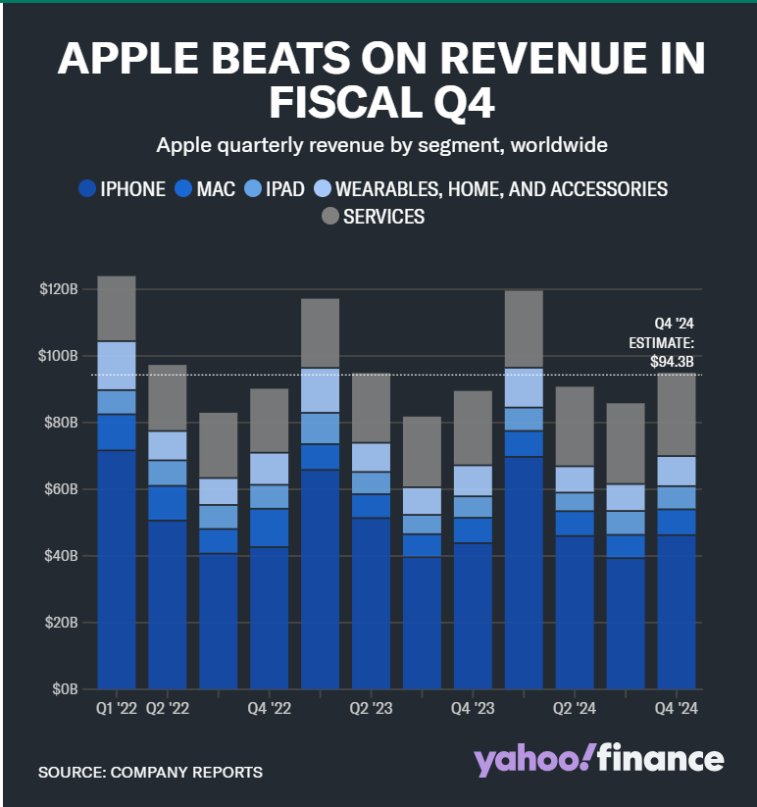
Fig 1: Apple Revenue
Source: (Bouichou et al., 2024)

New brand extension idea (Apple SmartDesk)
As hybrid and remote work grows increasingly common, Apple may expand its ecosystem into smart furniture and digital workspaces with the “Apple SmartDesk.” This AI-powered, premium smart desk would have an integrated macOS-compatible touchscreen, wireless charging stations, facial and fingerprint biometric security, ambient lighting with adaptive brightness, posture correction sensors, and seamless Siri voice control in Apple's iconic minimalist design. Converging market dynamics and consumer expectations require brand extension (Cai and Chen, 2024). 58% of U.S. workers work remotely one day a week, and 35% are entirely remote or hybrid. Smart furniture sales will rise from $16.3 billion in 2023 to $42.6 billion in 2030 due to productivity, health, and linked home devices. Given its 2.2 billion active devices and proven ecosystem of interoperable hardware and software, Apple should participate. The ideal customers for Apple's smart workplace solutions are tech-savvy professionals, creatives, and digital natives. Electronics-equipped home offices are becoming increasingly popular: 74% of 25–40-year-old workers feel they improve work effectiveness and mental health. Quality, security, and easy UX offer Apple an edge against ecosystem-less smart desks. Flexible and autonomous. Recycled aluminium and sustainable wood composites would make the SmartDesk appealing to 73% of eco-conscious Gen Z and Millennials. Apple predicts value chain carbon neutrality by 2030 (Crawford, 2024). This extension would diversify earnings and improve Apple's digital innovation and lifestyle brand influence on work and lifestyle. Apple connects hardware, environment, productivity, wellness, and humans with intelligent living spaces to drive tomorrow's digital workspace revolution.
SmartDesk extends Apple's reach beyond consumer devices into smart workspace and home-office industries, enabling strategic and financial growth. As the global smart office business increases 13.6% to $90.63 billion by 2030, Apple SmartDesk can join an underserved market. Post-pandemic, 58% of global workers work remotely part-time. The SmartDesk addresses professionals' growing demand for ergonomic, smart workstations. Workstations from Apple integrate iPhone, Mac, iPad, Apple Watch, and HomePod for productivity (Fatahilah et al., 2024). Interconnectivity increases Apple customer ecosystem interaction, boosting LTV and reducing churn. As smartphone and tablet competition increases, Apple can future-proof its product line and improve its lifestyle brand by moving into smart furniture and hybrid workspaces. Institutions, premium workspace providers, and tech-enabled co-working spaces can collaborate. Next-generation smart furniture complements Apple's aesthetics and functionality. This feature lets Apple capitalise on the $12 billion remote work-driven home office renovation market. The SmartDesk's recycled materials and energy-efficient components meet Apple's 2030 carbon neutrality goal and consumer sustainability expectations (Harmen et al., 2024). Apple SmartDesks generate revenue and let Apple control consumers' physical locations, making the ecosystem more immersive, productive, and future-ready.

Segmentation, targeting and positioning strategies for the new brand extension.

Segmentation strategies
Demographic Segmentation
Apple SmartDesk targets millennials and Gen Z 25–45-year-old workers. Tech-savvy early adopters make up most Apple fans. Over 65% of developed-country millennials have multiple Apple devices, making them perfect for Apple-integrated offices (HEPTARIZA et al., 2024). The company target software engineers, designers, digital marketers, freelancers, entrepreneurs, and C-level executives with mid- to high discretionary salaries who can afford a premium smart desk that boosts productivity, comfort, and health.
Geographic Segmentation
In mature economies, Apple SmartDesk targets tech-savvy urban and suburban professionals. Major urban locations in the US, Canada, the UK, Germany, Japan, Australia, and the UAE are appealing markets due to high digital literacy, Apple product penetration, and remote work culture. Over 58% of US professionals work remotely once a week, and San Francisco, New York, London, Berlin, and Tokyo want high-end digital offices (Jia et al., 2024).
Psychographic Segmentation
Psychographic segmentation targets Apple's ideal customers' values, interests, and lifestyles. For innovation, wellness, productivity, and seamless tech, the Apple SmartDesk is ideal. Workstations for remote and hybrid workers must be focused, comfortable, and convenient. In 2023, 74% of Gen Z and millennial workers said a clean and functioning office improved performance and job satisfaction, according to Forbes. Reduce fatigue with posture adjustment, integrated illumination, and device sync for optimal lifestyle minimalists. Apple intends to be carbon neutral by 2030, so eco-conscious computer users may welcome the SmartDesk (Kornelakis and Petrakaki, 2024).

Targeting strategies (differentiated targeting strategy)
Apple's SmartDesk launch should use a differentiated targeting strategy, which segments the market and tailors marketing, product features, and messaging to each group. This works because Apple's products appeal to varied consumer profiles, from price-sensitive iPhone SE users to creative professionals and power users with the MacBook Pro and iMac (Lestari, 2024). Apple would market the SmartDesk to high-earning techies and enterprise and business clientele in computing, digital media, and design. Apple would target 25–40-year-old millennials and Gen Z professionals who work remotely or hybridly and prioritise convenience, wellness, and digital ecosystem integration. This group could get a sleek base model with Siri, wireless charging pads, and ambient lighting for under $1,999 from Apple. Apple targets corporate and institutional buyers including design firms, tech startups, co-working spaces, and executive boardrooms. These companies are investing in smart workspaces to attract and retain talent. Over 56% of worldwide businesses are reorganising workspaces with embedded digital technology to improve productivity and collaboration. Apple may provide a SmartDesk Pro with larger touch panels, multi-user biometric profiles, enterprise-level macOS integration, and IT management for this segment (Lin and Lu, 2024).
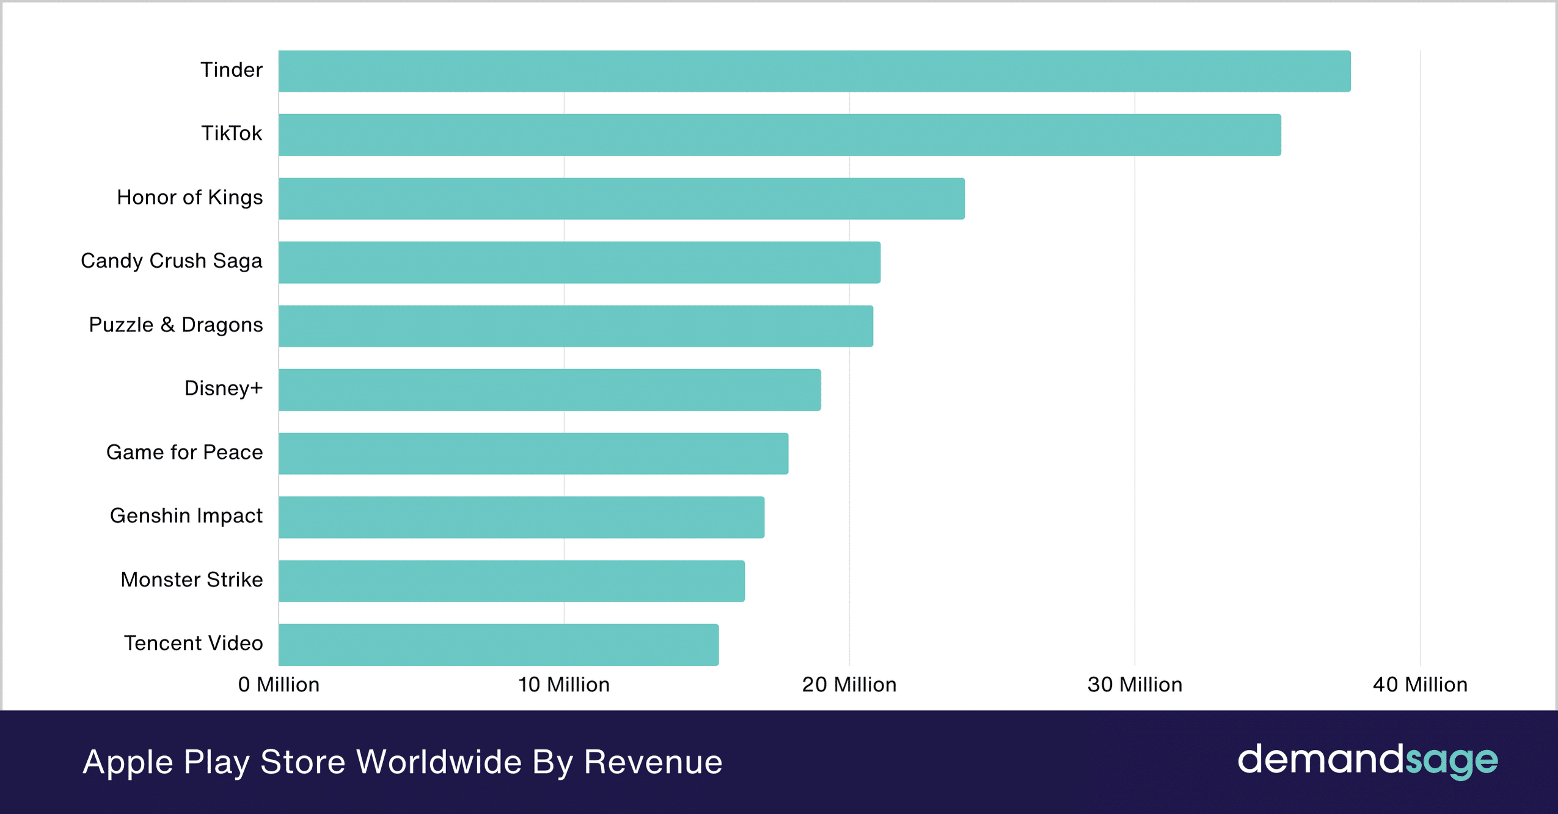
Fig 2: Apple Play Store Revenue Worldwide
Source: (Mansour et all., 2024)

Positioning strategies (brand image in the minds of the consumers)
Luxury, sophisticated, and wellness-focused, the Apple SmartDesk would transform how professionals work and integrate with Apple's environment. The strategy would highlight innovation, ecosystem integration, and lifestyle elevation, which are key to Apple's global brand image. Apple is known for its elegance, reliability, and innovative design, not simply technology. Using this brand property, the SmartDesk may be seen as an extension of Apple's “it just works” approach. The SmartDesk, the centrepiece of modern workstations, is ergonomic and intelligent (Mansour et all., 2024). Real-time posture monitoring, automated height adjustment, wireless charging, Siri voice commands, and integration with macOS, iOS, and iCloud would boost Apple's reputation for smooth, human-centered experiences. It would represent status, empowerment, and well-being like the iPhone and Apple Watch did for mobile communication and health tracking. The SmartDesk would promote Apple's environmental narrative and attract eco-conscious customers by using recyclable aluminium and responsibly sourced wood (Mohammed et al., 2024).

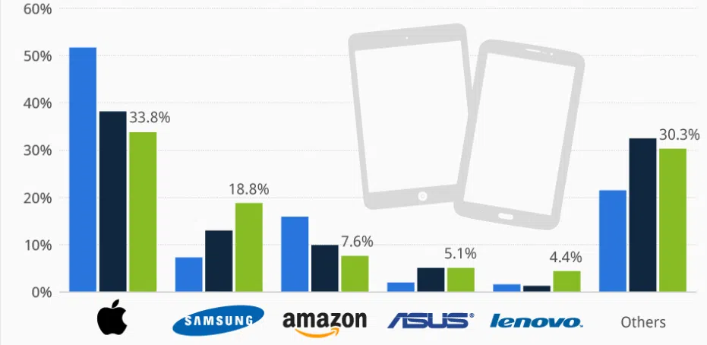
Fig 3: Apple being the most unique and creative product maker
Source: (Setiawan et al., 2025)

Profile of a typical customer
Components | Analysis
Age | Target customers for the Apple SmartDesk are 25–45. Millennials and Gen Xers who work remotely or hybridly are in this group. They are tech-savvy and adaptable to digital workspaces, seeking solutions to boost productivity and well-being in their home or flexible office.
Gender | Functionality and design make the product appealing to all genders. Apple's branding and inclusive product philosophy keep the SmartDesk gender-neutral and customizable to meet a variety of aesthetic and functional preferences.
Income | This consumer category often earns over 20,000 GBP and has a mid-to-high disposable income. Their income allows them to buy high-end technology that meets their quality, efficiency, and brand reputation standards. These customers are used to buying durable, multipurpose instruments for work and life.
Occupation | The target audience works in software development, digital marketing, entrepreneurship, UX/UI design, consulting, and remote project management. SmartDesks are designed for dynamic, ergonomic, and highly networked digital workspaces.
Education | Some have postgraduate degrees and bachelor's degrees. Their curriculum promotes analytical thinking, problem-solving, and forward-thinking, which complements the SmartDesk's AI-powered versatility.
Values | Customers that value innovation, sustainability, privacy, and simplified digital experiences like the Apple SmartDesk. These people value technologically advanced, ecologically friendly products that meet Apple's 2030 carbon-neutral target and employ recycled materials.
Attitudes | Minimalist design, intuitive technology, and lifestyle-enhancing solutions are popular with this group. They value balance, wellbeing, and productivity at work and prefer items that represent these values. Apple's ecosystem and UX philosophy match this group's expectations.
Lifestyle | Wellness and digital integration are their priorities. They have smart houses, employ wearable gear to track health and productivity, and create ergonomic work settings for mental clarity and comfort. The SmartDesk fits their work-life balance.
Buying Behaviour | These consumers choose expensive, trustworthy, and sustainable products and are brand loyal, especially to Apple. They research hard before buying and prioritize long-term usability over trends. They also respond well to ecosystem benefits like device interoperability and data security.
Aspirations | They aim to create smart, sustainable home workspaces that showcase success, innovation, and identity. They want tools that help them work smarter and live better to keep ahead in career and lifestyle trends. The SmartDesk becomes a prestige symbol of modern productivity and future-readiness.

Marketing mix strategy for the new brand extension idea
Product Strategy
Elite ergonomic workstations like the Apple SmartDesk improve teamwork with AI. Apple's sleek SmartDesk supports macOS, iPadOS, iOS, and Siri and has clever height adjustment, wireless charging, AI-powered posture detection, ambient lighting, and full macOS It automates workflows, syncs calendar alerts, and tracks health with Apple Watch (Thapa et al., 2024). To support Apple's 2030 carbon-neutral supply chain and products, the SmartDesk combines recycled aluminium and FSC-certified wood. The worldwide smart furniture business will reach $4.5 billion by 2027, with ergonomic and wellness-focused workplace furniture growing 12.6%, which Apple may exploit. Studio Display arms and MagSafe docks work with SmartDesk for individuals and Pro for creatives and enterprises
Price Strategy
Apple will charge more to represent its brand. SmartDesk Pro costs £2,199 and boasts Apple ecosystem connectivity, luxury materials, and AI. The base model cost £1,499. The desk's luxury lifestyle investment pricing emphasises its exclusivity and value. Apple sells more than Herman Miller's non-integrated £1,200–£1,800 smart workstations (Zechiel et al., 2024). SmartDesk may benefit from AppleCare+. MacBook or iPad bundles may boost cross-product sales and ecosystem retention.
Place (Distribution) Strategy
Apple Store Online, Apple Retail Stores, and certified premium resellers sold SmartDesks. Clients touch PCs in immersive demo zones. SmartWorkspace Pods in London, New York, and Tokyo enable MacBook and Studio Display with SmartDesk.11% more Apple Vision Pro showroom traffic in Q1 2024. Apple's rapid delivery and corporate and home office white-glove assembly enabled online sales. Apple may collaborate with B2B corporate procurement platforms and interior design businesses targeting startups and innovation hubs (Zhang et al., 2024).
Promotion Strategy
Apple showcased the SmartDesk on YouTube, Instagram, and X during a global Apple Event. SmartDesk pages on Apple's website and App Store would display AR, 3D product views, and assisted configuration. Technology reviewers like MKBHD and design influencers like Ali Abdaal boost early interest and reputation. Apple's "Work Smarter. Live Better." may improve health and productivity. Digital media, premium lifestyle periodicals, LinkedIn ads for B2B engagement, and coworking and innovation campus experiential marketing comprised the campaign. 76% of 25–40-year-old professionals consider workplace ergonomics a productivity issue, making them responsive. Apple's emotional branding and storytelling to enhance user experiences will make the SmartDesk a lifestyle upgrade.
People
Apple's Customer-facing and Internal Staff run SmartDesk smoothly. Apple's 520 Retail Stores in 26 countries and 70,000 customer-focused workers can help smart furniture shoppers. In-store consultants customize SmartDesk with posture tracking, Siri control, and Apple ecosystem connectivity. Apple's “Today at Apple” initiative might offer SmartDesk and workspace wellness courses to engage customers. Pre-pandemic attendance was 18 million. Apple may dispatch B2B enterprise support to co-working spaces and startups for onboarding and workspace optimization. Apple's high-touch service and Genius Bar approach produce brand loyalty and happiness, especially among its tech-savvy, health-conscious 25–40-year-old core audience, 74% of whom believe ergonomics boost work effectiveness and mental wellness The brand's personnel will translate technical complexity into productivity and wellbeing as smart, networked home-offices become more common.
Process
Apple will replicate its best-in-class retail and shipping process for premium furniture in the SmartDesk purchase and user trip. The Apple Store app and website allow customers to browse and setup SmartDesks utilizing 3D product visualization and AR to simulate desk installation at home or work. One of Gartner's top 10 global supply chains, Apple's logistics system delivers orders quickly and records them with white-glove assembly in critical regions. Apple can accelerate commercial purchases and installs with interior designers or corporate procurement systems. Apple ID integrates customer and device data for proactive support and software personalization. Apple Health may provide productivity and wellness feedback using Apple Watch and SmartDesk posture tracking data. Investment confidence is increased by AppleCare+'s SmartDesk repairs, software upgrades, and replacements. Apple's tech-enhanced method promises seamless, pleasurable customer experiences and calls the SmartDesk an intelligent lifestyle solution for the digital workforce.
Physical Evidence
Apple SmartDesk's elegant, premium appearance complements ecosystem products. The SmartDesk's recycled aluminium and FSC-certified wood demonstrate Apple's sustainability and attract 73% of Gen Z and Millennial eco-conscious shoppers. From unboxing to in-store displays and immersive demo zones like “SmartWorkspace Pods” in key locations, every touchpoint reinforces Apple's brand promise of quality, innovation, and straightforward design. Apple's 360-degree product views, HD films, and augmented reality previews let customers visualize their workstation desk before buying. Apple's Genius Bar, well-written user manuals, and white-glove delivery and installation make customers happy. The SmartDesk links Mac, iPad, and Apple Watch to smarten and connect workspaces. More than smart furniture, its materials, touchpoints, and service experiences make it a lifestyle enhancer that meets Apple's world-class standards.

Conclusion
Apple's SmartDesk is a unique foray into the fast-growing smart furniture and productivity technology sector. Apple's design, seamless device connectivity, and user-centric innovation make the SmartDesk ideal for modern professionals' workstation productivity, ergonomics, and sustainability. Apple could acquire a small but profitable market of wealthy digital experts, remote workers, and creative entrepreneurs with smart segmentation, targeting, and premium positioning. The 4Ps marketing strategy delivers dedicated customers a technologically better and emotionally captivating product to promote this value proposition. Global smart furniture market to exceed $4.5 billion by 2027. With mixed work cultures becoming common, the Apple SmartDesk goes beyond brand extension. Apple can improve connected living and working.

References:
Aniebonam, E.E., 2024. Strategic management in turbulent markets: A case study of the USA. International Journal of Modern Science and Research Technology, 1(8), pp.35-43.
Bouichou, E.H., Fadlaoui, A., Bouayad, A. and Allali, K., 2024. An hedonic evaluation of the impacts of vertical coordination on business performance amongst apple producers in Morocco. Heliyon, 10(6).
Cai, Q. and Chen, S., 2024. Analysis of the influencing factors of marketing strategy on consumer purchasing behaviour: A case study of apple. In SHS Web of Conferences (Vol. 188, p. 03005). EDP Sciences.
Crawford, C., 2024. TV plus what? data-capital, brand extension, and lock-in effects in the Apple ecosystem. New Review of Film and Television Studies, pp.1-22.
Fatahilah, A.A., Giovaningrum, P. and Supratikta, H., 2024. LITERATURE REVIEW APPLE Inc. STRATEGY IN DOMINATION OF THE TECHNOLOGY PRODUCT MARKET IN INDONESIA FROM 2015-2019. Multidisciplinary Indonesian Center Journal (MICJO), 1(3), pp.1112-1115.
Harmen, H., Aprinawati, A., Surbakti, O.M., Ramadhan, R., Gerald, J., Junaedi, M.R., Siregar, D. and Reynaldi, F.F., 2024. Analisis Teknologi Komunikasi Terhadap Bisnis Modern Pada Perusahaan Apple Inc: Meninjau Dampak Teknologi Modern Terkini Pada Operasi Bisnis di Perusahaan Apple Inc. J-CEKI: Jurnal Cendekia Ilmiah, 3(4), pp.1067-1073.
HEPTARIZA, A., DARMAWAN, A.J., SIHWINARTI, D., RAMAYU, I.M.S. and ERAWATI, K.N., 2024. Retrospective of IKN Nusantara Investment; Study of Apple Investment Curtailment: Technostructure of Indonesia and Vietnam. Journal of Tourism Economics and Policy, 4(4), pp.377-387.
Jia, X., Schneider, F., Ning, M. and Ding, J., 2024. Aesthetic grading causes food losses without financially benefiting farmers: Micro-level evidence from China’s fresh apple supply chain. Waste Management & Research, p.0734242X241280097.
Kornelakis, A. and Petrakaki, D., 2024. Technological innovation, industry platforms or financialization? A comparative institutional perspective on Nokia, Apple, and Samsung. Business History, pp.1-26.
Lestari, S., 2024, February. Analysis of the Boston Consulting Group (BCG) Matrix in Defending Market Share on Apple Brand Smartphones. In Proceeding of International Conference on Multidisciplinary Research (Vol. 6, No. 1, pp. 189-197).
Lin, S.W. and Lu, W.M., 2024. Using inverse DEA and machine learning algorithms to evaluate and predict suppliers’ performance in the apple supply chain. International Journal of Production Economics, 271, p.109203.
Mansour, A., Al-Ahmed, H., Deek, A., Alshaketheep, K., Al-Ma'aitah, M., Asfour, B. and Alshurideh, M., 2024. Developing Green Marketing Strategies: A Comprehensive Analysis of Consumer Behaviour and Business Practices. International Review of Management and Marketing, 14(6), pp.206-212.
Mohammed, A.A., Muhaimeed, K.A. and Mahmood, A.L.F.N., 2024. Diagnosing and Forecasting the Reality of Some Indicators Measuring Apple's Strategic Success in the 21st Century.
Rietveld, J. and Schilling, M.A., 2025. Hypercontinuous innovation and demand-side learning: Why digital platforms enjoy longer and more expansive market leadership positions. Academy of Management Perspectives, (ja), pp.amp-2023.
Sapkota, R., Ahmed, D., Churuvija, M. and Karkee, M., 2024. Immature green apple detection and sizing in commercial orchards using YOLOv8 and shape fitting techniques. IEEE Access, 12, pp.43436-43452.
Setiawan, E., Surarso, B. and Nugraheni, D.M.K., 2025. Customer Segmentation Based on Recency, Frequency, Monetary Analysis Using K-Means Algorithms in Apple Ecosystem. Jurnal Penelitian Pendidikan IPA, 11(2), pp.634-641.
Stier, B.G., 2024. Applying Steve Jobs's Insights on Innovation, Leadership, and Technology toward an Apple-Inspired Law School. Notre Dame JL Ethics & Pub. Pol'y, 38, p.217.
Suryawan, T. and Mubarok, H., 2024. Analysis of Leadership Influence Factors on Company Management Success. Kompak: Jurnal Ilmiah Komputerisasi Akuntansi, 17(1), pp.502-506.
Thapa, R., Ghimire, S., Bhattarai, P., Acharya, S., Chhetri, B.P. and Tharu, R.K., 2024. A comprehensive assessment of apple production in jumla district, Nepal: status, economics, marketing and challenges. Turkish Journal of Agriculture-Food Science and Technology, 12(2), pp.159-178.
Zechiel, F., Blaurock, M., Weber, E., Büttgen, M. and Coussement, K., 2024. How tech companies advance sustainability through artificial intelligence: Developing and evaluating an AI x Sustainability strategy framework. Industrial Marketing Management, 119, pp.75-89.
Zhang, X., Wang, Z., Duan, K., Wang, L. and Wang, P., 2024. What is the Spillover Effect of Punishments on App Store? A Mechanism Research From Apple App Store. IEEE Transactions on Engineering Management.

