Name: Rabia Miah
Student Number: 1605763
Module Title: EMPL4012

Assignment Title: Researching and Analyzing Data

Module Lecturers Name: Dr Isaiah Oino

Researching and Analyzing Data

Table of Contents
1. Introduction 1
2. Question 1
3. Data Collection & Analysis 1
3.1 Data Collection 1
3.2 Data Analysis 2
Primary Data Analysis 2
Secondary Data Analysis 7
2. 4. Conclusion 8
3. References 9
4. Appendix 10
Structured Question 10
Close-ended Question 11

Table 1: Frequency 4
Table 2: Mean, Median, Mode and Standard Deviation 5

Figure 1: Participants' perception of tax advantage on shop disclosure 3
Figure 2: Frequency 4
Figure 3: Participants' recommendations for the government to address this issue 6
Figure 4: Kingfisher's sales drop 7

Introduction
High street retail organisations like Kingfisher are gradually losing its market share because of more online oriented business organisations are taking their fair share from the market. This, coupled with the differentiated tax regulations that online firms are getting are exerting more pressure on these high street retail organisations to retreat. Kingfisher is burdened with as much as £120m in the means of tax burden, which is humongous. For this, the future of the business in UK is uncertain and the organization is thinking about closing a quarter of its stores to reduce the tax burden. So, in this report, how does the tax advantage of online stores lead to the closure of high street stores of Kingfisher in UK will be discussed and analyzed by taking responses from top level management employees in the form of primary data and by also considering secondary sources of data from existing studies. The underlying idea is that, for these businesses to continue to operate, government should take necessary measures in the means of raising tax from somewhere else and by changing the historic models to different ones.

2. Question
High street business organisations like Kingfisher are having to close their stores for the tax advantages their online counterparts get. Business rates are among the biggest charges that these business organisations face where Kingfisher along has to be charged with £120m each year (Farman, 2017). If it were not for the long-term leases and other arrangements that are, in fact, making the closure expensive, Kingfisher would actually make the approach to close a quarter of the company’s stores. The reason behind this disparity is that online retailers are not burdened with the same tax rate as with the one of the offline retailers. For online retailers, there is also a possibility of the treasury sector’s tax base to disappear (Co-ops' Tax Exemptions Hit, 2018). So, for better understanding of this seemingly threatening problem, this report will try to investigate-
“How does the tax advantage of online stores lead to the closure of high street stores of Kingfisher in the UK?”

3. Data Collection & Analysis

3.1 Data Collection
There are two ways by which data are collected. These are primary and secondary sources of data. The primary sources of data are the raw data which are collected by the researcher him/herself. Secondary data are collected by someone else for purpose other than the one the researcher is using. Secondary data sources are available in various research, articles, journal, books etc. One of the important distinctions between primary and secondary data is that primary data reflects the situation of the current market more than the secondary data. The reliability of the primary data is also greater than secondary data because the researcher collects the primary data first hand. A mixed method of both the primary and secondary data sources has been used by the researcher in this study. The researcher has used the primary data sources to gain first-hand knowledge on the influence of the tax advantage on the closure of high street stores. Another important consideration of using the primary first-hand data is that it helps the researcher to understand the changing nature of the business rates that are leading to the closure of the retail stores. The secondary data has also been used because to gain understanding of the possible impact of tax advantage on high street closure from the existing sources. The researcher used secondary data for the ease with which the existing data can be collected and the nature of the data being time saving and cost efficient. For these reasons, a mixed source of data has been used in this research.
This analysis is done for understanding how the tax advantage of online stores lead to the closure of high street stores of Kingfisher in the UK. Since, the decision to make the necessary approach for closing the high street stores is taken mainly by the top-level management position, a purposive sampling method has been used to make sure that the employees are selected based on the characteristics needed from them to make those decisions. Besides, to ensure the objective of the study, the purposive sampling method is also the most suitable method in this scenario. It will make sure that the employees are selected based on judgement, selection and subjective evaluation of the researcher. So, to analyze the impact of the independent variable on the dependent one, 20 top management level position employees have been selected by purposive sampling method by the researcher.

3.2 Data Analysis

Primary Data Analysis
20 top management level employees of Kingfisher have been asked 04 structured & 2 close ended questions to know the extent to which they are likely to take the decision of closing their high street stores for the tax advantages of the online stores get. Thus, the primary data has been collected by using a seven-scale numeric parameter helping the researcher convert the data into numeric form. The researcher has found adequate data from the respondents regarding their opinions about the influence of tax advantages of online stores leading to the closure of various high street stores.

Figure 1: Participants' perception of tax advantage on shop disclosure
The researcher has first asked the respondents if they feel that the business rates that Kingfisher is facing is among the biggest charges. 90% of the respondents replied positively as they think that it is, in fact, among the biggest charges Kingfisher face.
The perception derived from the findings of the first question are similar to those of Birge and Yang (2013) in which the researchers have opined that if the tax disadvantage for the offline high street businesses isn’t reformed government is to lose one of its biggest sources of revenue. Both Birge and Yang (2013) have mentioned that these business rates are one of the biggest rates the retailers face causing them to spend huge amount of money each year.
Frequency
 | Q1 | Q2 | Q3 | Q4
1 | 0 | 0 | 0 | 0
2 | 0 | 0 | 0 | 0
3 | 0 | 0 | 0 | 0
4 | 0 | 0 | 0 | 0
5 | 6 | 5 | 3 | 7
6 | 7 | 9 | 9 | 6
7 | 7 | 6 | 8 | 7
 | 20 | 20 | 20 | 20
Table 1: Frequency of the structured questionnaire data
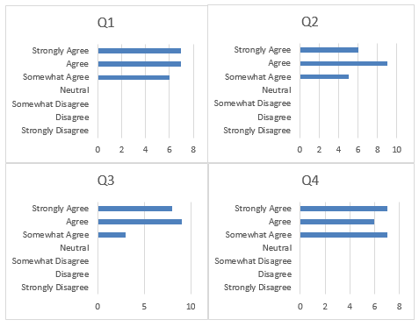
Figure 2: Frequency of the structured questionnaire data
The respondents were asked four structured question about the tax advantages of the online businesses and tendency to the closure of the shops. The first question asked to the respondents was to what extent they agree or disagree with the statement of “Online retailers don’t face the same tax as the offline retailers do” 30% of the respondents have responded that they somewhat agree with the statement, while when it comes to agreeing and strongly agreeing with the statement 35% of the participants have responded in both of the cases. The second structured questionnaire was for the participants to agree or disagree with the statement “Online retailers take advantage of their lower cost to undercut offline competitors”. In this case, 25% of the participants have replied that they somewhat agree with the statement, 45% of the respondents agreed with the statement and 30% of them strongly agreed with the statement. The third structured questionnaire was for the respondents to agree or disagree with the statement, “Offline retailers face higher tax rates along with higher energy and staffing costs”. This is the case where 25% of the participants somewhat agreed, 45% agreed and 30% strongly agreed. Finally, the participants were asked to provide their opinion for the statement “I think the reduction of high street stores will force the UK government to reduce tax rate”. In this case, 35% of the participants somewhat agreed, 30% agreed and the other 35% of the respondents strongly agreed with the statement.
Table 2: Mean, Median, Mode and Standard Deviation
Advertising | Q1 | Q2 | Q3 | Q4
Mean | 6.05 | 6.05 | 6.25 | 6.00
Mode | 6 | 6 | 6 | 5
SD | 0.83 | 0.76 | 0.72 | 0.86

The mean, median, mode and standard deviation has been identified in this analysis. It was found that the average value of the responses ranges from 6.00 to 6.25. This clearly shows that the participants provided positive responses while they were asked they questions. The little variation in the range of the standard deviation which is 0.72-0.83 provides the understanding that the participants’ perception about the question were same and they provided mostly the same answer.
The second close-ended question asked to the participants was to get their responses on what should be the government’s possible initiative be in order to reduce this seemingly threatening problem of high street store disclosure?
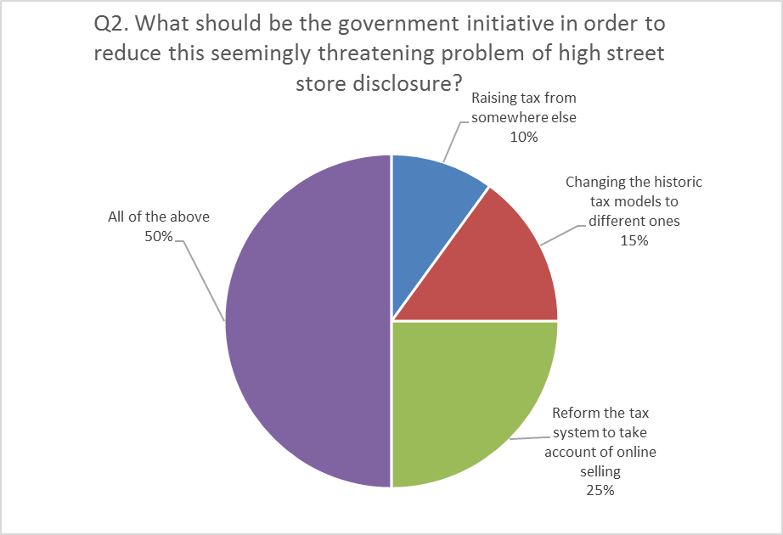
Figure 3: Participants' recommendations for the government to address this issue
10% of the participants have responded that government should raise tax from somewhere else in order to offset this imbalance, 15% of the respondents have replied that the government should change the conventional, historic tax models to different ones for fighting this discrepancy, 25% of the participants have replied that the entirety of the approach of the government should focus on to reforming the tax system to take account of online selling. However, half of the respondents have agreed that all of these approaches should work in a combine manner in order to reduce the risk of high street store closure. The findings from the findings of this question are similar to those of Brick and Palmon (2015) in which the researchers have clearly discussed how to reduce the brick and motor company’s’ risk of failing for the cause of undue tax advantages that the online stores get. They have, in their study, discussed that a combination of different approaches like those of raising tax from somewhere else, changing the tax models can contribute to lesser high street store disclosure.

Secondary Data Analysis
The high street retail organization, Kingfisher, is set to close its stores because of the retail woes the organization is facing evident from various journals, case studies, magazines, newspapers, blogs etc. The organization has issued a profit warning with a report on falling sales and is in talks with bankers and creditors to slim down the struggle the retail organization faces (Green and Hollifield, 2015). Kingfisher is set to close a quarter of its UK stores because of higher tax the business is facing. The organization is focusing on the company voluntary organization which will greatly help ease the process designed to greatly stave off the insolvency (Grinberg, 2016). The organization is facing issues from tax disadvantage coupled with a decrease in sales by 5.1%. This has led to trim down the profit of the organization by 10%. The huge tax burden has great influence on the economic uncertainty of the organization. The current total local sales tax of Kingfisher is 9.085%. This is huge in comparison to those online business leading to Kingfisher to take the decision of closing a quarter of its shops in UK (Lowndes, 2017). Another important consideration that leads the business organization to its store closure is the slipping of the shares of the organization by 5% in the early trading. This has taken the stock of the organization to the bottom of FTSE 100. The organization has announced a 1.9% drop in like-for-like sales, staggeringly higher in comparison to those of the online counterparts (Mahoro, 2015).
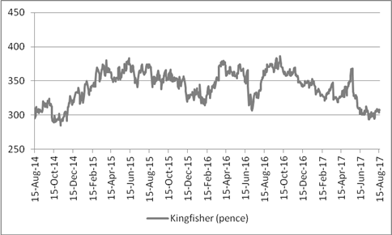
Figure 4: Kingfisher's sales drop
Source: (Harvey, 2018)

4. Conclusion
The tax system is in dire needs to be reformed for high street retail business organizations like Kingfisher to operate successfully. The rates at which these high street business organisations are charged is greatly higher than the online firms. Thus, these online firm can enjoy huge tax advantage than others (Niemann and Kiesewetter, 2015). As a result, government is likely to be losing one of its biggest sources of revenue by not being able to reform the tax system as organisations like Kingfisher threatens to close a quarter of its stores because of the huge tax burden the organization faces. This has been empirically evident in the findings from the respondents and by analyzing the secondary data as well. The participants have responded positively in most of the questions reinsisting the influence of online firm’s tax advantage leading to shop closure of high street shops (Norbäck, Persson and Tåg, 2012). They think that fewer stores would result in lesser tax for the organization. Thus, the online retail organization gain advantage from lower costs for undercutting offline competitors, who, in terms face higher business rates, higher energy and staffing costs (Palumbo, 2016). The findings from this report have suggested that the government should take accumulated approach of taking tax from elsewhere leading to a differential tax rates to stimulate the offline business. The findings also show the inability of the historic tax models and the need for a different model which will greatly help the offline retailers keep their business running and attract more customers to their physical stores (Harvey, 2018).

References
Birge, J. and Yang, S. (2013). A Model for Tax Advantages of Portfolios with Many Assets. SSRN Electronic Journal.
Brick, I. and Palmon, O. (2015). The Tax Advantages of Refunding Debt by Calling, Repurchasing, and Putting. Financial Management, 22(4), p.96.
Co-ops' Tax Exemptions Hit. (2018). Chemical & Engineering News, 38(7), pp.52-53.
Farman, R. (2017). Swiss Tax Decree Limits Advantages of Base Companies in Switzerland. Stanford Law Review, 16(2), p.416.
Green, R. and Hollifield, B. (2015). The Personal-Tax Advantages of Equity. SSRN Electronic Journal.
Grinberg, I. (2016). Implementing a Progressive Consumption Tax: Advantages of Adopting the VAT Credit-Method System. National Tax Journal, 59(4), pp.929-954.
Harvey, F. (2018). Kingfisher chief warns of store closure over online firms' tax advantage. [online] the Guardian. Available at: https://www.theguardian.com/business/2013/mar/04/kingfisher-warns-of-store-closures [Accessed 26 Aug. 2018].
Lowndes, C. (2017). Tax Advantages of Charitable Gifts. Virginia Law Review, 46(3), p.394.
Mahoro, J. (2015). A Comparative Study on Advantages of Tax Incentives and Exemptions Under Rwandan and Kenyan Legal Regimes. SSRN Electronic Journal.
Niemann, R. and Kiesewetter, D. (2015). The Tax Advantages of Life Insurance Policies. SSRN Electronic Journal.
Norbäck, P., Persson, L. and Tåg, J. (2012). Ownership Efficiency and Tax Advantages: The Case of Private Equity Buyouts. SSRN Electronic Journal.
Palumbo, A. (2016). Tax Advantages of Trusts in the Italian Civil Law Perspective. Trusts & Trustees, 3(6), pp.10-14.
Schlesinger, M. (2015). "Thin" Incorporations: Income Tax Advantages and Pitfalls. Harvard Law Review, 61(1), p.50.

Appendix

The questionnaire is as follows:

Structured Question
Scaling of survey questions
Strongly disagree | Disagree | Somewhat disagree | Neutral | Somewhat agree | Agree | Strongly agree
1 | 2 | 3 | 4 | 5 | 6 | 7

Question No. | Question | 1 | 2 | 3 | 4 | 5 | 6 | 7
1 | Online Retailers don’t face the same tax take as the offline retailers do
2 | Online retailers take advantage of their lower cost to undercut offline competitors
3 | Offline retailers face higher tax rates along with higher energy and staffing costs
4 | I think the reduction of high street stores will force the UK government to reduce tax rate

Close-ended Question
Please check the right answer.
- Do you think that business tax rates are one of the biggest charges that are faced by Kingfisher?
- Yes
- No
- What should be the government initiative in order to reduce this seemingly threatening problem of high street store disclosure?
- Raising tax from somewhere else.
- Changing the historic tax models to different ones.
- Reform the tax system to take account of online selling.
- All of the above.

