Calculating the oxygen balance and performance of a mixed explosive from defined parameters

ACDA 4019

2307750

Daniel Cowen

18/7/2025

Contents
1 Contents 2
2 Table of figures 2
3 Table of tables 2
4 Section one – Introduction 3
4.1 Calculating oxygen balance 3
4.2 Determine the Velocity of Detonation 3
5 Section Two – Evaluating the explosive mixture 4
5.1 Definition of brisance and its effects 4
5.2 Detonation products of an explosive mix (60% RDX and 40% TNT) 5
6 Section Three – Designing an Explosive Train 7
6.1 Detonator 7
6.2 Explosive booster 8
6.3 Final explosive train design 8
7 Section Four – Improving the explosive mixture for performance underwater 9
8 Section Five – Conclusion 9
9 References 10

Table of figures
Figure 1- Before and after Trauzl lead block test [4] 4
Figure 2- Graph showing the relationship between detonation pressure and brisance. 5
Figure 3- Kistiakowsky-Wilson rules [5]. 5
Figure 4- detailed breakdown of RP-83 detonator. 7

Table of tables
Table 1- Mixed explosive parameters 3
Table 2- Modified Kistiakowsky-Wilson rules [6] 6
Table 3- Explosive properties of RP-83 8
Table 4- Explosive properties for plastic explosive booster 8
Table 5- Final explosive train. 8
Table 6- Explosive properties of Torpex [17] 9

Section one – Introduction
This report will contain the information on how to calculate the oxygen balance for a certain explosive mixture that the author has been provided with to complete this assignment. The performance of the explosive mixture will then be determined using various techniques covered throughout the course.

Calculating oxygen balance
Explosive | TNT | RDX
Density | 1.654 g cm⁻³ | 1.793 g cm⁻³
VoD | 6850 ms⁻¹ | 8440 ms⁻¹
Detonation Pressure | 19 GPa | 31.9 GPa
Critical Diameter (unconfined) | 2 mm | 1.5 mm
Oxygen Balance | -73.96 | -21.61
Enthalpy of Formation | -62.07 kJ mol⁻¹ | +70.29 kJ mol⁻¹
A mixed explosive composition comprises 60% RDX and 40% TNT, with the following explosive parameters:
Table 1- Mixed explosive parameters
Oxygen balance is the amount of oxygen in a molecule compared to the amount required to complete full oxidation of the fuel elements. If the amount of oxygen is insufficient, then it will produce a negative oxygen balance which means the products will contain toxic gases. If the amount of oxygen is more than required, then the oxygen balance will be positive [1]. Oxygen balance is defined as a percentage therefore if the oxygen balance is 0% it has the exact required amount of oxygen to complete full oxidation. The closer the percentage is to zero the higher the performance of the explosive. The table above details the properties of both TNT and RDX this will be used to determine the oxygen balance of a 60% RDX and 40% TNT mixed explosive.
As detailed above the Oxygen balance of TNT is -73.96% this however is for a 100% TNT explosive therefor 40% will need to be calculated by doing 0.4 x -73.96% = -29.584%.
The Oxygen balance of 100% RDX is -21.61% therefore to work out 60% RDX 0.6 x -21.61% = -12.966 %.
Therefore, the total oxygen balance of the 40% TNT and 60% RDX mixture is -29.584% + -12.966% = -42.55%.

Determine the Velocity of Detonation
Velocity of detonation (VoD) is the velocity the detonation wave moves through a detonated explosive. The VoD will always be faster than the local speed of sound in the material [2]. The VoD figures in table 1 will be used to determine the velocity of detonation for the explosive mixture.
The first step to determining the VoD is to calculate the density of the mixture using the equation 1/(%TNT/Density of TNT)+(%RDX/Density RDX) = 1/(0.6/ 1.793) + (0.4/1.654) = 1.735 g cm⁻³
This then allows for the Velocity of detonation for TNT and RDX within the mixture to be calculated using the Equation VoD in mixture= VoD x (density of mixture/ density).
VoD for TNT in mixture = 6850 x (1.735/1.654) = 7185.46m/s
VoD for RDX in mixture = 8440 x (1.735/1.793) = 8166.98m/s
Total velocity of detonation for mixture = (%TNT x VoD of TNT in mixture) + (%RDX x VoD of RDX in mixture) = (0.4 x 7185.46) + (0.6 x 8166.98) = 7774.37 m/s.

Section Two – Evaluating the explosive mixture
Section two will contain a detailed definition of the word brisance and how it is used within the explosive industry this will allow for an in depth look at how well the explosive mixture works and other explosives that cause a brisance effect. Section two will also take a look at the products released by the explosive mixture.

Definition of brisance and its effects
The term brisance is the shattering capability of a high explosive. This determined by its detonation pressure. The term can be traced back to the French verb “briser” which means to break or shatter [3]. Brisance has been used throughout history for many purposes such as fragmentation shells which are designed to detonate mid-air causing structural damage, grenades which use fragmentation to cause significant injury to personnel, plastic explosives which are commonly use create a high brisance effect and are commonly used within the armed forces to cause damage to structures. An explosive with a high brisance effect usually has a VoD of between 7000m/s and 9000m/s. types of commonly known explosives with high brisance are TNT, PETN and RDX [3]. An example of a commonly used test to determine brisance effects is the Trauzl lead block test. The lead block test is a way of comparing two explosive mixtures by measuring how much they can expand in a cavity within a lead block [4].
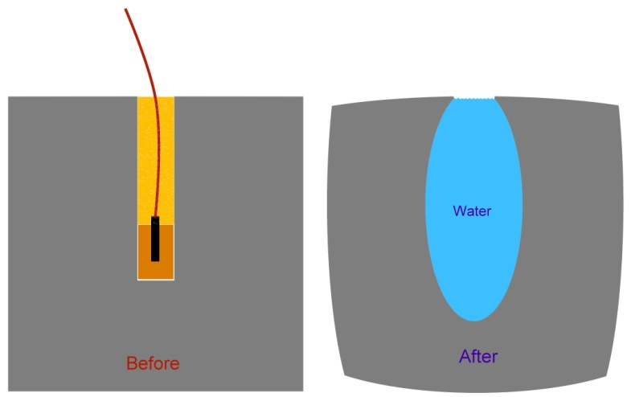
Figure 1- Before and after Trauzl lead block test [4]
As seen in figure 1 after detonation water is poured into the cavity and then emptied into a graduated cylinder to measure the volume [4].
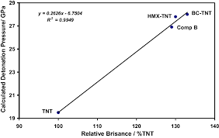
Figure 2- Graph showing the relationship between detonation pressure and brisance.
As seen from the graph in figure 2 due to velocity of detonation and detonation pressure having a direct correlation with brisance it can be worked out from table 1 that RDX has a higher brisance effect than TNT this is due to RDX having a VoD of 8440 m/s and a detonation pressure of 41.9 GPa compared to TNT which has a VoD of 6850 m/s and a pressure of 19 GPa. This information also allows for an understanding that the 60% RDX and 40% TNT mixture will have a higher brisance effect than the TNT due to the mixture containing 60% RDX and having a VoD of 7774.37 m/s however has a lower brisance effect than RDX as it contains 40% TNT and a lower VoD.

Detonation products of an explosive mix (60% RDX and 40% TNT)
To calculate the detonation products the Kistiakowsky-Wilson rules must be applied to the chemical equation if the oxygen balance is more than -40%.
Rule no. | Conditions
1 | Carbon atoms are converted to carbon monoxide
2 | If any oxygen remains, then hydrogen is then oxidized to water
3 | If any oxygen still remains, then carbon monoxide is oxidized to carbon dioxide
4 | All the nitrogen is converted to nitrogen gas, N ₂
Figure 3- Kistiakowsky-Wilson rules [5].

Due the oxygen balance of the 60% RDX and 40% TNT mixture being -42.55% the modified Kistiakowsky-Wilson rules must be applied.
Modified Kistiakowsky-Wilson rules
1 | All hydrogen atoms in the molecule are oxidized to water
2 | If any oxygen atoms remain, they are used to convert carbon to carbon monoxide
3 | If any oxygen atoms still remain, they are used by oxidizing their stoichiometric amount of carbon monoxide to CO2
4 | Any leftover oxygen atoms form oxygen gas (O2)
5 | Nitrogen atoms produce nitrogen gas (N2)
6 | Any remaining carbons form solid carbon (C)
Table 2- Modified Kistiakowsky-Wilson rules [6]
TNT has a chemical formula of C7H5N3O6 and a Molecular weight of 227.13 g/mol [7] and RDX has a chemical formula of C3H6N6O6 and a molecular weight of 222.12 g/mol [8]. Using this information, it can be said for ease that 100g of the mixture has been used which allows for the number of Moles for example TNT = 40% (40g)/227.13 = 0.176 mol and RDX = 60% (60g)/222.12 = 0.270 mol.
This allows for the mixture to be broken down by Mol. The final chemical formula for the mixture will be C2.04 H2.5 N2.15 O2.68.
Carbon is 0.27 x 3 = 0.81 mol for RDX and 0.176 x 7 = 1.232 mol for TNT. Overall, for the mixture it is 0.81 + 1.232= 2.04 mol.
Hydrogen is 0.27 x 6= 1.62 mol for RDX and 0.176 x 5 = 0.88 mol for TNT. Overall, for the mixture it is 1.62 + 0.88 = 2.5 mol.
Nitrogen is 0.27 x 6 = 1.62 mol for RDX and 0.176 x 3 = 0.528 mol for TNT. Overall, for the mixture it is 1.62 + 0.528 = 2.15 mol.
Oxygen is 0.27 x 6 = 1.62 mol for RDX and 0.176 x 6 =1.056 mol for TNT. Overall, for the mixture it is 1.62 + 1.056 = 2.68 mol.
Using the modified Kistiakowsky-Wilson rules it was found that:
- 2.5 mol of Hydrogen (H) oxidize to 1.25 mol Water (H20)
- Left over 1.43 mol of oxygen (O) convert to 1.43 mol of Carbon monoxide (CO)
- No Oxygen (O) remaining.
- No Oxygen (O) remaining.
- 2.15 Nitrogen mol (N) convert to 1.075 mol of Nitrogen gas (N2)
- 0.61 mol Carbon (C) remaining.
This can be compared to the detonation products of TNT alone using the modified Kistiakowsky-Wilson rules due to the oxygen balance being -73.96%:
- 5 mol of Hydrogen (H) oxidizes to 2.5 Water (H2O)
- Left over 3.5 mol of Oxygen (O) Converts to 3.5 Carbon monoxide (CO)
- No Oxygen (O) remaining.
- No Oxygen (O) remaining.
- 3 mol of Nitrogen (N) converts to 1.5 mol of Nitrogen gas (N2)
- 3.5 mol of Carbon (C) remaining.
As seen by the detonation products above there is far less Carbon remaining when detonating the 60% RDX and 40% TNT mixture than there is remaining for TNT alone. This is further backed up by the Oxygen balance of the mixture being -42.55% compared to TNT which has an Oxygen balance of -73.96%. this shows that the mixture has a higher performance and produces higher volumes of gas products.

Section Three – Designing an Explosive Train
The definition of an explosive train is a sequence of events that culminates in the detonation of explosives. This is due to high explosives such as TNT, RDX, HMX and PETN being largely insensitive and hard to detonate these explosive types are usually larger main charges. Therefore, a primary explosive such as lead azide, Lead styphnate and Mercury fulminate which have a higher sensitivity are used in order to provide the high explosive with enough energy to detonate this is usually in the form of a small detonator [9]. Some high explosives such as TNT require a booster in order to detonate as it is so insensitive the energy provided from a detonator alone will not be enough. An example of a booster could be a plastic explosive such as PE8 or PE4 which contain a significant percentage of RDX mixed with a plasticiser in order to be malleable.
Due to the 60% RDX and 40% TNT mixture being a relatively insensitive material, the explosive train will require a detonator and booster in order to detonate the main charge. The subsections detailed below will explore the diverse options that could be used in order to achieve detonation.

Detonator
A detonator is a device containing a detonating charge that is used to initiate an explosive at a desired time reliably. There are three distinct types of detonators commonly used which are non-electric which do not have an electrical input and require other means of initiation such as detonating cord or shock-tube systems. Another different type of detonator is an electric detonator such as exploding bridge wire (EBW) these contain a wire that once current is passed through it creates enough energy to initiate the first primary composition. The final type of detonator is the electronic detonator which uses electronic components to transmit a firing signal [10]. Detonators contain primary explosives such as lead azide, lead styphnate, tetryl or DDNP (Diazodinitrophenol) however some detonators also contain secondary explosives such as PETN, RDX, HMX or TNT in order to produce a larger shock wave.
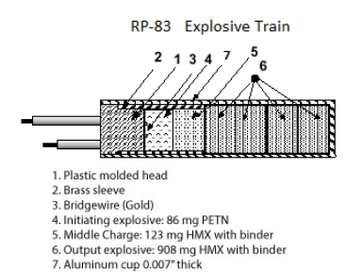
For this explosive train, the options have been considered and due to the reliability of the electric detonator it will be used for this specific explosive train. Some commonly used electric detonators are EBW and Slapper detonators which use a small capacitor to burst a thin copper bridge to accelerate dielectric flyer plates to a high enough velocity to initiate the secondary explosive [11]. Some examples of commercially used detonators are RP-1 dets for high precision, RP-83 for general purpose and RP-501 for economy. For this explosive train, the RP-83 will be used in a shock to detonation explosive train.

Figure 4- detailed breakdown of RP-83 detonator.

 | PETN | HMX
Density | 1.77 g/cm³ | 1.91 g/cm³
Run Length | 150 mm for DDT (Deflagration to detonation) | 6 mm RDD (run distance to detonation)
Critical diameter | 0.9 to 1.5mm | 2 to 10mm
Table 3- Explosive properties of RP-83

Explosive booster
An explosive booster is a sensitive charge that acts as a bridge between a smaller weak detonator and a low sensitivity high explosive. Due to the detonator not providing the main charge with sufficient energy a booster must be used [13]. Examples of commonly used boosters are RDX, PETN and tetryl in the forms of plastic explosives such as PE8, PE4, C4 and Semtex. For this specific explosive train, the booster will be PE8 which has a RDX content of 86.5% by weight, contains plasticisers and binders at 12.5% by weight and a DMNB taggant at 1% by weight which is used during manufacturing to allow for the detection by specialised instruments [14]. The information in the table below identifies the following properties for PE4 due to PE8 being a relatively new explosive type.
 | PE8 (RDX based)
Density | 1.57 g/cm³
Run length | Undefined
Critical diameter | 3.81 mm to 5.08 mm
Table 4- Explosive properties for plastic explosive booster

Final explosive train design
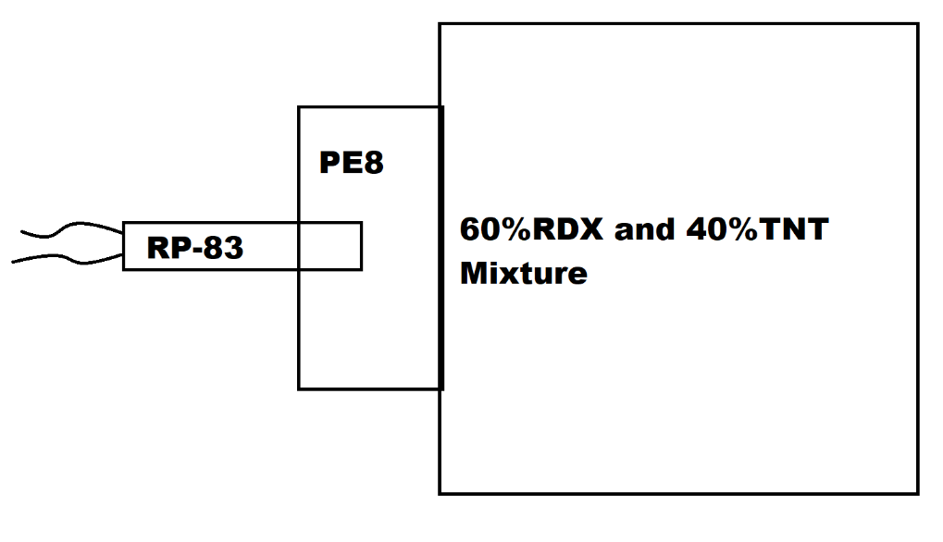
After reviewing the various different areas of the explosive train, it was decided to use a shock to detonation explosive train using an RP-83 EBW detonator into a PE8 booster which will then provide the 60% RDX and 40% TNT mixture with the sufficient energy to complete detonation. Due to the author having worked with RP-83 into PE8 into main charge regularly it can be confirmed that this will be a successful detonation of the material.
Table 5- Final explosive train.

Section Four – Improving the explosive mixture for performance underwater
This section will take an in depth look at the difference in performance of above ground explosive performance in comparison to underwater explosive performance. It will then look further in depth as to how the explosive mixture can be adapted to increase efficiency through researching current underwater explosive types.
Underwater explosives are significantly different compared to above surface explosives. This is due to the initial shock wave and the following gas bubbles that occur. Approximately half of an explosions total energy releases the shock wave, with the rest of the energy feeding into the gas bubbles internal pressure temperature and kinetic energy [15]. When explosives are detonated above ground the initial shock wave moves outwards as the gaseous products are released whereas underwater the shock wave is accompanied by a highly compressed bubble which expands and contracts causing enormous amounts of pressure.
RDX and TNT are commonly used within underwater mines, this is due to TNT and RDX being relatively safe to handle and produce and the high chemical stability however still yielding a high velocity of detonation and detonation pressure which is key in order to create maximum structural damage. During detonation of an explosive a large amount of the explosive effects are transferred to the air resulting in the loss of power. An example of how to improve the 60% RDX and 40% TNT mixture could be by adding aluminium powder which is commonly used within Torpex a deep-sea bomb and torpedo filler [17]. The aluminium is most effective due to its endothermic properties which allow for the absorption of heat during detonation reacting with this to create a quicker and more effective release of energy, increasing the velocity of detonation, and increasing the detonation pressure [16]. Table 6 shows the various different ratios of RDX/TNT/Aluminium powder and the different density and velocity of detonation values.
Explosive | Formulation | Density/ g cm-3 | Velocity of Detonation / m s -1
Torpex 1 | RDX/TNT/Al  45/37/18 | 1.78 | 7440
Torpex 2 | RDX/TNT/Al  42/40/18 | 1.85 | 7360
Torpex 2B | RDX/TNT/Al  42/40/18 +5.5% de-sensitiser | 1.77 | -
Torpex 5 | RDX/TNT/Al  30/50/20 +2% C black | 1.78 | 6990
Table 6- Explosive properties of Torpex [17]
Another area that could be improved is the addition of binders that are hydrophobic. This is a key area as sea mines are required to be long lasting and due to the water surrounding the mine and as the casing deteriorates the water can leak into the mixture. An example of a binder that could be used within this mixture could be a simple polymer which is used to create PBX’s (polymer-bonded explosives) not only is it good for protecting the mixture from the sea it is also an effective way of desensitising the material further.

Section Five – Conclusion
This report has shown how a detailed analysis on an explosive mixture can allow for the oxygen balance and detonation products to be calculated using various mathematical and scientific calculations. This allowed for an explosive train to be designed that is suitable to achieve full detonation of this mixture through detailed research of currently used detonators and boosters. The report has also detailed ways in which the material can be adapted in order to make it suitable for an underwater mine with the capability of large structural damage using various techniques that are currently used within the OME field.

References
[1] “OXYGEN BALANCE | GlobalSpec,” Globalspec.com, 2025. https://www.globalspec.com/reference/55649/203279/oxygen-balance (Accessed Jul. 7, 2025)
‌ [2] Wikipedia Contributors, “Detonation velocity,” Wikipedia, (Accessed Jan. 14, 2025)
[3] “Brisance - Knowledge and References | Taylor & Francis,” Taylor & Francis, 2021. https://taylorandfrancis.com/knowledge/Engineering_and_technology/Chemical_engineering/Brisance/ (accessed Jul. 08, 2025).
‌ [4] “Testing Explosives | Science Toys,” Scitoys.com, 2025. https://scitoys.com/testing_explo.html (accessed Jul. 08, 2025).
[5] “DECOMPOSITION REACTIONS | GlobalSpec,” Globalspec.com, 2025. https://www.globalspec.com/reference/55650/203279/decomposition-reactions (accessed Jul. 08, 2025).
[6] “A Calculated Bang,” Nsta.org, 2020. https://www.nsta.org/ncss-case-study/calculated-bang (accessed Jul. 09, 2025).
‌ [7] PubChem, “2,3,6-Trinitrotoluene,” Nih.gov, 2025. https://pubchem.ncbi.nlm.nih.gov/compound/2_3_6-Trinitrotoluene (accessed Jul. 08, 2025)
‌ [8] PubChem, “Cyclonite,” Nih.gov, 2024. https://pubchem.ncbi.nlm.nih.gov/compound/RDX (accessed Jul. 08, 2025)
‌ [9] Wikipedia Contributors, “Explosive train,” Wikipedia, Apr. 26, 2023. (accessed Jul. 09, 2025)
‌ [10] “Electronic Detonators,” Federal Register, Jan. 14, 2020. https://www.federalregister.gov/documents/2020/01/14/2019-28447/electronic-detonators (accessed Jul. 09, 2025).
‌ [11] R. Mendes, J. Ribeiro, J. Campos, and I. Plaksin, “Micro Slapper Initiators,” Springer eBooks, pp. 83–93, Oct. 2007, doi: https://doi.org/10.1007/978-1-4020-2795-6_6. (accessed Jul. 09, 2025)
‌ [12] “EBW Detonators,” Teledynedefenseelectronics.com, 2019. https://www.teledynedefenseelectronics.com/what-we-do/energetics/initiation-components-systems-us (accessed Jul. 09, 2025).
[13] Wikipedia Contributors, “Explosive booster,” Wikipedia, Dec. 21, 2024. (accessed Jul. 09, 2025)
‌ [14] “PE8 Plastic Explosive Specifications RDX Content 86.5% by weight (max) Plasticisers/ Binders 12.5% by weight (nominal) DMNB Taggant: 1% by weight (minimum).” Accessed: Jul. 09, 2025. [Online]. Available: https://www.chemring.com/~/media/Files/C/Chemring-V3/documents/energetics/PE8%20Plastic%20Explosive%20Iss%2013%20Nov%2020.pdf (accessed Jul. 09, 2025)
‌ [15] H. Matos, M. Galuska, C. Javier, S. Kishore, J. LeBlanc, and A. Shukla, “A review of underwater shock and fluid–structure interactions,” Flow, vol. 4, Jan. 2024, doi: https://doi.org/10.1017/flo.2024.8. (accessed Jul. 09, 2025)
‌ [16] J. Dong et al., “Effects of Nano Aluminum Powder on the Mechanical Sensitivity of RDX-Based Explosives,” Nanomaterials, vol. 11, no. 9, p. 2182, Aug. 2021, doi: https://doi.org/10.3390/nano11092182. (accessed Jul. 09, 2025)

[17] Jai Prakash Agrawal and J. Wiley, High energy materials : propellants, explosives and pyrotechnics. Weinheim: Wiley-Vch, 2012. Available: https://www.wiley.com/en-us/High+Energy+Materials%3A+Propellants%2C+Explosives+and+Pyrotechnics-p-9783527326105 (accessed Jul. 09, 2025)

[18] Wikipedia Contributors, “Polymer-bonded explosive,” Wikipedia, Jun. 09, 2025.
‌

‌

