Student Name: JAMES DWYER
P Number: 0950782
Programme of Study: PRODUCT DESIGN AND TECHNOLOGY
Module: M4X01559

Written Assignment = 1,319 WORDS

Collaborative Zine; Obsessively Creating Dissatisfaction

The intended purpose of my exhibition is to shine a light on an often misunderstood and poorly defined subject; mental illness. In particular I've chosen to focus upon Obsessive Compulsive Disorder (OCD) - a condition that I've suffered with over the last 4 years - and its interwoven association with both anxiety and depression. During this difficult period, I've often heard it stated that you can't truly appreciate the impact of mental illness unless you experience it first-hand, have met with the daily challenges it provokes and faced your own psychological struggles. It was this claim that inspired the theory behind my exhibition, where I aim - at least on some small level - to evoke and inflict my own symptoms onto those of the observer, in an attempt to cast the feelings of a suffer upon those previously unfamiliar to its manifestations. As Malchiodi (2003) stated;

Art is a powerful tool in communication. It is now widely acknowledged that art expression is a way to visually communicate thoughts and feelings that are too painful to put into words.

I believe that through artistic expression, it's not only possible to communicate thoughts and feelings that are too painful to put into words, but also thoughts and feelings that are otherwise too difficult to put into words - a problem I, and other suffers often encounter (Tracy, 2012). With that in mind, the symptoms I've chosen to focus on are frustration, unfulfillment and anxiousness, all of which are common emotions I experience on an excessive basis. I intend on conveying these emotions through an interactive artistic experience, where each exhibit utilises an 'art within art' approach in an attempt to stimulate a range of senses in the observer, challenging their cognitive understanding of mental illness through the use of light, darkness and space, and attempting to evoke further reactions of loneliness, fear and defeat.

I've chosen to feature the work of Vincent van Gogh, Francisco Goya and Edvard Munch. All three are world renowned artistic figures, though their inclusion is not just for lure, but the fact that all three were tragically known to suffer with severe mental illness. Van Gogh, for example, always displayed a rather precarious state of mental equilibrium (Graber and Guillou, 1992), which tormented him since childhood. He suffered an attack of insanity in 1888 that later resulted in his self-admission to a mental asylum. Incidents of self-mutilation and substance abuse tragically culminated in him taking his own life in 1890, aged just 37 years old (Gombrich, 1989). Munch, too, was posthumously diagnosed with bipolar disorder and psychosis. This was based upon;

[…] his own diary descriptions of visual and auditory hallucinations, […] disruptive behaviour that culminated in him shooting two joints off the ring finger of his left hand, and his psychiatric hospitalisation in 1908 for an intensification of auditory hallucinations, depression, and suicidal urges. (Rothenberg, 2015)

Intriguingly, Francisco Goya's work is often split into two periods - both pre and post-illness (Felisati and Sperati, 2010). The first, where he built his reputation and wealth upon commissioned tapestries and portraits, and the second, where following a mystery illness he lost his hearing and spiralled into deep depression, isolating himself from Spanish society and exploring increasingly provocative, darker themes within his artwork (Davis, 2011)

The exhibition itself would be held at Bethlehem Museum of the Mind, a gallery opened in 2015 by artist Grayson Perry and situated within the grounds of Bethlehem Royal Hospital. As per their website "the museum cares for an internationally renowned collection of archives, art and historic objects, which together offer an unparalleled resource to support the history of mental healthcare and treatment." Located in Kent, the hospital was first founded in 1247 and was the first in the United Kingdom to specialise in the care of the mentally ill, continuing to provide in-patient care to this day.

I have chosen "Wheatfield with Crows" [Fig.1] as the featured work of van Gogh. A brooding oil on canvas painting, it was created in July 1890 - making it one of the final pieces by the celebrated artist. Revered art historian Meyer Schapiro saw it as van Gogh's "deepest avowal" and the tortured artists last "defence against disintegration" (Benfey, 1998). Lewis (2015) summarised the piece as "nervous, emphatic brushwork applied thickly and wet-on-wet in layers, blood-red roads leading nowhere in a claustrophobic space, bluish-black skies roiled by clouds and impossibly dark shadows, and of course the haunting, black crows." The crows - often associated with bad luck and death - are particularly foreboding, whilst the overall image appears to foreshadow the imminent demise of the painter, who, just two weeks later, took his own life in the centre of a wheat field with a single gunshot wound to the chest.

For Goya, I have chosen to exhibit his collection of "Black Paintings" [Fig.2-15]. Though not amongst his most renowned work, they rank amongst his most revealing. They consist of 14 oil based murals, painted between 1819 and 1823, that adorned the dining and sitting rooms of his country house, which were later hacked from the walls and attached to canvas some 50 years after their creation (Lubow, 2003). They were never intended for public display, which suggests a deeply personal nature to the pieces, and came to symbolise his growing fear of insanity and bleak outlook on humanity. They were given their name due to the content and appearance of the paintings, which are consumed by heavy blacks, tea-stained browns and withered flesh tones. As Felisati and Sperati (2010) concluded, these were "the final vision of Goya’s world. Dominating were wide-open mouths and the whites of eye-sockets; the figures, monstrous and tragic, expressing all the desperation of the author."

Finally, I have chosen to display Munch's most celebrated work - "The Scream" [Fig.17]. Described as "a Mona Lisa for our time" (Lubow, 2006), four versions are known to exist - created in oil, tempera, crayon and pastel. They display a volcanic sky flowing with bright red, orange and yellow, setting an uncomfortable tone that is indisputably compounded by the corpse like figure releasing an almost audible, painful shriek. So tangible is the emotional impact of this image, it has been described as the visual embodiment of real life physical and psychological conditions (Williams, Dellon and Rosson, 2009; Simeon and Abugel, 2006). The disturbing nature of the composition can be summarised by Gombrich (1989) when he stated; "It looks as if the scenery shared in the anguish and excitement of the scream. […] The staring eyes and hollow cheeks recall a death's head. Something terrible must have happened, and the print is all the more disquieting because we shall never know what the scream meant."

Although the lives of the three artists span two centuries, all lived in a time where mental illness was heavily stigmatised (Foucault, 2006) - sufferers were locked away in mental institutions, exposed to experimental treatments and debilitating medication (Scull, 2015) - and yet, it could be argued that it was within their madness that each found their genius, and is the reason they live on in a celebrated history well beyond their mortal existence. As Munch himself stated;

My fear of life is necessary to me, as is my illness. Without anxiety and illness, I am a ship without a rudder... My sufferings are part of myself and my art. They are indistinguishable from me, and their destruction would destroy my art. I want to keep those sufferings.

It is estimated that 1 in 4 people will suffer some form of mental illness within their lifetime (Government of the United Kingdom 2009). The aim of this exhibition would be to shed light on this scourge, and, through the exposition of work by massively talented yet deeply flawed artists, proclaim that mental illness is no longer a prison sentence - great things can still be achieved.

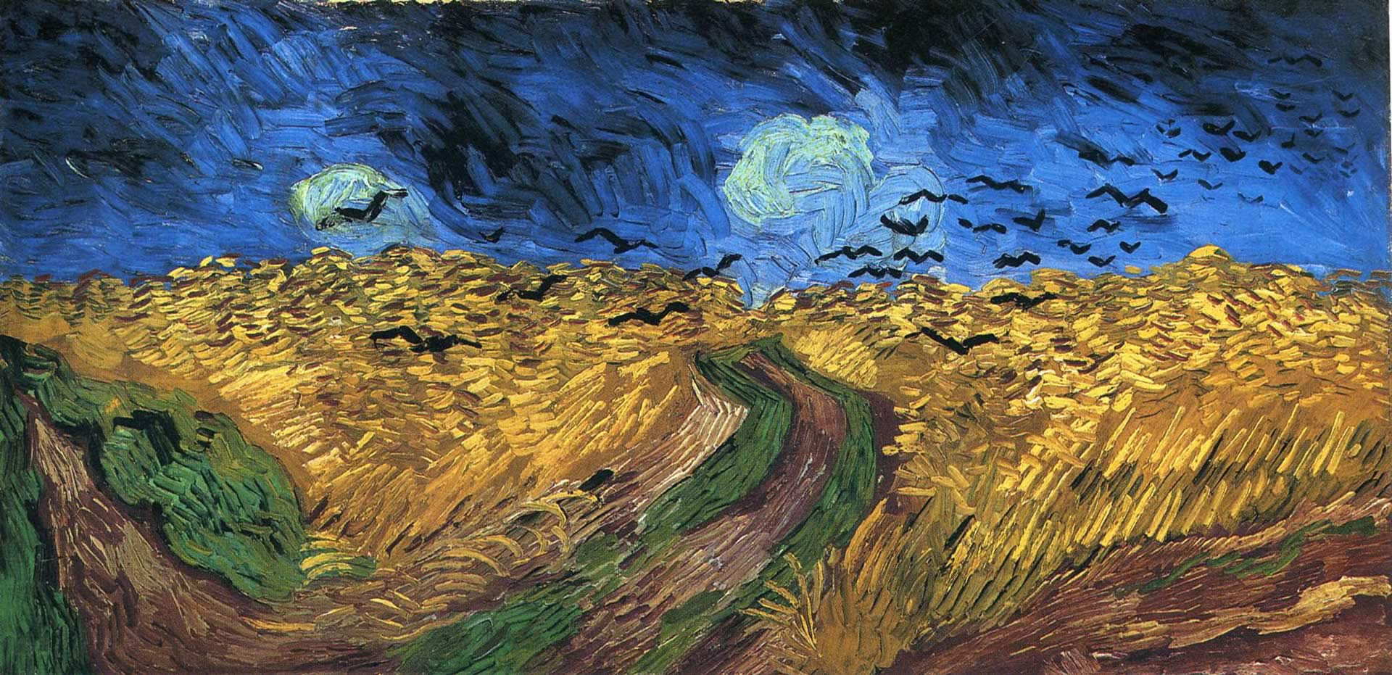

Fig.1

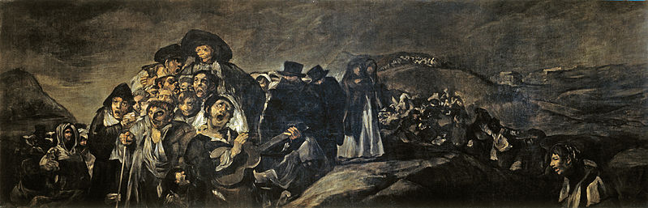
Fig.2

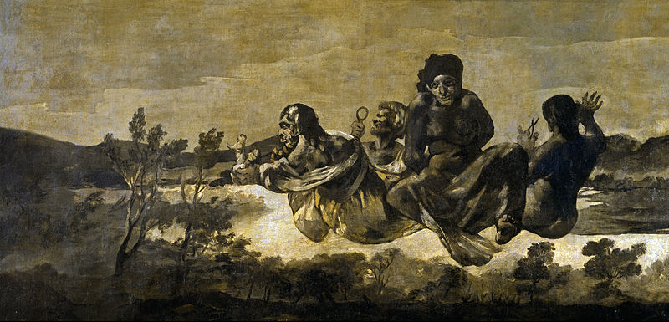

Fig.3

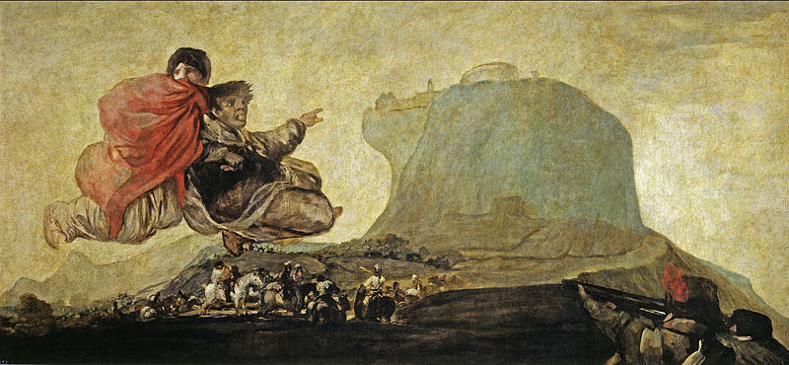

Fig.4

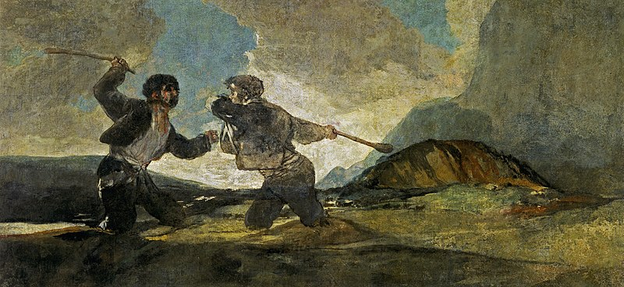

Fig.5

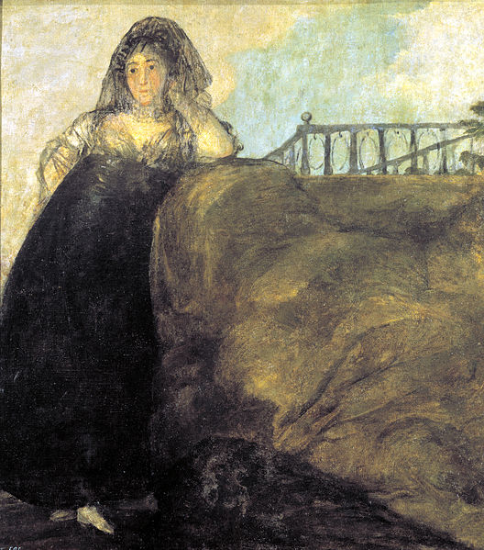
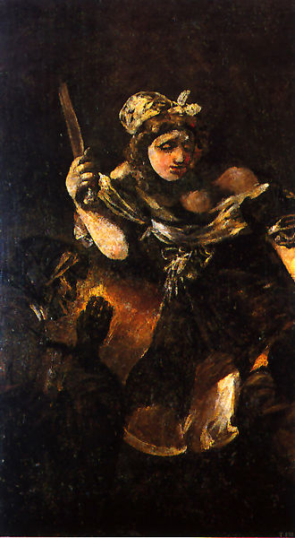

Fig.7
Fig.6
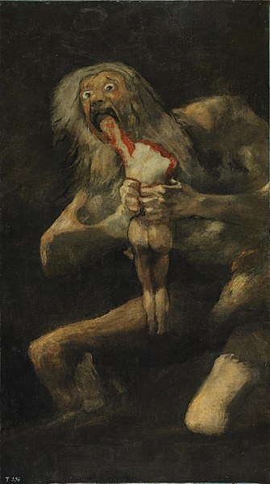
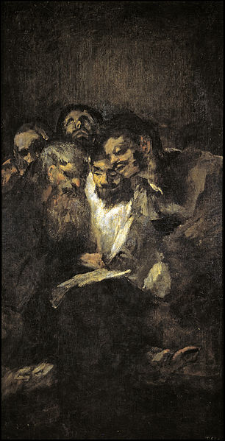
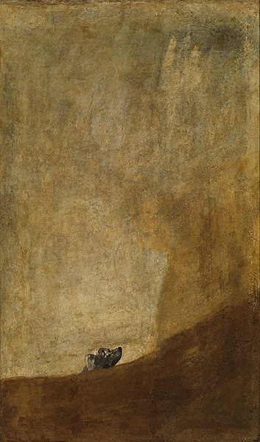

Fig.10
Fig.9
Fig.8

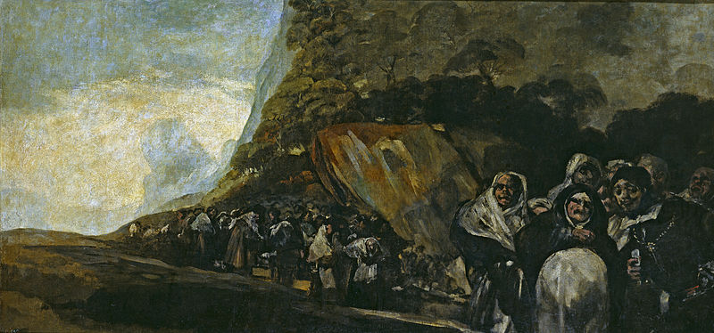

Fig.11

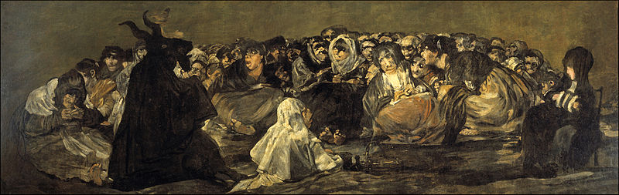

Fig.12
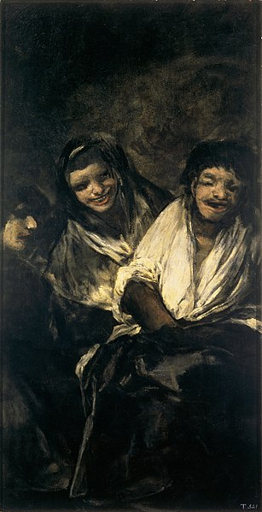
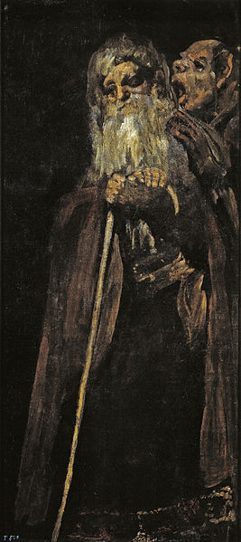

Fig.14
Fig.13

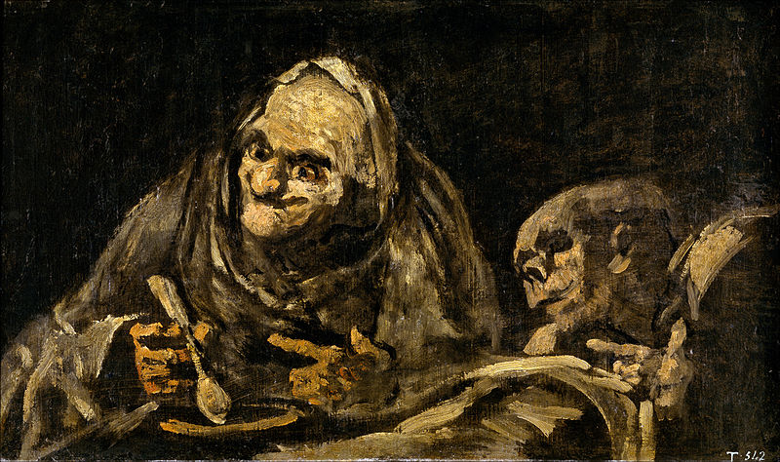

Fig.15

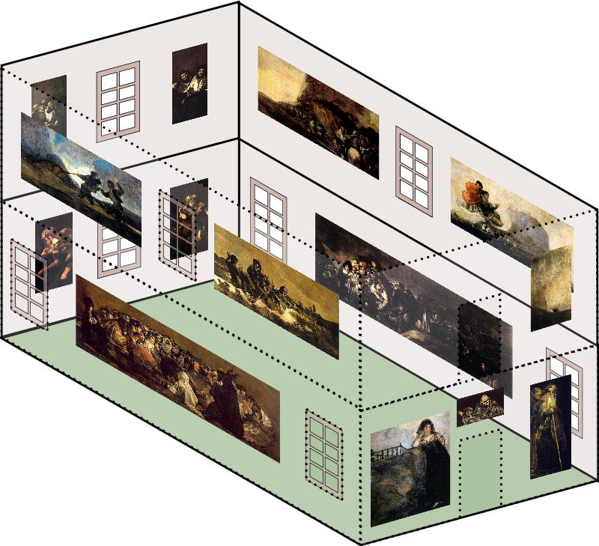

Fig.16

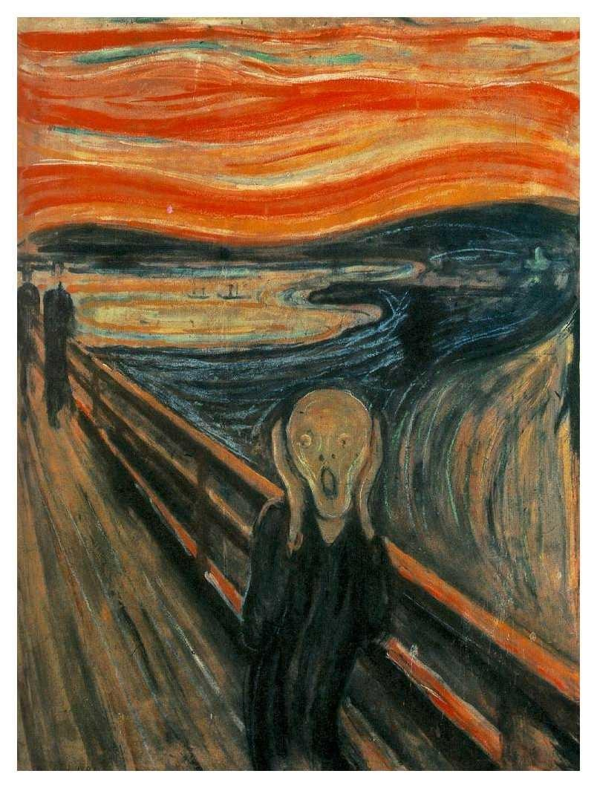

Fig.17
Reference List;
Books:

Foucault, M. (2006) History of Madness. Oxfordshire: Routledge

Gombrich, E. (1989) The Story of Art. London: Phaidon Press Ltd.

Graber, C. and Guillou, J. (1992) The Impressionists. Surrey: Colour Library Books Ltd.

Malchiodi, C. (2003) Handbook of Art Therapy. New York: The Guilford Press

Scull, A. (2015) Madness in Civilisation – A Cultural History of Insanity. London: Thames & Hudson Ltd.

Simeon, D. and Abugel, J. (2006) Feeling Unreal: Depersonalization Disorder and the Loss of the Self. New York: Oxford University Press

Journals:

Felisati, D. and Sperati, G. (2010) 'Francisco Goya and his illness', ACTA Otorhinolaryngologica Italica, vol. 30, no. 5, pp. 264-270

Williams, C., Dellon A. and Rosson G. (2009) 'Management of Chronic Facial Pain', Craniomaxillofacial Trauma and Reconstruction, vol. 2, no. 2, pp. 67-76

National Statistics:

Government of the United Kingdom 2009, Adult Psychiatric Morbidity in England, National Health Service (England). Available at: https://digital.nhs.uk/data-and-information/publications/statistical/adult-psychiatric-morbidity-survey/adult-psychiatric-morbidity-in-england-2007-results-of-a-household-survey#resources (Accessed: 03 June 2018)

Newspaper Articles:

Lewis, M. (2015, Oct 29) 'The Power of Van Gogh's Nature; Seeing "Wheatfield With Crows," one of the painter's final works, as part of a cohesive ensemble', Wall Street Journal (Online)

Websites:

Benfey, C. (1998) Poetry of the Ordinary: Van Gogh is less strange than you think. And more so. Available at: http://www.slate.com/articles/arts/art/1998/10/poetry_of_the_ordinary.html?via=gdpr-consent (Accessed: 03 June 2018)

Davis, K. (2011) Goya and Van Gogh, Masterpieces out of Madness. Available at: http://www.literarytraveler.net/blog/tag/francisco-goya-depression/ (Accessed: 03 June 2018)

Lubow, A. (2003) The Secret of the Black Paintings. Available at: https://www.nytimes.com/2003/07/27/magazine/the-secret-of-the-black-paintings.html (Accessed: 03 June 2018)

Lubow, A. (2006) Edvard Munch: Beyond the Scream. Available at: https://www.smithsonianmag.com/arts-culture/edvard-munch-beyond-the-scream-111810150/ (Accessed: 03 June 2018)

Rothenberg, A. (2015) Creativity and Mental Illness II: The Scream. Available at: https://www.psychologytoday.com/gb/blog/creative-explorations/201503/creativity-and-mental-illness-ii-the-scream (Accessed: 03 June 2018)

Tracy, N. (2012) Why is it so Hard to Explain Mental Illness? Available at: https://www.healthyplace.com/blogs/breakingbipolar/2012/10/why-hard-explain-mental-illness (Accessed: 03 June 2018)

Figures:

Fig.1: van Gogh, V. (1890) Wheatfield with Crows [Oil on canvas]. Van Gogh Museum, Amsterdam

Fig.2: Goya, F. (c. 1819 - 1823) A Pilgrimage to San Isidro [Oil on plaster]. Museo del Prado, Madrid

Fig.3: Goya, F. (c. 1819 - 1823) Atropos - The Fates [Oil on plaster]. Museo del Prado, Madrid

Fig.4: Goya, F. (c. 1819 - 1823) Fantastic Vision [Oil on plaster]. Museo del Prado, Madrid

Fig.5: Goya, F. (c. 1819 - 1823) Fight with Cudgels [Oil on plaster]. Museo del Prado, Madrid

Fig.6: Goya, F. (c. 1819 - 1823) Judith and Holofernes [Oil on plaster]. Museo del Prado, Madrid

Fig.7: Goya, F. (c. 1819 - 1823) Leocadia [Oil on plaster]. Museo del Prado, Madrid

Fig.8: Goya, F. (c. 1819 - 1823) Men Reading [Oil on plaster]. Museo del Prado, Madrid

Fig.9: Goya, F. (c. 1819 - 1823) Saturn Devouring His Son [Oil on plaster]. Museo del Prado, Madrid

Fig.10: Goya, F. (c. 1819 - 1823) The Dog [Oil on plaster]. Museo del Prado, Madrid

Fig.11: Goya, F. (c. 1819 - 1823) Procession of the Holy Office [Oil on plaster]. Museo del Prado, Madrid

Fig.12: Goya, F. (c. 1819 - 1823) Witches' Sabbath [Oil on plaster]. Museo del Prado, Madrid

Fig.13: Goya, F. (c. 1819 - 1823) Two Old Men [Oil on plaster]. Museo del Prado, Madrid

Fig.14: Goya, F. (c. 1819 - 1823) Women Laughing [Oil on plaster]. Museo del Prado, Madrid

Fig.15: Goya, F. (c. 1819 - 1823) Two Old Ones Eating Soup [Oil on plaster]. Museo del Prado, Madrid

Fig.16: [Online]. Available at: https://en.wikipedia.org/wiki/Black_Paintings (Accessed: 03 June 2018)

Fig.17: Munch, E. (1893) The Scream [Oil, tempera and pastel on cardboard]. National Gallery, Oslo

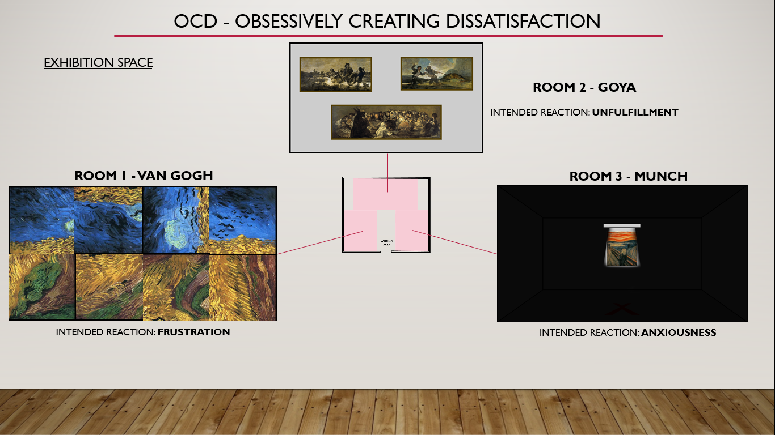

*See presentation slides for further explanation on exhibition ideas

 |  | RESULT:

ASSIGNMENT SPECIFICATION

Student name: | Edward James Dwyer |  |  | Student P number: |  | 0950782
Programme: | Contextual Practices |  |  | Faculty/School: |  | Art & Design/ Contextual Practices
Module: | Ways of Perceiving |  |  | Module Level (4, 5, 6, 7): |  | 4
Module code: | M4X01559 |  |  | Contribution to Overall  Module Assessment (%): |  | (100%) 10 credits
Lecturer: | Julia Lockheart, Rob Jones, Ryan Moule, Gwen Beynon, Simon Kilshaw, Jenn Kirby, Scott Smith, Martin Bush |  |  | Internal Verifier: |  | Rob Charters
Assignment Title: | Outcome = 1200 words, including maps and images per student + presentation of collaborative Zine. |  |  | Assignment No (x of x): |  | 1 of 1
Hand Out Date: | 30/01/18 | Submission Date: | By 10am on 08/05/18 |  | Feedback Date: |  | On 29/05/2018

Referencing: | Written coursework submissions: In the main body of your submission you must give credit to authors on whose research your work is based. Append to your submission a reference list that indicates the books, articles, etc. that you have read or quoted in order to complete this assignment (e.g. for books: surname of author and initials, year of publication, title of book, edition, publisher: place of publication). Harvard referencing systems is preferred.  Practical coursework submissions: You must give credit to designers or artists whose work you have used to inspire your own. Where specific designs or images have been used in your development work you must indicate the name of the ‘author’ and details of the source of the work (e.g. book, journal, website etc.).
Disclosure: | I declare that this assignment is all my own work and that I have acknowledged all materials used from the published or unpublished works of other people. All references have been duly cited.
Student’s Signature: | Assignments will not be accepted without a signature here and date >  EJ Dwyer | Date of submission: | 03/06/18
Turnitin: Lecturer to tick to indicate if an electronic version of the assignment must be submitted to Turnitin.  If both electronic and hard copy submissions are required then both versions MUST be submitted by the same deadline. No marks will be released until both submissions are received.  Note: the Turnitin version is the primary submission and acts as a proof of receipt for the student.  A paper receipt must be completed for hard copy submissions, including portfolios and other design work. |  |  | YES
 |  |  | NO
Penalties for late submission: Up to one week late, maximum mark of 40% for first attempt.
Work cannot be accepted after 1 week and will be recorded as a non-submission, 0%.

- The Assignment Specification Form MUST be at the front of all assignment submission. Assignments will not be accepted without this form, as it is a requirement that you sign the disclosure regarding referencing conventions.
- DO NOT include this form in your Turnitin submission or it will match many similarities with other students’ submissions.

ASSIGNMENT DESCRIPTION

Learning Outcomes
Module Learning Outcomes being Assessed:
- Recognise and employ a range of critical theories to the analysis of a cultural product.

- Create a response to different approaches to understanding elements of cultural endeavour.

Task
For this module students are asked to work collaboratively to re-envision history. In teams of 4-5, students choose a moment in history from which they can create relationships and connections to contemporary objects, movements, artists and designers.
Tasks to be completed:
- a team presentation (20% of mark) in week 9 of the programme:
(12 minutes per presentation = 2 minutes per student + 2 minutes of questions),
- written texts for the zine (1200 words per student) (80% of mark)
Using Foucault’s archaeology of knowledge/genealogy students define a history of a product/object/artefact and map its progression to contemporary use. This history is laid out in the form of a collaborative Zine.

Guidance for Students in the Completion of Tasks
This lecture series will consist of a carousel of three lectures, each lasting three weeks, which will introduce postmodern notions of the deconstruction of histories and theories presented in Semester 1. Thus, key ideas, histories, artists, designers, ideologies, philosophies and philosophers will be reassessed in relation to postmodern thinkers, such as Foucault’s archaeology and genealogy of knowledge, allowing students to assess power/knowledge relations. These lectures will be complemented by small group seminars which will focus on how you can communicate your ideas through zine texts, mapping and using imagery to communicate ideas. At the end of each lecture series, every 3 weeks, students will again experience a new lecturer with a different focus.
Whatever the topic, enquiry must be grounded in research. Books, journal articles, image banks, films, exhibitions/catalogues etc. are the most usual source of information and ideas. What we are looking for is a personal and critical evaluation of the relevant source material. A good argument, thesis or analysis is always supported by evidence.
Individual 1200-word texts will be submitted via Turnitin on the Moodle page 'Ways of Perceiving’. The collaborative Zine will be displayed and handed in for marking in the seminar, as a physical outcome.

Assessment & Feedback
You will be marked according to Assessment Criteria 1, 4 and 5:
- Research & Analysis – Example: where have you researched? Which sources have you used? How reliable are they i.e. peer-reviewed books and texts? Demonstrate depth and level of content of your research and practice.
- Subject Knowledge – Example: what is the appropriateness of your choice of concepts and underlying principles in your exploration?
- Presentation & Communication – Example: How well is the message communicated and is it clearly presented?



STUDENT SELF EVALUATION FORM (PG)

Student Name: | Edward James Dwyer | Student P Number: | 0950782
Programme: | Contextual Practices
Module: | Ways of Perceiving
Module Code: | M4X01559 | Contribution to Module: | 10 credits
Assignment Title: | Collaborative Zine (1200 words, including maps and images per student) Outcome = 6000-word collaborative Zine.

Common Assessment Criteria Applied | Level of Achievement
Common Assessment Criteria Applied | Outright Fail |  |  |  |  |  | MF |  | IMD: 2:2  MA: PASS |  |  | IMD: 2:1  MA: MERIT |  |  | IMD: 1st  MA: DISTINCTION
Common Assessment Criteria Applied | F |  |  | E |  |  | D |  | C |  |  | B |  |  | A
Common Assessment Criteria Applied | 1 | 2 | 3 | 4 | 5 | 6 | 7 |  | 8 | 9 | 10 | 11 | 12 | 13 | 14 | 15 | 16
Common Assessment Criteria Applied | 0-  9% | 10-  19% | 20-  29% | 30-  34% | 35-  40% | 41-  44% | 45-  49% |  | 50-  53% | 54-  56% | 57-  59% | 60-  63% | 64-  66% | 67-  69% | 70-  79% | 80-  89% | 90-  100
*1. Research & Analysis |  |  |  |  |  |  |  |  |  |  | X
2. Development
3. Technical Skill
*4. Subject Knowledge |  |  |  |  |  |  |  |  |  |  |  | X
*5. Presentation & Communication |  |  |  |  |  |  |  |  |  |  |  | X
6. Personal Learning & Development
7. Professional Practice

Please comment on areas in which you feel that you have performed well:
I like the general idea surrounding the exhibition

Please comment on areas that you feel you need to develop:
I was unable to tie my ideas in with theorists and philosophers, as the guidance document requested

Student Signature: | EJ Dwyer | Date: | 03/06/18

This form must be completed, signed and submitted with your assignment

COMMON ASSESSMENT AND MARKING CRITERIA
ASSESSMENT CRITERIA | OUTRIGHT FAIL | MARGINAL FAIL |  | PASS | MERIT | DISTINCTION
ASSESSMENT CRITERIA | 0-29% 30-44% | 45-49% |  | 50-59% | 60-69% | 70-79% 80-100%
1. Research & Analysis  Systematic exploration and selection of sources; effective interpretation and evaluation of findings. | Little or no Limited attempt to  attempt to plan plan and/or carry and/or carry out out projects which projects which gather information gather from appropriate information from sources. appropriate Interpretation may sources. be flawed, Interpretation incomplete, or largely absent. largely absent. | Partial attempt to  plan and/or carry out projects which gather information from appropriate sources. Interpretation may be flawed or incomplete. |  | Material presented  shows a good range of sources, is well organised and interpreted in a  manner relevant to the task. | Connections have  been made between sources and qualitative judgements have been made in the interpretation of these findings. | Research is Research and  extensive, well exploration is impressive documented and both in extent and depth critically evaluated and the level of  with new personal interpretation and  judgements made critical insight is highly and applied. advanced.
2. Development  Formulation of  innovative and effective concepts through appropriate application of problem solving,  creative experimentation and testing methods. | There is little or Attempts to solve  no evidence of novel and complex  any attempt to problems are solve novel and inadequate, with complex little reference to problems within either theory or the discipline. practice.  Little or no  reference to theory and practice. | Attempts to solve  novel and complex  problems are partial, with limited reference to current theory and practice. |  | Proposed concepts are  formulated with a good  degree of detail through the use of a variety of systematic and exploratory methods. | Concepts display  innovative ideas  within established territories, which are well resolved through sound practical and creative  processes. | Proposals respond Proposals both challenge  effectively to and extend the  unfamiliar or new conceptual territory and conceptual territories set new benchmarks for and expand innovation and perceptions of effectiveness within the process and/or field.  product.
3. Technical Skill  Effective utilisation of appropriate materials, tools and techniques and the level of skill demonstrated in their application to the realisation process. | Little or no Limited evidence of  evidence of the use of a limited technical skills range of materials with a poor level and methods with a of output quality. sub-standard level  of output quality. | Partial evidence of  the use of a limited range of materials and methods with a mediocre level of output quality. |  | Controlled application  of a range of materials and methods with good standards of output quality. | Communication of  intent is fully executed demonstrating diversity of process and effective technique. | Extensive and highly Outstanding levels of  advanced technical technical skill in all  skills in established aspects of the realisation  processes process demonstrating demonstrating the assimilation and sensitivity and development of cutting excellence in idea edge processes and realisation. techniques.
4. Subject Knowledge  Understanding and application of concepts and underlying principles associated with the discipline and the specific context of study. | There is little or There is limited or  no identification incorrect  of concepts and identification of  underlying concepts and principles. underlying  principles. | There is partial or  limited identification of concepts and underlying principles. |  | Knowledge is accurate  and effectively applied in relation to the specific context. | Knowledge is  extensive and the understanding of the context exhibits awareness of the  breadth and depth  of established views. | Knowledge has been Discipline and context  assimilated and specific knowledge are individual and substantive and a highly personal advanced synthesis of perspectives have these elements creates been formulated and new or expanded debated with perspectives. effectiveness.
5. Presentation &  Communication  Clarity and effectiveness in the deployment of appropriate media to communicate a message relevant to specialist and non-specialist audiences. | Appropriate Limited awareness  media for of the audience and  communication a lack of clarity and have not been organisation are identified or demonstrated. applied  effectively. | Basic awareness of  the audience and  clarity of message is demonstrated in deployment of standard communication forms. |  | Selection and  application of media  and conventions show good understanding of the audience and context. | Communication  media have been  selected and deployed to maximise impact for the selected audience and context. | Individual stylistic Presentation and  approaches have communication methods  been implemented to employed are not only communicate to a highly individual,  diverse range of compelling and effective audiences in a highly but also combine media compelling and in an innovative way. effective way.
6. Personal Learning &  Development  Personal responsibility demonstrated in managing own learning through programme engagement, self- directed study and reflective practice. | Little or no Inconsistency in  responsibility programme taken for own engagement and learning poor awareness of demonstrated by personal learning lack of and development engagement and needs.  reflection. | Evidence of some  reflective practice contributing to appropriate effort and engagement to further personal development. |  | Evidence of regular  reflective practice and awareness of individual strengths and weaknesses demonstrable in core learning and self directed study. | Reflective practice  and individual development is extended beyond core learning, is well managed and documented. | Full responsibility for Outstanding level of  own learning and engagement with all development is elements of the evidenced in detail programme enhanced by demonstrating the personal drive and critical appraisal of passion to extend purpose, progress learning beyond  and future direction. established parameters and into new domains.
7. Professional Practice  Demonstrates those  attributes expected in professional practice including individual initiative, project management, collaborative working and inter-personal skills. | There is little or There is limited  no evidence of evidence of any  working as an attempt to work as autonomous an autonomous professional or professional, and who implements limited evidence of project project management. management  techniques. | There is evidence of  a limited attempt to  work as an autonomous professional in various scenarios. Some evidence of project management techniques. |  | Works to the relevant  standards and meets  most requirements as stipulated in both individual and team working scenarios. | Meets most or all  of the relevant  standards and in some areas exceeds the requirements as stipulated, taking control of some aspects of project management. | Often works above Always works well above  the relevant the relevant standards  standards and and demonstrates exceeds the outstanding individual requirements as a and collaborative  team member, professional attributes in  leader or individual every working scenario in a variety of encountered.  working scenarios

