Data Handling and Business Intelligence
Student name-Daniela Nedelcu
Student ID- 1922478
Table of Contents
Part 1: Ice Cream Data Analysis 3
1. Introduction 3
2. Ice Cream Data (provide a description of the dataset) 3
3. Relationship/correlation Analysis 4
4. Analysis Conclusion 6
5. MS Excel Evaluation 6
Conclusion 8
Part 2 9
1. Introduction Covid-19 data analysis 9
2. COVID-19 Cases Data (provide a description of the dataset) 9
3. COVID-19 data analysis 9
4. Answer a) Text mining methods 11
Conclusion 13
Reference List 14

Part 1: Ice Cream Data Analysis

1. Introduction
Data handling is the process through which it is ensured that business research data is stored, used, achieved or disposed of properly in a safe manner. In this part of the study, the impact of MS-Excel on data interpretation, pre-processing, visualising and analysing will be discussed. Moreover, using MS-Excel an Ice-cream data set will also be analysed and discussed the relationship.

2. Ice Cream Data (provide a description of the dataset)
The dataset is containing information regarding sales of ice cream in various customer groups. From the dataset, it can be seen that male has been replaced by the number 0 and female have been replaced by the number 1. This data set is developed based on 200 male and female candidates to complete this analysis. Again number 1 stands for vanilla flavour, 2 for chocolate and 3 for strawberry. From the datasheet, it has been found that demand for all three ice cream flavours is high in male and female genders. Males have been found to be majorly interested in vanilla flavour ice cream. In row 1 male gender is replaced with 0 for chocolate ice cream flavour and video score of 47 and for puzzle it is showing 57. The second row is containing the number 1 in the place of gender which shows a female group for the number one flavour which is vanilla. In the video, it is 63 score and 61 in the puzzle column. From rows number 4 to 93, all male groups’ candidates are marked and their preference for ice cream flavour has varied between all three flavours such as vanilla, chocolate and strawberry. The puzzle score varied from 34 to a maximum of 72 for the male group. After columns, number 93 to 201 the data shows the female customer group for all three flavours of ice cream. However, the majority of ice-cream flavour data included number 1 which is vanilla and number 2 which is chocolate. Some of them contained the number 3. Video scores for female candidates have varied from 39 to 69. However, the strawberry flavour contains some portions that show a minimum preference for this flavour by candidates. Ice-cream and video data are showing number 1 from 30 to over 70 in the given chart. For number 2 it is showing over 20 to the edge of 70. Ice-cream Vs puzzle details showing number 1 is from 20 to 70, nu7mber 2 from under 30 to over 70 and for nu8kber 3 the data is showing from 30 to 70. From the data interpretation, it can be estimated that vanilla and chocolate ice cream are correlated with video and puzzle games for male and female candidates.

3. Relationship/correlation Analysis

 | gender | ice_cream | video | puzzle
gender | 1
ice_cream | 0.013684 | 1
video | -0.12774 | 0.131742 | 1
puzzle | 0.05237 | 0.169306 | 0.465106 | 1
Table 1: Correlation between the variables
(Source: Created by the learner)
The relationship between gender with ice cream, video games and puzzles have been analysed from the data set. The correlational aspects have also been analysed in from the data. A positive correlation has been observed between gender and ice cream which is positively significant but the correlation is weak. Therefore, it can be said that gender can play a significant role in choosing ice cream. On the other hand, also a positive but weak correlation has been found between gender and video games. The correlations between puzzles and gender have also been found weak and positive. The correlation between ice cream and puzzles has also been found positive but weak correlation value. Therefore it can be said that role of gender can be very effective to choose the flavours of the ice creams.
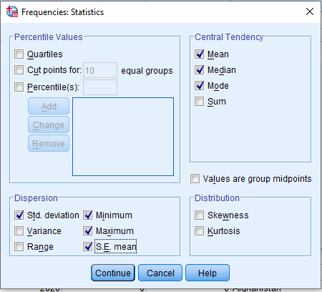

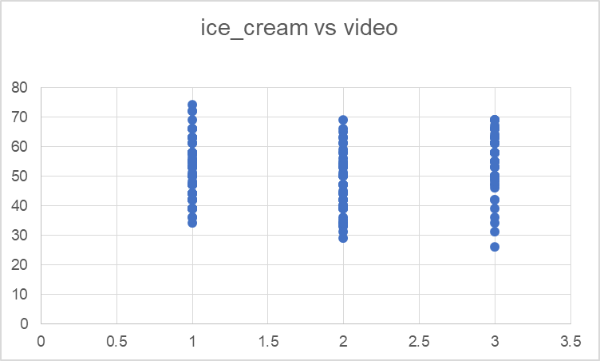
Figure 1: Relationship between ice cream and video
(Source: Created by the learner)
The correlation between ice cream and video games has been analysed from the data and it has been found that the score is very high for the vanilla flavoured ice cream. Inferring figure 1, it needs to be mentioned that, for students who prefer vanilla ice cream, their video game score has been above 30 to above 70. Similarly, the video game score of chocolate lovers has been 25-70 and for strawberry lovers, it has been again 25-70.
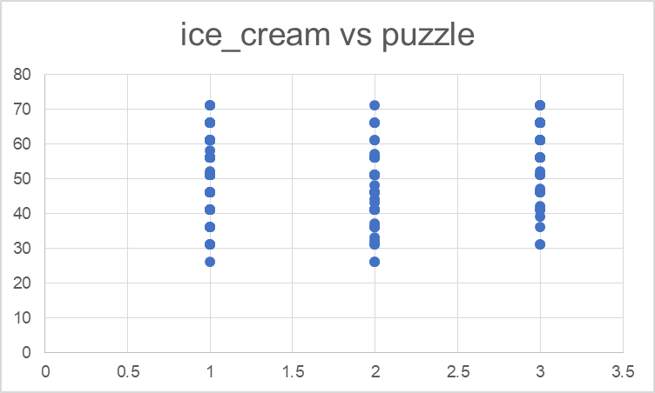
Figure 2: Relationship between ice cream and puzzles
(Source: Created by the learner)
It has also been found by analysing the current data. The correlation between ice cream and puzzles has been found also higher for vanilla flavoured ice cream. Inferring figure 1, it can be observed that, for the students who prefer vanilla ice cream, their video game score has been above 70 but ranges between 25-70. On the other hand, for people who preferred chocolate ice cream, their puzzle score ranges between above 20 to above 70. Finally, for students who prefer strawberry ice cream, their score ranges from 30 to above 70.

4. Analysis Conclusion
In terms of analysis conclusion, it needs to be mentioned that the ice cream data set is information about 200 high school students, regarding their sources on different types of interests such as ice-cream flavour. Moreover, the data set also contained information about their choices such as video games or puzzles. With the help of MS Excel, a relationship between ice cream flavour and gender, and video games has been established and analysed. In this reference, it has been observed that the relationship between ice cream flavour with respect to gender, video game and puzzle score has been positive it has been too weak. Usually, the score of correlation and coefficient generally stands between -1 to 1. If the result ranges from 0.5 to 1, it indicates that the relationship is strong. On the other hand, it also needs to be mentioned that if the score of the correlation coefficient ranges from 0.2 to -1, it indicates that the relationship is weak. However, in this case, the relationship between ice cream and other factors has been positive, however, they are extremely weak, as the score ranges from 0.1. Moreover, it also needs to be stated that the weakest relation among these factors has been observed between ice cream flavour and ice cream flavour. However, in the other two cases, the relationship has been a bit stronger despite they have been positive compared to the other variants. With respect to that, it can be mentioned that there is no practical significance in the relationships that have been identified between the given factors in the datasheet. It has been done to showcase the way data is analysed properly with the help of MS Excel and mathematical calculations including graphical representation.

5. MS Excel Evaluation
As stated by Niani and Lewaherilla (2021), MS-Excel is considered a worksheet application that effectively provides a huge collection of data processing menu. In terms of its evaluation, it can be mentioned that the process of data processing, visualising and analysing, MS-Excel has become a free tool that provides a toolbar menu. On the other hand, in the case of data analysis, all the statistical data can be properly solved by MS-Excel. Most importantly, it needs to be mentioned that, all these statistical calculations could be done in this free tool which are actually done in the paid statistical applications. The entire process of data pre-processing, visualising and analysing can be done by using MS Excel. In this case, it needs to be mentioned that analysis of data through the concerned software helps to understand the data through natural language. Moreover, it only helps to understand the data set but also reduces the number of complexities of the visualisation and analysis process. In fact, a user can also put relevant queries without using any complicated mathematical formula. With reference to that, it also reduces the difficulties of traditional and human calculation for the data pre-processing and data analysis, through which the tendency of human errors can also be eliminated. Moreover, data analysis and interpretation with MS-Excel usually provide high-level visual trends, summaries and patterns (Microsoft Support, 2022). Using MS-Excel in terms of data mining and pre-processing, it can be mentioned that it helps users to determine trends and organise data chronologically or in a desired manner. Moreover, it also helps to sort data properly. In the case of this specific study, all the data sets related to ice-cream and Covid-19 has been properly sorted with the help of MS-Excel. Initially, when the data as received, it was in a scattered form, for which making any mathematical calculations would not be possible. In this case, it can be mentioned all of the data sets could be properly sorted by using relevant formulae. However, in terms of making calculations and sorting data, the task could not have been done without knowing formulae. In this case, it has been evident that the user needs to be aware of the same. Further, the data analysis and interpretation process has also become time-saving and by selecting relevant fields, the entire process can be more focused. In fact, the Excel software comes in a table format, hence the visualisation and data representation gets easier. The utilisation of effective table names, headers and footers helps users to get proper clarity. Therefore, identifying each data from a range of data sets gets easier in the data interpretation and analysis process.
Similarly, in this case, the data analysis task has been extremely easier, as it has been accomplished by using MS-Excel. There has been a data set of 200 students, where each data set has been denoted with a unique name for which the identification of the same has been easier. Along with that, it needs to be stated that, with the implementation of relevant formulas, identification and establishment of the relationships have also been easier. Not only table format, but Excel also provides the features of mathematical calculation including charts and other graphical representation features. In this reference, it can be mentioned that the relationship between students has been effective as those features have been used. The relationship between ice cream flavours, gender, and puzzle scores has been presented in the study with the help of charts; hence the graphical representation of the data could be done efficiently. Restoration of data has been effective in the entire data handling process. As data handling is the process of entire amalgamation of pre-processing, the arrangement of data of all the 200 students could be done properly. The incorporation of proper formulae has helped immensely to proceed with the pre processing of the given data of 200 students. The data visualisation has been properly visualised as MS Excel has been used.

Conclusion
From the above discussion, it can be concluded that the role of MS-Excel in data pre-processing, visualisation and analysis is immense. The entire calculation process becomes more error-free and time-saving as the tendency of human error does not remain. Thus, data handling and analysis processes become more viable as the pressure of using complicated formulas gets eliminated in their process.

Part 2

Introduction Covid-19 data analysis
This part will attempt to analyse data regarding Covid-19. Different data interpretation regarding cases and death numbers due to Covid-19, all information will be interpreted efficiently along with a description of text mining methods and evaluation of SPSS and MS Excel.

2. COVID-19 Cases Data (provide a description of the dataset)
The covid-19 data is including information regarding date, cases, death rates, continents and cumulative percentage. Based on Covid-19 data from three continents such as Europe, Asia and America cases and the rate of total annual deaths due to Covid-19 have been identified and interpreted. The data sheet has been developed for the year 2020 on and monthly basis. Row number 2 to 4874, cases and death rates of Covid-19 have been included for the Asia continent. It can be seen in the datasheet that all months from January to December of 2020, people have died due to Covid-19. From day 1 to the 31st of every month there has been seen different case estimation of Covid-19. Cases varied between 0 to more than 1000 day-wise. In the first and third queerer of 2020, cases have increased majorly in Asia. It can be seen that very few dates included no death rate due to Covid-19. However, the majority of days caused deaths throughout the year 2020 and it has reached over 1000 death cases in the month of May 2020. Different regions of Asia have gone through Covid-19 cases and death rates throughout the year. After Asia, the data sheet contained information regarding Europe. From the data regarding Europe, it has been identified that there was not a single data when people did not die due to Covbid-19 in 2020. From the data of December 2020, it can be seen that cases have increased by over 800 on a daily basis. Death rates have increased over 19 days in Europe. From the statistics of America, it can be seen that death rates have reached 0 in the last months of 2020. However, the continent has faced daily cases near 20000. Death rates reached over 200 on daily basis in September and October. The statistics is showing the maximum severity of the pandemic in American regions.

3. COVID-19 data analysis

 |  | deaths
 |  | Mean | Sum | Maximum | Minimum | Standard Deviation
Continent Exp |  | . | . | . | . | .
Continent Exp | ASIA | 22 | 290129 | 2003 | -443 | 99
Continent Exp | EUROPE | 28 | 479789 | 2004 | -1918 | 98
Continent Exp | AMERICA | 57 | 785420 | 4928 | 0 | 232

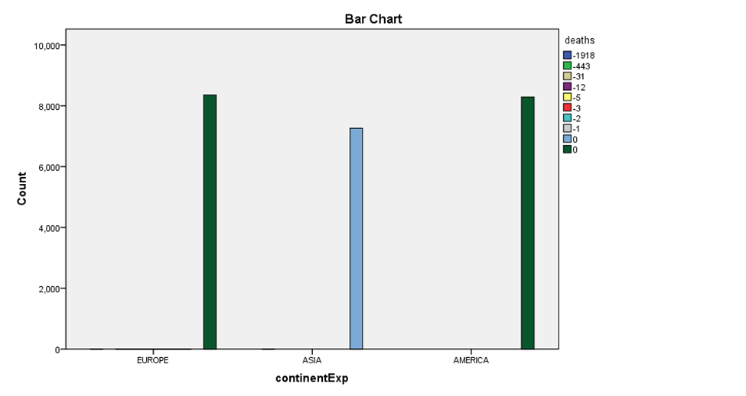
Figure 1: Covid 19 and death rates in Asia, Europe and America
(Source: Created by the learner)

It has been found from the above analysis of the Covid 19 data that the death rate is maximum in America. The different mean values have been observed in Asia, Europe and America. Therefore, the different continent has their different death rates. The maximum death rate has been found in America. The sum of deaths is very much higher than in Asia and Europe. In the above bar diagram, the highest peaks of the deaths are represented. These peaks only represented the highest value, these are not the actual value. The mean value of the death rate in America is very much higher than in Asia and Europe. Therefore, the correlation has been found positively significant with the Covid 19. The standard deviation has also been found very high for America. Therefore, the correlation value between the Covid 19 and America has been found strong. In the cases of Asia and Europe, the mean value of death rates was found low in comparison with the value of America. It has been found from the above data analysis that, only the death rate of America has been found higher than the Asia and Europe and the standard deviation of the death rate of America was also found very high. The mean value of the death rate in America has been found almost double that Asia and Europe. Therefore, it can be said that the Covid 19 affected the people of America so badly which in turn ultimately caused severe death of the people in America.
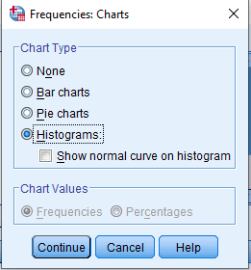

4. Answer a) Text mining methods
Text mining methods include the process of transferring unstructured text into a structured format that helps to determine effective and meaningful insights (Boggs and Kafka, 2022). This process helps to interpret data done by some specific methods. Text mining methods include some stages such as extraction of information, retrieval of information, language processing, clustering, visualization and summarization of text.
Information extraction includes the process of selecting and deriving the most significant information from a vast amount of data. It includes the process of focusing on specific information and attributes to recognise the relationship between associated databases.
Information retrieval includes the extraction of pertinent data and some connected patterns based on given words. This method is mainly dependent on algorithms to interpret data accordingly.
Natural language processing is about summarizing huge textual data concisely and tangibly. It works by allocating a tag for each word based on parts of speech such as the specification of nouns, adjectives, verbs and so on.
The clustering method is highly effective for classifying text documents through the application of several clustering algorithms (Jo, 2018). Its algorithm relies on similar measures of text to generate a great quality cluster.
The categorisation method includes different categories of text documents and the input and output of new documents. Processes of pre-processing, indexing, dimension reduction and classifications are included in the processes of categorization of text.
These are some effective text mining methods that are used for interpreting data from unstructured formats to structured systems.
5. Answer b) SPSS and MS Excel Evaluation and Conclusion
SPSS is mainly used for data analysis in quantitative research. SPSS is very much effective to analyse collected data and on the basis of the analysis of the data the outcomes of the research can be assumed. Different types of data sets can be analysed by the use of SPSS software. Scientific analysis can be performed with the help of this software. Different types of charts and diagrams can also be made with the help of SPSS. Differences between the multiple groups can also be identified by analysing data with the use of SPSS. Parametric and non-parametric both types of data can be evaluated with the help of the SPSS package. This package also helps to analyse complex data sets which can be very effective to know the upcoming outcome of the research. The data can also be manipulated with the help of the SPSS. There are mainly three types of files used in the SPSS which are mainly associated with data files, syntax files and output files (Anton and Ivan, 2015). The trend of the research can also be predicted by analysing data in the SPSS. Missing values of the data sets can also be scientifically manipulated by the SPSS. The researchers can be very benefited by using SPSS for data analysis.
The role of MS excel is very much essential for analysing simple data sets. It is one of the basic tools to perform statistical analysis. MS Excel is also very essential to understanding the trends of the data sets and it also helps to drive the research in a proper way. Basic and easy formulas are mainly used in MS Excel which is very effective to understand for new researchers. Excel is one of the handiest tools that is mainly used in simplified data analysis (Lee et al., 2018). Anybody can easily gather knowledge about their research by analysing data with Excel. Data entry, accounting and data management are the main things which can be performed with the help of MS Excel. Data can be easily interpreted as well as calculated with the help of MS Excel.

Conclusion
The collected data of the Covid 19 cases have been evaluated and analysed in this section. The key findings from the data have also been interpreted in this part. The role of SPSS and MS Excel in data analysis has also been discussed in this section. It has been found that SPSS is mainly used for analysing more complex data whereas MS Excel is mainly used for analysing simple data with the use of simple formulas. Moreover, both the SPSS and MS excel are very essential for the analysis of the data.

Reference List
Anton, M. and Ivan, C., 2015, July.The importance of SPSS software in performance predictability for throwing events.In The International Scientific Conference eLearning and Software for Education (Vol. 3, p. 285)." Carol I" National Defence University.
Boggs, J.M. and Kafka, J.M., 2022. A critical review of text mining applications for suicide research. Current epidemiology reports, pp.1-9.
Jo, T., 2018. Text mining: Concepts, implementation, and big data challenge (Vol. 45). Springer.
Lee, L., Kerler, W. and Ivancevich, D., 2018. Beyond Excel: Software tools and the accounting curriculum. AIS Educator Journal, 13(1), pp.44-61.
Microsoft Support, 2022. Analyze Data in Excel [Online] Available at: <https://support.microsoft.com/en-us/office/analyze-data-in-excel-3223aab8-f543-4fda-85ed-76bb0295ffc4#:~:text=Analyze%20Data%20in%20Excel%20empowers,summaries%2C%20trends%2C%20and%20patterns.> [Accessed on 13.08.2022]
Niani, C.R. and Lewaherilla, N., 2021. Analysis of Data Processing Ability using Ms Excel for Final-Year Students of Teuku Umar University.

