Scott Jones
1803767@student.uwtsd.ac.uk
Computer networks and cyber security

Introduction 2
Part 1 - Research and Analysis of Lab Exercises 2
Task A – Research 2
NotPetya 2
Norsk Hydro Attack 4
Task B – Analysis of Lab Exercises 5
Phishing 5
Metasploit 6
Part 2 – Synthesize a Solution to a Potential Real-Life Scenario 7
Security Measures 7
Servers 13
Conclusion 14
References 15

Introduction
Hacking can be defined as gaining unauthorised access to a system or computer. This does not necessarily mean all hacks are computer-related, but the amount of cyber-security attacks has grown subsequently alongside the increase of computer usage. Hacking goes back to the 1800s and was originally only know as a type of practical joke. It was not until around the 1960s where people began to understand what could be achieved through hacking and the seriousness of it. An American computer programmer by the name of John Draper is credited as one of the first hackers in a bizarre case where he used toy whistles from cereal boxes to commandeer phone lines enabling him and his fellow hackers to place free long-distance calls [1]. From that we can understand that most hackers are brilliantly minded, it is what they use their knowledge for that separates the good and the bad. Ethical hackers are constantly working against black hat hackers in order to prevent computer systems for being compromised. It is said that ethical hackers are smarter than black hat hackers, since they need to know what the malicious hacker does and how to prevent it [2]. Unfortunately, ethical hackers cannot stop every attack.

Part 1 - Research and Analysis of Lab Exercises
The first section of this report includes thorough research on a couple different cyber security attacks that have taken place over the years. There are thousands of attacks throughout the world each year, costing countries and companies millions in damages. Task A will cover two of these attacks and go in-depth about what happened. Task B covers a couple of different methods that can be used to gather information and gain access to a system. There are many ways to do this, but the author will talk about the methods that they personally feel are most effective.

Task A – Research

NotPetya
In late June 2017, Danish shipping company “Maersk” and Ukrainian power distributor “Kyivenergo” revealed that they had been compromised by a malicious form for ransomware. When the attack was first discovered, there was no way anybody could guess what the total cost of this attack would be. NotPetya got its name from a similar ransomware “Petra”. NotPetya was basically a stronger version of Petra, it included more tools that allowed it to infect more systems. This attack went across the world, some of the biggest names effected were Maersk, Kyivenergo, Merch, TNT Express, Saint-Gobian, Mondelēz and Reckitt Benckiser [3].

Motive
The motive of the NotPetya attack is somewhat confusing. Since it went across the world, different Countries and Governments seem to agree that Russia (more specifically the Russian Military) was responsible. Since the primary target was Ukraine, it is believed that the attack was to “destabilise Ukraine and demonstrates ever more clearly Russia’s involvement in the ongoing conflict” [4]. NATO Researcher Lauri Lindström said this about the attack.
“…it seems likely that the more sophisticated and expensive NotPetya campaign is a declaration of power – demonstration of the acquired disruptive capability and readiness to use it.” [5]

Method
A corrupted software update in a small firm in Ukraine is said to be the main entry point of NotPetya, another source claims it was when a worker downloaded a spam email and launched a program with administrative rights, another source says it started as a phishing campaign against banking services. It essentially altered administrative data to make recovery difficult. It searched the network for admin credentials that were readable on the server and used that to gain deep access into the network. It is said that Microsoft released patched for vulnerabilities that NotPetya targeted, yet some companies had not applied these fixes at the time of the attack [6]. As mentioned briefly above, NotPetya spreads on its own, using exploits such as Eternal Blue [7] (a cyber exploit that was developed by the U.S National Security Agency).

Weak Point
The writer mentioned in the method that there are a few different speculations of the original infected system that caused the global outbreak. This is because the malware spread so quickly, it would be difficult to find the original infection. Although many believe it was from a corrupted software update for M.E. Doc, an accounting software used by Ukrainian companies. It is said that the attackers targeted the M.E. Doc update servers and sent the malicious software to their customers, although apparently the company denies that this is true [8].

Overview
Unbelievably, the entire attack is said to have cost around $10Billion. This makes it one of the most expensive malicious attacks in history. Once a system is infected with NotPetya, it is almost impossible to completely stop the spread. Since it spreads so fast, it is unlikely that the user would realise it has been infected by the time it has been sent to another device on the same network.

Norsk Hydro Attack
Hydro is a sustainable future company producing energy and aluminium situated in Norway. Back in March 2019, Hydro fell victims of a massive cyber-attack which targeted the entire organisation.

Motive
The motive of this attack was simple, money. The hackers demanded money be sent to them via bitcoin (this way it is untraceable), after receiving the money they said that they would decrypt all the encrypted data. The hackers even wrote a note with a message on an infected machine, showing that they did in fact have the software that could decrypt the files to “confirm our honest intentions” [9]. The company decided from the start of the attack that they would not pay the ransom, and quickly shut down the network, and started working manually.

Method
After confirming that the problem was a type of ransomware, the next question was which type of ransomware. On the note the hackers left, they explained how they used “the strongest military algorithms RSA4096 and AES-256”. If this was correct Hydro would know that there would be no chance they could decrypt the messages themselves using methods such as brute force. AES-256 is far too strong and is virtually impenetrable [10]. The Norwegian National Security Authority confirmed that the ransomware used was called ‘LockerGoga’, this software changes users’ passwords and attempts to log them off once it has infected the system or network. It will then encrypt any files stored on said system and leave a readable ransom note on the computers desktop with instructions on how the infected organisation should act [11].

Weak Point
Hackers are generally seen to be very intelligent people, being able to get complete control of multi-million-dollar companies would never be easy. Companies that fall into this category usually spend a lot of money on up-to-date security measures and applications. Every system, despite these security applications, has some sort of weakness that can be exploited by somebody who has done the research. In the Norsk Hydro attack, the weakness is said to be one of the employees of the company. According to an article on the Microsoft website [9], the employees error happened 3 months prior to the attack, when they opened an infected email. This is what is said to be the weakness, yet the case gets a little odd when it also says the email was sent from a trusted computer. Obviously, many employees will open an email if the network trusts the computer the email was sent from. This asks the question, how did the trusted computer that sent the email originally get affected, and was this computer still seen as trusted. Since LockerGoga was new at the time of the attack, its processes were too simple to be detected by Virus and Malware detectors, this meant they were much slower to pick up the threat [12]. A web article from CIO Dive briefly talks about the attack. It quotes Phil Neray, Vice President of Industrial Cybersecurity at CyberX, saying that Hydro’s security “has been neglected for years”. This allowed the attack to quickly spread from the employee’s laptop to the global network [13].

Overview
Despite being targeted by one of the decades biggest cyber-attacks, Hydro managed to handle the situation very well. They quickly decided to never pay the ransom. Some industrial giants may take a different approach, by paying the ransom and attempting to get their data back without too much information getting out to the public. According to the FBI, you should never pay the ransom in a ransomware attack, this is because it rewards the attackers for their crime and would most likely lead to more malicious attacks [14]. Hydro also did not want to hide anything; they made the attack very open and tried to hide nothing. This decision was essential since it allows more people to analyse the attack which would quickly lead to the information the company needed. After discovering the threat, Hydro essentially switched off the entire network and turn to manual processes instead. This minimised the effect of the attack. Despite this, the attack is said to have cost Norsk Hydro around £45m.

Task B – Analysis of Lab Exercises
Gaining access to a system practically defines hacking, but its not as simple as just logging into a machine. First, the attacker needs to gain information that would aid in attacking the target. This information could be network layout, common traffic, security flaws, software checking and many more. This part of the report will talk about 2 different methods that can be used in an attack. The two main methods being gaining information and gaining access.

Phishing
Phishing is a very popular method of gaining information in the world of cybercrime. Phishing is where attackers pose as a legitimate/trusted organisation and contact potential targets to try and get them to hand over sensitive data. Usually by email, the attackers will state that the email requires immediate attention. To the right target, this will make them panic and usually hand over their information by logging into a fake website etcetera. This could even happen just by clicking an attachment or responding to a social media request [15]. There are multiple different types of phishing, a popular variant is Spear Phishing. Spear Phishing is essentially just phishing but with a specific target. Phishing attacks usually sends hundreds or thousands of emails to different targets at the same time, whilst Spear Phishing targets one person. These usually pose as co-workers or somebody the target trusts, these attackers would have a higher success rate. Another type of Phishing is Whaling. This involves targeting “very big fish”, meaning high value targets [16].
Real Life Example
If an attacker wanted to target a bank-teller, they would first need to do a little bit of research. They would need some contact details of the target, preferably an email that they can send the phishing attack to. They can find details about the employee through online searching, websites like LinkedIn, which usually contains contact details. The attacker can then replicate a login page from the bank and send a spoofed email, maybe from a higher-up employee, to try and get the target to log in through the fake page. This would then store that employee’s details for later use in an attack.

The best way to prevent phishing attacks is to educate employees, make sure they can identify a phishing attack, and maybe congratulate them if they spot one. Some phishing attacks look incredibly realistic, which can make it hard to distinguish between legitimate emails, also not download anything or click external links unless they are certain it is real. Using the real-life example, the bank-teller could directly contact the person that the email claims to be from to confirm they sent that email. They could also show the email to technicians or co-workers asking if they have received similar, since a usually phishing attack would say something like “the bank has a security breach please change your password”. Emails like this would be good to check with co-workers and technicians and can react accordingly. The disadvantage of asking co-workers is that they could also be a target of a mass-phishing attack, meaning they would receive the same email.

Metasploit
Metasploit is a popular penetration-testing tool used by hackers and cyber-security experts. Penetration testing is basically a simulated cyber-attack, which can be used to help security of a system. Metasploit is a very powerful tool, it is also very simple to use. It essentially finds a vulnerability in a system, and the user can then decide what to do with said vulnerability. This is very useful to a company, they can hire ethical hackers to try and break into their system or network, and then get them to fix/correct any vulnerabilities that could be used against them. Since Metasploit is so powerful, hackers also use this for the same reason, although it is very unlikely that hackers would break into a system just to fix it. When Metasploit identifies the vulnerability, the attacker can choose a specific payload which can be used to gain access through the weakness. This software is essentially a hacker’s dream, every tool that is needed for an attack can be found in Metasploit. Things like information gathering, gaining and maintain access and avoiding detection is all include in the software [17].
To prevent Metasploit attacks, its best to turn the weakness into the strength. Since Metasploit finds vulnerabilities, it is obviously best to make sure that it has a hard time finding any. Making sure all systems on the network are kept up to date is step one (since vulnerabilities usually gets patched in updates). It would also help to regularly get a penetration tester to try and get into your network and find weaknesses so they can patch them before the system becomes a target. Each update has the potential to open a new vulnerability, so it would be ideal to get the ethical hacker to try and get into the system after a updating each device in the network. This would search for vulnerabilities in the latest update.
Another method is to shut down all unused ports and systems. If a system is left unpatched, and for whatever reason cannot be patched for some time, it would be best to shut that system down and leave it off until it can be patched.

Part 2 – Synthesize a Solution to a Potential Real-Life Scenario
This section covers a potential real-life scenario for construction business Che-Si. This company has sites all over the world, so it is not just a basic connection. The design needs security measures for each aspect, including on site systems and cloud-based storage. There are also remote connections since the employees can access the server from anywhere.
There are multiple security measures that can quickly be put in place to help lower the risk of successful attacks. Basic methods such as difficult passwords to access admin privileges, encrypt all passwords so they are not stored in plain text, have a maximum amount of login attempts before the login is blocked etcetera. There are a lot of things that can be done to protect the system, but some would say the biggest issue are the employees. Since the employees need to log in from anywhere and any device, they would need a very strong password, preferably with two factor authentications any potential attacks would need more than just the password to be able to log in. Staff training is always essential to a company, since somebody with good social engineering skills could trick an untrained employee to give them access to the network.

Security Measures
Security is essential in a network, and there are so many ways somebody can protect a network. This section will talk about different ways that a network can be made more secure.
The first method of securing a network is to add passwords to each router. If each router had its own password, it would mean only authorised people would be able to edit the routers command line. Each router can have two different passwords, the enable password and the login password. It would be better if these passwords were different, and never to reuse the same password across the network. Below is a screenshot from the routers command line interface that shows how to set a password to enter enable mode and login.
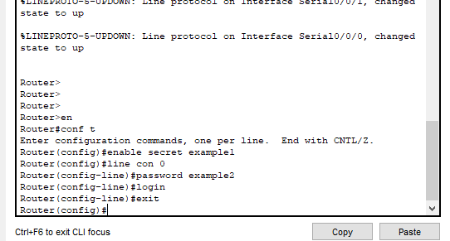
The ‘enable secret example1’ sets the enable password to ‘example1’, and then entering the console interface by using ‘line con 0’ and ‘password example2’ followed by ‘login’ sets the login password to ‘example2’. Obviously, a system would never use these passwords, but just for an example these passwords would now work.
Next time the user tries to login to the router’s command line, they will be asked to enter a password to gain access. 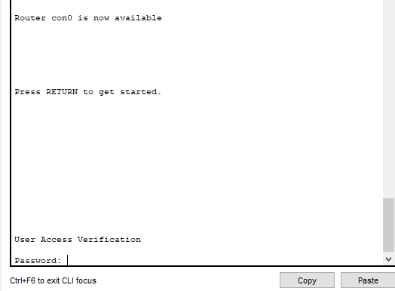
As seen in the image above, the user can now not enter the interface without the password, and when this password is entered, the user will need another different password to enter ‘enable’ mode. This mode allows the user to edit interfaces and change security etcetera, so it is important that it is protected. 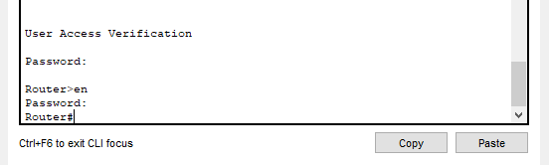
As shown, there are now two passwords that need to be entered for the user to be able to access ‘enable’ mode on the router. This is a good place to start when protecting a network, yet something needs to be done in order to ensure nobody manages to get these passwords.

If somebody managed to gain access, and used the ‘show run’ command, they would be able to see the passwords stored in clear text (meaning they would be able to see what they are). Since the first command was ‘enable secret’ and not ‘enable password’, the first password is already encrypted when it is stored (see below).
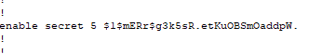
However, this is not the case for the console password.
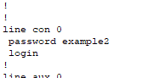
As shown, this password is completely readable. If somebody has access to the command line and sees this, it would help a massive deal the next time they try and gain access to the system. Luckily, a simple command ensures that all passwords stored on the router are encrypted. It is always important to encrypt sensitive data so it can not be used in the wrong hands. The command is ‘service password-encryption’.
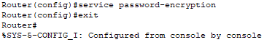
This simple command encrypts any passwords stored on the router, so they are not in plain-text or any readable form. What previously showed the exact command entered, including the exact password, now shows a string of random characters.
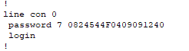

If an organisation takes their security seriously, they will implement a series of policies that the employees must follow in order to protect the network. Some of these policies would be expected anyway since they are common sense. The first policy could be to not share passwords with anybody, and to store them in a secure location. In addition to this, they could be told to meet specific criteria whilst choosing their password, and to change it regularly. It would be a good system to now allow somebody to change their password to one they have chosen before. For example, if somebody’s password were once “P@5sw0rD132”, they would not be able to use that password ever again once they are told to change it. It would be ideal for the employees to never use a password including their name or birthday, since these are quite common. If a password needed to include a symbol, it would be much harder for somebody to crack. Although there would be a higher change of somebody forgetting their password, it would be good for I.T technicians to have an encrypted database filled with passwords and a couple of paper copies of the master password to be locked in secure locations.
There would also need to be a Remote Access policy in place. Since the employees need to be able to access the network through their personal devices, it could be a security risk if specific guidelines are not met. For example, this policy could not include the use of Virtual Private Networks whilst connecting to the network, only allow access within work hours with the ability to request more time, and to closely monitor and log any activity that takes place whilst on the network [18]. The activity should be reviewed often to try and find anything that seems unusual, this can then be studied, and appropriate actions take place.
A lot of vulnerabilities are found in outdated machines are found in out-dated machines. It is important that each device on the network is kept up to date. Each employee would need to keep their personal devices updated as well, otherwise they could be a weakness. An obvious security feature would be a firewall. Firewalls essentially monitor all the traffic on a network and decide whether to allow or block it. The firewall can also block malicious software from affecting a device [19]. A less obvious security feature could be the use of Access Control Lists (ACLs). This is essentially a list of permissions on which users can access which files. So, if there are some files that some employees either do not need to see or are not supposed to see, it can be blocked from their devices. This is usually for sensitive information that only people higher up in the company can see. This lowers the chance that this data will be targeted since it is not available to everybody.
Switches and some routers have a lot of ports, and it is unlikely that an organisation will use every single port. It is a big security concern to leave unused ports open. Each open port could be used by a hacker to exploit the network [20]. Below is an example on how somebody would go about shutting down unused ports, as well as evidence showing they have been deactivated. Firstly, you would need to go into the switches command line, you can also set passwords here the same way it is done on the routers, you will need to know which ports are being used, and which ones are not. This can be done by activating the ports in the Packet Tracer preferences.
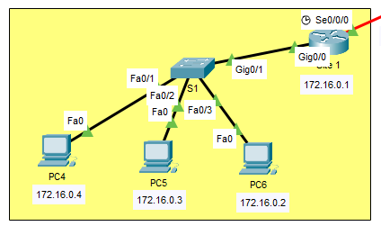
The FastEthernet 0/1, 0/2, 0/3 are being used on this switch, as well as the Gig0/1.
You will need to get into the interface range and use the shutdown command to shut them off.
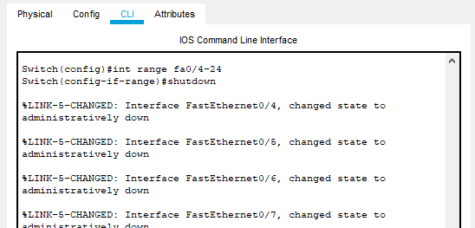
The command line will then show that they have been shut down, hovering over the switch will also tell you which ports are active.
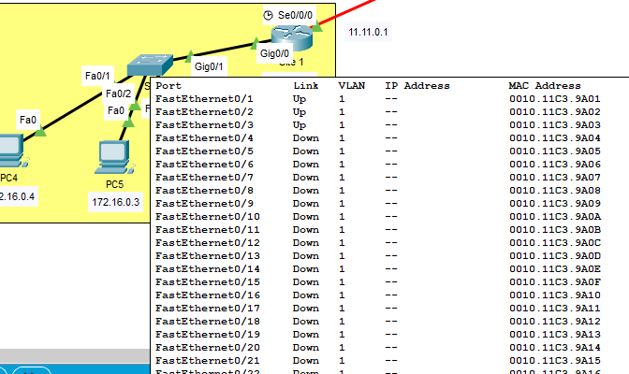
Setting up Network Address Translation (NAT) can help with the security in a network. Essentially, this reduces the number of IP address the organisation needs to use. NAT also helps to keep the original source and destination IP address hidden from outside the network. This would make it harder for anybody to try and target these addresses.
Telnet is a great feature that can be added to routers, in this example telnet has been added to the admin pc that is connected to the servers. Telnet allows the PC to enter the routers command line to make changes to the network. The image below shoes the setup of telnet for 1 user, followed by the evidence that it works from the pc.
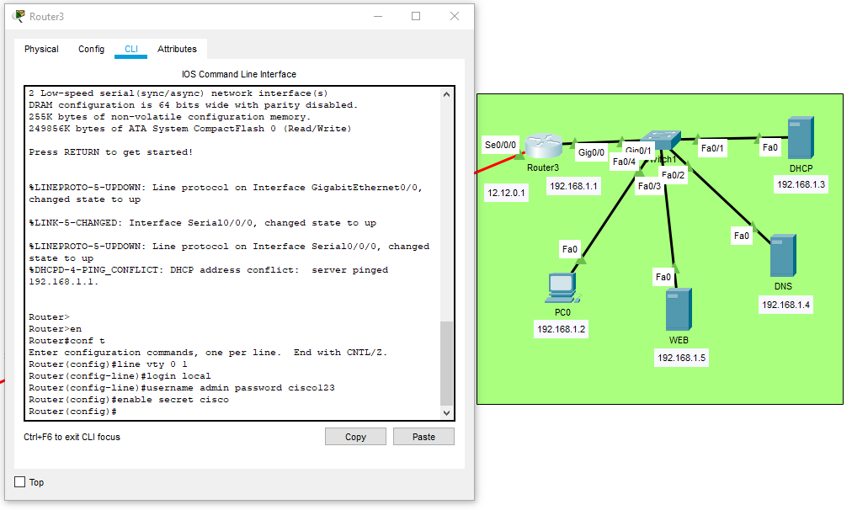
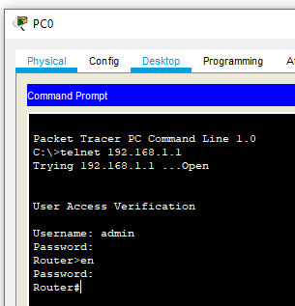The PC can telnet into the routers command line, basically giving it the privileges needed to maintain and edit the network accordingly. This gives it full control over this network.

Servers
DNS Server – A Domain Name Server basically translates domain names into IP addresses. This allows people to use a simple URL instead of needing to search for an IP address.
WEB Server – This server is mainly used to contain company websites. This is to allow the company to have control over the website without relying on a third party.
DHCP Server – A Dynamic Host Configuration Protocol server automatically assigns IP addresses and other parameters to the devices on a network.
Email Server – An email server allows the administrator to have complete control of emails being sent and received by employees.
An email server allows the company to monitor any emails that are sent to an email with a set domain name. Employees of the company will have their own email, typically their name followed by the company domain, so all emails sent to and from these accounts can be monitored to make sure nothing malicious enters the server through the email. This server also allows the administrator to change the passwords at any time. This would be in case either an employee forgets or leaves their job. If somebody is no longer part of the company, they should not have access to the server or email for security purposes.
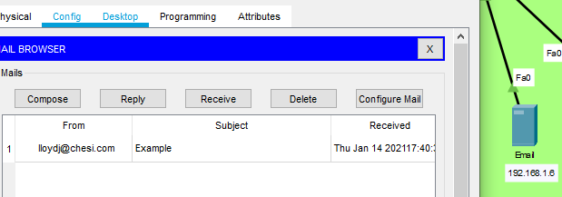
The company uses a lot of Bring Your Own Devices, meaning they would provide the employees and vendors with accounts to be able to access everything they need from their own devices. This can be anything from online cloud-based storage (such as Microsoft OneDrive) to video conferencing applications (such as Microsoft Teams). Yet they still need servers and offices because it is not exclusively from the employees’ own devices.
It sounds a little boring to mention, but each site needs physical security as-well. Any site where servers or systems are stored/ kept need to be always locked when nobody is using them. Devices such as time activated alarms and sensors would be ideal to stop any intruders from entering the site.

Conclusion
Cyber crime is a massive threat to any big organisation. One small mistake can cost a lot of money. It is always important that computers and network services are always kept up to date and secure to ensure the lowest possibility on getting attacked. There are so many ways that a computer network can be secured, and there are so many ways a computer network can be attacked. For any organisation, the best thing to do is to regularly test the security, educate all the employees of the risks of cybercrime, and ensure everyone only has access to what they need to have access for. The last thing needed is a brand-new employee having access to the entire network.

References

[1] | L. Yan, “An Early Hacker Used a Cereal Box Whistle to Take Over Phone Lines,” PopularMechanics, 22 October 2019. [Online]. Available: https://www.popularmechanics.com/technology/a20762221/an-early-hacker-used-a-cereal-box-whistle-to-take-over-phone-lines/. [Accessed 2 January 2021].
[2] | R. A. Grimes, in Hacking the Hacker: Learn from the Experts Who Take Down Hackers, Indianapolis, John Wiley & Sons, Inc., 2017, p. 3.
[3] | A. GREENBERG, “The Untold Story of NotPetya, the Most Devastating Cyberattack in History,” Wired, 22 August 2018. [Online]. Available: https://www.wired.com/story/notpetya-cyberattack-ukraine-russia-code-crashed-the-world/. [Accessed 7 January 2021].
[4] | S. Marsh, “US joins UK in blaming Russia for NotPetya cyber-attack,” The Guardian, 15 February 2018. [Online]. Available: https://www.theguardian.com/technology/2018/feb/15/uk-blames-russia-notpetya-cyber-attack-ukraine. [Accessed 7 Januaray 2021].
[5] | I. Kohen, “Motive & Effect: Implications of the NotPetya Attack,” IT Security Central, 19 June 2017. [Online]. Available: https://itsecuritycentral.teramind.co/2017/07/19/motive-effect-implications-of-the-notpetya-attack/#:~:text=Motive%20and%20Global%20Effect&text=It%20was%20speculated%20that%20the,to%20be%20a%20targeted%20attack.. [Accessed 7 January 2021].
[6] | K. Nash, S. Castellanos and A. Janofsky, “One Year After NotPetya Cyberattack, Firms Wrestle With Recovery Costs,” The Wall Street Journal, 27 June 2018. [Online]. Available: https://www.wsj.com/articles/one-year-after-notpetya-companies-still-wrestle-with-financial-impacts-1530095906. [Accessed 7 January 2021].
[7] | J. Fruhlinger, “Petya ransomware and NotPetya malware: What you need to know now,” CSO Online, 17 October 2017. [Online]. Available: https://www.csoonline.com/article/3233210/petya-ransomware-and-notpetya-malware-what-you-need-to-know-now.html#:~:text=NotPetya%20spreads%20on%20its%20own.&text=Having%20infected%20computers%20from%20Medoc's,implementation%20of%20the%20SMB%20protocol.. [Accessed 7 January 2021].
[8] | K. Magee, “NotPetya: What We Know So Far,” Gigamon, 28 June 2017. [Online]. Available: https://blog.gigamon.com/2017/06/28/notpetya-what-we-know-so-far/. [Accessed 7 January 2021].
[9] | B. Briggs, “Hackers hit Norsk Hydro with ransomware. The company responded with transparency,” Microsoft, 16 December 2019. [Online]. Available: https://news.microsoft.com/transform/hackers-hit-norsk-hydro-ransomware-company-responded-transparency/. [Accessed 4 January 2021].
[10] | SolarWinds MSP, “Understanding AES 256 Encryption,” SolarWinds MSP, 29 July 2019. [Online]. Available: https://www.solarwindsmsp.com/blog/aes-256-encryption-algorithm#:~:text=AES%20256%20is%20virtually%20impenetrable,encryption%20system%20is%20entirely%20secure.. [Accessed 4 January 2021].
[11] | TrendMicro, “What You Need to Know About the LockerGoga Ransomware,” TrendMiicro, 20 March 2019. [Online]. Available: https://www.trendmicro.com/vinfo/us/security/news/cyber-attacks/what-you-need-to-know-about-the-lockergoga-ransomware. [Accessed 4 January 2021].
[12] | Z. Zorz, “Norsk Hydro cyber attack: What happened?,” Help Net Security, 20 March 2019. [Online]. Available: https://www.helpnetsecurity.com/2019/03/20/norsk-hydro-cyber-attack/. [Accessed 7 January 2021].
[13] | S. Schwartz, “Weak industrial security one explanation for Hydro's global ransomware attack,” CIO Dive, 20 March 2019. [Online]. Available: https://www.ciodive.com/news/weak-industrial-security-one-explanation-for-hydros-global-ransomware-atta/550894/. [Accessed 7 January 2021].
[14] | C. Brumfield, “To pay or not pay a hacker’s ransomware demand? It comes down to cyber hygiene,” CSO Online, 19 July 2019. [Online]. Available: https://www.csoonline.com/article/3409016/to-pay-or-not-pay-a-hacker-s-ransomware-demand-it-comes-down-to-cyber-hygiene.html#:~:text=According%20to%20the%20FBI%20and,in%20an%20email%20to%20CSO.. [Accessed 7 January 2021].
[15] | Terranova Security, “19 Examples of Common Phishing Emails,” Terranova Security, [Online]. Available: https://terranovasecurity.com/top-examples-of-phishing-emails/. [Accessed 12 January 2021].
[16] | J. Fruhlinger, “What is phishing? How this cyber attack works and how to prevent it,” CSO Online, 4 September 2021. [Online]. Available: https://www.csoonline.com/article/2117843/what-is-phishing-how-this-cyber-attack-works-and-how-to-prevent-it.html. [Accessed 12 January 2021].
[17] | J. Porup, “What is Metasploit? And how to use this popular hacking tool,” CSO Online, 25 March 2019. [Online]. Available: https://www.csoonline.com/article/3379117/what-is-metasploit-and-how-to-use-this-popular-hacking-tool.html. [Accessed 12 January 2021].
[18] | Focal Point, “Free Remote Access Policy Template,” Focal Point, 25 January 2018. [Online]. Available: https://blog.focal-point.com/remote-access-policy-template. [Accessed 13 January 2021].
[19] | A. G. Johansen, “What is a firewall and do you need one?,” Norton, 20 March 2020. [Online]. Available: https://us.norton.com/internetsecurity-emerging-threats-what-is-firewall.html. [Accessed 14 January 2021].
[20] | C. Hartwig, “Why Closing Unused Server Ports is Critical to Cyber Security,” CryptoStopper, 15 December 2015. [Online]. Available: https://blog.getcryptostopper.com/why-closing-unused-server-ports-is-critical-to-cyber-security#:~:text=Why%20Closing%20Unused%20Ports%20on,exploit%20services%20on%20your%20network.. [Accessed 14 January 2021].

