Emanuela Poclid
2026943
Reflective Review on Employability Skills
Nazmul Hasan
Table of contents

- Task 2 Introduction: A Reflective Report…………………………………………. 3
- Time Management Skills…………………………………………………………………...4
2.1 4D for Time Management…………………………………………………………4
3.0 Presentation Skills……………………………………………………………………………..5
3.1 Gibbs Reflective Cycle……………………………………………………………….5
3.1 Gibbs Reflective Cycle……………………………………………………………….6
4.0 Finding information/research Skills…………………………………………………..7
4.1 CRAAP Test………………………………………………………………………………..7
4.1 CRAAP Test………………………………………………………………………………..8
5.0 Conclusion…………………………………………………………………………………………..8
References……………………………………………………………………………………………………..8
Feedback received………………………………………………………………………………………….9

1.0 Introduction: A Reflective Report

The following reflective report that I created for this assignment, is based on my experience, and acknowledge gathered during this module. The activities done in class have helped me to develop and improve employability skills, as well as the feedback received on Task 1 Assignment. Presentation Skill, Time Management Skill and Information finding/Research skill are the most important skills for me in order to become an extinguished academic student, but some of the skills are as well, useful, in my day-to-day life. To express myself in an academic way how these skills have helped me as a student and person, I will use the tools that were introduced to me during this module, such as: Gibbs Reflective Cycle, CRAAP Test by Blakeslee,Sarah(2004) and the 4D for Time Management.

Time Management Skill
One of the definitions of Time Management Skill is the process of planning and organizing how to divide our time between different activities in order to be more effective and efficient. The Presentation task done in class has helped me to learn more about Time Management Skill and the 4D Model which I will be explaining below each part of the Model and how I have learned to use it after the feedback received from my lecturer.

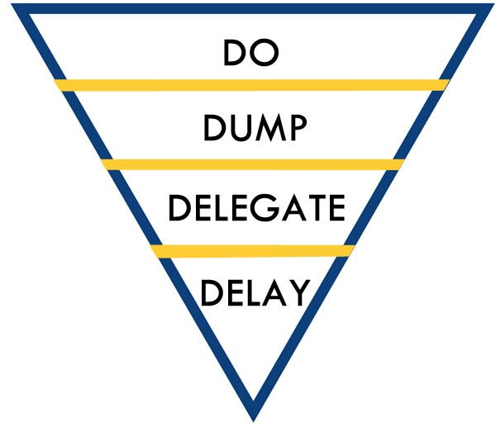
DO: In this first criteria, DO refers to sort the important work or activity we have. After I have read the feedbacks received, I have learned that I must improve this aspect, I should have prioritised my time to learn more about the Harvard referencing style. Also, the structure of my assignment was not properly formed and so I have decided to go through the lessons again and I have managed to understand how an academic assignment should look like.
DUMP: As I have learned during my researches on Time Management and 4D Model that I had to do for the Presentation Task, to DUMP the unimportant things has made an obvious difference in my work, as I was able to finish my Task faster, but I have started to use this in my day-to-day life too and I became more efficient.
DELEGATE: After a chat with the members of my group for the Presentation Task, I expressed my choice on choosing a question as I was confident with that, and I have seen the others can deal much better than me with the other questions. As a definition, DELEGATE refers to a task that can be done as well by the other team members of my group.
DELAY: After the first feedback received on Draft Task 1 Assignment, I have seen the mistakes done, so for the Presentation Task as a group I was better prepared. I have managed to sort my tasks and for all the important things but not urgent, I set a reminder, and this led to a Presentation well prepared.

Presentation Skills
As Marr, A. (2019) is saying in her post, Presentation Skills is not just one skill, but a various of skills. First of all, communication is the key when we are doing a Presentation, and this should be clear and concrete so that our audience can follow us and understand us easily. The way that we deliver the Presentation and the techniques applied, need to be in a way that captures the audience’s attention. The speech in a Presentation, like I had mine in the class for the group Assignment, should capture perfectly the context of the slides, but the slides should not contain excessive information. To reflect on the Presentation Task, I have used the Gibbs Reflective Cycle by (Gibbs,1988) as follow:
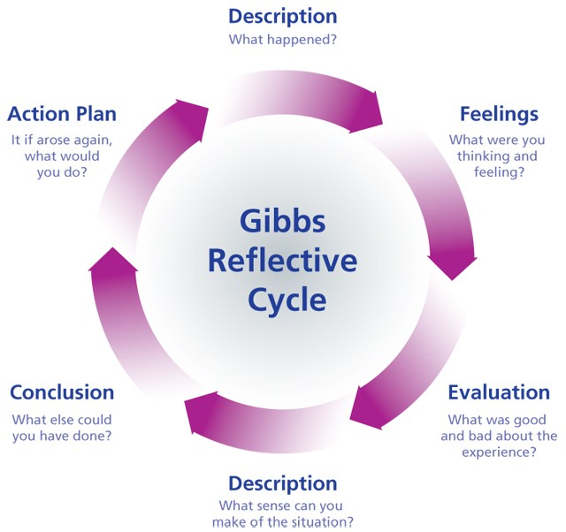
The Reflective Cycle (Gibbs,1988)

Description: The Presentation group Task involved a series of questions about Time Management and the 4D Model. A short text was given relating a person that had an Assignment to do. Each member of the group was supposed to answer one of the questions, identifying the Time Management issues, and to present the class how the given character could have improved her work by using the 4D for Time Management.
Feelings: Reading the story for the Assignment, I felt like I was reading my own experience from a while ago. I have once realised how many people are still out there who fail succeeding due to Time Management issues. During my speech I was anxious and wondering if my audience will understand what I want to explain, but more nervous I was about the overall outcome of the Presentation, because me and my colleagues, as a group, we did not manage to find time to repeat before we expose it. But in the end after receiving the feedback I was quite happy to see I was anxious for nothing, and I managed to do a good Presentation.
Evaluation: The group Feedback was as I expected. Some members of my group did not show too much interest on having a few meetings together to repeat and to make sure the Presentation runs smoothly, and this was easily seen by our lecturer. Even if my part of the Presentation had good feedback, I could not lead the other members to have the same, as I was designed the group leader only a short time before. I am sure if we would have sticked to the plan and each member would have contribute in the same amount, our Presentation would have been a success.
Analysis: After analysing this experience, I have seen that I managed to develop Presentation Skills, even if obviously I still need more practice in order to improve it and lead near to perfection. But the less good part, was as a group, due to lack of interest from my colleagues we did not managed to present the task given in a more appropriate academic way, and this showed that we still need to develop Team working Skills. I have learned that sticking to the main plan would cause less issues and to gain Team working skills needs effort from each member of the group.
Conclusion: In the end, I have learned that all the group members need to communicate more, or less but efficient, and it is essential for us to learn Team working skills. Some of the members were not as ready as they have said. Whilst a virtual Presentation we should turn our cameras on, as this does not go good for the audience, and they should put a face to the voice.
Action Plan: For the future, I will know how to control my anxiety during my speech. As well, in future I will try to manage the team much better and encouraging them to work more and to find time for an important Assignment like we had to do. As I was designated in the last minute the group leader, I could not lead them well, next time sticking to the plan will be an important aspect. In case in a future Presentation, I will be again the team leader, I will put more effort in encouraging the team members so that in the end we have a successful Presentation. For the individual tasks, I learned that I need to pay more attention in reading the task description and not omit important aspects.

Finding information/ Research Skills

The definition of this skills is mainly in the title, but finding the information is not enough, and having Research Skills means all the information found needs to be used effectively. In order to be able to have an answer to your research you need to use different strategies.

Research skills is one of the skills that I thought I already developed, but after taking part to this module of Academic and Employability Skills, I started to learn more about it and that are several techniques that we need to apply, in order to reflect more about it. I felt quite disappointed of myself jumping to this conclusion, but in the meantime, I was happy I get the chance to extend my knowledge and see what I need to improve and what I was doing wrong. For my assignments I had to do several research, and I will use the CRAAP Test to explain it’s relevance while doing my research.

CRAAP Test is a tool used for research, and stands for Currency, Relevance, Authority, Accuracy, and Purpose.
Currency: This means the timeliness of the information. For both my assignments I have found sources that have been recently updated and so I assured myself I present a liable content.
Relevance: All the information found were answering my questions and needs. The content of my assignment and Presentation Group was exactly what the task proposed and like this I made it easier for the audience to follow me, and I did not lose them with irrelevant phrases or pictures.
Authority: To do a Presentation or an Assignment as an academic student, all the information found had to be from liable sources and not from some untrusted websites with no author or no right on publishing.
Accuracy: Based on my own experience and personal knowledge I managed to present an accurate content during my presentation and the written task, and not only providing definitions. Given the fact that I combined the definitions and the information found with my personal knowledge, also checking for grammar error and knowing my presentation can be easily verified on many other sources, my content passes once again the CRAAP Test.
Purpose: The purpose of the Presentation Group and its content was to show ourselves we can easily identify Time Management issues, that we have learned what Time Management Skills is, and what tool to apply in order to understand it better.

Conclusion:
Joining University, and the lessons presented in this module have helped me develop new employability skills and some of the skills already gained during the time life, I have managed to improve them and to understand in a better way its importance. Through my reflective report I have used a various tool applied to each skill that I chose to discuss about. 4D for Time Management is a tool that shows us the way in gaining this skill based on a simple structure but important to follow in order to have success in achieving what we proposed or must do. Gibbs Reflective Cycle is a tool designated for personal development and especially focused on the teamwork. CRAAP Test is an important tool while researching information and makes us confident in saying that we have developed academic Research Skill, as all the information found need to be accurate and so the CRAAP Test helps us to demonstrate its accuracy. The purpose of the skills mentioned, and the tools used, is to highlight its importance in the employability sector but in my case, some of the skills are very helpful in my day-to-day life.

References:

Gibbs Reflective Cycle, image. Available at www.bing.com (Accessed 24 July 2021)
Introduction to research skills, 2021. Available at Home - Introduction to research skills - LibGuides@Southampton at University of Southampton Library (soton.ac.uk) (Accessed 24 July 2021)
Marr, A. (2019) 22 Presentation Skills(The Big List). Available at 22 Presentation Skills (The Big List) - Simplicable (Accessed: 24 July 2021)
What is Time Management? n.d., Available at What Is Time Management? - Time Management Skills From MindTools.com (Accessed: 24 July 2021)
Wikipedia(2021) What is Time Management. Available at Time management - Wikipedia (Accessed: 24 July 2021) ?
4D for Time Management, image. Available www.bing.com ( Accessed 24 July 2021)



