BMIH6004
Managing Hotel Administration

Assessment Component 1

Learning Log
Student name: Katerina Hristova
Student ID: 2232205
Lecture name: Jessica Newport

Table of Contents
Introduction 3
Section 1: Role Reflection 4
Role and Responsibilities 4
Leadership 4
Impact on Efficiency 4
Challenges and Management 5
Examples 5
Strength and Weaknesses 6
Action Plan 6
Section 2: Discussion of Key Hotel Administration Issues 7
Chosen Issue 7
Literature Review 7
Practical Application 7
Link to Module 8
Section 3: Future Trends in Hotel Administration 9
Emerging Trends 9
Impact on Department 9
Literature Review 10
Conclusion 11
References 12

Introduction
Hotel management is about taking responsibility and providing leadership, to ensure the hotel trades profitably while guests' expectations are exceeded. My placement was in Ashford International Hotel & Spa (Start date: 02/05 and End date: 10/07). My position was Food & Beverage, Managing Guest Service Operation: Housekeeping and Leisure, Managing Hotel Administration: Reception and Sales. Leaders used to make fast decisions during peak times to control the workflow and ensure the quality of services. This allowed me to ensure smooth operations as I actively managed my team and tried to find solutions.

Figure: Ashford Int Hotel and Spa (Wood, 2013).

Section 1: Role Reflection

Role and Responsibilities
At Ashford International Hotel & Spa, I was assigned the role of Managing Guest Service Operations within the Food & Beverage section. My main responsibilities were to manage guest check-ins, take reservations, and facilitate hassle-free administrative work. This position has enabled me to deal with the guest’s first-hand, which has improved my knowledge of their needs and preferences. On the whole, hotel duties provide an in-depth insight into the field of hospitality management (ASET, 2017).

Leadership
At the Food & Beverage department, I observed leadership to be effective due to delegation and decision-making. I observed managers distributing work depending on the strength of a team, which I considered effective. These habits increased team morale and working efficiency. A good working environment requires good leadership (Bardi, 2010). These lessons identified the relevance of flexibility and good communication in solving problems. I however noted technical skills especially on advanced PMS features as a point of improvement.

Impact on Efficiency
I worked in the Food & Beverage department, which greatly increased the efficiency. I also used my communication skills to simplify communication with the guests and the kitchen team. Moreover, I was successful in utilizing the Property Management System (PMS) and Customer Relationship Management (CRM) to handle reservations and guest preferences. Utilization of technology is essential in enhancing efficiency (Casado, 2012).

Figure: Food & Beverage (Fallon & Rutherford, 2010).

Challenges and Management
The problems that I had to solve during my placement at Ashford International Hotel & Spa included technical problems with the PMS and managing a multicultural team. I resolved these by consulting technical assistance and establishing free interactions among team members. Dynamic work environment challenges can only be won through effective problem-solving and communication (Fallon & Rutherford, 2010).

Figure: Challenges Management (Tewan, 2009).

Examples
One of the cases was when I was able to solve a guest complaint using my communication skills and made them satisfied. On another occasion, I used problem-solving skills to correct a reservation mistake in the PMS before inconveniencing potential guests. These important skills are essential in solving problems (Hagg, 2013).

Strength and Weaknesses
I understood that my strengths are time management and the ability to adapt to the situation at Ashford International Hotel & Spa. I effectively managed a variety of tasks, and operations went well. I will develop these skills by undertaking additional training. Professional development requires ongoing self-assessment and self-learning (Johnston, Clark, & Shulver, 2012).
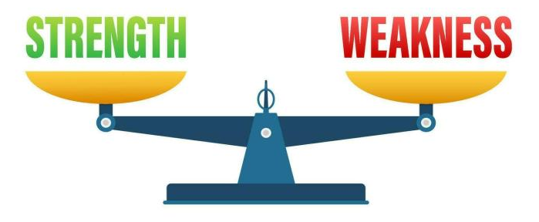
Figure: Strength and Weakness (Vallen & Vallen, 2014).

Action Plan
Skill Area | Action Step | Expected Outcome | Duration
PMS System Proficiency | Admit to PMS training courses and practice regularly (QAA, 2018). | Improved productivity while managing guest reservations and information. | 02/05 to 04/05
Leadership Skills | Attend leadership workshops and take advice from professionals. | Better ability to delegate tasks and make wise decisions. | 04/05 to 06/07
Communication Skill | Participate in communication seminars and practice daily (Rughubalan, 2009). | Better interaction with guests and colleagues leads to an overall positive work environment. | 06/07 to 08/07
Technical Skill | Practice advanced PMS features and CRM tools. | Enhanced technical skills to solve problems quickly. | 08/07 to 10/07

Section 2: Discussion of Key Hotel Administration Issues

Chosen Issue
During my placement at Ashford International Hotel & Spa, I have witnessed that workplace culture greatly influences staff morale and customer satisfaction. This was a lesson on the role of a supportive environment towards the improvement of overall hotel operations. Culture at the workplace is a very essential consideration in the success of any hospitality organisation (Tewan, 2009).
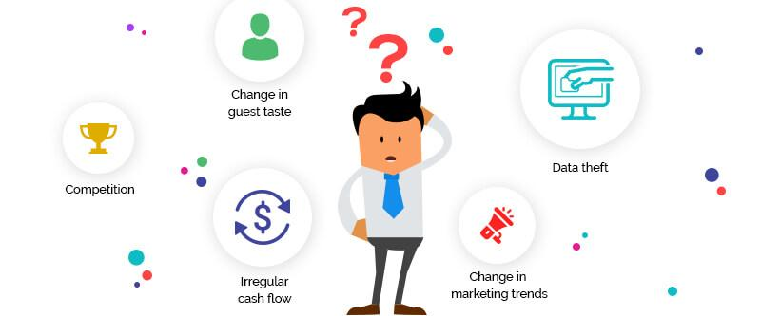
Figure: Common challenges in hotel management (QAA, 2018).

Literature Review
I discovered that culture in the workplace is a critical matter of hotel administration as illustrated by ASET (2017) which mentions the significance of an efficient learning environment. The issue regarding the effects of management practices on team dynamics, which I had a chance to witness, is also mentioned by Casado (2012). Generally, a healthy workplace culture is vital to the success of any hotel operation (Vallen & Vallen, 2014).

Practical Application
My experience working in the Managing Hotel Administration specifically in the Reception area at Ashford International Hotel & Spa showed me the importance of a harmonious work culture. I observed the way a positive environment enhanced teamwork and guest service. This working experience supported the importance of workplace culture in everyday hotel operations (Wood, 2013).

Link to Module
My workplace culture experience in Ashford International Hotel & Spa is directly related to the Personnel Resourcing & Development module. I was able to witness the application of the principles learnt in this module during my placement and how it improved the functioning of a team, as well as made the hotel successful. Modules can be very important as these show real-life challenges in hotel management (Fallon & Rutherford, 2010).
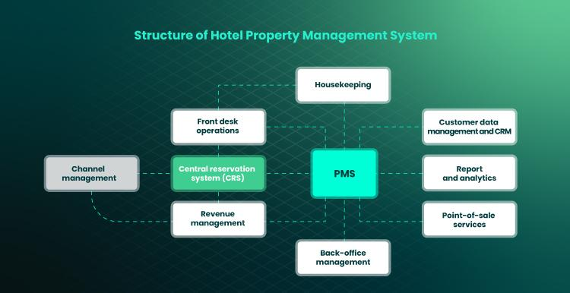
Figure: Hotel Management structure (Hagg, 2013).

Section 3: Future Trends in Hotel Administration

Emerging Trends
AI in Hotel Management: I felt the power of AI in person when I visited Ashford International Hotel & Spa which automated its tasks and personalized services. The trend improves operations and guest experiences. In theory, AI implementation is crucial to contemporary hotel management (ASET, 2017).
Changing Consumer Expectation: At the hotel where I witnessed customers who anticipated a personal and quick service. This change requires hotels to adjust in order to be competitive. In theory, consumer-oriented strategies play a crucial role in hospitality (Bardi, 2010).
Technological Advancement: My placement had technological equipment that made operations efficient, such as PMS systems. Such innovations are essential towards efficiency. In theory, the key to administrative excellence in hotels is tech adoption (Hagg, 2013).
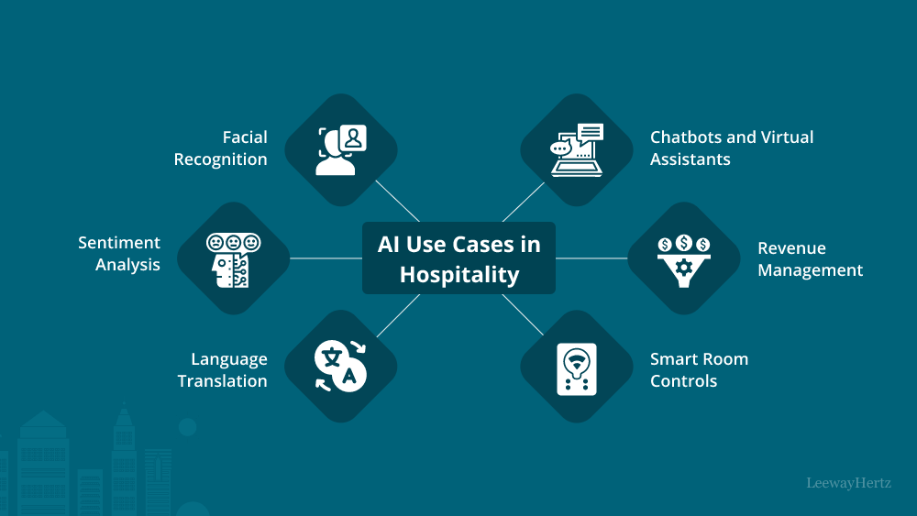
Figure: Use of AI in hotel management (Casado, 2012).

Impact on Department
During my experience at the Food & Beverage section of Ashford International Hotel & Spa, I witnessed how AI incorporation, following consumer trends, and technological developments would influence my operations. Fundamentally, the ability of my department to succeed in the area of hospitality depends on the adoption of such trends (Tewan, 2009).

Literature Review
I have discovered that Twan (2009) and Vallen & Vallen (2014) offer insightful information on the future trends of hotel operations. Their publications touch upon the augmenting role of technology and the need for hotels to comply with shifting consumer trends. The sources will assist in confirming what I have observed in Ashford International Hotel & Spa and how crucial it is to keep up with the trends in the industry. In theory, these trends are guiding the hospitality industry into a future that is more technology-oriented and customer-focused (Wood, 2013).

Figure: A literature review on hotel management (ASET, 2017).

Conclusion
I observed the way a positive and inclusive culture contributed to improved teamwork and quality of service. This is similar to what I encountered in Ashford International Hotel & Spa whereby the good culture enhanced morale and productivity. The module informed me of the need to establish a setting that fosters the development of employees and job satisfaction. These trends are an indication of a future where my department would be more efficient and capable of providing custom experiences.

References
ASET (2017) Good Practice Guide for Workbased and Placement Learning in Higher Education. Sheffield: ASET.
Bardi, J. (2010) Hotel Front Office Management. 5th Ed. London: Wiley.
Casado, M. (2012) Housekeeping Management. 2nd Ed. London: Wiley.
Fallon, M. & Rutherford, D. (2010) Hotel Management and Operations. London: Wiley.
Hagg, E. (2013) Internship Guide: Work Placements Step by Step. 5th Ed. The Hague: Eleven International Publishing.
Johnston, R., Clark, G. & Shulver, M. (2012) Service Operations Management. London: Pearson.
QAA (2018) UK Quality Code, Advice and Guidance: Work-based Learning. London: QAA.
Rughubalan, G. (2009) Hotel Housekeeping: Operations and Management. Oxford: Higher Education Press.IST
Tewan, J. (2009) Hotel Front Office: Operations and Management. Oxford: Higher Education Press.
Vallen, G.K. & Vallen, Jerome J. (2014) Check-In Check-Out: Managing Hotel Operations. 9th Ed. Harlow: Pearson Education Limited.
Wood, R.C. (2013) Key Concepts in Hospitality Management. London: SAGE Publications Ltd.

