
Skills for the Workplace
Module Assignment Submission
Student Name: | Telma Da Liva Rodrigues Pires
Student Number: | 1604712
Module No: | EMPL4010
Module Title: | Pathway Project 2

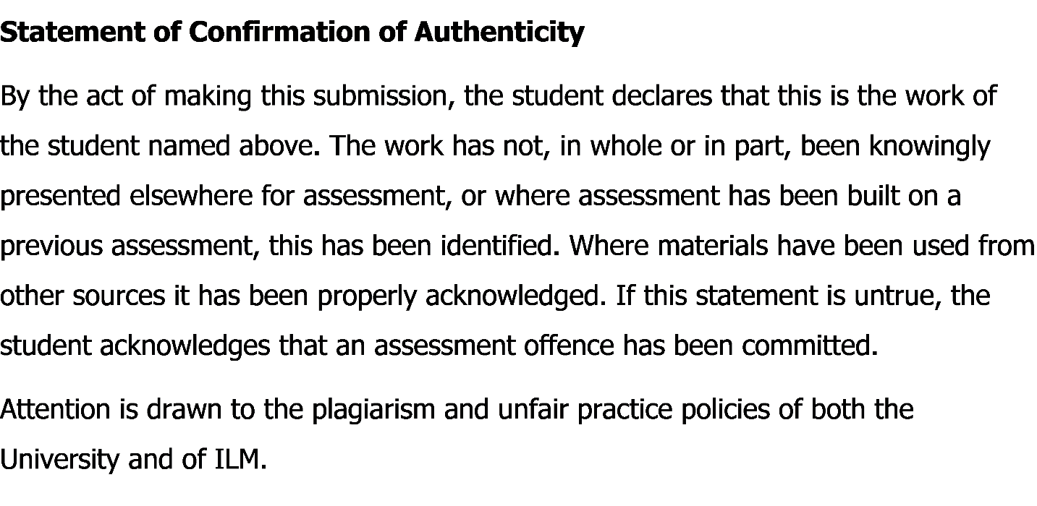
Contents
Introduction: 3
Reflection: 3
Conclusion and Action Plan: 6
References: 8
Learning log 9

Reflective Essay on Business plan of clothing store

Introduction:
Academic life is about full of experiences. In our academic life, we can know about how to do things in a structure way, how to apply experience in strategic way. According to Morgan, “the purpose of reading university, to disseminate knowledge, to create knowledge through research, to enhance the skills”, (Morgan, 2017). In this module, I learn such of essential knowledge that helps me to do a business, promote a business and run a business in effective way. In this semester I did a project of business plan, I did also a presentation on that business plan. I did those things in a group. I am now going to write reflective report on that topic what I achieved and experienced.

Reflection:
In this module I have realized importance of a business plan to minimize risk of wasting capital. I made a report and presentation about a business plan. I did a business plan about a clothing store. When I made the report and presentation, I learned lots of things that give me real life experience. I need to do it with my group and need to go through a plan. When I worked for the project initially we needed to find a suitable place and name for our clothing store. Here I am going to write about that and I am also going to tell about my academic skills which I learned from the business plan, While I was doing this business plan, I learned how to start a business. I also going tell about market analysis which was my part and from that analysis what I learned. As I completed my task in a group I experienced every process of a business. I did financial analysis, I also did objective of our business. I did pricing strategy, promotional strategy, marking strategy. As I worked in a group, I also experienced to learn team working, time management. As I said I also did a presentation of our business plan, these also helped my academic and employability skills a lot.
I passed a very enjoyable time when I did the report and presentation. I had experienced lots of things which were close to real world experience. In that report I was experienced about how to run a business in effective way. While I was doing the report I was experienced, how to work in group, I set objectives of business, I set location, I set schedule, I analyzed market, I set price, I did financial analyze, I did management analysis, risk analysis, did a breakeven chart and making an effective balance sheet. In presentation part, I experienced about time management, I experienced about technical skill and I also experienced an effective presentation.
At first, I did all those work in a group and for that reason I experienced to work with group. We are three members done with the project. I did a report and presentation by doing group study, visiting a new clothing store beside our university, doing online communication and so on.
I was authorized and briefed to make a business plan regarding a clothing store and the business was a partnership business. My one of my group member done the description part of the report. There mentioned about objective of a business. In this report the objective was to promote current fashion trends and make it affordable for the customers. We want our company to be up there with the other clothes shop and make our clothes made from good quality materials. I experienced to set primary objectives and secondary objectives for our business. I did product and service segmentation also set schedule of opening and closing time of our clothing store. I also needed to do a legal procedure of the business as the business is an ownership business. Some legal issues that I along with my group members faced in our line of work varies from health and safety issues to environmental problems. We must make sure that where our products are made are safe and a workable condition. Other issues could be how our waste products are handled and keep the environment safe and not create any harmful damages to the world. Everything was discussed briefly.
In market analysis part I did marketing strategy, market segmentation, set target customer, pricing strategy, promotion strategy. I also set perfect location, analyzing competitor and competition. In market segmentation, I categorized market and set middle income, low income, and student. Those are my target customers. In pricing strategy, I need to focus about price and that should be affordable to my target customers and when I set price I also need to keep in mind about competitor and that’s why, I also need to do competitor analyze. Those are my great experience while I did my part. I feel a real-life experience by doing this analyze. I also did promotional strategy and there I mentioned how to promotion my business. How people attract more in my business. What should be the offer that I will give to my customer and how to go through from it. I also set location which is an important part of the business. In report I mention where my business should set. For setting a perfect location I need to analyze competitor, customer and market. I also experienced to make an organogram of my business. So, I analyze internal and external analysis of our business.
I experienced doing management of operation and financial data. That part was done by another group member. But I also felt lots of things from that part. The financial analysis part was difficult though. We all done that by a group. The numbers needed to assume correctly otherwise the balance sheet was not matched properly. I also did risk management and that’s why, a proper income statement was also needed. We did sales forecast from our assumption and the amount should be realistic. Cash flow, balance sheet, income statement, break even analyses are quite difficult to do.
I communicated with my group members through Internet, all stuffs are good but sometimes I had face some technical problems. While I worked for the presentation I know about how to do presentation and how to manage time and experienced efficient communication in group. (Cottrell, 2013).
When I completed the report, I faced some situation. I am now going to write here about the review my whole experience that I got from doing that report and presentation. In my report, I set the objectives through analyze market, customer and competitors. In there all things were going well. Our objectives were satisfactory and those were related to accomplish our goal. I set three objectives of my business and each of the objectives are related to achieve my goal. In this report helped me to set successful objectives.
In this module the project I has been completed through a group. I am responsible for any unavoidable situation. As a group member, I needed to complete my work and cooperate with others. I had done this and done my part. Everything was going well in my group. I did my part and communicate with my other group mates. I communicated with group study but there was conflict that which part has done by whom. Though I managed it and I had experience to analyze market that’s why that part I chosen. I experienced to use team viewer and skype and mostly in WhatsApp when we needed to communicate online and in that time, I had face some problems like when I used my laptop there were net problem and software related problem. I needed to cope up with that. I also settled internet problem by using mobile data while my Wi-Fi had problem. When I was completed the presentation, I also learn how to make suitable presentation. I make my own slide and the slide was well prepared and lots of content which make the presentation good and I know about time management. (Adair and Adair, 1987)
In my part, market analysis, I did not face any problem, but I need to visit a clothing store and I needed to do learn somethings that I don’t know. There were a little bit problem occurs when I analyze competitor. The information while I talking from different coffee shop that was pretty hard but I managed it. This helped me a lot for doing SWOT analysis and PESTEL analysis of our clothing store.
This business plan report and presentation helped me to achieve a lot of knowledge. I learned a lot of things that I did not know before completing this project. After doing the project I think, my skills were developed. In this module, the content helps that how build up a business in this competitive market. Group members were friendly and they were very helpful. When I worked with in a group I did not find a single problem in my group. As I have some knowledge about a clothing store of my own, I thought that it would be easy for doing market analysis part. Like me, everyone had some experience of their part and we did in it a group also done with satisfaction. In presentation, I did not face any problem but when I communicated through internet, I faced some problems that I mentioned before. I mentioned regarding the difficulties of financial part and SWOT analysis part.

Conclusion and Action Plan:
This business plan project helps me to learn a lot of skills. I am thankful to my group members, they helped me a lot and I also learned lots of things from them. I learned how to work properly in a group, I learned time management, I learned leadership skill, I learned about presentation skill, time management skill and task management skills, learn about communication skill and critically thinking. I developed my academic content writing which is helpful for me. Those things are my interpersonal skill that I learned from this business plan. I learned those things from experimental learning theory. (“Gibbs - 1988 - Experiential learning theory.pdf,” n.d.). When I am going to set own business of clothing store in near future, I will set objectives and I also set vison and mission of my business. In that report, I focused on some objectives of our clothing store. When I will do my own business, I also set my objectives to keep in mind about customer satisfaction, quality of fabric, comfortable place of the shop and so on. I will also target my customer in three categories, low income, middle income and upper middle-income people and segment them in terms of their life style, culture and traditional occasion. I will also segment my products for my customers and will give the quality fabrics in an affordable price. I will give promotional offers. The promotion should be given to my loyal customers. Student should get offer. I also set my location in terms of what I mentioned before. I will analyze the market from different sector. I will take a legal certificate for doing a partnership business. I will manage my customer and attract them in different way. Online clothing store is rapidly increasing due to the extreme demand of social sites, websites and internet. So, Paradise Women’s Clothing Store will help all of us to be a successful business planner or entrepreneur in future.

References:
Cottrell, S., 2017. Critical Thinking Skills: Effective Analysis, Argument and Reflection, Palgrave Study Skills. Palgrave Macmillan.
Gibbs - 1988 - Experiential learning theory.pdf, n.d.
Gibbs, G., 1988. Experiential learning theory, in: Learning by Doing. Oxford Centre, Oxford Brookes University, Wheatley Campus, Wheatley, Oxford, UK, OX33 1HX, p. 14.
Morgan, P. (2017). The purpose of University. In K. Smy (Ed.), The Business Student's Guide to Study and Employability (p. 8). London: SAGE publication. Retrieved from https://books.google.com.bd/books?id=_pNlDQAAQBAJ&printsec=frontcover#v=onepage&q&f=false
Morgan, P., 2017. Presentation skill. In: K. Smy, ed. The Business Student's Guide to Study and Employability. London: SAGE, p. 191.
Morgan, P., 2017. The purpose of University. In: K. Smy, ed. The Business Student's Guide to Study and Employability. London: SAGE publication, p

Learning log
This was a great experience of working for a business plan with 3 group members. It helped to learn a lot from the group work.
We worked on this business plan by scheduling group studies. We studies at library, class and home together. Before my working with in group, I did not have knowledge of how to work with group. I worked on this business plan by scheduling group studies. I studied at library, class and home together. I managed time and took our resource like laptop, calculator, books and journal. In my weekend I also visited a clothing store with my group members. I took notes and I also used internet. We communicated through skype and mostly by WhatsApp. Tasks had divided and I completed my tasks and then other members evaluated those task. After the work, I know that how to work with group and I know the process. I took note, used resources and scheduled my time. Introduction, PESTEL and conclusion prepared by Telma Pires. Aims and objectives, mission and vision with legal issues done by Malini Ragupadi. Management process and SWOT analysis done by Nsole Mosengo. Nothing went wrong but the PESTEL analysis part was difficult. As we done it in a group, every work we did in a group. Though the PESTEL was for Telma Pires, but I also prepared some portions of it. We meet frequently to study on the plan. When we met, I learnt about how to communicate, how to work properly etc. As we did study plan, we solved everyone’s problems. And my problem also solved by others members. We used WhatsApp mostly. There were few technical problems in meeting online, though that was managed. When we were going to prepare slides, there were also a problem that I faced. The presentation slide was defected by virus and the slide was in short cut form though it was managed because I had backup. There were some difficulties regarding time matching. We worked together and compromised to manage that. We worked in weekend time. I learned about time management and how to overcome from it. There were some conflicts regarding contribution and performance. We discussed in group and managed satisfactorily. Everyone participated on work. I was doing my part. Every member was very responsible and attentive. We did not know, who was better in which section. We did not force anyone. Group discussion was also satisfactory. I learned from here how to manage group members and how to influence and motivate group members towards work. We divided the work based on discussion and opinion. The work has divided based on everyone’s opinion, everyone had freedom. Though we discussed if anyone had any experience he or she could do that part. I learned from here that, in a group, how should work has divided and should not force anyone. Yes, the report was fairly shared out. As I said we did not forced anyone, the work had fairly shared. Everyone was very cooperative and everyone took the work without any hesitation. In my part, I had an experience for that reason I took it. We learnt team work, analysis and problem solving. By doing this module, I learned lots of things. I learned how to work in a group, how to communicate properly, how to manage time. My personal skills have increased. When I did presentation, I also knew some technical skills through this module and I also learned how to prepare an effective presentation. We enjoyed the process through group discussion, group study. While we were doing this project, we had an experience of real life. We really enjoyed the process. While, a work has done in a group, that work become easier to complete. It helped to learn team work and learning in group study. Team working is very efficient to complete a work. I faced a real-life scenario. That is also a reason for enjoy the whole process. It can be improved if all the group members share their opinion and try to compromise for the group. Our personal skills also improved. We learned working in a team, problem solving and so, our communication skill also improved. We compromised for the group and for the group members. Everyone will face an improvement in themselves. While I was doing presentation, I also improved my presentation skill. Members will overcome from introvert situation after completing this report and presentation. We also faced a real life scenario and this is also an improvement for me and my group members.

