Synthesize A Solution to A Potential Real-life Scenario
James Beard
1901671
ACCA4018
Internet Technology and Security

Abstract-This report aims to discuss the aspects required for building a comprehensive Bring your own technology framework, that covers all aspects of building a safe and secure enterprise network for Coffee Capulus. This report includes a brief introduction of what BYOT is and why many companies are introducing it. A related work and problem sections that allow the author to discuss the research he completed whilst looking into this project and the problems that were flagged by other reports that he read. An implantation section which allows the author to discuss the test and simulations he completed testing the security of the network he designed. The next section is where the author will discuss the results of his simulations and his tests. The final section of this report is a conclusion section where the author will evaluate on his report, his framework, and the network he designed.
I. Introduction
The way we communicate, interact and do business has changed enormously thanks to the growth of the internet and networks as written in The Management of Network Security “networks has become essential to the functioning of business” [1]. The UK government comments on how "we are critically dependent on the internet” [2]. However, the Government's report states that the internet is "inherently insecure” [2] meaning that unchecked sensitive information can and will be stolen by criminals if capable. Another growing trend in business is to bring your own technology/device that sees business allowing staff and workers to complete work on their own chosen device. However, according to Vickerman, the concepts around BYOD are not that new arguing that for many years people have been trying to find a way to use their devices for work purposes even if it was prohibited to do so [3]. Disterer and Kleiner write that BYOD biggest draws are the ability to do anything on the device, meaning work and personal tasks can be completed on one device, allowing the ability to do work anywhere at any time [4].

II. Related Work
Why have companies embraced the concept of BYOD over the introducing company-owned smart devices you may ask, one of the main reason is surprisingly the increase in productivity from employees using their devices for business use as stated by Louise Bennett where she lists productivity in a top three reasons to implement a BYOD policy in the workplace [5]. The increase in productivity is usually put down to familiarity and preference that the user has with their device. According to a study by Cisco on their employee they have seen a 15-minute increase in productivity per day since they introduced BYOD [6]. Cisco’s employees put this down to being able to do their work anywhere and this fifteen-minute increase has made an estimated $300 million for cisco [6]. We as a society are greatly divided on what operating system and brand of smart devices are best. If a company was to implement a set business device and hand them all out, then a large proportion of staff will have to learn how to navigate a new operating system leading to more downtime in finding apps and changing settings.
Another leading factor in choosing BYOD is that the use of BYOD can save the company some money from not having to purchase dozens of smart devices for their employees to use. Cost is another one of Bennett’s three reasons to introduce BYOD [5]. The third key reason for allowing employees to bring their device to work is the likelihood that the employee's device is of a higher quality than a device that the company could provide [5]. If the company was to purchase and distribute company devices to its employees then not only would the company have a large expenditure, the company may choose or need to buy devices with poorer performance than employee’s devices. Finally, on this point employees using their own devices will likely have a top of the range model due to many purchasing their devices on contract, so they’ll be updated on average every two years. Whereas with company devices if they buy all the device outright then they could become outdated relatively fast and efficiency could decrease. If the need to update every couple of years is warranted, then the company will have also had a biannual high-cost expenditure.
As briefly mentioned in the introduction the concept of any time means that work can be completed at any time of the day, anywhere meaning that work can be completed in the workplace, on the commute or the employee could complete work at home, meaning that the device can be used for both personal and business use [4]. This could also allow the device users to complete work when they are unable to access to the workplace, when employees need to catch up on work or when they are away on business. (A list of advantages and disadvantages can be found in appendix five).

III. Problem
The approach of bringing your own device however encounters issues and security risks that could have serious implications to a company such as CoffeeCapulus. Some of the problems that the author believes that the company may face while implementing BYOD are:
- Loss and theft, according to Bennet somewhere around “20 per cent of mobiles in this country get stolen or lost and most don't have security on them” [5] meaning that sensitive data could be stolen with little to no resistance. Another problem the author felt could be a concern is that most modern devices contain a camera function and the chances of somebody taking pictures of sensitive information to sell on is a high risk.

- A joint device for work and personal use could also increase the risk of malicious attacks as people tend to use their devices to access and download content, this increases the chances that the user's device is subjected to a malicious attack. If the user has children, then the child could accidentally fall foul to malicious attacks as mentioned by Wade who wrote in in their article about the idea of a child using their parents work device to download games to play on the device [7].

- The everchanging staffing that comes with running a large company is another problem that must be considered, how does the company ensure that former employees don’t have sensitive data stored elsewhere and cannot cause security problems for the company once they have left the company. If the company uses agency workers, then will they have access to sensitive information and data?

- Smart devices usually connect to the internet via wireless network connections such as WI-FI. In today's society, many businesses such as fast-food restaurants offer their customers free WI-FI when eating or drinking in the establishment, the risk is these connections have little to no security meaning that they are high risk to sensitive data. Some of the most common threats to this data are spoofing which the BBC described as "falsifying the origin of an internet communication" [8] which is used to steal passwords, sensitive credentials and money from the victim [8]. Another threat is tampering which is when communication is overheard and the eavesdropper changes or deletes data while the file is in transit [9].

- Another possible concern is employees abusing the system in a manner which could lead to legal action against them and possibly the company. As discussed in (page167) Management of network security [1] where they discuss that employees miss use of an organizations network could be anything from surfing the web and not doing their work resulting in decreased productivity to a serious data breach from downloading dangerous files costing the company a significant amount. The discussion continues regarding how this could also lead to court proceedings for cases such as copyright infringement to accessing illegal web URLs [1]. This will lead to lengthy court cases, damage to public relations and large fines to the company if found to be turning a blind eye to employee’s activities.

- The risk of employees and customers having their details stolen is another major concern that requires consideration as the threat of spamming, bullying, harassment [1], ID theft and other criminal activity on employees are a serious threat if criminals can breach the network and steal the employee's details to sell on or use for themselves. This could lead to lawsuits from employees or customers against the company. Resulting in a serious effect on the integrity and public image of the company and could have long term effects on the victim's family, personal life, finances and mental health.

- The final major problem the company may face is ensuring that only authorised personnel can access the information that they are required to view to complete their job and allowing the general public to view the website and public material while preventing them from accessing sensitive material.

IV. Implementation
- The first problem the author aimed to resolve was that of the loss of devices whether that be stolen or lost. The Mobile Device Management system that the author recommends for the company, which can be found in appendix two. The MDM includes security features that allow admin and management to remotely lock the device or wipe the device of all sensitive data, this is also a possible fix to the everchanging staff problem that the author touched on in point two. Another feature allows admin to encrypt the data so that if the device is opened and data were stolen, using the sensitive data is made much more difficult. Speed is vital in limiting and stopping data leaks from device theft, that is why the security policy the author has written out details the procedures the employee must follow if they lose their device. These procedures include that the employee must inform the company immediately once they realise the phone is lost or stolen and then inform the police. Additionally, employees' devices must be password secured.

- A possible solution to problem two, limiting the risk of malware is to ensure that the company’s sensitive information, the company's hardware and the user's device is kept safe. The solution the author put forward is to ensure the security policy gives a comprehensive list of guidelines and procedures to ensure that employees have a comprehensive understanding on how to keep their device safe and the company’s data safe. These procedures and guidelines include how long passwords need to be to their device and what the MDM profile should be, the variety of characters, special characters, numbers, and capitals required. Guidelines advise users to take their time when typing in URLs and only download software from websites and companies that they trust.

- One solution to the third problem of keeping data secure with everchanging staffing is to set up the companies MDM systems to allow the company to create, clear and delete an unlimited amount of profiles when required, limiting the chances that they could still access the device when they have left the company. The security policy will inform the users of the procedures if an employee leaves the company.

- The author's proposed solutions to the fourth problem are to first make sure that wireless router security was configured to ensure that unauthorised personnel could not gain access to the network( screenshot in appendix three). This was done by configuring the router so that the SSID didn’t broadcast, meaning that it would be invisible to anybody outside the company and setting the security mode to WPA2 Enterprise. WPA2 is recognised as the most secure protocol for wireless networks, using 128-bit AES block cyphers for both the authentication and the encryption process as Khasawneh writes in his paper on the protocols of WI-FI [10]. Informing the employees of the dangers of public networks and the importance of securing your connection with a VPN connection or by only accessing information when at home or in the workplace. Other aspects were to configure the router command-line interface with password on the console line, VTY line and setting up SSH connectivity (screenshot can be found in appendix three).

- For the fifth problem the author identified, the author's first step was to ensure that the security policy informs the users and employees that accessing age-restricted, illegal web URLs or storing illegal software is prohibited and that anybody aware of this activity taking place will also be held responsible. Blacklisting certain websites and applications on the network by configuring the network to block access to these websites is another step the company could and should take. Finally informing the staff that their online activities are monitored whilst on the network and making sure that IT is regularly checking the network activity should work as a deterrent to the employees and help ensure that the company's reputation is upheld.

- The possible solutions to the sixth problem identified is to illustrate to employees that accessing files, data, or any content they are not permitted to view is prohibited and could lead to termination of contract and result in lawsuits. The policy also illustrates that abusing the resources that they are permitted to use such as other employees personal details and using them for non-work purposes or sharing them without the consent of the said person is a sackable offence and could lead to civil or criminal charges.

- Possible solutions to the seventh problem of setting privileges based on different groups such as customers, employees and management and limiting what each group can access the servers and network. The author proposes making sure that the servers and firewall are correctly configured so that the customers can access the company website and public files on the web/Public file server but that the other servers that contain sensitive information cannot be accessed (screenshots found in appendix three). This was done by configuring the servers with sensitive information with special login for those who would need access, for example, mixers and quality control were the only ones with access to the recipe files, but they didn't have the credentials to view the accounting files. The implementation of the MDM system the author recommends could also allow the company's admin and management to set privileges to the various workgroups and even to specific users, he can also limit what each group can view and what actions they can perform.
A complete look at the author’s security policy can be found in appendix one.

V. Results
Configuring the HQ router and Company Switch with secret encrypted passwords helped to prevent the tester from gaining entry to enter commands, the author also set up passwords when trying to use a console cable or virtual teletype, once again this prevented the security tester from gaining entry. The setting up of a message of the day banner warning of restricted access helped to act as a deterrent from trying to breach the system by warning them of the consequences of accessing the company's network devices. Setting up an ssh connection allowed for information to travel across the network encrypted and more securely with the sniffer device unable to find any plan text. By setting the wireless router's SSID to not broadcast it helped ensure that only trusted employees and customers could access the router by requiring they provide the router's name and password. The author corroborated his commands with Cisco’s introduction to Networks lab manual [11].

VI. Conclusion
In conclusion, the author feels that there is an adequate level of security as a starting point but that further tests into the security should be performed to try and penetrate the system to ensure that if there are any weaknesses or backdoors into the network that the company can fix them before hackers or criminals can exploit them. The author also feels that further researching and staying up to date with advances in BYOD, MDM systems and cyber threats will help to ensure that the company has the best chance of staying ahead and keeping their data safe.

Appendix One
Coffee Capulus
Bring Your Own Device
Security Policy

I. Purpose
The main aim of this document is to ensure all steps and requirements are taken to ensure the integrity, confidentiality, and accessibility of all of the company's information. This policy aims to provide absolute clarity to all employees on the correct practises and procedures that must be followed while using their own devices on the company’s network and for company purposes. The following of these rules is vital in limiting the chances of malicious attacks against the company. This policy applies to employee-owned laptops, tablets, Smartphones, or any device with network capabilities [12].

II. Scope
All employees of CoffeeCapulus are expected to read and follow the rules and procedures set out in this document at all times during employment. Ether that is in the workplace or at home. Failure to comply with these rules could result in termination of employment with CoffeeCapulus.

III. Procedures
- Employees must secure their devices with passwords featuring all of the following: numbers, letters, and special characters and at least 10 letters long.

- Password must be regularly updated. This will be required when admin and management seem it fit.

- Devices must be set up to close after 30 seconds to 1 minute of inactivity [13].

- Employees must log out when finished or not using. If they are found to be logged in to when not using their device for work purposes the disciplinary action could be taken.

- Accessing business data outside of the workplace must be done on a secure network and with an active VPN connection. It prohibited to access company data on an open or un-secure network.

- Employees are prohibited to use or share fellow employees contact details unless required for work purposes.

- Employees are prohibited from accessing age-restricted websites or social media on their devices while on the company’s network. This includes gambling sites

- If devices are lost or stolen, then management and the police must be notified immediately.

- Employees are prohibited from using their devices camera function while in the workspace.

- Employees must only store sensitive information in a separate folder that is password protected. on their devices at any time whether this is passwords to end devices or company information.

- Employees must not write, carry or leave notes with sensitive information this includes the device passwords, company information or anything else deemed private.

- Employees’ devices must contain some form of anti-malware software that is deemed acceptable by the company [12]. This must be kept up to date to lower the risk of being attacked. Should a device become infected, and sensitive company data is lost or stolen and it is found that the user hasn’t followed the practises then they will be held personally responsible.

- The employee must keep a high level of separation between corporate and personal data. If they do not the company cannot be held responsible or liable if personal data is lost or erased.

- Anybody who is not located in the IT branch of the company is prohibited for accessing the company’s hardware command line and IT must have permission from management before changing the config on the company’s hardware.

- Employees must have permission from management or IT before plugging in USB sticks or any flash memory devices. This is to prevent the risk of internal attacks from malicious software that could be stored on the device. Instead, take the device to IT to deal with.
- The company regularly monitors the internet activity of all employees on the company network and have denied access to certain web sites that the company does not deem fit.
- This policy is subject to change and update as risks and flaws are found in the system
- Employees are not permitted to save any files to a cloud-based storage site. The IT department will deal with all tasks concerning cloud storage and nobody else should take upon themselves [13].

- Employees should regularly back up personal-data and consider creating a backup plan for their data. The company will not be held responsible for the loss of data if devices require wiping [13]. This is only applicable to the employees own personal data and as stated above employees must never create or store company files in personal folders or anywhere other than the secured company folder.

IV. Exceptions of use
The Warehouse and distribution departments may be required use camera to prove damage of ingredients or scan barcodes of ingredients to locations. The public relation may also be excused to use a camera in the workspace for social media posts however permission must be granted by management.

V. Guidelines of use.
- Passwords should be made of three random unassociated words and numbers
- Passwords shouldn’t be of anybody or anything that you are closely associated with.
- Employees must be aware of their surroundings at all times.
- devices should not be used while driving, operating machinery, while on the move or performing any task that requires full concentration.
- Only download from trusted sites. If the software is free it may come with the unwanted bonus of malicious software being downloaded alongside, it.
- Take your time many malicious sites are one letter off trusted site URLs, for example, if you misspell "Google as "Goggle” then you could run the risk of going to a dangerous site. It always best to stop and check before clicking go.

VI. Risk assessment

The failure to comply to the company's procedures could lead to device been hacked and hacker gaining access to the company's information leading to a serious risk to the integrity and confidentiality of the company's sensitive data leading to the loss or stealing of the company's recipes, accounting and other private detail's that could be sold onto third parties or blackmailing the company to pay a ransom for the potential return of sensitive data.

The failure to prevent malware from accessing the employees devices and the network could lead to malicious software such as viruses and worms to rapidly infect multiple devices, the requirement of shutting down devices to stop the spread of the software will at best leave employees without devices for some time, at worst it could lead to a disaster for the company that could loss extortionate amounts of revenue in lost productivity and corrupted files.
The failure to prevent employees from accessing restricted website URLs could cause anything from employee productivity dropping because they're checking Facebook instead of working to trying to access or upload illegal content on the internet. Leading to public relations disaster for the company and possible civil or criminal charges against the company as written by Bailey, Snyder and Carr [1].

VII. Violations
Employees found to be in breach of the rules and procedures will be subject to disciplinary actions and in serious or repeat cases the employees could face termination to their contracts and civil or criminal charges against perpetrators.

The structure of this policy was done with the assistance of bacik [14], CEH guides [15] and the UK Government's BYOD Guidance [16].

Appendix Two
Mobile Device Management.
Information used comes from Miradore [17], [18]
The Mobile Device Management system that the author would recommend is either Miradore enterprise plan or the Miradore business plan. Miradore is cloud-based, cloud-friendly and is easy to use The Miradore enterprise EMM (Enterprise Mobility Management) plan that allows for any device platform. The Miradore enterprise plan cost £2 or J$351.72 (Jamaican Dollars) per device. The Miradore business MDM (mobile device management) plan that is half the price of the enterprise plan but contains many of the same security features. This report reviews both plans features to allow the company to decide which one is a better fit for them, with how much control they want over the devices.

I. Support
Both plans include a range of customer support features to provide clarity with any questions that the client company may have about their plan. These features include a community feature let allow the user to interact with the wider community for support and answers to questions. Quality phone support from Mondays to Fridays. Quality Email support with a response within one working day.

II. Security
Numerous security features come with the plans designed to help keep the company's information as safe as possible. These features include the ability to remotely lock devices in case they go missing to lower the chance that any sensitive information can be extracted from the device. The ability to wipe and erase data and device profiles can also be used if the device goes missing or an employee leaves the company. The ability to control passwords whether that is clearing, setting, enforcing or resting the device password is another feature for IOS and android devices can be used to ensure that nobody is locked out of their device, that users are setting up passwords with per the policy and the ability to ensure that password are being changed regularly. The ability to activate lost mode in case the device is lost or stolen on IOS devices. Storage Encryption on IOS and Android to add a layer of security in case the device is broken into then all sensitive date is difficult to read and use. An Alarm sound feature for Android device to scare away anyone trying to gain unauthorised access.

The following features are only included in the enterprise plan. The ability to Blacklist and whitelist URLs that company don’t want the employees having access to. The ability to Blacklist and whitelist specific apps that the company don’t deem safe or appropriate. A Secure Container to help manage the security on the devices. The management of data such as files, contacts and various other things to ensure safety. Deployment of files on android the ability to remotely check, delete and deploy the files in the company’s inventory on an employee’s device. The Deployment of Certificates on IOS devices for desired users.

III. Data collected
Miradore collects the following information and data from the devices that use their software. The data collected includes the Hardware Details. The device's Security Information, the devices Operating system Details, the memory/Disk space on the device, the devices Network and WI-FI information, the GPS coordinates and location data on the device and the Application details.

IV. Configuration
Both management systems allow for the admin to configure the Wi-Fi settings, the email settings such as IMAP or POP, the passcode settings the VPN settings and the devices roaming Settings

The enterprise plan also allows for the configuration of the Device usage restrictions, the files or certificates, the operating system update settings, the Web shortcuts and the Kiosk Mode, a single application mode, preventing the running of applications.

V. Location tracking
Both plans come with features, that allows for the company’s admin to track their employee’s devices in case of the device going missing. The location tracking features include tracking the Current location of a single device or current location of all devices associated with the company and the Device's location history for the last three months. The enterprise plan also includes the location information over the Application Programming Interface.

VI. Device usage restrictions
The enterprise plan allows the client to restrict some of the usages of the employee’s device. Though this could cause a problem as the device is being used as dual device then it will have to be carefully considered to ensure that both the company’s data is safe and personal privacy isn’t infringed upon. Some of the features included in the enterprise plan are the ability to restrict factory rest, application removal, data roaming, screen captures and the uses of certain apps.

VII. Data Analytics
Both plans come with a full and custom report to the company’s admin and management. A dashboard feature to give clarity to the company on the performance and management of the system. inventory reports on the security of the management systems, the hardware and the apps associated with the company. The enterprise plan allows for reports into the data usage of devices on the network.

VIII. Admin
Both management systems include many tools to ensure that the client's admin has a good level of control of the company's resources and data. These tools include allowing for an unlimited number of administrators that can be set up by the client to ensure they have as many administrators as required to ensure smooth operation. The use of Two-factor authentication, a Notification centre, allowing notifications to be sent to client’s and administrators email as well as allowing administrators to send messages to the device users.

The enterprise plan also allows the administrators to grant permissions to determine what data device users and groups can access and allows administrators to set read-only access to data for devices and groups.

IX. Conclusion
The enterprise plan has many features that give it an edge over the business plan such as the features exclusive to the enterprise plan in admin allows the company to have greater control on what its employees can access and do on the network, meaning that mixers cant view the accounts and the accountants cant view the recipes. The ability to prevent screenshots could be an important advantage in ensuring confidentiality and integrity of sensitive data. The extra security features should help keep the company's data more secure as well. The main drawback of the enterprise is that accesses more control on the user's devices than they may feel comfortable allowing and seems to suit a company allocated device structure better whereas the business plan suit the BYOD device structure better not having access to restrict the user's usage of the device and is half the price of the enterprise plan but has less control on admin and less security on the company's data.
More information can be found at https://www.miradore.com [19]

Appendix Three
Enterprise Network Design
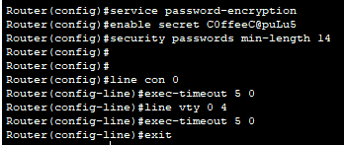
The Packet Tracer File can be found on the Moodle upload link.
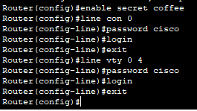
The first set the author took in Configuring the HQ router’s security by setting up an encrypted password, a console line password and a virtual teletype password to ensure only those with the password can access the company’s network devices.

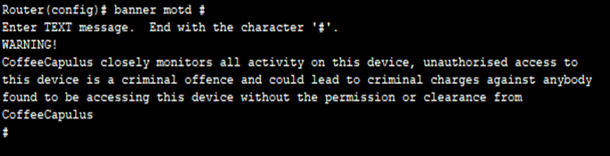
Next, the author set up a message of the day banner on the HQ router to act as a deterrent by warning potential intruders of the consequences of accessing the company's network devices without permission to do so.

The next step was to ensure that all passwords were secure and encrypted. After this, the author decided to increase the complexity of the router's password to lower the chances of unauthorised access. Then the author set up session time out on both console line and virtual teletype line to lower the chances that if somebody does leave without exiting correctly then the session will expire and require the password to return to entering commands.
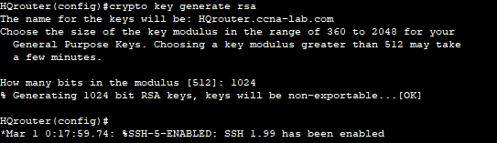
Next, the author set up SSH connections over the VTY line, first the author changed the hostname to Router, then configured the domain for the router to ccna-lab.com. Next, the author set up the encryption key method as RSA and key bit size [11].

Next, the author set up the databases name of admin and a password of C0Ffee_C@puLu5 with privilege 15 giving the user administrator rights [11].
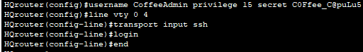
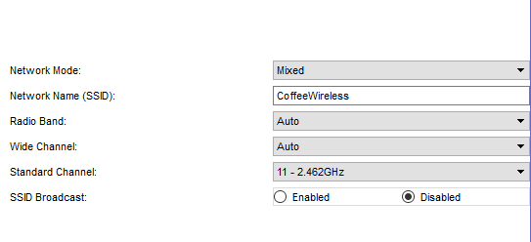
After configuring the HQ router the author began to set up the security on the wireless router by setting the hostname to Coffee Wireless, setting the standard channel to 2.462Ghz and disabling the SSID broadcast to help lower chances of unauthorised persons connecting to the network. Next, the author set the security mode to WPA2 enterprise with AES encryption and a shared password of WirelessCoffee.
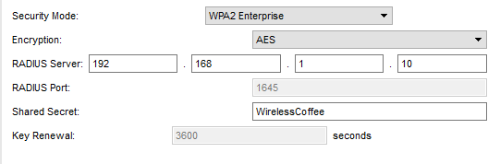

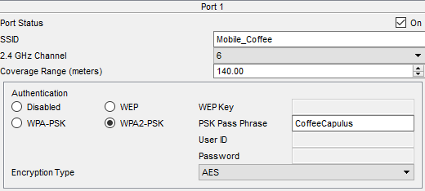
Next, I ensured that employees could securely connect to the company access point setting up a radius of 140 meters and a password of CoffeeCapulus.
Next, the author set up the email firewall to only allow emails to come from port 995 and be sent from port 465, to help ensure that emails are sent and received securely.
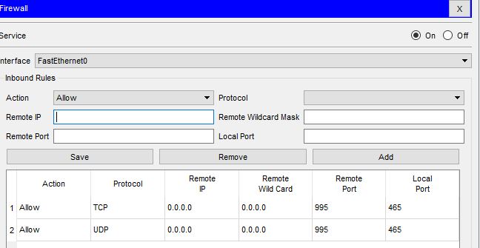

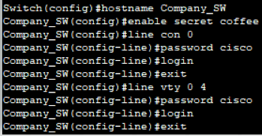
Next, the author began to Configure the security on the company's switch by setting up an encrypted password, a console line password and a virtual teletype password to ensure only those with the password can access the company's switch.
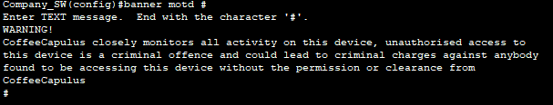
Next, the author set up a message of the day banner on the company switch to act as a deterrent by warning potential intruders of the consequences of accessing the company's switch without the permission of the company.

After this, the author set up session timeout on the switch for both console line connections and virtual teletype connection to again ensure that if correct measures are not followed then the chance that they are capitalized on are as low as possible.
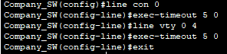
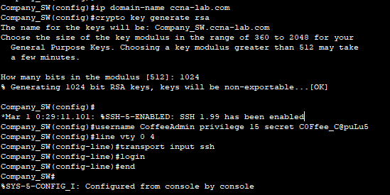
Finally, the author configured the switch to allow SSH connections over the VTY line, the first step this time was to set the domain for the router to ccna-lab.com. Next, the author set up the encryption key method as RSA and key bit size to 1024 [11]. Next, the author set up the databases name of CoffeeAdmin and a password of C0Ffee_C@puLu5 with privilege 15 giving the user administrators rights [11].

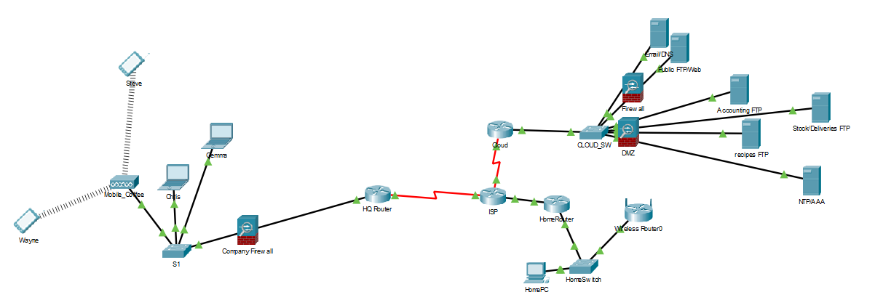

The author has included firewalls to help restrict the access to the company's sensitive information such recipes and financial files to those with the correct IP addresses, port numbers and other credentials. The use of Virtual private network will help ensure that the company can view the files well working at home. The author also included a Demilitarized zone firewall to allow the public and other companies to contact the CoffeeCapulus and view files that the company wish to allow anybody to view.

Other Passwords
- Cloud Router and switch password- cloud
- Cloud ssh password (Switch and Router)-Cl0Ud_P@55
- All VTY and Console passwords- cisco

Appendix Four
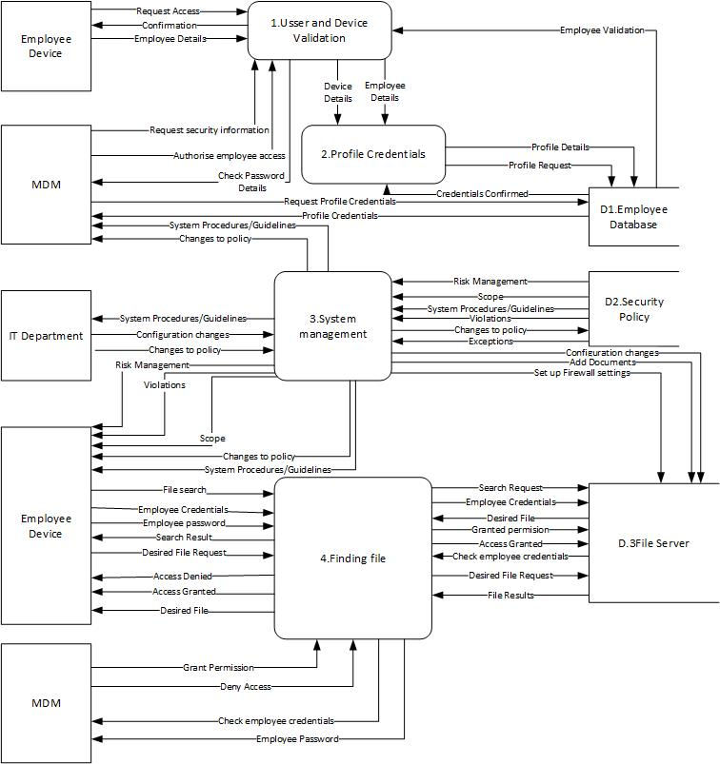

Appendix Five

BYOD Advantages and Disadvantages

Advantages
- Lower costs- when reading texts on this topic the savings possible by allowing employees to use their own devices. Reasons for the savings range from TrainingZONE that’s two main reasons are not “have to buy any devices, that represents significant savings” [20]. TrainingZONE second reason it saves the company money is that employees are more likely to take care of device if they owned it [20].

- Reduced support and training costs [21]. The employee will need less training to and support to navigate a device that they are familiar with, however, if somebody has used iPhones for a prolonged period then been handed an android device tell need training and support to find settings and specific apps.

- Productivity as mentioned by Bennett [5]. If somebody is familiar with the device, then they’ll spend less time navigating the device to find a specific bit of data and more time completing the tasks. Cisco themselves found that by introducing BYOD their employee’s productivity increased by about 15% [6].

- Flexibility on work hours, where employees can do their work at home or outside the office is another key advantage [22] and links in with increasing productivity according to Cisco who cite flexibility as the reason for their increase in productivity [6].

- Always connected [16] we bring our smart devices almost anywhere we go meaning that it is far more likely that an employee will see something and respond faster to important questions if the notification or alert is on their device when they are scrolling through Facebook or Twitter.

- Better balance between work and personal life according to staff base, one device will allow the employee to switch effortlessly between work and personal when required [23], the ability to work from home if required, closely tied to flexibility if a staff member can effectively build a schedule between family and friends as well as work. Instead of being stuck in the office allowing for a greater balance means happy staff, enthusiastic staff who will be more likely to be productive, and follow the rules set out.
Disadvantages
- Loss or theft of devices is a serious worry for companies as a staggering number of people have little to no security features on their phones according to Bennett about 20% of smartphones are stolen and many don't have security [5].

- Employee investment could have resentment toward BYOD according to Minno [24] this could be because not all people want to high tech supper computers some people still just want a bog-standard device that makes calls and text people.

- Could lead to an un-level “playing field” [24] as many people may not be able to afford top of the range devices or older generation who didn’t grow up with the technology and may have little experience with smart devices and are still using an old Nokia. Leading to those with the top of line devices and knowledge of using smart devices an unfair advantage of gaining promotion and climbing the corporate ladder well those without stuck at the bottom.
- The conflict between Personal privacy and company control is a thin line to walk between protecting company information and making sure not to intrude on employee's privacy
- Inappropriate behaviour from one employee to another could be a growing concern in network security as mentioned in The Management of Network Security [1]. Though it doesn’t directly mention BYOD the author would argue that if allowing employees access to each other's personal contact details for work purposes then you run the increased risk of anything from texting to full-on bullying or harassment.

- Risk of malware infections are something that is most probable to happen, every day we run the risk of accidentally installing malicious software or going to a dangerous website. There are numerous forms of malicious software including viruses, worms, trojans and ransomware to name a few and according to Singh "malware downloads not only infects the device itself; it also can easily spread to an entire organization's network within a few second".

- Everchanging Staffing the comes with running a big corporation means that staffing will forever be changing leaving the IT department with the enormous task of ensuring new employees can get access quickly and prevent former employees from accessing sensitive information anymore.
- Automatic backups of data to a cloud-based storage company are common amongst devices and users or device been synchronised with another device and copy's files over automatically according to publishing by the UK government [16].

Considerations
Although many of the main drawbacks to BYOD is the security risks that come with it from devices being lost to employees selling their credentials or using them to access sensitive information. However, one of Cisco’s point on BYOD and the security of it that should be up for consideration is that by ignoring and not developing a security policy you run security risks as employees will still use their devices to complete works tasks anyway but won’t have any guidelines or procedures to follow leave a company open to attack [6]. So in the long run, although security is something that must always be a top of any company's plans is it safer to implement BYOD and be able to give their employees guidelines and procedures that they must follow rather than ignoring it and running the risk that they use their devices anyway and all the security concerns listed above come true anyway.

References

References

[1] | H. Carr, C. Snyder and B. Bailey, The Management of Network Security, New Jersey: Pearson, 2010, p. 1.
[2] | HM Government, "NATIONAL CYBER SECURITY STRATEGY 2016-2021".
[3] | J. Vickerman, "Bring Your Own Device to Work," Risk Management, vol. 60, no. 1, pp. 38-41, Jan/Feb 2013.
[4] | G. Disterer and C. Kleiner, "BYOD Bring Your Own Device".
[5] | L. Bennett, "Bring Your Own Device," ITNow, vol. 54, no. 1, pp. 24-25, 2012.
[6] | Cisco, "Bring Your Own Device (BYOD)," 2014. [Online]. Available: https://www.cisco.com/c/dam/en_us/about/ciscoitatwork/borderless_networks/docs/Cisco_IT_Insight_BYOD.pdf. [Accessed 07 03 2020].
[7] | J. Wade, "Technology isn't The Problem, People are," Risk Management, vol. 60, no. 1, p. 40, 2012.
[8] | B. Mike , "What is spoofing," BBC, 09 09 2010. [Online]. Available: http://www.bbc.co.uk/webwise/guides/about-spoofing. [Accessed 07 03 2020].
[9] | A. Leung, "A mobile device management framework for secure service delivery," Information Security Group, Surrey, 2008.
[10] | M. &. e. Khasawneh, "A Survey on Wi-Fi Protocols: WPA and WPA2," in REcent Trends in Computer Networks and Distributed System Security, Trivandrum, 210.
[11] | Cisco, Introduction to Networks, Indianapolis: Cissco Press, 2013, pp. 355-358.
[12] | NLC, "BYOD Acceptable Use Policy," [Online]. Available: https://www.nlc.org/sites/default/files/users/user118/Handout_for_app--BYOD_Acceptable_Use_Policy_Template%5B1%5D.pdf. [Accessed 16 03 2020].
[13] | K. J. Smith and S. Forman, "Bring Your Own Device—Challenges and Solutions for the Mobile Workplace," Employment Relations Today , vol. 19, no. 1002, pp. 67-73.
[14] | S. Bacik, Building an Effective Information Security Policy Architecture, Boca Raton: Auerbach Publications, 2008.
[15] | M. Gregg, CEH Certified Ethical Hacker, Indianapolis: Pearson, 2017.
[16] | UK Goverment, "BYOD Guidance: Executive Summary," [Online]. Available: https://assets.publishing.service.gov.uk/government/uploads/system/uploads/attachment_data/file/360959/BYOD_Guidance_-_Executive_Summary.pdf. [Accessed 16 03 2020].
[17] | Miradore, "Choose a plan that works for you," Miradore, [Online]. Available: https://www.miradore.com/plans-pricing/. [Accessed 13 03 2020].
[18] | Miradore, "Miradore Online Plans & Features," [Online]. Available: https://2bdmle2czne0223zo91auv2y-wpengine.netdna-ssl.com/wp-content/uploads/2020/02/miradore_features_by_platform_02_2020.pdf. [Accessed 13 03 2020].
[19] | Miradore, "Miradore," Miradore, [Online]. Available: https://www.miradore.com/. [Accessed 26 03 2020].
[20] | TrainingZONE, "The Advantages and Disadvantages of BYOD (Sep 13)," 17 09 2013. [Online]. Available: www.cedma-europe.org/newsletter%20articles/TrainingZONE/The%20Advantages%20and%20Disadvantages%20of%20BYOD%20(Sep%2013).pdf. [Accessed 16 03 2020].
[21] | P. Adams, "The advantages and disadvantages of BYOD," 28 10 2014. [Online]. Available: https://www.fieldservicenews.com/blog/advantages-disadvantages-byod. [Accessed 17 03 2020].
[22] | investintech, "The Pros And Cons of BYOD," [Online]. Available: https://www.investintech.com/resources/blog/archives/3513-the-pros-and-cons-of-byod.html. [Accessed 17 03 2020].
[23] | S. K. Lockley, "6 Advantages of BYOD (Bring Your Own Device)," Staffbase, [Online]. Available: https://staffbase.com/blog/six-advantages-byod-bring-your-own-device/?utm_campaign=dsa_search_dynamic&utm_medium=ppc&utm_source=google&utm_term=&gclid=Cj0KCQjwx7zzBRCcARIsABPRscOcds50av0Eh-Fe0ic6-y5PHBdPmHsPZg-LUhUlObNLloKYVo9xkpoaAqUAEALw_wcB. [Accessed 16 03 2020].
[24] | Minno, "Bring Your Own Device (BYOD) Policies are a Bad Idea," Minno, [Online]. Available: https://www.minnotablet.com/wp-content/uploads/2017/12/5-Disadvantages-of-BYOD.pdf. [Accessed 18 03 2020].

marking criteria and Student FEEDBACK

This section details the assessment criteria. The extent to which these are demonstrated by you determines your mark. The marks available for each criterion are shown. Lecturers will use the space provided to comment on the achievement of the task(s), including those areas in which you have performed well and areas that would benefit from development/improvement.

Common Assessment Criteria Applied (Assignment 1) | Marks available | Marks  awarded
1. Engagement with Literature Skills
Extent of research and/or own reading, selection of credible sources, application of appropriate referencing conventions.
Your work include appropriate articles, though more current ones could be used. Key concepts discussed. (Grade mark: 73.33%) | 15 | 11
2. Knowledge and Understanding Skills
Extent of knowledge and understanding of concepts and underlying principles associated with the discipline.
You have displayed the relevant knowledge and understanding (Grade mark: 73.33%) | 15 | 11
3. Cognitive and Intellectual Skills
Analysis, evaluation and synthesis; logic, argument and judgement; analytical reflection; organisation of ideas and evidence
You have done an abstract, very good introduction. Your report discuss all the relevant areas for this assignment; policy, DFD, network design, etc. Very good conclusion. Very detailed DFD diagram. (Grade mark: 75.00%) | 40 | 30
4. Practical Application Skills
Deployment of methods, materials, tools and techniques; application of concepts; formulation of innovative and creative solutions to solve problems.
You have a working design that implement a number of countermeasures within your core devices. It would be good if you had considered redundancy but it is not mandatory for this level. You have also configured rip on your routers. (Grade mark: 85.00%) | 20 | 17
5. Transferable Skills for Life and Professional Practice
Attributes in professional practice: individual and collaborative working; deployment of appropriate media; presentation and organisation.
Your work could do with some shorter paragraphs; avoid those long ones. Spell out all acronyms use first time. (Grade mark: 65.00%) | 10 | 6.5

Assignment Mark (Assessment marks are subject to ratification at the Exam Board. These comments and marks are to give feedback on module work and are for guidance only until they are confirmed. ) | Late Submission Penalties (tick if appropriate) |  | 76%
 | Up to four weeks late |  | 76%
 | First Attempt? |  | 76%

