
Management communication in the Workplace
Module Assignment Submission
Student Name: | Carla Tonkin
Student Number: | 2329147
Module No: | BMSK4013
Module Title: | Management communication
Statement of Confirmation of Authenticity
By the act of making this submission, the student declares that this is the work of the student named above. The work has not, in whole or in part, been knowingly presented elsewhere for assessment, or where assessment has been built on a previous assessment, this has been identified. Where materials have been used from other sources it has been properly acknowledged. If this statement is untrue, the student acknowledges that an assessment offence has been committed.
Attention is drawn to the plagiarism and unfair practice policies of both the University and of ILM.

Contents page
Page No.
Introduction....................................................................................................3
Communication Models..................................................................................3
1.communication cycle....................................................................................3
2.shannon & weaver........................................................................................4
3. Schramm......................................................................................................5
4.berlo .............................................................................................................6
Models in my workplace.................................................................................7
Importance of Tone, language, and formality in the workplace......................8
Range of communication approaches used in my workplace..........................8
Recommendations to improve communication in my workplace....................9
Motivation Theories........................................................................................10
Motivation.......................................................................................................10
Intrinsic v Extrinsic Motivation.........................................................................11
Relating a motivation model to my workplace.................................................11
Factors the affect motivation in the workplace.................................................12
Resolving Conflict...............................................................................................12
Reflection on my communication......................................................................13
Conclusion..........................................................................................................14
References..........................................................................................................14
Appendices
Appendix A – PDP...............................................................................................16
Appendix B – Questionnaire...............................................................................17

Introduction
The present study investigates several communication models, including Shannon & Weaver, Schramm, Berlo, and the communication cycle. It talks about how these models work in the workplace and stresses the importance of formality, language, and tone. It also discusses various workplace communication strategies and provides suggestions for development. It also explores theories of motivation, identifying between extrinsic and intrinsic motivation, and applies them to the context of the workplace. There is also discussion of the variables influencing motivation and dispute resolution techniques.

Communication Models

Communication cycle
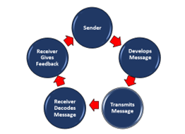
The process through which information is transferred between a sender and a recipient is commonly referred to as the communication cycle. There are usually multiple steps involved, such as encoding, transferring, receiving, decoding, and providing feedback.
The cycle of communication begins with a sender who has a message to share, and it proceeds like an information transmission. They transform this communication into words, gestures, or symbols, then express it to a recipient via a selected channel. After that, the recipient decodes the message and recognises its meaning. Many factors, such as background (the circumstances) and noise (distractions), have an impact on this process. After the message is understood, the recipient responds, completing the communication cycle. Each conversation in this cycle aims for mutual understanding between the sender and the recipient. The Communication Cycle is a six-step process that can help you to tailor and refine your messages.](argyle1972)
The good thing about communication cycle is that the communication cycle improves the understanding and quality of messages. Feedback is possible to ensure awareness and address any issues. It also helps in determining potential obstacles to effective communication. By following this cycle, people can modify their messages as necessary and improve relationships by communicating clearly. It increases efficiency and saves time.
Culture has an important impact on the communication cycle because it influences the ways in which people encode, decode, and understand messages. A role is played by various languages, word choices, and nonverbal cues.

Shannon & Weaver
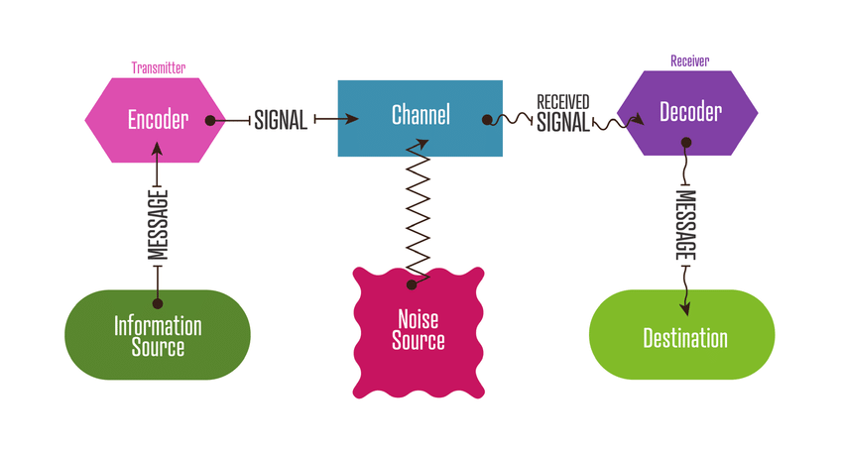
(Shannon and Weaver’s Model, 2024)
Claude Shannon and Warren Weaver created the Shannon-Weaver model in 1949. It is a mathematical understanding of communication that highlights the technical features of communication.
To ensure effective communication, the Shannon-Weaver model highlights how crucial it is to reduce noise and increase the signal-to-noise ratio. It is commonly used in information theory and telecommunications to understand message transmission and reception, especially in digital communication systems.
Claude Shannon and Warren Weaver created the Shannon-Weaver model of communication, which describes the sequential steps involved in message transmission. The transmitter transforms the message into a suitable signal for transmission across a selected channel. It starts with the information source, where messages arrive. This signal passes via the channel—a wire or the air, for example—until it is picked up by the receiver. After arriving at its destination, the message is read by the designated recipient. Nevertheless, noise, or interference or disturbances, may occur during this process and impact the message's accuracy or clarity.

Schramm

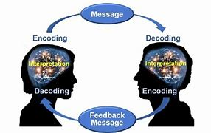
(Chakravarty, 2016)

The Schramm model, proposed by Wilbur Schramm in 1954, is a communication model that illustrates the process of communication between a sender and a rec According to the Schramm communication model, communication is an ongoing exchange that takes place between a sender and a recipient. It starts with the creator of the message, the source, who encodes ideas or thoughts into a message. These concepts are converted by the encoder into a language or set of symbols that can be understood. The message the actual material being conveyed—then proceeds by a selected medium, which could be written, spoken, or electronic. The message is decoded after it reaches the recipient, who then tries to fully understand its meaning.
Numerous elements, such as the receiver's experiences, beliefs, and cultural background, influence this understanding. The loop is finally closed by feedback, which comes from the recipient's reaction to the message and gives the sender useful information for future correspondence.
The Schramm model of communication, like any communication model, has its advantages and limitations. The Schramm communication model outlines the roles of the sender, message, channel, receiver, and feedback to provide an understandable structure. Its simplicity makes it easier to understand basic communication techniques and underlines how crucial feedback is to equal understanding. However, its basic representation oversimplifies the context and noise sensitivities in real-world communication processes. Although the model has limitations, it is nevertheless useful for basic communication conversations. However, for a deeper understanding of communication issues, more complete theories need be included to the model.

Berlo
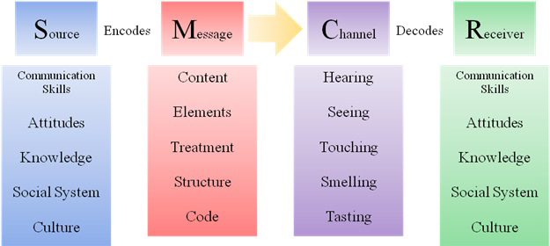
(BERLO’S SMCR MODEL of COMMUNICATION, 2010)

David Berlo presented his 1960 proposal, the Berlo's Communication Model, which offers a framework for understanding the communication process.
The four main parts of Berlo's communication model are the source, message, channel, and receiver. The person who first created the message and encoded ideas or thoughts into a form that could be shared is known as the source. The information or content being communicated from the source to the recipient through a variety of channels is expressed in the message itself. On the other end, the receiver attempts to understand the message by decoding and interpreting it. These parts function within an interactive structure in which feedback—that is, the receiver's reactions or responses—closes the loop and allows the sender to assess how well their communication was received. This model emphasises the complex interactions that occur between senders and recipients, emphasising the value of knowledge, feedback, and clarity in communication exchanges.
The feedback focused Berlo Communication Model is easy to understand and can be used to a variety of communication situations. However, while its simplicity may ignore the complex nature of real-world communication. Moreover, the model's insufficient attention to context ignores the significant impact that circumstances, social, and cultural elements have on communication. Even with these drawbacks, Berlo's model is still a useful place to start when learning about communication dynamics, if it is complemented by other ideas and viewpoints to take into consideration the complicated nature of interactions with others.

Models in my workplace
As it is straight and technical, the Shannon and Weaver model of communication is not suitable for the retail industry. It focuses on a single method communication, lacks a feedback loop, and ignores nonverbal signals and personalised encounters. This model does not address the instant feedback, emotional intelligence, handling of various channels, and dynamic interactions that retail communication requires. A model more suited to representing the intricate nature of communication in a retail setting would be the model of transaction, which incorporates feedback and continuous transactions.
Although Berlo's SMCR model offers a helpful basis for understanding the elements of communication in a retail environment, it must be combined with knowledge of nonverbal indications, feedback, and the emotional components of consumer encounters. In a retail setting, it might be more successful to combine Berlo's model with components of the Transactional Model for an approach that is more

Importance of Tone, language, and formality in the workplace
Formality in the workplace, especially in structured situations, establishes boundaries and defines relationships by demonstrating professionalism and respect using formal language. It makes sure that, for example, formal language is used in meetings, reports, and emails to clients, and that, in less formal team interactions, a more informal tone is used. In addition to maintaining workplace standards and decorum, formality helps to ensure that communication is courteous and professional, particularly when it comes to written documents and official communications.
Successful interaction in the workplace requires language adaptation for various audiences. When speaking with coworkers, be straightforward and professional in your written communication. Supervisors should speak in a polite, formal manner, staying on point and avoiding unnecessary jargon. Use polite, professional language and provide clear explanations of technical vocabulary while speaking with clients. Give new employees encouraging, clear directions and refrain from assuming knowledge. Use inclusive and culturally aware language while working with different teams; stay away from slang or phrases that may not be understood by everyone. Formality plays a significant role in maintaining efficiency in the retail sector. It can be used to set a polite and professional tone in customer emails and interactions, write reports and communications in a clear and respectful manner, and discuss sales targets and shop standards in formal meetings.

Structure with different audiences

A retail store has a structured team to keep things running smoothly. The store manager leads everyone, assistant managers handle specific tasks like sales and inventory, and shop assistants help customers, stock shelves, and manage sales. This setup ensures everyone knows their role and can work together effectively. Structure is very impotent as setting clear expectations and support and maintaining structure helps make sure that jobs are organised employees know what's expected of them and everything runs smoothly it can also lead to increased productivity and overall success while structure in the workplace has many advantages but can also make things difficult it can make things to strict and not leave any room for change its very impotent to have a good balance and being able to adapt when needed.

Content with different audiences

Understanding different audiences' identities and interests is necessary when producing material for them. Determine their requirements, desires, and online socialising. Make sure your material speaks directly to each group by changing the wording, tone, and images, as necessary. Ensure that each audience group finds value and connection in your material. Over time, test, learn, and improve your strategy while keeping your brand messaging consistent.

Different modes of communication with different audiences and situations

It is important to change your communication style when speaking to various audiences and in different situations to effectively communicate your message. Written communication via emails, reports, or formal letters may be suitable in formal or professional situations, such as business meetings or academic they work well as they provide a professional way to communicate vital information however they can sometimes be to formal which may lead to misunderstanding or lack of personal touch.
presentations. Face-to-face or phone chats may be more effective in casual or interpersonal contacts for establishing trust and communicating details although they can be good for connecting in person but can be time consuming with phone chats, they are convenient but lack in the personal connection.
Videos, charts and graphs, and presentations are examples of visual aids that help improve understanding and engagement when delivering complicated information with larger audiences. In addition, digital platforms like websites, blogs, and social media provide flexible means of connecting with a range of audiences and enable vibrant and active conversations. Knowing the purpose of your communication, the audience's preferences, and the situation will help you choose

Range of communication approaches used in my workplace.
There are several models of communication used in my workplace.
Verbal
Type | Use in my workplace | Advantages | Disadvantage
One to one | Enables us to ask questions and get answers | Immediate feedback | Misunderstanding
Phone | Better understanding as in you can hear the tone on their voice | Personal connection | Distractions
Meetings | Be open with issues in the workplace | Get ideas | No paper trail

Written
Type | Use in my workplace | Advantages | Disadvantage
email | They can be used to get a message quick | convenience | miscommunication
Text message | To cover shifts | Written record | tone
Letters | To give a warning or information | Personal touch | Time it takes to be delivered

Recommendations to improve communication in my workplace.
Set clear expectations clearly communicate the goals, deadlines this will help to make sure everyone is on the same page and understands what is expected of them also maintain regular communication with all staff as in check ins or meetings to keep lines of communications open provide platforms for employes to share ideas ask questions and give feedback this can be done through visual meetings chat platforms.
By following these practices, you can enhance communication in our workplace leading to increased sales and productivity

Motivation
The desire or drive that pushes people to pursue and accomplish their goals is known as motivation.
In the retail sector motivation is what drives the employees to do their absolute best and work to their best ability motivation will keep them happy and productive it involves understanding what inspires them.
The processes that start, stay, and maintain behaviour that is goal-oriented are referred to as motivation. It includes the physical, emotional, social, and mental processes that drive behaviour and provide it with guidance towards the accomplishment of specific goals. Motivation can come from rewards from without, from within, or from a mix of the two. It is a major factor in motivating people to pursue and keep up their efforts to accomplish their goals.

Intrinsic v Extrinsic Motivation
Intrinsic motivation comes from within like finding joy in their work it is what makes them happy while extrinsic is the type of motivation that comes from external factors such as bonuses or acknowledgment of their hard work with a balance of both.

Motivation Theories
Theories for motivation help us understand what motivates people to behave and maintain certain behaviours throughout time. Listed below are a few of the most known theories:

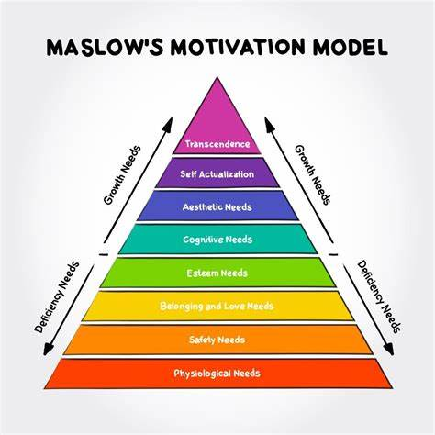
‌ (Miner, 2008)
Maslow's model is like a pyramid that shows different needs people have. At the bottom are basic needs like food and shelter as we move up there re needs for safety love esteem and at the top achievement. It's about how people are motivated by fulfilling these needs in a specific order for example someone starting their new job at first, they may focus on earning more money to cover basic needs like rent or food. As they feel more secure, they might want to find friendship with coworkers with time recognition at work they could aim for promotions or praise (esteem) finally they might pursue personal development within their role (achievement).

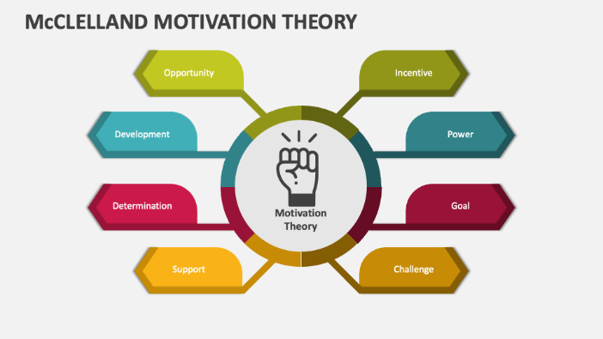
McClelland's theory of needs
(Pardee, 2024)
Motivation among humans is motivated by three primary needs, according to McClelland's Theory of Needs, sometimes referred three Needs Theory: the need for success, the need for connection, and the need for power. The desire for power pushes people to influence and lead others, the need for achievement pushes people to excel and seek out difficult activities, and the need for affiliation pushes people to seek out friendly and personal connections. Recognising a person's primary need can improve motivation and performance, especially in work environments, and assist project their behaviour.

McGregor's X – Y Theory
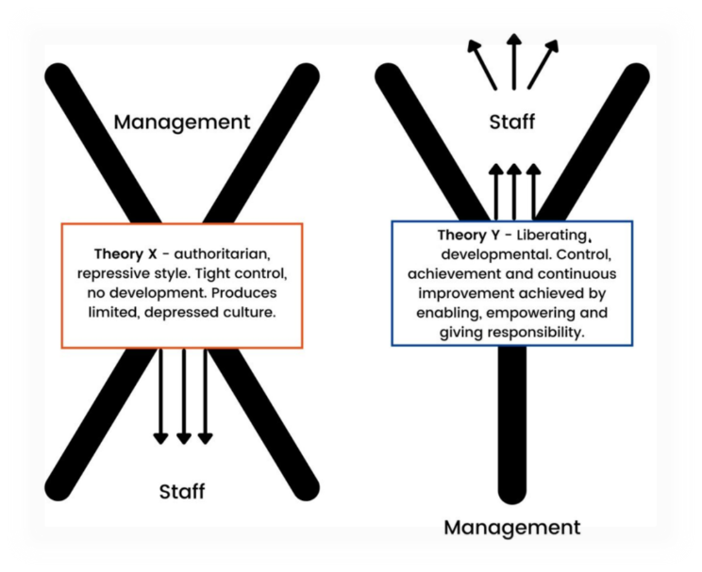
(McGregor, 1960)
The X-Y by McGregor Two views of workers by managers are explained by theory. According to Theory X, employees need close supervision, detest their jobs, and are mostly motivated by financial gain. According to Theory Y, employees are responsible, self-motivated, and like their jobs. While managers who follow to Theory X are more ruled by those who adhere to Theory Y are more encouraging and have more faith in their staff members' ability to work on their own.

Relating a motivation model to my workplace
Combining many models can lead to effective motivation in a retail setting. A sense of freedom, skill development, and team support should be encouraged (Self-Determination Theory); basic needs like fair wages and safe conditions should be met (Maslow’s Hierarchy); and factors that prevent dissatisfaction and increase satisfaction, like good working conditions and recognition, should be addressed. Establish clear, achievable targets and clearly connect efforts to rewards. Managers can establish a creative and effective work environment by understanding and addressing the various demands of their employees.

Factors the affect motivation in the workplace
Factors that affect motivation in the workplace include fair compensation, safe and comfortable working conditions, recognition and appreciation, opportunities for growth and advancement, a sense of autonomy and control over one's work, supportive management, clear and achievable goals, and a positive team environment. Meeting these needs helps employees feel valued and engaged, which boosts their motivation and productivity.

Resolving Conflict
To overcome conflict in the workplace, it is important to listen to all sides and understand their points of view. Seek for common ground, promote open communication, and put a higher priority on working together than casting blame. Once a solution has been reached, make sure that everyone is aware of their roles and that the problem has been carefully handled. Also, make sure that the solution is being carried out. (Systematic Literature Review on Emotional Intelligence and Conflict Management, 2022) There is also the suggestion that conflict management styles can help to resolve conflicts and that emotional intelligence can be a key means to resolving conflict.

Reflection on my communication
On my reflection of myself at my workplace i will be focusing more on my confidence and having more structure I got this information by handing out a questionnaire to my work colleagues I've taken all feedback on board and will make improvements which will then help me become a better manager
Questionnaire included (see appendix B.)
I've also included a PDP (see appendix A.)

Conclusion
motivation and communication are crucial. Effective communication promotes trust and teamwork by ensuring that everyone is aware of the duties, goals, and difficulties. In the meantime, motivation spurs workers to give it their all, increasing output and generating a happy workplace. Together, motivation and communication empower workers, boost output, and create a more successful and joyful work environment.
References
McGregor, D. (1960). The Human Side of Enterprise. McGraw-Hill
(The Social Psychology Argyle 1972 - Bing, 2024)
Shannon and Weaver’s model. (2024). Oxford Reference
.
Chakravarty, B. (2016, June 27). Schramm’s Model of Communication. Academia.edu. https://www.academia.edu/26534964/Schramms_Model_of_Communication

BERLO’S SMCR MODEL OF COMMUNICATION. (2010, January 23). Communication Theory. https://www.communicationtheory.org/berlos-smcr-model-of-communication/

Miner, J. B. (2008). Role Motivation Theories. In Routledge eBooks. Informa. https://doi.org/10.4324/9780203135778

Pardee, R. L. (2024). Motivation Theories of Maslow, Herzberg, McGregor & McClelland. A Literature Review of Selected Theories Dealing with Job Satisfaction and Motivation. Ed.gov. https://eric.ed.gov/?id=ed316767
‌
Systematic literature review on emotional intelligence and conflict management. (2022). Journal of Global Scholars of Marketing Science. https://www.tandfonline.com/doi/abs/10.1080/21639159.2020.1808847
‌

‌

‌

‌
Appendices
Appendix A: Personal Development Plan (PDP)
 | Area | Areas to improve | goal | Specific actions you need to improve | Support and resource do you need to achieve your goal | When do you plan to achieve it
1 | Listening skills | Pay more attention | Understand better | Focus completely | Regular reflection | July 24
2 | Body language | Try practising good posture | Be confident | Eye contact | Professional coaching | Sep 24
3 | Handling feedback | Don't be defensive | Handle effectively | Reflecting on the feedback | Training workshops | 2 weeks
4 | effectiveness | Improve listening skills | Improving my communication effectiveness | Stay updated on industry trends, | Online blogs and articles | 5mths
5 | Enhance marketing skills | Enrol on a course | Complete 2 online courses | Computer skills | Seek guidance from digital marketers | 6 mths
6 | Verbal communication | Nervous talking in front of Crowd | Be confident in speaking | Speak clearly | Video myself talking | Jan 25

.

Appendix B: Communication Questionnaire
(Rate on a 5-point scale: 1 represents uncertain, and 5 represents very clear.)

1. Listening
How well do you think i listen?
1 2 3 4 5

2. Efficiency
how efficient do you feel you are at completing tasks and achieving goals at work?"

1 2 3 4 5

3. body language
How confident do i come across with my body language
1 2 3 4 5

4. feedback
How well do i take feed back
1 2 3 4 5

5.written communications
Do my written communications come across professional
1 2 3 4 5

I appreciate you taking the time to comment on my communication style. Your observations are useful and will improve communication procedures.

