

Student name: Emilia Dunguiongue
Student ID:2328855
Module code: BMHP5015
Lecturer name: Caroline Salami

Module name: CHANGEMAKERS: BUILDING PERSONAL BRAND FOR SUSTAINABLE EMPLOYMENT

Table of Contents
1. Introduction
2. Reflection on Unit 1: Ambition, Motivation and Boundaryless Careers
2.1 Screenshot of Boundaryless Career Brainstorm
3. Reflection on Unit 2
3.1 Screenshot of Forum Post on Networking Definition
4. Reflection on Unit 3
5. Reflection on Unit 4
6. Conclusion
Reference List

1. Introduction
Developing a personal brand for sustainable employment requires a clear purpose, consistent values, and a visible online presence (Schawbel, 2019). This assignment reflects on four module units and explains their contribution to my development in health and social care.
The units strengthened my understanding of goal setting, emotional intelligence, and career development in changing care environments (Clutterbuck et al., 2020; Matthews et al., 2019). For example, structured goal setting supports tasks such as improving shift handovers, while emotional intelligence helps respond appropriately to patients showing anxiety or distress.
The reflection examines how I improved leadership, digital visibility, and engagement with professional networks to support progression (West et al., 2015). For instance, platforms like LinkedIn allow healthcare workers to demonstrate competence and connect with mentors.
The assignment also considers global perspectives such as social prescribing, which links clinical care with community resources to improve patient wellbeing (NHS England, 2019). Examples include referring patients to exercise groups or community activities to reduce isolation.
Overall, the reflection shows how theoretical learning has been applied to practical strategies for sustained growth in care settings.

2. Reflection on Unit 1: Ambition, Motivation and Boundaryless Careers
The foundational concepts have been introduced in Unit 1, which evaluated my understanding of career development, motivation and ambition in health and social care. The topics in Unit 1 have covered the aspects of ambition along with its effective role in success. However, it also demonstrated the psychological drivers behind the goal-setting involving the ‘Pink’s Theory of Autonomy, Mastery and Purpose’ and the efficient nature of emotional intelligence and boundaryless careers.
I have realised through lectures and activities that ambition refers to a desire and strategic force. Furthermore, ambition significantly fuels the resistance and persistence extensively (Maddux, 2016). Similarly, Roy (2018) articulated that ambition in terms of desire often be directed toward meaningful objectives. I have developed a relevant understanding of processing visualising career progressions during classroom discussions including shift from care assistant to supervisor often assisting in clarifying long-term aspirations.
I have explored the role regarding motivation within goal settings from the lectures based on Unit 1. I have learned that motivation effectively sustains effort over time and assists in focusing attention on goal-relevant behaviours. Hence, it significantly connects with the ‘Locke and Latham’s Goal Setting Theory’. This theory demonstrates the significance of commitment and clarity in attaining objectives (Ab Rahman, 2025). Moreover, the ‘Pink’s Framework of Autonomy, Mastery and Purpose’ has been evaluated within me in a detailed manner. I have effectively reflected on my own autonomy in selecting a career within social care, which is supported by my personal values and family.
The concept regarding boundaryless careers has expanded my opinion on professional development. I have learned that the careers within health and social care are highly flexible with gig economy models including per-diem nursing that offers diverse opportunities. Furthermore, emotional intelligence as articulated by Salovey, Caruso, and Mayer (2004), contemplates practitioners for managing emotions along with delivering patient-centred care. Hence, I have efficiently connected the concerned aspect to ‘Johari’s Window’ that illustrates the process of self-awareness in improving professional competency and interpersonal relationships.

2.1 Screenshot of Boundaryless Career Brainstorm
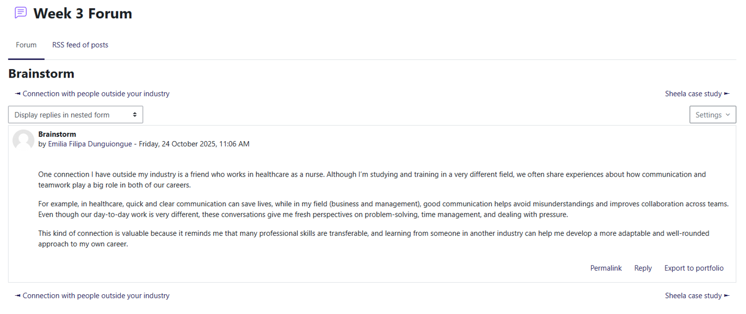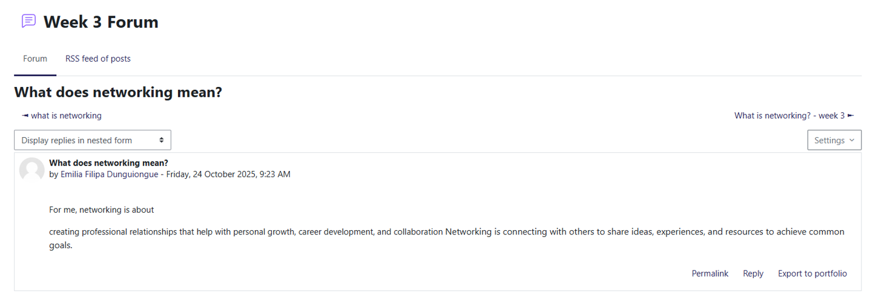
Figure 1: Boundaryless Career Brainstorm
(Source: Extracted from Week 3 Forum)
Figure 1 highlights the screenshot related to boundaryless career brainstorming. The above screenshot demonstrates my level of contribution to the classroom forum based on boundaryless careers. I have explored the gig economy roles as well as their relevance within healthcare in a detailed manner.

3. Reflection on Unit 2
Unit 2 has evaluated my level of understanding on the process of networking as well as hierarchical structures that demonstrate social care and global health systems. The topics covered in Unit 2 involve Social Prescribing, Making Connections, Network Society and Bureaucratic Hierarchy. The concerned aspects have represented the dynamic interplay between informal relationships and formal structures within professional practice.
I have learned from Unit 2 that networking articulates with the exchanging information with a strategic focus that develops trust, enhances decision-making and facilitates collaboration (Gibson, Hardy and Ronald, 2014). Furthermore, networking primarily enables the professionals within health and social care to mobilise community resources, share vital patient updates and coordinate services (Khatri et al., 2023). Hence, this aspect connects with ‘Castell’s Theory of the Network Society (2000)’, that evaluates the power regarding digital communication in reconducting the social structures.
The concept regarding bureaucratic hierarchy is defined as multilayer systems, which ensure uniformity and control (Zeitlin, 2023). Hence, it assisted me in appreciating the clarity and stability that have been provided by bureaucratic hierarchy within large organisations. However, I have also recognised its drawbacks including reduced flexibility and slow decision-making. As a result, the concerned duality is common within health and social care, within which hierarchies offer accountability, whereas the networks provide responsiveness and adaptability.
The ‘Connecting People’ model is especially insightful as it illustrates the process of the practitioners to support the people with mental health difficulties to develop social capital (Webber et al., 2021). Presently, I have understood that demonstrating connections is a professional duty along with the therapeutic intervention, which promotes wellbeing and combats isolation.
Social prescribing has emerged as a transformative approach, which connects the individuals towards community-based support and addresses social determinants of health (Morris et al., 2022). The concerned model evaluates the principles regarding ‘Universal Personalised Care’ along with supporting individuals with long-term conditions, complex social requirements and low-level mental health problems. Overall, my understanding regarding social care and global health has been demonstrated by Unit 2 through revealing the process of hierarchies and networks complementing and coexisting with each other.

3.1 Screenshot of Forum Post on Networking Definition

Figure 2: Forum Post on Networking Definition
Figure 2 articulates the forum post related to the definition of networking. I’ve shared the meaning of networking along with articulating its importance to multidisciplinary collaboration extensively.

4. Reflection on Unit 3
Topics 1 to 4 has been elaborated in Unit 3, that effectively articulated my understanding regarding digital professionalism and career development within health and social care. The themes including ‘Open Doors’, ‘Me.com’, ‘Identifying Career Opportunities’ and ‘Creating Your Own Luck’ have contemplated proactive strategies collectively for success from digital engagement to mindset shifts.

Figure 3: Post on a Case study
I have gained to articulate the career progression in terms of linear path irrespective of a dynamic process that evaluated my strategic visibility, stretch goals and serendipity. The concept regarding serendipity about the unexpected opportunities that often arise when we remain observant and open (Busch, 2024). For example, I have found that the noticing improvements within the patient outcomes which are outside the scope related to initial treatment often spark innovation. However, the idea regarding stretch goals have challenged me to think more than the routine objectives.
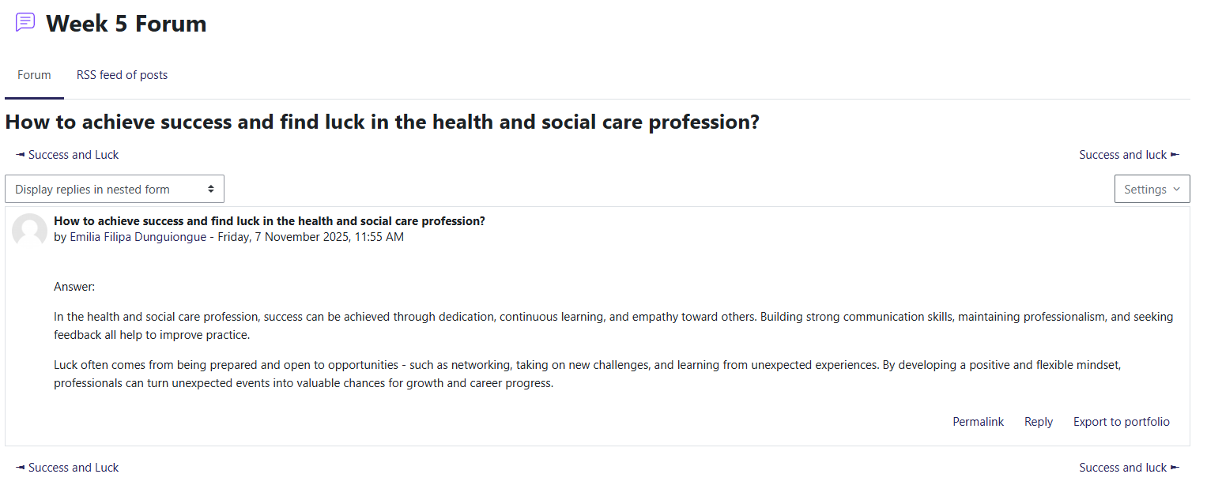
Figure 4: Post on health and social care profession
I have learned to execute ambitious targets including the implementation of the new care protocols or evolving advanced techniques that connect with ‘Locke and Latham’s Goal Setting Theory’ that evaluates that challenging and specific goals improve performance particularly when paired with commitment and feedback.
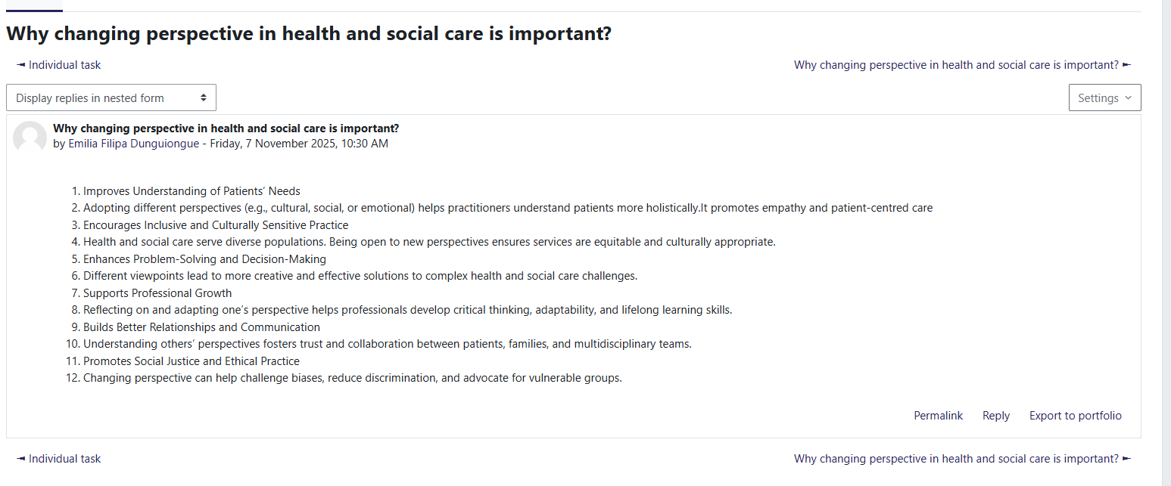
Figure 5: Perspectives in HSC
I have discovered the process of effective online presence that often ‘opens doors’ in a professional manner in Week 6. Moreover, I have learned to update my Curriculum Vitae (CV), use blogs and engage with LinkedIn to develop credibility and share insights. In addition, Stansky (1996) has defined blogging as a strategic tool rather than personal diary for community building and knowledge sharing. I have applied the 5Cs (Content, Consistency, Clarity, Credibility and Connection) for determining my digital footprint along with improving my professional visibility.
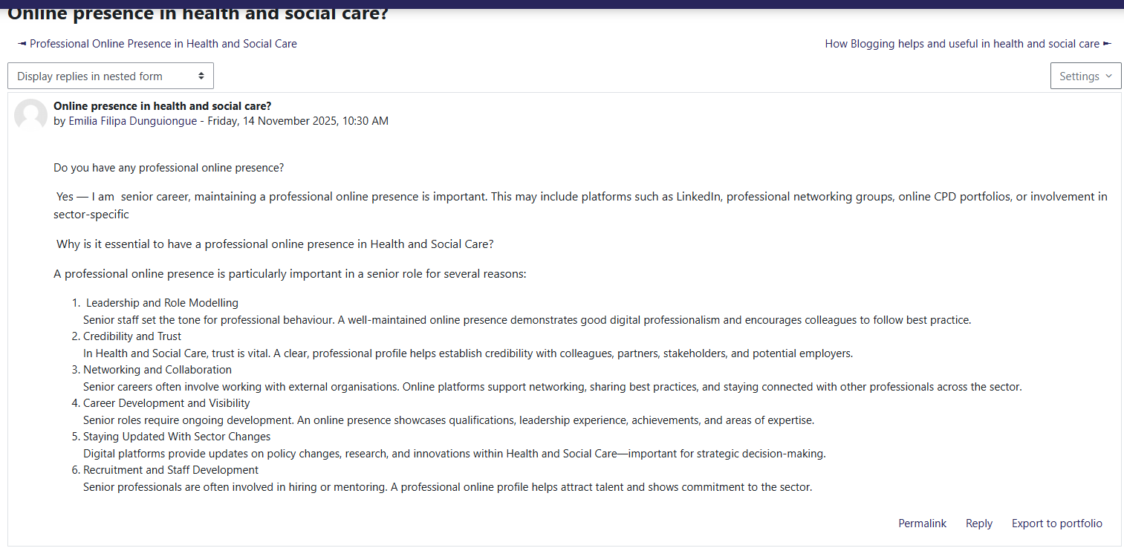
Figure 6: Online Presence in HSC
I have analysed from this unit that communication plays an important role in offering an additional channel for communication between those in need of care and caregivers. On top of that, the professional presence assists in developing an online professional presence that showcases the services and expertise in an accurate manner (Asante, 2024). As a result, the communication as well as professional presence are the vital aspects in terms of websites that assists within Human services.

5. Reflection on Unit 4
Unit 4 has provided detailed understanding to me about career adaptability along with the evolving role of technology within health and social care. The mentoring and social learning theory as a relevant tool for professional growth has been demonstrated within ‘Career Role Models’ covered in Unit 4. It also explored proactive career planning with regard to response towards digital transformation.
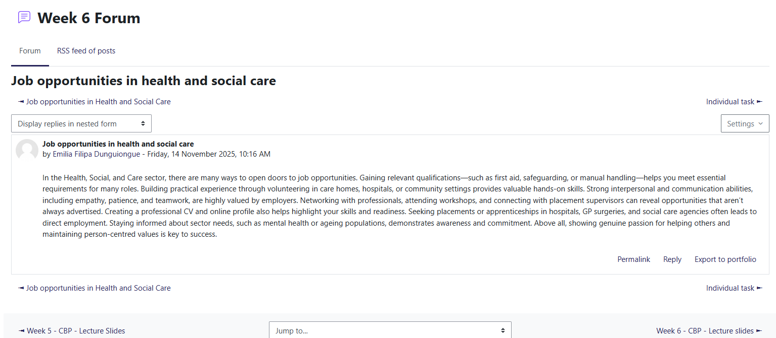
Figure 7: Job opportunities
I have learned that the digital transformation within health and social care imposes both challenges and opportunities. Additionally, Sheikh et al. (2021) articulated the challenges including lack of interoperability, digital leadership and infrastructure. Hence, the concerned insights have critically assisted me in assessing the process of technology that impacts workforce inclusion and service delivery. Moreover, I engaged with Moodle forums to evaluate the process of digital tools and Artificial Intelligence (AI) that are executing employment actively. I have also observed that health and social care faces a lower level of displacement risk than other sectors. Hence, it connects with the ‘anti-fragility’ concept, within which systems grow effectively with the help of disruption (Axenie et al., 2024). It is treated as a concept, which I often apply to my own planning of career.

Figure 8: Replying on Post
The ‘Social Learning Theory’ contemplated the significance of modelling and observing the successful professionals (Lee and Kumar, 2023). Hence, I have reflected on the process of mentors influencing my career trajectory through improving motivation, expanding networks and providing advice. Moreover, I have identified explored platforms and potential mentors for professional connections through online activities. Therefore, the concerned process has enhanced my goal-setting and self-awareness along with providing support to my development as nursing across ethically complex sectors.
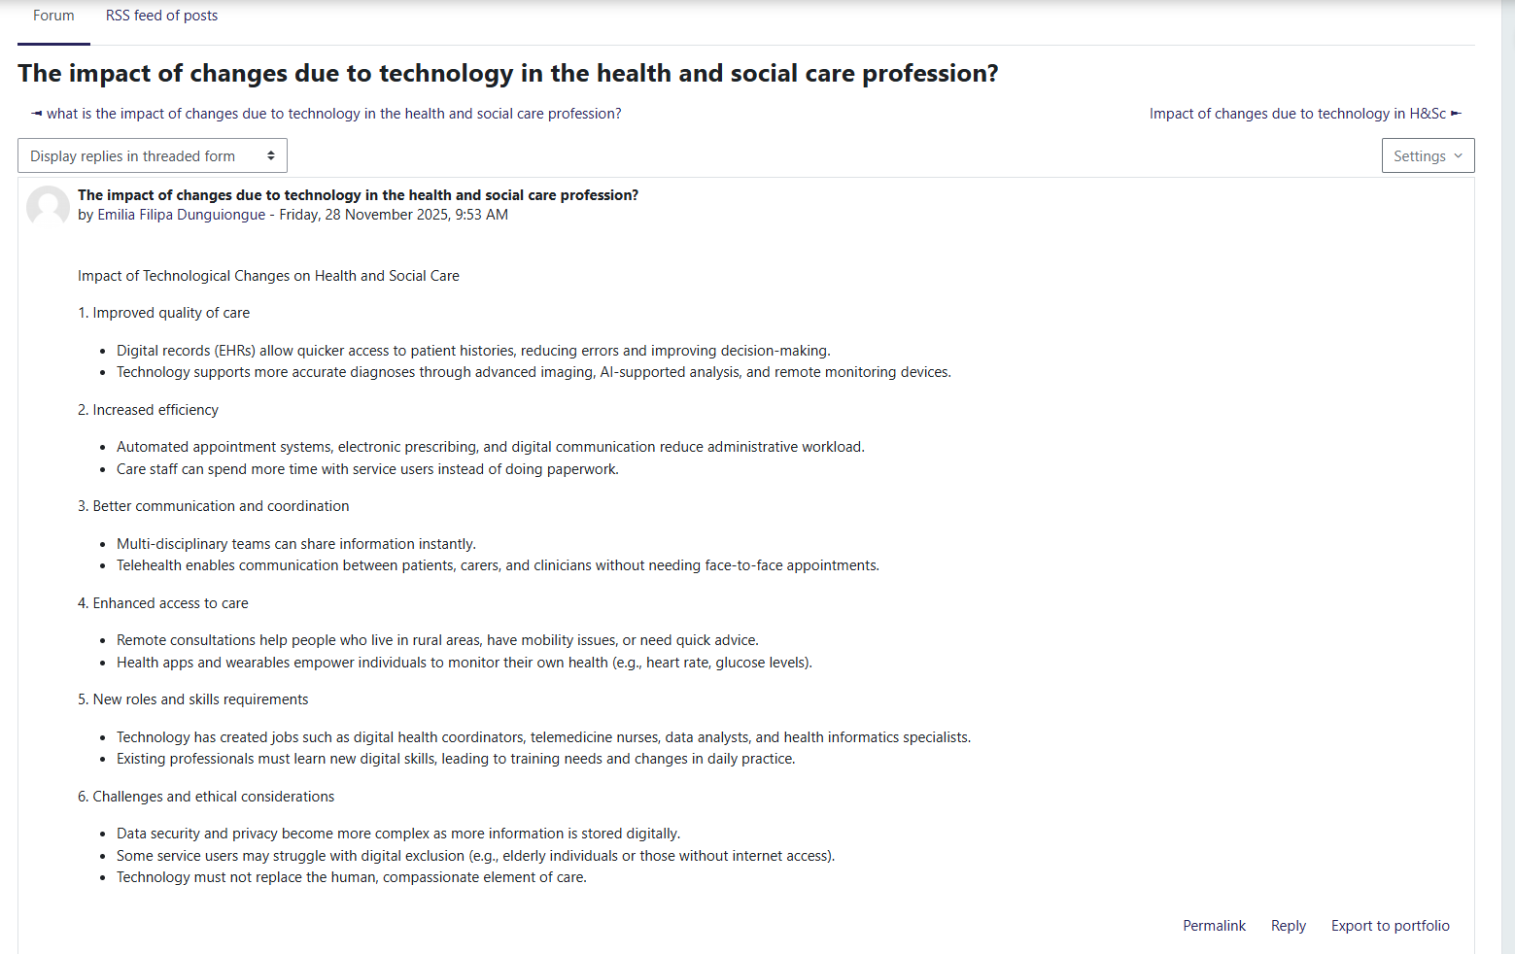
Figure 9: Technologies in HSC
The topics based on personal and professional impact improved my ability for translating theory into practice. Presently, I can approach career development with enhanced resilience as well as strategic foresight. Furthermore, I have improved my digital literacy along with seeking mentoring relationships actively to enhance my leadership skills. As a result, this unit has supported my short-term objective to retain lecture content on boundary-less careers, motivation and ambition, which are the essential concepts to succeed across dynamic work environments.
I have articulated from this unit that proper adoption of the technological changes within health and social care involves various strategies including training for staff in utilising new technologies. In addition, integrating or updating new technologies or policies into the existing ones primarily evolve relevant changes within the health and social care extensively (Bibri et al., 2023). Moreover, I have demonstrated from the concerned unit that practicing skills for improving the ability including computer skills towards adapting change helps to execute technological change within the respective sector.

6. Conclusion
I have gained effective understanding regarding adaptability, digital professionalism, boundaryless careers, networking, motivation and ambition within health and social care across Units 1 to 4. Furthermore, I have explored ‘Locke and Latham's Goal Setting Theory’, ‘Mastery and Purpose’ and ‘Pink’s Theory of Autonomy’ along with the role of self-awareness and emotional intelligence through Johari’s Window. I have also reflected on progression of career, recognised the flexibility provided by boundaryless careers across the gig economy and evaluating transitions to supervisor from care assistant. Moreover, bureaucratic hierarchy and networking were demonstrated through the ‘Connecting People’ and the ‘Castell’s Network Society’ models that represented the balance between responsiveness and structure.
Unit 3 improved my strategic visibility, digital literacy and the use of platforms like blogging and LinkedIn with the applications of 5Cs to develop professional presence. Furthermore, Unit 4 focused on digital transformation, social learning theory and mentoring involving technological integration and anti-fragility. The concerned insights have improved my leadership development, strategic foresight and resilience. I am currently able to approach planning a career with enhanced agility and seek mentorship relationships actively. My improved understanding of technological change and digital skills equipped me for contributing to evolving care environments effectively. Overall, the concerned learning significantly supports my short-term objective to regain key content of lecture along with applying theory to practice within dynamic settings of Integrated care.

7. Reference List
Ab Rahman, M.R.Z.B. (2025) ‘Why Goal Setting Theory is the Most Relevant in Today’s Workforce?’, Malaysian Journal of Business, Economics and Management, pp. 41–48. Available at: https://doi.org/10.56532/mjbem.v4i1.90

Asante, E. (2024) ‘Leveraging on the Internet for Professional Development, Job Search and Building Professional Presence’, ESS Open Archive eprints, 317, p. 31755625. Available at: https://doi.org/10.22541/au.172227123.31755625/v1

Axenie, C., López-Corona, O., Makridis, M.A., Akbarzadeh, M., Saveriano, M., Stancu, A. and West, J. (2024) ‘Antifragility in complex dynamical systems’, npj Complexity, 1(1), p. 12. Available at: https://doi.org/10.1038/s44260-024-00014-y

Bibri, S.E., Alexandre, A., Sharifi, A. and Krogstie, J. (2023) ‘Environmentally sustainable smart cities and their converging AI, IoT, and big data technologies and solutions: an integrated approach to an extensive literature review’, Energy Informatics, 6(1), p. 9. Available at: https://doi.org/10.1186/s42162-023-00259-2

Busch, C. (2024) ‘Towards a theory of serendipity: A systematic review and conceptualization’, Journal of Management Studies, 61(3), pp. 1110–1151. Available at: https://doi.org/10.1111/joms.12890

Clutterbuck, D., Kochan, F., Lunsford, L., Dominguez, N. and Haddock-Millar, J. (2020) The Sage Handbook of Mentoring. London: Sage.

Gibson, C., Hardy III, J.H. and Buckley, M.R. (2014) ‘Understanding the role of networking in organizations’, Career Development International, 19(2), pp. 146–161. Available at: https://doi.org/10.1108/CDI-09-2013-0111

Khatri, R. et al. (2023) ‘Continuity and care coordination of primary health care: a scoping review’, BMC Health Services Research, 23(1), p. 750. Available at: https://doi.org/10.1186/s12913-023-09718-8

Lee, M.M. and Kumar, S.I. (2023) ‘Kolb meets quality: Applying learning theory to a process improvement and safety curriculum’, ATS Scholar, 4(4), pp. 431–440. Available at: https://doi.org/10.34197/ats-scholar.2023-0021PS

Maddux, J.E. (2016) ‘Self-efficacy’, in Interpersonal and Intrapersonal Expectancies. Routledge, pp. 41–46.

Matthews, G., Roberts, R. and Zeidner, M. (2019) What is Emotional Intelligence? London: Routledge.

Morris, D., Thomas, P., Ridley, J. and Webber, M. (2022) ‘Community-enhanced social prescribing: integrating community in policy and practice’, International Journal of Community Well-Being, 5(1), pp. 179–195. Available at: https://doi.org/10.1007/s42413-020-00080-9

NHS England (2019) Social Prescribing and Community-Based Support: Summary Guide. Available at: https://www.england.nhs.uk/personalisedcare/social-prescribing/ (Accessed: [insert date]).

Roy, S.K. (2018) ‘Identifying the dimensions of attractiveness of an employer brand in the Indian context’, South Asian Journal of Management, 15(4), pp. 110–130. Available at: https://sajm-amdisa.org/sajm_journals/SAJM_15.4.pdf#page=115

Salovey, P., Caruso, D. and Mayer, J.D. (2004) ‘Emotional intelligence in practice’, in Positive Psychology in Practice, 30, pp. 447–463. Available at: https://doi.org/10.1002/9780470939338

Schawbel, D. (2019) Back to Human: How Great Leaders Create Connection in the Age of Isolation. London: Piatkus.

Sheikh, A. et al. (2021) ‘Health information technology and digital innovation for national learning health and care systems’, The Lancet Digital Health, 3(6), pp. e383–e396. Available at: https://doi.org/10.1016/S0140-6736(21)00232-4

Stansky, L.J. (1996) ‘Opening doors’, ABAJ, 82, p. 66. Available at: https://heinonline.org/hol-cgi-bin/get_pdf.cgi?handle=hein.journals/abaj82&section=65

Webber, M. et al. (2021) ‘The implementation of connecting people in community mental health teams in England: A quasi-experimental study’, The British Journal of Social Work, 51(3), pp. 1080–1100. Available at: https://doi.org/10.1093/bjsw/bcaa159

West, M., Eckert, R., Collins, B. and Chowla, R. (2015) Caring to Change: How Compassionate Leadership Can Stimulate Innovation in Health Care. London: The King’s Fund.

Zeitlin, J. (2023) ‘Hierarchy, polyarchy, and experimentalism in EU banking regulation: the Single Supervisory Mechanism in action’, Journal of European Integration, 45(1), pp. 79–101. Available at: https://doi.org/10.1080/07036337.2022.2144279

