
3/21/2026
- Programme: CertHE Computing Skills for Workplace
- Module: Software Solutions for Business
- Module code: ACCA4026
- Lecturer: Martin Svejda,
- Assignment Title Component 1- Coursework: Portfolio
- Student name Muhammad Shahid
- Student ID number 2530120 ( Birmingham campus)

Table of Contents
Task 1 2
A. Shopify vs. Wix: Which E-Commerce Platform is Right for You? 2
b. Wix eCommerce 2
Task 2. 3
Mindmap 3
Task 3. 4
Advantages of Microsoft Office 5
1. Microsoft Word 6
2. Microsoft PowerPoint 6
3. Microsoft Excel 6
4. Microsoft Access 7
Task 4. Communication and Collaboration Applications in the Modern Business World 9
Introduction 9
Overview of Slack 9
Key Features of Slack 9
Online Collaboration Tool: Microsoft Teams 10
Overview of Microsoft Teams 10
Key Features of Microsoft Teams 10
Practical Testing of Communication and Collaboration Applications 11
Description of the Feature 11
Steps Performed 11
Feature Tested – File Sharing within a Team Channel 13
Description of the Feature 13
Steps Performed 13
Conclusion 16
Reference 17

Task 1

A. Shopify vs. Wix: Which E-Commerce Platform is Right for You?
[1] In today’s digital world, having a website isn’t optional—it’s essential. Customers expect to research products, make purchases, book services, and interact with businesses online. If your website doesn’t provide what they need, they’ll quickly turn to a competitor.
Two popular tools that help businesses build online stores without needing advanced technical skills are Shopify and Wix.

Shopify
Shopify is a cloud-based platform built specifically for online stores. It combines website creation tools with a full retail management system, making it a popular choice for everyone from small startups to large brands.
Shopify’s drag-and-drop editor makes designing pages and arranging content simple—no coding required. Users can choose from hundreds of professional themes and manage inventory, payments, and secure checkout, all from one dashboard.
You can sell physical products, digital downloads, and even subscription services. Shopify also lets you connect custom domains and expand your store with thousands of apps for marketing, shipping, accounting, and more. A standout feature is Shopify Magic, an AI tool that helps generate product descriptions, page content, and basic SEO material.
Analytics and reporting tools give merchants insight into sales, customer behaviour, and orders in real time, making it easier to make informed decisions. Because Shopify is fully hosted, it handles updates, security, and scalability, allowing business owners to focus on growth instead of technical maintenance.

b. Wix eCommerce
Wix started as a general website builder but now includes robust e-commerce capabilities. It’s particularly useful for small businesses or creators who want to combine a content-rich website with online selling.
Like Shopify, Wix uses a drag-and-drop editor, making it easy to design storefronts, manage product catalogs, set pricing and shipping rules, and integrate external services. Wix also offers features for bookings, restaurant orders, and service-based businesses, making it versatile for a range of industries.
The platform emphasises flexibility, letting developers and partners add custom business solutions while providing non-technical users with responsive templates, built-in SEO, and marketing tools. Wix is ideal if you want a visually appealing website that combines content and commerce seamlessly.

Task 2.
Mindmap. In modern business operations, mind mapping has become an essential tool that helps organisations manage complex tasks more effectively. [2] The concept of mind mapping became widely known through the work of Tony Buzan, who explained that visual structures improve memory, creativity, and understanding. One of its biggest advantages is improving clarity. Companies often handle multiple departments and processes at the same time, such as finance, marketing, human resources, and operations. A well-designed mind map allows managers and employees to see how these areas are connected, making complicated information much easier to understand and follow. By visualising relationships and workflows, everyone in the organisation can grasp their roles and responsibilities more clearly.
Another important benefit of mind mapping is that it aids in better planning and decision-making. When goals, strategies, risks, and resources are shown visually, managers can quickly identify strengths, weaknesses, and areas that need attention. This makes it easier to make informed decisions, prioritise tasks, and allocate resources efficiently. Seeing the big picture helps leaders align daily operations with long-term objectives, reducing errors and improving overall organisational efficiency.
Figure 1: mindmap using online free tool.
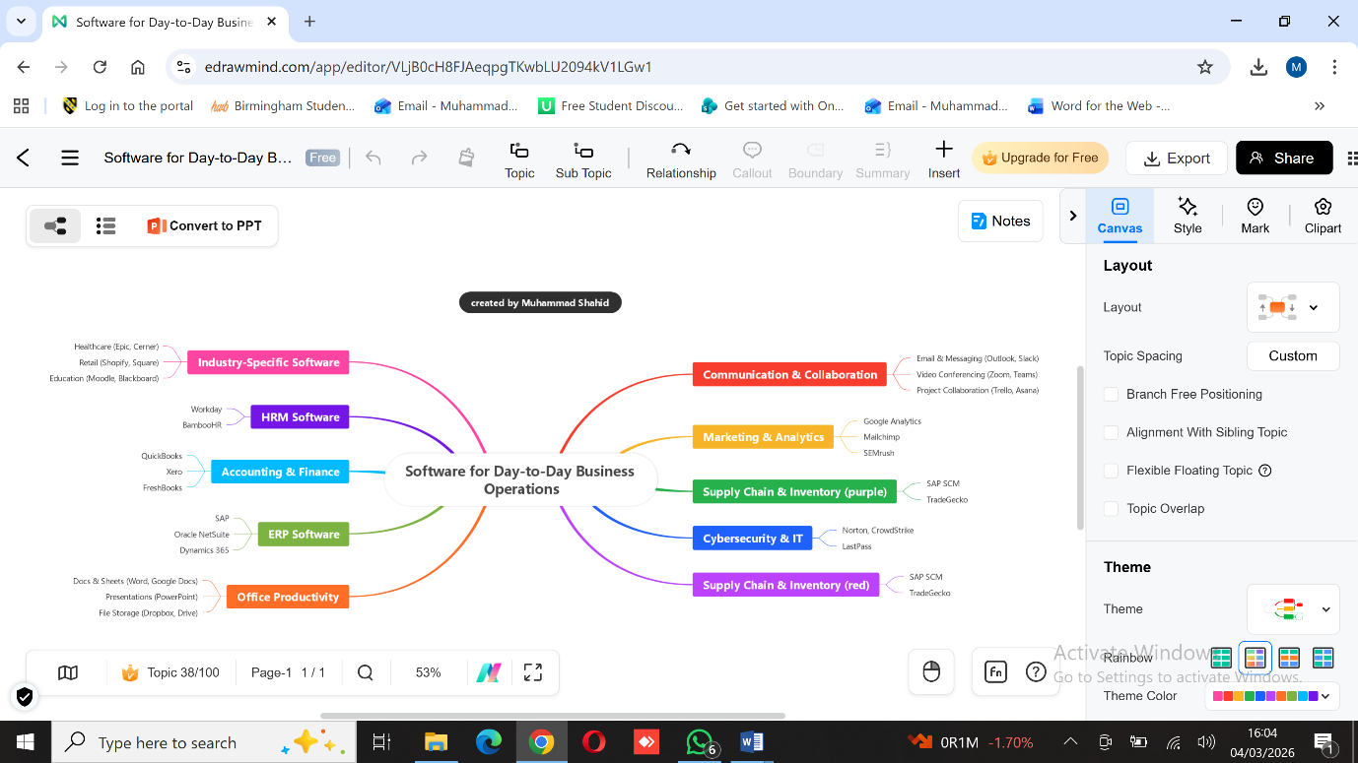
Mind mapping also encourages creativity. During brainstorming sessions, employees can share their ideas without worrying about immediate organisation or structure. This freedom often leads to new and innovative solutions that may not come up in traditional meetings. It also allows team members from different departments to collaborate, bringing in diverse perspectives that enhance problem-solving and innovation.
Collaboration and communication within a team are strengthened through mind mapping as well. When everyone has access to the same visual plan, misunderstandings are reduced, and team members stay on the same page. This shared understanding ensures smoother cooperation and helps teams work more effectively toward common goals. Mind maps can also be used for training new employees, allowing them to understand processes and workflows quickly without reading through long documents.
[3] Another advantage of mind mapping is its adaptability. Businesses operate in dynamic environments where plans and priorities change frequently. Mind maps can be updated easily to reflect new strategies, processes, or organisational changes. This flexibility allows teams to adjust quickly and maintain productivity even when unexpected challenges arise.
Overall, mind mapping is a practical and powerful tool that supports clarity, planning, creativity, teamwork, and adaptability. It helps employees and managers visualise complex information, communicate ideas more effectively, and make smarter decisions. By turning complicated data into a simple visual format, mind mapping strengthens organisation, boosts productivity, and encourages innovative thinking. Businesses that use this technique can operate more smoothly, improve collaboration across departments, and respond to challenges more effectively, making mind mapping an indispensable tool in today’s fast-paced business world.
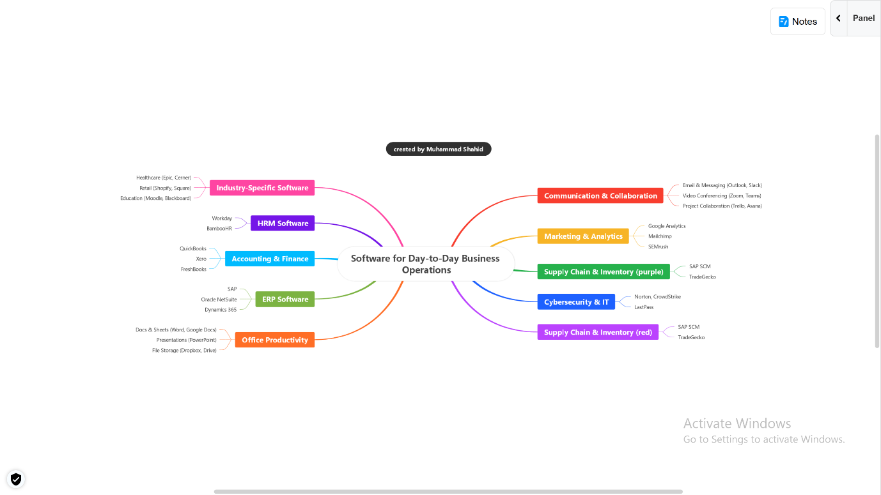

Task 3.
- Microsoft Office has long been a cornerstone of productivity in both professional and educational settings. Its suite of applications—most notably Word, PowerPoint, Excel, and Access—offers tools that make tasks more efficient, support skill development, and enhance collaboration. Beyond their immediate functionality, these programs provide opportunities for learning and problem-solving, allowing users to expand their technological capabilities in ways that go beyond their everyday routines.

Advantages of Microsoft Office
[4] One of the most significant advantages of Microsoft Office is its ability to improve work efficiency. Applications like Excel and PowerPoint make tasks that were once time-consuming much more manageable. Excel allows users to perform calculations, analyse data, and visualise trends with ease, while PowerPoint provides a platform for crafting engaging, visually clear presentations. These tools are not only helpful for professionals; they also play an important role in education. For instance, training programs for teachers often include hands-on exercises in Office applications, combining direct practice with interactive learning. Participants benefit from refreshed skills, exposure to new functions, and greater confidence in using technology effectively.
[5] Another key advantage lies in the way Office files are structured. With the introduction of the Office Open XML (OOXML) format in MS Office 2007, documents became more secure and versatile. This format reduces the risk of unintentional information leakage and even allows documents to be used for steganography, meaning hidden information can be embedded within a file. While this might seem niche, it has real-world applications in secure communication or data protection. At the same time, it underscores the importance of awareness, as these capabilities could be misused if not handled responsibly.
Challenges and Security Considerations
Despite its many advantages, Microsoft Office also presents certain challenges. Documents often contain sensitive information, which can be critical in business or forensic contexts. Traditional methods for analysing documents—such as examining metadata or using keyword searches—can be unreliable because metadata can be edited or deleted. To address this, advanced techniques have been developed, such as revision identifiers (RSID) in Word files. RSIDs track document edits and associate changes with specific users, providing more accurate history and improving document management. This example illustrates a broader reality: securing and managing Office documents requires more than basic knowledge—it demands deliberate strategies and awareness of technological nuances.
Figure 2 overview of ms office application
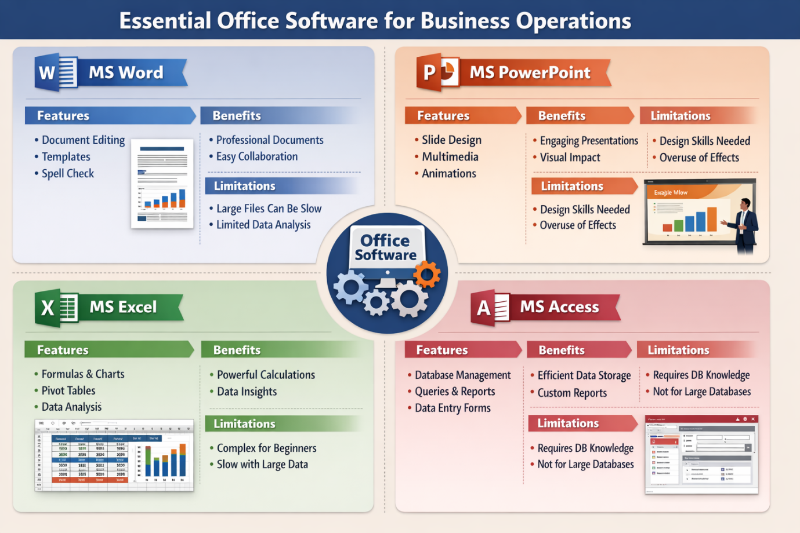

Detailed Overview of Core Applications

1. Microsoft Word
Purpose: Word is primarily a word-processing application used to create letters, reports, memos, and proposals.
Features:
- Advanced text formatting, headings, tables, and templates.
- Spell check and grammar suggestions for professional documents.
- Real-time collaboration with comments and track changes.
Benefits:
- Produces polished, professional documents efficiently.
- Templates and formatting save time and ensure consistency.
- Supports teamwork by allowing multiple contributors to work on a single document.
Limitations:
- Large documents with graphics or embedded charts may slow performance.
- Limited data analysis capabilities compared to Excel.
- Advanced features require some learning for new users.

2. Microsoft PowerPoint
Purpose: PowerPoint is designed for creating visual presentations for meetings, training sessions, and pitches.
Features:
- Slide creation with customizable layouts, themes, and fonts.
- Multimedia integration, including images, videos, and audio.
- Animations, transitions, and presenter tools like notes and timers.
Benefits:
- Makes presentations engaging and visually clear.
- Helps audiences understand complex ideas quickly.
- Supports team collaboration on shared presentations.
Limitations:
- Overuse of transitions or animations can distract viewers.
- Professional-looking presentations require some design skill.
- Not suitable for detailed data analysis.

3. Microsoft Excel
Purpose: Excel is used for managing, calculating, and analysing numerical data.
Features:
- Organised spreadsheets with rows and columns.
- Powerful formulas and functions for calculations.
- Charts, graphs, and pivot tables for visualising data.
Benefits:
- Enables accurate financial reporting and data-driven decisions.
- Automates repetitive tasks through formulas and macros.
- Provides visualisations that simplify large datasets.
Limitations:
- Advanced features can be difficult for beginners.
- Large datasets can reduce software performance.
- Not ideal for relational databases.

4. Microsoft Access
Purpose: Access is a database management system for storing and analysing large amounts of structured data.
Features:
- Create relational databases with tables, forms, queries, and reports.
- Simplifies data entry while maintaining consistency.
- Supports detailed reporting and query-based analysis.
Benefits:
- Efficient storage and retrieval of large datasets.
- Maintains integrity across interconnected tables.
- Facilitates complex queries and reporting for decision-making.
Limitations:
- Requires knowledge of database design for optimal use.
- Not as scalable as enterprise systems for very large datasets.
Conclusion
Microsoft Office is more than just a set of tools; it is a platform that empowers users to work more efficiently, learn new skills, and manage information effectively. Its applications—Word, PowerPoint, Excel, and Access—each have unique strengths and limitations, but together they provide a versatile ecosystem suitable for education, business, and beyond. While Office documents present security and management challenges, understanding features like OOXML and RSID, combined with proper training, can help users navigate these complexities confidently. Ultimately, Microsoft Office remains an indispensable suite for anyone looking to combine productivity, creativity, and technical capability in a professional or educational context.

- In our recent class activity, we worked on analysing and managing a dataset in MS Excel to understand how different formulas and tools can simplify data processing. The activity focused on using the IF function to apply conditional logic and the Pivot Table feature to summarise and visualise data efficiently. These tools allowed us to automate calculations, organise information, and gain insights from the dataset more quickly than manual methods. To provide clear evidence of the practical work, I have included screenshots showing the formulas applied and the resulting Pivot Tables.

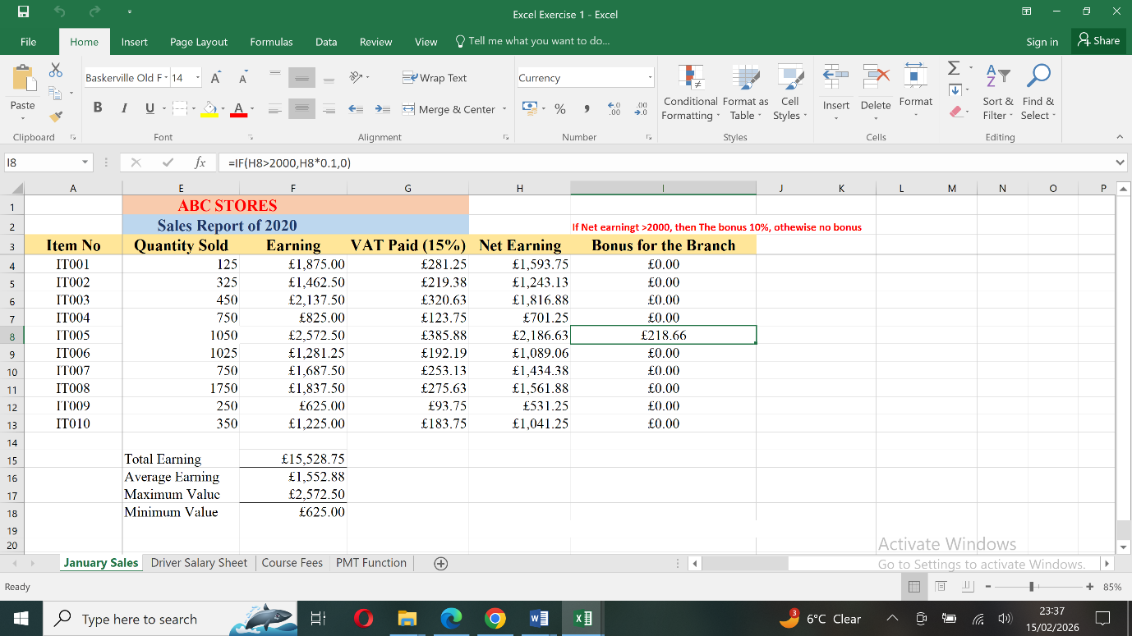
Figure 3: this is class activiy I have attacched for if function how to implemnt and and how it work

Figure 4: using farmula and doing class activity

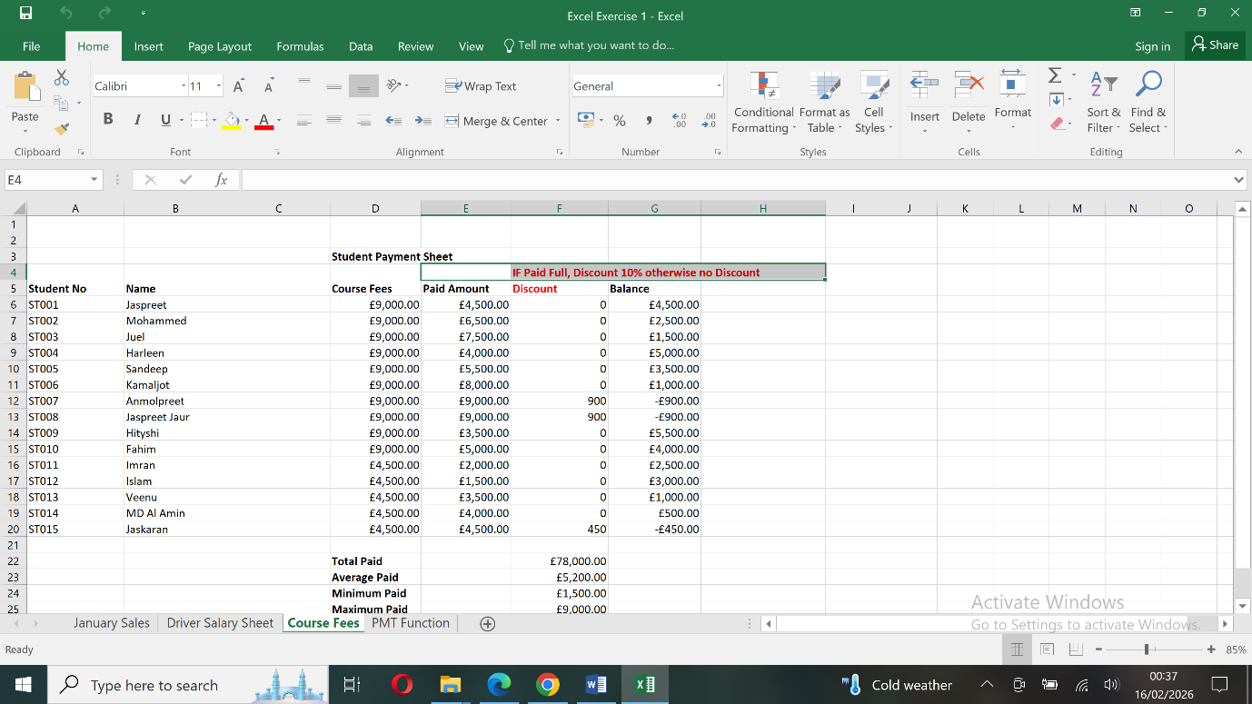

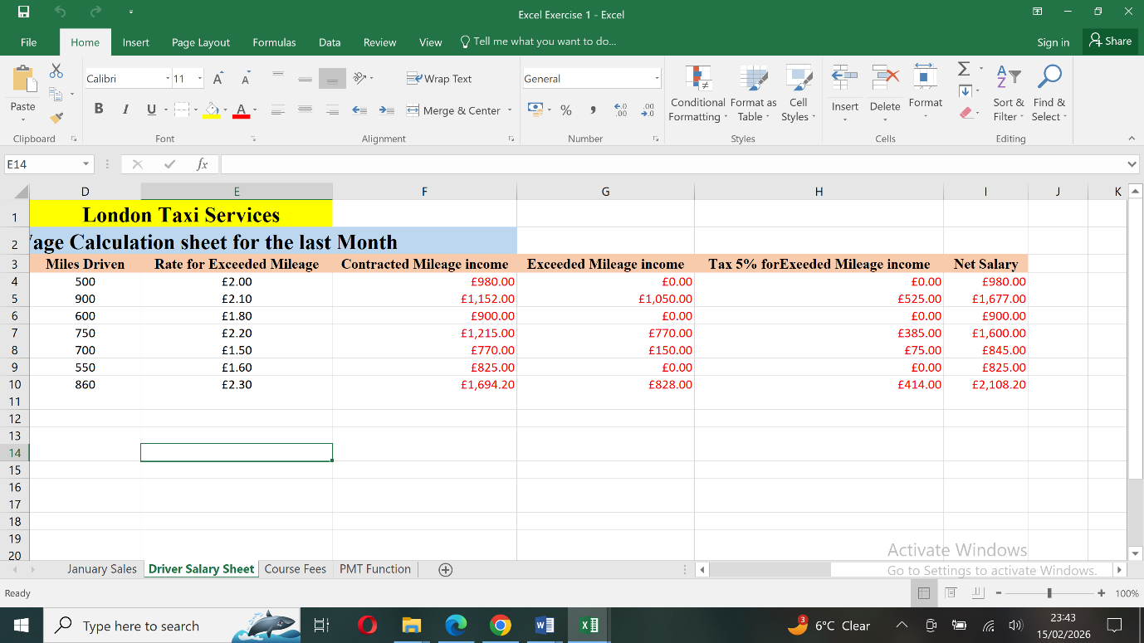

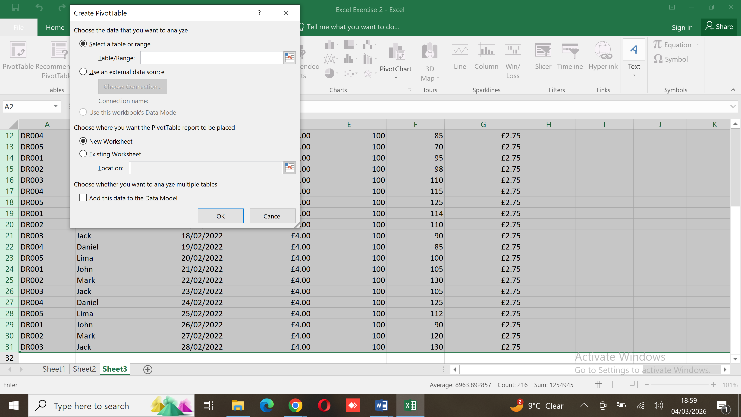
Figure 5: doing a pivot table in class activity
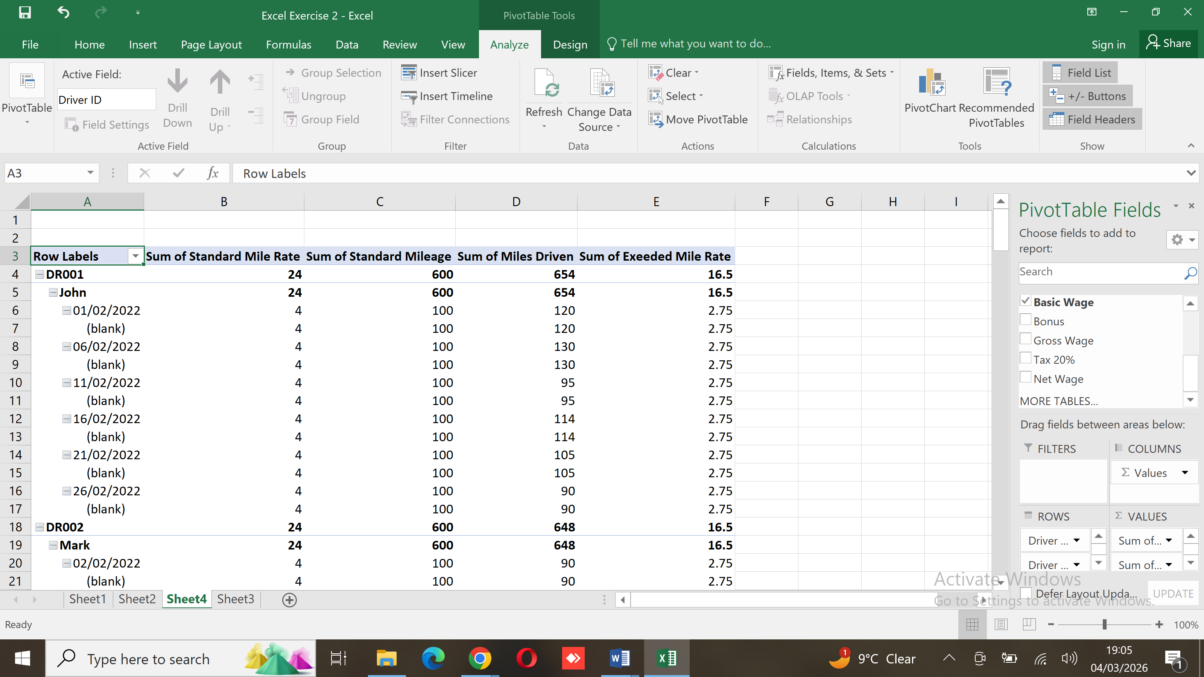
Figure 6: Pivot table was created successfully on right hand side, where we can check the pivot table field and select as per requirement.

Task 4. Communication and Collaboration Applications in the Modern Business World
Case Study: Domino’s Pizza

Introduction

(6)In the modern business environment, communication and collaboration play a vital role in ensuring organisational success. Businesses today operate in highly competitive and fast-moving markets, where information needs to be shared quickly, and teams must work together efficiently. With the rise of digital transformation and remote working, organisations now depend heavily on communication and collaboration applications to support daily operations.
This assignment analyses one contemporary communication application and one online collaboration tool that are commonly used in modern businesses. The selected tools are Slack as the communication application and Microsoft Teams as the online collaboration platform. The discussion is based on how these tools can be used within Domino’s Pizza, a global organisation with a large and geographically distributed workforce.

Overview of Slack

Slack is a cloud-based communication application designed to support fast and organised communication within organisations. Unlike traditional email, Slack focuses on real-time messaging, allowing employees to communicate instantly.(7) The platform is widely used by businesses to improve internal communication, reduce email overload, and encourage teamwork.
For a company like Domino’s Pizza, which operates thousands of stores and corporate offices worldwide, Slack provides a practical way to communicate across departments such as marketing, IT, supply chain, and operations.

Key Features of Slack
Channels for Organised Discussions
One of Slack’s main features is the use of channels. Channels allow conversations to be organised by topic, project, or department. This helps employees easily locate relevant discussions and prevents important messages from being lost.
For example, Domino’s Pizza could use channels such as:

- Store operations updates
- Marketing campaigns
- Technology and system support

This structure supports clear and focused communication across the business.
Direct Messaging and Group Communication
Slack allows users to send direct messages to individuals or create group conversations. This feature is useful for quick questions, problem solving, or coordination between small teams. Communication becomes more informal and efficient compared to emails, leading to faster decision-making.
File Sharing and Message History
Employees can share documents, images, and reports directly in Slack conversations. All messages and files are stored in the system and can be searched later. This is particularly helpful for a business like Domino’s Pizza, where staff changes and shift work require easy access to past information.
Integration with Other Applications
(8)Slack integrates with a wide range of third-party business tools, such as scheduling systems, video conferencing software, and project management applications. These integrations allow teams to receive updates and manage tasks without switching between different platforms.
Benefits of Slack for Domino’s Pizza
(9)Slack supports quick communication and improves information flow across the organisation. Store managers can report operational issues, marketing teams can discuss promotions, and technical teams can respond to system problems in real time. As a result, Slack helps Domino’s Pizza maintain efficiency, improve coordination, and respond quickly to business challenges.

Online Collaboration Tool: Microsoft Teams

Overview of Microsoft Teams
Microsoft Teams is an online collaboration platform that combines communication, file sharing, meetings, and teamwork in a single application. It is part of the Microsoft 365 ecosystem and is commonly used by businesses to support collaboration across teams and locations.
Domino’s Pizza uses Microsoft Teams to connect employees at different levels of the organisation, including corporate staff, regional managers, and support teams. The platform helps bring people together and supports both in-office and remote working environments.

Key Features of Microsoft Teams
Team and Channel Structure
Microsoft Teams allows organisations to create teams for departments or projects, with channels for specific tasks or topics. This structure helps keep conversations, documents, and meetings organised in one place.
For example, Domino’s Pizza could create teams for:
- Human resources
- Supply chain management
- Marketing and promotions
- Each team can collaborate effectively without confusion or information overload.
- Online Meetings and Video Conferencing
Microsoft Teams includes built-in video conferencing features that support virtual meetings, training sessions, and presentations. Employees can share their screens, record meetings, and communicate face-to-face even when working remotely.
This is particularly important for Domino’s Pizza, as the business operates across multiple regions and countries.
Real-Time Document Collaboration
One of the strongest features of Microsoft Teams is its ability to support real-time collaboration on documents. Multiple users can edit Word documents, Excel spreadsheets, or PowerPoint presentations at the same time. Changes are saved automatically, ensuring everyone works on the most up-to-date version.
This feature helps Domino’s teams collaborate on reports, operational guidelines, and training materials more efficiently.
File Storage and Accessibility
Microsoft Teams stores shared files securely in the cloud, allowing employees to access documents from any location or device. This improves flexibility and ensures consistent access to important information across the organisation.
Integration with Microsoft 365 Tools
Teams integrates seamlessly with Microsoft 365 applications such as Outlook, OneDrive, and SharePoint. This creates a connected digital workspace that supports communication, collaboration, and productivity in one platform.
Benefits of Microsoft Teams for Domino’s Pizza
Microsoft Teams helps Domino’s Pizza improve collaboration across departments and geographical locations. It supports structured teamwork, remote communication, and shared access to documents and resources. The platform also supports training, meetings, and company-wide communication, making it an effective collaboration tool for a large global business.

Practical Testing of Communication and Collaboration Applications
Communication Application: Slack
Feature Tested – Channel Messaging

Description of the Feature
The feature tested in Slack is channel-based messaging. This feature allows users to communicate in group channels that are organised by topic, department, or purpose. Channel messaging is available in Slack’s free version and is widely used in business environments for quick and structured communication.

Steps Performed
- A free Slack account was created
- A new workspace was set up
- A public channel named #store-updates was created
- Messages were sent in the channel
- Emoji reactions were added to messages
- Screenshot Evidence

Figure 7: Screenshot 1: Slack Workspace and Channel List
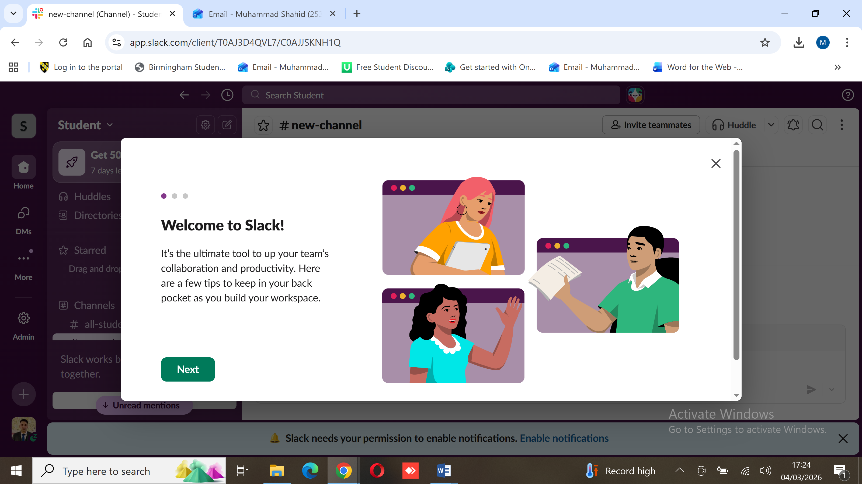
Figure 8: welcome page after creating an account

Description:

This screenshot shows the Slack workspace interface with the list of channels displayed on the left-hand side. The store-updates channel is visible, demonstrating how Slack organises communication into structured channels.

Figure 9: Screenshot 2: Message Posted in and store-updates Channel
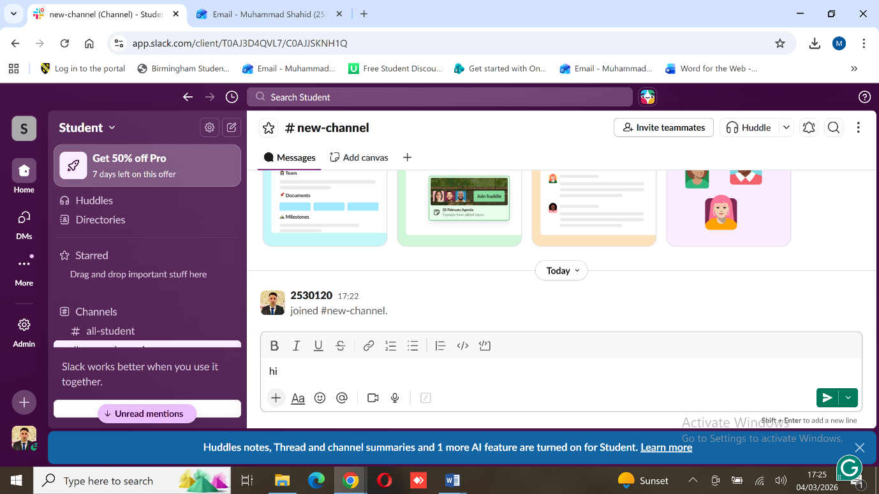

Description:
This screenshot shows a message sent inside the store-updates channel. It demonstrates real-time communication within Slack and how business-related updates can be shared instantly with team members.

Figure 10: Screenshot 3: Emoji Reaction Added to a Message
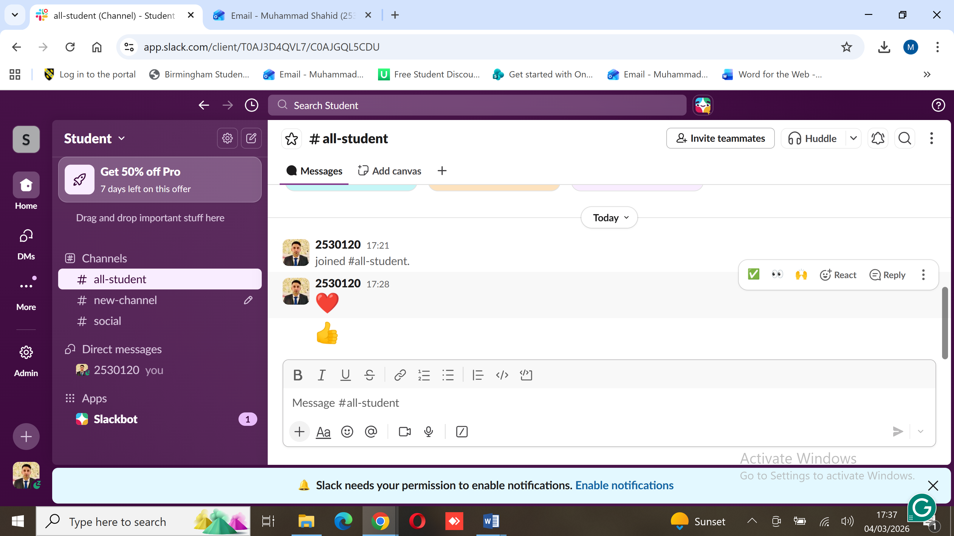
Description:
This screenshot shows an emoji reaction added to a message. This feature allows users to acknowledge messages quickly without replying, which is useful for confirming receipt of information in a business setting.
Practical Business Use
In a business such as Domino’s Pizza, channel messaging can be used to share store announcements, operational notices, or promotional updates with staff. This ensures fast communication and keeps information organised.

Feature Tested – File Sharing within a Team Channel

Description of the Feature

The feature tested in Microsoft Teams is file sharing within a team channel. This feature allows users to upload, store, and access documents in a shared workspace. It supports collaboration by ensuring all team members have access to the same files.

Steps Performed

- A free Microsoft Teams account was created
- A new team named the Operations Team was set up
- A channel called Weekly Reports was created
- A Word document was uploaded to the Files tab
- The document was opened within Microsoft Teams
- Screenshot Evidence

Figure 12 Screenshot 4: Microsoft Teams – Team and Channel View
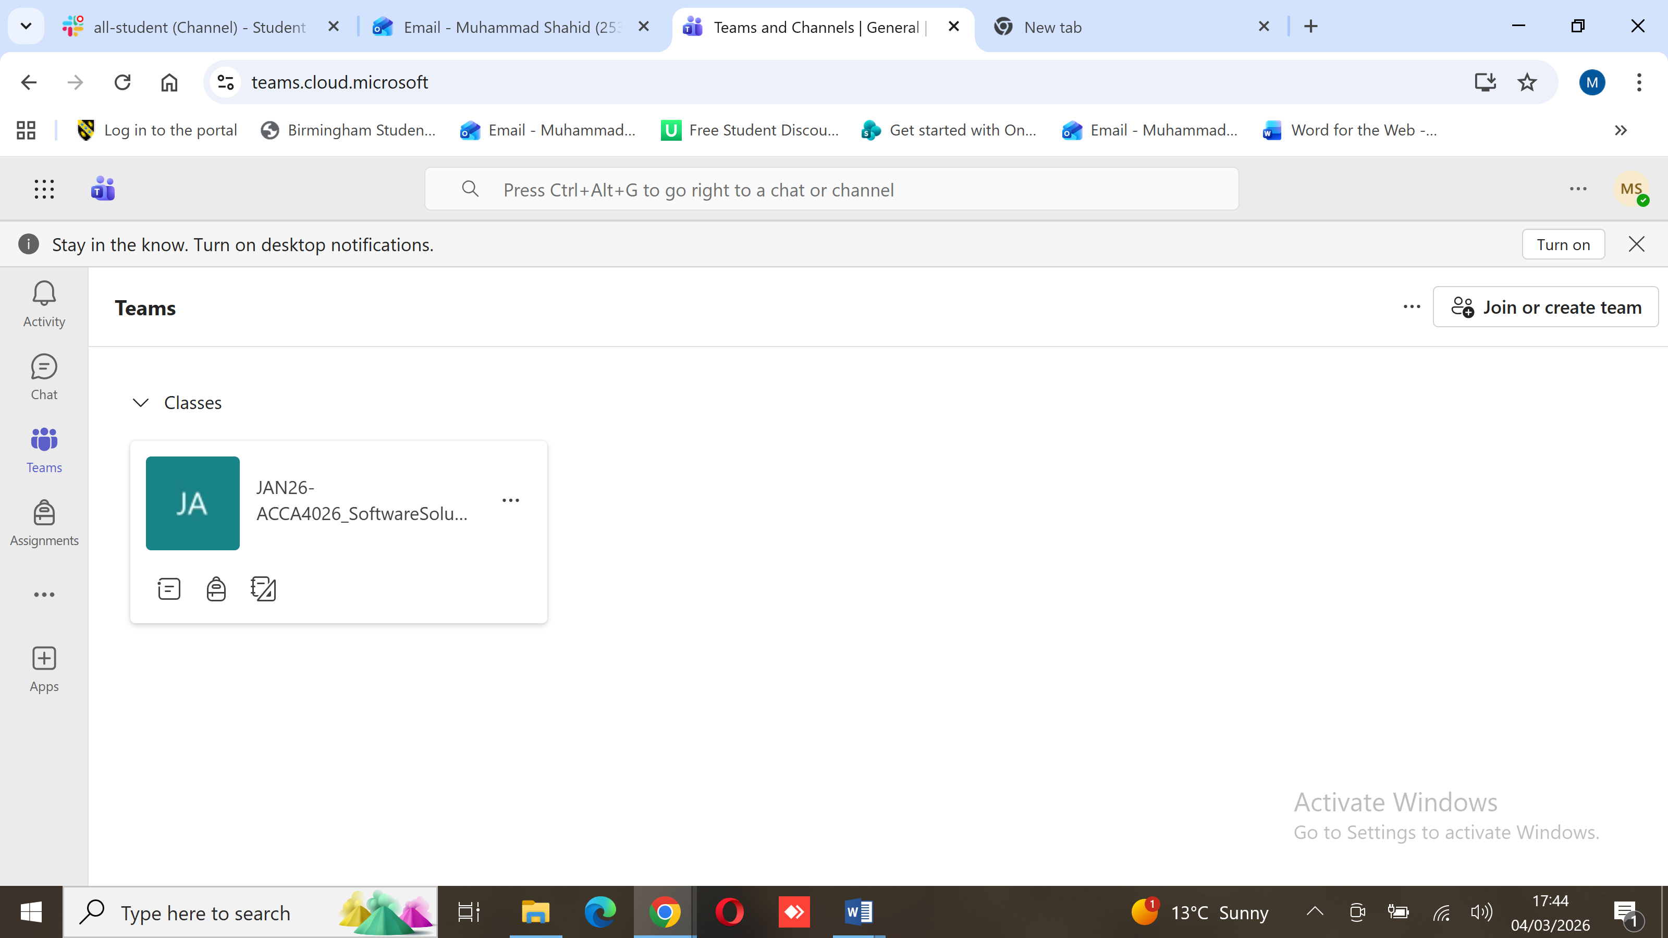
Description:
This screenshot shows the Microsoft Teams interface with the Operations Team and Weekly Reports channel visible. It demonstrates how Teams organises collaboration into teams and channels.

Figure 12: Screenshot 5: File Uploaded in the Files Tab
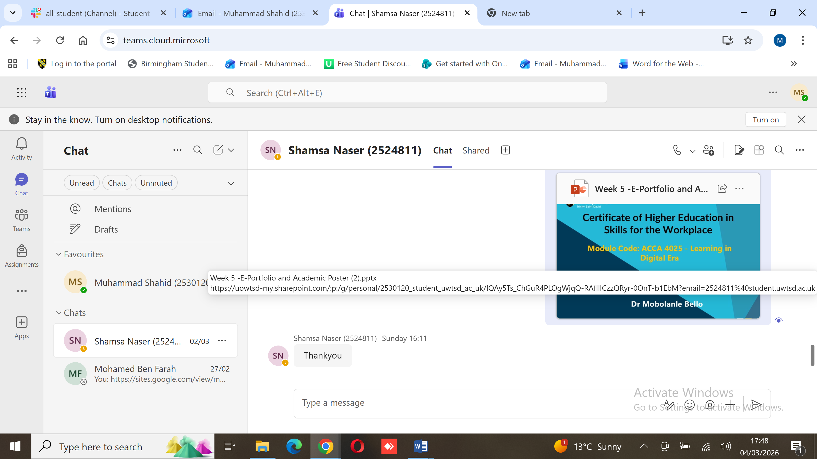
Description:
This screenshot shows a Word document uploaded in the Files tab of the Weekly Reports channel. It provides evidence of successful file sharing within Microsoft Teams.

Figure 13: Screenshot 6: Document Opened Inside Microsoft Teams
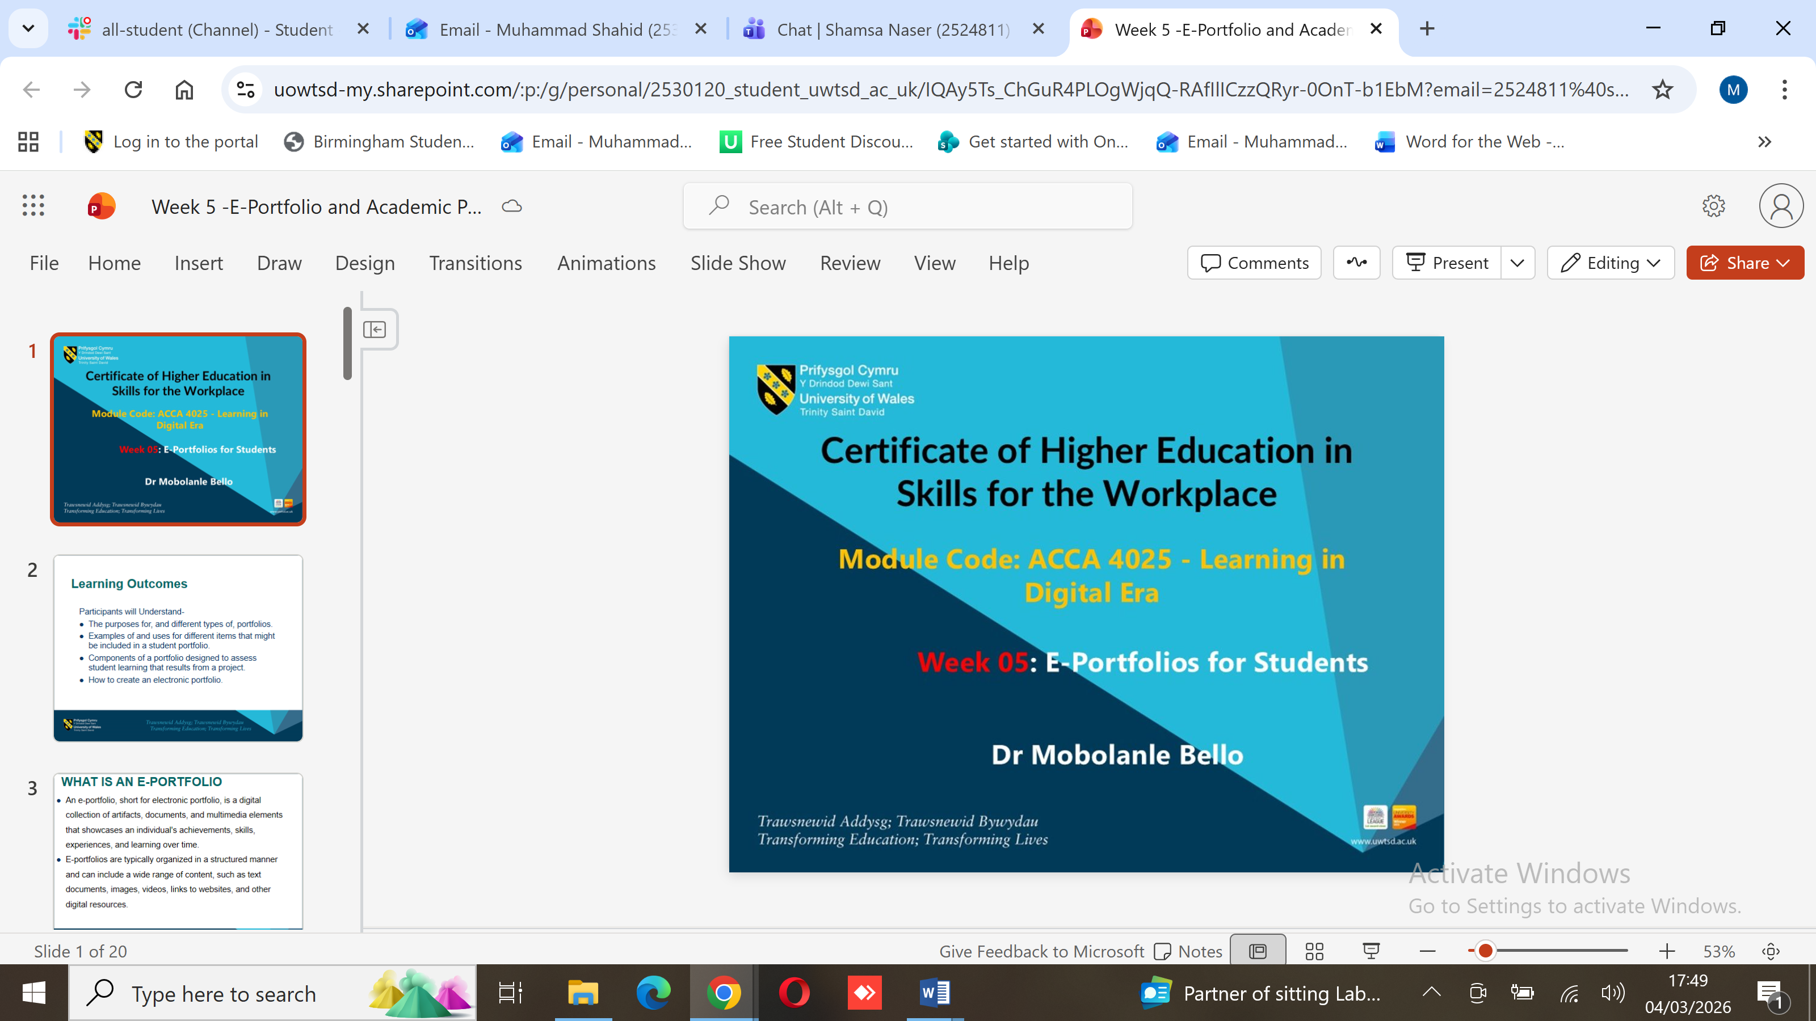
Description:
This screenshot shows the uploaded document opened directly within Microsoft Teams. It demonstrates that users can access and view shared documents without leaving the platform, supporting effective collaboration.

Practical Business Use

For Domino’s Pizza, this feature can be used to share training materials, operational guidelines, or performance reports. All team members can access the same document, ensuring consistency and reducing errors.

Conclusion

This assignment shows how digital tools have become essential for running modern businesses effectively. Platforms like Shopify and Wix make it easy for companies to build online stores, with Shopify offering a complete retail management system and Wix giving small businesses more creative flexibility. Mind mapping helps teams visualise ideas and processes, making it easier to plan, make decisions, and work together without confusion.

Microsoft Office applications—Word, PowerPoint, Excel, and Access—remain key tools for everyday business tasks. They allow professionals to create documents, analyse data, prepare presentations, and manage databases. Hands-on exercises, like using Excel formulas and pivot tables, show how these tools can save time and make work more organised.

Communication and collaboration apps like Slack and Microsoft Teams are vital for global companies such as Domino’s Pizza. Slack helps teams communicate quickly and stay on the same page, while Teams makes sharing files, collaborating on documents, and holding virtual meetings easy.

Overall, these tools help businesses work more efficiently, keep teams connected, and adapt to challenges. Using them well can make a big difference in productivity and success.

Reference
[1] D. Steiner, "Shopify takes aim at Wix and WordPress for top dog in the ecommerce space," Cio, 2017. [Online]. Available: https://www.proquest.com/trade-journals/shopify-takes-aim-at-wix-wordpress-top-dog/docview/1872436932/se-2
[2] T. Buzan, "Mind Mapping," Executive Excellence, vol. 8, no. 8, p. 3, 1991. [Online]. Available: https://www.proquest.com/trade-journals/mind-mapping/docview/204634892/se-2
[3] A. S. Sajadi, A. Babajani, S. S. Maroufi, and N. Sarraf, "Using the mind map method in medical education, its advantages and challenges: A systematic review," Journal of Education and Health Promotion, vol. 13, no. 1, p. 483, 2024, doi: 10.4103/jehp.jehp_1323_23.
[4] H. Mulyani, "Pelatihan MS. Office Excel dan MS. Powerpoint Guru Bimbingan Konseling SMA/SMK Se-Kabupaten Purwakarta, Karawang Dan Subang," Dinamisia (Online), vol. 5, no. 5, 2021, doi: 10.31849/dinamisia.v5i5.4642.
[5] MS Office Productivity Suite-Product M365 A3, "Tender Invite for M365 A3 Unified Edu Sub Student Use Benefit Per User (1:40 student licenses at no extra cost)," P. Camden: Di sco Digital Media, Inc., 2025.
[6] J. N. Lane, P. M. Leonardi, N. S. Contractor, and L. A. DeChurch, “Teams in the Digital Workplace: Technology’s Role for Communication, Collaboration, and Performance,” Small group research, vol. 55, no. 1, pp. 139–183, Feb. 2024, doi: 10.1177/10464964231200015.
[7] D. Cesarini, A. Bartolini, A. Borghesi, C. Cavazzoni, M. Luisier, and L. Benini, “Countdown Slack: A Run-Time Library to Reduce Energy Footprint in Large-Scale MPI Applications,” IEEE transactions on parallel and distributed systems, vol. 31, no. 11, pp. 2696–2709, Nov. 2020, doi: 10.1109/TPDS.2020.3000418.

[8] M. S. Muhammad and G. A. Abandah, “Characterization of shared-memory multi-core applications,” Jordanian journal of computers and information technology (Online), vol. 2, no. 1, pp. 37–54, Apr. 2016, doi: 10.5455/jjcit.71-1448574289.

[9] T. D. Luu, “Leveraging digital transformation and agile slack to integrate team‐level I‐deals with strategic agility for enhancing international performance,” Thunderbird international business review, vol. 66, no. 1, pp. 101–122, Jan. 2024, doi: 10.1002/tie.22365.

