

Internet Protocols

By student:
Mari I. Uchkunova
Student number:
1917112
Course title:
Internet Protocols

Bsc Cloud Computing

Module Leader:
Terry Walcott
Table of Contents
I. Part 1: Research report of Ipv6 Benefits and Deployment Issues 3
1.Abstract 3
2.Introduction 4
3.Benefits of Ipv6 5
3.1 Address Space 5
3.2 Security 5
3.3 Multicasting 5
3.4 Simple Network Configuration 6
3.5 Smooth Data Flow 6
3.6 Efficient Data Processing 6
3.7 Efficient Routing 6
3.8 Scope of New Value Services 6
4. Deployment Issues 6
4.1 Network Infrastructure Issue 7
4.2 Application Compatibility Issue 7
4.3 Network Performance Issue 7
4.4 Security and Maintenance 7
4.5 DNS and DHCP Architectural Issues 7
4.6 IP Address Configuration Tracking 8
5. Conclusion 9
Referencess 10
II. Part 2: IP Addressing Scheme 11

I. Part 1: Research report of Ipv6 Benefits and Deployment Issues

1.Abstract
In the year 2011, the address space of IPv4 was exhausted, and IPv6 was launched. IPv6 was launched with an intention to replace IPv4 and provided many benefits to the users. Apart from a large address space, Ipv6 provides numerous other benefits also. Various other benefits of Ipv6 include multicasting, smooth flow of data, enhanced security, efficient routing, and much more. However, as we know, with everything that has several positive aspects, there are some negative issues also. Same with Ipv6, Ipv6 has some associated deployment issues. The issues related to the transitioning from IPv4 toIPv6 are discussed in detail. These include compatibility issues, address configuration issues, IP tracking issues, network performance issues, etc. These issues, if handled correctly with prior and proper preparedness, can lead to a successful transition from IPv4 to IPv6.

2.Introduction
Internet Protocol, commonly known as IP, is the main protocol of the Internet Protocol Suite. IP is a protocol used for communication among systems connected through the Internet. The main function of IP is the transferring of datagrams from the source to the destination. There are two versions of IP that IP version 4 (IPv4) and IP version 6 (IPv6). IP addresses are composed of binary numbers and are responsible for routing the information over the Internet.
The older version, IPv4, supports a 32-bit addressing scheme. At the time when IPv4 was developed, this address space was considered to be more than enough. As the world of the Internet grew, the number of devices connected to the Internet also increased a lot. With a laptop or PC in every other house, smartphone sin every hand, this address space became too small, and we needed more address space.
Then IPv6 was developed by the IETF (Internet Engineering Task Force ) in 1998 that supports 128-bit addressing scheme IPv6 was developed to replace IPv4 because of the problem of address exhaustion in IPv4.(Deering et al, 1998) Later on, IETF declared IPv6 as an Internet Standard in July 2017.(Deering et al, July 2017). The latest version of the Internet Protocol is Internet protocol version 6 [Ipv6]. Apart from a large address space, Ipv6 provides numerous other benefits also. But as we know, with everything that has several positive aspects, there are some negative issues also. Same with Ipv6, Ipv6 has some associated deployment issues. Both the benefits and the deployment issues are discussed in detail in this report.
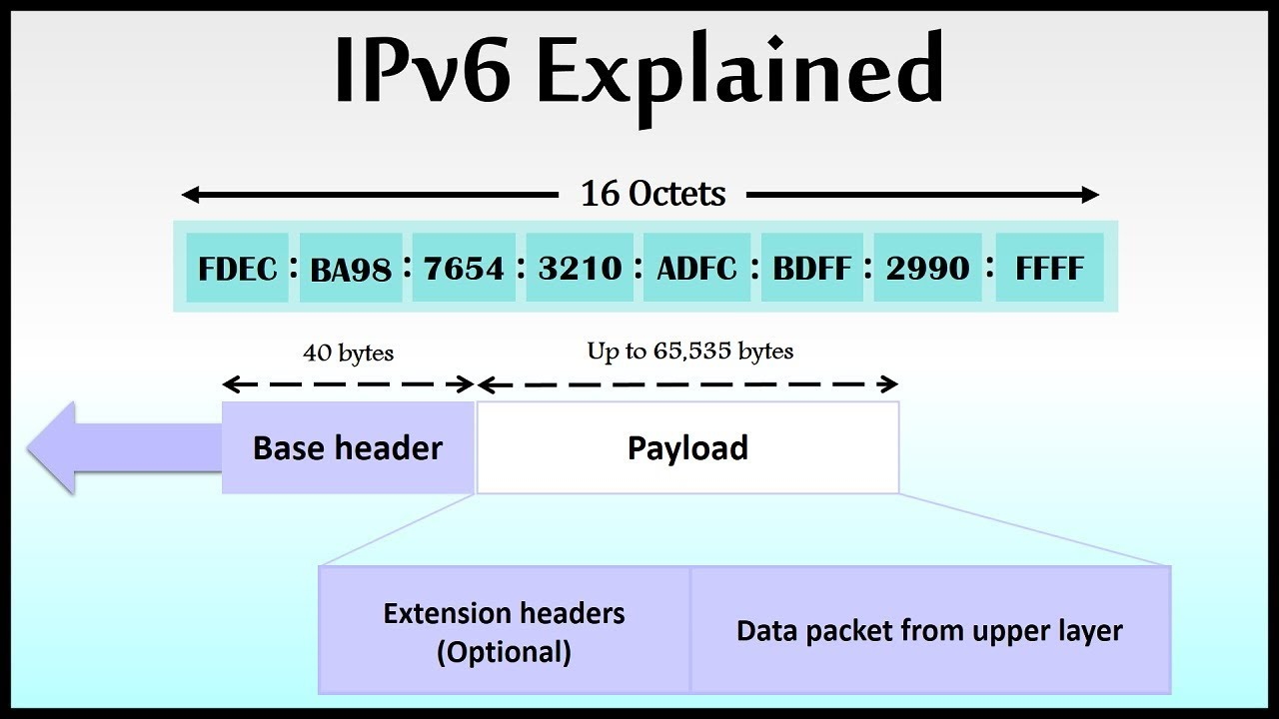

3.Benefits of Ipv6

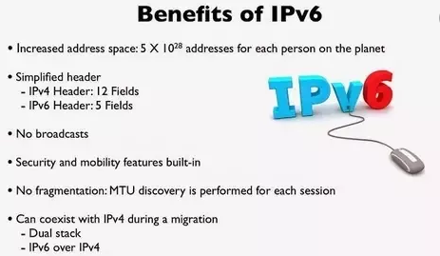
IPv6 is the protocol of the Future Web World. There are numerous benefits of Ipv6; some are discussed below:

3.1 Address Space
The major benefit of using IPv6 is its large address space.IPv6 address is 128 bits long, which means it can accommodate 2¹²⁸ different addresses. The subnet size in IPv6 is 2⁶⁴ addresses that are about four billion times more than the size of the IPv4 address space. This huge subnet space enables in improving the overall efficiency of data transmission as well as proper network management.

3.2 Security
Internet Protocol Security (IPsec) helps in maintaining data integrity, data confidentiality, and provides proper authentication measures.(Hagen, 2011) In Ipv6, the data and information to be transmitted are authenticated and encrypted to ensure security between two systems(source and destination) that communicate over the Internet.

3.3 Multicasting
Multicasting means the transferring of data from source to multiple destinations simultaneously.(Deering, August 1989) IPv6 broadcasts the data to multiple destination machines by forwarding a data packet to a multicast address. Multicast address corresponds to a group of systems referred to as multicast group. The multicast address in Ipv6 has prefix ff00::/8. When a data packet is sent to the multicast address, it contains a unicast address of the source(Savola et al, 2004), making the data more secure.

3.4 Simple Network Configuration
IPv6 enables the systems to generate their IP addresses. It can be done by appending the EUI converted MAC address of the host with the local-link address prefix. The local-link address prefix can be obtained from the router advertisement sent b the router. In this way address can be automatically configured.

3.5 Smooth Data Flow
IPv6 used multicasting. Due to multicasting, the data and information flowing through the Internet support bandwidth-intensive data flow. This helps to save the overall bandwidth of the network. The header in IPv6 contains a filed called the Flow Label, used for packet identification and filtering packets that have a similar flow.

3.6 Efficient Data Processing
The processing of data packets in IPv6 is very efficient. When the data packet is transmitted, it doesn't need to get into IP level checksum. IP level checksum is very important but in Ipv6 it can be ignored as there are checksums already at link layers and transport layers that provide error detection then why waste time in calculating checksums at each router hop.

3.7 Efficient Routing
The routing of data packets with IPv6 is very efficient and effective. This is due to the fact that the size of the routing tables in IPv6 is less in comparison to IPv4. IPv6 works by enabling the Internet Service Providers to combine all the prefixes of their clients' networks and communicate this combined prefix to the IPv6 Internet. In IPv6, the source machine handles the fragmentation in place of the router and thus reducing the router's load and increasing its capacity.

3.8 Scope of New Value Services
IPv6 enables the creation of new value services. The Network Address translation, popularly known as NAT, is eliminated in IPv6. Besides this, it supports the end to end connectivity at the Internet Protocol layer. These things assist in easy implementation of peer to peer networks that are easy to maintain and efficient at the same time.

4. Deployment Issues
It's been years since IPv6 has been launched. In these years, we are still not able to make a complete transition from IPv4 to IPv6. Why is this so?. Because of the deployment issues associated with it. To understand these issues, let us discuss them in detail.
Deploying IPv6 is a big challenge in itself. There are many threats and issues a practitioner faces when he starts deploying IPv6. The positive thing is that many organizations around the globe have made the transition successfully.
While thinking of deploying IPv6, one thing is understood that while transitioning from IPv4 to IPv6, nothing can be done at once. But a slow approach should be followed, running both IPv4 and IPv6 parallelly and slowly reducing IPv4 use and increasing IPv6. Then gradually adopting IPv6 as a whole. It sounds easy, but it is not so easy. Several issues are related to this transition. Some are:

4.1 Network Infrastructure Issue
Failure to analyze network infrastructure and analysis of the data routing before deploying IPv6 results in failure of the deployment process of IPv6. When IPv6 is deployed in subnets, there is a need to watch on the path to the backbone network. It should be enabled; otherwise, you will end up with broken links that take you nowhere.

4.2 Application Compatibility Issue
Transitioning to IPv6 can lead to various application compatibility issues. The network applications running within an organization should be compatible with IPv6. These should be tested before making the transition, or some alternative applications compatible with IPv6 should be kept handy in order to retain smooth organizational functioning.

4.3 Network Performance Issue
Network performance is a big issue that is encountered with Ipv6. There are some network vendors whose firmware still does not supports IPv6. This should be taken care of before deployment. Deployment of IPv6 in such cases requires firmware migration, and most of the time's hardware upgrading is also needed to maintain the network performance.

4.4 Security and Maintenance
Maintaining security is a big issue while transitioning from IPv4 to Ipv6. Proper threat assessments are needed, as every protocol has a different level of vulnerabilities. The security and maintenance policies need to be updated before the deployment starts.

4.5 DNS and DHCP Architectural Issues
The DNS and DHCP Architecture must be tested for interoperability. The compatibility with IPv6 is very important as a failure of which can lead to huge trouble and losses. The IPv6 readiness of the whole DNS and DHCP infrastructure should be accessed before any other step. All the servers in use should be IPv6 compliant.

4.6 IP Address Configuration Tracking
The most basic change that IPv6 deployment brings is on the IP address management and assignment. A transition from a 32-bit addressing scheme to a 128-bit addressing scheme requires changes to be implemented in the configuration and tracking systems, too, that should be incorporated before the actual deployment of the protocol. The processes that are used for tracking IPv4 addresses are of no use with IPv6 addresses. IPv6 requires IPv6 compatible automated tools for IP Management.
Apart from these issues, there are several other issues too that need to be considered before transitioning from IPv4 to IPv6. The first step towards transitioning to IPv6 is to analyze, review, update, and upgrade all the existing infrastructure components and services for achieving a successful transition.

5. Conclusion
When in the year 2011, the address space of IPv4 exhausted, and IPv6 was launched in June 2012, the whole internet world got a big boom. IPv6 was intended to replace IPv4 and provided a lot of benefits to the users. Apart from a large address space, Ipv6 provides numerous other benefits also. Various other benefits of Ipv6 include multicasting, smooth flow of data, enhanced security, efficient routing, and much more. But as we know, with everything that has several positive aspects, there are some negative issues also. Same with Ipv6, Ipv6 has some associated deployment issues. The issues related to the transitioning from IPv4 toIPv6 are discussed in detail. These include compatibility issues, address configuration issues, IP tracking issues, network performance issues, etc. These issues, if handled correctly with prior and proper preparedness, can lead to a successful transition from IPv4 to IPv6.

Referencess
Deering, S., & Hinden, R. (1998). Internet protocol, version 6 (IPv6) specification..
Deering, S. E. (1989). RFC1112: Host Extensions for IP multicasting.
Hagen, S. (2011). Planning for IPv6: IPv6 Is Now. Join the New Internet. " O'Reilly Media, Inc.".
Savola, P., & Haberman, B. (2004). RFC3956: Embedding the Rendezvous Point (RP) Address in an IPv6 Multicast Address.
Siddiqui, A. (2018). RFC 8200–IPv6 has been standardized. Internet Society, 1.
Rajahalme, J., Conta, A., Carpenter, B., & Deering, S. (2004). IPv6 flow label specification. RFC3697, March

II. Part 2: IP Addressing Scheme
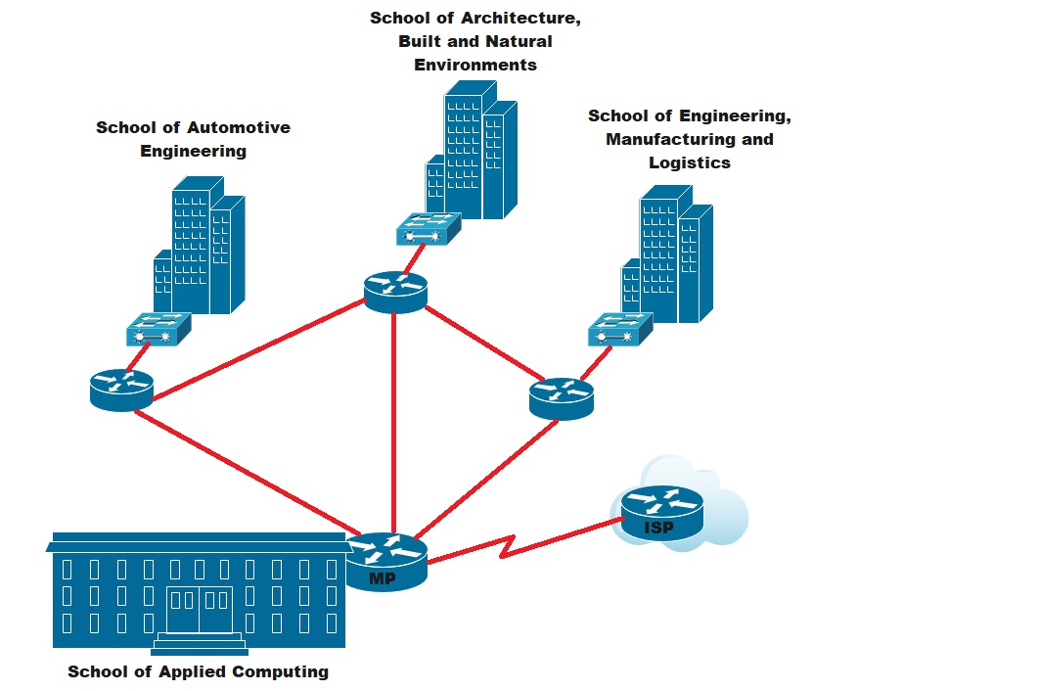
For the Faculty’s network, I choose the following address: 172.16.0.0/20. This is class B address and it suits up to 4,094 hosts, which is more than enough to support 2000 users and future growth. I subdevided it to 4 networks:
- School of Applied Computing with network address: 172.16.0.0/20, 1,022 allocated hosts, 704 required for the labs, which as well as, includes an Open Access lab with 240 pcs and 5 printers.
- School of Automotive Engineering with network address: 172.16.6.0/23, 510 allocated hosts, 285 required for the labs.
- School of Architecture, Built and Natural Environment with network address 172.16.4.0/23, 510 allocated host, 337 required for the labs.
- School of Engineering, Manufacturing and Logistics with network address 172.16.8.0/23, 510 allocated hosts, 278 required for the labs.

School of Applied Computing – Network Address 172.16.0.0/22
Lab no | Network Address | First IP Address | Last IP Address | Broadcast | Subnet Mask
OA – 245 devices | 172.16.0.0/24 | 172.16.0.1 | 172.16.0.254 | 172.16.0.255 | 255.255.255.0
TC – 18 devices | 172.16.3.32/27 | 172.16.3.33 | 172.16.3.62 | 172.16.3.63 | 255.255.255.224
Staff 25 pcs | 172.16.2.224/27 | 172.16.2.225 | 172.16.2.254 | 172.16.2.255 | 255.255.255.224
Lab 301 – 50pcs | 172.16.1.192/26 | 172.16.1.193 | 172.16.1.254 | 172.16.1.255 | 255.255.255.192
Lab 302 – 30pcs | 172.16.2.128/27 | 172.16.2.129 | 172.16.2.158 | 172.16.2.159 | 255.255.255.224
Lab 303 – 30pcs | 172.16.2.160/27 | 172.16.2.161 | 172.16.2.190 | 172.16.2.191 | 255.255.255.224
Lab 305 – 20pcs | 172.16.3.0/27 | 172.16.3.1 | 172.16.3.30 | 172.16.3.31 | 255.255.255.224
Lab 306 – 40pcs | 172.16.2.0/26 | 172.16.2.1 | 172.16.2.62 | 172.16.2.63 | 255.255.255.192
Lab 308 – 120pcs | 172.16.1.0/25 | 172.16.1.1 | 172.16.1.126 | 172.16.1.127 | 255.255.255.128
Lab 411 – 30pcs | 172.16.2.192/27 | 172.16.2.193 | 172.16.2.222 | 172.16.2.223 | 255.255.255.224
Lab 410 – 60pcs | 172.16.1.128/26 | 172.16.1.129 | 172.16.1.190 | 172.16.1.191 | 255.255.255.192
Lab 412 – 36pcs | 172.16.2.64/26 | 172.16.2.65 | 172.16.2.126 | 172.16.2.127 | 255.255.255.192
School of Automotive Engineering – Network Address 172.16.6.0/23
Lab no | Network Address | First IP Address | Last IP Address | Broadcast | Subnet Mask
Staff - 20 pcs | 172.16.7.64/27 | 172.16.7.65 | 172.16.7.94 | 172.16.7.95 | 255.255.255.224
Lab 101 – 25pcs | 172.16.7.32/27 | 172.16.7.33 | 172.16.7.62 | 172.16.7.63 | 255.255.255.224
Lab 102 – 35pcs | 172.16.6.192/26 | 172.16.6.193 | 172.16.6.254 | 172.16.6.255 | 255.255.255.192
Lab 103 – 30pcs | 172.16.7.0/27 | 172.16.7.1 | 172.16.7.30 | 172.16.7.31 | 255.255.255.224
Lab 205 – 20pcs | 172.16.7.96/27 | 172.16.7.0.97 | 172.16.7.126 | 172.16.7.127 | 255.255.255.224
Lab 206 – 55pcs | 172.16.6.128/26 | 172.16.6.129 | 172.16.6.190 | 172.16.6.191 | 255.255.255.192
CAD Lab – 20pcs | 172.16.7.128/27 | 172.16.7.129 | 172.16.7.158 | 172.16.7.159 | 255.255.255.224
Lab 301 – 80pcs | 172.16.6.0/25 | 172.16.6.1 | 172.16.6.126 | 172.16.6.127 | 255.255.255.192
School of Architecture, Built and Natural Environment – Network Address 172.16.4.0/23
Lab no | Network Address | First IP Address | Last IP Address | Broadcast | Subnet Mask
Staff - 32 pcs | 172.16.5.0/26 | 172.16.5.1 | 172.16.5.62 | 172.16.5.63 | 255.255.255.192
Lab 201 – 54pcs | 172.16.4.64/26 | 172.16.4.65 | 172.16.4.126 | 172.16.4.127 | 255.255.255.192
Lab 202 – 25pcs | 172.16.5.160/27 | 172.16.5.161 | 172.16.5.190 | 172.16.5.191 | 255.255.255.224
Lab 203 – 30pcs | 172.16.5.64/27 | 172.16.5.65 | 172.16.5.94 | 172.16.5.95 | 255.255.255.224
Lab 205 – 28pcs | 172.16.5.96/27 | 172.16.5.97 | 172.16.5.126 | 172.16.5.127 | 255.255.255.224
Lab 404 – 35pcs | 172.16.4.192/26 | 172.16.4.193 | 172.16.4.254 | 172.16.4.255 | 255.255.255.192
Lab 408 – 28pcs | 172.16.5.128/27 | 172.16.5.129 | 172.16.5.158 | 172.16.5.159 | 255.255.255.224
Lab 409 – 60pcs | 172.16.4.0/26 | 172.16.4.1 | 172.16.4.62 | 172.16.4.63 | 255.255.255.192
Lab 410 – 45pcs | 172.16.4.128/26 | 172.16.4.129 | 172.16.4.190 | 172.16.4.191 | 255.255.255.192
School of Engineering, Manufacturing and Logistics – Network Address 172.16.8.0/23
Lab no | Network Address | First IP Address | Last IP Address | Broadcast | Subnet Mask
Staff - 18 pcs | 172.16.9.96/27 | 172.16.9.97 | 172.16.9.126 | 172.16.9.127 | 255.255.255.224
Lab 301 – 35pcs | 172.16.8.192/26 | 172.16.8.193 | 172.16.8.254 | 172.16.8.255 | 255.255.255.192
Lab 302 – 30pcs | 172.16.9.0/27 | 172.16.9.1 | 172.16.9.30 | 172.16.9.31 | 255.255.255.224
Lab 303 – 30pcs | 172.16.9.32/27 | 172.16.9.33 | 172.16.9.62 | 172.16.9.63 | 255.255.255.224
Lab 305 – 25pcs | 172.16.9.64/27 | 172.16.9.65 | 172.16.9.94 | 172.16.9.95 | 255.255.255.224
Lab 306 – 50pcs | 172.16.8.128/26 | 172.16.8.129 | 172.16.8.190 | 172.16.8.191 | 255.255.255.192
Lab 308 – 90pcs | 172.16.8.0/25 | 172.16.8.1 | 172.16.8.126 | 172.16.8.127 | 255.255.255.128

Ipv6 addressing
DNS server | ::ffff:ac10:348
Email server | ::ffff:ac10:348
Finance server | ::ffff:ac10:348
Registry server | ::ffff:ac10:348
File server | ::ffff:ac10:348
Printer server | ::ffff:ac10:348
Link between MP and ISP server | ::ffff:ac10:340

