Unit 4 Topic 3: Reflection
This section has three sub-sections. These are:
Sub-section 1: Reflectivity as a mindset
Sub-section 2: Models of reflection
Sub-section 3: Practicing reflection

WHAT DO YOU KNOW?
Before you start this section, it is important that you take some time to think about what you already know in relation to reflection.
Please take some time to answer the questions below and rate your confidence in each topic area. Use the following key to complete your answers to questions 1 to 4 and type your answers out in the answer boxes. You can then write out your answer in full for question 5.
At the end of the unit, you will be asked to take another look at these questions so that you can rate your confidence again and identify how you have progressed throughout the unit and how your knowledge and awareness in each area has developed.–

1 | Not confident at all
2 | A little confident
3 | Somewhat confident
4 | Confident
5 | Very confident
6 | Confident enough to share my knowledge with others

What do you know?
- How confident are you in your knowledge of reflective practice?
- How confident are you in your understanding of the process of reflexivity?
- How confident are you in your ability to apply appropriate models of reflection?
- How confident are you in your understanding of locus of control?
- What are you hoping to learn in this section?

Sub-section 1: Reflectivity as a mindset

Upon completion of this sub-section, you will be able to:
- Recognise reflexivity as a mindset (learning through experience).

Introduction
In this sub-section, you will explore how reflection facilitates ongoing personal and professional learning; developing and creating individuals capable of demonstrating progression towards learning outcomes, whilst also providing a structure in which to make sense of learning.​

Introductory activity
Test your knowledge by doing the one-minute exercise:
Set a timer and see how much you can write about your knowledge of reflection in one minute.
Then, review the next slide. Did you write something similar to this?

​What is reflection?
Reflecting is a process which allows you to think deeply about something that you might not otherwise have considered, which helps to develop and reinforce learning.
To reflect, you must consciously think about and look back on your experiences, actions, feelings, and responses. You must then interpret or analyse these in order to learn from them. (Atkins and Murphy, 1994; Boud et al., 1994).

The best way to reflect would be to ask yourself questions on what you did, how you did it, and what you learnt from this. In order to reflect effectively, you must spot any patterns emerging as a result of your experiences and responses, and identify any links between your thoughts.

Becoming reflective
Critical thinking requires you to ‘unpack’ whatever you are focusing on. You should never simply accept everything you hear and read at face value – you must always unpack it using the skills needed to reflect by looking, listening and pausing. This will allow you to identify things you may otherwise not notice.

Moon (2004) likens this reflective process to using a ‘pensieve’, a fictional instrument seen in the Harry Potter series.

Key Quote:
‘One simply siphons the excess thoughts from one’s mind, pours them into the basin, and examines them at one’s leisure. It becomes easier to spot patterns and links, you understand, when they are in this form.’
- (Rowling, 2000, pp.518) Harry Potter and the Goblet of Fire

Learning through reflection
Reflecting on your own academic or professional practice through questioning helps you to identify your personal expectations, biases and beliefs more easily. Developing an understanding of yourself can help you to succeed more effectively in your studies through an increases awareness of your automatic assumptions.

Ask yourself:
- What did I do?
- How did I do it?
- What did I learn?
What is reflexivity?
In order to learn from your experiences, you must consider not only the practice of reflection, but also the process of reflexivity. Your previous experiences, attitudes and beliefs influence your thought processes, and being reflexive involves being open-minded in examining the influence that these will have on your thinking.

Click on the link to watch a video on reflexivity in perception:

https://youtu.be/VcHT10xICKg

Ann Cunliffe Reflexivity (watch from 1:28 – 2:44):
https://www.youtube.com/watch?v=ejKK0E2gwU0

Do you see what I see? The story behind the picture
As explored in Cunliffe’s video, reflexivity involves questioning your own assumptions, which you would usually take for granted, by actively questioning why you make such assumptions. You will now look at how your attitudes, beliefs and values inform your perceptions and how these differ from others using critical thinking.

Stop and Think
Remembering and recalling key learning
Building on the themes introduced in the video, take a look at the picture below. What do you see? Post your thoughts to the forum.

Application
Consider the similarities and differences between your answers and those of others.

Developing depth
Can you think of any assumptions, beliefs or previous experiences you have had that may explain the differences between your own answers and those of others?

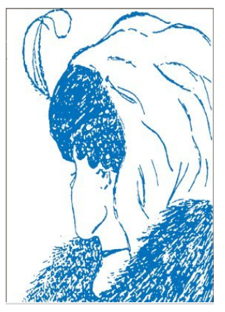(Source: Mullins, 2016, p 184)
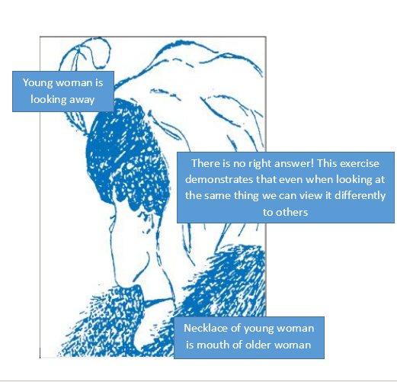

This demonstrates how your attitudes, beliefs and values can inform your perceptions and how these differ from others. When you meet people, you automatically make assumptions about them based on your past experiences.​

Let’s Summarise
- Fill in the missing word. ‘Reflection is concerned with consciously looking at and thinking about our--------------, actions, feelings, and responses, and then interpreting or analysing them in order to learn from them.’ (Experiences)
- Fill in the missing words. ‘The key to reflecting is spotting the -------- and -------- in thought that emerge as a result of your experiences in life and in learning.’ (patterns and links)
- Which is the correct statement?
- Attitudes and beliefs allow you to ‘unpack’ whatever you are focusing on and not simply accept what you read or hear at face value.

- Critical thinking requires you to ‘unpack’ whatever you are focusing on and not simply accept what you read or hear at face value.

- Having a biased attitude allows you to ‘unpack’ whatever you are focusing on and not simply accept what you read or hear at face value.

Sub-section 2: Models of reflection

Upon completion of this sub-section, you will be able to:
- Select and apply appropriate models of reflection.

Introduction
The aim of this session is to introduce you to models you can use to frame your reflective practice.​
You are learning everyday through experience, trial and error and reflecting on how you could improve your performance. In the context of your studies, you will frequently be asked to reflect on learning using a deliberate process.

For the purpose of this sub-section, you will be looking at Gibbs’ reflective model. However, you will be asked to research other reflective models later in the section.

Introductory activity
Watch the following video that explains Gibbs’ reflective cycle:
https://www.youtube.com/watch?v=-gbczr0lRf4

Gibbs’ reflective cycle includes six stages of reflection, as seen in the diagram below.
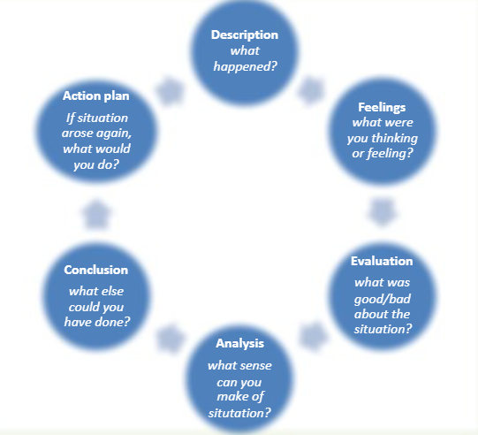
Source: Dye, V. (2011) ‘Reflection, Reflection, Reflection. I’m thinking all the time, why do I need a theory or model of reflection?’, in McGregor, D. and Cartwright, L. (ed.) Developing Reflective Practice: A guide for beginning teachers. Maidenhead: McGraw-Hill Education (pp. 217-234).
You can use this reflective framework to structure your response to the assessment brief.

Description
This section must set out what you will be reflecting on. It should include context, including what you are reflecting on and who was involved. Ensure that any information you choose to include is relevant and straight to the point. You do not need to waste time on details that aren’t necessary, as these won’t benefit your assessment.

Feelings
Here, you should explore your thoughts and feelings about what you are reflecting on. The following questions may help you with this:
- What did you think at the time?
- How did you feel at the time?
- What did you think about the situation afterwards?
You can be open and honest about your feelings, but bear in mind that you are reflecting academically and should always be writing professionally.

Evaluation
This section should discuss how well you think things went. You could also incorporate the theory and work of other authors and theorists here – remember, it is important to reference any wider reading you have done. You can consider questions such as the following:
- How did you react to the situation?
- How did other people react to the situation?
- What was good and bad about the experience?
- If you are reflecting on a difficult situation, did you feel that the situation was resolved afterwards? Why/why not?

Analysis
This section is crucial to get right, as many students are let down by failing to bring together their experience and theory in a reflective assignment. Your analysis should include considerations of what might have helped or hindered the situation. You should also use this section to compare your own experience with any relevant works you have read, in order to boost your grade.

Conclusion
Your conclusion should acknowledge the things you did right, what you learnt from this, whether there is more you could have done, or whether you could have responded differently. If you are reflecting on a negative experience, explore how you could have avoided the situation occurring and how you can ensure that it doesn’t happen again. If the situation was positive, consider whether you would change anything should the situation happen again in order to ensure another positive outcome, or if there are things you could change to improve things further.

Action plan
You can create an action plan to remind you of what to improve next time and any information you need to bear in mind, for example any further training or learning you need to undertake. From this, you could ask your tutor for some advice in order to achieve this. Consider anything you can do to ensure that you are better equipped to cope with a similar situation in future.
Source: https://www.coursehero.com/file/30942234/ReflectiveCycleGibbspdf/

Using Gibbs’ reflective model in reflective writing
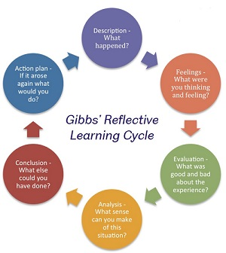

Source: https://www.sheffield.ac.uk/ssid/301/study-skills/university-study/reflective-practice

Stop and Think

Remembering and recalling key learning
List the six elements of the Gibbs model.

Application
Refer back to your reflective blog from Section 3 – ‘My Experience on Virtual Collaboration’. Rewrite your blog using the Gibbs headings as a guide. To help you with this task, an example of a piece of reflective writing following Gibbs’ model can be found in the ‘Learn More’ tab.

Developing depth
Take some time to look into different reflective models. Some are very similar, but most learners will find their favourite and stick with it throughout their academic career. Some may even use the same model throughout any reflections in employment too.

Other examples of reflective models include:
- Kolb (1984)
- Driscoll (1994)
- Johns (2006)
- Schön (1991)
- Rolfe (2001)
- Brookfield (2005).

Do you have a favourite? Post your thoughts to the Padlet along with a brief explanation of your choice, and share some likes.

Example
The following text is an example of a piece of reflective writing, following Gibbs’ model. The task was to write a reflection about an incident which occurred during the first few weeks of a teaching placement (1,000 words). Please note that the references used are fictional. This example is taken from https://my.cumbria.ac.uk/media/MyCumbria/Documents/ReflectiveCycleGibbs.pdf

Description
I am currently on a teaching practice placement in an adult education college in the south-west of England, learning how to teach GCSE maths to various groups of adults. As my placement is in the early stages, I am mainly assisting the class tutors and have just started planning and delivering a small part of each lesson. The incident occurred in an evening class during which I was due to deliver my very first session. The class tutor had been teaching the learners about fractions, and my task was to continue with this instruction, looking specifically at how to multiply two fractions. However, when I was due to teach the session, I got to the whiteboard and became so nervous that I struggled to speak to the group. I felt myself visibly shaking and was unable to articulate my first sentence coherently. The students were quite understanding, as they are all mature students who are aware that I am new to teaching and am nervous, but the class teacher was unsympathetic and responded by taking over the lesson whilst I sat at the back of the room trying not to cry. I left the session as soon as the class was over, and did not speak to anyone.

Feelings
I felt extremely miserable at the time and even considered leaving my teacher training course. I was also embarrassed and upset by my own inability to speak in front of the group, but I was also extremely angry with the class teacher for her response in the presence of the learners. I felt afterwards that she had not given me sufficient time to compose myself, and that she should have allowed me to address my nerves. The situation left me very distressed and I rang in sick the following week; it was only when I reflected on the experience that I decided I needed to speak to the placement supervisor. I also realised later that feeling nervous is a natural reaction to speaking in public (Jones, 2000) which made me feel less embarrassed.

Evaluation
At the time, I did not feel that the situation had been resolved at all. I very deliberately left at the end of the class without speaking to the class teacher or the learners. However, after speaking to a fellow trainee about his own experience, I felt much more positive. I realised that everyone feels nervous before their first few classes. This is clear in the relevant literature, as Greene (2006, p. 43) points out, saying that nine out of ten new trainee teachers found their first session “incredibly daunting”. It appears that most trainee teachers have moments of being “tongue-tied” and “losing their way with the lesson” (Parbold, 1998, p. 223).

Analysis
The situation was made worse by both my own actions and those of the class teacher. I feel that I should have stood up to her, rather than letting her take control of the lesson, and that I should have spoken to her immediately after the lesson about how I was feeling. Dealing with situations like this immediately is preferable, as Cooper (2001) points out. Instead, I spoke to my placement supervisor several days later, and did not see the class teacher again until a formal meeting consisting of myself, the teacher and the supervisor. Daynes and Farris (2003) say that, by not dealing with situations immediately and personally, and instead taking it to an authority figure, the situation can be made worse. The class teacher could have felt that she was being “ganged up on” (Thomas, 2003, p. 22), which could lead to future problems. The teacher’s actions also made the situation worse, because she did not give me time to overcome my fears and she deliberately embarrassed me in front of the class. She claimed that she had thought she was helping me to overcome my anxieties, but I do not believe that to be the case. However, as we only spoke about the incident over a week later in the meeting with the supervisor, she rightly argued that I should have said something to her at the time.

Conclusion
In retrospect, I would do several things differently. I should have spoken to the class teacher immediately after the session and voiced my opinions. I should also have been more assertive by advising the tutor that I could continue with the lesson. However, the incident made me realise the importance of building up a relationship with the teacher, a skill that Jackson (1999) stresses as fundamental to a successful placement. I feel that, had I developed a professional relationship with the teacher in the preceding weeks would have been able to explain how nervous I was beforehand. This would have provided the opportunity to discuss strategies for dealing with nerves and perhaps the incident could have been avoided entirely.

Action Plan
In future, I will ensure that I build up a relationship with colleagues. I am working alongside several different teachers during my placement, and I intend to speak to each of them about my nerves. I have already had a beneficial conversation with one teacher and together we have developed a programme of team-teaching for the next few weeks so that I do not feel so pressurised. I plan to do this with the other class teachers, as it will help them to understand how I feel. I also need to speak to my fellow trainees more often about how they feel, as I think I will be able to learn from them. In terms of training, I have booked onto a presentation skills workshop at University, and intend to follow it up by attending the practise sessions afterwards. This experience has made me realise that I need to gain more confidence with presenting, and I feel addressing my presentation skills will help me to do this.

Let’s Summarise:
Drag and drop exercise in order for design purposes
Match the correct sentence to each element of the Gibbs model:

Explain what you are reflecting on Description
Discuss your feelings and thoughts about the experience Feelings
Discuss how well you think things went Evaluation
Consider what might have helped or hindered the event Analysis
What else could you have done, and what have you learnt from the experience? Conclusion
Sum up anything you need to know and do to improve for next time Action plan

Sub-section 3: Practicing reflection

Upon completion of this sub-section, you will be able to:
- Reflect on your own process and progress as a learner.

Introduction
The aim of this sub-section is to get you thinking about how you can apply reflective practice to your own development.

Introductory Activity

Do you make things happen, or are you at the mercy of chance? Consider this question and write a summary of your thoughts on the topic.

Key Quote
“I am the master of my fate; I am the captain of my soul”
- Nelson Mandela

Locus of control–
Whether you choose to attribute your failure and success to forces outside of your control or things you can control can affect your long-term success. This orientation is known as your ‘locus of control’. One of the main questions asked is ‘Are you the master of your fate?’. Your locus of control reflects the way in which you view the world and your role in determining the course of your life.

- Power and destiny - If you believe that the power to control and determine your own destiny and direction lies with yourself, you have a strong internal locus of control. This is generally an important attitude to have in order to succeed.

- Adapt to succeed – Those who have a strong internal locus of control tend to work harder and persevere longer in order to achieve what they want. However, having an external locus of control is not necessarily bad, as there are certain situations in which this approach can be useful. For your own personal development, it is vital to understand your natural tendencies and then adapt this to the situations you are faced with. (Mindtools, n.d)
.
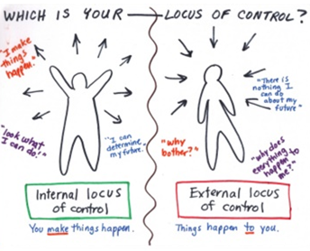

(Source: https://www.kgrierson.com/uncategorized/understanding-relational-locus-control/)

How well do you understand your locus of control?
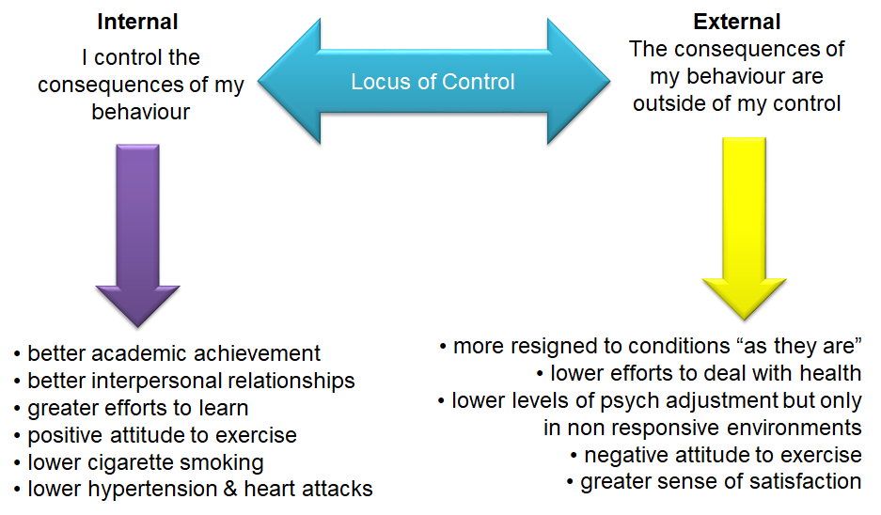

Drag and drop quiz: Choose internal or external in order for design purposes

Internal
- Better academic achievement
- Better interpersonal relationships
- Greater efforts to learn
- Positive attitude to exercise

External
- More resigned to conditions ‘as they are’
- Lower efforts to deal with health
- Negative attitude to exercise

Stop and Think
Remembering and recalling key learning
Recall what is meant by an internal and external locus of control.

Application
Undertake the online self-assessment via the following link to assess your own locus of control:
https://www.mindtools.com/pages/article/newCDV_90.htm

Developing depth
What impact does your locus of control have on your learning, and how can you develop a more internal focus?
Reflect on an experience that did not go as you planned, e.g. some feedback on an assessment that you were expecting would be more positive. How did you react? Did you blame external factors, such as tutors, time, events etc., or did you think about how you could improve next time?

Further Research
Research some methods to help you develop a more internal locus of control and write down three actions you will take using the ‘My Notes’ tab.

Here are some links that might help you:

https://www.mindtools.com/pages/article/locus-of-control.htm
https://psychcentral.com/blog/cultivating-an-internal-locus-of-control-and-why-its-crucial/
https://themotivationmindset.com/internal-locus-of-control/

Stop and Think
Personal and Academic Development – Reflection
Quiz – How reflective are you?

Take this self-assessment to see how reflective you are. Simply circle the letter for the statements that apply to you.

1 You receive a poor mark for an assignment. Do you:
- Look at where you went wrong, seek advice, and talk to your tutor about how to improve future performances?
- Feel overwhelmed by emotion and think ‘I’m a failure, I’ll never be able to do this, I might as well give up’?
- Feel quite angry and dismiss the mark, arguing that ‘It was good enough before coming to university – clearly they haven’t a clue’?
2 You are facilitating a group. The session goes particularly well. Do you:
- Spend time thinking about the group and try to identify what made it so successful, drawing up ideas for ways to facilitate future sessions?
- Think ‘What a complete fluke. More luck than judgement.’?
- Take it in your stride: ‘Of course it went well. After all, it was your group.’?
3 What items do you associate with reflection?
- A journal and a diary
- A notebook and a mirror
- A mirror and a hairbrush
4 Which of these statements do you most closely identify with?
- Before I tackle something new, I tend to think back to previous experiences and draw on my learning from these.
- I worry about trying new things, particularly if I have not done anything like this before.
- I tend to jump into situations, and I enjoy the thrill of seeing what happens.
5 Identify the statement you agree with the most.
- Reflection is a skill that needs to be developed.
- We all reflect naturally.
- Reflection is a form of navel-gazing.

Results
If you have answered mainly a), congratulations! You recognise that reflection is an active process that enables you to transform experience into learning.

If you have answered mainly b), you may mistakenly assume that reflection is quite a passive process and something that you are already doing. However, your answers suggest that, at times, you are too emotionally close to a situation, which makes it difficult for you to revisit experiences to gain the depth of learning reflection offers.

If you have answered mostly c), your confidence does you credit, but make sure that it does not act as a barrier to your learning and prevent you from gaining insight to areas where you need to develop. If you constantly find yourself thinking ‘I’m alright, it is the rest of the world that is wrong’, you might want to revisit some of the materials covered in this section.

(Adapted from source: Chapter 9 of Craig, C. (2009) Study Skills for Health and Social Care Students. London: Sage)

Let’s Summarise
      - Having a strong internal locus of control means:
- Believing that you are in control of your destiny
- Believing that other forces are in control of your destiny
      - Having an external locus of control is always a bad thing. True or false?

WHAT DO YOU KNOW?
Now you have completed this resource, it is important that you take some time to reflect on what you have learnt in relation to reflection. –
Take some time to answer the same questions you answered at the start of the resource, to see how much your knowledge has developed. Please use the same key to answer the first four questions and then type your answer out for question 5.

1 | Not confident at all
2 | A little confident
3 | Somewhat confident
4 | Confident
5 | Very confident
6 | Confident enough to share my knowledge with others

What do you know?
- How confident are you in your knowledge of reflective practice?
- How confident are you in your understanding of the process of reflexivity?
- How confident are you in your ability to apply appropriate models of reflection?
- How confident are you in your understanding of locus of control?
- How do you think your knowledge has improved since beginning this section?

Further Reading
Mullins, L. J. (2016) Management and organisational behaviour.11th edn. Essex: Pearson Education.

Dye, V. (2011) ‘Reflection, Reflection, Reflection. I’m thinking all the time, why do I need a theory or model of reflection?’, in McGregor, D. and Cartwright, L. (ed.) Developing Reflective Practice: A guide for beginning teachers. Maidenhead: McGraw-Hill Education (pp. 217-234).

Hargreaves, J. & Page, L. (2013) Reflective Practice. Cambridge: Polity Press

