University of Wales Trinity Saint David
Wales Institute of Science & Art



Design of Filter circuit
ELECTRICAL PRINCEPLES (ACMA4031)

Isaac Wilmore
2519409
May 2026

1. Abstract 2
Introduction 2
2. Circuit Description 3
2.1. Low-pass filter 3
2.2. High-pass filter 3
2.3. Theoretical cutoff theory 4
2.4. Measurement method 4
3. Results 5
3.1. Low-pass filter 5
3.2. High-pass filter 6
4. Discission 8
5. Conclusion 9
6. Reference 9
Bibliography 9

Abstract

This report presents the analysis and experimental investigation of first-order RC low-pass and high-pass filters. The aim of the work was to develop practical measurement skills and data analysis techniques using circuit simulation software and laboratory equipment. The cutoff frequencies for both filters were first calculated analytically using standard RC filter equations. The circuits were then constructed in a simulator and tested across a frequency range from 100 Hz to 300 kHz, maintaining a constant input signal of 4 V peak-to-peak. Output voltages were recorded, and attenuation was calculated in decibels. Graphs of attenuation versus frequency were plotted on logarithmic scales to identify the -3 dB cutoff points. The results show that the simulated and calculated cutoff frequencies closely agree, with minor deviations attributed to measurement resolution and component tolerances. The low-pass filter exhibited a cutoff frequency near 28 kHz, while the high-pass filter showed a cutoff near 1 kHz. These findings confirm the expected behaviour of first-order filters and confirm the theoretical models.

Introduction

Electronic filters are important components in signal processing systems, used to selectively allow or attenuate specific frequency ranges. Among the simplest and most widely used filters are first-order RC (resistor-capacitor) filters, which include low-pass and high-pass configurations. (Smith, 2014)

A low-pass filter (LPF) allows signals with frequencies below a certain cutoff frequency to pass through while attenuating higher frequencies (Figure 1). These are commonly used in audio systems to remove high-frequency noise or in power supplies to smooth voltage signals.

A high-pass filter (HPF) allows high-frequency signals to pass while attenuating lower frequencies (Figure 2). These are often used in communication systems to block DC offsets or low-frequency interference.

The theoretical behaviour of these filters is determined by their frequency response, which depends on the resistor (R) and capacitor (C) values (Smith, 2014). The cutoff frequency, also known as the -3 dB point, is defined as the frequency at which the output signal power drops to half of its maximum value, corresponding to approximately 0.707 of the input voltage.

Circuit Description
  - Low-pass filter
The low-pass filter consists of a resistor (10 kΩ) in series with the input signal and a capacitor (560 pF) connected to ground (All About Circuits, 2026), see Figure 1 for representation of the circuit diagram.
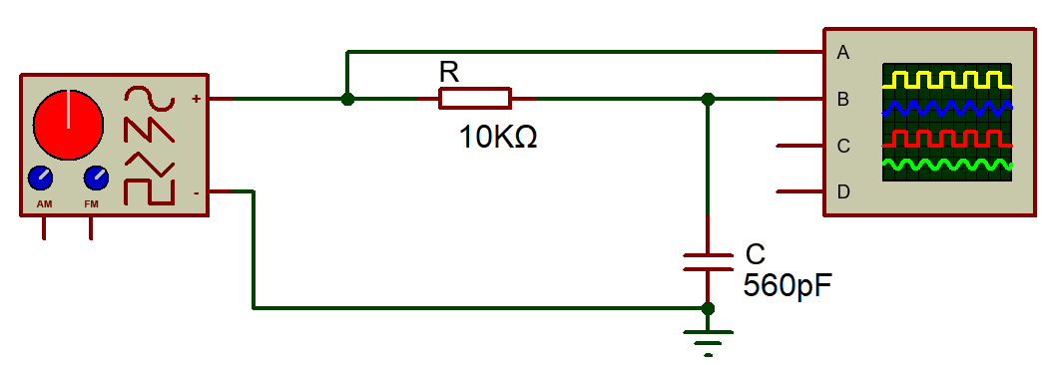
Figure 1 : Low-pass filter

The output is taken across the capacitor. For the parameters used, see Table 1

Table 1: Low-pass filter parameters
Component | Value
Resistor | 10 kΩ
Capacitor | 560 pF
Input signal | 4 V peak-to-peak
Frequency range | 100 Hz to 300 kHz
  - High-pass filter
The high-pass filter consists of a capacitor (15 nF) in series with the input signal and a resistor (10 kΩ) connected to ground (All About Circuits, 2026), see Figure 2 for representation of the circuit diagram.
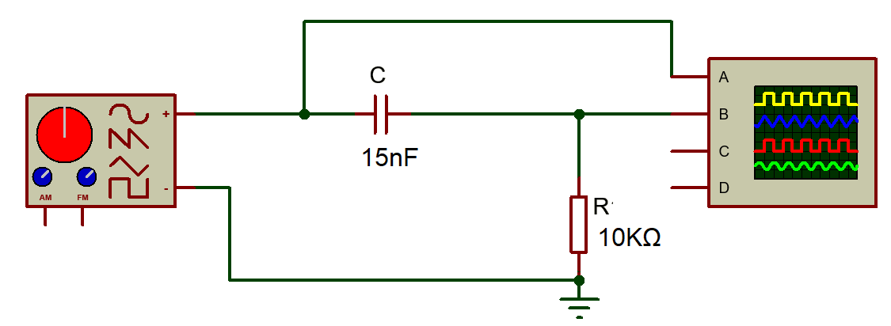
Figure 2: High-pass filter
The output is taken across the resistor. For the parameters used, see Table 2

Table 2:High pass filter parameters
Component | Value
Resistor | 10 kΩ
Capacitor | 15 nF
Input signal | 4 V peak-to-peak
Frequency range | 100 Hz to 300 kHz

  - Theoretical cutoff theory

The theoretical cutoff frequency is calculated using the formula:

Equation 1: Formula for theoretical cutoff
$$f_{c}=\frac{1}{2πRC}$$

Which, when substituting a resistance of 10 KΩ and a capacitance of 15 nF, gives a cutoff frequency of approximately 1.06 kHz, indicating the point where the circuit begins to significantly attenuate higher-frequency signals.

Equation 2: Theoretical cutoff
$$fc=\frac{1}{2π×10,000×15×{10}^{-9}}≈1.06 kHz$$

  - Measurement method

For all circuits investigated and to ensure results were accurate the following measurement methods were used:

- The input signal amplitude was fixed at 4 V peak-to-peak
- Output voltage was measured across the relevant component
- Measurements were taken at increasing frequencies, with finer steps near the cutoff region
- Attenuation was calculated using Equation 2 (Horowitz, 2015)

Equation 3: Attenuation
$$A=20\log_{10}\left(\frac{V_{Out}}{V_{In}}\right)$$

Results

The theoretical and experimental attenuation curves were plotted together for both the low-pass and high-pass filters using logarithmic frequency scales. The theoretical responses were calculated using standard first-order RC filter equations (Smith, 2014), while the experimental data was obtained from the simulated measurements.

The experimental data closely follows the theoretical curves for both filters, particularly in the region surrounding the cutoff frequency. This strong alignment validates both the analytical calculations and the simulation approach used in this task.

  - Low-pass filter

For the low-pass filter, the experimental curve aligns closely with the theoretical prediction, with the cutoff frequency observed between approximately 27.5 kHz and 28 kHz. At lower frequencies, specifically between 100 Hz and 1 kHz, the output voltage remains nearly equal to the input voltage (approximately 4 V peak-to-peak), indicating negligible attenuation. These trends are visible in Figure 4

As the frequency increases, the output voltage begins to decrease gradually, demonstrating the expected filtering effect. Around the cutoff region, the attenuation approaches −3 dB, which defines the transition point of the filter. From the recorded data, the attenuation is approximately −2.93 dB at 27 kHz and −3.16 dB at 28 kHz, confirming that the cutoff frequency lies within this range.

Above the cutoff frequency the attenuation increases steadily, and the response curve follows a smooth downward slope, consistent with the theoretical behaviour of a first-order low-pass filter.

The low-pass filter shows a flat response at low frequencies followed by a downward slope; this can be seen in Figure 3

Figure 3: Low-pass filter graph for experimental

Figure 4:Low-pass filter graph for comparison

  - High-pass filter

The high-pass filter has many similarities between theoretical and experimental results is observed. The cutoff frequency is identified at approximately 1.0 kHz to 1.05 kHz, which is in close agreement with the calculated theoretical value, and this is visible in Figure 6

At low frequencies, particularly between 100 Hz and 500 Hz, the output voltage is significantly lower than the input voltage, indicating strong attenuation of low-frequency signals. As the frequency increases, the output voltage rises steadily, reflecting the increasing ability of the filter to pass higher-frequency signals.

Around the cutoff region, the attenuation approaches −3 dB, with measured values of approximately −3.50 dB at 950 Hz, −3.27 dB at 1000 Hz, and −3.07 dB at 1050 Hz which can also be seen in Figure 5. These values confirm that the cutoff frequency occurs close to 1 kHz. At frequencies above the cutoff, the output voltage approaches the input voltage, indicating minimal attenuation and effective signal transmission.

Although the overall agreement between theoretical and experimental results is strong, minor deviations between the curves are observed, particularly at higher frequencies. These differences can be attributed to factors such as measurement resolution, component tolerances, and limitations within the simulation environment. Despite these small discrepancies, the results clearly demonstrate the expected frequency response characteristics of both low-pass and high-pass RC filters.

Figure 5: High-pass filter graph for experimental

Figure 6: High-pass filter for comparison

Discission
The results obtained from the simulation show strong alignment with the theoretical predictions for both the low-pass and high-pass filters, confirming the strength of the standard first-order RC filter equations (Smith, 2014). The close alignment between the experimental and theoretical attenuation curves, particularly around the cutoff frequency, shows that the analytical model accurately describes the behaviour of these circuits. This also indicates that the simulation environment provides a reliable representation of real circuit performance under ideal conditions.

For the low-pass filter, the observed cutoff frequency of 27.5–28 kHz closely matches the calculated theoretical value of 28.4 kHz. The experimental data shows that at low frequencies, the output voltage is still equal to the input voltage, which is consistent with the expected behaviour of a low-pass filter allowing low-frequency signals to pass with minimal attenuation.
As the frequency increases, the capacitive reactance decreases, allowing more current to pass through the capacitor and reducing the output voltage across it (Dorf, 2013). This results in the gradual attenuation observed in the results. The smooth transition through the −3 dB point and the subsequent downward slope of 20 dB per decade further confirm the expected first-order response (Horowitz, 2015).

Similarly, the high-pass filter shows behaviour that is consistent with theoretical expectations. The cutoff frequency was identified at 1.0–1.05 kHz, which is very close to the calculated value of 1.06 kHz. At low frequencies, the capacitor presents a high reactance, effectively blocking the signal and resulting in a low output voltage (circuits, 2026).

As the frequency increases, the capacitive reactance decreases, allowing more of the signal to pass through to the output. This explains the gradual increase in output voltage observed in the results. The transition through the −3 dB point and the flattening of the response at higher frequencies confirm the correct operation of the high-pass filter.

Despite the strong similarities between theoretical and experimental results, minor differences are clear, particularly at higher frequencies. These variations can be put down to several factors.

- Component tolerances may introduce small deviations in resistance and capacitance values, which directly affect the cutoff frequency.
- Measurement resolution and the spacing of frequency intervals can influence the precision with which the −3 dB point is identified.
- Limitations within the simulation software, such as numerical approximations and idealised component models, may contribute to slight differences between theoretical and simulated data.

In a laboratory setting, other factors such as noise and instrument loading effects would further contribute to these deviations.

Overall, the results clearly demonstrate the characteristics of first-order RC filters, including their frequency-dependent attenuation and predictable cutoff behaviour. The strong link between theoretical, simulated, and expected responses confirms that the experimental approach and data analysis methods used in this investigation are valid. This reinforces the reliability of RC filter theory in practical circuit design and highlights the importance of accurate measurement and analysis techniques when evaluating electronic systems.

Conclusion

This investigation successfully analysed the behaviour of first-order RC low-pass and high-pass filters through both theoretical calculations and simulation-based experimentation. The cutoff frequencies for each circuit were determined analytically and then verified through measured attenuation data across a wide frequency range.

The results demonstrate strong agreement between theoretical predictions and simulated performance. The low-pass filter exhibited a cutoff frequency in the range of 27.5–28 kHz, closely matching the calculated value of 28.4 kHz, while the high-pass filter showed a cutoff near 1.0–1.05 kHz, aligning well with the theoretical value of 1.06 kHz. In both cases, the attenuation curves followed the expected first-order response, including the characteristic −3 dB cutoff point and a slope of approximately 20 dB per decade.

Minor deviations between theoretical and experimental results were visible, particularly at higher frequencies, and can be put down to factors such as component tolerances, measurement resolution, and limitations within the simulation model. Despite these small differences, the overall trends remained consistent with established RC filter theory.

In conclusion, the experiment confirms the validity of first-order RC filter models and demonstrates the predictable relationship between circuit components and frequency response. The work also highlights the importance of accurate measurement techniques and careful data analysis in validating theoretical predictions within electronic systems.

Reference

Bibliography
All About Circuits. (2026). Low-pass Filters. Retrieved from All About Circuits: https://www.allaboutcircuits.com/search?q=low-pass+filters

circuits, A. A. (2026). High-pass filters. Retrieved from https://forum.allaboutcircuits.com/threads/difference-in-circuitry-of-low-and-high-pass-filters.174204/

Dorf, R. a. (2013). Introduction to Electric Circuits.

Horowitz, P. a. (2015). The Art of Electronics. Cambridge.

Smith, S. &. (2014). Microelectronic Circuits.

