INTRODUCTION
This report critically analyses the innovative marketing strategies of Rolls-Royce, its marketing mix, competitor analysis and various campaigns conducted to increase its brand awareness. The report also examines the customer journey and touch points, critically analysing its strengths and weakness and recommends new promotional strategies for the company to satisfy its current and future shareholder needs.

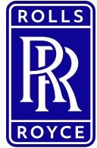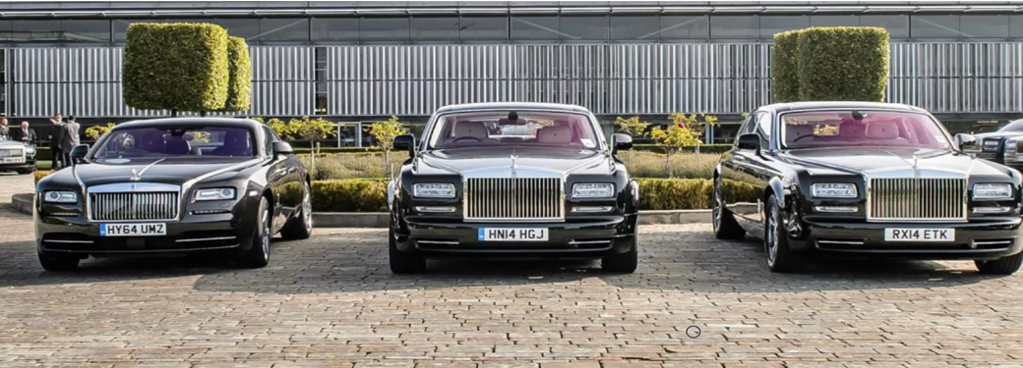
Source: Rolls-Royce motorcars.com

Rolls-Royce is a British luxury car manufacturer founded in 1904 in Manchester, United Kingdom. Known for producing the finest automobiles in the world, the company has a highly respected brand image built on the partnership of Charles Rolls and Henry Royce. It is a subsidiary of Rolls-Royce Holdings plc, a British aerospace and defence multinational founded in February 2011. The company was taken over by the German automobile brand BMW in 1998 and employs around 1,300 people. The aerospace portfolio is in Derby and the automotive portfolio is in Goodwood, West Sussex, (Rolls-Royce.com).

COMMUNICATION

Communication is the sending and receiving of information between two or more parties. The Oxford Advanced Learner's Dictionary, 8th edition (2010) defines communication as the activity or process of expressing ideas and feelings or providing information to people. Maund et al. (2017) describe communication as “the exchange of thoughts, ideas, or information that leads to a mutual understanding between two or more people”. From a marketing perspective, Philip Kotler and Kevin Keller define communication as the means by which companies try to inform, convince and remind their clients directly and indirectly about products, services and brands that they sell them.

Fig: 00 Diagrammatic illustration of communication.

SENDER
MESSAGE
RECIEVER
FEEDBACK
-Face to Face
-Telephone
-Letter
-E-mail
Etc.
CHANNEL
Encodes
Decodes
Decodes
Encodes

Source: www.skillsyouneed.com/communication

Communication is a critical aspect of any business as it helps increase brand awareness. Therefore, it is very important to do it effectively. Effective marketing communication is a crucial factor in business effectiveness and its value cannot be underestimated because it is what makes a marketing campaign such as advertising, product design and brand image remain in the customer's memory.

Communication can be direct or indirect.
Direct communication - is a process whereby two or more people interact with each other without the use of any intermediaries. This type of communication is often considered to be the most effective and efficient way of communicating, as it allows for immediate feedback and eliminates the possibility of miscommunication (Basin,2022).

Indirect communication – refers to any attempt to convey a message, whether written or oral, to an intended recipient. Susan Heitler (2015), in GoodTherapy.org, describes indirect communication as “hinting or acting out,” often with nonverbal behaviours like gestures, facial expressions, tone of voice, pauses, or periods of silence.

SHANNON - WEAVER COMMUNICATION MODEL
It is a cyclic communication model that emphasizes the effects of noise in a communication channel. Authors Shannon and Weaver argue that, communication can be categorised into seven important parts, namely; sender, encoder, channel, noise, decoder, receiver and feedback. Shannon developed this model to identify what happens to portions of information as they are transmitted over a telephone line from sender to receiver (Akinfeleye et al. 2010). In its original model it had no feedback element. It was later added by his colleague Weaver. Because of its popularity in the field of communication, it is sometimes referred to in some circles as the "mother of all models". The model is highly revered for its emphasis on the effects of "noise" on effective communication. The term noise here simply refers to anything that disrupts the proper flow of information from sender to receiver or vice versa, resulting in messages being lost or distorted during transmission. Noise is simply any physical disruptive element such as the environment, people etcetera.

Fig: 00 Diagram of Shannon-Weaver model.
Transmitter
(Encoder)
Information Source
(Sender)
Feedback
Receiver
(Decoder)
Noise
Source
Received Signal
Message
Message
Signal
Channel
(Medium)

Destination
(Receiver)

Source: International Journal of soft computing 7(1): 13, 2012

Explanation of what happens at each stage

Sender - The sender is the person from whom the message originated. The sender is the one who grafts the message and sends it to the recipient. The sender can be a person or machine from whom the the message originates.

Encoding - Encoding is the process by which the message is conveyed. Example, binary data on the Internet or electrical impulses in video or sound waves on the radio. It can be any one of these or a combination of all.

Channel - The channel is the medium used to transmit the message from the sender to the receiver. For example, email, phone, movie, etcetera.

Decoder - Decoding performs exactly the opposite function of encoding. For example, if the encoding packs the box to deliver , the decoder unpacks the box or if an encrypted email is sent from your computer, it is decrypted by the recipient's computer to transmit the email to the recipient.

Receiver –This is the recipient of the message. The recipient is at the other end of the communication channel exactly opposite the sender. This is the person or entity the sender was previously trying to communicate with. The recipient must be able to understand the message and respond accordingly.

Noise: Noise is the disruption that happens during the communication process. In a marketing perspective, noise is a critical factor that marketers need to pay attention to prior to sending a message to customers. For example, if there is an advertisement for a new model of Rolls-Royce in the newspaper you are reading, the advert is a form of communication where the sender (Rolls-Royce plc) is promoting the product while the recipient is the potential customer. The message is the advert itself. Now, instead of reading the advert, the reader's attention is captured by the news of the Russian bombing of Ukraine, printed in the newspaper alongside the advert.
In this case, news played the role of noise, by hindering the intended purpose of the advert.
Feedback: is when the recipient responds to the sender.

INTEGRATED MARKETING COMMUNICATION

Integrated Marketing Communications (IMC) is a marketing strategy used to achieve advertising goals, reach target markets, and create awareness of a company's products and services.
It can also be described as the arrangement and amalgamation of all marketing communication tools within an organisation in to a comprehensive program that maximises impact on clients at the lowest possible cost. It is an elementary approach to ensure that all forms of communication and messages are strategically linked. Finne and Grönroos, (2009); Kliatchko, (2008) in Bruhn, M. and Schnebelen, S.
(2017), argues that, integrated marketing communication is more than just amalgamating, coordinating and unifying communication tools, but rather, about strategic relationships and positioning.
Rolls-Royce's integrated communication approaches deliver consistent and persuasive messages, specifically tailored to its chosen target customers. This include; sales promotion, advertisements, marketing directly or interactively and public relations among others.

NEW PROMOTIONAL STRATEGIES FOR ROLLS-ROYCE

Rolls-Royce motor has strategically designed a personalised marketing policy and implemented it in the target market. The existing promotional tools include: presentation at high profile meetings, promotional events in premium hotels and exclusive car shows. It caters for a very exclusive and niche market and therefore relies majorly on the power of word of mouth from satisfied customers who unknowingly become brand ambassadors and marketers.
These sophisticated marketing strategies have helped it achieve and maintain its leadership position in the luxury car market. Despite this success, there is still more options it can add to its promotional basket both online and offline.

ONLINE PROMOTION

Geofencing
Geofencing is a marketing technology that gives companies the ability to target potential customers in a specific geographic area. Geofencing is about creating virtual boundaries around physical locations for more targeted mobile advertising ( Aguilera, 2022).

Using Geofencing , Rolls-Royce can create virtual perimeters to target customers within these virtual boundaries by identifying potential buyers through a rapid profiling mechanism using keywords. For example, when a person opens their phone and searches for information about a luxury car, the first thing they might see is an ad for Rolls-Royce. Geofencing as a marketing tool offers a number of advantages, such as; Greater ability to analyse metrics, customer personalisation and local sales improvement.

Financing Agreement
Rolls-Royce is currently only targeting wealthy people who have the financial strength to buy their product. This business model limits the company's market size. Roll-Royce can expand its customer base by introducing a car finance scheme to cater for customers who would love to own a Roll-Royce car but cannot afford a one-off payment.

Contextual advertising

Contextual advertising is a form of targeted advertising in which the content of an email is directly correlated with the content of the web page that the user is viewing. It is also referred to as "in-text" advertising. Zhang and Katona (2012) asserts that, contextual advertising is one of the most important forms of advertising on the Internet. Using this medium will enable Rolls-Royce to place advertisements on relevant websites that a potential customer visits. For example, if the person is researching reviews of a specific vehicle model, its ad can appear on that site, or if they are reading an article about the best vehicles for 2022, then is ad can appear there.

OFFLINE PROMOTION
Strategic car-spotting: This strategy involves parking a Rolls-Royce strategically near potential buyers so they can physically see the car, walk around it, and take photos ( selfie).

Car influencer ride along: With this strategy, Rolls-Royce identifies an influencer in the buyer community, who is then driven to a predetermined location and time such as lunch hour when employees are free from office duties and able to interact with the influencer to answer their questions.

The Supercar shopping vacation: It offers potential buyers in-car shopping tours to experience the benefits of a Rolls-Royce car.

BRANDING AND BRAND EQUITY

BRANDING
A brand can be described as a set of tangible and intangible attributes aimed at creating awareness and identity as well as building reputational characteristics of a product, service, person, place or organisation (Tanya, 2015). Activities such as product innovation and marketing communication undertaken to achieve these goals are known as branding. According to the American Marketing Association, a brand is a "name, sign, symbol, design, or a combination of any of them, specifically to identify the goods and services of a business or group of businesses and to distinguish them from those of the competitor.

BRAND EQUITY

Bettencourt (2017) in the American Marketing Association describes brand equity as the value of a brand that goes beyond what can be explained by a product's functional attributes. Leuthesser (1988) describes brand equity as the combination of associations and behaviours of stakeholders of a brand that enable it to achieve greater value than it would without the brand name . Srivastava and Shocker(1991) define it as the aggregate of all attitudes and behavioural patterns accumulated in the minds of stakeholders that will improve future profits and cash flow over the long term..
Brand awareness campaigns of Rolls-Royce use a variety of media to promote the company's products. This includes; television, radio, print and internet
platforms.
Some of the campaigns carried out are:
Rolls-Royce “One of one” by Havas London: It is a movie in which, Siamese fighting fish is in comparison to a Rolls-Royce Phantom to reveal how every Rolls-Royce car is an elegant unique invention without a competitor. The campaign, that was Havas London’s first for Rolls-Royce, was designed to emphasise that a Rolls-Royce is built on a platform of customisation and or personalisation that cannot be found elsewhere.
Rolls-Royce “The spirit of ecstasy” by Hingston Studio: Is a marketing strategy that was launched by Rolls-Royce Motor Cars to show case the tales, experiences, and legendary attributes of the brand. the fascinating two and half minutes 3-D movie attempts to bring to life the Rolls-Royce story.

Digital Presence:
The current trend in marketing is fast shifting to online platforms and Rolls-Royce is right in the trenches of this digital shift. Budgets for digital marketing has increased to become a major component of its marketing resource utilisation as it focuses on remaining a customer-centric company that thrives on the unique individual connections it has with its clients globally.
Customer interaction influenced by the growth of digital media such as Facebook, LinkedIn, Twitter, Instagram and YouTube, continues to metamorphose into a major way the company keeps in touch with its customers share its brand story, facilitated by search engine optimization, paid search, and direct online marketing through emails.

KELLER’S BRAND EQUITY MODEL (Relate to Rolls-Royce)

The Keller brand equity model, also known as the customer-based brand equity model (CBBE), was originally developed by Kevin Lane Keller, a marketing professor,(Keller, 1997).
The notion behind the pyramid model is that, in order to build a strong brand, an organisation like Rolls-Royce, must conceptualise its customers' thoughts and feelings about its product by creating the right type of experiences around its brand. A strong brand equity means Rolls-Royce customers will buy more, recommend it to others, become more loyal and therefore less likely to switch to a competitor.

Fig: 00
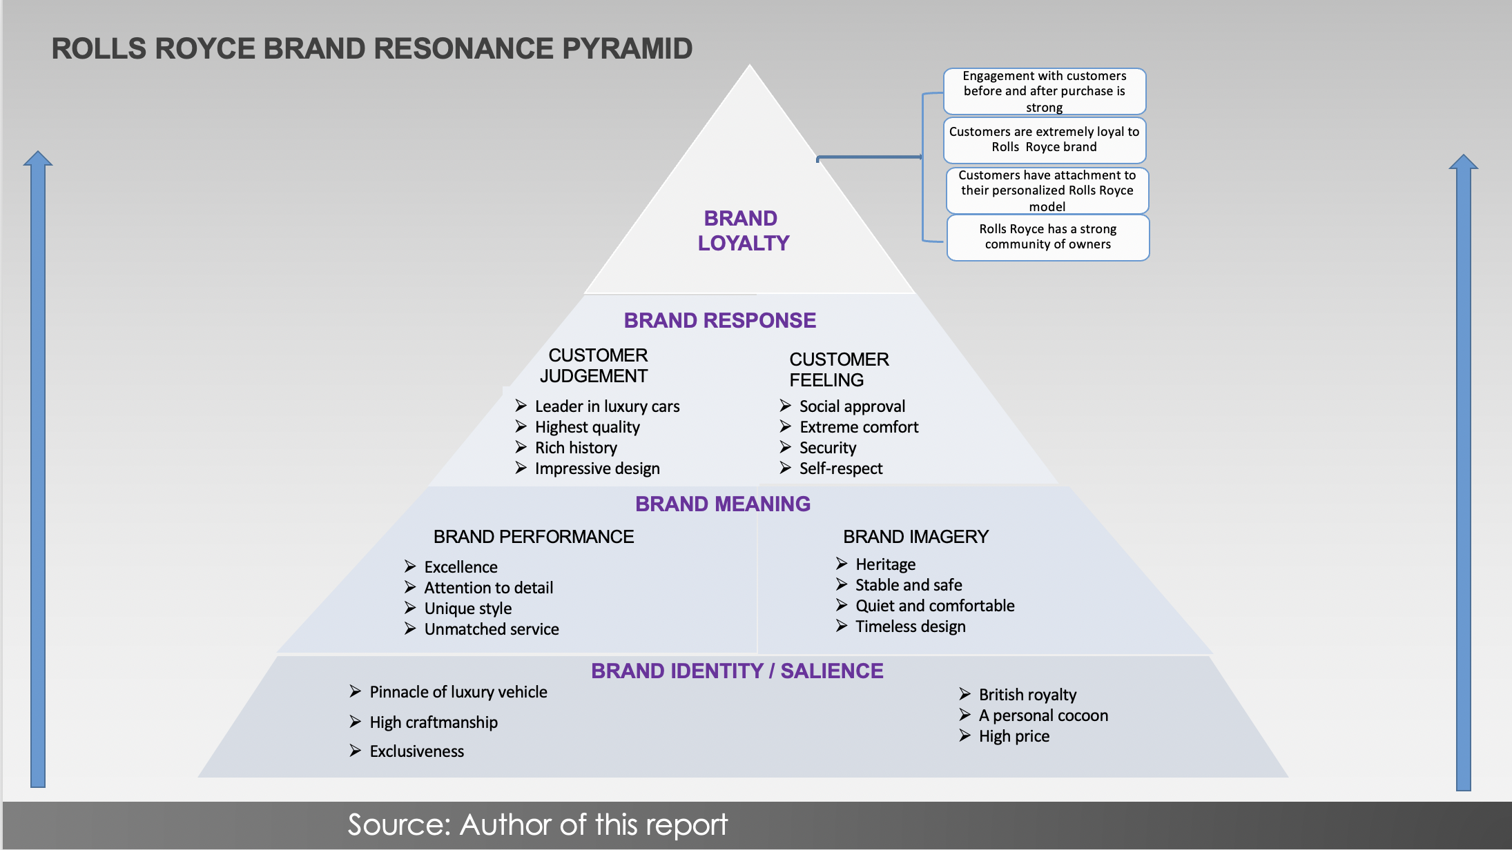
Brand Salience
Every Rolls-Royce automobile is hand built at the company's state-of-the-art manufacturing facility in Goodwood, England, (Rolls-Royce, 2022a). Rolls-Royce brings the elegance of its British heritage to the rich around the world. For people who care most about their social class, Rolls-Royce offers cutting-edge products that outperform the competition. The philosophy of ‘Take the best that exist and make it better’, is the motivation behind the strong investments in technological innovation which supports its core values. ​​

Brand loyalty
Almost all Rolls-Royce customers are business personalities who consider themselves royalty. Rolls-Royce brands like Ghost, Phantom and Wraith are well received by people and they believe in the quality of the products. Rolls-Royce is for individuals who love luxury, so the brand focuses on premium cars to satisfy their need. The company customises its products to meet the needs of high profile clients. The impeccable service they receive makes them loyal to the brand.
Brand Performance
Branding Strategy of Rolls-Royce has enabled the company to expand its’ business to Europe and beyond with a tremendous success. Over the years, the company has successfully produced and sold different models of the Rolls-Royce vehicles. In 2021, it reported the best ever sales performance in its 117 year history.
Brand Imagery
Rolls-Royce has been and is still one of the most reputed brands in the luxury automobile industry. The brand has made its presence felt in more than 50 countries and boosts of customers in more than 150 countries (Rolls-Royce,2022b), thanks to its superb marketing strategy worldwide. Rolls-Royce is considered as the true symbol of luxury and royalty by many.

ROLLS-ROYCE IN AIKERS PERSPECTIVE

David Aaker was a professor at the University of California. He introduced the Aikers brand equity model in the 1990s. The concept describes brand equity as a combination of brand awareness, loyalty and perceived quality. These features can help Rolls-Royce to increase the value of its products and services for the benefit of its customers.

Brand Awareness
Rolls-Royce is one of the most famous and attractive luxury car brand in the world. Rolls-Royce has been providing excellent service for more than 100 years. The brand's motto is "The best car in the world and trusted to deliver excellence" and they have proved it. It is a well-known name within the wealthy social class of the society. The company targets customers who own five to six luxury cars (Hitesh, 2019). The main markets for the brand are, United Kingdom, North America, China and Saudi Arabia .

Perceived Quality
Rolls-Royce has maintained its integrity, reliability and innovation, delivering high quality automobiles with the utmost comfort and luxury thereby winning customers' confidence in the brand. In 2017, the parent company Rolls-Royce plc pledged to protect nearly seven thousand engineering jobs at the aerospace plant in Derby as part of a 150 million pound investment, (Independent, 2017). A move which helped to maintain customer confidence in the company’s determination to maintain quality.

Brand Association
Whenever the wealthy think of a undemanding car journey filled with comfort, luxury and speed, the name that pops up is Rolls-Royce. Exactly what the founders Rolls and Royce wanted.

MERITS OF KELLER’S BRAND EQUITY MODEL

- The brand resonance pyramid is used as a tool for analysing the effectiveness of marketing communications on brand equity through creation of relationships and loyalty, (Keller, 2009). Rolls-Royce brand resonance is so powerful. Its brand cognizance strategy is tremendously reliant on word of mouth by wealthy business personalities and successful celebrities.

- Brands which are capable of attain resonance and affinity with clients gain a bunch of valuable benefits such as premium prices, and more efficient advertising and marketing programmes. Rolls-Royce vehicles are the most expensive in the luxury car market costing hundreds of thousands of dollars or pounds. Rolls-Royce as a corporation does not reveal the price of their products, however, it is reported that a Rolls-Royce Ghost sedan cost $343,000 ( Car and Driver.com,2022)

- The model has helped Rolls-Royce to build a strong brand by shaping how their clients think and feel about them.

- Additionally, it enables Rolls-Royce to identify the reputation of the brand in the market and what it need to do to grow.

DEMERITS OF KELLER’S BRAND EQUITY MODEL
- Kuhn et al (2008) found feelings did not play a role in the industrial marketing context and suggested resonance, may need modifications to be more relevant. This argument however, is not relevant to Rolls-Royce because its customers proudly resonate with it and happily recommends it to their friends.

CUSTOMER JOURNEY

A customer journey is the end-to-end experience a customer has with a brand. This experiences are classified into 5 stages namely; Awareness; when a customer first discovers Rolls-Royce brand. Research; where a customer is considering buying one of the products. Consideration; when customers are actively considering buying a product. Purchase; Is where customers cross the i’s and dot the t’s of a buying decision. Support; Where the customer makes use of the product or service, engages with the business enterprise and makes a decision whether or not to buy once more. Loyalty; is technically a part of support. It is wherein the clients might also additionally refer different
clients to Rolls-Royce and buy again in the future.

Fig. 00 Stages in the customer journey of a car buyer
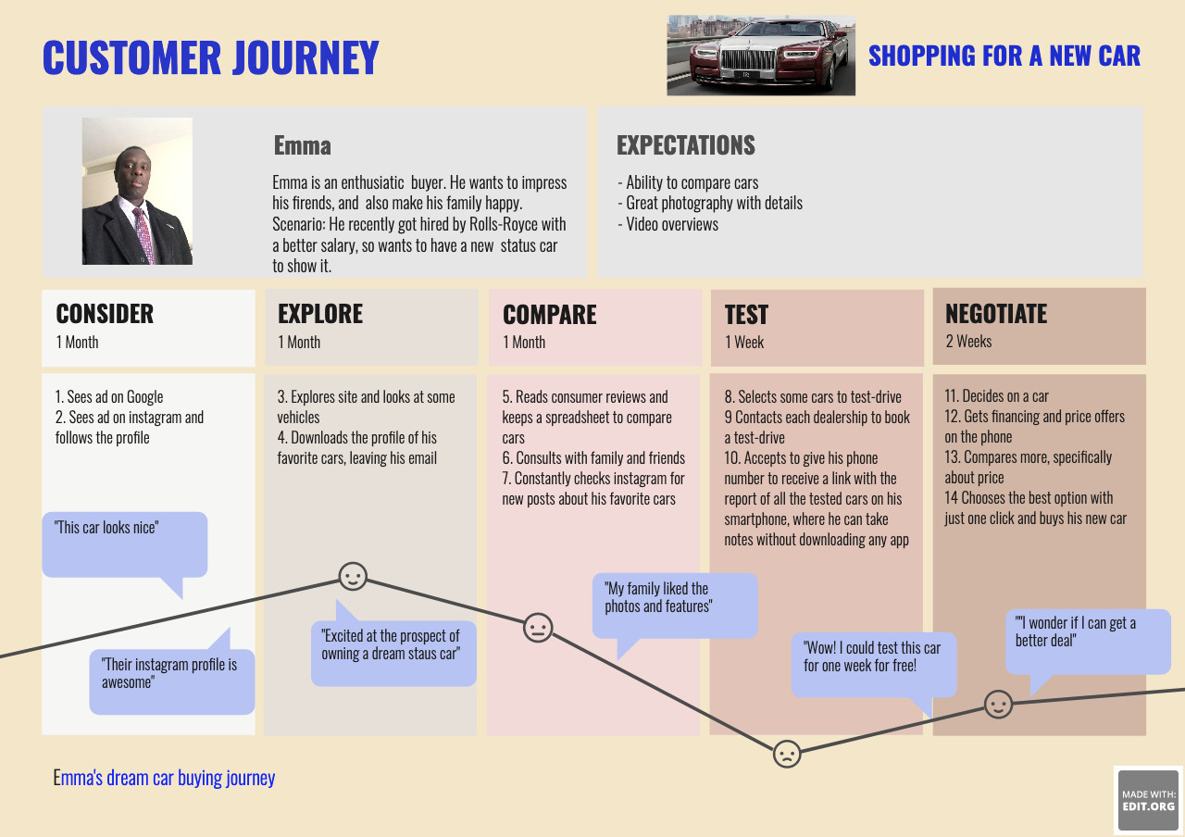
Source: Author of this report

CUSTOMER TOUCH POINTS
Customer touch-points refers to how a customer interacts the with the brand at the three main stages of the customer life-cycle, namely; Awareness, evaluation and post-purchase.
The automotive industry is one of the industries that has undergone a massive digital transformation in recent years. Digitization is revolutionizing the automobile experience for consumers. Recent technological innovations in the automobile industry, have been focusing on complementing consumers' overall driving experience in terms of safety, comfort and convenience. In fact, one could say that there is a definite shift from RPM (revolutions per minute) to EPM (experiences per mile), when it comes to customers' expectations . This demand is even higher at Rolls-Royce due to the status of its customers.

PRE-PURCHASE
Customer touch points that Rolls-Royce clients come across before putting an order include;
- Advertisements on its website: Through the website, the clients are able to see a virtual model of the cars, make enquires and also customize their preferred car.
- Print commercials in magazines: Through its distinctly customised magazine, Rolls-Royce clients are able to see the image of their preferred car and examine its specification.
- Blog post on social media platforms such as Instagram and LinkedIn amongst others, also are utilized by Rolls-Royce clients to interact with the company.
- Word of mouth marketing: Peer reference or customer review is a very important advertising channel for Rolls-Royce. Through it, existing clients tell potential clients about Rolls-Royce motor cars.
- Product launch events: Usually executed in exclusive hotels and events, they enable potential clients to have a physical feel of a Rolls-Royce car through test drives and also physical interact with the makers of their dream car.

PURCHASE
Rolls-Royce uses various activities such as event sponsorship, personalised emails and directly mailing customised magazines and product catalogues to engage with customers and raise awareness, arouse interest, facilitate choice formation and purchase decisions. The touch-points here include; Test drives, free vehicle delivery, , customisation of the car interior etcetera.

POST-PURCHASE
Rolls-Royce provide a variety of after sales services to its clients as tools for it customer relationship management. These services helps to encourage and maintain customer engagement. Some of the post-purchase touch-points include;
- A four year peace of mind warranty.
- A customised service from technicians acquainted with the customer’s car
maintenance records and requirements.
- Allocation of a service adviser for consultations at any time of need.
- Provision of a complimentary chauffeur collection and delivery service on the scheduled service and repair date.

THE CUSTOMER JOURNEY MAP
Customer Journey Mapping is a customer relationship management tool which enables brands like Rolls-Royce, to enhance their customer service by initiating a positive client experience. It begins with figuring out the persona of a potential buyer. Effective Customer Journey Mapping comprise of stages through which customer feedback on the level of delivered customer experience, preference, purchase habit and support systems, (Jacobsons, 2019).

Fig. 00 Customer Persona - Stats for Emma

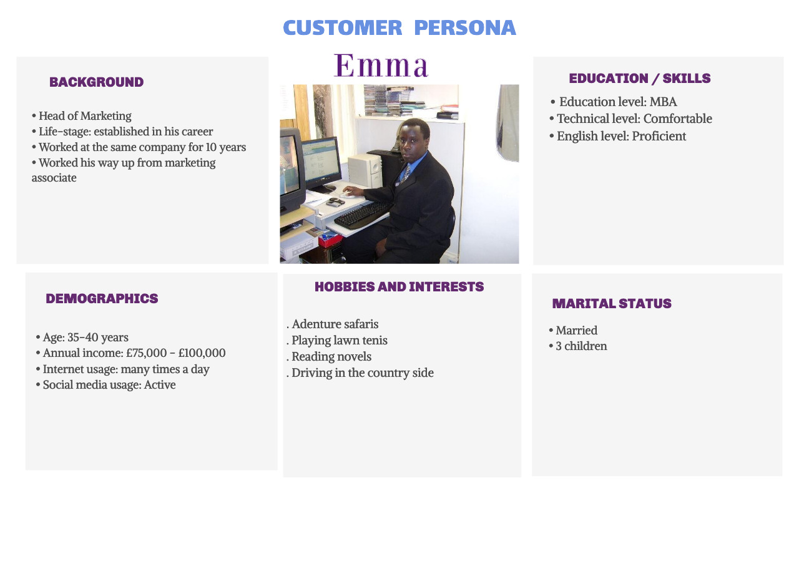

Source: Author of this report

Fig: 00 ROLLS-ROYCE CUSTOMER JOURNEY MAP

Rolls-Royce Ghost
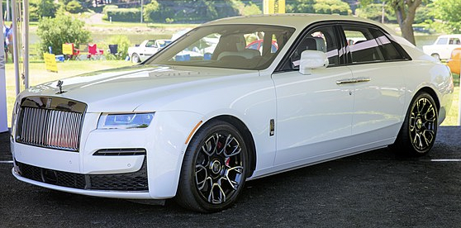
Source: Rolls-Royce motorcars.com

Customer Journey  Receives Email about Rolls-Royce luxury cars  Test drives the Ghost  Purchases a Rolls-Royce  Ghost  Reviews available models and price  Reviews the after sales services and offers  Reviews a Rolls-Royce Ghost model  Express satisfaction with the Rolls-Royce Ghost and recommends to friends  Existing customer with luxury cars  1  2  8  4  6  7  3 | Awareness | Discover | Purchase | Use | Bond
Website

Show room |  | 5
Phone call

Social media

Word of Mouth
Television

Email

Post

(Brochure
& letters)

CRITICAL ANALYSIS OF ROLLS-ROYCE CUSTOMER JOURNEY MAP

Rolls-Royce customer journey is an elaborate compelling series of experiences that is meticulously designed to deliver touch points that keeps customers coming back for more.
The diagram above, showcase a eight step journey to procure the most popular model,
a Rolls-Royce Ghost,
The process starts by identifying wealthy people who already owns a number of luxury vehicles including those who already owns a Rolls-Royce. They receive a personalised Rolls-Royce brochure showing the various models available. For those who already own a Rolls-Royce, they get a brochure showing a model they do not already have. They become aware of the models and goes on to choose the Ghost model at stage 4. After this, they book a test drive which usually ends up in a purchase. This is then followed by the customer reviewing the after sales services and offers. Rolls-Royce after sales service is a class comparable to none, in the automobile industry, purposefully designed to provide a complete peace of mind for the customer. To achieve this, every new Rolls-Royce car comes complete with a four-year comprehensive ownership package. This includes servicing, repairs and maintenance, as well as roadside assistance,(Rolls-Royce motorcars.com). To provide a faster and more effective servicing, every new Rolls-Royce features a “Condition Based Servicing”, (Rolls-Royce,2022c) . This means that, sensors in the Rolls-Royce actively monitor important components such as engine oil, brake pads and filters. This information enables Rolls-Royce as a company to ensure that, services are scheduled to meet the precise needs of the vehicle, at a time most suited to the customer. These meticulous touchpoints crate customer satisfaction with the Rolls-Royce Ghost. They bond with the Rolls-Royce brand, become loyal and recommends Rolls-Royce to their friends.

STRENGTHS OF ROLLS-ROYCE CUSTOMER JOURNEY MAP

Website: Rolls-Royce is website has proved to be a very effective touch point for the company. Through, customers are able to carry of product and service reviews.
Show room: The showroom has also been a very effective touch point because it is where the physical interaction with the product mostly takes place and the decision to buy is arrived at.
Social media: This digital platform has also been working well as a touch point through which customers get to know the latest product offers.
Word of mouth: The most effective touch point for Rolls-Royce due to nature of its target market.
Email: This is also one of the most used touch point by the company. Through it, customers are made away of existing product offers and after sales services. It also one the most common medium of customer interaction with the company.

Post (Letter and brochure): Is another effective touch point used by Rolls-Royce. The chief executive is known to always hand write and sign letters thanking individual customers. In the same way, personalised brochures are also sent out.

Through these touchpoints, Rolls-Royce has been able to improved customer acquisition, increase customer value and improve customer retention.

WEAKNESSES OF ROLLS-ROYCE CUSTOMER JOURNEY MAP (touch points that have not worked well)

For this report, I have not been able to identify a touch point that does not do what it is designed to do in Rolls-Royce. However, generally, the following are the limitations of a customer journey map

Require Cross Functional Support
It a cumbersome task that requires the active support of all department. If an organisation is resistant to working across departments. it might be difficult to create an accurate map of the customer journey.

They can become a hidden Document
Like many other strategic documents, the map tend to become something hidden in a drawer and not used day to day, as such, its ability to be a core communication document is lost.

Need for multiple maps for different personas
Where their journey’s differ, a good customer journey map is centred around a specific customer persona. This implies a need to create more than one map to cater for those different personas.

Customer’s do not always follow the map
Customer’s do not always follow the journey map directly from A to B. They often skip steps, loop back and re-do steps, etcetera.

THE TOTAL ENGAMEMENT MODEL

The total engagement model is a business management approach carried out with the sole objective of putting together everything within a business into an efficient and effective system that promote customer engagement. Key to this, is the focus on aligning all activities such as; advertising, service, products and organisational culture on a unified plan for effective customer engagement.

The success of a business is driven largely by whether customers decide to purchase its products (Alpert, 2010). Achieving this requires taking steps beyond just encouraging customers to make one-off purchases but repeat purchases, by creating engaged customers, (Alpert, 2010). In this case, an engaged customer is one that is loyal to Rolls-Royce brand and actively recommends its products and services to others. These customers increase the company’s sales and growth performances. Kirby, (2006) argues that, Engaged customers drive word-of-mouth marketing that is ten times more effective at resonating with a target audience than television or print advertising.

When customers interact with Rolls-Royce, they have an experience which determines how they engage with the company. To ensure effectiveness of this interaction, Rolls-Royce focuses on four key elements of the Total Engagement model. These are; Customer experience, Customer value proposition, Brand advertising, and culture.

Customer experience and satisfaction is of great importance to Rolls-Royce because, its customers pay huge prices for a model like Ghost. So in order to maintain quality of products and services and also encourage customer engagement, it uses a customised model of Total Engagement called ‘Total Care’. Although it was originally designed for its Aerospace portfolio, the principles are also applied in the Motor car portfolio through the after sales services offered. Through this customised Total Engagement model, Rolls-Royce is able to deliver a distinct value proposition and customer experience that has created engaged customers. This is corroborated by the report of customer survey conducted by Glass Door which rates Rolls-Royce above its competitors (Glassdoor.co.uk,2022).

Fig. 1 Rolls-Royce Total Care
Source: Author of this report
KEY PARTNERS  Rolls-Royce partnership is operated in a sort of franchise model whereby all are called Rolls-Royce. Key partners are in Qatar, Edinburgh, Orlando, New Orleans, Philadelphia, and Abu Dhabi.  -HR Owen is a partner as an approved used dealers. | KEY ACTIVITIES  -Sales and After sales services  -Marketing / Promotions | VALUE PROPOSITIONS  - Status symbol  - Comfort  - Safety  - Speed  - Great customer care | CUSTOMER RELATIONSHIPS  - Close and long term relationship | CUSTOMER SEGMENTS  - Gender  - Age  - Social class (Income)  - Ethnicity
 | KEY RESOURCES  - Rolls-Royce models e.g. Ghost  -Personnels  -Show rooms | COST STRUCTURE  - Rolls-Royce operates a cost sharing model | CHANNELS  - Direct sales  - Care stores | REVENUE STREAMS  - After sales services are charged depending on model, age of the car and milage
SOCIAL & ENVIRONMENT
- Training of scientist through scholarship
- Move to net zero carbon foot print through electric Rolls-Royce cars

Furthermore, it has also effectively aligned its brand as a tool to consistently communicate its value propositions and culture, as the key enabler for delivering distinct customer experiences through engaged employees. LaMalfa, (2008) asserts that, engaged employees are more productive, more committed to settling disputes peacefully and are more loyal to their company in general. Rolls-Royce motorcars employees engagement is incomparable and is evidenced by the irreputable quality cars that are handcrafted. Customer value proposition refers to what Rolls-Royce can offer its customers to satisfy their needs and wants expectations. Brand is about what Rolls-Royce is and what it stands for. Culture on the other hand, reflects what goals, values and behaviours should be in place to ensure that employees can consistently provide a quality service to the customer.

Fig. 2 The Total Engagement Model
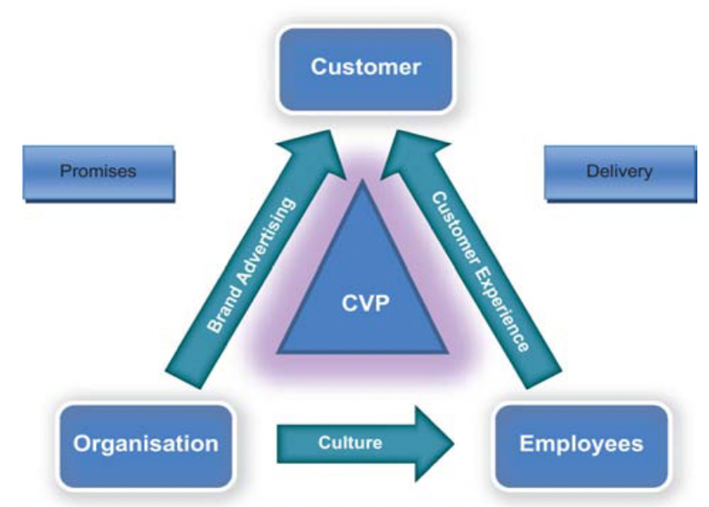
Source: Frank Alpert

RECOMMENDATIONS
Rolls-Royce has been quite successful with its current strategies and has been able to hold its place in the market effectively. I recommend that it continues with the same strategies however, it should consider forming more joint ventures especially with financing options. This is because the luxury car industry is a high investment and very competitive market.

The core objective of customer value driven marketing strategy is to create an engaging relationship with the right customer. The strategic choice of target customers is critical because Rolls-Royce motorcars ca not serve all the customers in the luxury car industry. It has to carefully choose the customers which it can satisfy their needs based on its resources and capabilities. Rolls-Royce motorcars can utilise these four strategic steps to crate a customer value driven Marketing strategy.

Cross market segmentation: A sizeable number of consumers possess similar wants and needs, as well as buying behaviour despite being in different geographical locations, practising different cultures, and participating in different political systems. Rolls-Royce motorcars can use cross market segmentation principle to define and target the same type of consumers in different markets.

Multiple segmentation strategy: Rolls-Royce motorcars marketing team should not restrict itself to a single segmentation strategy but rather, strive to include various features to effectively identify target groups and define the segments.

Differentiation: Using this strategy, Rolls-Royce can target different market segments with unique offerings such as financing option for those who prefers instalment payments as opposed to one-off.

Strategic positioning: Value proposition and brand positioning are critical factors for effectiveness in today’s highly volatile luxury car market. With the age group of the wealthy getting lower and lower, Rolls-Royce motorcars needs to position its product in such a way that it provides specific identity points of reference and creates a distinct brand image in the minds of younger customers. For example, a more sporty exhaust sound.

CONCLUSION

This report concludes that, the marketing strategies of the world’s most famous luxury car brand is very effective. The strategy used is fully customer centric with great emphasis on customer experience and satisfaction.
Rolls-Royce motor cars serves a very niche market of the ultra-rich in the society with unique characteristic needs. Meeting these needs require unique marketing strategies which the company has demonstrated the ability to do by understanding the market, creating highly distinctive value propositions and total customer satisfaction, as evidenced by their productivity in this highly competitive sector, reporting the highest ever annual sales result in 2021. Rolls-Royce continues to inspire greatness with cutting edge innovations in the automobile industry.

