Module: Knowledge and Information Management Skills for the Workplace
2022
Natasha Nothando Tshili (2020475)
Module: Knowledge and Information Management Skills for the Workplace
1/1/2022
Knowledge Management Report & Poster
Lecturer: Md Kalam
Assignment: Report & Poster
Table of Contents
Introduction 3
Knowledge and Information Management 3
Evaluation of Knowledge and Information Management Theories/Models 5
Investigating Amazon’s Knowledge Management Techniques 9
Conclusion 11
Recommendation 12
References 12

Introduction
In this report, will evaluate Amazon’s use of knowledge management principles. Amazon is an e-commerce website that specialises in offering a fast personalised an easy way to find all the products they need. I collected secondary research from a variety of sources but mainly Amazon’s website, news articles and the 2021 annual report to evaluate Amazon’s current knowledge management framework.

This report has 6 sections. First, I will introduce Amazon, define knowledge management and explain its importance in an organisation and at Amazon, and its role in achieving customer satisfaction and competitive advantage. Then I will critically evaluate 3 knowledge management theories, SECI model, EFQM, and Wiig model. Following this, I will offer my analysis on Amazon’s current knowledge management framework, AWS (Amazon Web Services) and its effectiveness and offer a recommendation of a new framework Amazon can utilise. Finally, I will conclude on my findings from my research.
Knowledge and Information Management

Background of Amazon
Amazon is a multi-billion-dollar e-commerce giant whose guiding principles are, ‘customer obsession rather than competitor focus, passion for invention, commitment to operational excellence, and long-term thinking.’ (Amazon, 2022). The organisation prides itself on striving to be the most customer centric company on Earth. (2021 Annual Report, 2022). They offer a one stop shopping site with customer reviews and 1-Click shopping, and personalised recommendations based on customer’s past shopping activity. (Amazon, 2022). Amazon offers products ranging from produce, movies, electronics with artificial intelligence capabilities, fulfilment centres, music and eBooks to name a few. (Amazon 2022). Amazon was founded by Jeff Bezos in 1994, in Seattle. (Mohammed, 2022). initially set up to be an online bookstore, however, has evolved so much that it has Amazon Web Services (AWS), which is its cloud computing side of the business. (2021 Annual Report, 2022).
Importance of Knowledge Management
According to Nonaka and Ichijo (2007), holistic knowledge management involves 4 activities, the creation of knowledge, sharing of knowledge, protection of knowledge and discarding knowledge. the creation of knowledge is about generating new knowledge before competitors, whereas the sharing stage is about the transfer of knowledge within an organisation. The protection of knowledge has to do with safeguarding this intellectual property from competitors or potential threats. Finally discarding involves companies constantly reflecting over the knowledge they have acquired and choosing to discard outdated knowledge for new knowledge creation. (Nonaka and Ichijo, 2007).
Knowledge refers to a justified true belief, sometimes it is individual or social and tacit and explicit. (Nonaka and Ichijo, 2007). There are 3 types of knowledge, tacit, implicit, and explicit knowledge. Tacit knowledge refers to personal knowledge which is often based on intangible factors such as perspectives, believes, values or intuition. it can often be split into two these the technical and cognitive, where the technical aspect what is often referred to as ‘know-how’ and the cognitive side is ‘beliefs and perceptions.’ (Nonaka and Ichijo, 2007). Implicit knowledge refers to knowledge that explains how to implement explicit knowledge, for example a senior manager explaining from their expertise (implicit knowledge) how to carry out explicit steps in a process. (Andreev, 2022). Explicit knowledge on the other hand is easily communicated and can be transferred in data, it is systematic, and this form of knowledge is the most acceptable in the business world. (Nonaka and Ichijo, 2007). Explicit and tacit knowledge are considered, ‘the most important source of competitive advantage.’ (Nonaka and Ichijo, 2007).

Knowledge management is important because it increases an organisation’s ability to make decisions and as a result efficiency is boosted. (Andreev, 2022). Knowledge can be dispersed throughout an organisation, and it allows for expertise to be gained across business functions. Knowledge management provides organisations with a competitive advantage, especially if it can safeguard its expertise or intellectual property. Overall, this brings about cost savings, time savings, improved customer satisfaction and closes a significant amount of the skills gap within an organisation. (Andreev, 2022).

The strategic management of knowledge within an organisation, if applied to key business functions Can be profitable for a business. If organisations successfully transferred new knowledge into key departments such as research and development, marketing or customer relationship management, it would convert into customer satisfaction and customer retention. Thus, this would create a great competitive advantage for the organisation, If the knowledge is implemented into business decisions and is protected from competitors. (Nonaka and Ichijo, 2007).

Importance of Knowledge Management at Amazon
For Amazon to be able to offer such a personalised customer experience they must collect, store and analyse customer data. Since Amazon’s business model is customer centric, it relies heavily on data collected to maximise its profits. (2021 Annual Report, 2022). At Amazon knowledge management starts with a collection of customers data from the checkout point and the next step is the storing of the data onto the management information system (MIS). This information management system is utilised by middle managers to establish trends in consumer choices and becomes the basis of strategic decision making. This is done through the transferring of knowledge gained from analysis into product recommendations, process teams and to the technology department, for implementation. (Mohammed, 2022). Amazon utilises its customer engagements to transform their business through their AWS Cloud Adoption Framework. (Amazon, 2021).

Evaluation of Knowledge and Information Management Models/Theories

There are 9 knowledge management theories/models, they include Nonaka and Takeuchi ,Inukshuk model, the EFQM, SECI model, Wiig model, Bukowitz and Williams model, Meyer and Zack model, Von Krogh and Ross model ,and the Choo sense making model. For the purpose of this report, I will analyse three models, SECI model, EFQM and Wiig Model.

SECI Model

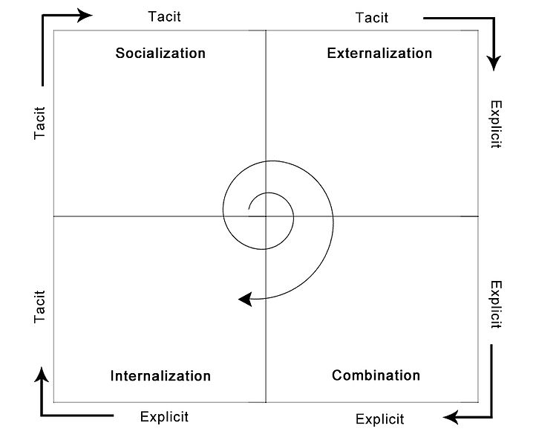
Figure 2. SECI Model (Tlu, n.d.)

The SECI Model stands for socialization, externalization, combination and internalization. This model was introduced by Nonaka in 1991, and later expanded upon by Nonaka and Tekeuchi in 1995. (Tlu, n.d.). Nonaka and Takeuchi concluded on four modes of knowledge conversion. It was created in the context of business organisations. The main components off the SECI model are the transfer of tacit knowledge to tacit knowledge, which is referred to a socialisation, the transfer of tacit knowledge to explicit knowledge, which is referred to as externalisation, the transfer of explicit knowledge into tacit knowledge which is referred to as internalisation and the transfer of explicit knowledge into explicit knowledge which is referred to as combination.

The SECI model is based on the transfer of individuals knowledge to others in the workplace, which is always taking place at all levels within an organisation. (Tlu, n.d.) This has to do with the creation of knowledge. During socialisation, tacit knowledge is exchanged through practice, participation and observation, it usually occurs in communal spaces set up for interaction, (Tlu, n.d.). Socialisation is sometimes referred to as empathising. In the externalisation process, due to tacit knowledge being internal in nature, for it to be converted to explicit knowledge a process of articulation must occur to share and create this knowledge. (Tlu, n.d.). During the combination process the focus is on integration of concepts into a system for the purpose organising and organisations explicit knowledge. The internalisation process involves the embodiment of explicit knowledge into tacit knowledge. The spiral in the middle of the model represents the continuous generation of new knowledge, through the different conversions of tacit and explicit knowledge. (refer to Figure 2).

The interaction between the four modes occurs when the Japanese word Ba, which is a representation of the context in which the transfer of knowledge takes place. (Patel, 2021).
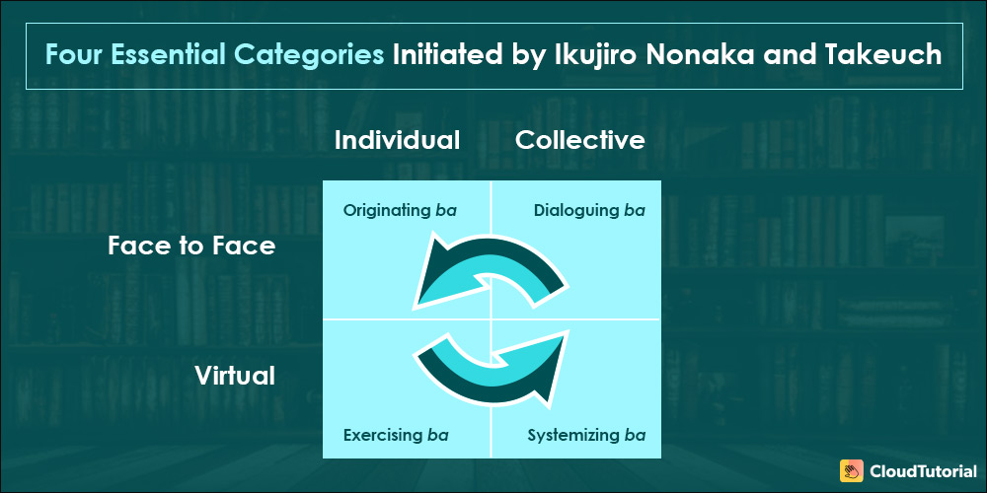
Figure 3 Ba Four Essential Categories (Patel, 2021)

The transfer of knowledge can occur from creating, sharing, and using the knowledge as a training or learning platform in the organisation. Originating ba, refers to place or spaces where individuals interact. (Patel, 2021). Dialoguing ba, refers to the exchange of tacit knowledge between professionals, to create knowledge. Systemizing ba, refers to the analysis and measurement of new knowledge, can be considered the storing of the knowledge. Finally, the exercising ba, takes the analysis conducted and it is integrated into the organisation and incorporated into best practices. (Patel, 2021).

The strengths of the SECI model is that it takes into consideration the constant flow of knowledge and knowledge creation either within the groups or individuals involved in the exchange. It considers all employees being a part of

Weakness of the SECI model are that it was designed in the context of Japanese culture and assumed Buddhism principles guiding employees to strive so one is. However, in western culture we consider it the knowledgeable employees and junior employees as separate entities, and we tend to view knowledge transfer as being top down or bottom up. This model looks at more of an approach where middle managers serve as the bridging gap between the junior staff and senior management’s objectives. In our society, it may not fit into the context of our organisations.

The European Foundation for Quality Management (EFQM)
The EFQM Excellence Model was introduced in 1992, as a model of a criteria for the European Quality Award. (Tlu, n.d.) this model recognises varying approaches to achieving excellence. The ETQM Excellence model is based on 9 criteria and of these 5 are considered enablers and four results criteria.(Tlu, n.d.).

Results orientation is the criteria that considers results that impress stakeholders as the basis for excellence. Customer focus is the criteria that considers sustainable customer value generation. There is leadership and constancy of purpose criteria, it investigates leadership's alignment with purpose and being a visionary as the measure of excellence. Management by processes and facts is another criterion and it focuses on the management through interrelated systems and processes. people development and involvement criteria looks at the maximisation of employee contribution through engagement and development will stop continuous learning innovation an improvement criteria measures excellence by the level of innovation and opportunities for improvement, as well as the generation of ground breaking ideas. Partnership development criteria faces excellence on the maintenance and development of partnerships that add value. Finally, corporate social responsibility criteria measures excellence based on organisations ability to comprehends and act on the expectations of their stakeholders in society. (Tlu, n.d.).

A strength of this model is it encourages organisations to do a self-assessment and it serves as a management system. It addresses the gaps within an organisation highlighting where knowledge needs to be generated. (EFQM, n.d.). This model serves an organisation that values innovation and the power of organisational analysis, forecasting and intelligence in the implementation of organisational transformation. (EFQM, n.d.). Ultimately the EFQM model strives to build sustainable business, through assessing an organisation for areas of improvement, in a detailed manor with detailed criteria. EFQM Excellence model is constantly updated for relevance based on stakeholder’s feedback. For example, with the 2020 EFQM, there was the addition of the United Nations Sustainable Development Goals (SDGs) and European values business ethics added to the model’s criteria. (Fonseca, 2022).

Some setbacks of this model is that it is a business model and it looks at a broader picture of the business, not specifically knowledge management. It includes 32 sub criteria and a few of the sub criteria focuses on knowledge management. Thus, it is not fully applicable for the analysis of knowledge management exclusively.

Wiig Model

The Wiig model was developed by Karl Wiig KM model in 1993, its main principle is that organised knowledge is the most valuable and useful. (Tlu, n.d.). The Wiig model, states that the knowledge must be organised based on the purpose it will be used for. The dimensions covered in the model are completeness, connectedness, congruency, perspective and purpose. (Tlu, n.d.).

Completeness refers to the relevance of tacit or explicit knowledge, based on the source it is coming from. If it is possible for all the knowledge on the subject to be available but if people are not aware of the existence of the knowledge, they cannot take advantage of it. (Dalkir, 2011, pp. 76-77). Connectedness looks at the cohesiveness of interdependent knowledge objects, and the value they bring to the content created as a result. (Dalkir, 2011, pp.77). Congruency looks at the consistency of the facts, judgments or relational links between knowledge objects in a knowledge base. (Dalkir, 2011, pp.77). Perspective and purpose, refers to the point of view in which we take in knowledge and the specific purpose for which we take in knowledge, being the determining factor of how we organise the knowledge we are presented. (Dalkir, 2011, pp.77).

The Wiig model aims to define the variation in levels of internalisation of knowledge, it can be said that it focuses on the fourth quadrant of the SECI model. the levels of internalisation in the model are classified as novice, beginner, competent, expert and master. I know this is described as not knowing the use of knowledge or its existence. The beginner is aware of the knowledge and how to find it but is unable to reason with it. The competent classification is also known as the competent knower, and they know about the existence and use of knowledge, and they reason with the knowledge with the help of external knowledge bases. However, an expert nose in retains the knowledge and memory, understands its application and reasons with it without external help. Finally, the master fully internalises the knowledge and thoroughly understands it and integrates the values and consequences of using this knowledge. (Dalkir, 2011, pp.80).

Wiig take it a step further and suggests hierarchy of knowledge, that includes that knowledge can be public, shared or personal. In addition, each of the three forms of knowledge can classified as factual, conceptual, expectational or methodological (Dalkir, 2011, pp80-81).

Strengths of this model are that Wiigs, considers the organization in its entirety and covers business functions found in most businesses. This is a result of its emphasis on the internalisation of knowledge.

Some setbacks are that it only looks at the internal environment and excludes some external factors that do affect the business. It focuses mainly on collecting quality data and knowing how to discriminate between the sources of the data and its relevance.

Investigating Amazon’s Knowledge Management Techniques

Last year Amazon introduced, a new and improved version of its knowledge management system, AWS Cloud Adoption Framework 3.0. (Amazon, 2021). This framework serves as a road map of Amazon’s best practises gathered from thousands of customers engagements. (Amazon, 2021). The focus of this 3.0 version was the use of data and analytics being at the forefront and digital transformation. The framework is comprised of 6 foundational perspectives which include business, people, governance, platform, security and operations. (Amazon, 2021). From these perspectives for transformation areas are identified and they are, technology, process, organisation and product. (Amazon, 2021). These transformation areas must be addressed for digital transformation to be successful. With the foundation of the transformation areas and the seven perspectives, the framework introduces 4 phases for cloud transformation, these are envision, align, launch and scale. Ultimately, utilising their framework should lead to reduced business risk, improve the ESG (measure of sustainable operation, that looks at environment, social factors and governance), increase revenue and increase operational efficiency.( Amazon, 2021). (refer to Figure 1).

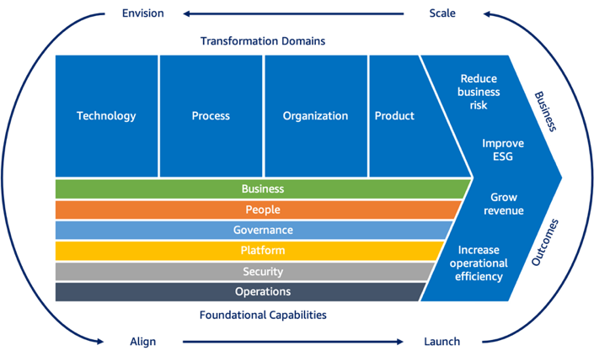

Figure 2 AWS Cloud Adoption Framework 3.0 (Amazon, 2021).

Knowledge has been integral in Amazon’s Standard operating procedures, in the business perspective capabilities data science is an integral aspect of Amazon's knowledge management system. Amazon believes in , ‘leveraging advanced analytics and machine learning to solve complex business problems.’(AWS, 2021). Also, Amazon Web Services leverages data to obtain business benefit through the monetisation of data. An example Amazon shares is leveraging customer behaviour insights from data analysis to increase hyper personalisation. (AWS, 2021). However, Amazon encourages that data be monetised internally to reap business benefit before considering external monetization opportunities. With the advantage of business insights and the competitive advantage Amazon has with the Amazon Web Services knowledge management framework, it comes with great responsibility in data protection. (AWS, 2021). Amazon considers encrypting the knowledge they receive through customer data to protect customers sensitive data and they have clearly defined data protection controls.

Amazon acquires knowledge through big data based on customers behaviours. Amazon acquires knowledge through Alexa eco products that use voice artificial intelligence. The voice recordings a stored-on Amazon server and they help improve customers experience with Alexa because the data improves the accuracy of voice recognition. (Invisibly, 2021) Amazon collects customer data by using a collaborative filtering engine CFE, and it observes customers behaviour previous from previously bought items, items in carts, wish list items, product previously rated and most Google goods. (Invisibly, 2021). This is how Amazon creates personalised recommendations.

Amazon has sophisticated data qualifying and storing information systems. Data is analysed through a collaborative filtering engines and big data analysis using Amazon predictive analytics. (Invisibly, 2021). Then the data is stored on Amazon servers which are cloud based on Amazon Web Services. an example is if a customer adds a phone number that data signals Amazon to recommend phone cases, as the artificial intelligence and data analytics predict that the consumer may have bought a new phone. This analysis is happening constantly through Big Data analytics. (Invisibly, 2021).

Amazon Strategically disseminates knowledge across departments and to external stakeholders for the optimization of their business functions. They use the data for supply chain optimization, which tracks inventory and reaches up to suppliers to restock products. (Invisibly, 2021). The data is also used for price optimization as Amazon changes their prices about 2.5 million times in a day based on customers willingness to buy, availability and competitor’s price. (Invisibly, 2021).
In turn Amazon’s Improvement in customer experience, which draws from their customer centric approach and data focus, increased Amazon's market share to 50% by the end of 2021. (Invisibly, 2021).

Conclusion

In conclusion, Amazon utilises its unique mix of knowledge and information management systems that are heavily data based. through its a WS cloud adoption framework it has been able the business functions as well as the different areas of potential transformation and align those to achieve reductions in business risk improved environmental social and governance, grow revenue and increase operational efficiencies. Practically, Amazon achieves this through the utilisation of consumer data in real time to achieve price optimization supply chain optimization and to keep consumers on the site through personalised recommendations.

Recommendation

I do not have a recommendation for Amazon as far as a framework, as they utilise one of the most sophisticated knowledge management systems. However, Amazon can improve on adding more functions to their website and their user experience by offering additional services such as pharmacy, additional service products and expand to more locations globally.

References
Andreev, I. (2022) Knowledge Management. Available at: https://www.valamis.com/hub/knowledge-management (Accessed 3 August 2022).

Amazon, (2022) 2022 Amazon Annual Report. Available at: https://s2.q4cdn.com/299287126/files/doc_financials/2022/ar/Amazon-2021-Annual-Report.pdf (Accessed 3 August 2022).

Amazon, (2022) Who We Are. Available at: https://www.aboutamazon.com/about-us (Accessed 2 August 2022).

AWS, (2021) AWS CAF Ebook. Available at: https://d1.awsstatic.com/whitepapers/aws-caf-ebook.pdf (Accessed 4 August 2022).
Barr, J. (2021) AWS Cloud Adoption Framework (CAF) 3.0 is Now Available. Available at: AWS Cloud Adoption Framework (CAF) 3.0 is Now Available | AWS News Blog (amazon.com) (Accessed 02 August 2022).

Dalkir, K. (2011). Knowledge Management in Theory and Practice. Cambridge, Massachusetts: the MIT Press.

EFQM, (n.d.) The EFQM Model. Available at: https://efqm.org/the-efqm-model/ (Accessed 01 August 2022).

Eliot, S. and Valverde, L. (2018) The 6 Pillars of the AWS Well-Architected Framework | Amazon Web Services. Amazon Web Services. Available at: https://aws.amazon.com/blogs/apn/the-6-pillars-of-the-aws-well-architected-framework/ (Accessed 6 August 2022).

Invisibly, (2021) How Does Amazon Use Big Data? Complete Insights for 2022. Available at: https://www.invisibly.com/learn-blog/how-amazon-uses-big-data Accessed 01 August 2022)

Luis Fonseca (2022) The EFQM 2020 model. A theoretical and critical review,Total Quality Management & Business Excellence, 33:9-10, 1011-1038, DOI: 10.1080/14783363.2021.1915121

Mohammed, S. (2022) Manage information system of Amazon. [video] Available at: https://www.youtube.com/watch?v=FVOpvQu8XXE (Accessed 25 July 2022).

Nonaka, I. and Ichijo, K. (2007) Knowledge creation and management: new challenges for managers. New York: Oxford University Press.

Patel, R. (2021) SECI Model: Knowledge Creation & Dimensions. Available at: https://www.thecloudtutorial.com/seci-model/ (Accessed 01 August 2022).
Sanchez, R. (2003) Knowledge Management and Organizational Competence. Oxford :, Oxford University Press.

Tlu, (n.d.) Theoretical Models of Information and Knowledge Management. [online] Tlu.ee. Available at: https://www.tlu.ee/~sirvir/IKM/Theoretical_models_of_Information_and_Knowledge_Management/the_european_foundation_for_quality_management_efqm_km_model.html (Accessed 9 August 2022).

LIMITATIONS
- Increased tightening of data protection laws
- It can still fail to increase revenuw

OBJECTIVES
- reduced business risk
- improve the ESG (measure of sustainable operation, that looks at environment, social factors and governance)
- , increase revenue
- increase operational efficiency

References
- Barr, J. (2021) AWS Cloud Adoption Framework (CAF) 3.0 is Now Available. Available at: AWS Cloud Adoption Framework (CAF) 3.0 is Now Available | AWS News Blog (amazon.com) (Accessed 02 August 2022).
Amazon’s Current Knowledge Management Framework
A.W.S

