LEVEL 5 ASSESSMENT
Component 2: Written Assignment (Report)
Developing Employability for a UK PCN Care Coordinator Role

Programme | BSc Health and Social Care
Module | Changemakers: Building your Personal Brand for Sustainable Employment
Module code | BMHP5015
Assignment title | Component 2: Assignment (Report)
Student name | Sumaira shah
Student number | 2414021
Lecturer | Olufemi Oluranti

Contents
1. Introduction 3
2. Selected role and person specification 4
3. Analysis of employability skills 6
4. Evaluation of my current skills 8
5. Personal brand, professional identity and network 10
6. Five-year action plan and timeline 12
7. Resources and communication with employers 14
8. Conclusion 15
Appendices 16
Appendix A: MY CV 16
Reference list 18

1. Introduction
This report focuses on the role of Primary Care Network Care Coordinator in the United Kingdom. I selected this role because it combines health knowledge, communication, organisation and practical support for people with complex needs. It also offers a clear route into personalised care. The report uses a current vacancy from Buckhurst Hill, Loughton and Chigwell Primary Care Network. The vacancy was open until 17 July 2026. Primary Care Careers (2026) describes the post as a full-time role that supports GP practices and works closely with a multidisciplinary team.
The report analyses the skills required by the vacancy. It then compares these needs with my present strengths and gaps. A SWOT matrix is used to make the assessment clear. The report also explains how I will build a professional identity, develop a useful network and communicate my value to employers. Finally, it gives a five-year action plan.

2. Selected role and person specification
A care coordinator helps people move through health and social care services. NHS England (2023) explains that care coordinators listen to what matters to each person, build trusting relationships and connect people with the right teams at the right time. The role is especially useful for people with long-term conditions, frailty or several services involved in their care. It can reduce confusion and help clinical staff use their time well.
In the selected vacancy Buckhurst Hill, Loughton and Chigwell PCN is recruiting a full-time Care Coordinator in Buckhurst Hill, with a salary of £25,000–£28,000 per year. It requires the coordinator to identify and manage a caseload with GPs and other professionals. The worker must develop care plans, help patients prepare for clinical conversations, provide follow-up and keep care records current. The post also includes digital work and daily use of a clinical system. Primary Care Careers (2026) asks for experience in healthcare, voluntary work or community services. It also asks for empathy, strong listening, clear communication, non-judgmental support, local service knowledge and experience of holistic care planning. A Level 2 Diploma in Health and Social Care is desirable but not essential. Benefits include an NHS pension and 25 days’ annual leave. A DBS check is required.
This person specification shows that the role is not only administrative. It requires safe judgement and relationship skills. NHS England (2026a) states that care coordinators bring together different professionals and support people to be active in their own care. NHS England (2026b) also explains that personalised planning should be a shared conversation about the person’s whole life, not only a list of medical tasks.
Current vacancy evidence used for the report is attached as screenshot in figure 1, with available source.

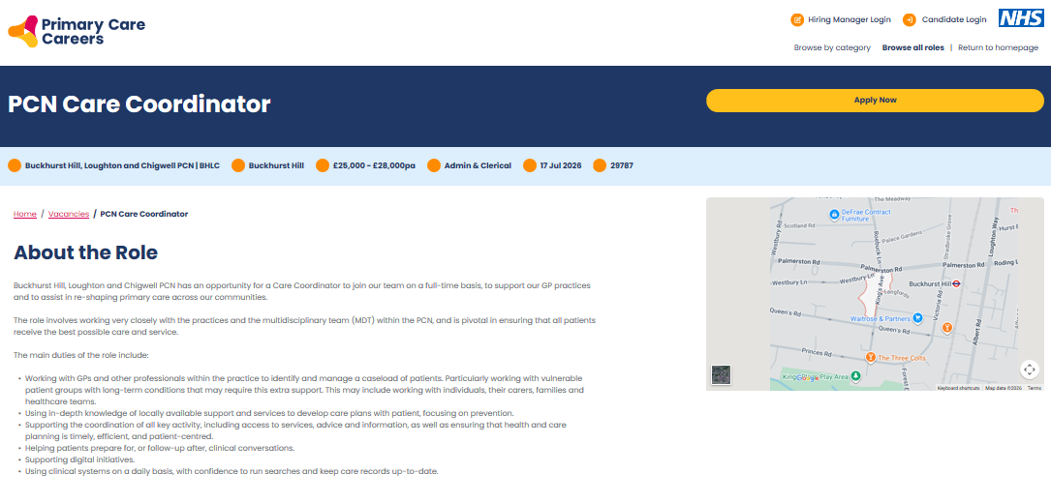
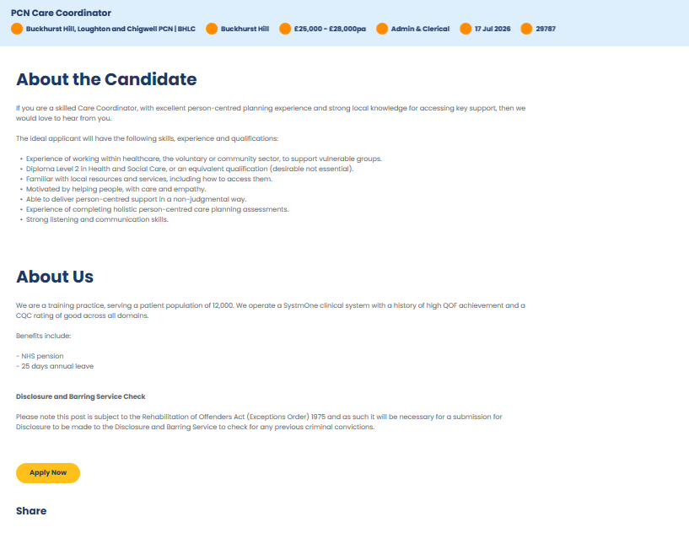
Figure 1: Current vacancy evidence used for the report. Text captured from Primary Care Careers (2026) on 14 July 2026. Available at: https://vacancies.eoeprimarycarecareers.nhs.uk/vacancies/29787/pcn-care-coordinator.html

3. Analysis of employability skills
The diagram below illustrates the main skills and qualities expected of a PCN Care Coordinator in the UK health and social care sector.

Figure 2: Employability Skills Required for this Job (PCN Care Coordinator) (Source: Data Taken form Primary Care Careers (2026) Job Vacancy and created by using MS Word)
The first key skill is person-centred communication. A coordinator must listen carefully, use simple language and check understanding. Skills for Care (2025) explains that communication supports trust with individuals, families and colleagues. This matters because a person may feel worried, confused or unheard. Professional boundaries need to be integrated with empathy, therefore. The worker must take note of the choices, while at the same time acting, when there is a risk.
The second skill is teamwork. Care coordinators liaise with GP, Nurses, Social prescribers, Carers, Voluntary groups and social care teams. They are required to pass on relevant information, follow up actions and avoid duplication. Care coordination, as described by McDonald et al. (2007), involves organizing activities amongst people to ensure the care is suitable and sustained. There also needs to be confidence in asking questions and challenging unsafe practice to make good team working.
The third skill is organisation. The worker could have a lot of patients, referrals, and deadlines to deal with. They should focus on immediate issues, document the actions and track progress. Digital confidence is also of a must. Daily use of clinical systems and maintaining accurate records are necessary for the position. The Information Commissioner's Office (2026) emphasizes the importance of the sensitivity of health information and the need for it to be treated transparently and lawfully. Safeguarding is also a fundamental duty in the Care Act 2014 where an adult is thought to be at risk of abuse or neglect.
Employability includes more than technical ability. It is a collection of accomplishments that enable a person to get and maintain a job, according to Yorke (2006). Career development, experience, subject knowledge, emotional intelligence and reflection function together according to Dacre Pool and Sewell (2007). Fugate, Kinicki and Ashforth (2004) also point out that adaptable and understanding employable individuals can comprehend their professional identity. Adaptability is required in this position, as patient needs, services and digital systems can shift rapidly. Emotional strength is also essential since such work may be accompanied by sickness, loneliness, family pressures and losses.
Lastly, the worker must be reliable, aware of equality, willing to learn and a problem solver. The Care Quality Commission (2025) has set the benchmark that staff are competent, skilled, supported and supervised. A good coordinator, therefore, should be familiar with the boundaries of the position, ask for assistance and apply feedback.

4. Evaluation of my current skills
A SWOT matrix is used to make the assessment clear for evaluation of my current skills (Pickton & Wright, 1998).
4.1 SWOT matrix
Table 1: Personal SWOT matrix for the PCN Care Coordinator career goal
Strengths  BSc study; communication; teamwork; organisation; empathy; basic Word and Excel skills. | Weaknesses  Limited direct UK care experience; no clinical-system practice; little formal care-planning evidence; limited local-service knowledge.
Opportunities  Care Certificate; PCI training; volunteering; placements; mentoring; NHS webinars; university careers support. | Threats  Strong competition; employers may prefer recent experience; changing digital systems; emotional pressure; limited time or training funds.
My main strength is my current study at BSc in Health and Social Care. It is helping me to build my knowledge of health inequalities, person centered practice, safeguarding and professional values. I also possess transferable skills that I acquired from assignments, presentations and group work. These include written communication skills, teamwork, meeting deadlines and locating evidence. I am confident using basic digital tools (such as Word, email and Excel). I am driven to serve others and I know that it is more helpful to listen than to assume.
These strengths align to portions of the vacancy, but are not yet indicative of full job readiness. Tomlinson (2017) explains that employability includes human, social, cultural, identity and psychological capital. While my qualification is human capital, I need more social capital, in the form of professional contacts and more practical capital, in the form of work experience. My current strengths are in learning and communication. Weaker in clinical systems, formal care planning and handling a live caseload.
My main improvement area is direct health or community experience. I also need current safeguarding and information-governance training. I have not yet built detailed knowledge of UK local referral pathways. I need practice in writing concise case notes and using systems such as SystmOne or EMIS. I should also develop confidence in difficult conversations and learn when to escalate risk.
The SWOT matrix prevents the self-assessment from becoming only a list of positive qualities. Helms and Nixon (2010) warn that SWOT can be subjective, so I will test it through feedback from lecturers, placement supervisors, careers advisers and care staff. I will review it every six months and add evidence, such as feedback, certificates and examples from practice.

5. Personal brand, professional identity and network
My personal brand should be honest, consistent and connected to patient value. Gorbatov, Khapova and Lysova (2018) describe personal branding as a planned process of presenting a clear professional value. My proposed brand statement is: “A compassionate, organised and digitally confident future care coordinator who listens, connects services and helps people take control of their care.” This is not a claim that I already have every skill. It shows the direction of my development.
My unique selling point is the combination of health and social care knowledge, clear communication, organisation, digital confidence and reflective learning. I can add value by making information easier to understand, following actions carefully and treating the person as a partner. McCormack and McCance (2017) show that person-centred practice depends on respectful relationships and a supportive care environment.
I will communicate this identity through a two-page CV (Attached in Appendix A), a complete LinkedIn profile and a small digital portfolio (Shown in Figure 3). LinkedIn (n.d.) advises users to show relevant skills, education, experience and certificates. My portfolio will include training records, anonymised reflective examples, feedback and a map of local services. It will never include confidential patient details.
Networking will help me understand hidden expectations and find learning opportunities. Bridgstock (2009) argues that career management and network skills help graduates manage changing work. Granovetter (1973) shows that wider professional connections can provide new information. I will connect with university tutors, placement staff, GP practice managers, care coordinators, voluntary organisations and professional groups. I will attend NHS and Personalised Care Institute webinars and request short informational conversations. I will focus on learning and contribution rather than asking strangers directly for jobs.
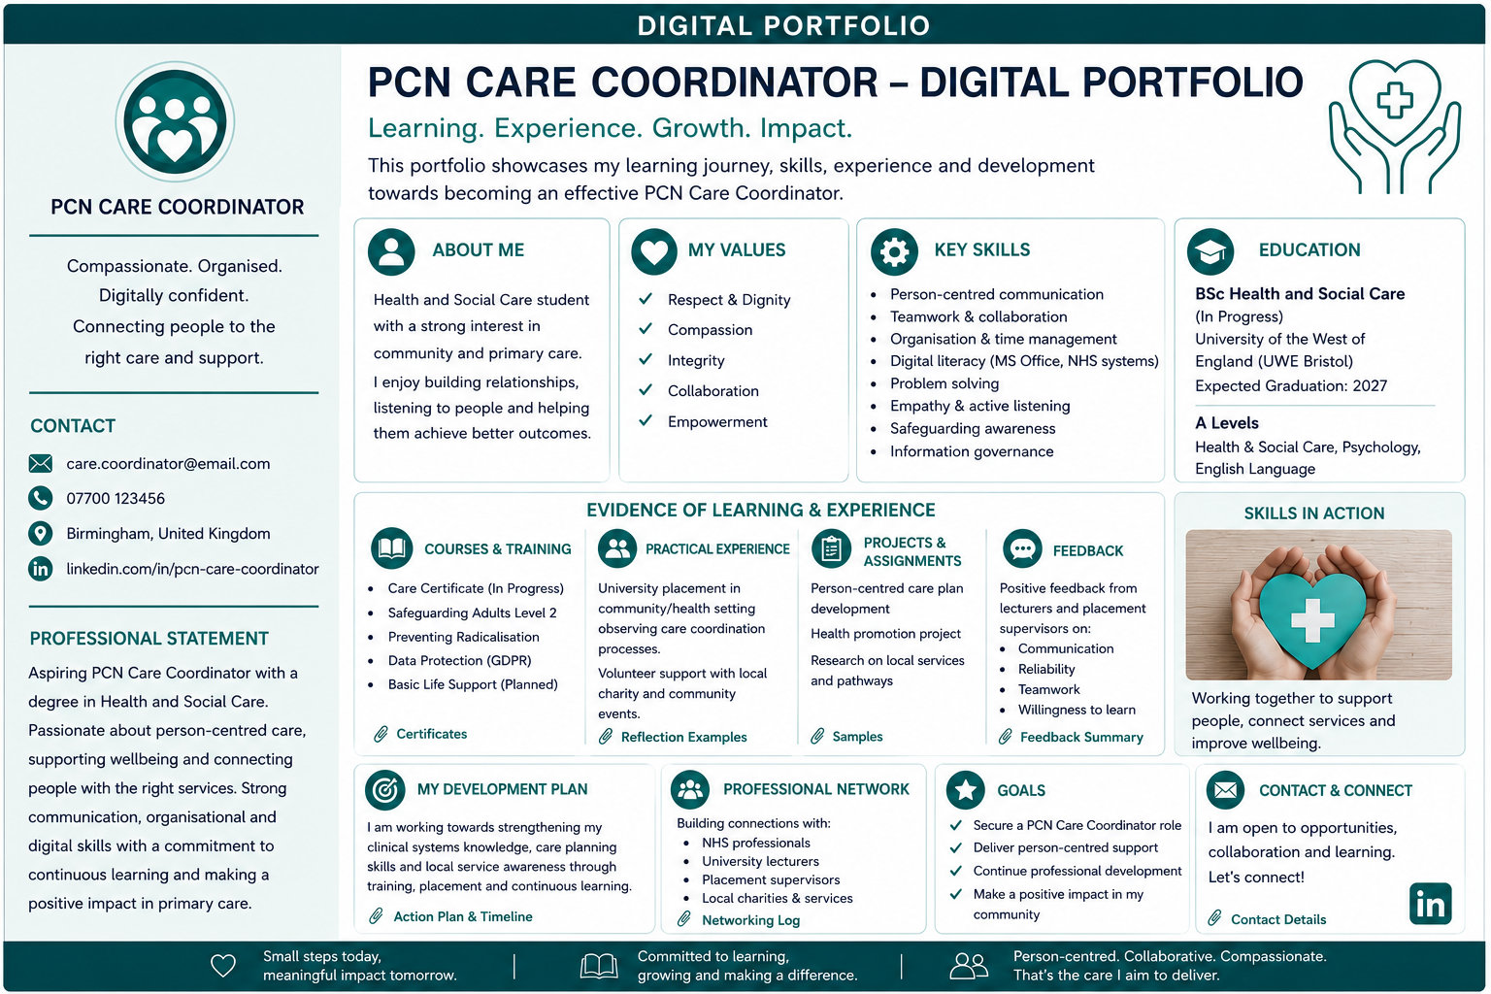
Figure 3: Small digital portfolio for Job Role PCN Care Coordinator (Created by using Canva)

6. Five-year action plan and timeline
My action plan uses clear goals, regular review and evidence. Doran (1981) recommends goals that are specific, measurable, achievable, relevant and time-based. Schön (1983) explains that professionals improve by reflecting on action. I will therefore keep a monthly reflective log and review the plan every six months.
Table 2: Five-year action plan and timeline
Timeline | Development actions | Evidence of progress | Support and resources
0–6 months | Complete safeguarding, data protection, equality and Care Certificate learning. Improve Excel, case notes, CV and LinkedIn. | Certificates; reviewed CV; three sample case notes. | University tutor, careers adviser and online courses.
6–12 months | Gain weekly voluntary or paid community experience. Map local services and request shadowing. | Supervisor feedback; reflective log; service directory. | Charity, GP practice, care home or community team.
Year 1–2 | Apply for support roles. Complete accredited two-day Care Coordinator training and personalised-care learning. | Course certificate; applications; interview feedback. | PCI provider, mentor and NHS Jobs.
Year 2–3 | Secure a Care Coordinator role. Learn caseload, care planning, safeguarding escalation and SystmOne or EMIS. | Induction signed off; appraisal goals met; outcome examples. | Line manager, supervisor and MDT.
Year 3–5 | Take advanced CPD and lead a small service-improvement project. Prepare for senior responsibility. | Project results; updated portfolio; progression discussion. | Employer training, professional network and mentor.
Table 2. Five-year SMART development plan, reviewed every six months.
The plan moves from basic safety learning to supervised experience, entry employment and then a Care Coordinator post. The Personalised Care Institute (2026) states that accredited training gives coordinators the knowledge and skills needed for safe practice. The Chartered Institute of Personnel and Development (2022) also explains that CPD should build strengths and address capability gaps. Progress will be measured through certificates, feedback, work examples and successful applications.

7. Resources and communication with employers
The plan needs time, training access, digital equipment, transport and supportive people. University careers services can help with applications and interviews. A placement supervisor or mentor can give practice-based feedback. NHS England resources, the Personalised Care Institute, Skills for Care and local safeguarding partnerships can provide learning. Voluntary organisations can provide supervised contact with service users.
For applications, I will match each CV and supporting statement to the person specification. I will use the STAR method to explain situations, tasks, actions and results. I will describe evidence rather than write general claims such as “I am caring.” At interview, I will give examples of listening, confidentiality, teamwork, prioritisation and learning from feedback. I will also explain how I would seek help when a situation is outside my competence.

8. Conclusion
To conclude, the PCN Care Coordinator role is a realistic long-term goal, but it requires more than a degree. My current strengths are study-based knowledge, communication, organisation, digital confidence and motivation. My key gaps are direct care experience, local service knowledge, safeguarding practice, care planning and clinical systems. The five-year plan addresses these gaps through training, volunteering, entry-level work, mentoring, reflection and targeted applications. A clear personal brand and a genuine professional network will help employers see both my current value and my commitment to safe development.

Appendices

Appendix A: MY CV
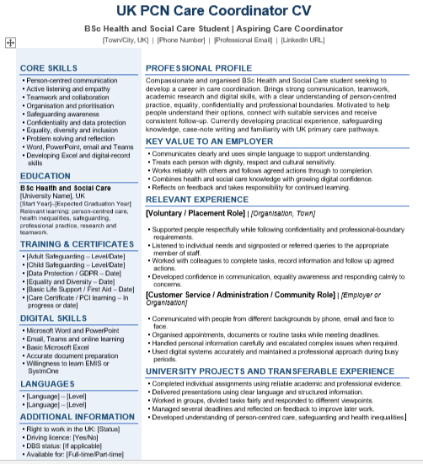
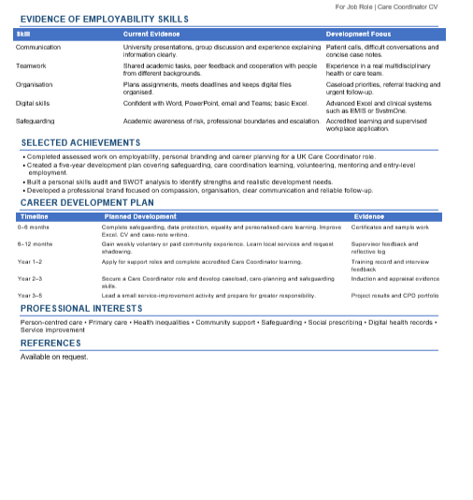

Reference list
Bridgstock, R. (2009) ‘The graduate attributes we have overlooked: enhancing graduate employability through career management skills’, Higher Education Research & Development, 28(1), pp. 31–44. https://doi.org/10.1080/07294360802444347
Care Act 2014, c.23. Available at: https://www.legislation.gov.uk/ukpga/2014/23/section/42 (Accessed: 14 July 2026).
Care Quality Commission (2025) Regulation 18: Staffing. Available at: https://www.cqc.org.uk/guidance-regulation/providers/regulations-service-providers-and-managers/health-social-care-act/regulation-18 (Accessed: 14 July 2026).
Chartered Institute of Personnel and Development (2022) Continuing Professional Development (CPD). Available at: https://www.cipd.org/en/learning/cpd/ (Accessed: 14 July 2026).
Dacre Pool, L. and Sewell, P. (2007) ‘The key to employability: developing a practical model of graduate employability’, Education + Training, 49(4), pp. 277–289. https://www.proquest.com/docview/237071588/65131CCB57B04F27PQ/3?sourcetype=Scholarly%20Journals (Accessed: 14 July 2026).
Doran, G.T. (1981) ‘There’s a S.M.A.R.T. way to write management’s goals and objectives’, Management Review, 70(11), pp. 35–36. https://www.eval.fr/wp-content/uploads/2020/01/S.M.A.R.T-Way-Management-Review-eval.fr_.pdf
Fugate, M., Kinicki, A.J. and Ashforth, B.E. (2004) ‘Employability: a psycho-social construct, its dimensions, and applications’, Journal of Vocational Behavior, 65(1), pp. 14–38. https://doi.org/10.1016/j.jvb.2003.10.005
Gorbatov, S., Khapova, S.N. and Lysova, E.I. (2018) ‘Personal branding: interdisciplinary systematic review and research agenda’, Frontiers in Psychology, 9, article 2238. https://doi.org/10.3389/fpsyg.2018.02238
Granovetter, M.S. (1973) ‘The strength of weak ties’, American Journal of Sociology, 78(6), pp. 1360–1380. https://snap.stanford.edu/class/cs224w-readings/granovetter73weakties.pdf
Helms, M.M. and Nixon, J. (2010) ‘Exploring SWOT analysis – where are we now? A review of academic research from the last decade’, Journal of Strategy and Management, 3(3), pp. 215–251. https://doi.org/10.1108/17554251011064837
Information Commissioner’s Office (2026) Transparency in health and social care. Available at: https://ico.org.uk/for-organisations/uk-gdpr-guidance-and-resources/data-protection-principles/transparency-in-health-and-social-care/ (Accessed: 14 July 2026).
LinkedIn (n.d.) Create a good LinkedIn profile. Available at: https://www.linkedin.com/help/linkedin/answer/a554351 (Accessed: 14 July 2026).
McCormack, B. and McCance, T. (2017) Person-Centred Practice in Nursing and Health Care: Theory and Practice. 2nd edn. Chichester: Wiley Blackwell.
McDonald, K.M., Sundaram, V., Bravata, D.M. et al. (2007) Care Coordination. Closing the Quality Gap: A Critical Analysis of Quality Improvement Strategies, Volume 7. Rockville, MD: Agency for Healthcare Research and Quality. https://www.ncbi.nlm.nih.gov/books/NBK44015/ (Accessed: 14 July 2026).
NHS England (2023) Workforce development framework for care co-ordinators. Available at: https://www.england.nhs.uk/long-read/workforce-development-framework-for-care-co-ordinators/ (Accessed: 14 July 2026).
NHS England (2026a) Care co-ordinators. Available at: https://www.england.nhs.uk/personalisedcare/workforce-and-training/care-co-ordinators/ (Accessed: 14 July 2026).
NHS England (2026b) Personalised care and support planning. Available at: https://www.england.nhs.uk/personalisedcare/pcsp/ (Accessed: 14 July 2026).
Pickton, D.W. and Wright, S. (1998) ‘What’s SWOT in strategic analysis?’, Strategic Change, 7(2), pp. 101–109. https://doi.org/10.1002/(SICI)1099-1697(199803/04)7:2%3C101::AID-JSC332%3E3.0.CO;2-6
Personalised Care Institute (2026) Accredited training menu: Care Coordination. Available at: https://www.personalisedcareinstitute.org.uk/accredited-training-menu-care-coordination-new/ (Accessed: 14 July 2026).
Primary Care Careers (2026) PCN Care Coordinator, Vacancy ID 29787. Available at: https://vacancies.eoeprimarycarecareers.nhs.uk/vacancies/29787/pcn-care-coordinator.html (Accessed: 14 July 2026).
Schön, D.A. (1983) The Reflective Practitioner: How Professionals Think in Action. New York: Basic Books. https://raggeduniversity.co.uk/wp-content/uploads/2025/03/1_x_Donald-A.-Schon-The-Reflective-Practitioner_-How-Professionals-Think-In-Action-Basic-Books-1984_redactedaa_compressed3.pdf
Skills for Care (2025) Care Certificate Standards, March 2025. Available at: https://www.skillsforcare.org.uk/resources/documents/Developing-your-workforce/Care-Certificate/Care-Certificate-Standards/Care-Certificate-standards-March-2025.pdf (Accessed: 14 July 2026).
Tomlinson, M. (2017) ‘Forms of graduate capital and their relationship to graduate employability’, Education + Training, 59(4), pp. 338–352. https://doi.org/10.1108/ET-05-2016-0090
Yorke, M. (2006) Employability in Higher Education: What It Is – What It Is Not. York: Higher Education Academy. http://www.employability.ed.ac.uk/documents/Staff/HEA-Employability_in_HE(Is,IsNot).pdf

