A written assignment critically evaluating how assessment for learning can be utilised in a series of learning opportunities to aid progression across areas of learning and experience.
By
Kelly Ellis

Introduction.
It is vital to identify how a cohort can most effectively and comfortably progress in their learning. In this article one will explore how formative assessment for learning AFL, and summative assessment of learning AOL, allows one to gain the best standard of pedagogical knowledge. According to (Smith and Conti, 2016) Dylan William believes, giving clear learning objectives and retrieving feedback gives the opportunity to take action to progress because of AFL. Gaining feedback on where a learner is at and the progression of the learner may allow one to be in the best position to educationally cater for each specific learner, hence meet a cohort’s individual needs. Focus throughout this article will be based on one’s own experiences with Dosbarth Skomer, year 3 and 4 KS2 learners, and how one identified how AFL and AOL were critical for both teacher and learner. One recognised that in a mixed year 3 and 4 class the need for thorough assessment in each lesson is critical for every learner’s progression. AFL and AOL strategies one used allowed one to gain evidence of what learners already knew, moreover gave one the knowledge required to identify if learners were on task during the activity set for them, and where each learner is at when the lesson is drawing to the end. Enforcing AFL and AOL, one was able to plan for each ability within the cohort for each AOLE so each learner would not be in a position where they would be challenged beyond what they were capable of. If this was to occur, it would be brought to light in AOL and their learning moving forward would adapt in accordance with their ability. Likewise, more able learners would have the opportunity to be excelled to a higher level of learning if required. AFL gives lower ability LA and some middle ability MA learners opportunities to gain inspiration and ideas from the higher ability HA learners, which is a huge asset to teachers as LA and MA learners are not only gaining the knowledge the teacher has but that of their peers. This also can highlight when LA learners have an increased knowledge of other AOLE’s. It is relevant to consider that whereas some learners excel in all areas, many learners have weaknesses and strengths that differ from their peers across the AOLE’s, for example a LA learner may not be so able in terms of LLC and numeracy, but be classed as MA or HA in PE, Cymraeg, or Expressive arts. However, one has to be vigilant with observing discussions during an AFL strategy as the discussions that take place between learners are likely to influence their peers work; One must be alert to incorrect information being discussed and address without highlighting the discussion as useless information. AOL is not only essential for the progression of LA, MA, and HA learners but vital for learners with additional learning needs ALN highlighting when these learners and some LA learners may need intervention; In contrast the more able talented MAT learners who can be challenged beyond the ‘expected’ level for their age. AOL gives a measure of how much of what one has taught during each lesson has been absorbed. Having this knowledge will allow more effective planning as one identifies if a lesson must be revisited for reinforcement or consolidation or what to plan next. Reflection comes from this data where one can decide what went well and what did not work. One will be mainly focusing on two Humanities lesson plans, and an RE plan. The cross curricular AOLE’s covered within these plans are: LLC by understanding the meaning behind images, expressive arts by creating a sketch and painting, health and wellbeing by creating an eat well plate for the WW1 soldiers. In RE: LLC by legibly writing a message on a card to be hung on the class Jesse tree and DCF by linking inserting images of symbols to scripture references on the iPads. Previous learning for humanities in Dosbarth Skomer was ‘The rainforest’ and for this half term one moved onto WW1. To begin this topic pupil voice was enforced to scaffold teaching around what the learners desired to know. Each learner in the class were asked to write one thing they wanted to know about WW1 on a post it note and stick it on the board. A class mind map was created on the board with each learner’s input and the whole term of learning for Humanities included every learner’s input. There were a few additions to cover any aspects that had been missed. Doing this highlighted as a class just how much collectively the learners knew and that some learners had little knowledge, and some had more knowledge than expected of a topic the learners had not explored. One realised using pupil voice instantly made the learners engage and create wonder and awe. The learners had created their own learning which covered what they needed to know.
Literature review.
According to Cox (2019) who wrote a book about ‘opening doors’ to fundamentally create new learning; learners may be intimidated by ‘language, genres, and styles’ because of no or too little teaching strategies that unlock the potential to learn. Strategies seem to be the key to the most effective teaching and learning outcomes. One would suggest this may not be possible without a good, structured plan. Planning for a lesson may be most effective with a child centred approach such as pupil voice. Estyn (2018) acknowledged Glan Usk Primary School for their embedment of pupil voice within their school. Estyn (2018) believed that the impact pupil voice had on the ‘standards of teaching and learning’ and the wellbeing of the learners was due to the influence of pupil voice. They witnessed the learners being the core of their own education creating enthusiasm, and thirst to learn through the cohorts’ own interests. Estyn (2018) witnessed this having a positive impact on the learners’ innovative curriculum involvement. This is underpinned by the whole aim of the curriculum which has been designed by Donaldson (2015) in a way that allows learners to be educated through their own interests. Donaldson enforced this design this way for learners to engage, hence achieve having a positive impact on pupil progression (Donaldson, 2015). For the smooth and most effective flow of a lesson, one would suggest it may lean heavy on having a well-structured, detailed plan. In this plan one would recommend making note of the AFL strategies on intends to use and where they will be used within the lesson. This may contain any hooks or stimuli being used, open ended questions being posed and the methods one will use to retrieve answers, mini plenaries checking learners are on task with the activity set, and a final plenary. Plans require an outline of ‘preparation, presentation, and evaluation’. Learning objectives LO and Success criteria should be shared to the cohort to give learners an overview of ‘what to expect’. Existing knowledge must be covered to gain focus and recap what learners already know (Smith and Conti, 2016 Pp. 314-315). To encourage instant engagement, one would recommend the use of a hook. This is supported by Cox (2019, Pp. 8) who believes by giving the learners snippets of what they are about to learn will encourage engagement and thirst to see what the overall idea of the lesson or text is. Moreover, supported by Thomas (2019) who believes a hook opens learners’ imaginations through immersion creating curiosity. Similar to Smith and Conti (2016), Cox (2019, Pp12) also believes deep objectives key to the teaching of concepts. He believes a plan contains open ended questions to encourage motivation through setting themselves goals to answer the questions. One may suggest that to create ideas, evaluations, and conclusions collaboration between teachers and peers may be key. Teachers working collaboratively with learners is supported by Darling-Hammond who refers to this as ‘communities of discovery’ enhancing learners’ creativity (Aubrey and Riley, 2021. Pp312). However, Darling-Hammond was critiqued where it was believed her theory was not practical and would cause chaos in the setting where no one would be of authority (Aubrey and Riley, 2021. Pp 318). ‘Communities of discovery’ may be key to assessing one’s own teaching and what the learners are achieving from one’s teaching, or for learners gaining inspiration from their peers. Vygotski and Piaget both agreed with Donaldson that in the process of learning learners powerfully participate actively. Moreover, that cognitive conflict creates the development of cognition, meaning when learners challenge each other during discussion they develop cognitively. This may give weight to thought and language internalisation however, Vygotski had very little studies to support give weight to what he claimed, which were interpreted by his supporters who later provided evidence (Gray and Macblain, 2015). It may be relevant to suggest each learner has their own specific needs which need to be met. ‘Cognitive empathy’ is the ability a teacher possesses to link a structured plan together to meet the cognitive needs of each learner. AFL strategies seem to be vital for a teacher to gain an indication of what knowledge their learner has or has gained. It seems to be possible that consistently reflecting on one’s practice pre, throughout, and post lesson; Use of personal language experience, provide consistent AFL methods for feedback, and continuously seek opportunities to improve practice to gain ways for the learners to ‘further understand’ the cognitive needs of one’s learners the most effective way to approach metacognition (Smith and Conti, 2016. Pp. 166-167). One would believe this may be why differentiation based on AFL strategies where a learner can put their knowledge into language to share with peers is vital for learners’ progression. Vygotski believed ‘thinking and learning’ is enhanced by language spoken when learners interact. He believed through learners having discussions more knowledgeable others MKO’s broaden their peers understanding, hence provide cognitive development (Gray and Macblain, 2015. Pp 96). He believed that discovery was initiated by teachers, in contrast Piaget disagreed believing discovery was initiated by learners themselves (Gray and Macblain, 2105. Pp108).

Lesson one.
One explored Humanities with cross curricular links to Expressive Arts and LLC. This lesson focuses on one’s learners’ perception of a given stimuli, a water colour painting of a soldier in a trench. The learning goal was to ‘use landscape art to express ideas’; The success criteria were to: sketch to add on to an image, use water colours to add depth to a drawing, include an effective amount of colour, consider the mood of the image, and consider the message the artist is trying to tell the viewer. One believes it is necessary in each lesson to make as many cross curricular links as possible to gain a broad access to education and knowledge. Dosbarth Skomer always fully interact with all arts and crafts lessons, hence for them to create their own work of art using water colours encouraged their engagement and therefore enhanced their learning experience. This lesson being Humanities focused on what message an artist was trying to get across to its viewer. The learners were presented by PowerPoint with an immediate hook which encouraged prompt engagement. The hook was a water-coloured painting of a soldier in a trench. This was followed by one’s first AFL strategy; Voice 21 is an oracy based, social constructivist, strategic framework that believed learners education is most effective through listening and talking in discussion. Voice21 is a framework that is scaffolded, planned, designed, structured, and modelled by teachers to encourage discussion throughout the lesson (Voice21, 2022). Voice21 provide sentence builder cards, laminated prompts that allow learners to have visual guides to encourage the use of language. The cards one was exploring with the cohort when using the methods for AFL were challenge and build. Hand signals were encouraged when learners wanted to contribute, challenge, or build upon their peer’s input. Learners would get raffle tickets when they would use these actions and language without being asked to. There are many methods that underpin the strengths of Voice 21 and for this lesson one started with the ‘nest’ method. The ‘nest’ method is a very good starting point for a lesson and gives learners opportunity to think about what they may already know about the stimuli and questions one is presenting. The question’s one posed while learners were in their nests were: ‘Where is this soldier?’ and ‘How does this picture make you feel?’. Ones intentions were to tap into prior knowledge to see if the learners knew this soldier was in a trench as we had previously had a lesson on trenches in WW1. This would allow learners to think about their previous learning and to gain some thought of their own feelings surrounding the picture. This is a solo method and does not always require an answer but possibly just thought. The ‘nest’ method gives learners time to gain access to the process of thinking therefore the opportunity to be ready to share their thoughts further on into the lesson with teacher and peers. One then moved onto a second painting of a soldier sitting in a room with his hat and bag hanging on the wall and if you look closely enough you may see there is a soldier slumped beside him, although this is not obvious. For this painting one posed two further questions: ‘What message is this painting trying to get across to the viewer?’ and ‘What else do you notice?’. For these questions one used another Voice21 method called the ‘traverse’ method. This involved Dosbarth Skomer standing and finding a group of 6 peers creating movement in the classroom but they were not allowed with anyone who was on the same table as them. If there was anyone left one would assign them to groups. They would then stand in two rows of 3 facing each other and when the question was posed, they would discuss with only the peer directly in front of them; When the bell rang one row would move down one person and the one on the end move to the top they would discuss again until the bell sounds. This would repeat until every learner had spoken to each other. This gave the opportunity to share ideas within a small social group creating the opportunity to contribute to conversation, build upon what peers have said, and challenge each other’s thoughts (Voice21, 2022). If the Traverse strategy is not executed professionally this method may easily create chaos within the classroom and is very timely meaning one could not squeeze this method into a mini plenary; Ones recommendation is to use this method as an exercise that can integrate into the body of the intro or activity set as an AFL strategy. Having put this into one’s practice proved to be an effective method for learners sharing what they already know in regards to questions, hence use their sentence builders to build on their vocabulary.
The link to the LLC AOLE is to infer meaning from an image. Creating discussion amongst the cohort allows ideas to be shared and thoughts to be pushed to a new dimension. One may suggest additional vocabulary may be gained when information is shared amongst peers. Voice21 (2022) seem to correlate with Ofsted (2022) who believe it is vital for a learner to develop the use of the language they speak to progress academically. This is due to vocabulary and syntax underpinning what learners absorb resulting in successful long-term readers. To follow one’s presentation focused on the use of water colours to scaffold the activity where the learners were provided a WAGOLL to guide them create their own sketch and water colour painting given a piece or pieces of the painting already stuck in their workbooks. This activity was adapted for the ability groups. The LA were given half of the picture, MA were given two sections with a gap in the middle and each end, and the HA were given one small section. The learners had to follow on from the pieces of art in their books and try to create the painting using their own interpretation of how the image looks, including the correct colours for the mood of the painting and what they believe the finished piece would look like. The WAGOLL was available and on the board for the LA and some MA if needed. The AFL Voice21 strategies used gave an idea of what the learners already knew and the AOL including the WAGOLL gave an indication of who relied on being guided and what the learners had taken in from the lesson. The learners had the opportunity to show and tell their work sharing their ideas and giving explanations behind their artwork in the plenary at the end of the lesson. This supports that of Smith and Conti (2016, Pp. 166-167) that by using these strategies allowed one to gain data of where learners were at to individually adapt their learning moving forward into future lessons.

Lesson two.
One explored Humanities with a link to Wellbeing which posed a different hook. Initially, the learners walked into the lesson to an unfamiliar smell creating curiosity and desperation to find out what was in store. The learning objective explained was ‘to analyse a WW1 soldier’s diet during the war’. The learners had the opportunity to taste foods the soldiers had access to in the trenches such as, bread and jam, hard biscuits, and tinned meat taking serious precautions to two allergies within the cohort, hence adaptions were put in place. Short video clips of how families back home sourced food and soldiers were then presented. One then requested a discussion in the learners table groups with the Voice21 oracy signals and sentence builders to be used. The learners had to discuss how the soldiers may have felt and how the families may have felt after the gained knowledge of watching the clips and feedback one word for each. One’s cohort were then able to instantly make comparisons to their own luxuries, voice their ideas and challenges, then come to an agreement for a word for the soldiers’ feelings and the families’ feelings to feedback. The reason for this strategy is to strengthen vocabulary and empathise with the sacrifices the soldiers made to fight for our country. The success criteria for this lesson were to: ‘give vocal feedback the topic of food, express your feelings toward the soldiers and their families, analyse good and bad foods, and create an ideal eat well plate for the soldiers. Sharing success criteria will create an understanding for the learners of how they can do well with their work, and to know each step of the task set throughout each activity. For the activity the learners were shown the recommended healthy eat well plate and for the link to health and Wellbeing asked to create their own eat well plate for the soldiers with food they would like the soldiers to have access to. For the plenary for AOL, one asked the learners to name and swap plates with learners on another table the peer assess giving ‘one star and one wish’. ‘One star’ is what the learner thinks their peer has done well and ‘one wish’ is what their peer could do to improve their work moving forward. This was a lovely way of learners being able to compliment their peers on the achievement of their work. It was also a fantastic method for the HA and MA to give some MA and LA advice to progress. The LA also got the opportunity to possibly view MA and HA work which allowed them to gain inspiration and ideas from their work.

Lesson three.
One explored RE with a cross curricular link to digital competency framework DCF and LLC. The LO was to ‘make links and describe the Jesse tree’; The success criteria was to ‘create your own message to praise your grown-ups, include gratification in your language, seek for the correct scripture that matches a chosen symbol, link symbols to scripture reference, insert images on the iPad, and label symbols with scripture reference. One initially presented a PowerPoint introducing the influence of the Jesse tree during advent. Following the introduction was a series of questions. In each lesson, questioning was key to offer open ended questions. It was apparent that the majority of one’s cohort wanted to answer as many questions as they could. Asking questions within class gives learners the opportunities to explain their ideas reinforcing their own understanding and gives peers the opportunity to build upon their answers with their understanding possibly expanding knowledge as a cohort. There are learners that enjoy volunteering to answer and some that are too introvert. To answer the questions, one posed the pencil pot names method was used. This is a nomination AFL method that encourages the quieter learners that will speak in front of the class but not volunteer to the opportunity to be heard and share their knowledge with the cohort. This is also a visually fair method as the learners can see one picking names at random from the pot. The negative with this method was one had one extreme quiet, shy member of the cohort who would not be vocal in front of the cohort. If this learner was picked at random one knew there would be no chance of any advances of input. In this situation one recommends after practicing in teaching to ask if this learner would like to nominate another learner to help them explain which worked very well. However, one found the Voice21 traverse method (2022) a fantastic AFL for this learner as they would be vocal in a small group when discussions were taking place between this learner and one other in a group of six rotating around upon the sound of the bell. This way this learner spoke to three peers sharing and gaining knowledge. The activity for this was set in ability groups. The LA wrote a message on a card which was hung on one’s class Jesse tree. MA were linking symbols to scripture reference. HA were on the iPads inserting pictures and linking them to scripture references. The plenary was for the cohort to think of five words to sum up their learning in today’s lesson and write them on a post it note then stick it to the whiteboard with their name on it. This gave one the opportunity to see if what was written on the learners post it notes reflected what one taught throughout the lesson.

Conclusion.
In conclusion, learners progressing in their education is what teachers aim to achieve. It seems without AFL it would be extremely difficult to differentiate forming groups of ability in the classroom. Having different abilities in the class seems to help the LA move forward and reinforces the understanding of the MA and HA. A well-structured, detailed plan makes a lesson flow most efficient, where teachers make notes of their LO’s and clear expectations of what is expected of the learners for activities; Hooks can be explained and AFL questions and methods for answering can be recorded. There are many methods for AFL and the Voice21 one used in practice seemed most effective. Voice21 methods all serve different time sections within one’s lesson plan there are enough methods to uses throughout the entire lesson that cover both AFL and AOL across all AOLE’s. The effectiveness and strength of each of these methods must not be dismissed. Having used all strategies in practice saw learners enthusiastic to contribute to discussion, challenge, and build upon peers’ knowledge. Even the quieter learners within the cohort had the opportunity to contribute to discussion in the comfort of a duo or trio even if they did not share to the whole class when their small group was asked to; One saw these learners still have an input when the method was being exercised.
Open ended questions may spark curiosity and creativity moreover, collaborative discussion within the class provides the perfect opportunity to gain assessment data for differentiated tailored learning. This may benefit the cohort, where HA can inspire LA expanding their learning and reinforcing their own knowledge. However, one must consider MAT learners may need more challenge and ALN learners may need intervention to meet their needs. It seems most effective for learners to sculpture their own learning based on their own interests with a hook and adding extra scaffolding to cover what they need to learn. This may encourage motivation and engagement. In discussion challenge and conflict may be effective for broadening vocabulary when learners can build upon their peers’ knowledge. In practice one identified discussion must be well observed and drawn in on occasions to minimise chaos in the classroom. It is relevant to consider the positive impact discussion has on the quieter members of the cohort where it gives these learners the opportunity to participate and teachers the opportunity to gain data for assessment. It is one’s belief that AFL is paramount and should be used as much as it is appropriate in all AOLE’s which are created by the learners but scaffolded by teachers professional planning for the most effective progression of the learners.

Appendix
Lesson one – Humanities: Landscape art to express ideas.
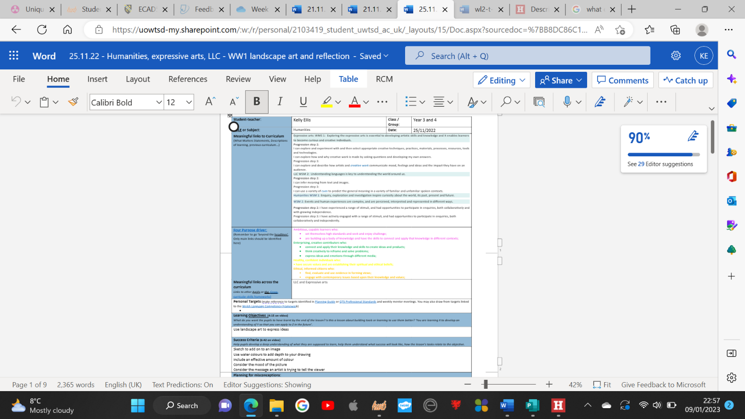

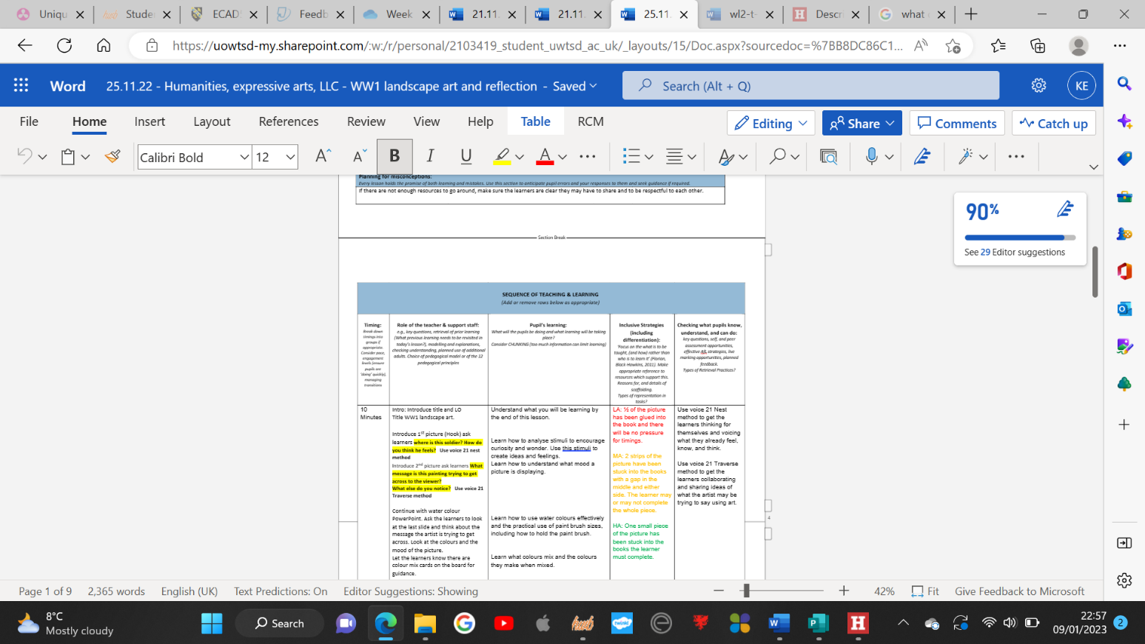

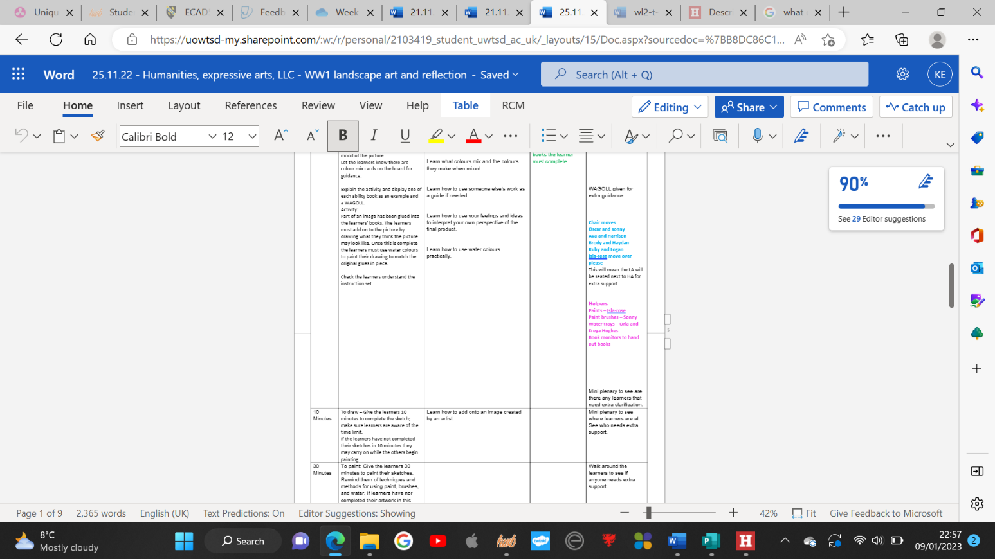

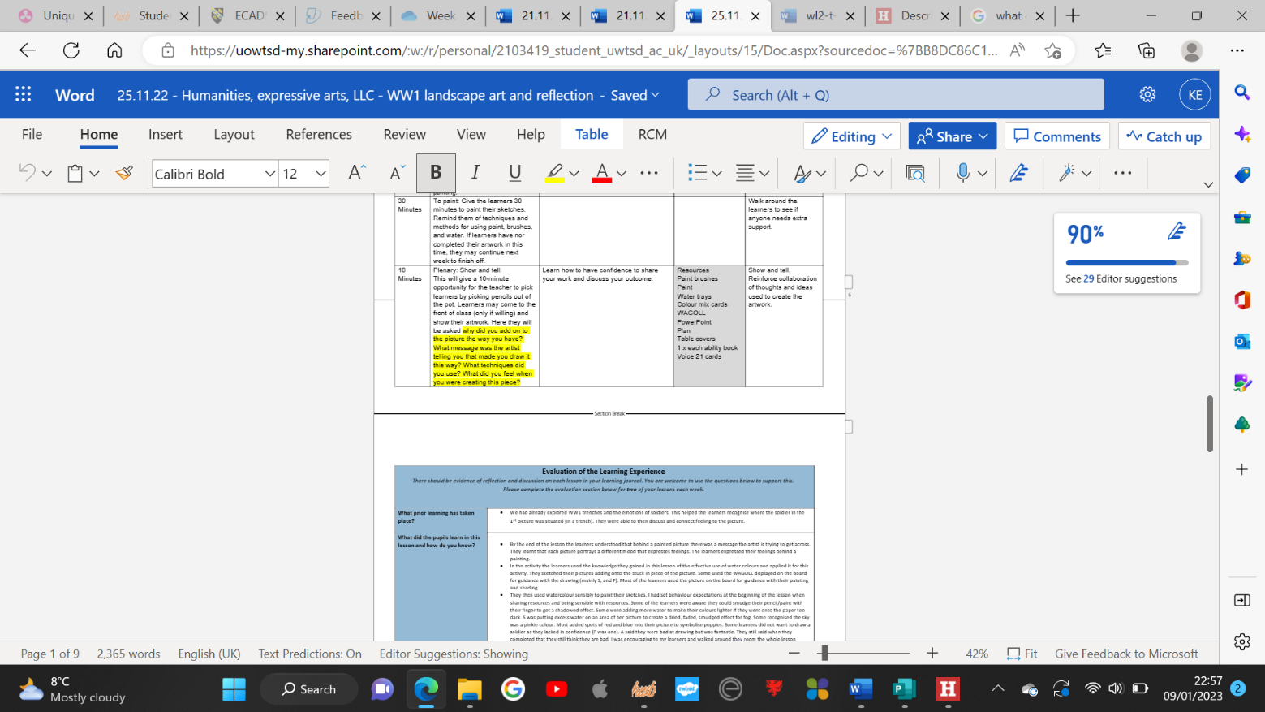

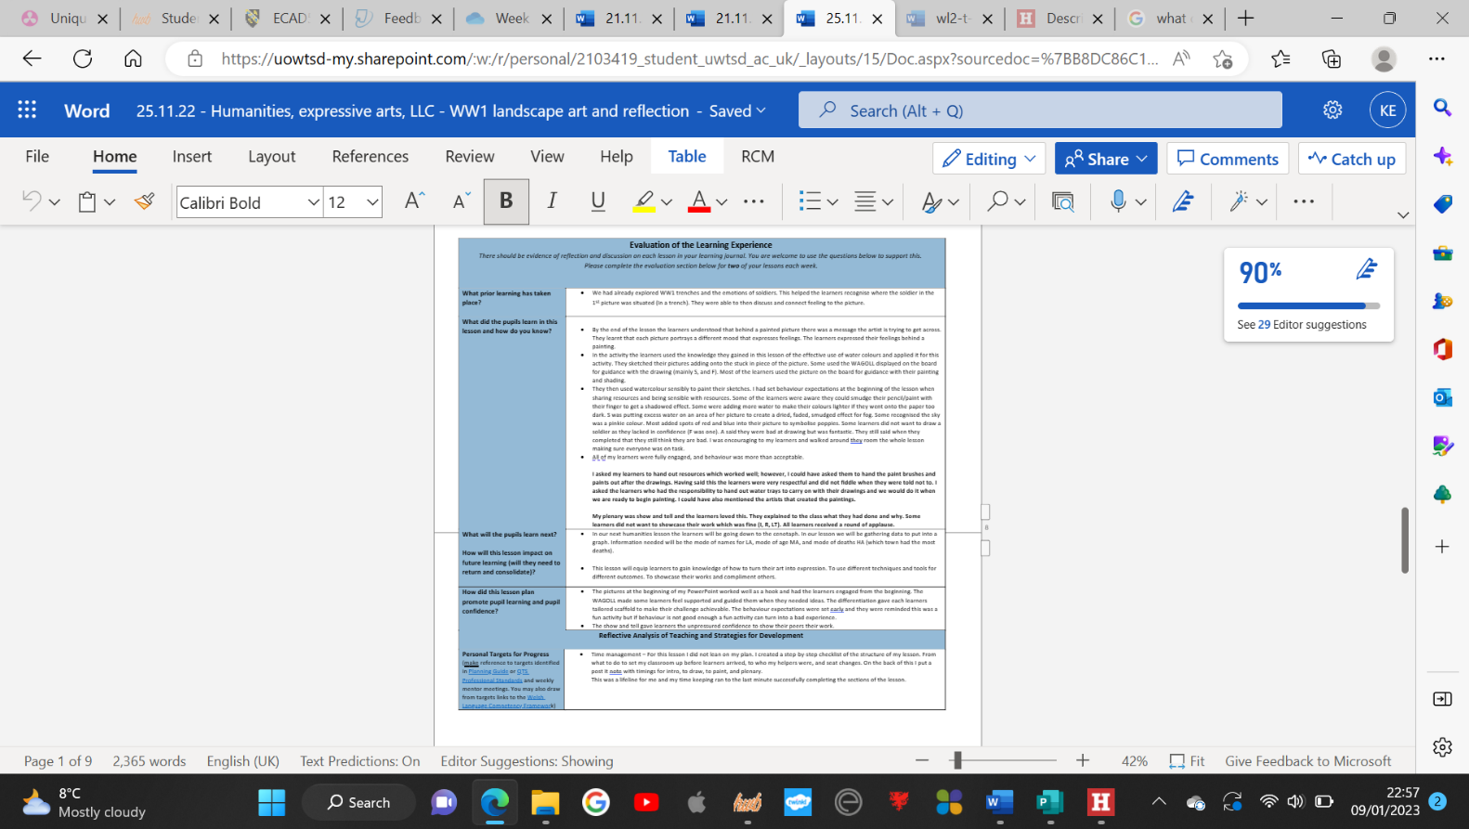

Lesson two – Humanities: A WW1 soldiers diet.
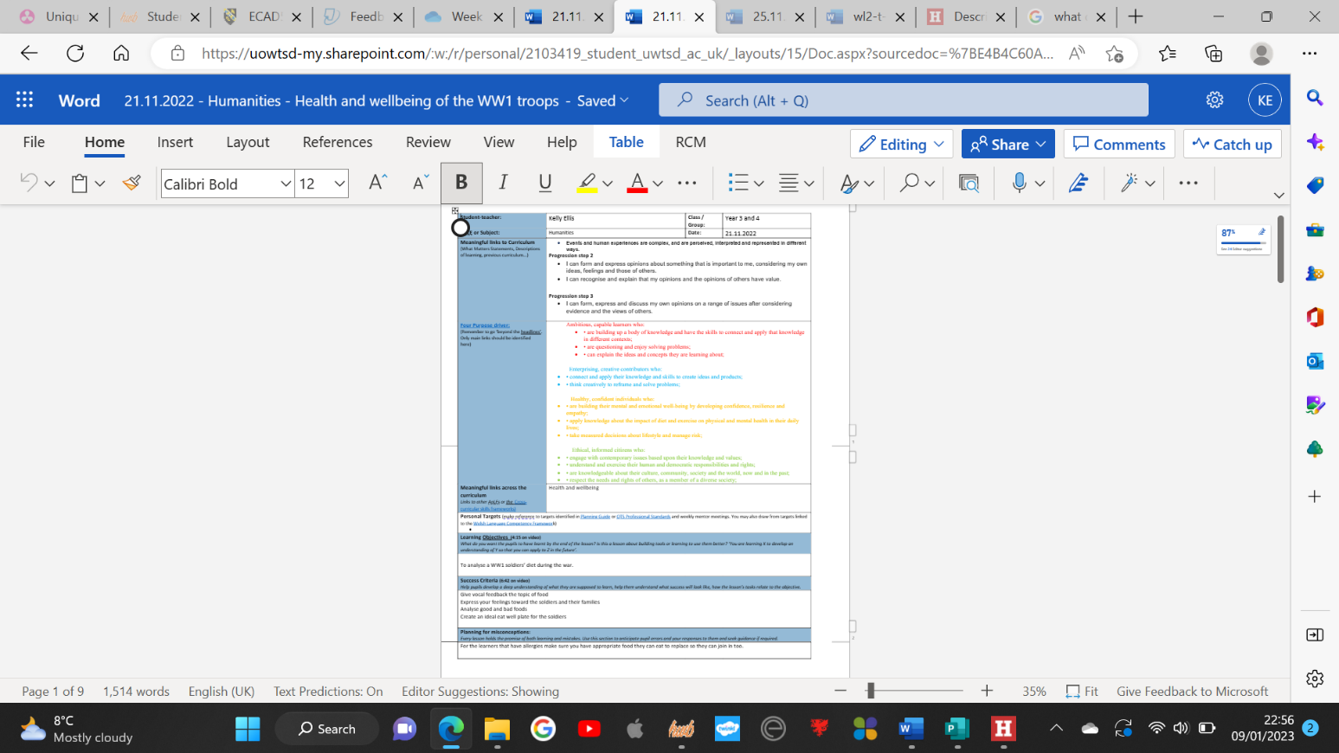

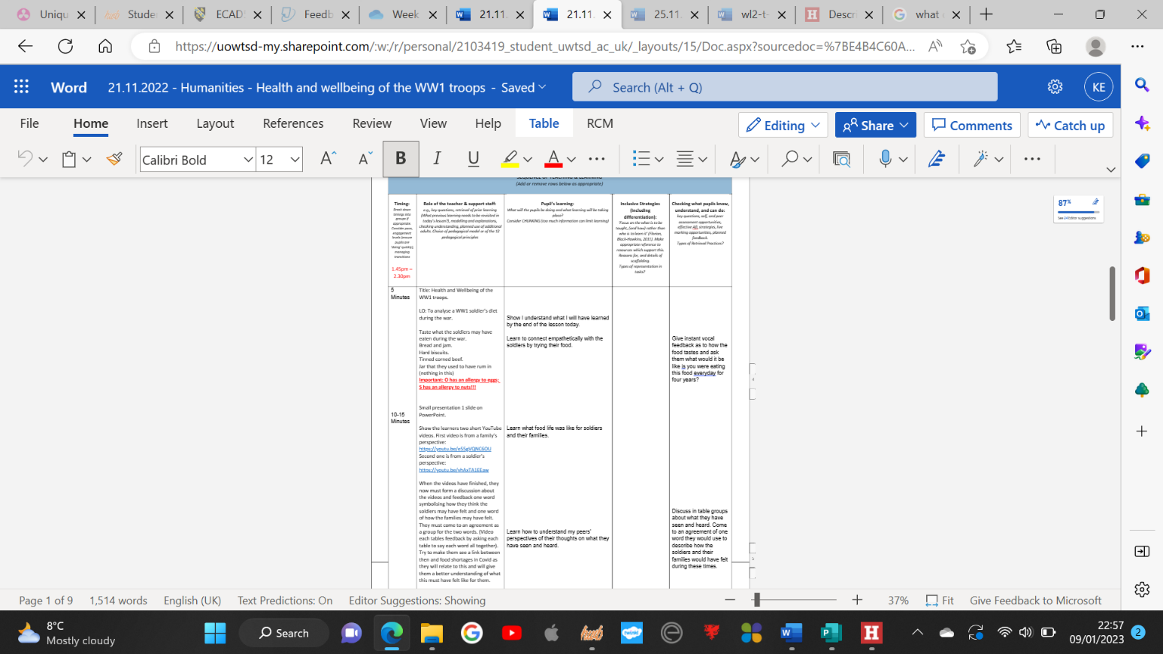

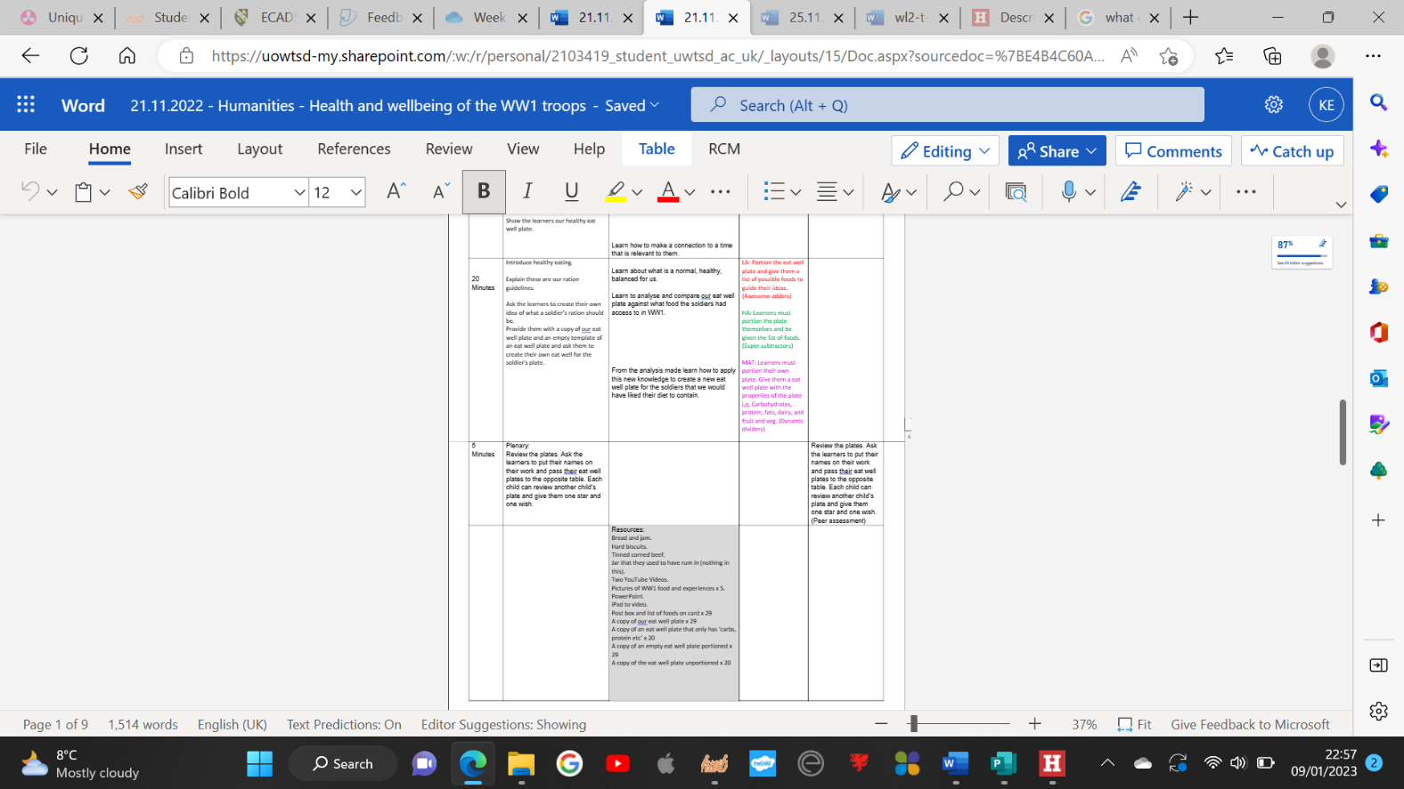

Lesson three – RE: The Jesse Tree.
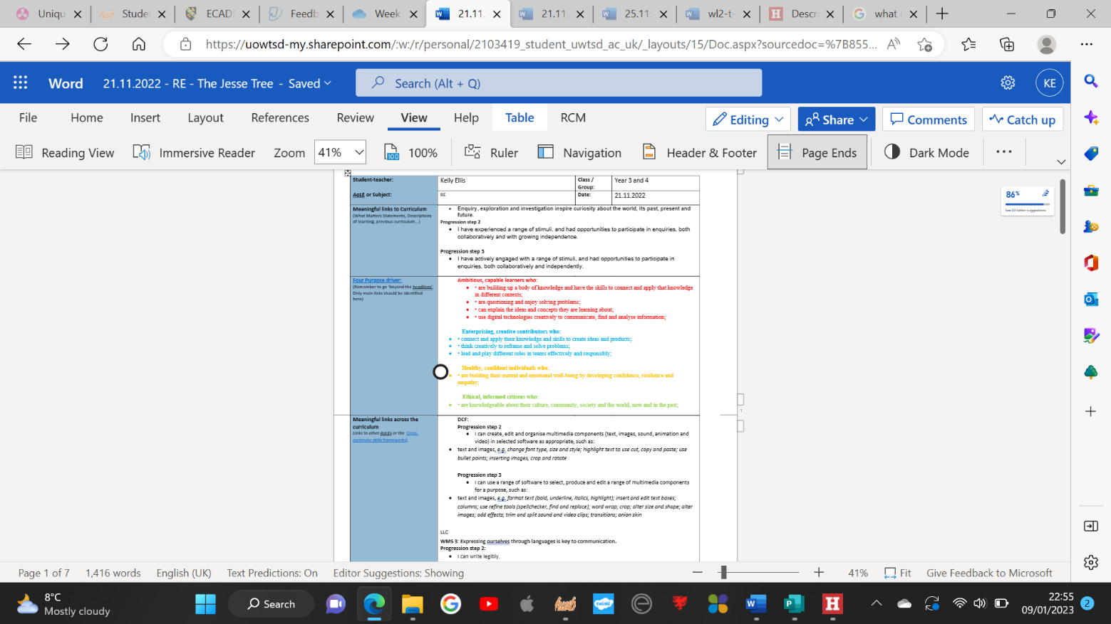

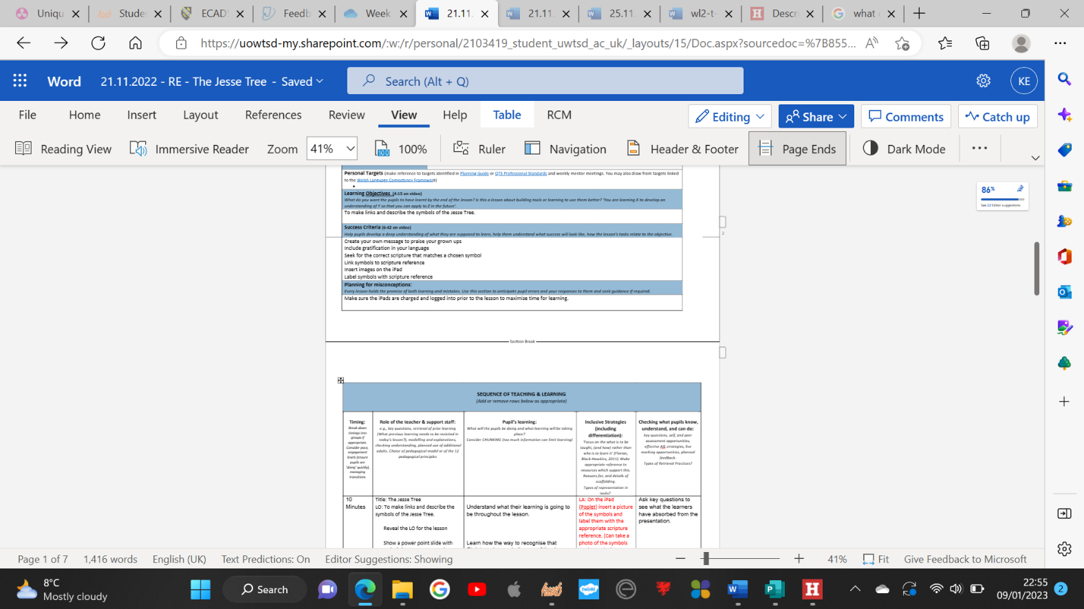

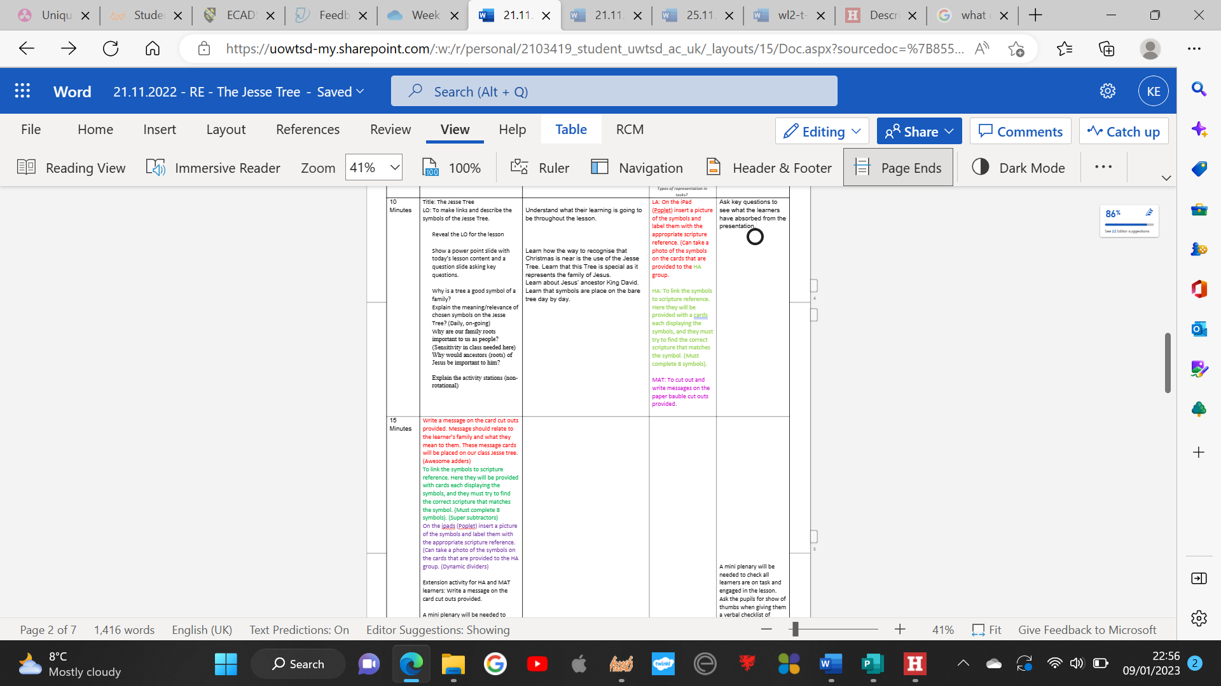

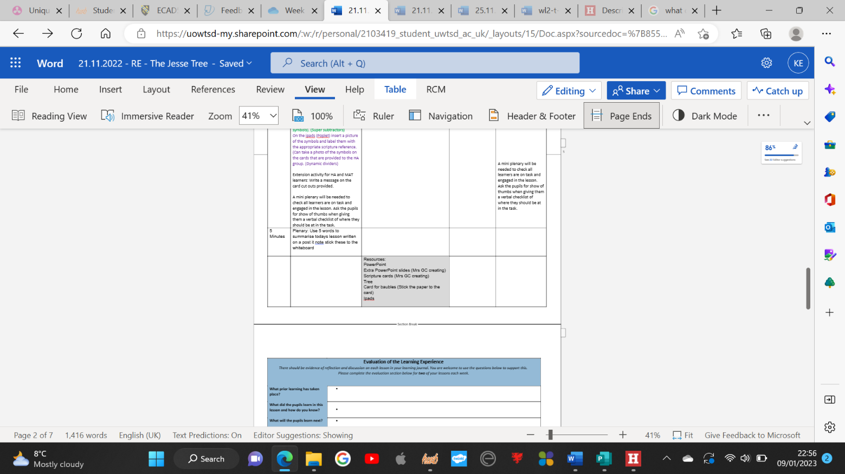
Reference List.
- Aubrey. K and Riley. A (2021) Understanding and Using Challenging Educational Theories. ‘Critiquing theory’. 2nd edition Pp 318. London: Sage

- Aubrey. K and Riley. A (2021) Understanding and Using Challenging Educational Theories. ‘Darling-Hammond and her ideas of an equitable educational system, teachers and teaching’. 2nd edition Pp 312. London: Sage

- Cox. B (2019) Opening Doors to a Richer English Curriculum. ‘Deep objectives’. Pp. 12. Williston: Crown house publishing

- Cox. B (2019) Opening Doors to a Richer English Curriculum. ‘Access strategies and beyond the limit link reading’. Pp. 4. Williston: Crown house publishing

- Cox. B (2019) Opening Doors to a Richer English Curriculum. ‘Taster drafts’. Pp. 8. Williston: Crown house publishing

- Donaldson. G (February 2015) Successful Futures. [online] ‘The case for change’. Available at: successful-futures.pdf (gov.wales) (Accessed on 09/01/2023)

- Estyn (07/08/2018) Pupil Voice Shapes the Curriculum [online] ‘Context and background to the effective or innovative practice’. Available at: Pupil voice shapes the curriculum | Estyn (gov.wales) (Accessed on 09/01/2023)

- Gray. C and Macblain. S (2015) Learning Theories in Childhood. ‘Developing language and thought’. 2nd Edition Pp96. London: Sage

- Gray. C and Macblain. S (2015) Learning Theories in Childhood. ‘Similarities in Vygotski and Piaget’s theoretical perceptives’. 2nd Edition Pp109. London: Sage

- Gray. C and Macblain. S (2015) Learning Theories in Childhood. ‘Summary’. 2nd Edition Pp108. London: Sage

- Ofsted (15/07/2022) Research review series: English [online] ‘The importance of high quality spoken language’. Available at Research review series: English - GOV.UK (www.gov.uk) (Accessed on 06/01/23)

- Smith. S and Conti. G (2016) The Teacher Language Toolkit. ‘Lesson structure’. Pp. 314-315. Great Britain.

- Smith. S and Conti. G (2016) The Teacher Language Toolkit. ‘Cognitive empathy’. Pp. 166-167. Great Britain.

- Smith. S and Conti. G (2016) The Teacher Language Toolkit. Cognitive empathy Metacognition. Pp. 166-167. Great Britain.

- Thomas. J (2019) Hook, line, and sinker [online] Available at: Ideas-for-Hooks1.pdf (Accessed on 09/01/2023)

- Voice 21 (2022) ‘Understanding Oracy’. [online] Available at Understanding oracy - Voice 21 (Accessed on 05/01/2023)

- Voice21 (2022) ‘Oracy across the Curriculum: The Evidence – Humanities’. [online] Available at Oracy Across the Curriculum: The Evidence - Voice 21 (Accessed on 05/01/23)

