University of Wales Trinity Saint David

Wales Institute of Science


Alternative propulsion systems
ACHA5010

Kairan Bennett
2305389
15/10/2025

Contents page
Contents
University of Wales Trinity Saint David 1
Contents page 2
Chosen car 3
WLTP 5
KERS System 8
KERS 11
System operation 12
Vehicle dynamics comparison 13
References 14

Chosen car

Car is a Toyota Yaris gr 2024
Frontal area = A ≈ 2.21 m²
overall width x overall height x projection factor = 1.805 m × 1.455 m x 0.84 = 2.206 m² → = 2.21 m²
Drag confident
Manufacturer value (road spec GR Yaris): Cd = 0.352 (Toyota spec).
Toyota Motor Corporation. (2020) Toyota GR Yaris Technical Specifications. [PDF] Toyota Media. Available at: https://media.toyota.co.uk/wp-content/uploads/sites

CdA = 0.777 m² (Cd = 0.352 and A = 2.206 m² → 0.352 x 2.206 = 0.777 m²).
Test mass
Recommended for most simulations: 1,355 kg (calculated as kerb weight 1,280 kg + driver 75 kg).
WLTP
• (WLTP / reference approach used in some test procedures): = 1,380 kg (kerb weight 1,280 kg + 75 kg driver + 25 kg luggage / extra test allowance).
Toyota Motor Corporation. (2024) The New Toyota GR Yaris: Press Pack. [PDF] Toyota Media. Available at: https://media.toyota.co.uk/wp-content/uploads/sites/5/pdf/240813-GR-Yaris-Press-Pack.pdf

Parameter | Symbol | Value | Source
Test Mass | m | 1,355 kg | Toyota 2024 + driver
Air density | ρ | 1.225 kg/m³ | Standard
Frontal area | A | 2.21 m² | Calculated earlier
Drag coefficient | Cd | 0.352 | Toyota data
Rolling resistance coefficient | Crr | 0.012 | Standard
Gravity | g | 9.81 m/s² | Constant

WLTP
Appropriate WLTP cycle:
WLTP Class 3b Duration =1800 sec (30 mins)

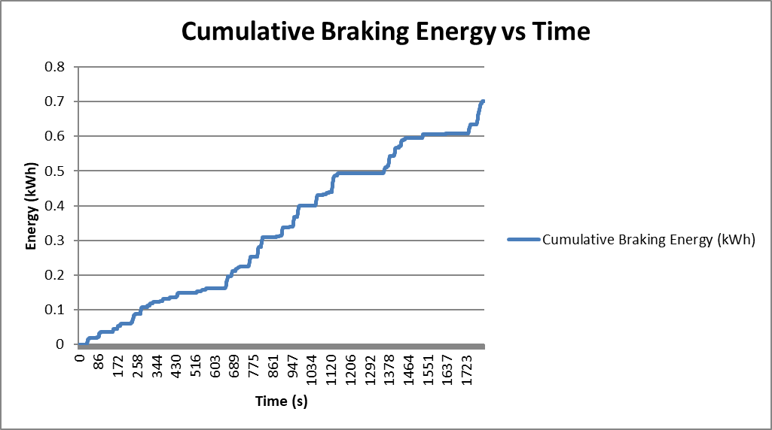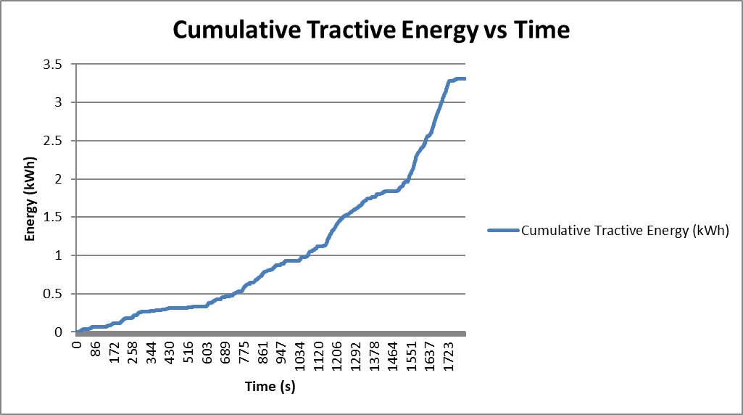
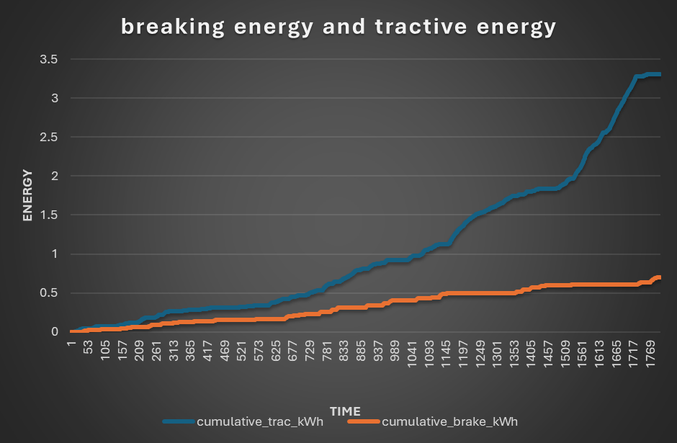
This graph shows the cumulative tractive energy and cumulative break energy over time. This the amount of tractive energy and breaking energy over the entire cycle at the contact patch.

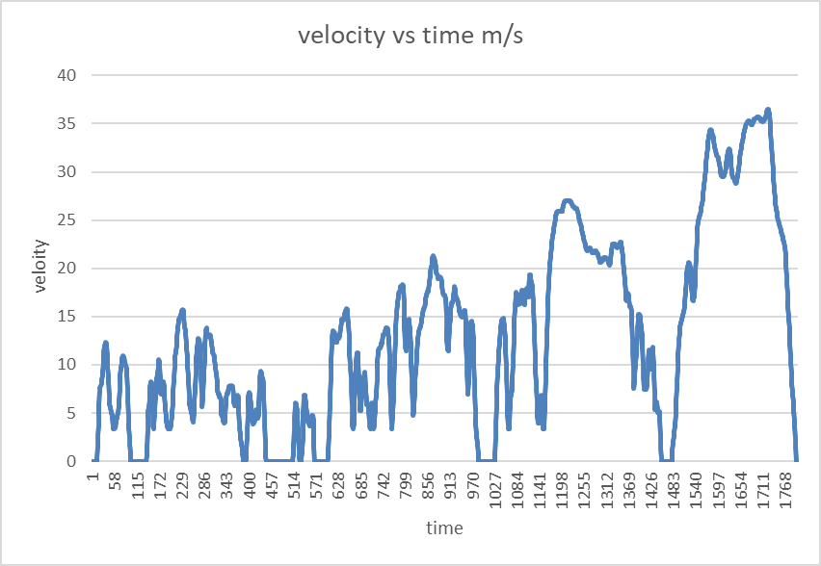
This graph shows the velocity over time. Also known as the wltp The duration of the of the cycle is 1800 seconds the car reaches a max velocity of 36.4 m/s. during the cycle the vehicle experiences areas of harsh breaking and attraction theses periods of braking is where a lot of the cumulative breaking energy is generated from.

KERS System
Looking at the WLTC cycle we can locate the areas with the largest kinetic energy recovery. The greater the breaking effort the more energy we could recover.

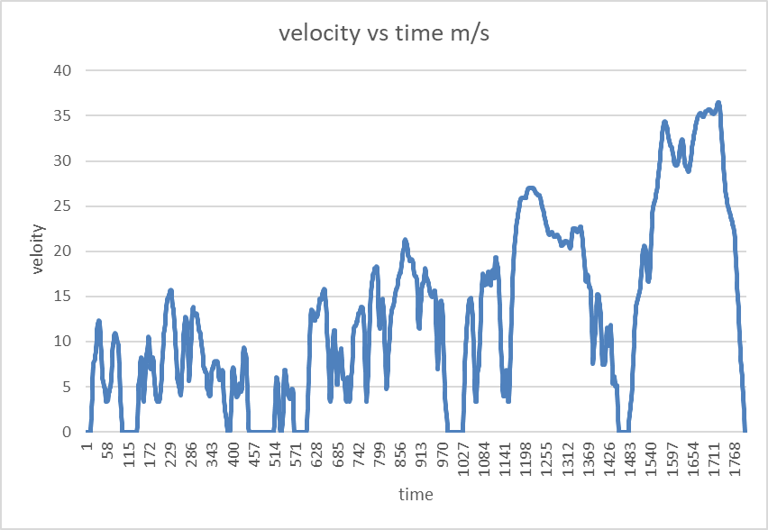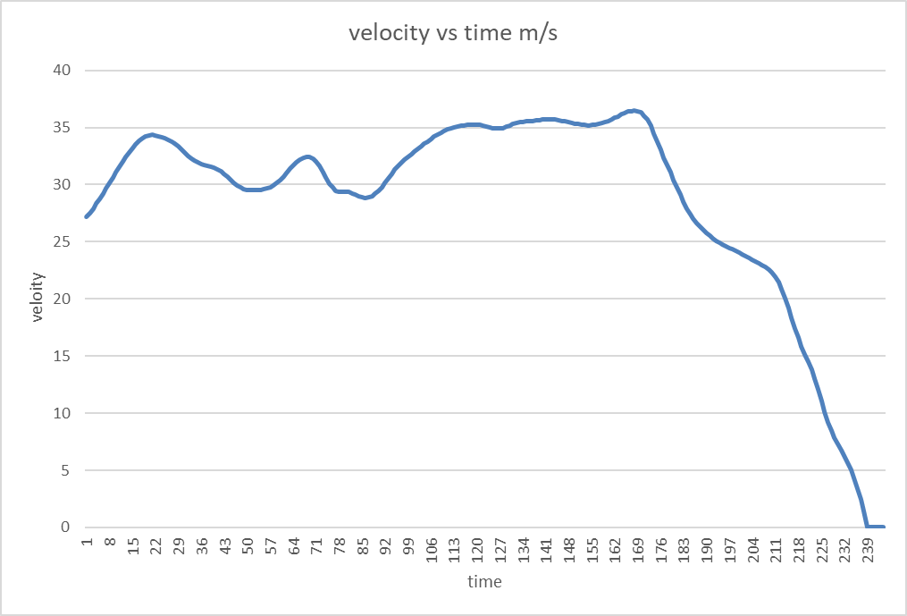
This is the final part of the graph were on the cycle the car goes from traveling at a velocity of 36m/s to a complete stop. This offers the most amount of theoretical kinetic energy to harvest. However this isn’t the best breaking profile to design our KERS around because it isn’t representative of real life. Hardly ever would someone on a normal road break from 36m/s to a complete stop that violently.
A more realistic profile would look more like this.
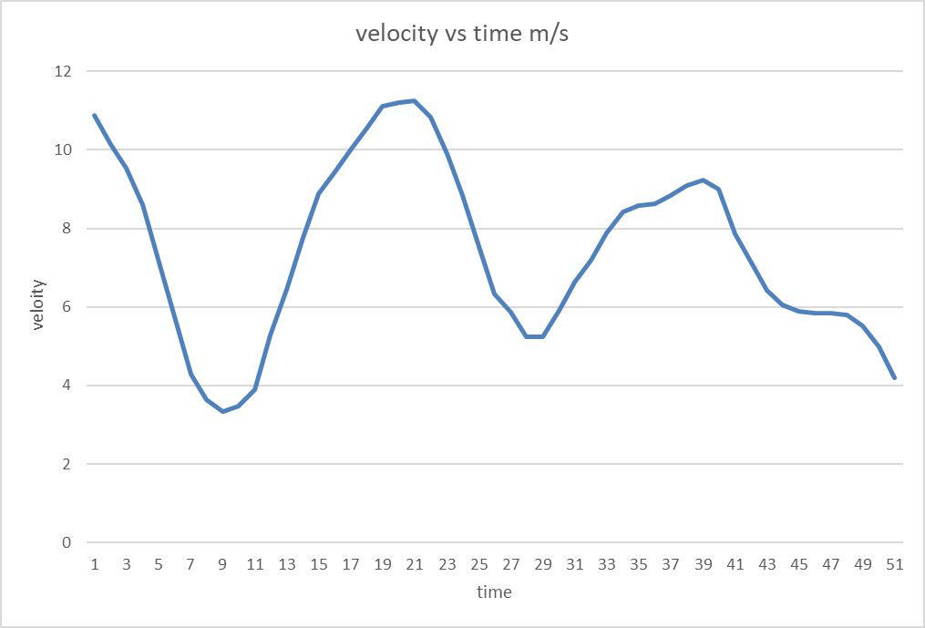
This id taken from points 659 too 709 seconds on the WLTC cycle this shows a more realistic profile of what normal day to day breaking and accelerating would look like.
Therefore, designing our KERS around this profile would be more useful in real life as
It would directly affect factors like fuel consumption and over working of engine and transmission components.

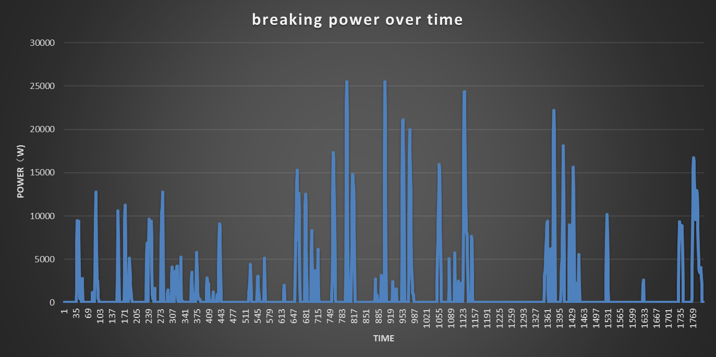

This graph shows the power generated by breaking across the run time.
Although the power generated dose reach highs of 25-26kw it wouldn’t be realistic to make a energy recovery system that could hold that much energy due to the size that the battery or other storage device would have to be.
A more ideal solution would be to look at what is the average power being generated each time we break. Which is 14kw.
Designing the battery to only hold the average amount of power may seem counterproductive when we could recover more energy from each breaking moment. However, batteries have an ideal working window so the battery will perform better if it’s not held at 100% capacity for long periods of time plus if it’s not drained to 0%.

KERS
Components | Efficiency | Size
Motor-generator | 90% – 97% | Diameter: 120–200 mm  Length: 100–200 mm
Power electronics converter | 95% - 98% | 200 × 150 × 60 mm
Flywheel Rotor | 97% -99% | 220-320 mm
Vacuum chamber | 100% | Diameter 360mm 450mm x length 320mm – 520mm
Magnetic bearing | 100% | Mass 3kg – 6g
Control system (BMS/EMS) | 100% | 150–250 mm (L)  120–180 mm (W)
Cooling system | 100% | Length: 100–150 mm  Diameter: 70–100 mm

Overall system efficiency = efficiency of;(motor gen x power electronics converter x flywheel rotor drivetrain)
0.96*0.96*0.98*0.90 = overall efficiency 0.81 = 81%
Cumulative break energy * efficiency of components in the kers over WLTP (time)

This graph shows the overall collective breaking energy that can be collected and returned back to the wheels.

System operation
A flywheel KERS captures and stores kinetic energy during braking, then releases it during acceleration. Instead of dissipating the braking energy as heat though friction in the brakes, a significant amount of the energy is transferred as rotational energy into a high-speed flywheel. When the driver presses the brake pedal, the system engages regenerative braking. The vehicle’s kinetic energy drives the motor-generator unit (MGU), which acts as a generator. This torque spins the flywheel up to higher speeds, storing energy as rotational kinetic energy.
Energy storage, the flywheel stores this energy in a vacuum chamber this it to reduce the frictional losses. Magnetic bearings are used to reduce friction too. And the control system monitors flywheel speed.
When the driver accelerates, the MGU draws energy from the flywheel, which slows down as it transfers rotational energy back to the wheels to assist the ICE engine.
The control unit (EMS) manages the MGU, brake blending, and clutch engagement to ensure smooth transitions between regenerative and frictional braking.
Safety systems monitor overspeed, vacuum level, temperature, and bearing condition.
  - Assumptions
- Flywheel storage capacity (1.1MJ)
- Flywheel efficiency (95–97%)
- MGU/inverter efficiency (90-95%)
- Total wheel-to-wheel efficiency 81%

  - Driver feel
Under breaking.
Brake pedal feel.
The pedal will feel Slightly firmer or less linear compared to friction-only brakes, especially at low speeds.
Braking smoothness
Breaking will feel smoother under light braking due to energy capture but less effective at very low speeds. KERS torque reduces as vehicle speed drops below flywheel engagement speed.
Under acceleration
Throttle response
The throttle responsiveness will have a more immediate torque when accelerating out of corners or from low speed.
System re-engagement
The driver may feel a light surge or smooth boost.

Flywheel decelerates as energy is returned to wheels. Proper torque blending minimises jerk.

Vehicle dynamics comparison
Features | ICE only friction breaks | Kers + friction breaks
Fuel consumption | Higher and no energy recovery | Regen + friction breaks
Acceleration performance | Only engine power | Both engine power and energy stored
Break wear | high | Less because of less friction
Cost and complexity | Simple and cheaper | Added components (flywheel, MGU, CVT, control) means more complex and cost
Driver feel | Predictable and linear | Can be unpredictable and depends on power delivery and the amount of energy stored

References
Flywheel and storage systems
- Pullen, K. R., 2019. The Status and Future of Flywheel Energy Storage. Joule, 3(6), pp. 1394–1399.
- Amiryar, M. E. & Pullen, K. R., 2017. A Review of Flywheel Energy Storage System Technologies and Their Applications.
Kinetic energy and moment of Intria
- Engineering Toolbox, 2025. Flywheels – Kinetic Energy. (online) Available at: EngineeringToolBox.com.
WLTP
- Vehicle Certification Agency (VCA). (2021) The Worldwide Harmonised Light Vehicle Test Procedure (WLTP). [Online] Last updated 1 April 2021. Available at: https://www.vehicle-certification-agency.gov.uk/fuel-consumption-co2/the-worldwide-harmonised-light-vehicle-test-procedure
- Diesel Net. (n.d.) “Worldwide Harmonized Light-duty Vehicles Test Cycles (WLTC).” Diesel Net. Available at: https://dieselnet.com/standards/cycles/wltp.php
Toyota yaris
- Toyota Motor Corporation (2024) Toyota GR Yaris: 2024 Press Pack. [PDF] Toyota Media. Available at:
https://media.toyota.co.uk/wp-content/uploads/sites/5/pdf/240813-GR-Yaris-Press-Pack.pdf
- Carfolio. (2024) “2024 Toyota GR Yaris (model 808885) technical data.” Carfolio. Available at: https://www.carfolio.com/toyota-gr-yaris-808885
- Toyota Motor Corporation. (2024) The New Toyota GR Yaris: Press Pack. [PDF] Toyota Media. Available at: https://media.toyota.co.uk/wp-content/uploads/sites/5/pdf/240813-GR-Yaris-Press-Pack.pdf
KERS efficiency
- Szumska, E. M., 2025. Regenerative Braking Systems in Electric Vehicles: A Comprehensive Review of Design, Control Strategies, and Efficiency Challenges.

